Know Your Nzone - Manual Token
Screenshot Based Standard Operating Procedure
For authorised users processing customer or unloading latitude-longitude to Nzone. No Python installation and no Client ID entry are required.
Golden rule: Unzip first, start the EXE, and keep the black application window open until every Excel download is finished.

The full process at a glance
1. Unzip | 2. Start | 3. Sign in | 4. Process | 5. Download
Extract All | Open the EXE | Paste today's token | Single or bulk | Save XLSX outputs

Five rules that prevent almost every problem
- Never open the EXE while it is still inside the ZIP file.
- Never close the black application window while using the browser app.
- Use the current token from the authorised official email; paste the token only, not the Client ID.
- For bulk processing, do not rename, remove, or rearrange the template columns.
- Download the result before closing the app. Closing the EXE clears the token from memory.

What you need
Required | Details
Windows laptop | Internet access and permission to run the supplied EXE.
App ZIP | Know Your Nzone_ManualToken.zip received from the authorised sender.
Today's token | Latest Mappls access token from official Outlook email.
Input | Customer ID, Customer Name, Latitude, Longitude; State is normally automatic.

Step 1 - Extract the ZIP
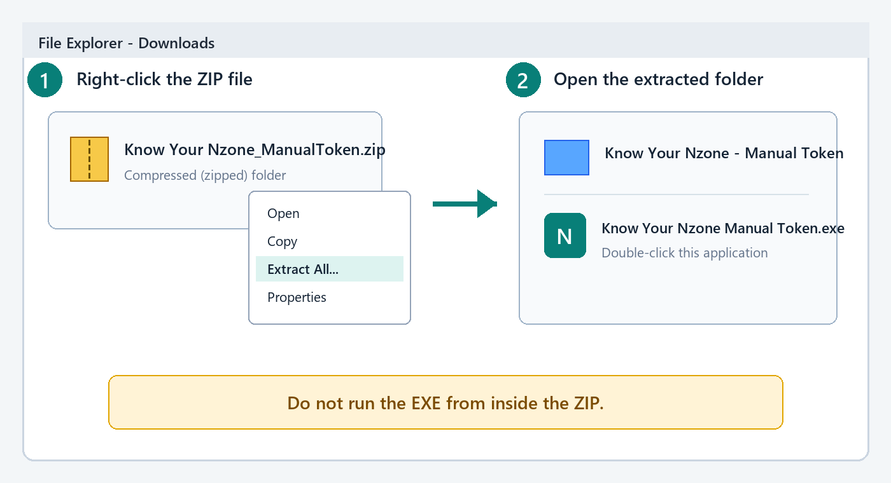
Illustration: extract the ZIP, then open the extracted folder.
1. Save the ZIP - Put the received ZIP in Downloads or another normal folder.
2. Extract it - Right-click the ZIP and select Extract All. Accept the suggested destination.
3. Open the new folder - Make sure you can see Know Your Nzone Manual Token.exe.
Check: The address bar should show a normal folder path. It must not say Compressed Folder or show the ZIP as the open location.

Step 2 - Start the app and leave it running
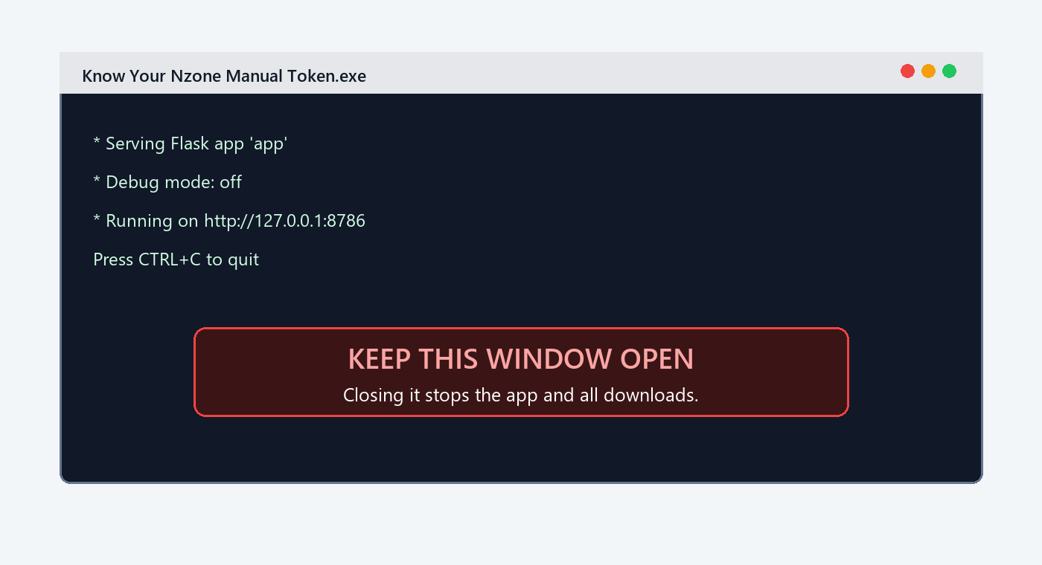
Illustration: the black application window must remain open.
1. Double-click the EXE - Open Know Your Nzone Manual Token.exe.
2. Wait - The black window starts the local app; the browser normally opens automatically.
3. Keep it open - Minimise the black window if needed, but do not close it.
4. If the browser does not open - Open Chrome or Edge and enter http://127.0.0.1:8786.
Why this matters: The browser is only the screen. The EXE is the engine. If the black window closes, the page and Excel downloads stop working.

Step 3 - Start the manual-token session
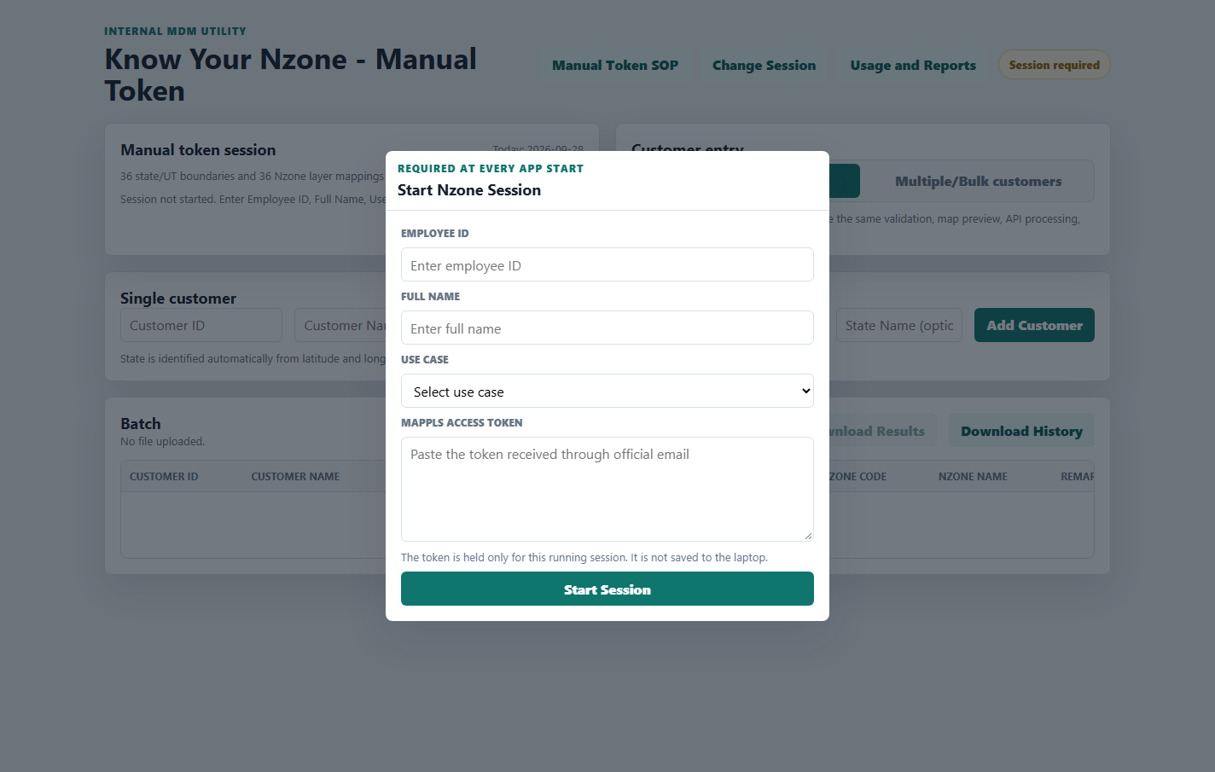
Actual app screen: session details are required at every start.
1. Employee ID - Enter your official employee ID.
2. Full Name - Enter your full name as it should appear in reports.
3. Use Case - Select one of the three approved use cases listed below.
4. Access Token - Paste today's token received through official email. Do not enter a Client ID.
5. Start Session - Click the green button and wait for Session ready.
Token safety: The token stays only in the running app memory. It is not saved to the laptop and is cleared when the app closes.

Step 4 - Confirm the user and select the right use case
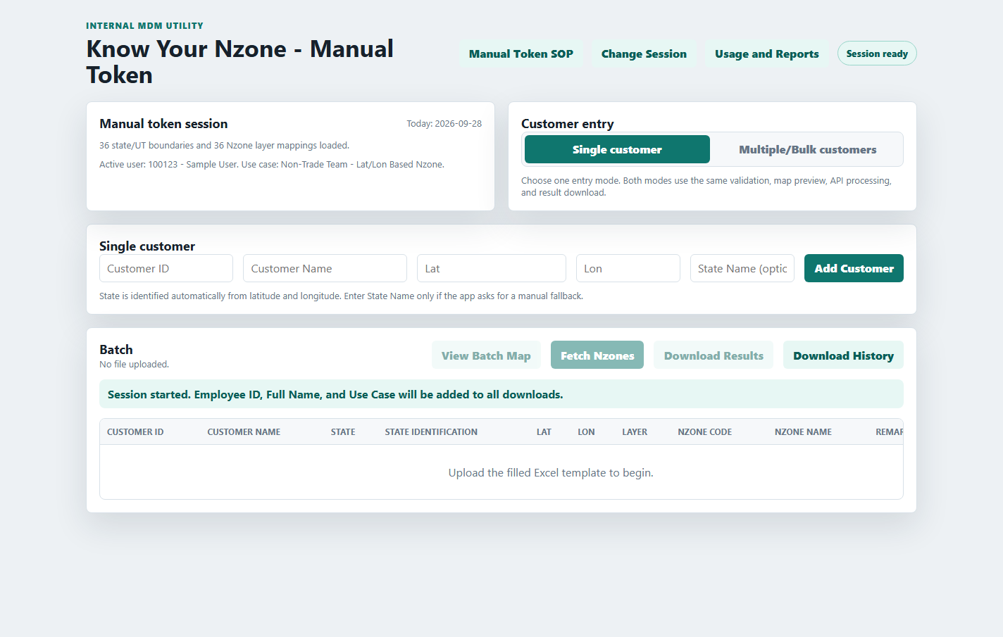
Actual app screen: confirm Session ready and the Active user line.
Use Case | Select it when
Non-Trade Team - Lat/Lon Based Nzone | The Non-Trade team is converting supplied latitude-longitude to Nzone.
FleetX - Customer Lat/Lon to Nzone | FleetX coordinates represent the customer location.
FleetX - Unloading Lat/Lon to Nzone | FleetX coordinates represent the unloading location.

Check before processing: The top-right badge must say Session ready. The Active user line must show your Employee ID, Full Name, and chosen Use Case.

Step 5A - Process one customer
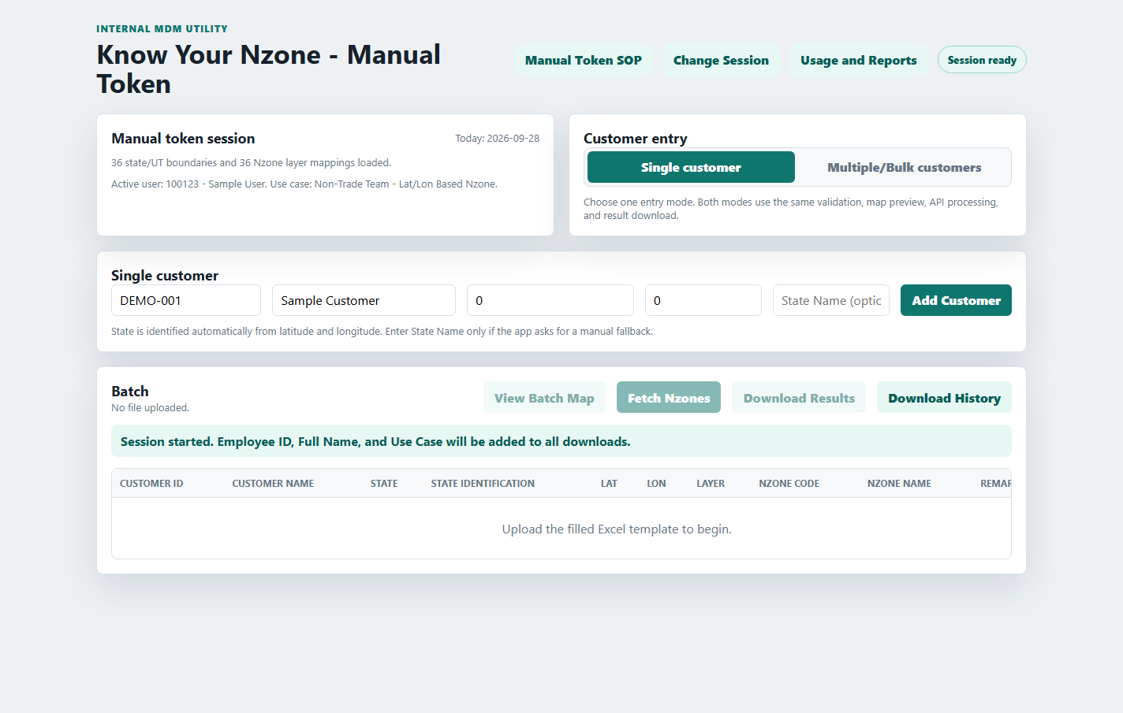
Actual app screen: enter the four mandatory customer fields; State Name is normally blank.
1. Select Single customer - Use this mode for one coordinate pair.
2. Enter four fields - Customer ID, Customer Name, Lat, and Lon are mandatory.
3. Leave State Name blank - The app first identifies the state automatically from the coordinates.
4. Add Customer - Review the row that appears in the Batch section.
5. Fetch Nzones - Click only after checking the ID, name, latitude, and longitude.
6. Download Results - When complete, save the XLSX result.
Coordinate check: Latitude must be between -90 and 90. Longitude must be between -180 and 180. A swapped or mistyped value can point to the wrong location.

Step 5B - If the app asks for the State
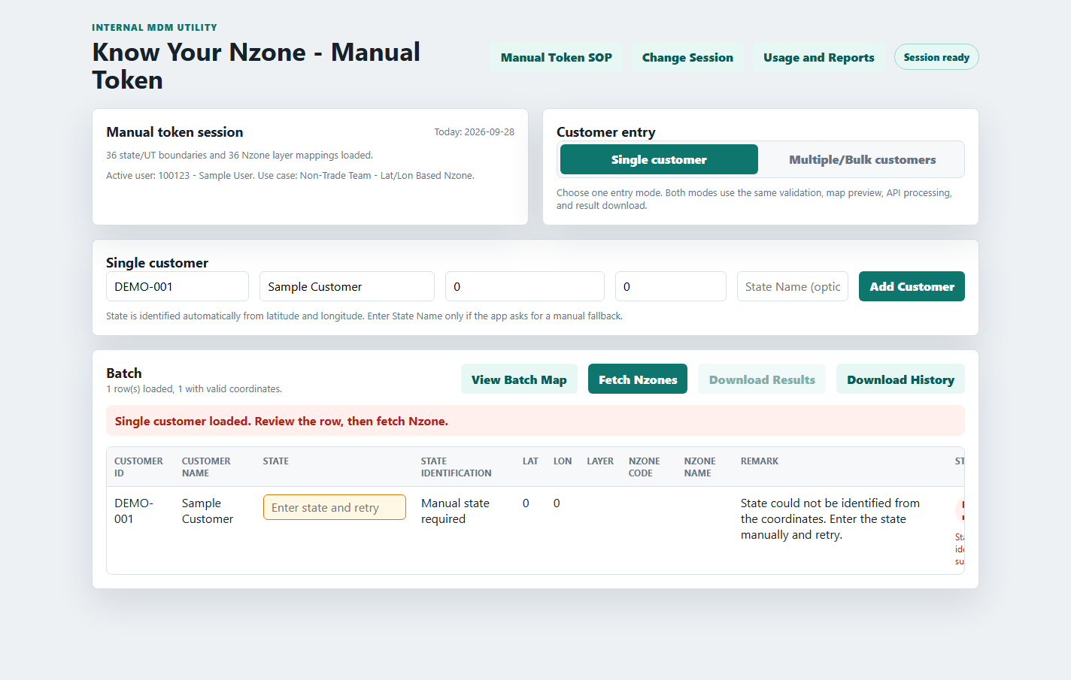
Actual app screen: Manual state required is highlighted in the row.
1. Read the remark - Confirm the row says Manual state required.
2. Check Lat and Lon - Correct any typing or swapped-coordinate error first.
3. Enter the State - Type the correct state in the highlighted State box.
4. Retry - Click Fetch Nzones again for the corrected row.
5. Escalate if still unresolved - Preserve the output and share the row details with the authorised support owner.
Do not guess: Use the actual state for the coordinate. A wrong manual state can query the wrong Nzone layer.

Step 6 - Process a bulk Excel file
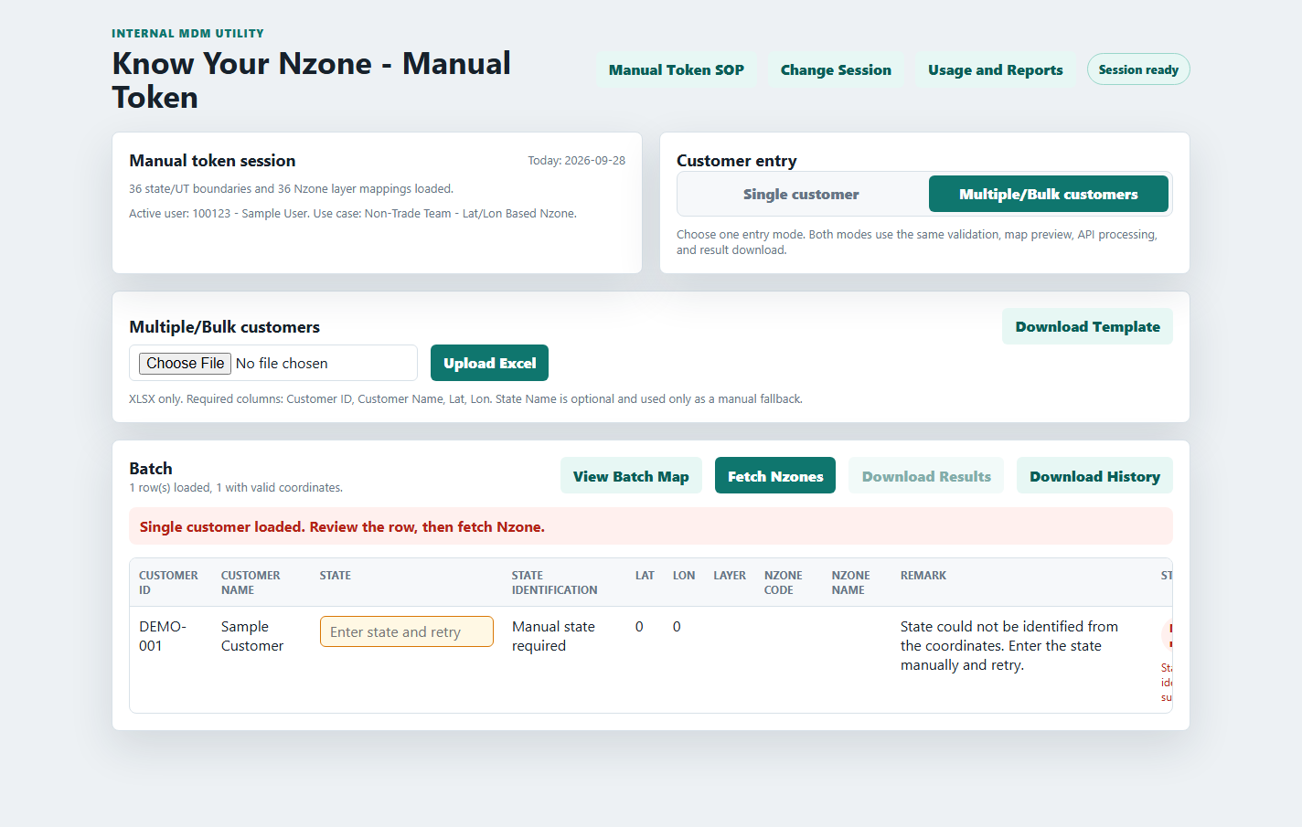
Actual app screen: bulk upload uses the supplied XLSX template.
1. Select Multiple/Bulk customers - This changes only the entry method; validation and output remain the same.
2. Download Template - Open the downloaded XLSX and keep the column names unchanged.
3. Complete the file - Fill Customer ID, Customer Name, Lat, and Lon. State Name is optional fallback.
4. Choose File and Upload Excel - Select the completed XLSX and review the loaded row count.
5. Optional map review - Use View Batch Map to spot obviously misplaced coordinates.
6. Fetch Nzones - Keep the browser and black application window open until processing finishes.
7. Resolve and download - Fix Manual state required rows, retry them, then download the XLSX result.
Recommended batch size: There is no fixed app row limit. For easier monitoring and recovery, use about 250 to 500 rows per file. Larger files take longer because requests run sequentially.

Step 7 - Download outputs and reports
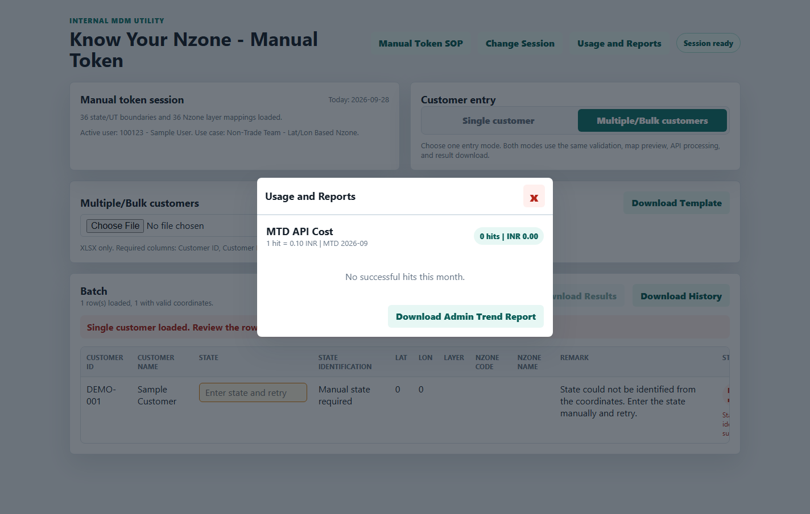
Actual app screen: Usage and Reports provides the admin trend workbook.
Button | What it downloads
Download Results | Current run in XLSX format.
Download History | Successful customer mappings stored on this laptop.
Download Admin Trend Report | Summary, time trend, state, use-case, user, and customer-level audit sheets.

Audit fields: Result, history, and customer-level admin outputs include Employee ID, Full Name, and Use Case.

Meaning of common statuses
Status | Action
Success | Download the result. The mapping is recorded in local history.
Manual state required | Enter the correct state in the highlighted row and retry.
Error | Read the row message; correct input, token, connectivity, or API issue, then retry.
Re-hit blocked | The Customer ID was previously successful, so another paid hit was prevented.

Troubleshooting Windows file block
Use these steps when double-clicking the EXE does not open the application, especially after receiving the ZIP through email or downloading it from a shared location.
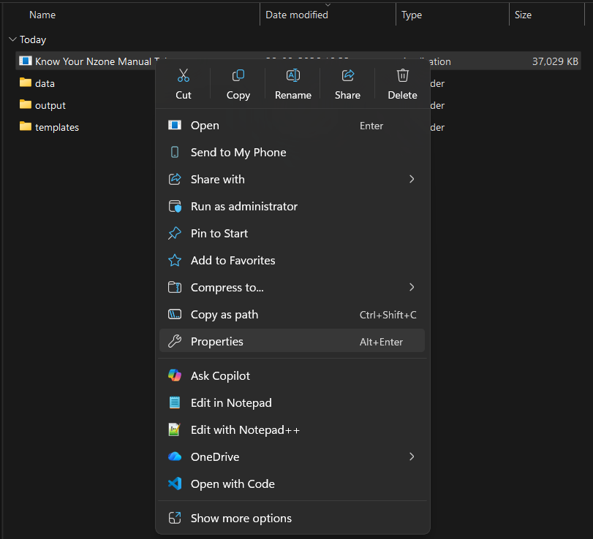
Right-click Know Your Nzone Manual Token.exe and select Properties.
1. Return to the extracted folder - Do not perform these steps while viewing the EXE inside the ZIP file.
2. Right-click the EXE - Select Know Your Nzone Manual Token.exe in the extracted folder.
3. Open Properties - Choose Properties from the right-click menu.
If Properties is not visible: Select Show more options, then choose Properties.

Remove the Windows file block
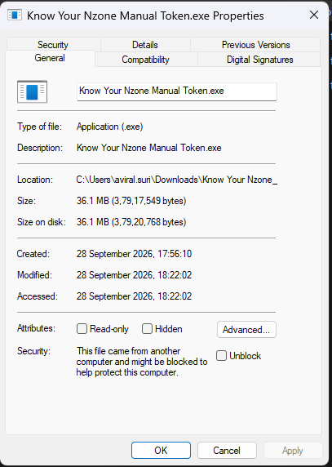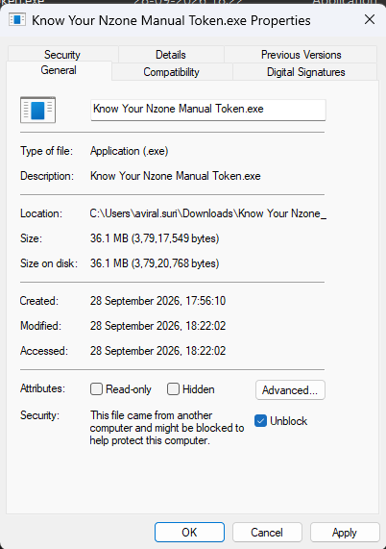
Left: the downloaded EXE is blocked. Right: select Unblock before applying the change.
1. Stay on the General tab - Look at the Security message near the bottom of the Properties window.
2. Select Unblock - Tick the Unblock checkbox when Windows says the file came from another computer and might be blocked.
3. Apply the change - Click Apply, then click OK.
4. Start the app again - Double-click the EXE and keep the black application window open.
If Unblock is not shown: The file is not blocked using this Windows setting. Close Properties and continue with the troubleshooting table on the next page.

Troubleshooting and safe closing
Problem | What to do
EXE does not open after download | Right-click the EXE, open Properties, select Unblock if shown, click Apply and OK, then retry.
Browser says 127.0.0.1 refused to connect | The EXE is not running. Return to the extracted folder and start it again.
Browser did not open | Keep the EXE running and enter http://127.0.0.1:8786 in Chrome or Edge.
Session required | Enter Employee ID, Full Name, Use Case, and today's access token.
Token rejected or expired | Click Change Session and paste the latest token from official email.
Manual state required | Check coordinates, enter the correct state, and retry.
Excel download cannot connect | Confirm the black EXE window is still open, return to the app page, and download again.
Large batch is taking time | Do not close either window. Use 250-500 row files for future runs.

Close in the correct order
1. Finish all downloads - Open the saved XLSX if necessary to confirm it is complete.
2. Close the browser tab - The page is no longer needed.
3. Close the black application window - This stops the local app and clears the token from memory.
Final reminder: Share the ZIP or full extracted folder with users as instructed by the process owner. Never distribute a folder containing your own token, output files, or local history.

