Portuguese Bank – Consulting Memo concerning Saving Subscription Campaign

To those it may concern regarding the savings program subscription campaign,

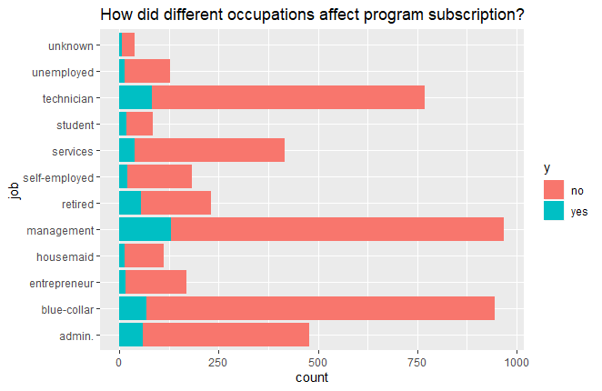To the right is Figure 1. Takeaways from Figure 1, relating occupation to subscription call outcomes, shows that the three primary occupations that were contacted are management, blue-collar, and technician. Almost 150 managers accepted the subscription offer, which is almost twice as much as the next occupation (technician), though management did have almost 1,000 people contacted.

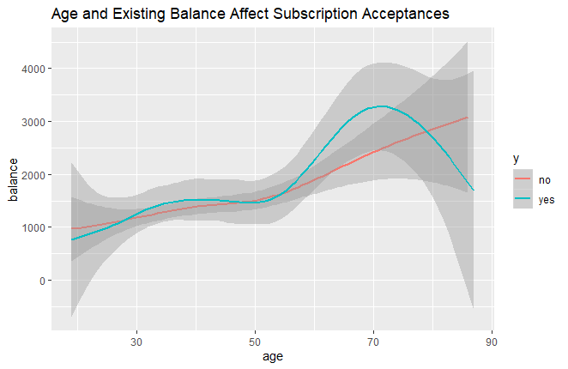To the left is Figure 2. In Figure 2, the relationship discovered is more subtle, but explainable with context: for contacts between the age of 50 and 70, which is retirement age, contacts with higher balances are more likely to accept the subscription program. The line to fit demonstrates that at the age of 70, the average “Yes” response had a significantly higher preexisting balance.

What are key takeaways from these two images? Management (managers, executives, etc) are our highest success rate among the occupations, and should be targeted in a future campaign. Meanwhile, those between the ages of 50 and 70 are more likely to accept the subscription as their account balance increases, which is a trend that should be noted as we move forward.