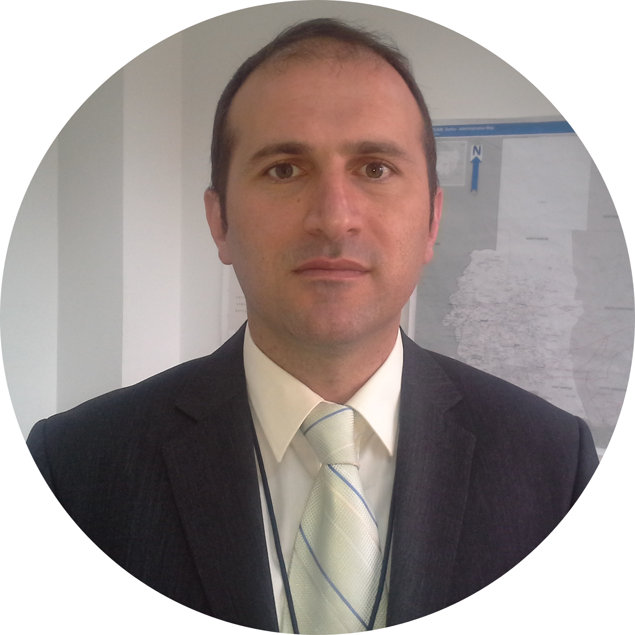

Kaan BÖKE | kaanboke@gmail.com | Finland | +358465837576

# About Me

I am highly motivated and well experienced project person and programmer. I love data and programming.

# Work Experience

**UN** *2013 2015*Project Manager and Training Coordinator

**TNP** *2007 2013* Data analysis, Project Maangement

**MSU** *2004 2007*Teaching Assistant and instructor - Statistical Mthods

**TNP** *1997 2003*Junior Project Officer, Data Analysis

# Skills

* **Project Management** *professional*
* **Training Coordinator** *professional*
* **Python** *professional*