Kimberly Brock

February 14, 2021

Foundations of Programming (Python) – IT FDN 110 A

Assignment05

GitHub: [*kb1981/Assignment_05 (github.com)*](https://github.com/kb1981/Assignment_05)

Introduction

This week lists and dictionaries were the main topics. We watched Module05 to become familiar with list and dictionaries. A few extras were added into the module too, such as improving scripts, functions, and GitHub. We read Chapter 5 of *Python Programming for the Absolute Beginner, Third Edition,* that furthered knowledge on list and dictionaries. We reviewed a few additional webpages that included videos and tutorials. Finally, we put our knowledge into action with Assignment05 and updating the previous assignment to include dictionaries.

Module 05 – Lists, Dictionaries, etc.

Module 05 continued the discussion on Lists. We learned the * can be used to unpack lists. We also learned how to save and load a file into a list. We discussed the *split()* and the *strip()* functions to use with list and help with formatting. Next topic was dictionaries. Dictionaries are mapping types, meaning that are stored in Key:Value pairs instead of an index. We went through some dictionary methods. Like lists, dictionaries are also mutable. A couple of other additional topics included way to improve our scripts. Discussed was the separation of concerts (SoC), and during this topic we learned how to set up a template in Spyder. We learned about calling functions but will explore more of that next week.

Structured Error Handling can be used so that we can make use of some python internal error handling procedures to not have the script crash. Last, but not least, we learned how to set up a GitHub account and create a repository to begin using to submit assignments.

*Module 05 can be found at the link:* [*https://saravji.github.io/saravjis_hut/FDN_Prog/Modules.html*](https://saravji.github.io/saravjis_hut/FDN_Prog/Modules.html) *and the Lab05_A, B, are shown in Appendix A.*

Python Programming for the Absolute Beginner, Third Edition

This week in the book *Python Programming for the Absolute Beginner, Third Edition*, By Michael Dawson I read through. “Chapter 5– Lists and Dictionaries: The Hangman Game.” First, we discussed lists and some functions that can be used with lists. The book discussed understanding using lists versus tuples. Basically, tuples are faster code to execute, but you cannot change them. The next topic was dictionaries. Dictionaries use Keys and Values, instead of indexing, meaning if you want to find an item in the dictionary, you must look up the key. We read about setting up a dictionary and some functions that can be used with them.

Additional Webpages

1. <https://realpython.com/python-lists-tuples/>

The link above talks about Python’s lists and tuples functions. Learned was that list and tuples are very useful in python, and contain multiple types of object, including functions, modules, and classes. Both list and tuples are sequences and can accessed by an index. Both lists and tuples can also be nested. Both lists and tuples have many uses and available functionality. One main difference between the two is that lists are mutable, and tuples are immutable. We may want to use a tuple because they execute faster, or we have data we do not want to change.

1. <https://realpython.com/python-dicts/>

This link covered some basic functions of the Python dictionary. Dictionaries are mutable, dynamic, and can be nested, like list. However, unlike list, they can not be indexed. Dictionaries us a key to point to data.

1. <https://www.geeksforgeeks.org/file-handling-python/>

Link number three is information on handling files in Python.

Additional Videos

1. Reading from a text file: <https://youtu.be/m0o0CkYsDzI>

The linked video went through a simple example of writing and reading a text file. Some examples were shown of how to read an entire file as well as reading line by line

Applying Knowledge – CDInventory.py, *enhanced*

*\*Location on GitHub:* [*kb1981/Assignment_05 (github.com)*](https://github.com/kb1981/Assignment_05)

For this assignment, we were given a ‘starter code’ and asked to add to it to enhance the CDInventory.py script from Assignment04. We were asked to:

1. Modify the script as required to replace the inner data structure by dictionaries.

This changed the previous assignment from a 2D list-of-list to a 2D list-of-dictionaries.

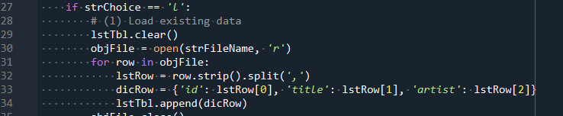

Listing . Copy of Script for Creating List-of-Dictionary

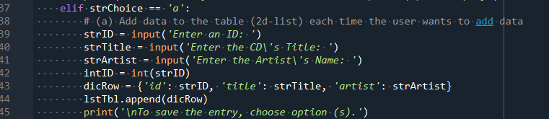

Listing . Copy of Script for Creating List-of-Dictionary

1. Add the functionality of loading existing data.

This functionality allowed the user to bring in data from a text file and load it into the dictionary and list.

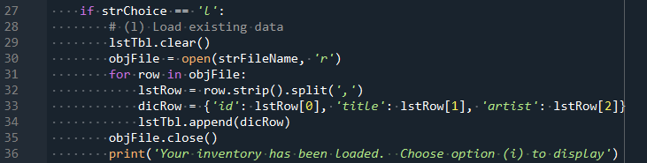

Listing . Script for Loading Existing Data

1. Add functionality of deleting an entry.

This functionality allowed the user to delete an entry from the CD inventory.

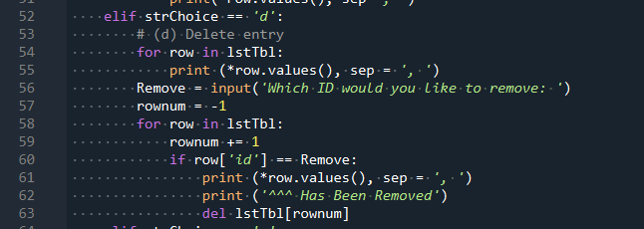

Listing . Script for Deleting an Entry

1. Use a list of dictionaries as 2D table

This functionality can be seen in Listing 1 and Listing 2 above. The code takes the entries from the user and enters them into the dictionary. Then, the added dictionary items are then appended to the list, making this is 2D table.

Below are screenshots of CDInventory.py working in both Spyder and Terminal. Also below is a screenshot of the program output to the text file.

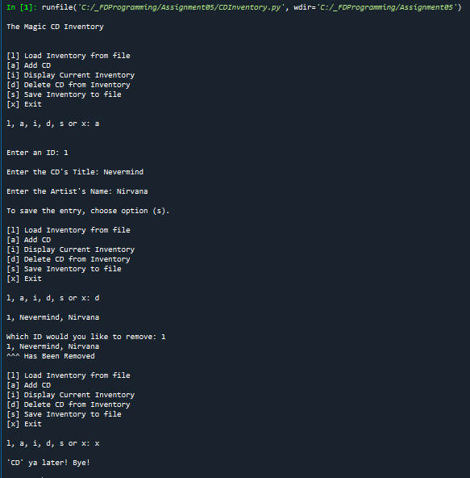

Listing . CDInventory.py Running in Spyder

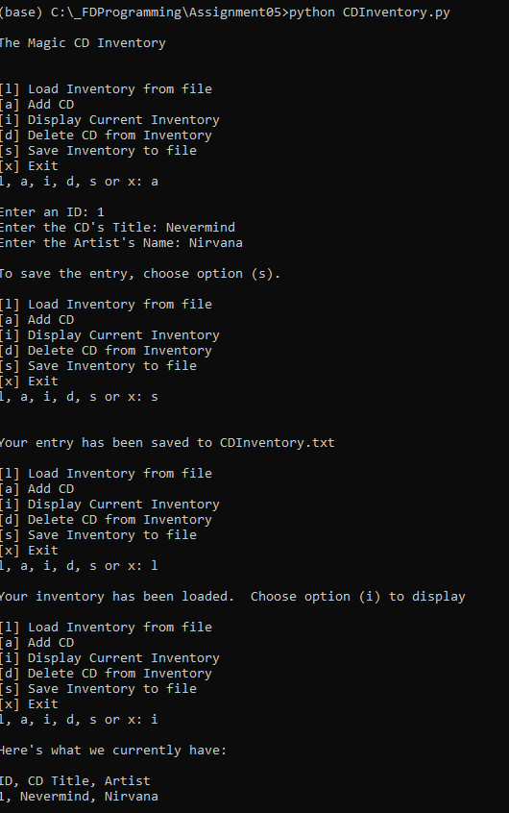

Listing . CDInventory.py Running in Terminal

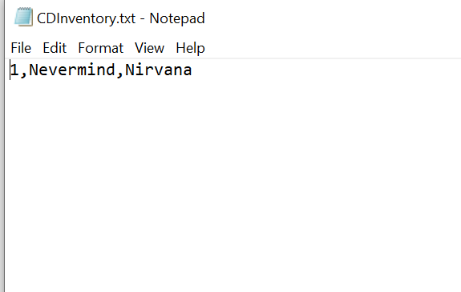

Figure . Output of CDInventory.txt

Summary

In summary, this was a tough assignment for me. I struggled at first with understanding how a list of dictionaries worked. I understood them separately but was having trouble understanding them together. Luckily, I continued researching and trying out examples, and was able to finally get the basic understanding down without throwing my computer out the window! 😊 While the assignment was frustrating for me this week, I do feel like I learned a lot, and am appreciative for that.

Appendix

*Appendix A. Module 05 Lab Listings*

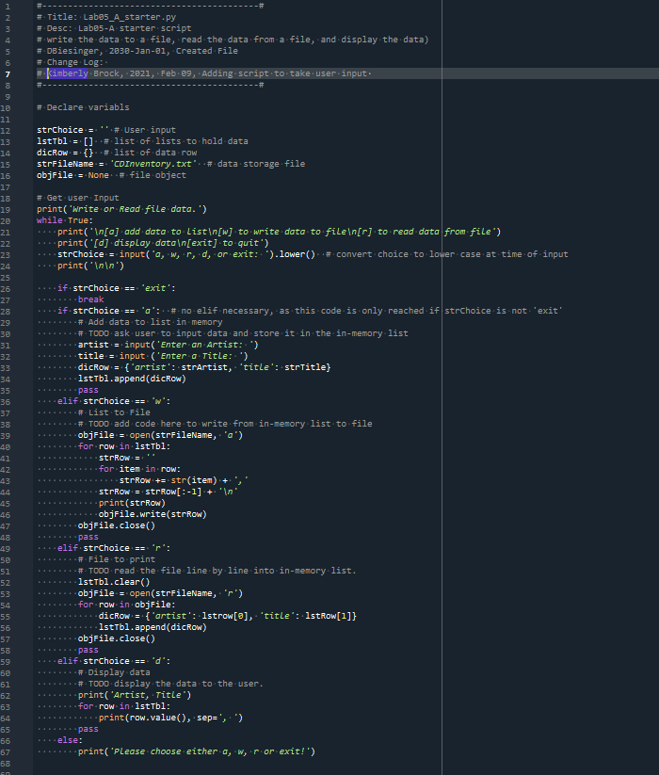

Appendix A Listing . Lab05_A.py

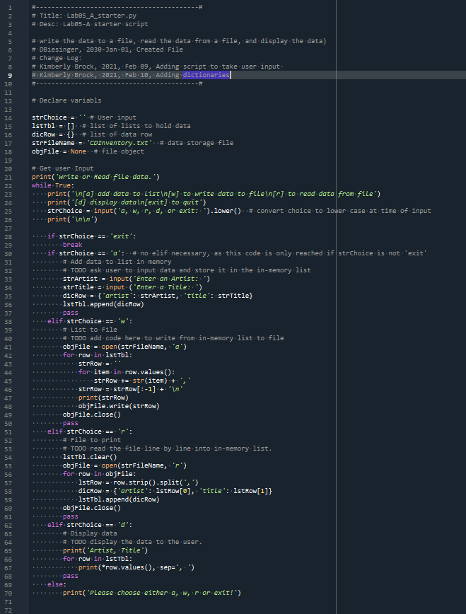

Appendix A Listing . Lab05.B.py

*Appendix B. Assignment04 – CDInventory.py*

Assignment uploaded to GitHub: [kb1981/Assignment_05 (github.com)](https://github.com/kb1981/Assignment_05)

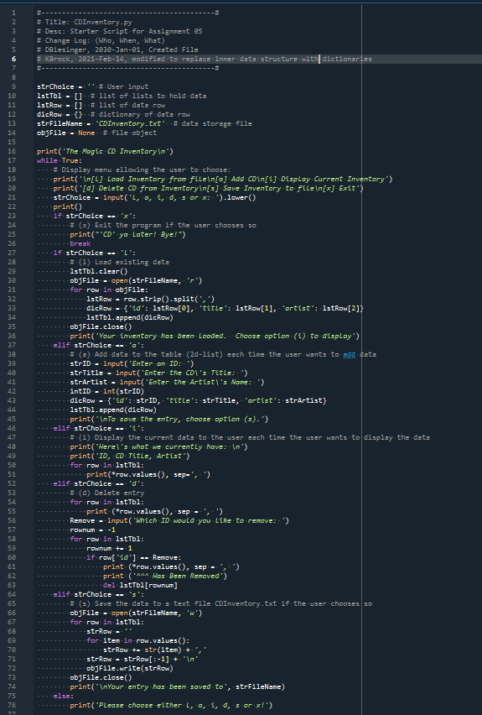

Appendix B Listing . CDInventory.py (Assignment 05)