|  |  |
| --- | --- |
| RESTAURANTS IN MUMBAI | Kunal Bhargava  Applied Data Science Capstone |

**Introduction/Business Problem**

According to the website <https://worldpopulationreview.com/world-cities/mumbai-population/>, Mumbai has a population of about 22 million people which creates a high demand for places like restaurants and cafes where people can socialize in a preordained ambiance.

As stated by a blog on [www.torqus.com](http://www.torqus.com/), Mumbai is known to be a melting pot of all regional tastes of India. It is not a surprise that a city like Mumbai that offers impeccable and varied flavors for all palates and all pocket sizes stands for a unique gastronomical experience. From roadside food stalls to hoity-toity restaurants, Mumbai serves it all.

The overall Indian foodservice industry is estimated to be Rs 5.99 trillion by 2022-23, growing at a compounded annual growth rate of 9 percent, a National Restaurant Association of India (NRAI) report said. Pegging Mumbai's organized foodservice market at Rs 40,480 crore, the report noted it was the highest amongst metros in the country.

## Target Audience

Entrepreneurs interested in the opening Fast Food Restaurant in Mumbai, who may require external advice concerning what type of restaurants are in trend and where exactly it should be originated which could create a high chance of being successful. Fast Food Restaurant category is based on personal preference but this analysis can be applied to any business.

**Data Description**

I used the following data to analyze the city of Mumbai

## 1. Neighbourhood Data

Using pandas converted the table on <https://www.mapsofindia.com/pincode/india/maharashtra/mumbai/>  website consisting name of the neighborhood with respect to its Pin code.

## 2. Geopy.geocoders

Using geopy.geocoders library to get the latitude and longitude of each neighborhood in Mumbai.

## 3. Foursquare API

Using Foursquare API to explore venue information for each neighborhood in the Mumbai city. Some features extracted include ‘Venue’, ‘Venue Category’, ‘Venue Latitude’, ‘Venue Longitude’, etc.

**Methodology**

After extracting the data of Mumbai neighborhoods and grouping them by their pin codes I got the following data frame containing **182** neighborhoods.

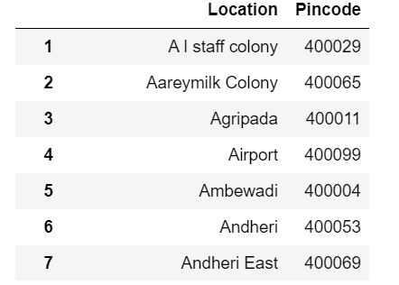

I used the **goepy**library to pass the name to get the latitudes and longitudes and merged the data into the above dataset.

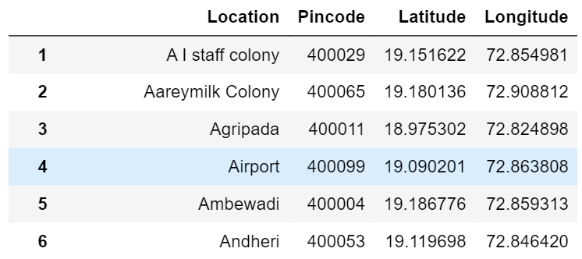

The **folium**library was used to visualize the geographic details of Mumbai and superimposed the markers on the map indicating the neighborhoods with a popup text.

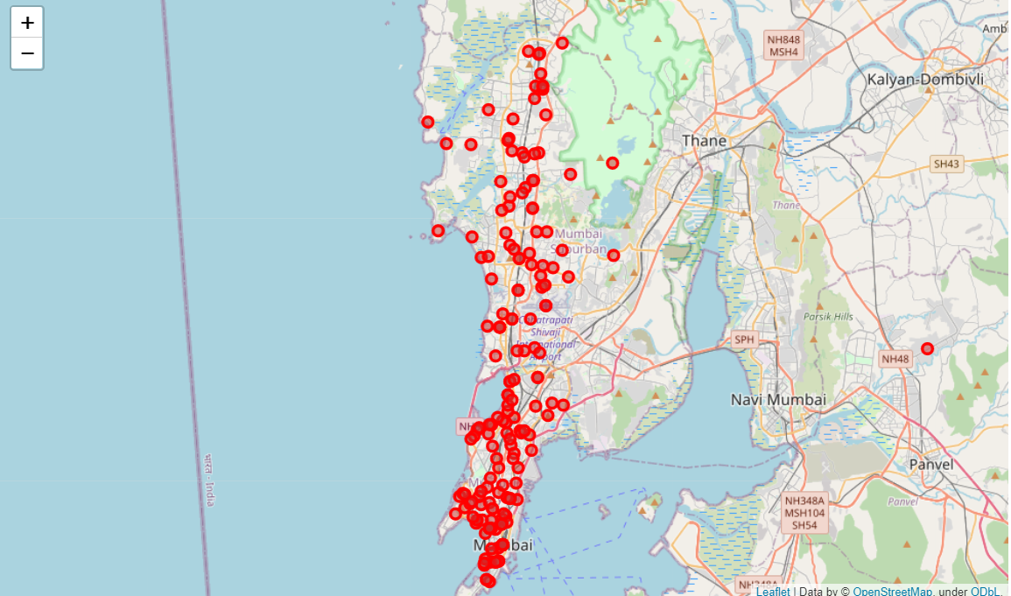

I utilized the Foursquare API to explore the boroughs and segment them. It fetches the venues located nearest to location passed through the URL. I assigned the limit as **200** and the radius as **500** meters for each neighborhood from their given latitude and longitude information. From the data gathered I created the following data frame consisting of **2738** venues categorized by the venue type.

Exploring the dataset is important because it gives you initial insights and may help you to get a partial idea of the answer that you are looking to find out from the data. By exploring the above dataset I found out that "Indian Restaurants" was the most reoccurring venue category and the "Fast Food Restaurant" category has 80 unique venue locations in the dataset.

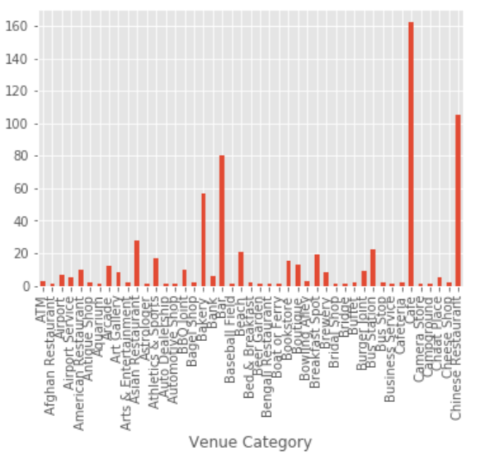

For this study, I used one-hot encoding and standardization to process our categorical variable (venue category) into a form that machine learning algorithms can further classify the data. Since we have some common venue category that is why I decided to choose K -means algorithm for clustering the dataset as it is one of the simplest and popular unsupervised machine learning algorithms. To decide the optimal number of clusters I used the Elbow method.

## 

Here is my merged table with cluster labels for each Location.

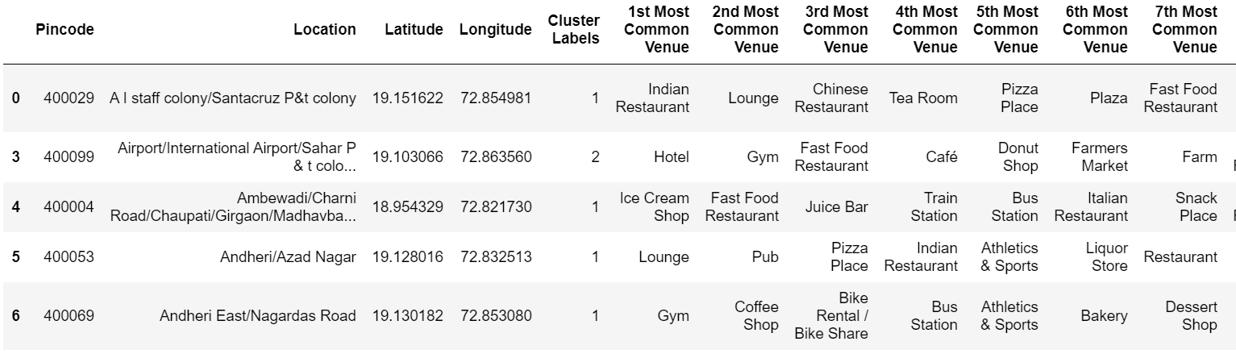

Exploring the dataset to see the distribution of venues among the clusters.

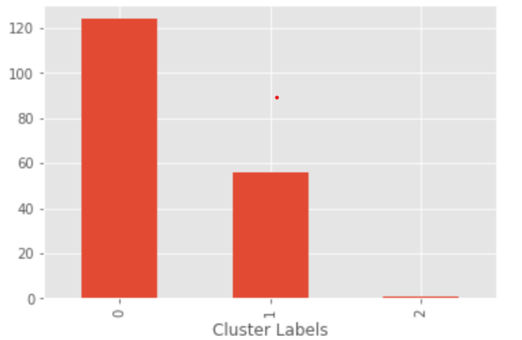

**Result**

## Cluster 1: Neighborhoods where Fast Food Restaurants aren't a common venue

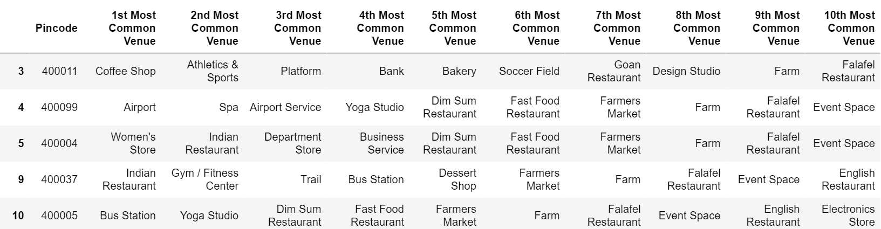

## Cluster 2: Neighborhoods where Fast Food Restaurant are a common venue

## 

## Cluster 3: Neighborhoods where Fast Food Restaurant are the most common venue

## 

## 

In the final section, I created a map to visualize all clusters on the map of Mumbai. The results are visualized in the above map with Cluster 0 in red color, Cluster 1 in purple color, and Cluster 2 in light green color.

**Discussion**

The fast-food restaurants' being the most common venue is observed in cluster 2, followed by moderate density in cluster 1 and none in cluster 0.

Therefore, when choosing a neighborhood to open a fast-food restaurant, it is advisable to consider locations in Cluster 0 and 1 because of the lack of competition and the ability to conquer the market. It is also important to be centrally located in the city to cover the maximum radius of potential customers.

**Limitation**

This project can be further improved by adding constraints like **population density**, **property costs**, and the proximity of **farmers market**. This analysis allows the developer to provide information on a more profitable place to set up shop for their services. Reducing competition and differentiating your business from those around you allows businesses to develop strategies to grow and thrive. However, to put all these data into this project is not possible to do within a short time frame for this capstone project. Also, the **Foursquare API**used had a limit of 200 calls in a radius of 500m, therefore, all the predictions are based on the data gathered by the Foursquare data platform.

**Conclusion**

This project was concerned with the data science methodology where one identified a business problem, collected the data required, processed the data, used relevant methods to prepare data for analysis by the appropriate machine learning techniques, and lastly used the results to recommend solutions to relevant entrepreneurs.

Based on the Clusters formed it would be a good idea to open a restaurant in Clusters 0 & 1 since the other clusters already have fast-food restaurants in their vicinities. Also, clusters 0 & 1 have many restaurants in the vicinity (Pizza restaurants, cafe, coffee shop, Indian restaurants) so one will be able to attract a good crowd.