Hardware Electrical Info Cheatsheet
A. Young 11/11/2018

Raspi GPIO:
NOTE: PINS NOT NUMBERED IN ORDER.

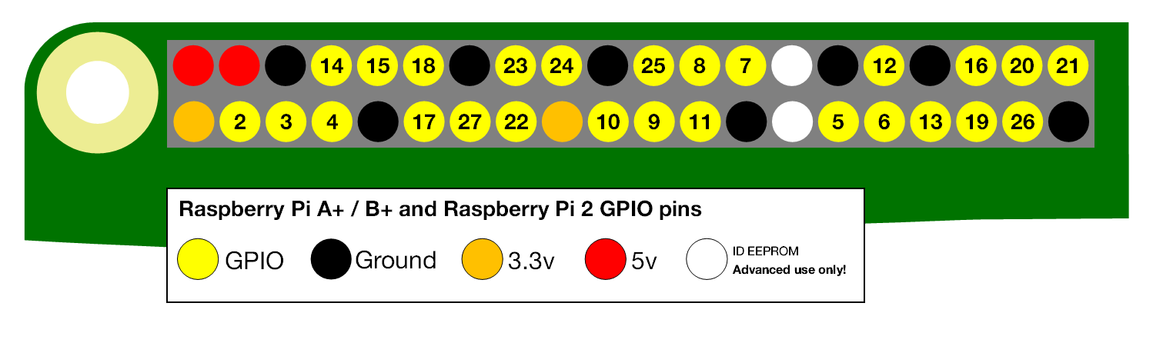
- Provides both 3.3v and 5v
- Inputs are 3V3 (CMOS level) - need to drop voltage before taking 5V inputs
- Output max 16mA per pin, total current output not to exceed 51mA

- SPI Interface - SPI0: MOSI (GPIO10); MISO (GPIO9); SCLK (GPIO11); CE0 (GPIO8), CE1 (GPIO7)
- Info about GPIO pin impedance: http://www.thebox.myzen.co.uk/Raspberry/Understanding_Outputs.html
- pinout web app https://pinout.xyz/#

ADC: MCP3008

- 10bit ADC
- 8 channels
- SPI Interface
- Sampling Rate: 200kSPS
- Supply Voltage 2.7V to 5.5V
- Supply Current: 425µA (No need for external Supply)
- 16 pin DIP
- Conversion Time: 10µs
- Alternative part, same family is MCP3004 (less channels, but we only need one)
- Datasheet: https://cdn-shop.adafruit.com/datasheets/MCP3008.pdf

AD8232 Board:
- Supply range 2.0-3.5V

- Hookup Guide: https://learn.sparkfun.com/tutorials/ad8232-heart-rate-monitor-hookup-guide?_ga=2.126626253.1325472777.1541926096-457725050.1540673738
- Board Homepage: https://www.sparkfun.com/products/12650
- Board Schematic: https://cdn.sparkfun.com/datasheets/Sensors/Biometric/AD8232_Heart_Rate_Monitor_v10.pdf

- Chip Datasheet: https://www.analog.com/media/en/technical-documentation/data-sheets/AD8232.pdf

Connections:
- GND
- 3.3v+
- Output Signal A0 to ADC Input pin CH0
- From page 23 of the datasheet:
