Dust Cyclone Design

- 2D2D cyclone, or AEC cyclones are almost 100% efficient for particles larger than 20um

- barrel and cone heights are equal to two barrel diameters. Shepherd and lapple design was of the same aspect ratio.

- higher gas flow, with higher pressure drop, yields an increase in efficiency.

- rough seams in cyclone body can reduce collection efficiency.

-1d3d cyclones with enhancements are now most common
- 1d3d refers to barrel height of one barrel diameter, and cone height of three barrel diameters.
- inlet is ½ diameter high, ¼ diameter wide.
- cone bottom is 1/3 diameter wide with an expansion chamber

Design Choices
High efficiency (i.e. rejection ratio) cyclone, Type 1.

Outlet diameter: 4”
Outlet proportion: 0.5
Barrel diameter: 8
Inlet width: 1.6
Inlet height: 4
Vortex finder length: 4
Barrel length: 12
Cone length: 20
Dust outlet diameter: 3

Blower:
Harbor freight 1HP / 660CFM blower, 120V 7A

Will I have the correct surface speed at the inlet?

Speed Requirements:

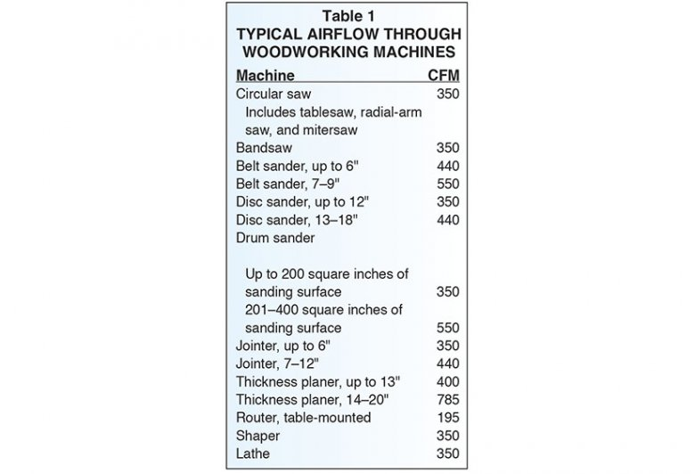
From: https://www.woodmagazine.com/figure-dust-collection-needs-by-the-numbers 8/3/2019
Largest need is 400CFM for the thickness planer.

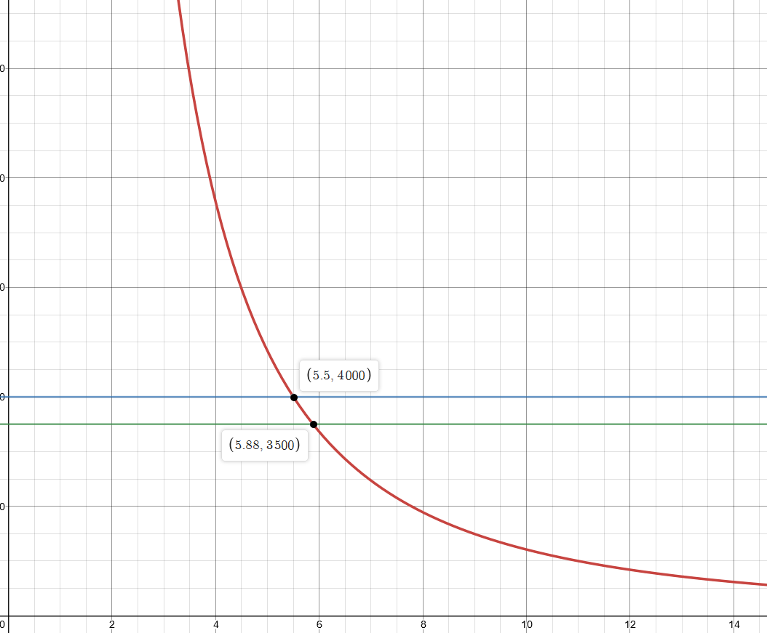
Recommended duct air velocity is 4,000FPM for branch lines and 3,500 in main line
Duct diameter (x) versus SFM (y) @660CFM:
https://www.desmos.com/calculator/55iziwbvro

Static Pressure Loss:
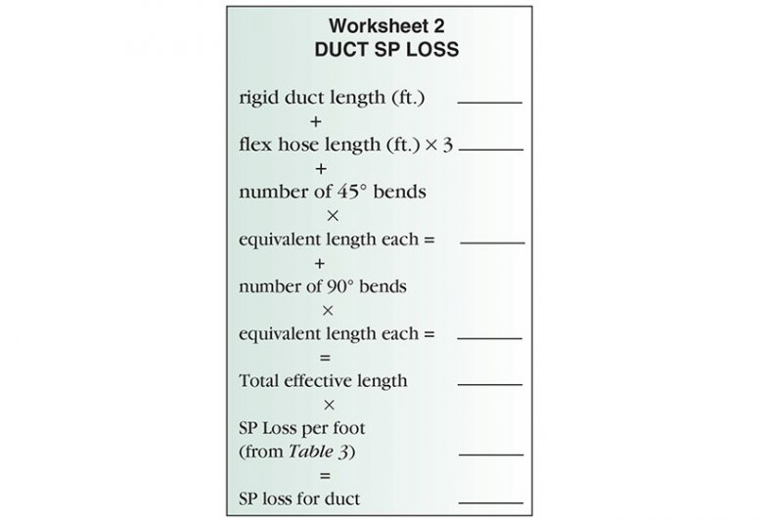

Main line: 10ft of rigid duct, 4x 45 degree bends, 3’ eq. Len (4” duct)
Pressure loss: 22ft eq. Len * 0.07 = 1.54” W.C. loss
Trunk line: 10ft flex hose
Pressure loss: 30ft eq. Len * .1 = 3” W.C. Loss
Total loss = 4.54” W.C

Joint Design
The barrel to cone joint will be with a gasketed flange and draw latches.

Patterns
Gas Outlet and lid:
The lid will be made with a lip 3/8 high, with an inner diameter of 8.375, with a vinyl rubber gasket adhered to it using silicone adhesive for a dust seal. The outside of the lip will have a wire edge. Three latch points will be riveted to the lip edge.
The gas outlet will be a foot of 4” pipe, protruding 4.5” into the barrel. It will be joined to the lid with a soldered lap joint. The lid will have a lip raised upon it, the pipe passed through, and then an airtight solder joint made. The interior end of the pipe will be straight and smooth – the exterior end will be crimped for flexible hose connection.
Dust Inlet:
- 1.6” wide, 4” high at barrel side, rectangular duct entering at a tangent of the outside of the barrel
- 4” round pipe inlet
- Triangular development, approximately 1’ long
Barrel:
- 8” diameter, 12” long.
- Top and bottom should be rolled wire edges.
- Support lugs on side to form stiffening ribs

Cone:
- 20” long, 8” diameter top, 3” diameter bottom
- Side seam should be grooved flat lock type:

- Top and bottom seams should be rolled over wire:
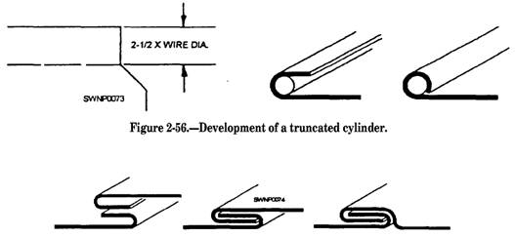

Dust Outlet:
Dust outlet will be attached to cone using a grooved flat lock seam. Tube diameter is 3” and stickout will be 6”. Crimp ends for hose clamp connection.
Clamps:
Draw Latches will be used to hold down the lid and hold up the cone.

Tools

Hand Groover:
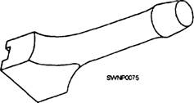
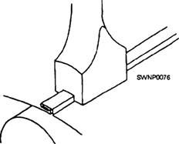

References
(Baker et al., 1997; Holt et al., 1999; Obermair and Staudinger, 2001).

Baker, R.V., S.E. Hughes, M.N. Gillum and J.K. Green. 1997. Improvements for cotton gin trash cyclones. Trans. ASAE 40(1):5–12.
Holt, G.A., R.V. Baker and S.E. Hughs. 1999. Evaluation of static pressure drops and PM10 and TSP emissions for modified 1D-3D cyclones. Trans. ASABE 42(6):1541–1547.
Obermair, S. and G. Staudinger. 2001. The dust outlet of a gas cyclone and its effects on separation efficiency. Chem. Eng. Technol. 24(12):1259–1263.

https://www.cotton.org/journal/2013-17/1/upload/JCS17-40.pdf

First, M.W., 1950. Fundamental Factors in the Design of Cyclone Dust Collectors. Ph.D. dissertation. Cambridge, Mass.: Harvard University.
Lapple, C. E. 1951. Processes use many collector types. Chemical Engineering 58 (5):144-151
Shepherd, C.B. and C.E. Lapple. 1940. Flow pattern and pressure drop in cyclone dust collectors

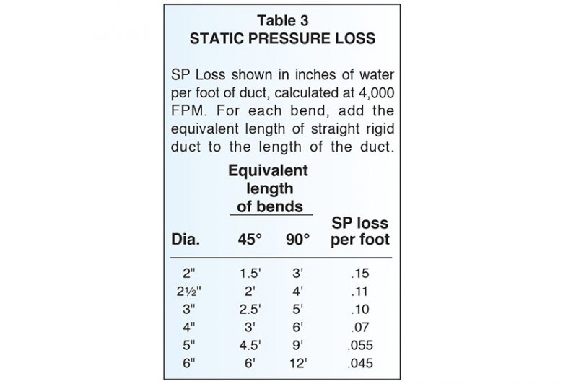

NFPA484 requires daily removal of dust from collectors

