Andrew Young
WRTG393
5/25/2018
Instruction Manual Introduction
Rough Draft

I Audience
This document describes the process of replicating a spur gear using a Van Norman 16 milling machine. The instructions are intended for technical students or hobbyists interested in making a replacement gear via horizontal milling.

II Overview / Outline
This manual will take you through the steps of measuring a gear and replicating it on a Van Norman milling machine.

Please read and understand the operator manual for the mill - all relevant information for gear cutting will be included here, but you should consult the manufacturer's manual for matters such as routine lubrication and maintenance of the mill.

In addition, you will need to make or procure a cylindrical blank for cutting the gear teeth into. Determining the dimensions of the blank will be part of section 1, but the turning of the blank on the lathe is outside of the scope of this manual.

The steps for gear replication are, broadly:
1) Measure the gear that is desired to be replicated
2) Machine Setup
3) Gear Cutting
4) Verifying Measurements
5) Cleanup

III. Needed Items and Resources
The following tools and materials will be needed to make a replacement gear. Many of the exact sizes needed for tools will depend on the gear being cut - see section 1 for the procedure determining how to choose cutters, arbors, and measuring tools appropriately.
Tools:
Van Norman 16 Milling Machine
Van Norman 10" horizontal index head
Index Plate
Cutter arbor fitting a VN 'C' taper
Mandrel for gear blank
Lathe Dog for Mandrel
Gear Cutter
S.A.E Wrenches
Gear measuring wires
Micrometer of appropriate size or calipers (micrometer preferred)
Acid brush or coolant system
Materials:
Gear example to copy
Gear blank of appropriate size (calculate size using procedure in section 1)
Cutting oil or coolant of choice
IV. Dangers, Warnings, Cautions, and Notes
A. Do NOT attempt to cut gearing without coolant, with the exception of cast iron gearing. Doing so will reduce tool life significantly.
B. Machine tools are dangerous. Observe standard shop safety procedures including wearing eye protection and hearing protection, if necessary. Keep hands away from moving parts.
C. Read all instructions thoroughly before attempting to follow procedure.
D. Ensure procedure is followed carefully and double-check setups before running under power. Failure to do so may result in a machine crash and, under certain circumstances, severe injury or death.

V. Time Needed
The exact time needed depends on the number of teeth that need to be cut and the size of the gear. Generally, you should plan on taking your time, maybe 5 minutes per tooth starting out, plus setup and cleanup time. For a 16-tooth gear, that might be about 2 hours, provided all materials are at hand.

VI. An Orientation to The Mill

You should be familiarized with all basic controls of the milling machine, having read the manufacturer's instruction manual. The images from the manual pointing out the major features are reproduced here for convenience.
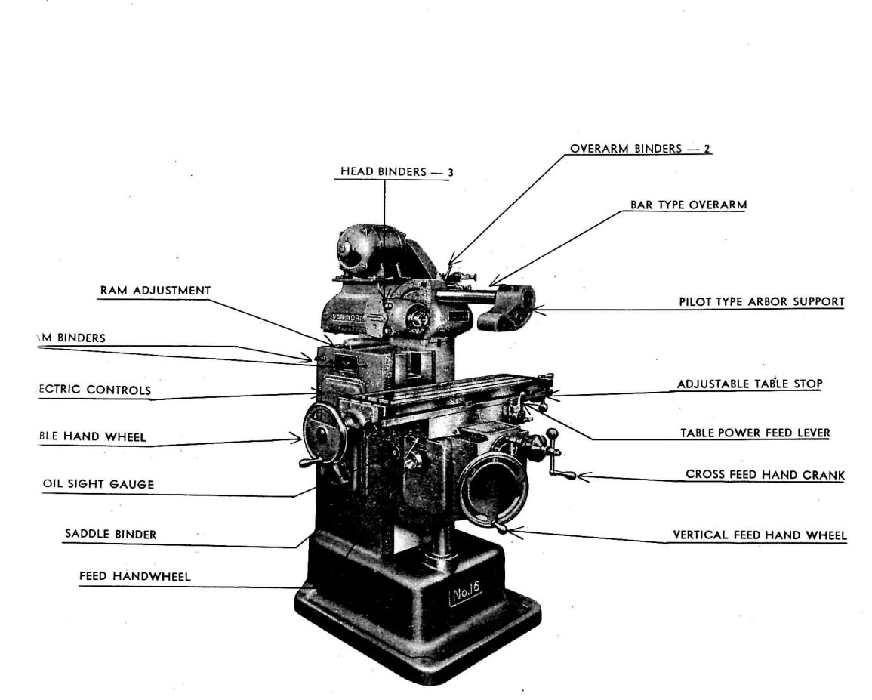
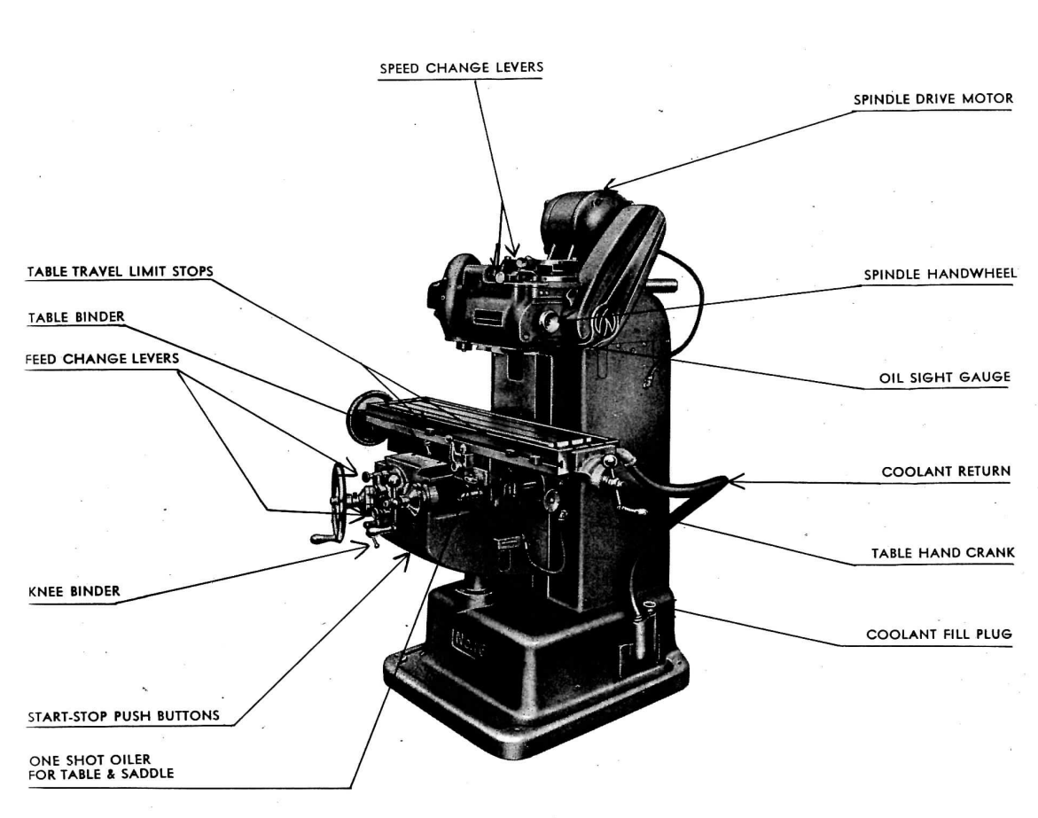

Bibliography:

Installation, Operation, and Maintenance Instructions and Parts List for No. 16 Van Norman Ram Type Milling Machine Plain and Universal Models [Pamphlet]. (1952). Springfield, MA: Van Norman Company.

