Assignment #11: Solubility Curves and Supersaturation
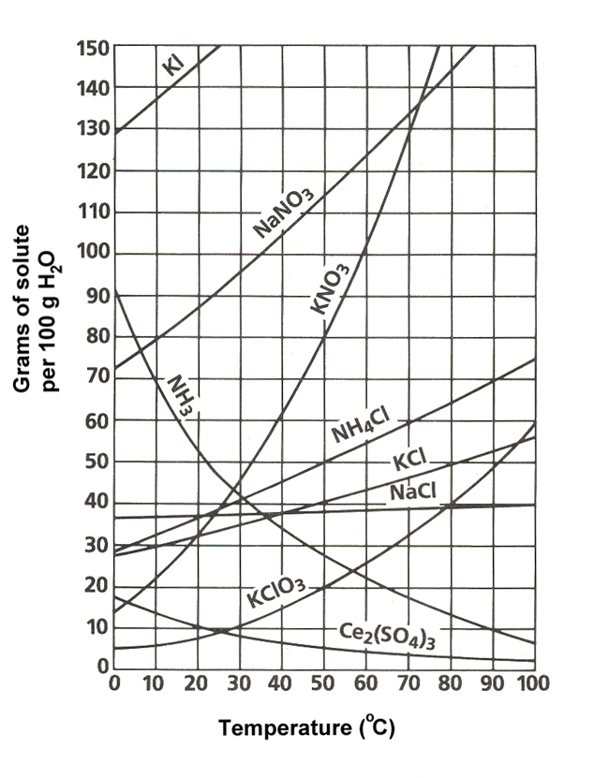
1. What are the names of the 8 substances shown in the graph?

2. Which compound is the most soluble at 20°C?

3. What is the approximate amount of Ammonium Chloride would it take to saturate 100g of water at 70°C?

4. Two saturated solutions are cooled from 90°C to 40°C. One solution contains potassium nitrate, the other contains sodium nitrate.
a. Which solution will have more crystals in it?

b. If the solution contains 200g of water, what will the mass of the crystals in the Potassium
Nitrate be?
5. Your fishtank has large deposits of minerals on the glass. Your friend suggests raising the temperature of the fish tank to dissolve more of the minerals. After doing so, the minerals dissolve. Two days later, all your fish are dead. Name at least four things that could have happened to the fish.

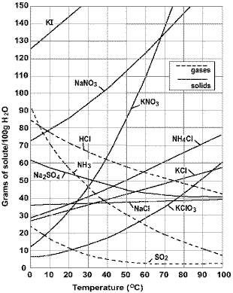
6. HCl, NH₃, and SO₂ are all gases when pure, but all dissolve in water. What would happen if you were to boil a solution containing any of these?

7. Sodas often taste better when they are cold. Why is this?

8. According to the graph, how much Potassium Chlorate would dissolve in 250g of water at 70°C?

