Assignment #11: Introduction to Moles

1. Label the parts of the Atom below. Which atom does this most closely correspond to?
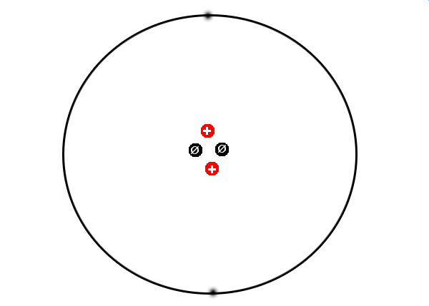

2. A square from the periodic table is shown here. Label each piece of information that is found in this square.

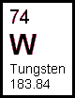
3. One mole is equal to what number?

4. Find the atomic symbol or formula and molar mass for each of the following:

a. Lithium

b. Phosphorous

c. Silicon

d. Lead
e. Iron

f. Carbon Dioxide

g. Sodium Chloride

h. Water
6. How many Moles of Iron are present in a 5,000 g iron frying pan?

7. What is the mass of 13 moles of Arsenic?

8. A piece of lead pipe has a mass of 2,500 g.
a. How many moles of lead are present?

b. How many atoms of lead is this equivalant to?

9. What is the mass of 5.0 x 10²⁴ atoms of chromium?

10. How many atoms would it take for a piece of Nickle to have a mass of 3 grams?

11. How many atoms are present in a 57 gram sample of arsenic?

