Assignment #9: Combined Gas Law
- Show how the combined gas law is a combination of Boyle's law and Charles's law.

- What are the three laws that can be derived from the Combined Gas Law?

- Define the following terms:
  - adiabatic -

  - isobaric -

  - isochoric -

- An can of hair spray at room temperature (300K) is thrown into a fire.
  - If the pressure inside the can is 4 times that of the atmosphere, what is the pressure when the can reaches 500K?

  - The can will explode if the pressure reaches 9 atmospheres. At what temperature will the can explode?

- A bicycle pump compresses 20 cm³ of air into 1 cm³. The pressure increases from 100,000 pa to 300,000 pa. If the initial temperature is 300K, what is the final temperature of the gas?

- The temperature of 1 mL of gas in a gun changes from 300K to 1500K. The pressure increases from 120,000 pa to 600,000 pa. What is the final volume of the gas?

- A sample of gas has a volume of 200 mL at 300K and 50,000 pa. What is the volume of the gas at 400K and 100,000 pa?

- A balloon has a volume of 100 mL.
  - Use Boyle's law to find the pressure of the gas in the balloon when the volume undergoes adiabatic reduction to 40 mL.

  - The gas then undergoes isobaric expansion as the temperature is raised from 310K to 400K. Use Charles's law to find the final size of the balloon.

  - Use the combined gas law to find the final size of the balloon. What information is lost when using the combined gas law?

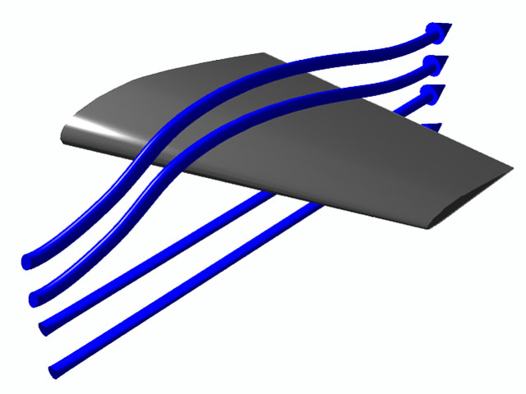
- An airfoil (as seen to the right) provides lift by increasing the speed of air flowing over top of the wing. This, in turn, reduces the pressure on the top of the wing. If this is an adiabatic process, what part of the wing is most likely to experience ice build-up while flying? (Hint: How does pressure effect evaporation and sublimation?)

