Kayla Bachler & David Cha

3/17/2019

CSS490

Program 5 Report

Location of the URL of the site:<http://css490triviagame.us-west-2.elasticbeanstalk.com/home>

**Services Utilized**

1. S3 Bucket - Image storage for website
2. DynamoDB Table - Store users name, phone number & high score
3. Elastic BeanStalk - Website hosting
4. Consuming a RESTful API - Open Trivia API (<https://opentdb.com/api_config.php>)
5. Notifications - AWS Simple Notification Service to notify user upon account creation
6. GitHub/AWS Codepipeline - Supports push events from GitHub for development to automate

deployment.

**Design Diagrams**

Service Relationship Overview

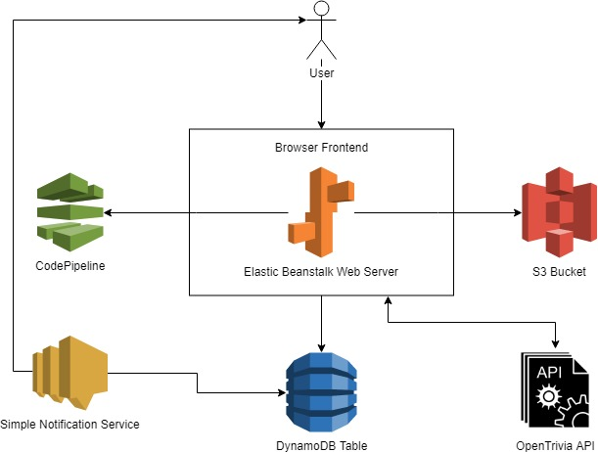

3-Tier Architecture

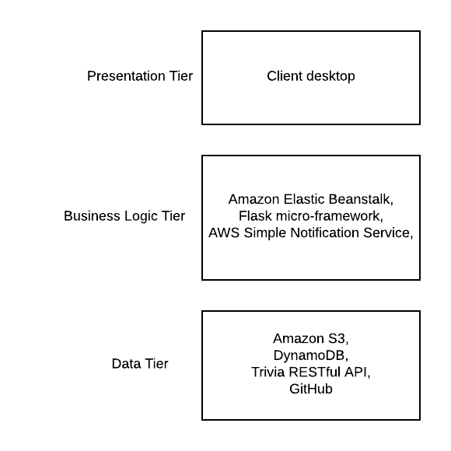

**Why Amazon?**

Going into this project there was an established familiarity with Amazon’s services. When planning the cloud service we wanted to provide, we found that AWS supports several of the features we wanted to utilize such as text-message notifications, Github push event support, and website hosting through Elastic BeanStalk.

**Monitoring**

In terms of monitoring, Amazon provides monitoring systems in place whenever you deploy a

service which readily displays information regarding metrics and overall utilization of the services.

To account for any errors that may occur during the deployment of the cloud service, we relied

on checking the health of the EC2 service provided by Beanstalk, to see if users encountered

any HTML response errors like a 4xx or 5xx and we also depended on the logs produced by

Beanstalk to debug any coding issues that arose.

AWS DynamoDB metrics:

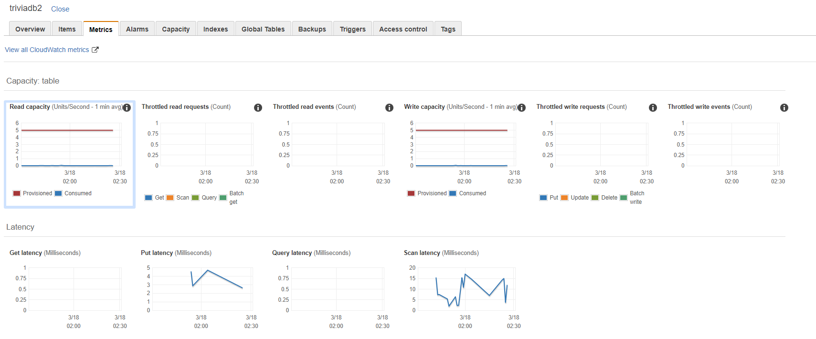

AWS Elastic Beanstalk logs, health of service, and metrics:

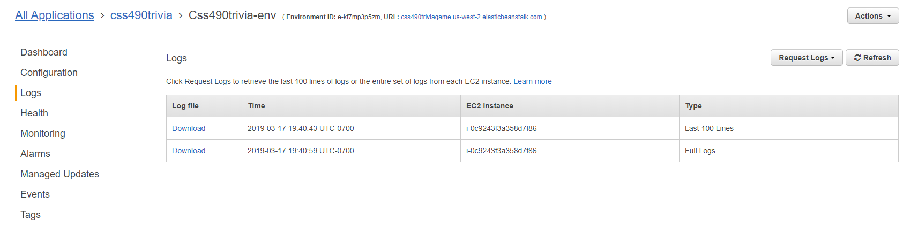

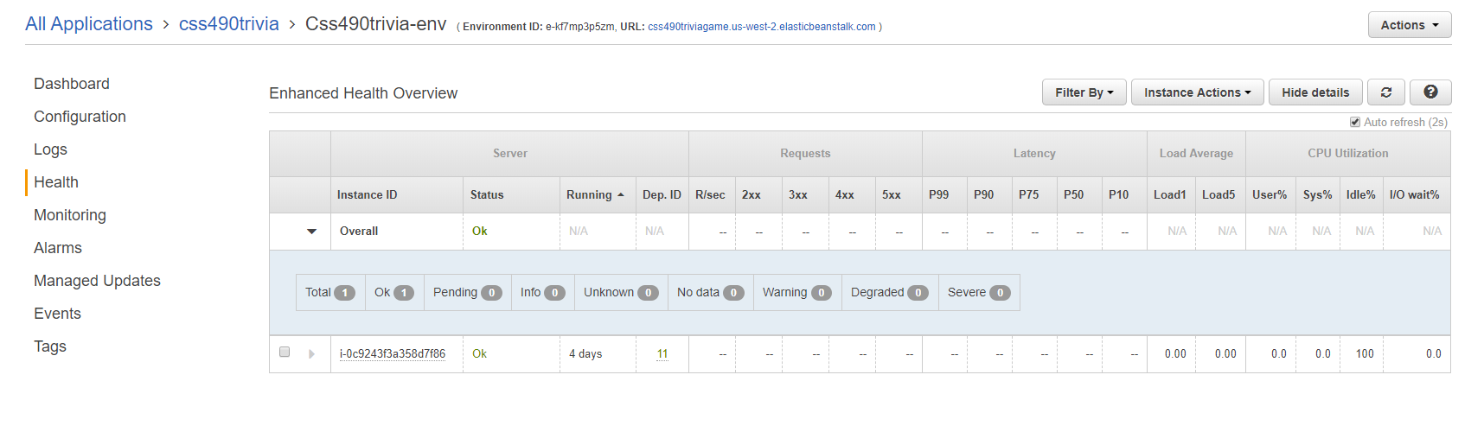

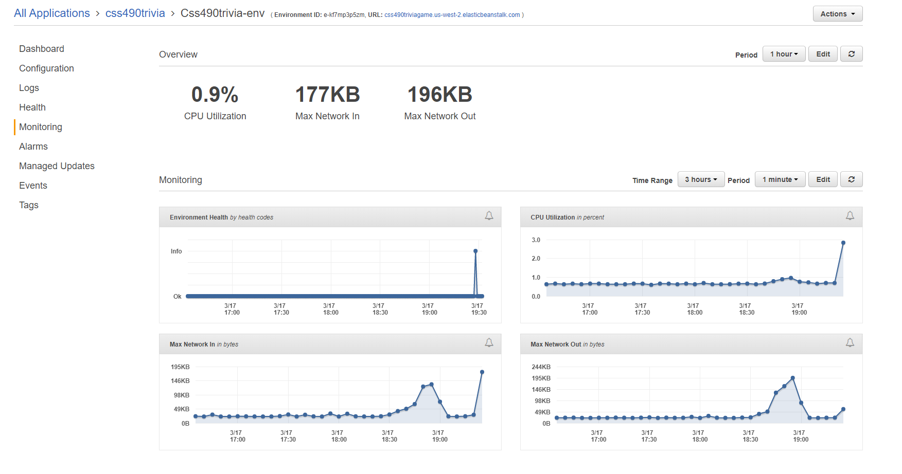

AWS CodePipeline process and health status:

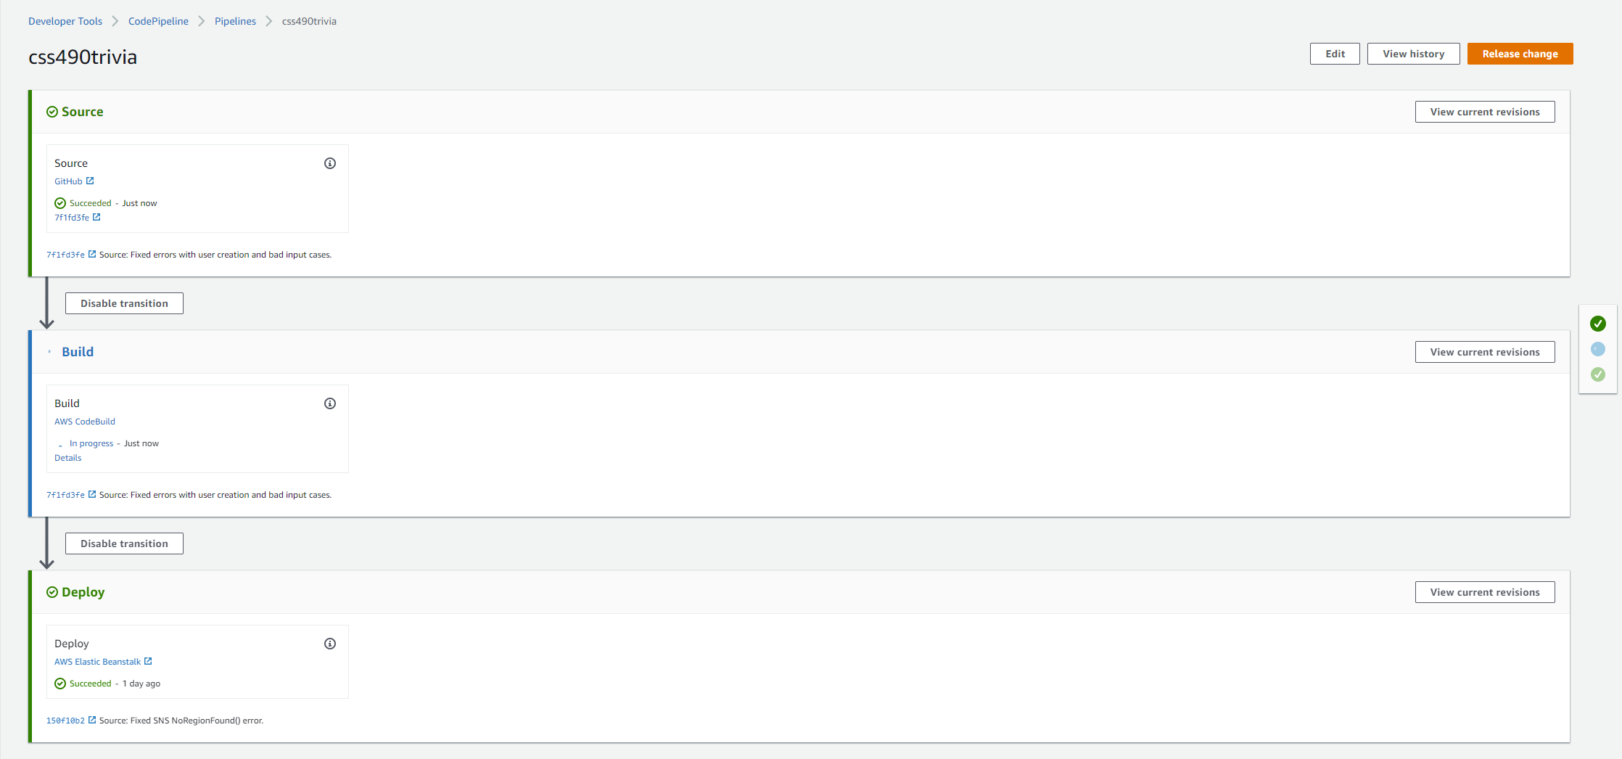

**Estimated Service SLA**

AWS S3: 99.99%

DynamoDB: 99.999%

AWS Elastic Compute Cloud (EC2): 99.99%

Open Trivia API: 99.9%*

AWS SNS: 99.9%

CodePipeline: = 99.99%

.9999*.99999*.9999*.999*.999*.9999 = .99769

**With the above dependencies, the estimated SLA for our website is: 99.77% or 1 9’s**

*\*Open Trivia DB is maintained by PIXELTAIL GAMES LLC. This is an estimation of availability*

This SLA is achievable because we utilize high availability services through AWS. With our website depending on services that mesh together, such as the CodePipeline and EC2 instance, there is a high dependency amongst the services listed. Once one service goes down, we are unable to provide the service as a package because they require each other to operate.

**Scalability**

If our service were to become highly popular, one thing that we must first attend to is increasing the range of availability of our website itself that is hosted through AWS Elastic Beanstalk. Currently, the only region that our service is hosted on is us-west-2 (which is located in Oregon). By expanding the range of availability of our service to different regions, like us-east-1, us-east-2, etc. it would at least lessen the load onto our service by splitting up the users accordingly based on region.

Another way to scale our system would be to increase the amount of tables that exist in DynamoDB. If we were to create more tables with another key that further partitioned the tables to easily distinguish users, it would make it easier to parse through the records if we were to attain a large amount of user records.

We can also increase the amount of S3 buckets available to download data from, so that it is not acting as a bottleneck once there are many users on the website.