title: “R Notebook” output: html_document: df_print: paged

#Loading ISLR Package  
  
library(ISLR)  
#Summary of Car seats  
summary(Carseats)

## Sales CompPrice Income Advertising   
## Min. : 0.000 Min. : 77 Min. : 21.00 Min. : 0.000   
## 1st Qu.: 5.390 1st Qu.:115 1st Qu.: 42.75 1st Qu.: 0.000   
## Median : 7.490 Median :125 Median : 69.00 Median : 5.000   
## Mean : 7.496 Mean :125 Mean : 68.66 Mean : 6.635   
## 3rd Qu.: 9.320 3rd Qu.:135 3rd Qu.: 91.00 3rd Qu.:12.000   
## Max. :16.270 Max. :175 Max. :120.00 Max. :29.000   
## Population Price ShelveLoc Age Education   
## Min. : 10.0 Min. : 24.0 Bad : 96 Min. :25.00 Min. :10.0   
## 1st Qu.:139.0 1st Qu.:100.0 Good : 85 1st Qu.:39.75 1st Qu.:12.0   
## Median :272.0 Median :117.0 Medium:219 Median :54.50 Median :14.0   
## Mean :264.8 Mean :115.8 Mean :53.32 Mean :13.9   
## 3rd Qu.:398.5 3rd Qu.:131.0 3rd Qu.:66.00 3rd Qu.:16.0   
## Max. :509.0 Max. :191.0 Max. :80.00 Max. :18.0   
## Urban US   
## No :118 No :142   
## Yes:282 Yes:258   
##   
##   
##   
##

# No.of rows in dataset  
print(paste("no. of rows in dataset:",nrow(Carseats)))

## [1] "no. of rows in dataset: 400"

# Max value in advertising  
print(paste("Max value of Advertising attribute:",max(Carseats$Advertising)))

## [1] "Max value of Advertising attribute: 29"

# IQR Value  
print(paste("IQR value of Price attribute:",IQR(Carseats$Price)))

## [1] "IQR value of Price attribute: 31"

# Loading car package for scatterplot  
library(car)

## Loading required package: carData

# Scatterplotting sales vs price  
scatterplot(Price ~ Sales, data=Carseats, xlab='Sales', ylab='Price', main='Sales vs Price')

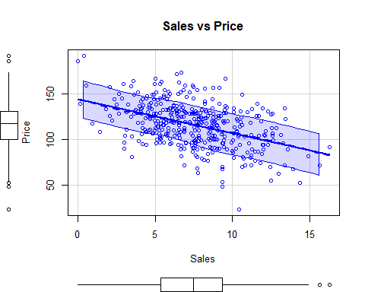

# Correlation between Sales and price  
cor(Carseats$Sale,Carseats$Price)

## [1] -0.4449507

Here, from the plot we notice that, as the Price of the Carseats are increasing the sales are decreasing.  
From the above we calculated the correlation of Price and Sales of the Carseats. We notice that the correlation between the two is a negative moderate linear correlation.