1. Midterm Fall

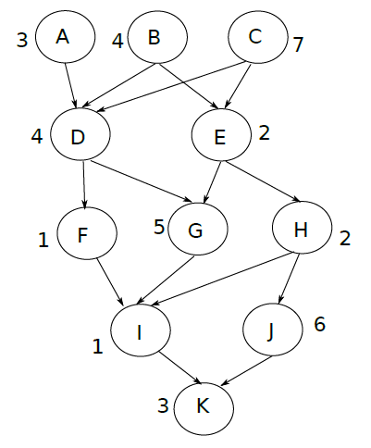

1. Question: Using the metrics of this parallel task graph (you computed last activity) and analysis of List

Scheduling, provide a lower bound and an upper bound of the time it would take to schedule this graph on 2 processors. Provide the bounds on 3 processors.

Ans. Lower Bound for 2 Processors –

TotalWork/#Processor = 38/2 = 19

CP - 20

These both are lower bounds, but we consider lower value as inactive. So the lower bound of the graph is 20.

Lower Bound for 3 Processors –

TotalWork/#Processor = 38/3 = 12

CP - 20

These both are lower bounds, but we consider lower value as inactive. So the lower bound of the graph is 20.

Upper Bound for 2 Processors –

CP + TotalWork/#Processor = 20+19 = 39

Upper bound of the graph is 39.

Upper Bound for 3 Processors –

CP + TotalWork/#Processor = 20+12 = 32

Upper bound of the graph is 32.

1. Question: Use List Scheduling to build a schedule of this task graph on 2 processors.

Ans.

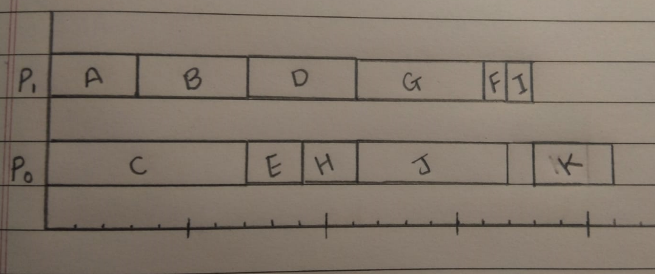

1. Question: Use List Scheduling to build a schedule of this task graph on 3 processors.

Ans.

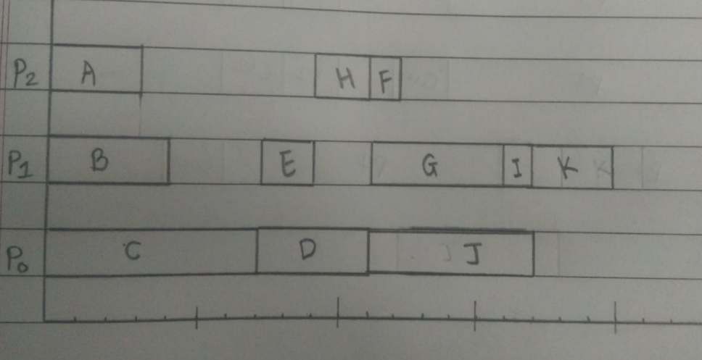

1. Strassen

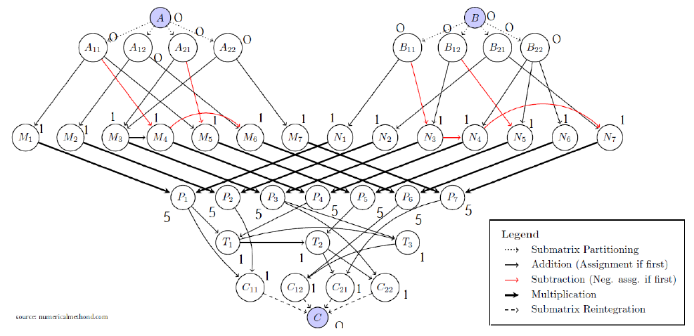

1. Using the metrics of this parallel task graph (you computed last activity) and analysis of List

Scheduling, provide a lower bound and an upper bound of the time it would take to schedule this graph on 4 processors. Provide the bounds on 6 processors.

Ans. Lower Bound for 4 Processors -

TotalWork/ #Processor = 56/4 = 14

CP = 10

These both are lower bounds, but we consider lower value as inactive. So, the lower bound of the graph is 14.

Lower Bound for 6 Processors -

TotalWork/ #Processor = 56/6 = 9

CP = 10

These both are lower bounds, but we consider lower value as inactive. So, the lower bound of the graph is 10.

Upper bound for 4 Processors –

CP + TotalWork/#Processors = 10 + 14 = 24

So, the upper bound of graph is 24.

Upper bound for 6 Processors –

CP + TotalWork/#Processors = 10 + 9 = 19

So, the upper bound of graph is 19.

1. Question: Use List Scheduling to build a schedule of this task graph on 4 processors.

Ans.

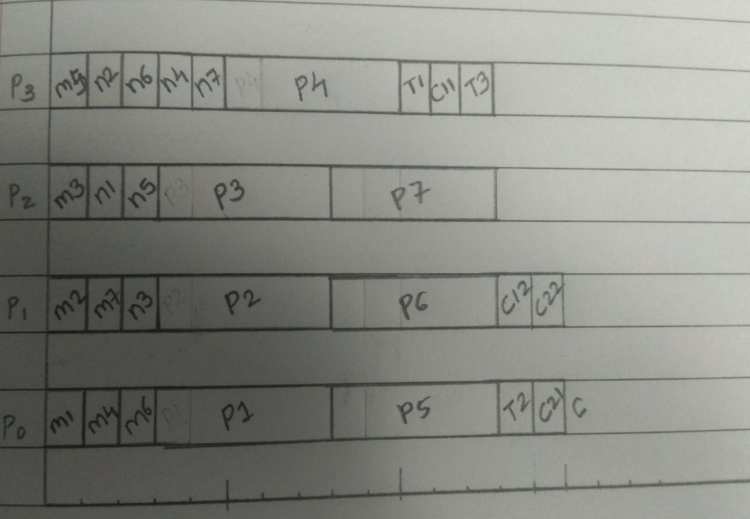

1. Question: Use List Scheduling to build a schedule of this task graph on 6 processors.

Ans.

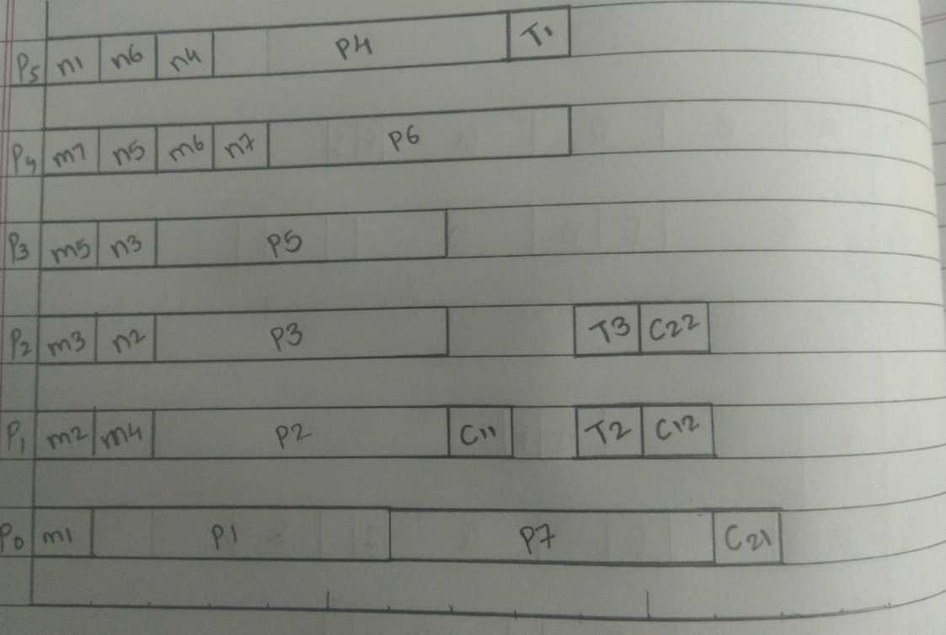

1. Lemon Pie

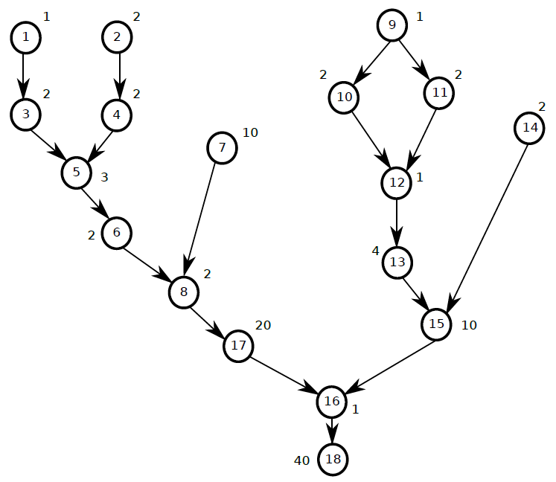

1. Question. Using the metrics of this parallel task graph (given in the video lecture) and analysis of List Scheduling, provide a lower bound and an upper bound of the time it would take to schedule this graph on 2 processors. Provide the bounds on 4 processors.

Ans. Lower Bound for 2 Processors -

TotalWork/ #Processor = 107/2 = 53

CP = 73

The lower bound of the graph is 73.

Lower Bound for 4 Processors -

TotalWork/ #Processor = 107/4 = 27

CP = 73

These both are lower bounds, but we consider lower value as inactive. So, the lower bound of the graph is 73.

Upper bound for 2 Processors –

CP + TotalWork/#Processors = 73 + 53 = 126

So, the upper bound of graph is 126.

Upper bound for 4 Processors –

CP + TotalWork/#Processors = 73 + 27 = 100

So, the upper bound of graph is 100.

1. Question: Use List Scheduling to build a schedule of this task graph on 2 processors.

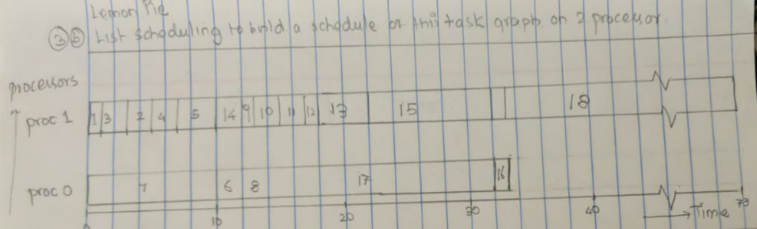

1. Question: Use List Scheduling to build a schedule of this task graph on 4 processors.

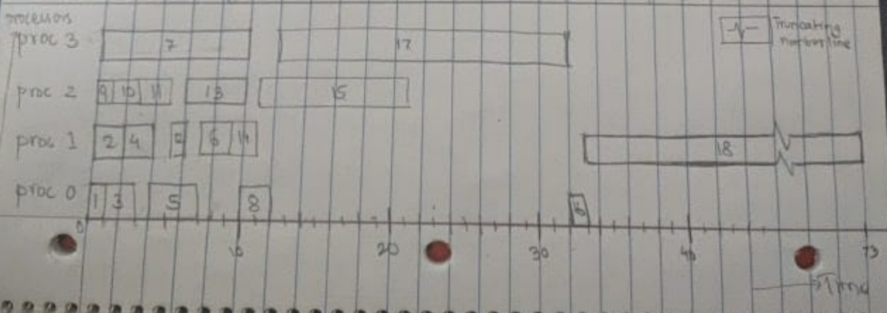

1. Independent Tasks 1

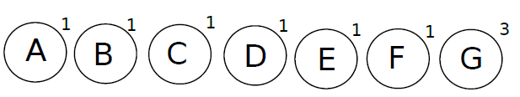

1. Question: Using the metrics of this parallel task graph (you computed last activity) and analysis of List Scheduling, provide a lower bound and an upper bound of the time it would take to schedule this graph on 3 processors. Provide the bounds on 4 processors.

Ans. Lower Bound for 3 Processors -

TotalWork/ #Processor = 9/3 = 3

CP = 3

The lower bound of the graph is 3.

Lower Bound for 4 Processors -

TotalWork/ #Processor = 9/4 = 2

CP = 3

These both are lower bounds, but we consider lower value as inactive. So, the lower bound of the graph is 3.

Upper bound for 3 Processors –

CP + TotalWork/#Processors = 3 + 3 = 6

So, the upper bound of graph is 6.

Upper bound for 4 Processors –

CP + TotalWork/#Processors = 3 + 2 = 5

So, the upper bound of graph is 5.

1. Question: Use List Scheduling to build a schedule of this task graph on 3 processors.

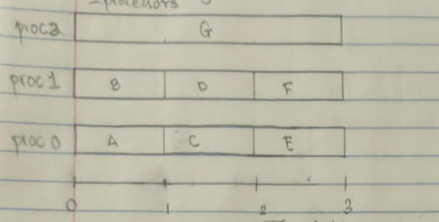

1. Question: Use List Scheduling to build a schedule of this task graph on 4 processors.

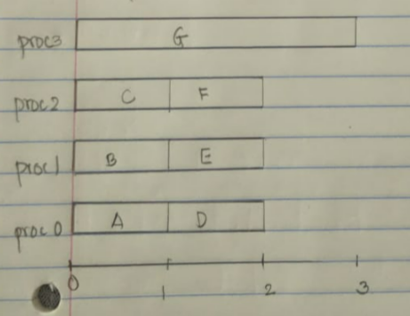

1. Independent Tasks 2

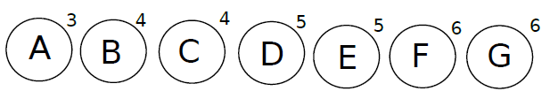

1. Question: Using the metrics of this parallel task graph (you computed last activity) and analysis of List Scheduling, provide a lower bound and an upper bound of the time it would take to schedule this graph on 3 processors. Provide the bounds on 4 processors.

Ans. Lower Bound for 3 Processors -

TotalWork/ #Processor = 33/3 =11

CP = 6

These both are lower bounds, but we consider lower value as inactive. So, the lower bound of the graph is 11.

Lower Bound for 4 Processors -

TotalWork/ #Processor = 33/4 = 8

CP = 6

These both are lower bounds, but we consider lower value as inactive. So, the lower bound of the graph is 8.

Upper bound for 3 Processors –

CP + TotalWork/#Processors = 6 + 11 = 17

So, the upper bound of graph is 17.

Upper bound for 4 Processors –

CP + TotalWork/#Processors = 6 + 8 = 14

So, the upper bound of graph is 14.

1. Question: Use List Scheduling to build a schedule of this task graph on 3 processors.

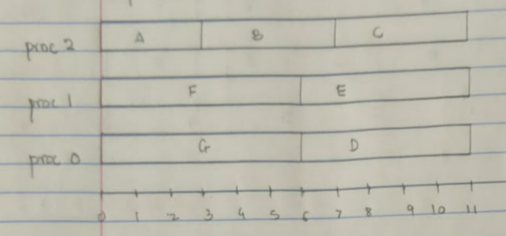

1. Question: Use List Scheduling to build a schedule of this task graph on 4 processors.

