

Detection of Ventricular Tachyarrhythmias

Course: Introduction to Bioinformatics

Kostadin Bajalcaliev, 239038
Skopje, July 2026

Contents
Abstract 4
1. Introduction 4
1.1 The ventricular tachyarrhythmias 4
1.2 Why detection matters 6
1.3 Why detection is hard 6
1.4 Aim and scope 7
2. Background and related work 7
2.1 Threshold-crossing measures 7
2.2 Amplitude distribution and shape 8
2.3 Complexity and entropy 8
2.4 Spectral measures 8
2.5 Phase-space measures 8
2.6 Learned methods, and why they are out of scope here 9
3. Materials and methods 9
3.1 Databases 9
3.2 Signal preprocessing 10
3.3 Segmentation and labeling 10
3.4 Feature set and candidate detectors 11
3.5 Feature screen 13
3.6 Candidate shootout 14
3.7 Candidate tuning 14
3.8 Flutter vs fibrillation 15
3.9 Evaluation metrics 15
4. Results 16
4.1 Dataset composition 16
4.2 Feature screen 17
4.3 Candidate shootout 19
4.4 Tuned candidates 21
4.5 Flutter vs fibrillation 23
5. Discussion 24
5.1 Discriminative features 24
5.2 Discrimination against cost 24
5.3 Comparison with the literature 24
5.4 Flutter versus fibrillation 25
5.5 Threats to validity 25
6. AI as a research collaborator 25
6.1 A closed-world, grounded setup 25
6.2 A phased process with review 26
6.3 Division of labour 26
6.4 Safeguards against fabrication 26
6.5 What the collaboration shows 27
6.6 Authorship and responsibility 27
7. Conclusion and future work 27
References 28
Databases 28
Comparative studies 28
Algorithm papers 29

Abstract
Life-threatening ventricular tachyarrhythmias (ventricular tachycardia, flutter, and fibrillation) are a leading cause of sudden cardiac death, so detecting them from short ECG segments quickly and reliably matters for any device that has to act on them. This paper measures which classical, deterministic signal-processing features best separate shockable from non-shockable rhythms, then tunes the two strongest candidates into detectors. From four PhysioNet databases (VFDB, CUDB, AHADB, MITDB) we build a labeled sliding-window dataset at 8 and 4 seconds, screen 16 signal-only features (a validated reimplementation of the 27 in Hong’s thesis), and run a five-candidate shootout (TCSC, VFLEAK, SPEC, HILB, JEKOVA) on both discrimination and compute cost. JEKOVA’s 14.6 Hz band-pass counts lead the screen (single-feature AUC 0.986) and the shootout; tuning its published decision cascade reaches F1 0.847 (Se 0.898, Sp 0.976), and the reproduced published cascade gives Se 0.973 and Sp 0.900, close to the original. TCSC is about fourteen times cheaper and second on discrimination (F1 0.706), so both go forward as an accuracy-first and a cost-first option. The winning feature does not separate flutter from fibrillation (AUC 0.603). The study stays deterministic by design, as the feature-selection step toward a regulatory submission, so learned classifiers are reviewed as future work, not evaluated.

1. Introduction

1.1 The ventricular tachyarrhythmias
The heart beats because electrical impulses travel through it in a coordinated sequence. When that sequence breaks down in the ventricles, the heart’s main pumping chambers, the result is a group of dangerous rhythms called ventricular tachyarrhythmias. This paper looks at three of them: ventricular tachycardia (VT), ventricular flutter (VFL), and ventricular fibrillation (VF). They form a continuum of increasingly disorganized electrical activity, and where each sits on that continuum is what makes it easy or hard to detect. For reference, Figure 1 shows a normal sinus rhythm and Figures 2 to 4 the three arrhythmias.
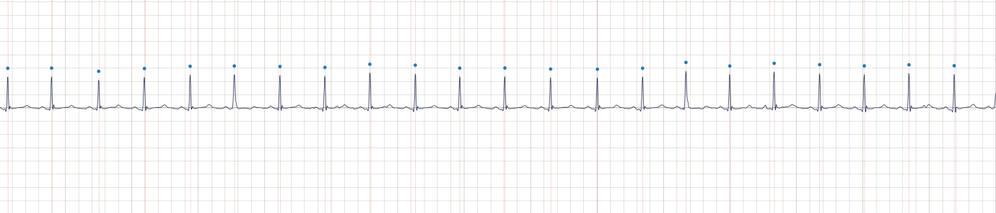
Normal sinus rhythm
Figure 1. Normal sinus rhythm (15 s strip). Regularly spaced, narrow QRS complexes on a near-flat baseline; the detected beats are marked.
VT is a fast but still organized rhythm, typically above 100 bpm, arising in the ventricles rather than the normal conduction path. The ECG still shows distinct QRS complexes, though they are wide and abnormal in shape, and the rhythm is regular or nearly so (Figure 2). Because individual beats stay identifiable, standard QRS detectors can follow VT, as long as they can tell it apart from other fast rhythms. Rates above 180 bpm are considered shockable [JEKOVA-2004].
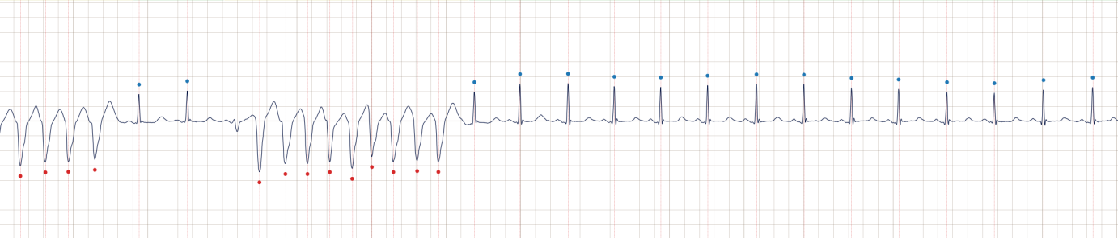
Ventricular tachycardia
Figure 2. Ventricular tachycardia (15 s strip). Runs of fast, wide, abnormal ventricular complexes, with narrow normal beats before and after.
VFL sits between VT and VF. The ventricular rate is very fast (200–350 bpm) and the ECG becomes a continuous, smooth, sine-wave-like oscillation in which individual beats can no longer be separated (Figure 3). VFL is usually short-lived and unstable, tending either to revert to a more organized rhythm or to deteriorate into VF.
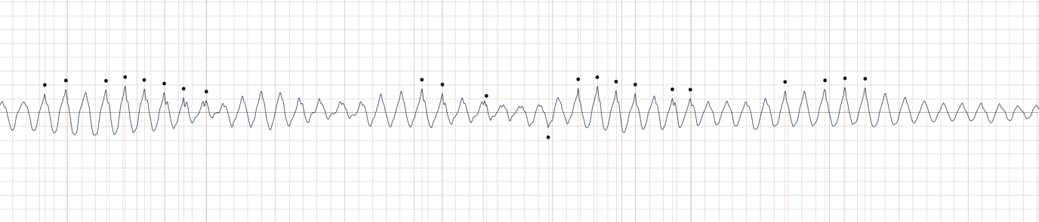
Ventricular flutter
Figure 3. Ventricular flutter (15 s strip). A fast, smooth, near-sinusoidal oscillation with no separable QRS complexes.
VF is the most severe form. The ventricles are activated chaotically by many independent wavefronts at once, and the ECG shows rapid, irregular, low-amplitude activity with no P waves, QRS complexes, or T waves (Figure 4). There is no effective pumping, and without immediate defibrillation the patient dies within minutes. On the surface ECG, VF can resemble noise or motion artifact, which adds to the difficulty of recognizing it.
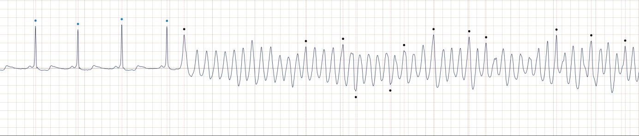
Ventricular fibrillation
Figure 4. Ventricular fibrillation (15 s strip). A few normal beats at the onset give way to rapid, irregular, low-amplitude activity with no QRS complexes.

1.2 Why detection matters
These arrhythmias are a leading cause of sudden cardiac death (SCD). In the United States about 325,000 people suffer an out-of-hospital cardiac arrest each year, and VF is involved in about 75% of sudden cardiac arrest cases at the onset of the event [MODERN-2024]. SCD accounts for roughly half of all cardiovascular deaths [MODERN-2024]. Survival depends on how fast treatment arrives: for every minute without defibrillation the chance of survival falls by about 10% [MODERN-2024]. Rapid and reliable automatic detection is therefore central to any device that has to decide whether to treat.
Automated external defibrillators (AEDs) exist for this purpose. They recognize a shockable rhythm and deliver a shock without needing a trained clinician [JEKOVA-2004, COMP5-2000]. The detection has to be both highly sensitive, so it never misses a true event, and highly specific, so it never shocks unnecessarily. Missing a VF episode is fatal, and an inappropriate shock is harmful. That double requirement is what makes the detection problem genuinely hard [COMP4-1993].

1.3 Why detection is hard
Each rhythm poses a different challenge. VT is organized enough for beat-by-beat analysis, but it has to be told apart from fast normal rhythms, paced rhythms, and bundle branch blocks that also produce wide, abnormal-looking QRS complexes. VFL and VF cannot be handled by counting beats at all. A QRS detector works by emphasizing slope, amplitude, and temporal isolation, so during VFL, when the ECG is a continuous narrow-band oscillation, it either misses peaks or over-counts them, and during VF, when the signal is irregular and can look like noise, beat detection stops being meaningful. Detecting VFL and VF is therefore a matter of characterizing the signal segment as a whole: its dominant frequency, its regularity, its amplitude distribution, and how concentrated its spectrum is. Several other conditions make this harder, because muscle artifact, electrode noise, and atrial flutter or fibrillation share surface features with VF and cause false positives [COMP4-1993]. Data scarcity adds to the problem, since recordings that capture the onset and progression of VF are rare and the number of labeled episodes is small.
Reproducibility is a difficulty of its own. These algorithms are almost never published with a reference implementation, only with a prose description and, at best, a formula, so their exact behaviour has to be reconstructed and re-validated before it can be compared fairly against others or reused. Rebuilding a trusted, validated implementation of the feature set is therefore a precondition for the comparison this paper makes.

1.4 Aim and scope
This paper measures which classical, deterministic signal-processing features best separate the shockable ventricular tachyarrhythmias from other rhythms, then tunes the two strongest candidates into detectors. Five candidate detectors are compared on the same databases under the same evaluation, and judged on both discrimination and computational cost. The two that lead on those axes are then tuned in full, and the leading detector gets one further test: whether it can also separate flutter from fibrillation, which have very different signatures.
The scope stays inside classical, deterministic methods on purpose. The downstream goal is to extend an existing beat-detection and classification engine toward a regulatory submission, and machine-learning and deep-learning detectors need a different validation and approval path. Learned methods are reviewed in section 2 and named as future work, but they are not evaluated here. The reference implementation of every feature is the vftx package, a validated pure-Python reimplementation of the 27 features from Hong’s thesis [HONG-2016].

2. Background and related work
Algorithms for VT, VFL, and VF detection span several decades and moved from simple counting rules to spectral and phase-space analysis. The progression was shaped partly by the hardware of early AEDs, which had little memory and no floating-point unit, so counting and threshold operations were the only practical option at first. This review groups the methods by their underlying principle rather than by date, following the feature categories Hong used to organize his 27-feature set [HONG-2016]. Amann et al.’s comparative study anchors the review: across the methods they tested, the best-performing features worked in the time domain, the spectral parameters used energy distribution but not phase information, and the complexity-based methods performed poorly wherever specificity had to stay above 80% [COMP55-2005]. That finding guides which methods this paper carries forward as candidates.

2.1 Threshold-crossing measures
The simplest family asks how often the signal leaves the baseline. In normal sinus rhythm the ECG rests near the isoelectric line and departs from it only briefly at each beat, when the QRS complex crosses the threshold twice, once as it rises and once as it falls, while during VF the signal is in constant motion and crosses continuously. The zero-crossing rate is the earliest such feature, but it is sensitive to baseline drift [COMP4-1993]. Threshold crossing intervals (TCI) use an adaptive threshold set at 20% of the local maximum and measure the mean time between upward crossings, which falls sharply in VF [COMP4-1993, COMP5-2000]. Threshold crossing sample count (TCSC) counts the fraction of samples above a normalized threshold over a 3-second cosine-tapered window: a normal ECG spends most of its time near baseline and gives a low count, VF does not and gives a high one. On the full MIT-BIH and CU databases without preselection, TCSC gave the best area under the ROC curve among the classical algorithms compared in that study [TCSC-2009].

2.2 Amplitude distribution and shape
A second time-domain family looks at the distribution or shape of the amplitude rather than the crossing rate. In sinus rhythm the amplitude is concentrated near zero with narrow peaks at the QRS complexes; in VF it is spread more evenly across the range. The standard and modified exponential algorithms (STE and MEA) count how the ECG intersects a decaying exponential envelope, capturing that property without an explicit threshold. On standard databases MEA reached an IROC of about 82%, better than STE’s 67% [COMP55-2005]. IROC is Amann et al.’s name for the area under the ROC curve, the same single-number measure this paper elsewhere calls AUC.

2.3 Complexity and entropy
A third family asks how predictable the signal is. Sinus rhythm is quasi-periodic and predictable, VF is chaotic. Sample entropy and approximate entropy measure the chance that a short pattern that recurs also recurs one sample longer, and the complexity measure applies Lempel-Ziv complexity to a thresholded binary version of the signal, scoring high for VF and low for sinus rhythm [COMP5-2000, COMP55-2005]. These measures are sensitive to noise, and Amann et al. found they performed poorly wherever specificity had to stay above 80% [COMP55-2005]. Hong added a related measure for a different job: Lempel-Ziv complexity computed on the intrinsic mode functions of an empirical mode decomposition, which separates VF from VT better than the same measure on the raw signal [HONG-2016].

2.4 Spectral measures
VF produces a narrow-band signal roughly between 4 and 9 Hz, while organized rhythms carry energy at the heart-rate fundamental and its harmonics. The VF-filter (VFLEAK) estimates the mean signal period, adds each sample to the one half a period away, and measures the residual leakage, which is near zero for a sine-like signal and near one for a wideband one [COMP4-1993, COMP5-2000]. The SPEC algorithm windows the segment, takes its FFT, and extracts descriptors of where the spectral energy sits, a normalized mean frequency together with band-energy ratios, which tell a narrow-band VF spectrum from a harmonic-rich sinus spectrum [SPEC-1989, COMP5-2000]. Both reach an IROC near 87–89% on standard databases, with very high specificity but a sensitivity that depends on threshold tuning [COMP55-2005]. Jekova and Krasteva’s band-pass approach filters near 14.6 Hz, a band where normal QRS complexes carry energy but VF does not, and reports about 96% sensitivity and 94% specificity on the combined AHA and MIT databases [JEKOVA-2004].

2.5 Phase-space measures
A signal can be plotted against a time-delayed or Hilbert-transformed copy of itself, which turns the recording into a trajectory in a plane. Periodic signals trace a tight, repeating loop, and chaotic signals fill a large area. The Hilbert-transform method (HILB) overlays the trajectory on a 40 by 40 grid and measures the fraction of boxes it visits, which is low for sinus rhythm and high for VF, and which depends on the shape of the trajectory rather than its amplitude. On combined databases with more than 330,000 decisions, HILB reached an IROC of about 95%, the highest of the classical algorithms in that study [HILB-2005].

2.6 Learned methods, and why they are out of scope here
Recent work puts a classifier on top of several features at once. VFPred combines empirical mode decomposition with a support vector machine and reports sensitivity near 99.99% and specificity near 98.40% on the MIT-BIH and CU databases with 5-second windows [VFPRED-2018]. Hong’s thesis aggregates all 27 features with a support vector machine and meets the AHA performance goals, and notes that even a linear classifier on the same features performs well [HONG-2016]. Convolutional and recurrent networks have reported sensitivity and specificity above 95% on benchmark databases [MODERN-2024, DEEP-2023]. These methods are strong, but they need large annotated training sets and a validation and regulatory path that differs from that of a deterministic detector. This paper takes Hong’s 27-feature set as its candidate pool and its category structure, and treats the learned classifiers as future work rather than evaluating them here.

3. Materials and methods

3.1 Databases
Four PhysioNet databases are used, read through a common reader at a uniform 250 Hz. For each record the reader selects the best available channel, preferring lead II (MLII, ML2, or II) and otherwise the nearest lead (V5, V2, and so on), rather than a fixed channel index.
The MIT-BIH Malignant Ventricular Arrhythmia Database (VFDB) holds 22 two-channel records of about 35 minutes, from patients with sustained VT, VFL, and VF. Its rhythm annotations mark the ventricular episodes this study targets [VFDB].
The Creighton University Ventricular Tachyarrhythmia Database (CUDB) holds 35 single-channel records of 8 minutes, also from patients with sustained ventricular arrhythmias. Its episodes are short, which is one reason for the 4-second window test [CUDB].
The MIT-BIH Arrhythmia Database (MITDB) holds 48 two-channel records of about 30 minutes, spanning normal sinus rhythm and a range of non-shockable rhythms: atrial fibrillation and flutter, bundle branch blocks, paced rhythms, and ectopic beats. It is the main source of non-shockable diversity and carries few ventricular episodes. Its native 360 Hz is resampled to 250 Hz [MITDB].
The American Heart Association Database (AHADB) holds 30-minute two-channel records and requires a licence from ECRI. Its records carry beat annotations and VF markers but no rhythm-episode labels, so only the 8-series ventricular records (8201 to 8210, the ones with VF brackets) are used. In those records the bracketed spans are shockable and the surrounding background is non-shockable. This is the same AHA ventricular material used by Jekova and Krasteva [JEKOVA-2004, AHADB].
Together the four give rich shockable content (VFDB, CUDB, and the AHADB subset) against a broad non-shockable background (MITDB), matching the combination used in the benchmark literature [COMP55-2005].

3.2 Signal preprocessing
Preprocessing runs in two stages, once per record and once per window.
Per record, the signal is conditioned in a single pass: a moving-median baseline removal (596 ms window) followed by a Lynn recursive band-pass (48 ms window). This matches the real-time pipeline, where baseline removal and band-limiting run once as the signal streams in, not per analysis window. Filtering the whole record once, rather than each overlapping window, also avoids repeating the same work on the seven seconds that two adjacent 8-second windows share.
Per window, the integer signal is converted to millivolts by dividing by the standard gain of 200. It is then conditioned for the feature functions by the steps the feature math needs: mean subtraction, min-max normalisation to unit peak-to-peak, order-5 moving-average smoothing, and a re-centering to zero mean. The frequency filtering that the reference pipeline applies (a 1 Hz high-pass and a 30 Hz low-pass [COMP55-2005]) is turned off here, because the record is already band-limited from the per-record stage. The zero-mean re-centering stands in for the high-pass, so features that assume an oscillation around zero (the leakage, spectral, and phase-space measures) behave correctly. All records are unified at 250 Hz (MITDB resampled from 360 Hz), so every feature works at one sampling rate.

3.3 Segmentation and labeling
Each record is scanned with overlapping windows at a 1-second step, at two lengths: 8 seconds (2000 samples), the length most of the benchmark algorithms were defined on, and 4 seconds (1000 samples), which catches the short episodes CUDB and MITDB contain. Each window position produces one row, written to a per-record tab-separated file.
A row holds identifiers (database, record, window start and end), episode-duration labels, beat counts, and the feature columns. The episode labels record how many samples of the window each annotated rhythm covers: normal sinus, bigeminy, trigeminy, VT, VFL, the bracketed VF onset marker, VF, atrial flutter, atrial fibrillation, and an “other” bucket. The beat counts tally the annotation marks in the window by type. Storing durations and counts, rather than one collapsed label, keeps the raw evidence in the file, so the target definitions below can change without rebuilding.
Each window carries two labels. The rhythm label names the dominant episode when one covers at least 90% of the window, otherwise MIX; it gives clean, homogeneous examples and keeps VT, VFL, and VF as distinct classes for the sub-analysis. The shockable label follows the benchmark convention [COMP55-2005, JEKOVA-2004]: a window is shockable when shockable episodes (VT, VFL, VF) cover at least 90% of it, non-shockable when no shockable episode is present, and MIX only when a shockable episode partially straddles the window. An unannotated background window is therefore non-shockable, which is how these algorithms are scored over a whole recording, and MIX is limited to shockable-boundary transitions. Because VFL sits between VT and VF and the databases annotate it separately, the three VFL configurations (VFL shockable, VFL non-shockable, VFL excluded) are all available from the same file. The clean windows are used for the feature analysis and tuning; evaluation uses all windows, since a deployed detector cannot skip boundary windows.
Per-window decisions become reference episode annotations by majority voting. Each sample belongs to several overlapping windows and takes the majority label across them; contiguous runs of the same label collapse into episodes with start and end times. This smooths isolated errors and produces the interval output the standard WFDB tools compare against. The window and class counts from the build are reported in Results (4.1).

3.4 Feature set and candidate detectors
Each window is described by 16 signal-only features, computed by a validated pure-Python reimplementation of the feature set from Hong’s thesis [HONG-2016]. They fall into the same categories as the review in section 2.
Feature | Category | What it measures
TCSC | threshold crossing | fraction of samples whose amplitude exceeds a normalised threshold; high in VF
TCI | threshold crossing | mean interval between threshold crossings; short in VF
STE | amplitude shape | intersections of the signal with a standard decaying exponential envelope
MEA | amplitude shape | same idea with a modified envelope that separates VF better [COMP55-2005]
MAV | amplitude shape | mean absolute amplitude of the window
PSR | phase space | fraction of a grid filled by the time-delay phase-space trajectory
HILB | phase space | fraction of a grid filled by the Hilbert-transform phase-space trajectory [HILB-2005]
VF_LEAK | spectral | residual after half-period cancellation; low for a sine-like VF/VFL signal [VFLEAK-1978]
M | spectral | first-moment spectral parameter of the amplitude spectrum
A2 | spectral | energy in a band around the dominant frequency; high for narrow-band VF
FM | spectral | amplitude-weighted mean frequency of the spectrum
LZ | complexity | Lempel-Ziv complexity of the binarised signal; high for disordered VF
jc1 | band-pass | samples in the upper half [0.5·max, max] of the absolute 14.6 Hz band-pass output [JEKOVA-2004]
jc2 | band-pass | samples above the mean of the absolute band-pass output [JEKOVA-2004]
jc3 | band-pass | samples within the mean plus or minus the mean deviation of the absolute band-pass output; low in VF [JEKOVA-2004]
Amplitude | amplitude | peak-to-peak amplitude in millivolts
The three band-pass counts (jc1, jc2, jc3) are computed on the absolute filter output, as Jekova and Krasteva specify [JEKOVA-2004]. The vftx reference set also computes them on the signed filter output (count1, count2, count3), and those columns are kept in the data, but the signed second count is degenerate (about half the samples sit above a near-zero mean for every rhythm), so the JEKOVA candidate, and the feature screen, use the absolute-output counts. Sample entropy (how predictable the signal is) is also available but off by default, because at about 55 ms/window it is the slowest of the kept features; it is computed only when a step needs it.
Two feature families are excluded, and the reasons matter for the paper’s claim to be a signal-only, real-time detector. QRS-derived features (mean RR interval and beat-type ratios) are dropped because a QRS detector must blank during VF and VFL: there is no QRS to detect, so a VF/VFL detector that consumed QRS output would be circular and would fail exactly when it is needed. The EMD-based IMF-LZ features are dropped because empirical mode decomposition costs about 2 seconds per window, which cannot keep up with a real-time 1-second step. Both families exist in the reference set but have no place in a signal-only real-time detector.
Five candidate detectors are compared, each one algorithm computed from one or a few of the features above plus a threshold decision. Each maps onto a distinct method family.
Candidate | Feature(s) | Family | Reference
TCSC | tcsc | threshold crossing | [TCSC-2009]
VFLEAK | vf_leak | spectral, leakage | [VFLEAK-1978]
SPEC | m, a2, fm | spectral, FFT descriptors | [SPEC-1989]
HILB | hilb | phase space | [HILB-2005]
JEKOVA | jc1, jc2, jc3 | 14.6 Hz band-pass | [JEKOVA-2004]
TCSC, VFLEAK, and SPEC come from the benchmark literature. HILB is added to bring in the phase-space family, which the first three do not cover; it is a natural choice for that slot because Amann et al. report it as the strongest single algorithm they tested (IROC about 95%, against 82 to 89 for the classical algorithms) [HILB-2005], though on our data it lands mid-pack. The fifth slot first held MEA (the amplitude-shape family), but the feature screen (section 4.2) ranked MEA poorly and ranked JEKOVA’s band-pass counts at the top, so JEKOVA takes the slot: it is a strong published detector (about 96% sensitivity and 94% specificity) that uses only integer arithmetic, which suits the real-time target [JEKOVA-2004]. Complexity and entropy measures are left out of the candidate set because they perform poorly wherever specificity must stay above 80% [HONG-2016, COMP55-2005]. Each candidate’s decision threshold is set in the shootout and tuned in the sections that follow; the tuned values and the per-window compute cost are reported in Results.

3.5 Feature screen
The feature analysis runs in two passes: a broad screen that ranks every feature on its own, then the shootout of section 3.6 that compares the candidate detectors. The screen works on the clean windows (shockable versus non-shockable, with the MIX transition windows dropped), since that keeps the ranking honest, the boundary windows having no single correct label. It scores each of the 16 signal-only features against the binary shockable label by three complementary measures, chosen so that a feature has to look good from three different angles (a linear one, an information-theoretic one, and a decision one) to be trusted.
Point-biserial correlation is the Pearson correlation between a continuous feature and the binary label (coded 0 and 1). It ranges over [-1, 1] and is signed, so it gives the direction of the effect: positive means the feature rises for shockable rhythms, negative means it falls, which is what tells us how to orient a threshold. Its weakness is that it sees only linear, monotonic association, so a feature that separates the classes non-monotonically can score near zero even when it is highly informative; it cannot be the only measure.
Mutual information measures how much knowing the feature reduces uncertainty about the label, and is zero only when the two are statistically independent. Unlike correlation it assumes neither linearity nor monotonicity, so it captures any form of dependence, which is why it guards the blind spot of the correlation. It is estimated with a nearest-neighbour method on a random subsample of the windows, and being non-negative and unbounded it is read comparatively (higher is more informative) rather than against a fixed scale.
Single-feature AUC is the area under the ROC curve obtained by thresholding that one feature and sweeping the threshold across its range. It equals the probability that a random shockable window scores above a random non-shockable one, so 0.5 is chance and 1.0 is perfect separation; a feature that separates in the opposite direction scores below 0.5, so the value is oriented to max(AUC, 1 - AUC). Being threshold-free it is the natural match to a single-threshold detector and is directly comparable to the ROC figures the benchmark papers report [COMP55-2005, TCSC-2009], which makes it, of the three, the closest proxy for how the feature behaves as a detector.

3.6 Candidate shootout
The shootout treats each candidate as a deployable detector rather than a bare feature. Every candidate is a single feature (its primary feature, the strongest of the group by oriented AUC) plus one threshold, and its discrimination is reported three ways: the oriented single-feature AUC and mutual information from the screen, plus the best F1 score reached at any single threshold. F1, the harmonic mean of precision and recall, is used because the classes are heavily imbalanced (far more non-shockable than shockable windows), a setting in which plain accuracy is misleading; it is computed here as the maximum F1 over all thresholds and both orientations, so it reads as the best operating point a single threshold on that feature can reach. Full multi-threshold tuning of the multi-feature detectors is deferred to the tuning stage (section 3.7); in the shootout each is fairly represented by its best sub-feature.
Alongside discrimination each candidate carries a rough compute cost, reported as milliseconds per 1000 windows for readability. It is timed through the same feature path the dataset build uses (preprocess the window once, then compute the feature), and charged at the primary feature, which carries the detector’s one shared heavy step exactly once: JEKOVA’s 14.6 Hz band-pass, or SPEC’s power spectrum. Summing the sub-features would redo that step and overstate a detector that a real implementation computes once. These are pure-Python, single-thread measurements on one machine, given only for relative scale between candidates, not as absolute or portable timings; an embedded C implementation would be far faster, and only the ordering between candidates carries over. The winner is argued from both axes together, because the downstream target is a real-time, embedded detector: a cheaper candidate that trails the best discrimination by a small margin can still be preferred, so the shootout reports the two axes side by side rather than collapsing them into one score.

3.7 Candidate tuning
The two candidates that lead on the two axes of the shootout are tuned in full: TCSC, the cheapest detector and the established threshold-crossing design [TCSC-2009], and JEKOVA, the strongest on discrimination and still real-time friendly [JEKOVA-2004]. Both are tuned on the clean set, separately for each window length (the feature distributions shift with window length, so a threshold tuned at 8 seconds may not be optimal at 4 seconds) and under each of the three VFL configurations.
TCSC is a single feature with a single threshold. The threshold is swept across the whole range of the feature, and the operating point that maximises F1 is reported, together with the full ROC curve, in the manner of the [COMP55-2005] single-threshold analysis. This is the same sweep that produced the shootout AUC, now read at a chosen operating point rather than as an area.
JEKOVA is not a single threshold but the cascade of count rules from the original paper [JEKOVA-2004]: two rules that declare a segment non-shockable, two that declare it shockable, and a combined term jc1·jc2/jc3, with anything unmatched left “not classified” for a later wave-detection stage. Two adjustments make the published cascade transfer to this study, both recorded so the tuning stays honest. First, the counts use the absolute band-pass output (section 3.4), not vftx’s signed counts, because the signed second count is degenerate and the cascade relies on exactly that count’s spread. Second, the window length: the paper’s constants are raw sample counts over a 10-second epoch, so they do not transfer to an 8 or 4-second window; the counts are normalised to fractions of the window sample count, which are comparable across window lengths, and the published constants are expressed on the same fractional scale. The cascade thresholds are then grid-searched for best F1, with the published-constant cascade reported as a baseline. The “not classified” branch cannot use the paper’s wave detection without a peak detector, which a signal-only detector avoids by design (section 3.4), so those windows fall back to a threshold on jc3, which is low for shockable rhythms; that fallback is one of the grid-searched parameters.

3.8 Flutter vs fibrillation
The winning detector gets one further test: does a cheap feature separate flutter from fibrillation? The two are physiologically distinct, VFL being a fast, regular, near-sinusoidal oscillation and VF being disorganised, so spectral-concentration and regularity measures should carry the split. Using the rhythm label, the VFL and VF windows are scored by the oriented AUC of each candidate feature (spectral concentration a2, leakage vf_leak, the phase-space fills psr and hilb, and the band-pass count jc3). Hong’s answer to the related VF-versus-VT question was Lempel-Ziv complexity on the empirical-mode-decomposition modes [HONG-2016], but that is out of scope here because EMD is too slow for the real-time target (section 3.4). Flutter is rare in these databases (its window count is reported in section 4.1), so this result is indicative rather than definitive.

3.9 Evaluation metrics
Each detector produces a binary decision per window, which is compared against the window’s shockable label to give the four confusion counts: true positives (TP, shockable windows correctly flagged), false positives (FP, non-shockable windows wrongly flagged), true negatives (TN), and false negatives (FN, missed shockable windows). All the metrics below are functions of these four counts, and all are reported at the tuned operating point.
Sensitivity (Se = TP / (TP + FN)) is the fraction of shockable windows caught, the safety-critical metric since a false negative is a missed shock. Specificity (Sp = TN / (TN + FP)) is the fraction of non-shockable windows correctly passed over; low specificity means inappropriate shocks. Positive predictive value (PPV = TP / (TP + FP)) is the fraction of flagged windows that were truly shockable, which matters under this imbalance, where even a high specificity can leave many false positives per true positive. Accuracy (Acc = (TP + TN) / total) is reported for completeness but is weak under imbalance, where predicting the majority class alone already scores high.
The headline metric is F1, the harmonic mean of PPV and sensitivity (F1 = 2·PPV·Se / (PPV + Se)); it rewards a detector only when both are high and, unlike accuracy, is not inflated by the non-shockable majority, which makes it the right single number for tuning under imbalance. The G-Mean (sqrt(Se·Sp)) is reported alongside as a balance measure that, unlike F1, is symmetric in the two classes and so penalises sacrificing either one. The ROC curve (sensitivity against 1 minus specificity as the threshold sweeps) is used only for the tuning here, not for the shootout, where a single AUC per candidate already summarised the threshold-free separation.

4. Results

4.1 Dataset composition
The build produced 167,783 windows at 8 seconds and 168,243 at 4 seconds across the four databases, stepping by 1 second and keeping the AHADB 8-series only. Under the benchmark labeling most windows are non-shockable, as expected from recordings that are mostly background rhythm with embedded ventricular events: 148,689 non-shockable, 16,036 shockable, and 3,058 MIX at 8 seconds. The shorter window straddles fewer episode boundaries, so at 4 seconds MIX falls to 1,851 while the shockable count rises slightly to 16,483. The per-database split shows where each class comes from: the shockable windows are supplied by VFDB, CUDB, and the AHADB subset, while MITDB contributes little but dominates the non-shockable background.
Database | NON (8s) | SHOCK (8s) | MIX (8s) | NON (4s) | SHOCK (4s) | MIX (4s)
VFDB | 37,417 | 6,835 | 1,772 | 37,889 | 7,096 | 1,127
CUDB | 13,432 | 3,513 | 590 | 13,704 | 3,664 | 307
AHADB | 12,371 | 5,447 | 102 | 12,427 | 5,480 | 53
MITDB | 85,469 | 241 | 594 | 85,889 | 243 | 364
All | 148,689 | 16,036 | 3,058 | 149,909 | 16,483 | 1,851
The separate rhythm label, which keeps the ventricular classes distinct for the flutter-versus-fibrillation analysis, shows how uneven the shockable material is inside itself. At 8 seconds the clean ventricular windows split into 10,569 VF, 4,937 VT, and only 474 VFL, against 77,932 normal-sinus and 41,313 other non-shockable windows (the remaining windows are MIX). Flutter is by far the rarest of the three, which is expected given how short-lived VFL is, and it sets the main limit on the flutter-versus-fibrillation sub-analysis in section 4.5. The three VFL configurations (flutter shockable, non-shockable, or excluded) are all derived from this same labeling without rebuilding, since the file stores episode durations rather than one collapsed label.

4.2 Feature screen
The screen was run on the 8-second clean set (16,036 shockable, 148,689 non-shockable). The 16 features rank as follows, by oriented single-feature AUC, with point-biserial correlation and mutual information alongside.
Feature | Point-biserial | AUC | Mutual information
jc2 | 0.722 | 0.986 | 0.237
jc3 | -0.710 | 0.985 | 0.229
jc1 | 0.784 | 0.974 | 0.222
TCSC | 0.623 | 0.964 | 0.185
MAV | 0.643 | 0.964 | 0.189
HILB | 0.614 | 0.954 | 0.183
PSR | 0.616 | 0.944 | 0.167
A2 | 0.656 | 0.940 | 0.172
VF_LEAK | -0.605 | 0.924 | 0.154
M | -0.331 | 0.923 | 0.145
TCI | -0.229 | 0.900 | 0.115
LZ | 0.336 | 0.797 | 0.063
FM | -0.276 | 0.781 | 0.051
MEA | 0.292 | 0.778 | 0.049
STE | 0.286 | 0.732 | 0.040
Amplitude | 0.142 | 0.538 | 0.066

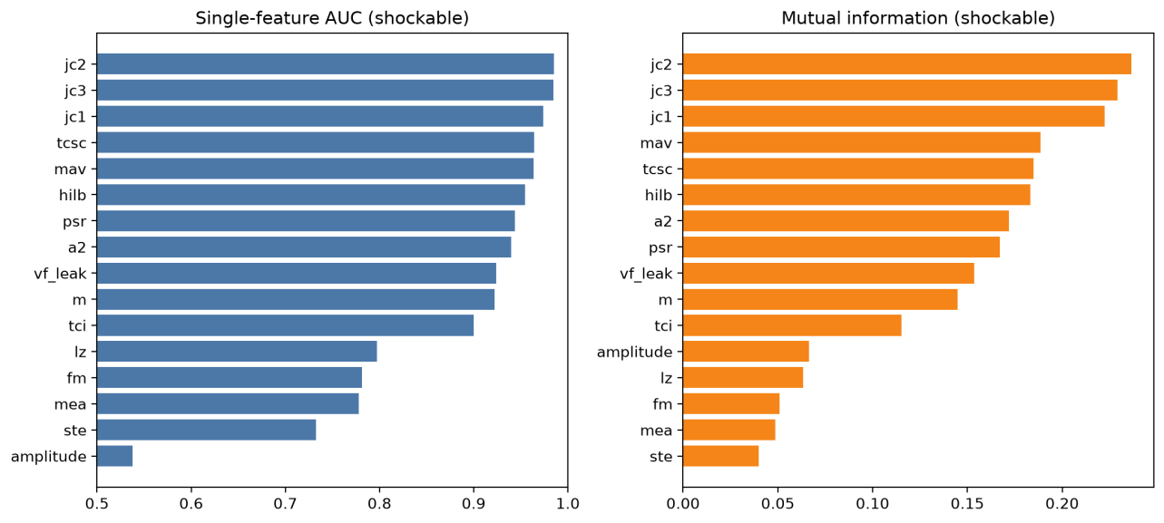
Single-feature AUC and mutual information
Figure 5. Single-feature AUC (left) and mutual information (right) for each feature against the shockable label, sorted. The three band-pass counts (jc2, jc3, jc1) lead on both.
The three measures agree on the overall ordering (Figure 5). The three band-pass counts lead on all three metrics (AUC 0.986, 0.985, 0.974 for jc2, jc3, jc1), and the rest of the top is filled by the threshold-crossing, amplitude, and phase-space families, with the spectral features close behind. The complexity measure LZ, the amplitude-shape measures MEA and STE, and the raw peak-to-peak Amplitude sit at the bottom. This confirms the two decisions the candidate set rests on: the band-pass counts are the strongest single features, which is why JEKOVA replaced MEA in the fifth slot, and the complexity and amplitude-shape measures discriminate poorly, matching Amann et al.’s finding that they fail wherever specificity must stay high [COMP55-2005]. The feature-feature correlation heatmap (Figure 6) shows the strong features are not independent: the threshold-crossing, band-pass, and phase-space measures form a correlated block, so they largely re-measure the same underlying property (how much of the window departs from baseline) rather than adding separate evidence.
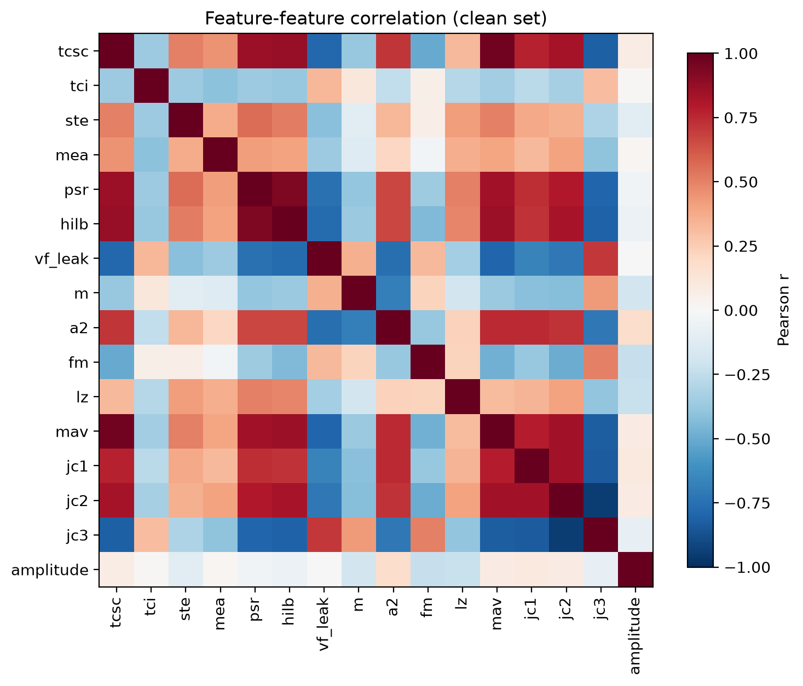
Feature-feature correlation heatmap
Figure 6. Feature-feature correlation over the clean set. The threshold-crossing, band-pass, and phase-space features form a correlated block, so their strong individual scores are not independent evidence.

4.3 Candidate shootout
The shootout compares the five candidates as detectors. At 8 seconds:
Detector | Primary feature | AUC | Mutual information | Best F1 | Cost  (ms/1000 win)
JEKOVA | jc2 | 0.986 | 0.237 | 0.846 | 1318
TCSC | tcsc | 0.964 | 0.186 | 0.707 | 94
HILB | hilb | 0.954 | 0.182 | 0.723 | 109
SPEC | a2 | 0.940 | 0.172 | 0.719 | 114
VFLEAK | vf_leak | 0.924 | 0.154 | 0.692 | 111
JEKOVA leads every discrimination column by a clear margin, most visibly on best F1 (0.846 against 0.72 or below for the rest), so the hypothesis that TCSC would top the shootout does not hold: TCSC is strong and comes second on AUC, but the band-pass detector is better. Each detector’s primary feature pulls the shockable and non-shockable windows apart visibly, most cleanly for JEKOVA’s jc2 (Figure 7). The cost column tells the other half of the story. TCSC is the cheapest by more than an order of magnitude (94 ms per 1000 windows against JEKOVA’s 1318), because it is a single normalised-threshold count over the window, whereas JEKOVA has to run the sample-by-sample recursive band-pass filter first. The three FFT and leakage detectors sit together near 110 ms. On the discrimination-versus-cost scatter (Figure 8) JEKOVA sits at the top right (best, most expensive) and TCSC at the far left (cheapest, second-best), with the others clustered between them, which is exactly the tradeoff that makes the winner an argued choice rather than a lookup of the top score. The cost numbers are pure-Python timings on one machine and shift with load, so only their ratios carry meaning: JEKOVA costs about fourteen times TCSC at both window lengths.
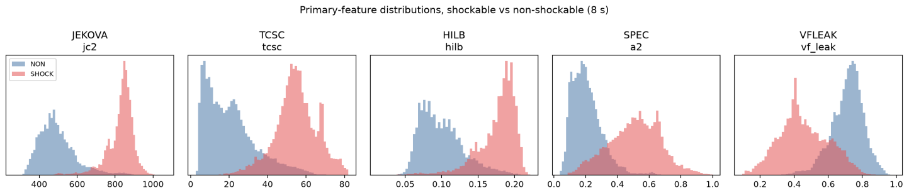
Primary-feature separation
Figure 7. Primary-feature separation, shockable versus non-shockable (clean set, 8 s), one panel per candidate. The shockable and non-shockable distributions overlap least for JEKOVA’s jc2.
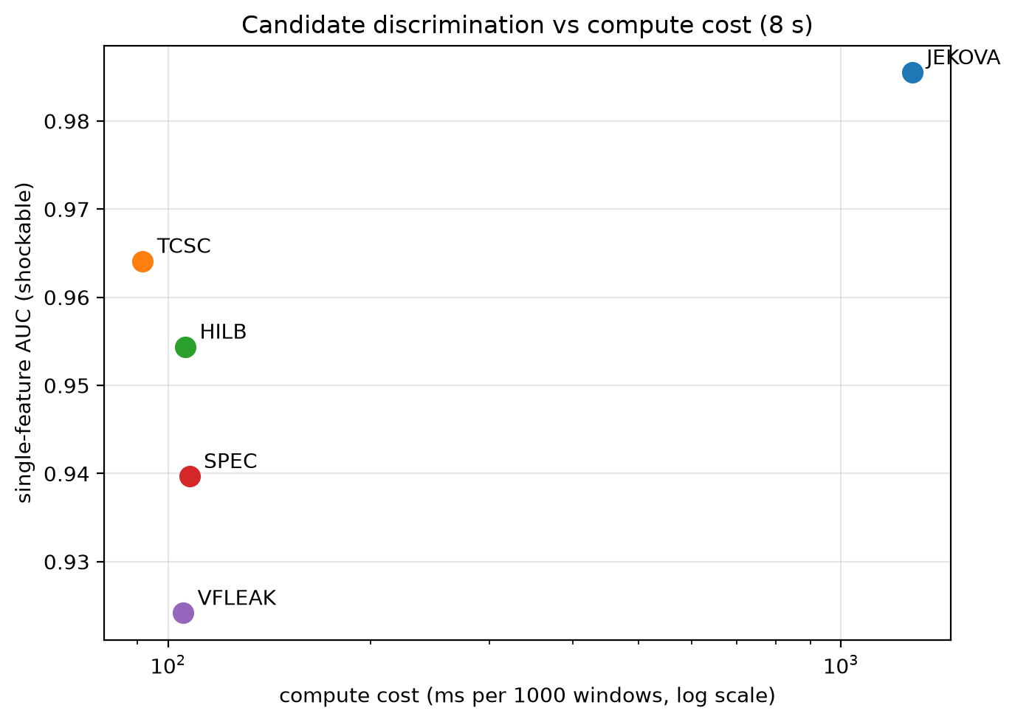
Discrimination versus compute cost
Figure 8. Discrimination (single-feature AUC) versus compute cost per candidate at 8 s, cost on a log axis. JEKOVA is best but most expensive; TCSC is the cheapest and second best.
The 4-second rerun holds the picture. JEKOVA still leads (AUC 0.982, best F1 0.826), the ordering of the rest barely moves (HILB and TCSC swap by a hair on AUC), and every cost roughly halves with the shorter window, so the ranking is not an artifact of the 8-second length.
Detector | AUC (8 s) | F1 (8 s) | Cost (8 s) | AUC (4 s) | F1 (4 s) | Cost (4 s)
JEKOVA | 0.986 | 0.846 | 1318 | 0.982 | 0.826 | 660
TCSC | 0.964 | 0.707 | 94 | 0.955 | 0.681 | 55
HILB | 0.954 | 0.723 | 109 | 0.960 | 0.731 | 91
SPEC | 0.940 | 0.719 | 114 | 0.938 | 0.707 | 77
VFLEAK | 0.924 | 0.692 | 111 | 0.926 | 0.680 | 74
Because the two axes point at different candidates (JEKOVA on discrimination, TCSC on cost), both are carried into the tuning of section 4.4, and the choice between a single detector and a combination of the two is left to that stage and to future work.

4.4 Tuned candidates
Both candidates were tuned on the clean set at each window length and under the three VFL configurations. The operating points below are for the shockable configuration (flutter counts as shockable); the other two configurations move every number by less than a percentage point, because flutter is rare, so only the shockable configuration is tabulated here.
Window | Detector | Se | Sp | PPV | F1 | Acc | G-Mean
8 s | TCSC (tuned) | 0.827 | 0.945 | 0.617 | 0.706 | 0.933 | 0.884
8 s | JEKOVA (published) | 0.973 | 0.900 | 0.511 | 0.670 | 0.907 | 0.936
8 s | JEKOVA (tuned) | 0.898 | 0.976 | 0.802 | 0.847 | 0.969 | 0.936
4 s | TCSC (tuned) | 0.778 | 0.944 | 0.605 | 0.681 | 0.928 | 0.857
4 s | JEKOVA (published) | 0.962 | 0.893 | 0.497 | 0.656 | 0.900 | 0.927
4 s | JEKOVA (tuned) | 0.875 | 0.973 | 0.783 | 0.826 | 0.964 | 0.923
Two things stand out. First, the published JEKOVA cascade, reproduced on our absolute-output counts with its constants only rescaled to the window length, already reaches Se 0.973 and Sp 0.900 at 8 seconds. That is close to the Se 0.959 and Sp 0.944 the original paper reports on the AHA and MIT databases [JEKOVA-2004], which is a strong independent check that the cascade and the absolute counts were reproduced correctly, given that our counts follow Hong’s band-pass and our evaluation scores every window of every recording rather than curated 10-second episodes. The small specificity gap (our 0.900 against the paper’s 0.944) is the expected cost of scoring the full continuous recording, including the noisy MITDB background, without the paper’s separate noise and asystole gates.
Second, tuning moves JEKOVA along its operating curve: the grid search trades a little sensitivity (0.973 to 0.898) for a large gain in specificity (0.900 to 0.976) and precision (0.511 to 0.802), which lifts F1 from 0.670 to 0.847, the best of any detector at either window length. The tuned thresholds are the same at 8 and 4 seconds (the fraction normalisation makes them transfer), which is a useful robustness property for deployment. TCSC tuned to its best-F1 threshold reaches F1 0.706 at 8 seconds, below tuned JEKOVA on every metric except that both keep specificity high; its strength is elsewhere, in cost (section 4.3). The ROC figure (Figure 9) shows the TCSC sweep as a curve with the two JEKOVA cascade points marked: the tuned point sits up and to the left of the published one, and both JEKOVA points sit above the TCSC curve, so at matched specificity JEKOVA reaches higher sensitivity. All numbers drop by one to three points at 4 seconds, as expected from the shorter evidence window, without changing the ordering.
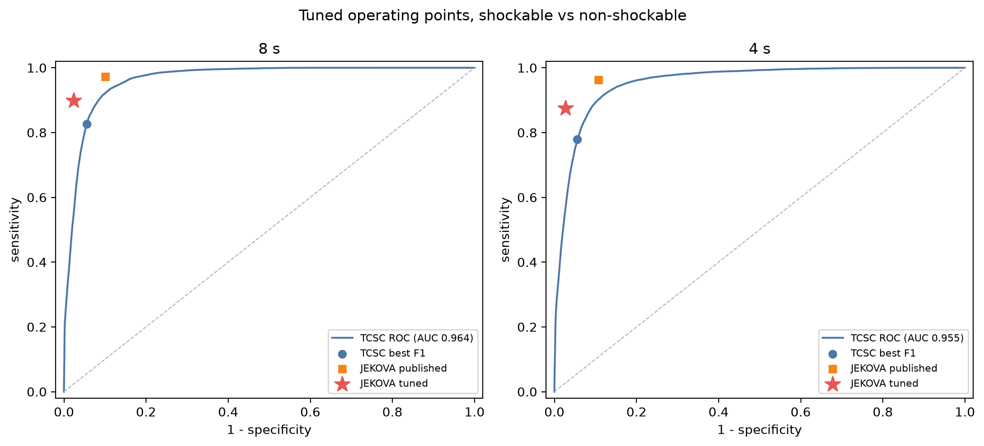
Tuned operating points
Figure 9. TCSC ROC curve (8 s and 4 s) with the JEKOVA published and tuned cascade operating points marked. Both JEKOVA points sit above the TCSC curve.
For reproducibility, the tuned thresholds are collected below. TCSC is a single threshold: it flags a window shockable when its sample-count feature exceeds 45.8 at 8 seconds (47.1 at 4 seconds). JEKOVA’s cascade is expressed as fractions of the window sample count, so one set of thresholds applies to both window lengths; the published fractions are Jekova’s 10-second raw counts divided by the 2500-sample epoch (Count1 gates 250 and 400, Count2 gates 600, 950, and 1100, and 210 for the ratio term).
JEKOVA cascade parameter | Published | Tuned
Count1 lower gate | 0.10 | 0.16
Count1 upper gate | 0.16 | 0.20
Count2 lower gate | 0.24 | 0.24
Count2 upper gate | 0.38 | 0.30
Count2 shockable gate | 0.44 | 0.35
ratio term (jc1·jc2/jc3) | 0.084 | 0.08
Count3 fallback | 0.70 | 0.55
The Count3 fallback is not one of Jekova’s constants; it stands in for the paper’s wave-detection branch on the unclassified windows, flagging shockable when the Count3 fraction is at or below the value shown. In effect the tuned cascade raises the lower Count1 and Count2 gates and lowers the shockable Count2 gate, which is what trades sensitivity for the specificity and precision gain above.
Reading the two axes together (section 4.3 and this table), JEKOVA is the accuracy choice and TCSC the cost choice. Which one, or which combination, a deployment should carry is left to future work, since it depends on the embedded compute budget and the required sensitivity floor, both outside the scope of this feature study.

4.5 Flutter vs fibrillation
The winning detector, JEKOVA, is built on the band-pass counts, which barely separate flutter from fibrillation: on the VFL and VF windows the jc3 fraction gives an oriented AUC of only 0.603 at 8 seconds, close to chance. This is expected, since the count measures how much 14.6 Hz band energy is absent, which both flutter and fibrillation share, so it cannot tell the two apart. Cheap spectral-concentration and regularity features do better, though only modestly. Scoring VF against VFL by oriented AUC on the flutter and fibrillation windows (section 4.1) at 8 seconds, the threshold-crossing count TCSC leads at 0.735, followed by the phase-space fill PSR at 0.722 and the leakage measure VF_LEAK at 0.706, with the spectral concentration A2 at 0.682; the 4-second window gives the same ordering (TCSC 0.740, VF_LEAK 0.706, PSR 0.697). The distribution figure (Figure 10) shows the separation is real but with heavy overlap, which matches the physiology: flutter is the fast, regular, near-sinusoidal precursor and fibrillation the disorganised end state, but the two form a continuum and flutter often degrades into fibrillation within the same episode. Flutter is rare in these databases (section 4.1), so this is an indicative result rather than a tuned flutter-versus-fibrillation detector: a deployed detector would need a second, regularity-oriented feature (TCSC or the phase-space fill) on top of the band-pass count to attempt the split, and even then only partially.
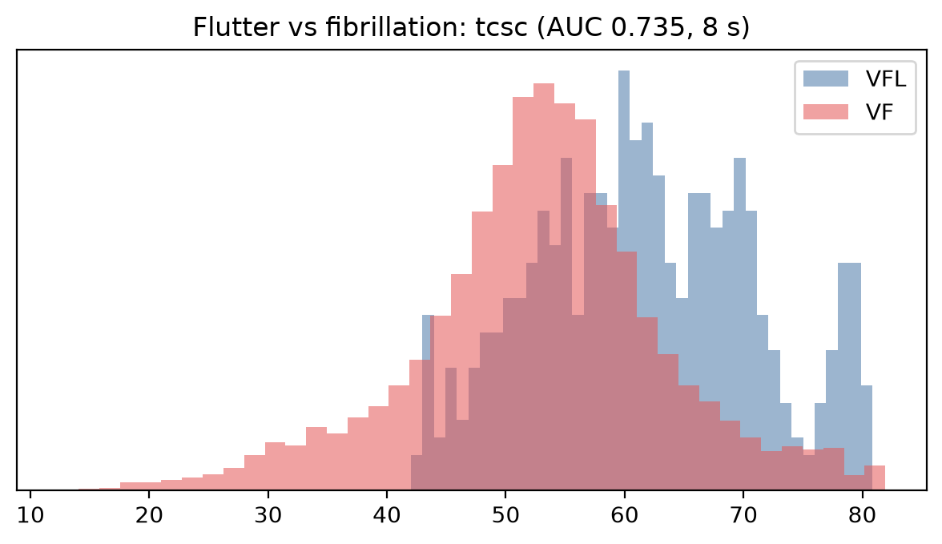
Flutter versus fibrillation
Figure 10. Flutter versus fibrillation: distribution of the best separating feature (TCSC) at 8 s. The two classes separate, but with heavy overlap.

5. Discussion

5.1 Discriminative features
The screen and shootout point to a single property above all others: how much of the window’s energy sits outside the narrow band where a normal ECG puts its sharp features. The three band-pass counts top the screen (AUC 0.986, 0.985, 0.974), ahead of the threshold-crossing count TCSC (0.964), the mean absolute amplitude MAV (0.964), and the phase-space fill HILB (0.954). These leading features are, at bottom, measuring the same thing from different angles: a normal ECG rests near baseline for most of the window with brief sharp excursions at the QRS complexes, whereas a shockable rhythm is in continuous motion. The correlation heatmap confirms it, since the threshold-crossing, band-pass, and phase-space features form one correlated block, so combining them adds little independent evidence. The spectral leakage and FFT descriptors (VF_LEAK 0.924, A2, M) trail slightly and measure a related property, spectral concentration. The features that measure something genuinely different, signal complexity (LZ 0.797) and amplitude shape (MEA 0.778, STE 0.732), discriminate worst, which matches Amann et al.’s finding that complexity measures fail wherever specificity must stay high [COMP55-2005]. The useful signal for the shockable decision is therefore concentrated on one axis, and the candidate that reads that axis most cleanly wins.

5.2 Discrimination against cost
The hypothesis going in was that TCSC, the established cheap design, would top the shootout. It did not. JEKOVA leads every discrimination metric (F1 0.846 against 0.72 or below), because its 14.6 Hz band-pass isolates exactly the property above and its counts read it directly. But it is the most expensive candidate, about fourteen times TCSC, because the recursive filter runs sample by sample where TCSC is a single normalized-threshold pass. This gap is the crux for the downstream embedded target: on an embedded processor a fourteenfold compute cost can weigh more than a fifteen-point F1 gap, so the paper deliberately keeps the two axes separate rather than folding them into one score. Both detectors go forward, JEKOVA as the accuracy-first option and TCSC as the cost-first one, and the deployment choice is left to the compute budget and the required sensitivity floor, which are outside a feature study.

5.3 Comparison with the literature
The strongest external check here is the reproduction of Jekova’s published cascade (section 4.4): on our reimplemented counts and a stricter, whole-recording evaluation, it lands within a few points of the paper’s reported sensitivity and specificity [JEKOVA-2004]. That says the feature math and the decision logic were reconstructed faithfully, which is the reproducibility gap of section 1.3 closed in miniature. Tuning then trades sensitivity for precision to maximise F1, which is the right move under this class imbalance but not under an AED sensitivity floor, where the higher-sensitivity published operating point would be preferred. TCSC trails JEKOVA mainly on precision, that is, on false positives, which the band-pass suppresses better. Neither single-feature detector reaches the AHA sensitivity goal, but both are scored per window without the majority-vote episode smoothing a deployed system would add, so these are lower bounds rather than final operating numbers.

5.4 Flutter versus fibrillation
The band-pass detector cannot make this split, which is expected: it measures a property flutter and fibrillation share, the absence of 14.6 Hz energy. Regularity and phase-space features do modestly better but overlap heavily (section 4.5), so a clean flutter-versus-fibrillation boundary would need a dedicated regularity feature, and even then the two form a physiological continuum that resists one. This matters little for the shock decision, where both are shockable, but it limits any finer characterization of the episode.

5.5 Threats to validity
Three limits qualify these results. First, class imbalance: non-shockable windows outnumber shockable ones roughly nine to one, which inflates accuracy and depresses precision, so the paper leads with F1 and G-Mean and the absolute PPV figures should be read against that imbalance. Second, coverage: flutter is represented by only a few hundred windows (section 4.1), so the flutter-versus-fibrillation result is indicative rather than settled, and the AHADB contribution is limited to its 8-series records, which narrows its non-shockable diversity. Third, the evaluation is per-window at a 1-second step with no majority-vote episode reconstruction, so the confusion counts are windows rather than episode durations in milliseconds; the published algorithms were scored on episode-level decisions, which smooth isolated errors, so the per-window numbers here are conservative by comparison. The 8-second versus 4-second comparison, by contrast, is robust: the ranking barely moves and the tuned JEKOVA thresholds are identical at both lengths, so the choice of window is not driving the conclusions.

6. AI as a research collaborator
This study doubled as a test of method. Using an AI assistant was an objective from the start, not a convenience adopted along the way: the aim was to see how far a large language model can be folded into an academic workflow, from code to prose, while keeping the result honest and reproducible. This section records how that collaboration worked, because the process is part of what the paper reports. The assistant was Claude Opus 4.8 (model claude-opus-4-8, Anthropic), driven through the Claude Code extension for VS Code, with access to the repository, a Python environment, and the cached literature.

6.1 A closed-world, grounded setup
The author owned the questions and the evidence. The author chose the scope, the candidate detectors, the databases, and every reference, and collected the source papers into the repository (paper sources under docs/papers/), where each was extracted to plain text (docs/texts/). The assistant worked from that fixed corpus rather than from open-web recall, which turned the literature into a closed-world ground truth: a claim in the paper traces to a document the author had already vetted, not to the model’s parametric memory. The feature mathematics was grounded the same way, through a reimplementation (the vftx package) validated feature by feature against a reference implementation, so the numbers rest on checkable code rather than on a prose description.

6.2 A phased process with review
The work ran in phases, recorded in paper/PLAN.md: scope and skeleton, introduction and literature review, dataset construction, the feature screen and shootout, candidate tuning, and the write-up. Each phase ended at a review point where the author read the output, gave feedback, and corrected direction before the next began; paper/NOTES.md and the version-control history track that progression. Several turns of the paper exist only because of that review: the move from a single tuned detector to two, the reframing of the JEKOVA candidate around its absolute-output counts after its signed counts were found degenerate, and the split of the results into separate screen and shootout sections all followed author feedback rather than the assistant acting on its own.

6.3 Division of labour
Within each phase the assistant did most of the mechanical work: it wrote the analysis pipeline and the notebook, ran the experiments, drafted the prose, and applied the house conventions (the block-closing style in the code, the writing rules in STYLE.md). The author supplied the structure, the content decisions, the scope of the claims, and the style, and made the judgement calls that shaped the argument. The assistant proposed; the author disposed. This division moved the work quickly through the laborious parts (building the dataset, timing the detectors, tabulating results) while keeping interpretation and scope under human control.

6.4 Safeguards against fabrication
The characteristic failure of this mode is a confident but false statement, and the assistant produced several. In this project a JEKOVA decision rule was written with an inverted threshold, a compute cost was inflated about threefold by charging a shared band-pass step once per count rather than once, and one reference was given a fabricated author. Each was caught, and how it was caught matters more than that it happened. Every quantitative result in the paper is produced by executing the notebook rather than typed by hand, so a wrong rule surfaces as a wrong number instead of hiding in prose: the inverted threshold showed up at once as a near-zero specificity. Every external figure is tied to a cited source in the closed corpus, and cross-checking those citations reconciled the IROC values in the background section, caught a score attributed to the wrong comparative study, and removed the invented author. Holding references and numbers consistent across a long document is where the assistant is strongest, and also where it fails quietly, so the executable notebook and the closed corpus are what make its mistakes visible rather than trusted. The whole exchange is auditable (the version history, the plan and status notes, and the notebook), so a reader can inspect the process and regenerate every number rather than take this account on faith. Where a fact could not be grounded in the corpus, it was softened or dropped rather than invented.

6.5 What the collaboration shows
The honest reading is that the assistant was a capable collaborator on everything downstream of a decision, and a poor substitute for the decisions themselves. It accelerated the implementation, enforced consistency, and handled the bookkeeping, but it needed a grounded corpus, an explicit scope, and steady review to stay truthful and on target. This is a single, uncontrolled case: the same work was not repeated without assistance, so nothing here measures a speed-up or an error rate, and the account should be read as a worked example rather than evidence that generalises. What it does show is narrower and still useful: used as a directed collaborator inside a closed world with human checkpoints, an AI assistant can be folded into an academic workflow without turning it into guesswork.

6.6 Authorship and responsibility
The assistant is a tool, not an author. The human author chose the problem and the evidence, made every scientific decision, and takes full responsibility for the content of this paper, including any error that survived review. This section is offered as a disclosure of how the assistant was used, in the spirit of the AI-use statements that journals increasingly require.

7. Conclusion and future work
Across a screen of 16 signal-only features and a five-candidate shootout on four PhysioNet databases, the property that best separates shockable from non-shockable rhythms is how much of the window departs from the narrow band of a normal ECG, and the detector that reads it best is the 14.6 Hz band-pass of the JEKOVA algorithm (single-feature AUC 0.986, tuned F1 0.847 with sensitivity 0.898 and specificity 0.976). TCSC is a cheaper second, about one-fourteenth the compute cost at F1 0.706, so the two are offered as an accuracy-first and a cost-first candidate rather than a single winner. The winning feature does not separate flutter from fibrillation (AUC 0.603); that split needs a regularity-oriented feature.
The contribution is the feature-selection groundwork for extending an existing beat-detection engine toward a regulatory submission: a reproducible screen and shootout over classical, deterministic features, and two tuned deterministic detectors as concrete candidates. Staying deterministic was a deliberate scope choice tied to that regulatory path. The learned methods reviewed in section 2, empirical-mode decomposition with a support vector machine [VFPRED-2018] and convolutional or recurrent networks [MODERN-2024, DEEP-2023], report higher numbers but need a separate validation and approval track, so they remain future work. On the deterministic side, the immediate next steps are a majority-vote episode layer to turn the per-window decisions into episode-level output comparable to the published benchmarks, and a regularity feature to attempt the flutter-versus-fibrillation split for the winning detector.

References

Databases
[MITDB] Goldberger, A., Amaral, L., Glass, L., Hausdorff, J., Ivanov, P. C., Mark, R., … & Stanley, H. E. (2000). PhysioBank, PhysioToolkit, and PhysioNet: Components of a new research resource for complex physiologic signals. Circulation [Online]. 101 (23), pp. e215–e220. RRID:SCR_007345. https://physionet.org/content/mitdb/1.0.0/
[CUDB] Goldberger, A., Amaral, L., Glass, L., Hausdorff, J., Ivanov, P. C., Mark, R., … & Stanley, H. E. (2000). PhysioBank, PhysioToolkit, and PhysioNet: Components of a new research resource for complex physiologic signals. Circulation [Online]. 101 (23), pp. e215–e220. RRID:SCR_007345. https://physionet.org/content/cudb/1.0.0/
[VFDB] Goldberger, A., Amaral, L., Glass, L., Hausdorff, J., Ivanov, P. C., Mark, R., … & Stanley, H. E. (2000). PhysioBank, PhysioToolkit, and PhysioNet: Components of a new research resource for complex physiologic signals. Circulation [Online]. 101 (23), pp. e215–e220. RRID:SCR_007345. https://physionet.org/content/vfdb/1.0.0/
[AHADB] Goldberger, A., Amaral, L., Glass, L., Hausdorff, J., Ivanov, P. C., Mark, R., … & Stanley, H. E. (2000). PhysioBank, PhysioToolkit, and PhysioNet: Components of a new research resource for complex physiologic signals. Circulation [Online]. 101 (23), pp. e215–e220. RRID:SCR_007345. https://physionet.org/content/ahadb/1.0.0/

Comparative studies
[COMP4-1993] Clayton RH, Murray A, Campbell RW. Comparison of four techniques for recognition of ventricular fibrillation from the surface ECG. Med Biol Eng Comput. 1993 Mar;31(2):111-7. doi: https://doi.org/10.1007/BF02446668 PMID: 8331990.
[COMP5-2000] Jekova I. Comparison of five algorithms for the detection of ventricular fibrillation from the surface ECG. Physiol Meas. 2000 Nov;21(4):429-39. doi: https://doi.org/10.1088/0967-3334/21/4/301 PMID: 11110242.
[COMP55-2005] Amann, A., Tratnig, R. & Unterkofler, K. Reliability of old and new ventricular fibrillation detection algorithms for automated external defibrillators. BioMed Eng OnLine 4, 60 (2005). https://doi.org/10.1186/1475-925X-4-60
[MODERN-2024] Fira, Monica & Costin, Hariton & Liviu, Goras. (2024). Ventricular Fibrillation Prediction and Detection: A Comprehensive Review of Modern Techniques. Applied Sciences. 14. 11167. https://doi.org/10.3390/app142311167
[DEEP-2023] Ansari Y, Mourad O, Qaraqe K, Serpedin E. Deep learning for ECG Arrhythmia detection and classification: an overview of progress for period 2017-2023. Front Physiol. 2023 Sep 15;14:1246746. doi: 10.3389/fphys.2023.1246746. PMID: 37791347; PMCID: PMC10542398. https://pmc.ncbi.nlm.nih.gov/articles/PMC10542398/

Algorithm papers
[VFLEAK-1978] Kuo S and Dillman R 1978 Computer detection of ventricular fibrillation Proc. Computers in Cardiology 1978 (Long Beach, CA: IEEE Computer Society Press) pp 347–9
[SPEC-1989] Barro S, Ruiz R, Cabello D, Mira J. Algorithmic sequential decision-making in the frequency domain for life threatening ventricular arrhythmias and imitative artefacts: a diagnostic system. J Biomed Eng. 1989;11:320–8. doi: https://doi.org/10.1016/0141-5425(89)90067-8
[EMD-1998] Huang, Norden & Shen, Zheng & Long, Steven & Wu, Manli & Shih, Hsing & Zheng, Quanan & Yen, Nai-Chyuan & Tung, Chi-Chao & Liu, Henry. (1998). The empirical mode decomposition and the Hilbert spectrum for nonlinear and non-stationary time series analysis. Proceedings of the Royal Society of London. Series A: Mathematical, Physical and Engineering Sciences. 454. 903-995. https://doi.org/10.1098/rspa.1998.0193.
[EMD-2010] A. Zeiler, R. Faltermeier, I. R. Keck, A. M. Tomé, C. G. Puntonet and E. W. Lang, “Empirical Mode Decomposition - an introduction,” The 2010 International Joint Conference on Neural Networks (IJCNN), Barcelona, Spain, 2010, pp. 1-8, doi: https://doi.org/10.1109/IJCNN.2010.5596829.
[JEKOVA-2004] Jekova I, Krasteva V. Real time detection of ventricular fibrillation and tachycardia. Physiol Meas. 2004 Oct;25(5):1167-78. doi: https://doi.org/10.1088/0967-3334/25/5/007 PMID: 15535182.
[HILB-2005] Amann, Anton & Tratnig, R. & Unterkofler, Karl. (2005). A new ventricular fibrillation detection algorithm for automated external defibrillators. Computers in Cardiology. 32. 559 - 562. doi: https://doi.org/10.1109/CIC.2005.1588162
[TIME-2007] Amann A, Tratnig R, Unterkofler K. Detecting ventricular fibrillation by time-delay methods. IEEE Trans Biomed Eng. 2007 Jan;54(1):174-7. doi: https://doi.org/10.1109/TBME.2006.880909 PMID: 17260872.
[TCSC-2009] Arafat, M.A., Chowdhury, A.W. & Hasan, M.K. A simple time domain algorithm for the detection of ventricular fibrillation in electrocardiogram. SIViP 5, 1–10 (2011). https://doi.org/10.1007/s11760-009-0136-1
[VFPRED-2018] A Fusion of Signal Processing and Machine Learning techniques in Detecting Ventricular Fibrillation from ECG Signals. https://ar5iv.labs.arxiv.org/html/1807.02684
[HONG-2016] Hong, Jen-Yee. Detecting Life-Threatening Arrhythmia with Machine Learning Algorithms. Master Thesis, Department of Computer Science and Information Engineering, National Taiwan University, July 2016.

