Forecast.R

Kuanysh

2020-03-03

## Importing packages  
library(readr)

## Warning: package 'readr' was built under R version 3.6.2

library(plyr)  
library(astsa)  
library(ggplot2)

## Warning: package 'ggplot2' was built under R version 3.6.2

library(xts)

## Warning: package 'xts' was built under R version 3.6.2

## Loading required package: zoo

## Warning: package 'zoo' was built under R version 3.6.2

##   
## Attaching package: 'zoo'

## The following objects are masked from 'package:base':  
##   
## as.Date, as.Date.numeric

library(forecast)

## Warning: package 'forecast' was built under R version 3.6.2

## Registered S3 method overwritten by 'quantmod':  
## method from  
## as.zoo.data.frame zoo

##   
## Attaching package: 'forecast'

## The following object is masked from 'package:astsa':  
##   
## gas

library(fGarch)

## Warning: package 'fGarch' was built under R version 3.6.2

## Loading required package: timeDate

## Warning: package 'timeDate' was built under R version 3.6.2

## Loading required package: timeSeries

## Warning: package 'timeSeries' was built under R version 3.6.2

##   
## Attaching package: 'timeSeries'

## The following object is masked from 'package:zoo':  
##   
## time<-

## Loading required package: fBasics

## Warning: package 'fBasics' was built under R version 3.6.2

##   
## Attaching package: 'fBasics'

## The following object is masked from 'package:astsa':  
##   
## nyse

library(fpp)

## Warning: package 'fpp' was built under R version 3.6.2

## Loading required package: fma

## Warning: package 'fma' was built under R version 3.6.2

##   
## Attaching package: 'fma'

## The following objects are masked from 'package:astsa':  
##   
## chicken, sales

## The following object is masked from 'package:plyr':  
##   
## ozone

## Loading required package: expsmooth

## Warning: package 'expsmooth' was built under R version 3.6.2

## Loading required package: lmtest

## Warning: package 'lmtest' was built under R version 3.6.2

## Loading required package: tseries

## Warning: package 'tseries' was built under R version 3.6.2

##   
## Attaching package: 'fpp'

## The following object is masked from 'package:astsa':  
##   
## oil

library(tidyverse)

## Warning: package 'tidyverse' was built under R version 3.6.2

## -- Attaching packages ------------------------------------------------ tidyverse 1.3.0 --

## <U+2713> tibble 2.1.3 <U+2713> dplyr 0.8.3  
## <U+2713> tidyr 1.0.2 <U+2713> stringr 1.4.0  
## <U+2713> purrr 0.3.3 <U+2713> forcats 0.4.0

## Warning: package 'tidyr' was built under R version 3.6.2

## Warning: package 'dplyr' was built under R version 3.6.2

## Warning: package 'forcats' was built under R version 3.6.2

## -- Conflicts --------------------------------------------------- tidyverse_conflicts() --  
## x dplyr::arrange() masks plyr::arrange()  
## x purrr::compact() masks plyr::compact()  
## x dplyr::count() masks plyr::count()  
## x dplyr::failwith() masks plyr::failwith()  
## x dplyr::filter() masks timeSeries::filter(), stats::filter()  
## x dplyr::first() masks xts::first()  
## x dplyr::id() masks plyr::id()  
## x dplyr::lag() masks timeSeries::lag(), stats::lag()  
## x dplyr::last() masks xts::last()  
## x dplyr::mutate() masks plyr::mutate()  
## x dplyr::rename() masks plyr::rename()  
## x dplyr::summarise() masks plyr::summarise()  
## x dplyr::summarize() masks plyr::summarize()

library(Metrics)

## Warning: package 'Metrics' was built under R version 3.6.2

##   
## Attaching package: 'Metrics'

## The following object is masked from 'package:forecast':  
##   
## accuracy

library(knitr)

## Warning: package 'knitr' was built under R version 3.6.2

getwd()

## [1] "C:/Users/Kuanysh/Documents/GitHub/Time-Series-in-R/Exam"

setwd("C:/Users/Kuanysh/Documents/GitHub/Time-Series-in-R/Exam")  
data <- read.csv("C:/Users/Kuanysh/Documents/GitHub/Time-Series-in-R/Exam/Elec-train.csv")  
  
#1.Preprocessing  
  
#Rename  
names(data)[2]<-"Power"  
names(data)[3]<-"Temperature"  
  
#Date format  
data$Timestamp <- as.POSIXct(data$Timestamp, format ="%m/%d/%Y %H:%M", tz = "GMT")  
power.ts <- ts(data$Power, frequency = 96)  
data$time <- as.numeric(time(power.ts))  
temperature.ts <- ts(data$Temperature, frequency = 96)  
  
#Plot  
autoplot(power.ts)+  
 ggtitle('Power consumption per day')+  
 xlab('Days')+  
 ylab('Power')

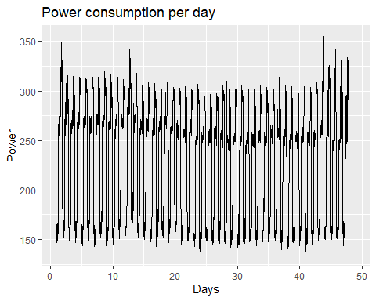

autoplot(temperature.ts)+  
 ggtitle('Temperature per day')+  
 xlab('Days')+  
 ylab('Temperature')

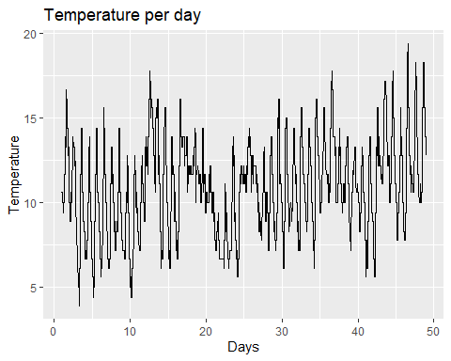

#2.Splitting data  
nvaldays <- 3  
  
test.power <- tail(data$Power, 96)  
full.train.power <- head(data$Power, -96)  
train.power <- head(full.train.power, -nvaldays*96)  
val.power <- tail(train.power,nvaldays*96)  
  
  
val.time <- tail(as.numeric(time(ts(full.train.power, frequency = 96))), nvaldays*96)  
  
plot(ts(train.power, frequency = 96),xlim=c(0,50))  
par(new=TRUE)  
lines(val.time, val.power, col="red", xlim=c(0,50))

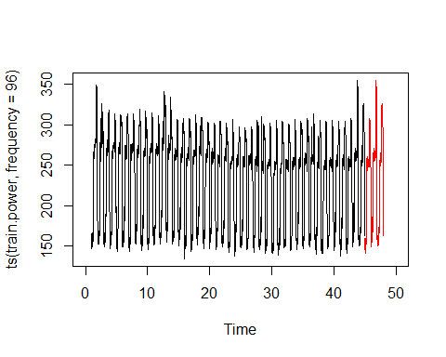

#3. Forecast  
  
# simple ES with only alpha  
Power<-ts(val.power, frequency = 96)  
plot(Power,col="red")  
SES=HoltWinters(Power,alpha=NULL,beta=FALSE,gamma=FALSE)  
p1<-predict(SES,n.ahead=nvaldays*96)  
par(new=TRUE)  
plot(ts(as.numeric(p1),frequency = 96),col=3,ann=FALSE,axes=FALSE)  
rmse(val.power, as.numeric(p1))

## [1] 88.22327

# full ES with alpha beta gamma  
#plot(ts(val.power, frequency = 96),col="red")  
SES=HoltWinters(Power,alpha=NULL,beta=NULL,gamma=NULL)

## Warning in HoltWinters(Power, alpha = NULL, beta = NULL, gamma = NULL):  
## optimization difficulties: ERROR: ABNORMAL_TERMINATION_IN_LNSRCH

p1<-predict(SES,n.ahead=nvaldays*96)  
par(new=TRUE)  
plot(ts(as.numeric(p1),frequency = 96),col=6,ann=FALSE,axes=FALSE)

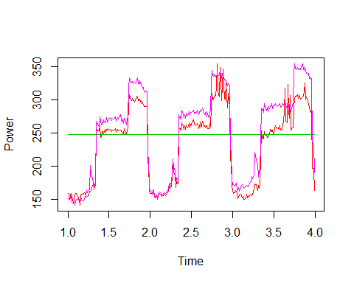

rmse(val.power, as.numeric(p1))

## [1] 14.03703