INTERFACE CONTROL DOCUMENT (ICD)

Table of Contents
Table of Contents 2
1. Document Metadata 4
2. Introduction 4
Architecture / Flow Diagrams 4
3. Purpose and Scope 5
4. System Identification 5
Architecture / Flow Diagrams 6
5. Assumptions, Constraints & Risks 7
6. Interface Overview 8
Functional Allocation (Summary) 8
Major Data Flows (Summary) 9
Security Requirements (Summary) 9
End-to-End Sequence Diagram (Mermaid) 9
Architecture / Flow Diagrams 10
7. Detailed Interface Requirements 11
NZ-REQ-1265 11
NZ-REQ-1267 15
NZ-REQ-1268 18
NZ-REQ-1269 21
NZ-REQ-1270 24
NZ-REQ-1271 27
NZ-REQ-1272 29
NZ-REQ-1274 32
NZ-REQ-1275 35
NZ-REQ-1276 38
NZ-REQ-1277 41
NZ-REQ-1278 44
Architecture / Flow Diagrams 47
8. Interface Verification 47
Verification Flow Mapping (Source/Target/Validation) 50
9. Interface Control / Change Management 55
10. Appendices 56
11. Appendix A: Change Record 56
12. Appendix B: Glossary 57
13. Appendix C: Referenced Documents 58
14. Appendix D: Approvals 60

1. Document Metadata
Field | Value
Document ID | TBD
Version | TBD
Date | 2026-03-02
Prepared By | TBD

2. Introduction
Section 1 - Introduction
This Interface Control Document (ICD) describes the Concession Instance Management APIs, which facilitate the lifecycle operations of concession instances between the Central Back Office (CBO), Concession API Consumers (such as TCA, Institutions, or Client Apps), and the CBO Internal Data Store (CBO-DB). The scope of this ICD is strictly limited to requirements NZ-REQ-1265 through NZ-REQ-1278, focusing on the creation, update, retrieval, and management of concession instances within the enterprise fare management ecosystem.
The primary business and operational driver for this interface is to enable secure, reliable, and auditable exchange of concession instance data, ensuring that eligible users can access and maintain their concession entitlements efficiently. The interface contract defines standardized API interactions, request-response flows, and data exchange protocols between the CBO and authorized API consumers, as mandated by NZ-REQ-1265, NZ-REQ-1267, NZ-REQ-1268, NZ-REQ-1269, NZ-REQ-1270, NZ-REQ-1271, NZ-REQ-1272, NZ-REQ-1274, NZ-REQ-1275, NZ-REQ-1276, NZ-REQ-1277, and NZ-REQ-1278.
At a high level, the interface operates by exposing a set of RESTful APIs from the CBO, which are consumed by external systems to perform concession instance lifecycle actions. All interactions are governed by the requirements listed above, ensuring data integrity, security, and compliance with enterprise standards. Where explicit RFP details are absent, operational behaviors are inferred from standard enterprise practices, strictly within the context of concession instance APIs.

Architecture / Flow Diagrams
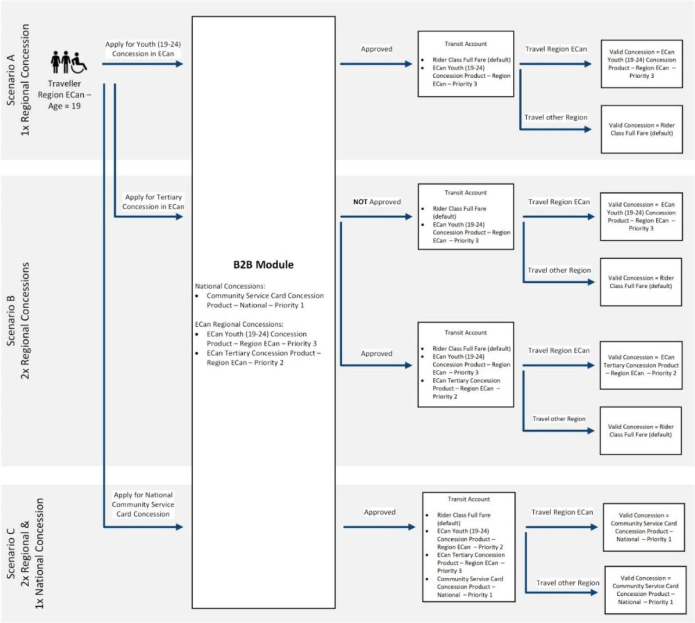
Architecture / Flow Diagram (sad_img_5)

3. Purpose and Scope
Field | Details
Purpose | This Interface Control Document (ICD) defines the contract for Central Back Office (CBO) Concession Instance APIs. It specifies purpose, scope, message structures, flows, and verification criteria for NZ‑REQ‑1265 to NZ‑REQ‑1278.
In Scope | All Concession Instance APIs from NZ‑REQ‑1265 to NZ‑REQ‑1278 including: retrieval, update, lifecycle operations, travel history, and fare media association.
Out of Scope | UI behaviour, frontend validation, non‑CBO back office processes, and any system not covered in NZ‑REQ‑1265..1278.
NZ‑REQ References | NZ‑REQ‑1265..1278

4. System Identification
System | Description | Role | Owner | Environment | Interfaces | REQ References
Customer Portal (CP) | Customer-facing channel retrieving concession details and initiating updates. | Consumer | Transport Agency | Web/Mobile | CBO Concession APIs | NZ‑REQ‑1265..1272
OMS (Order Management System) | Handles concession order creation and status management as part of back office workflow. | Internal Subsystem | Cubic | Cloud | CBO Internal Interfaces | NZ‑REQ‑1267..1274
ABP (Account-Based Processing) | Performs billing, account linking, and concession entitlements processing. | Internal Subsystem | Cubic | Cloud | Billing APIs | NZ‑REQ‑1265..1278
Fare Manager | Stores and defines fare‑media types and allows CBO to associate fare media with concessions. | Internal Subsystem | Cubic | Cloud | Fare Media APIs | NZ‑REQ‑1272, 1277, 1278
Central Back Office (CBO) | Owns all Concession Instance lifecycle APIs. | Provider | Cubic | Cloud | Concession APIs | NZ‑REQ‑1265..1278
Traveler / Customer | End‑user retrieving concession details via CP. | Actor | N/A | Web/Mobile | Customer Portal | NZ‑REQ‑1265

Architecture / Flow Diagrams
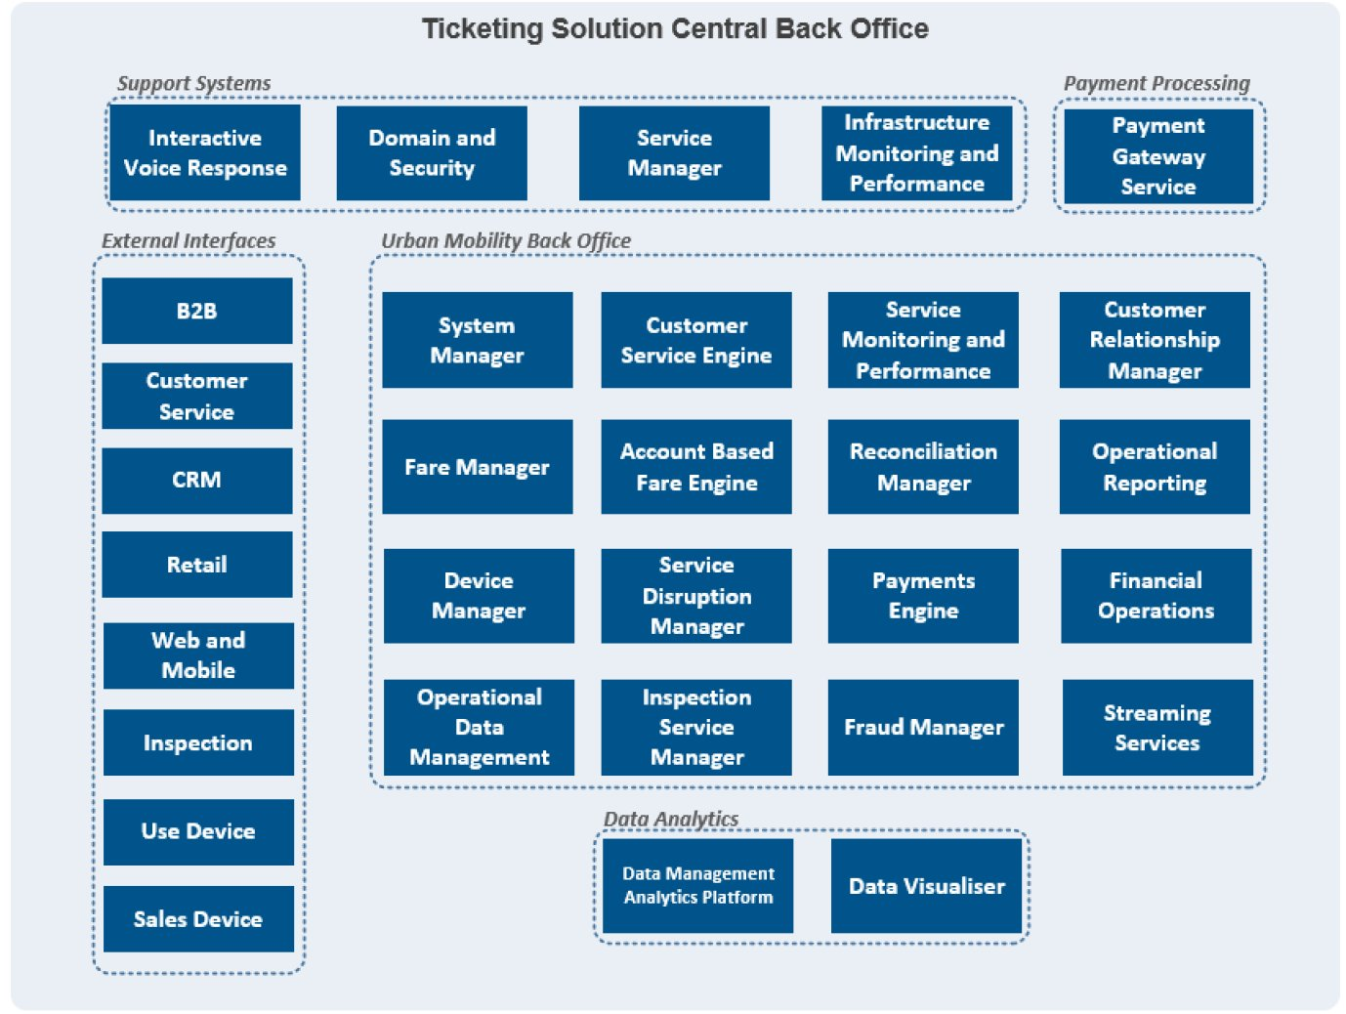
SAD Figure

5. Assumptions, Constraints & Risks
- Section 4.1 - Assumptions, Constraints & Risks
- Assumptions
- All assumptions are explicitly supported by the provided requirements (NZ-REQ-1265 to NZ-REQ-1278) or are annotated as 'Inferred from standard enterprise practices' where RFP data is missing.
- Constraints
- Technical Constraints:
- Only the Central Back Office (CBO) and directly referenced subsystems are in scope for Concession Instance lifecycle management (NZ-REQ-1265..1278).
- API endpoints, request/response formats, and data types must conform to specifications outlined in NZ-REQ-1265 to NZ-REQ-1278.
- Interface flows and architecture diagrams must reference only actors, systems, and flows explicitly mentioned in NZ-REQ-1265..1278.
- No external systems or workflows may be introduced beyond those referenced in the requirements.
- Versioning, roles, and workflows must be strictly limited to Concession APIs (NZ-REQ-1265..1278).
- Any missing technical detail is annotated as 'Inferred from standard enterprise practices' and is strictly relevant to Concession APIs.
- Security Constraints:
- Security boundaries, authentication, and authorization layers must be included in architecture diagrams as per NZ-REQ-1270 and NZ-REQ-1271.
- No additional security mechanisms may be assumed unless explicitly referenced in NZ-REQ-1265..1278.
- All API interactions must be traceable to the relevant NZ-REQ ID for audit and compliance purposes (NZ-REQ-1271).
- Regulatory Constraints:
- Regulatory requirements are limited to those referenced in NZ-REQ-1271 and NZ-REQ-1272.
- Any missing regulatory information is annotated as 'Inferred from standard enterprise practices' and is strictly relevant to Concession APIs.
- Operational Constraints:
- Only operational flows, roles, and contacts referenced in NZ-REQ-1265..1278 are permitted.
- No operational assumptions may be made beyond the provided requirements.
- Error handling and conditional branches must be explicitly referenced in NZ-REQ-1274, NZ-REQ-1275, and NZ-REQ-1276.
- Risks
- Missing Information Risks:
- Any gaps in RFP detail (e.g., specific API error codes, data validation rules, or workflow steps) are annotated as 'Inferred from standard enterprise practices', which may introduce ambiguity or require further clarification during implementation.
- Lack of explicit information on system boundaries or inter-system dependencies may lead to integration risks (NZ-REQ-1270, NZ-REQ-1271).
- Compliance Risks:
- If regulatory or security requirements are not fully specified in NZ-REQ-1271 or NZ-REQ-1272, there is a risk of non-compliance with enterprise or legal standards.
- Technical Risks:
- Strict adherence to NZ-REQ-1265..1278 may limit flexibility in API design or error handling, potentially impacting extensibility or maintainability.
- Any inferred practices may not fully align with future enterprise standards, leading to potential rework.
- Operational Risks:
- Limitation to only referenced roles and workflows may result in incomplete operational coverage, especially if future requirements expand beyond NZ-REQ-1265..1278.
- Limitations
- All assumptions, constraints, and risks are strictly limited to the Concession Instance lifecycle and related APIs as defined in NZ-REQ-1265 to NZ-REQ-1278.
- No assumptions, constraints, or risks are introduced beyond the provided requirements or 'Inferred from standard enterprise practices' strictly relevant to Concession APIs.
- Any missing information is explicitly stated as a limitation and annotated accordingly.

6. Interface Overview
NZ-REQ ID | Functionality/Flow Step
NZ-REQ-1265 | Concession instance creation initiation
NZ-REQ-1267 | Concession instance creation completion
NZ-REQ-1268 | Update concession instance
NZ-REQ-1269 | Modify concession instance status
NZ-REQ-1270 | Retrieve concession instance details
NZ-REQ-1271 | Retrieve concession instance status
NZ-REQ-1272 | Delete/deactivate concession instance
NZ-REQ-1274 | Bulk concession instance operations
NZ-REQ-1275 | Bulk status management
NZ-REQ-1276 | Error handling
NZ-REQ-1277 | Conditional processing
NZ-REQ-1278 | Security enforcement

Functional Allocation (Summary)
System/Component | Responsibilities | NZ-REQ Reference
Client / Concession API Consumer | Invokes CBO APIs for issue/revoke/suspend/resume; retrieves attributes, travel history, fare media | NZ-REQ-1265, 1267–1272, 1274–1278
Central Back Office (CBO) | Validates requests, enforces rules, executes lifecycle operations, returns responses | NZ-REQ-1265..1278
CBO Internal Data Store (CBO-DB) | Persists concession instances and related data (attributes, associations, travel history) | NZ-REQ-1267–1272
Audit Logging (Inferred) | Records API calls and lifecycle state changes for traceability | Inferred (relevant to NZ-REQ-1265..1278)

Major Data Flows (Summary)
Flow | Description | NZ-REQ Reference
Retrieve / Update Instance | Client retrieves/updates concession instance via CBO | NZ-REQ-1265
Attributes / Type / Dates | Client manages attributes/type/issue-expiry date-times | NZ-REQ-1267–1270
Travel History | Client retrieves travel history for an instance | NZ-REQ-1271
Fare Media Association | Associate/disassociate fare media with instance | NZ-REQ-1272, 1277, 1278
Lifecycle Operations | Issue / revoke / suspend / resume concession instances | NZ-REQ-1274–1276

Security Requirements (Summary)
Area | Requirement
Authentication | OAuth2/token-based auth (Inferred from standard enterprise practices)
Authorization | Role/scope-based access controls (Inferred)
Transport | TLS 1.2+ for API calls (Inferred)
Audit | Log API calls and lifecycle changes (Inferred)

End-to-End Sequence Diagram (Mermaid)
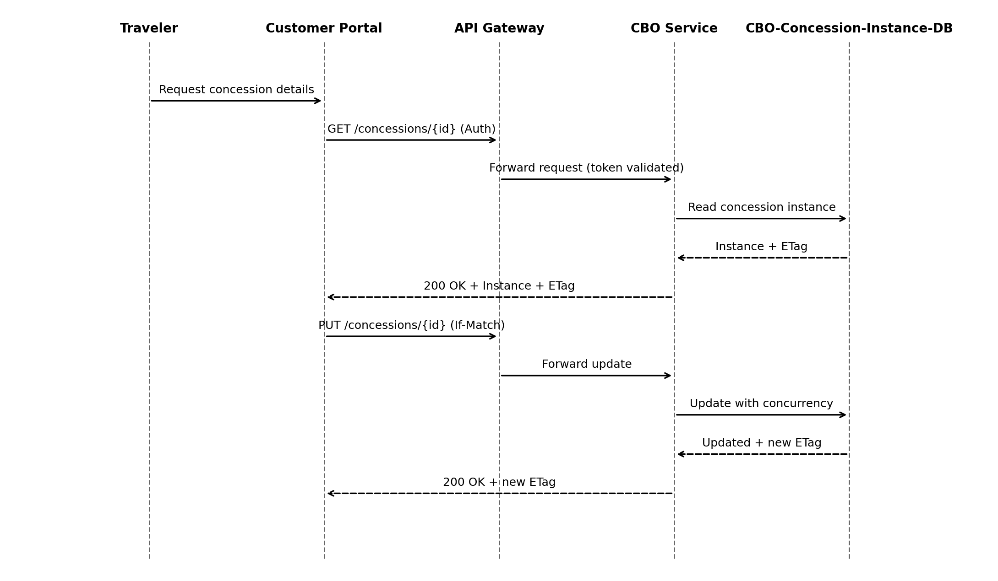

Architecture / Flow Diagrams
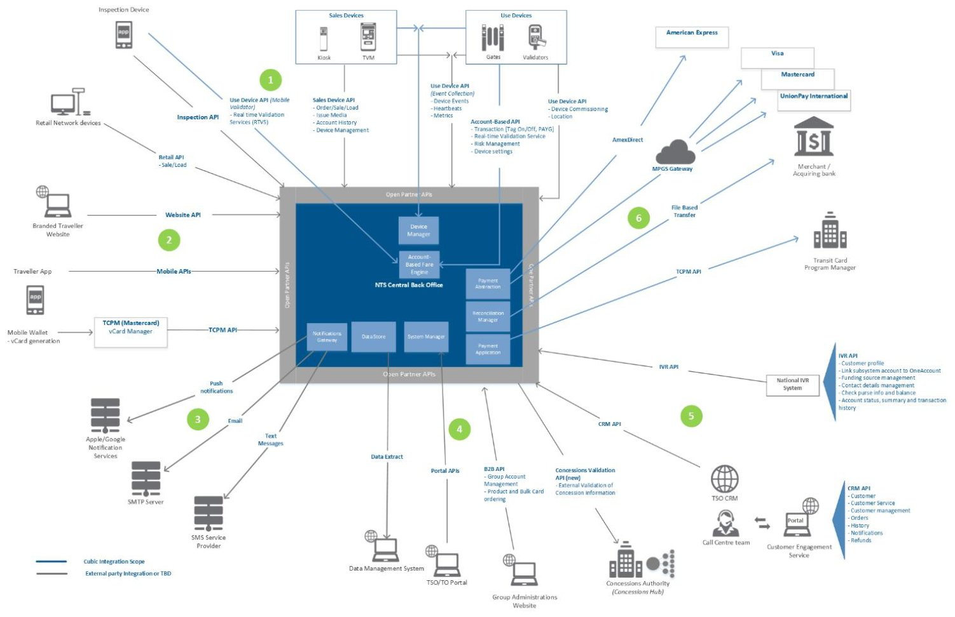
SAD Figure
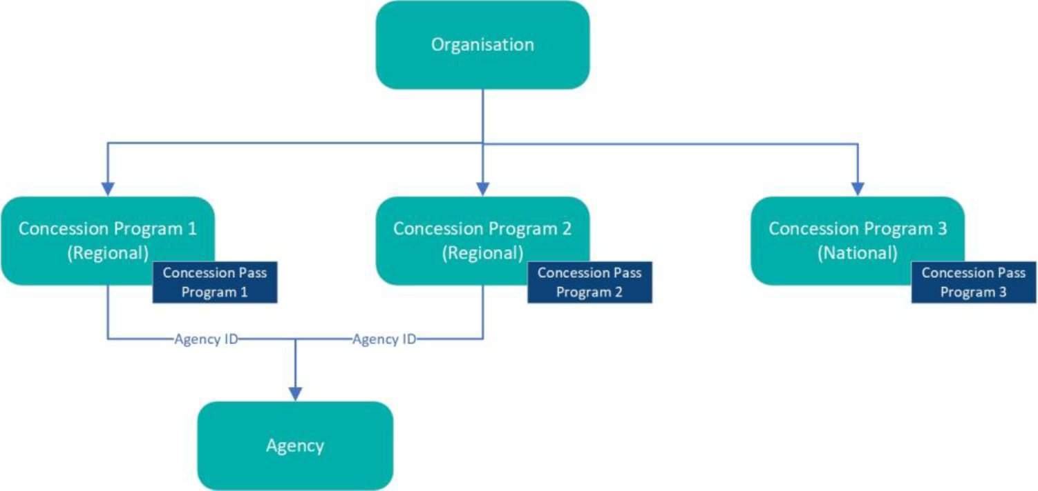
SAD Figure

7. Detailed Interface Requirements

NZ-REQ-1265
Interface providing issuance, suspension/resumption, revocation, and association of concessions to fare media.

API Endpoints
Method | Path | Summary | Scopes | Roles
GET | /concessions/{id} | Retrieve concession instance. | concession.read | ClientApp, CBO Operator, Customer Portal, Traveler/Customer
PUT | /concessions/{id} | Update concession instance (ETag/If-Match). | concession.write | ClientApp, CBO Operator
POST | /v1/concessions/issue | Issue a new concession instance (inferred). | concession.write | ClientApp
POST | /v1/concessions/{id}/associate-fare-media/{fareMediaId} | Associate fare media to concession instance (inferred). | concession.write | ClientApp
PATCH | /v1/concessions/{id}/suspend | Suspend concession instance (inferred). | concession.write | ClientApp
DELETE | /v1/concessions/{id} | Revoke / delete concession instance (inferred). | concession.write | ClientApp

HTTP Headers
Header | Required | Applies To | Description
Authorization | Yes | All endpoints | Bearer token (OAuth2).
Content-Type | Conditional | POST/PUT | application/json when body is present.
Accept | Recommended | All endpoints | Expected response type (application/json).
If-Match | Conditional | PUT updates | ETag concurrency control (optimistic locking).
ETag | Returned | GET/PUT responses | Returned for concurrency control.

Request Body Schema
Field | Type | Required | Validation
concessionType | string | Optional | Must be one of the allowed concession types defined in system design.
issueDateTime | datetime | Optional | ISO‑8601 format; cannot be greater than expiryDateTime if both exist.
expiryDateTime | datetime | Optional | ISO‑8601 format; must be equal or greater than issueDateTime.
instanceAttributes | object | Optional | Dictionary of attributeName: value. Keys must match approved attribute definitions.
fareMediaId | string | Optional | Required for associate/disassociate APIs (NZ‑REQ‑1277, 1278).
lifecycleStatus | string | Optional | Used for lifecycle APIs (NZ‑REQ‑1267, 1274–1276). Must be a valid enum value.

Response Body Schema
Field | Type | Description
concessionId | string | Returned ID
status | string | active | suspended | revoked
ETag | string | Concurrency token for If‑Match

Data Attributes
Name | Type | Source | Target | Persisted In
concessionId | string | ClientApp | CBO | CBO-Concession-Instance-DB
fareMediaId | string | ClientApp | CBO | CBO-Concession-Instance-DB
status | string | CBO | ClientApp | CBO-Concession-Instance-DB
issueDate | string | ClientApp | CBO | CBO-Concession-Instance-DB
expiryDate | string | ClientApp | CBO | CBO-Concession-Instance-DB

Sequence Diagram
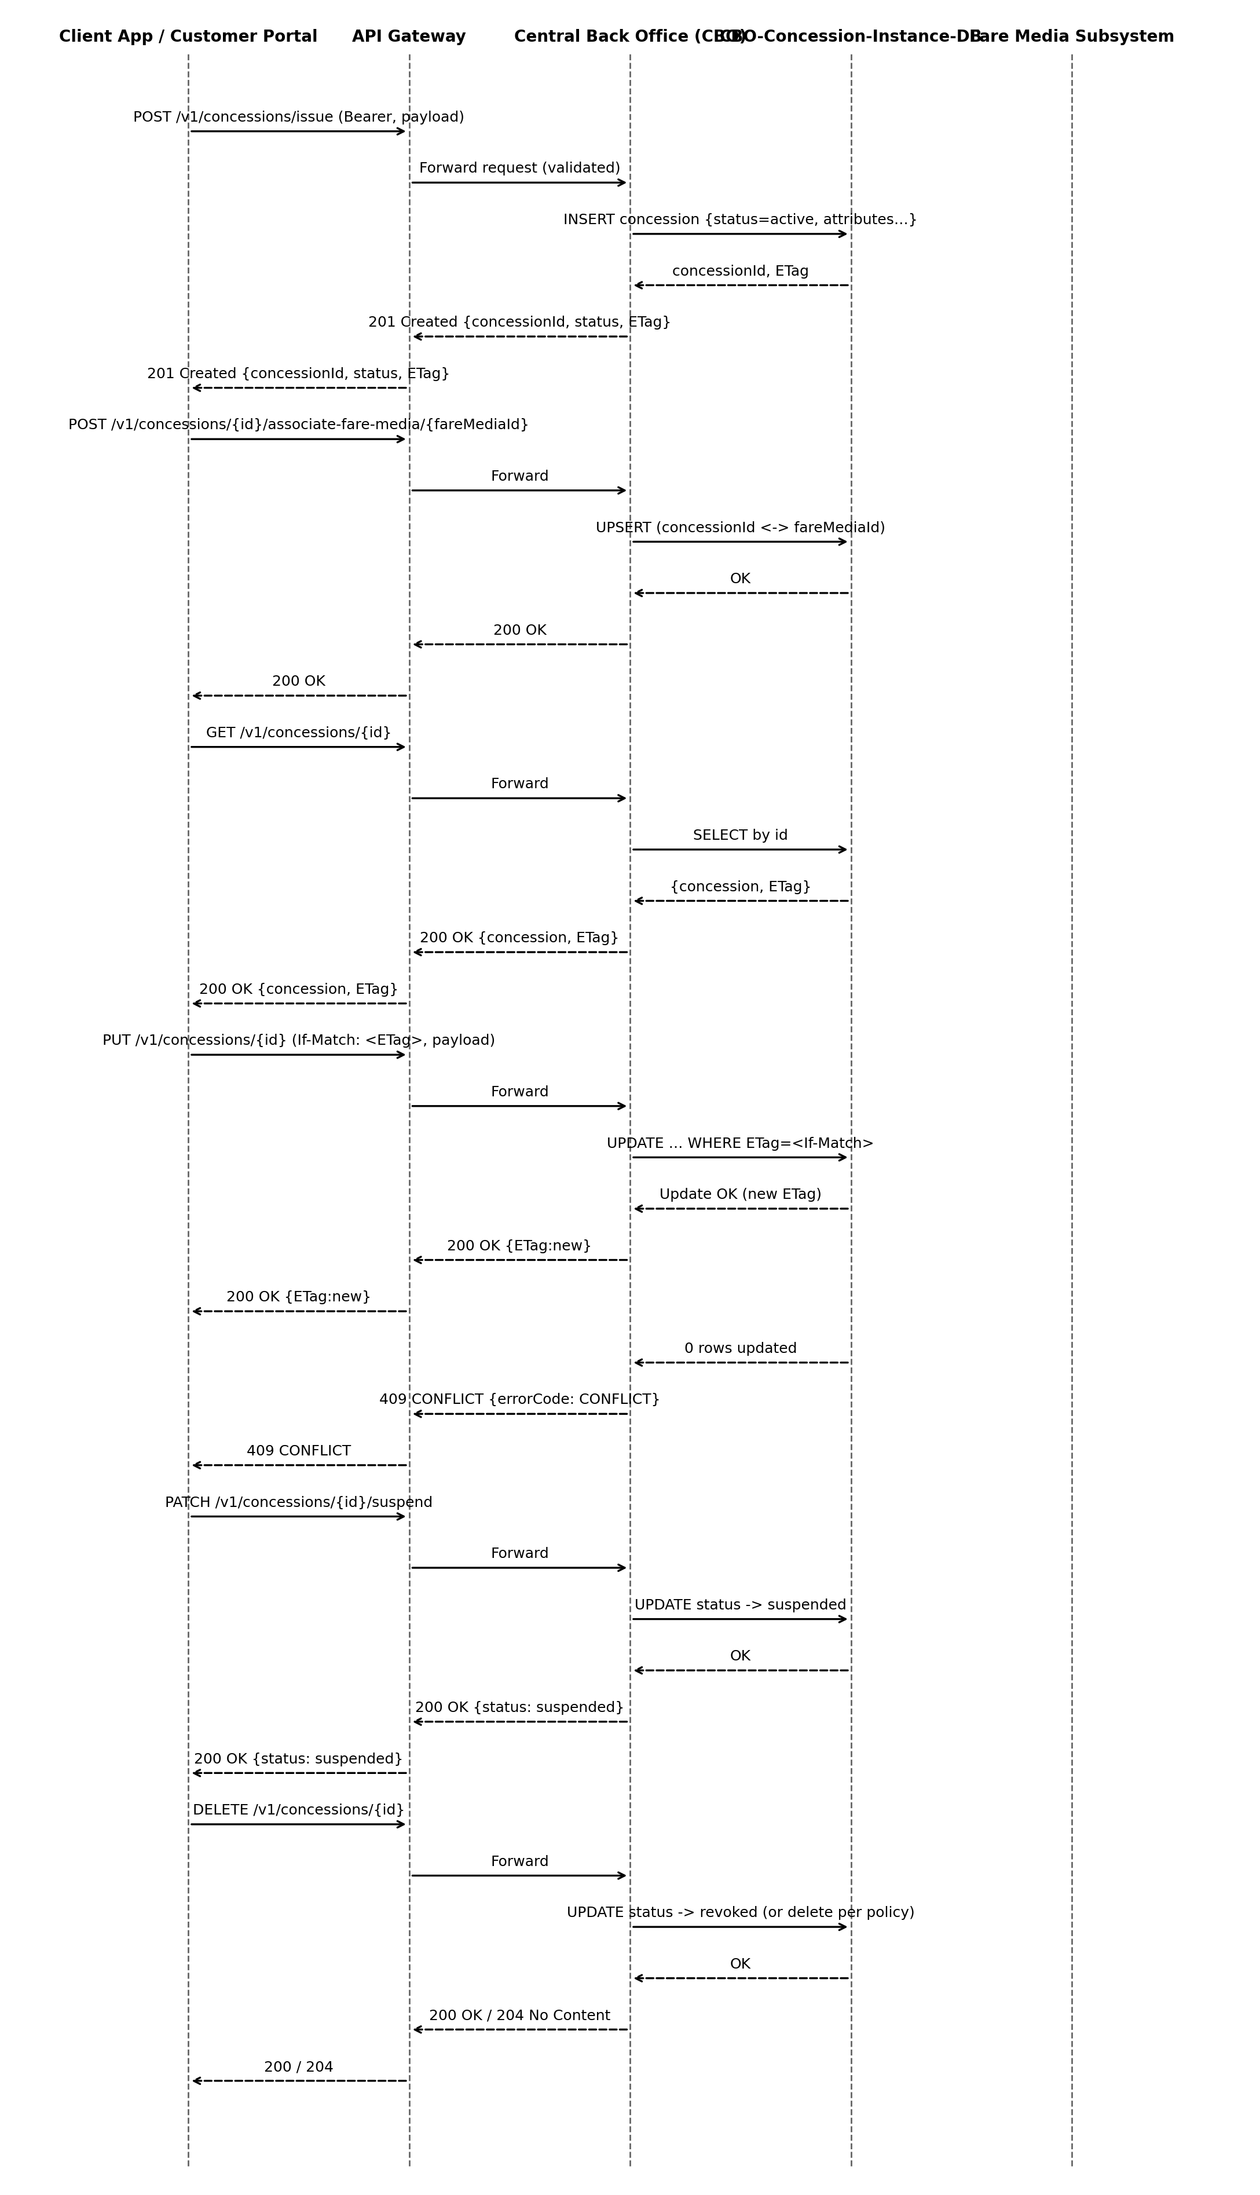

Cross-System Flow (NZ)
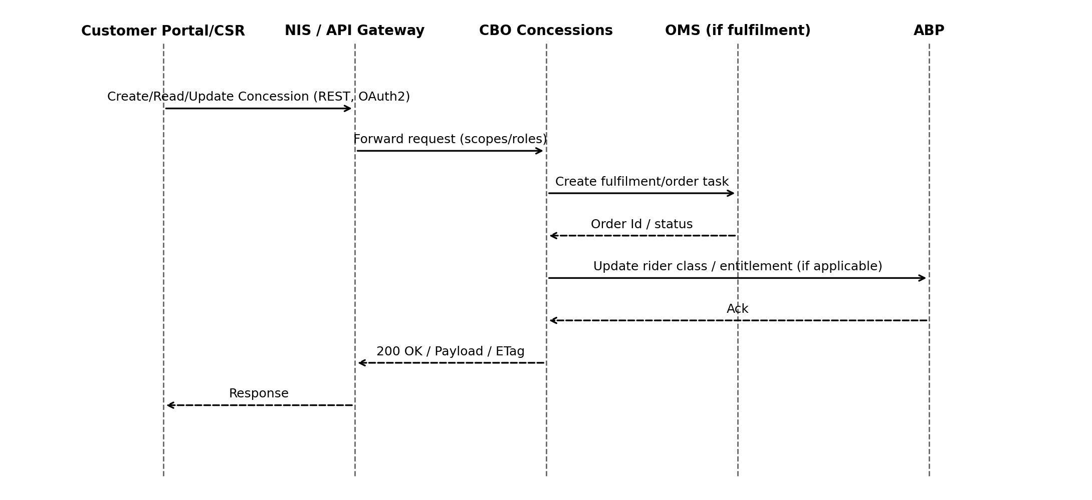
Source: UMB‑HLD pp. 68–71 (Interfaces), 44–46 (ABP components), 9–12 (3A overview); UMB‑FDS pp. 498–504 (Retail Concession Apply), 1295–1307 (Order orchestration)
- Flow derived from NZ HLD and UMB FDS.

Error Handling
HTTP | Code | Title | Retryable
400 | INVALID_INPUT | Invalid request payload or parameters. | False
401 | UNAUTHORIZED | Authentication required or invalid token. | False
403 | FORBIDDEN | Insufficient permissions for operation. | False
404 | NOT_FOUND | Concession instance not found. | False
409 | CONFLICT | Concurrency/state conflict. | True
500 | INTERNAL_ERROR | Unexpected server error. | True

Error Response Schema
Field | Type | Required | Description
timestamp | datetime | Recommended | ISO-8601 time of error.
status | integer | Yes | HTTP status code.
errorCode | string | Yes | Application-specific error code.
message | string | Yes | Human-readable message.
correlationId | string | Recommended | Trace ID for debugging.
details | object | Optional | Field-level validation details.

NZ-REQ-1267
Interface providing issuance, suspension/resumption, revocation, and association of concessions to fare media.

API Endpoints
Method | Path | Summary | Scopes | Roles
GET | /concessions/{id} | Retrieve concession instance. | concession.read | ClientApp, CBO Operator, Customer Portal, Traveler/Customer
PUT | /concessions/{id} | Update concession instance (ETag/If-Match). | concession.write | ClientApp, CBO Operator
POST | /v1/concessions/issue | Issue a new concession instance (inferred). | concession.write | ClientApp
POST | /v1/concessions/{id}/associate-fare-media/{fareMediaId} | Associate fare media to concession instance (inferred). | concession.write | ClientApp
PATCH | /v1/concessions/{id}/suspend | Suspend concession instance (inferred). | concession.write | ClientApp
DELETE | /v1/concessions/{id} | Revoke / delete concession instance (inferred). | concession.write | ClientApp

HTTP Headers
Header | Required | Applies To | Description
Authorization | Yes | All endpoints | Bearer token (OAuth2).
Content-Type | Conditional | POST/PUT | application/json when body is present.
Accept | Recommended | All endpoints | Expected response type (application/json).
If-Match | Conditional | PUT updates | ETag concurrency control (optimistic locking).
ETag | Returned | GET/PUT responses | Returned for concurrency control.

Request Body Schema
Field | Type | Required | Validation
concessionType | string | Optional | Must be one of the allowed concession types defined in system design.
issueDateTime | datetime | Optional | ISO‑8601 format; cannot be greater than expiryDateTime if both exist.
expiryDateTime | datetime | Optional | ISO‑8601 format; must be equal or greater than issueDateTime.
instanceAttributes | object | Optional | Dictionary of attributeName: value. Keys must match approved attribute definitions.
fareMediaId | string | Optional | Required for associate/disassociate APIs (NZ‑REQ‑1277, 1278).
lifecycleStatus | string | Optional | Used for lifecycle APIs (NZ‑REQ‑1267, 1274–1276). Must be a valid enum value.

Response Body Schema
Field | Type | Description
concessionId | string | Returned ID
status | string | active | suspended | revoked
ETag | string | Concurrency token for If‑Match

Data Attributes
Name | Type | Source | Target | Persisted In
concessionId | string | ClientApp | CBO | CBO-Concession-Instance-DB
fareMediaId | string | ClientApp | CBO | CBO-Concession-Instance-DB
status | string | CBO | ClientApp | CBO-Concession-Instance-DB
issueDate | string | ClientApp | CBO | CBO-Concession-Instance-DB
expiryDate | string | ClientApp | CBO | CBO-Concession-Instance-DB

Sequence Diagram
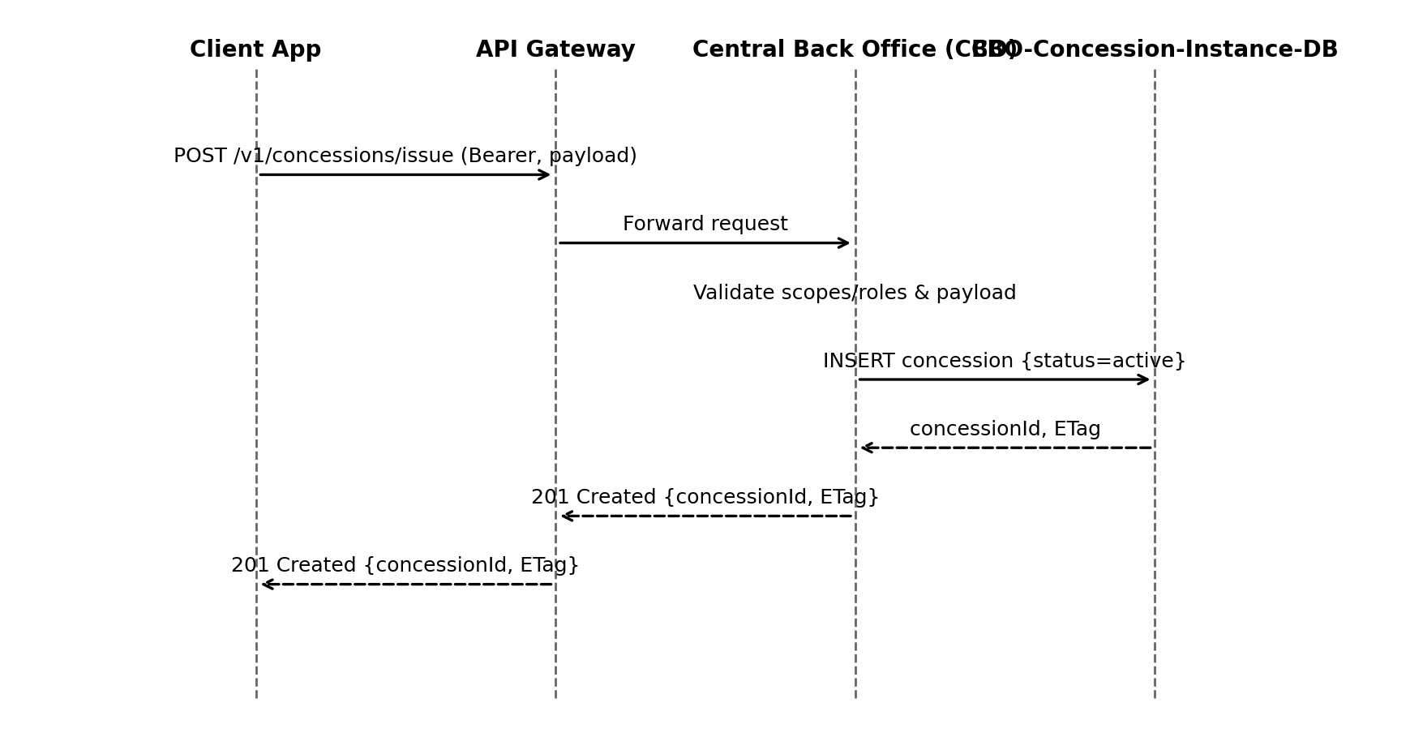

Cross-System Flow (NZ)
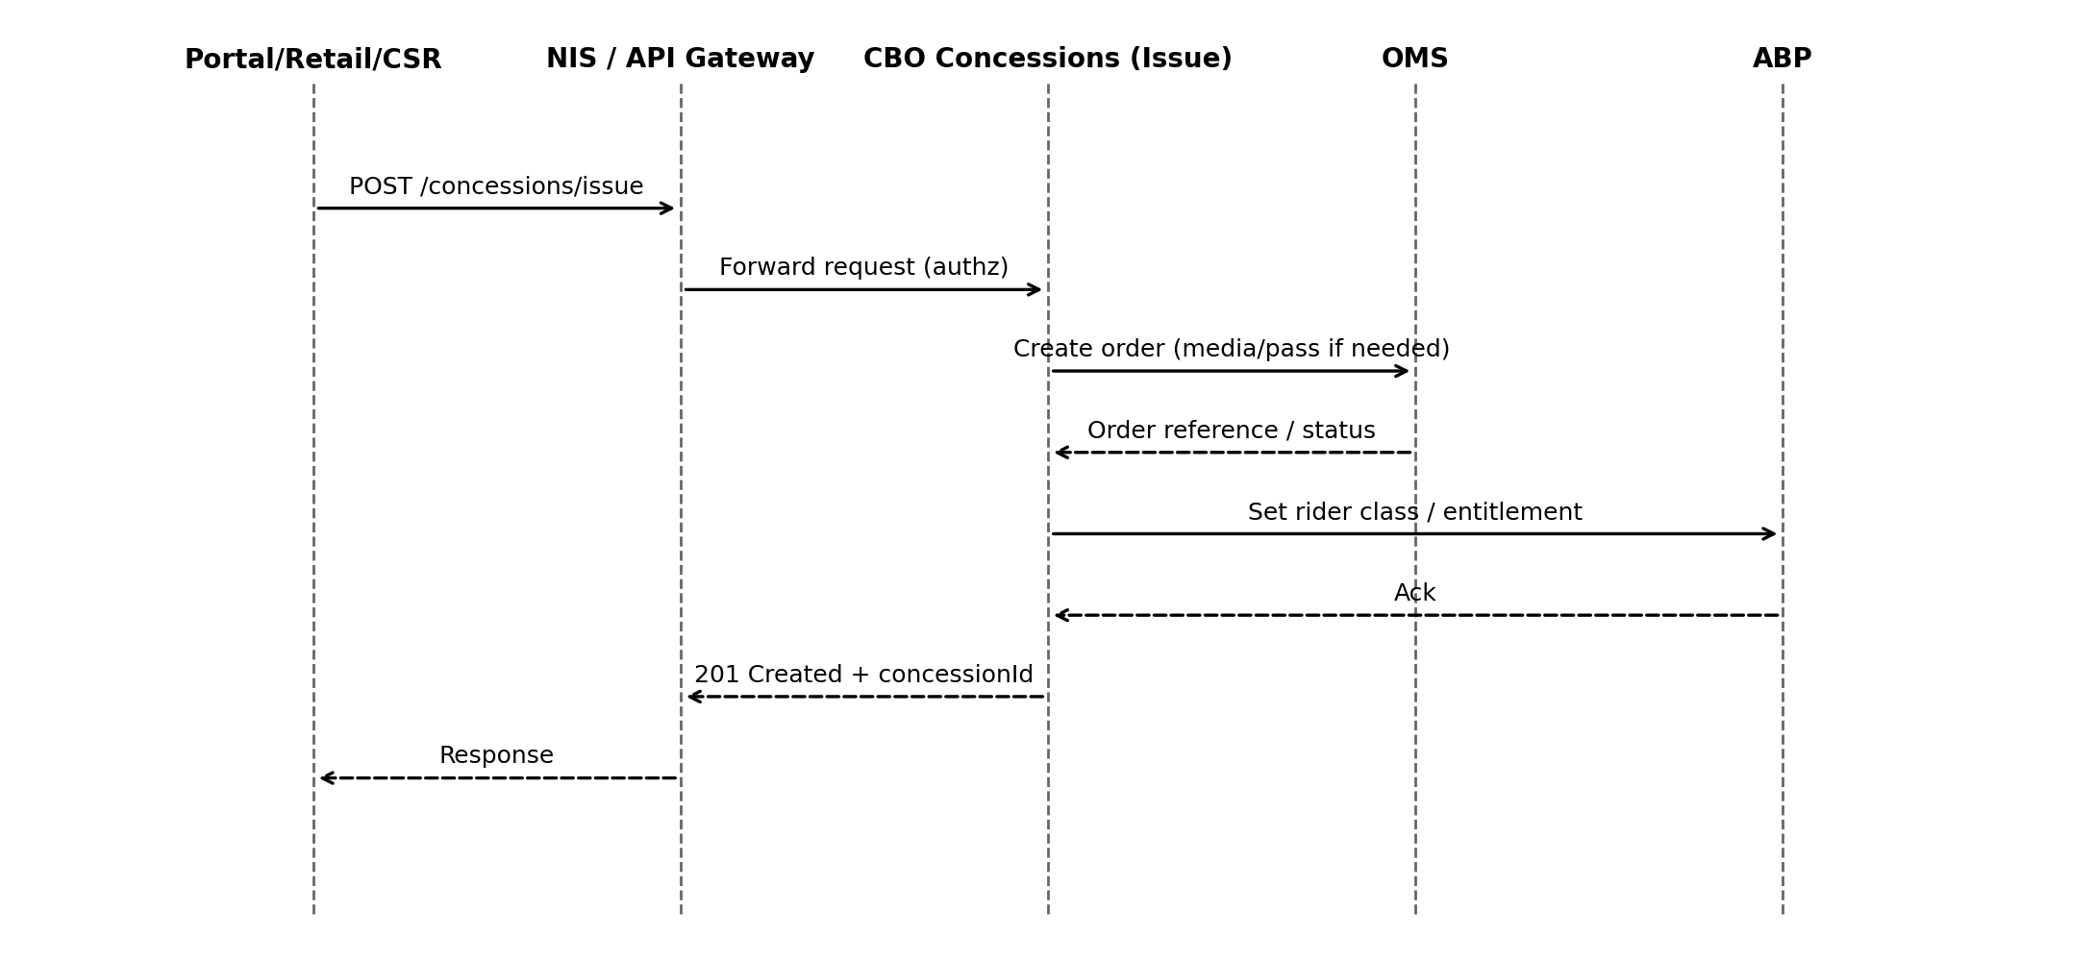
Source: UMB‑HLD pp. 68–71 (Interfaces), 44–46 (ABP components); UMB‑FDS pp. 1295–1307 (Fulfilment/order flows)
- Flow derived from NZ HLD and UMB FDS.

Error Handling
HTTP | Code | Title | Retryable
400 | INVALID_INPUT | Invalid request payload or parameters. | False
401 | UNAUTHORIZED | Authentication required or invalid token. | False
403 | FORBIDDEN | Insufficient permissions for operation. | False
404 | NOT_FOUND | Concession instance not found. | False
409 | CONFLICT | Concurrency/state conflict. | True
500 | INTERNAL_ERROR | Unexpected server error. | True

Error Response Schema
Field | Type | Required | Description
timestamp | datetime | Recommended | ISO-8601 time of error.
status | integer | Yes | HTTP status code.
errorCode | string | Yes | Application-specific error code.
message | string | Yes | Human-readable message.
correlationId | string | Recommended | Trace ID for debugging.
details | object | Optional | Field-level validation details.

NZ-REQ-1268
Interface providing issuance, suspension/resumption, revocation, and association of concessions to fare media.

API Endpoints
Method | Path | Summary | Scopes | Roles
GET | /concessions/{id} | Retrieve concession instance. | concession.read | ClientApp, CBO Operator, Customer Portal, Traveler/Customer
PUT | /concessions/{id} | Update concession instance (ETag/If-Match). | concession.write | ClientApp, CBO Operator
POST | /v1/concessions/issue | Issue a new concession instance (inferred). | concession.write | ClientApp
POST | /v1/concessions/{id}/associate-fare-media/{fareMediaId} | Associate fare media to concession instance (inferred). | concession.write | ClientApp
PATCH | /v1/concessions/{id}/suspend | Suspend concession instance (inferred). | concession.write | ClientApp
DELETE | /v1/concessions/{id} | Revoke / delete concession instance (inferred). | concession.write | ClientApp

HTTP Headers
Header | Required | Applies To | Description
Authorization | Yes | All endpoints | Bearer token (OAuth2).
Content-Type | Conditional | POST/PUT | application/json when body is present.
Accept | Recommended | All endpoints | Expected response type (application/json).
If-Match | Conditional | PUT updates | ETag concurrency control (optimistic locking).
ETag | Returned | GET/PUT responses | Returned for concurrency control.

Request Body Schema
Field | Type | Required | Validation
concessionType | string | Optional | Must be one of the allowed concession types defined in system design.
issueDateTime | datetime | Optional | ISO‑8601 format; cannot be greater than expiryDateTime if both exist.
expiryDateTime | datetime | Optional | ISO‑8601 format; must be equal or greater than issueDateTime.
instanceAttributes | object | Optional | Dictionary of attributeName: value. Keys must match approved attribute definitions.
fareMediaId | string | Optional | Required for associate/disassociate APIs (NZ‑REQ‑1277, 1278).
lifecycleStatus | string | Optional | Used for lifecycle APIs (NZ‑REQ‑1267, 1274–1276). Must be a valid enum value.

Response Body Schema
Field | Type | Description
concessionId | string | Returned ID
status | string | active | suspended | revoked
ETag | string | Concurrency token for If‑Match

Data Attributes
Name | Type | Source | Target | Persisted In
concessionId | string | ClientApp | CBO | CBO-Concession-Instance-DB
fareMediaId | string | ClientApp | CBO | CBO-Concession-Instance-DB
status | string | CBO | ClientApp | CBO-Concession-Instance-DB
issueDate | string | ClientApp | CBO | CBO-Concession-Instance-DB
expiryDate | string | ClientApp | CBO | CBO-Concession-Instance-DB

Sequence Diagram
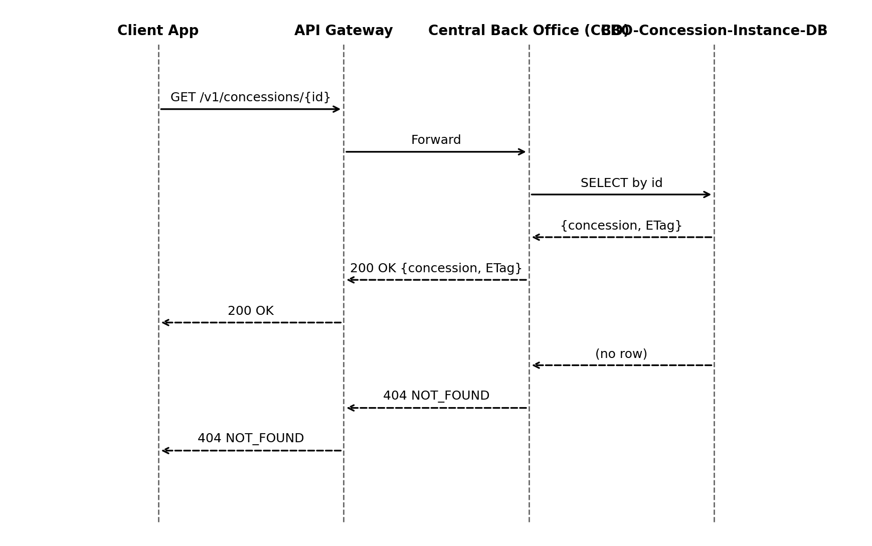

Cross-System Flow (NZ)
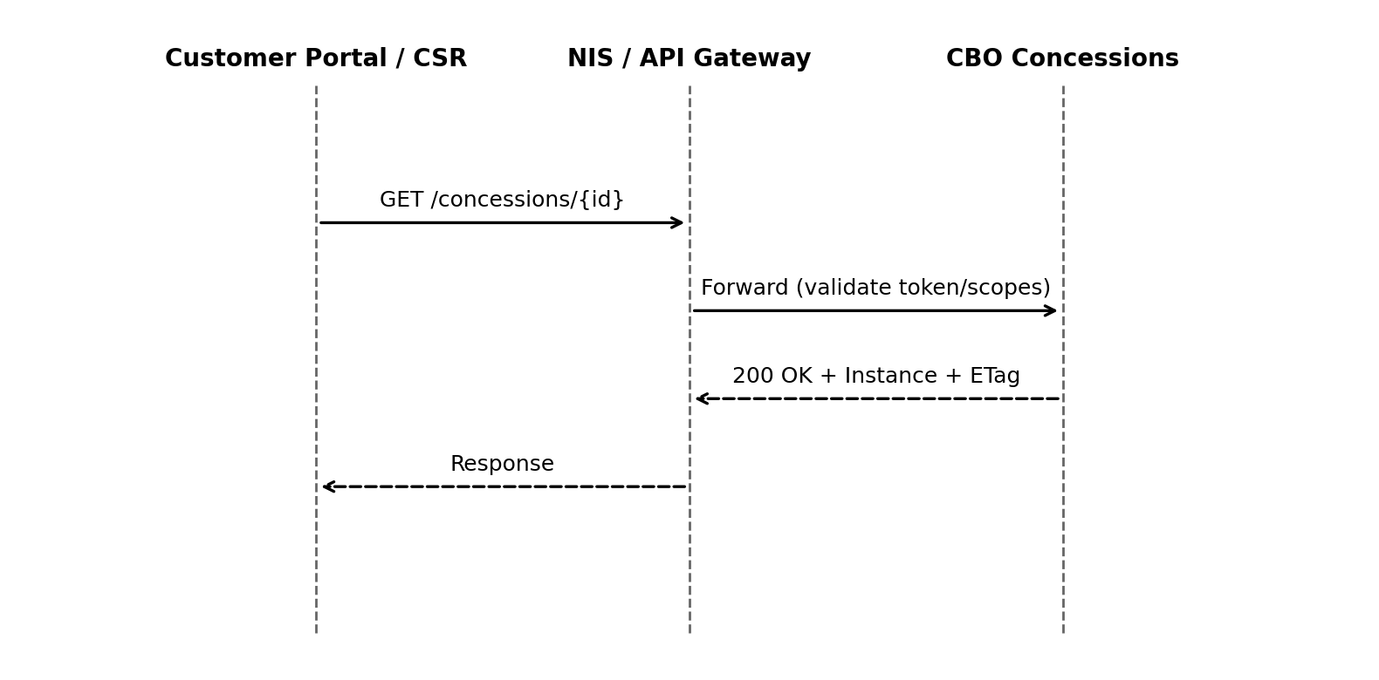
Source: UMB‑HLD pp. 68–71 (Interfaces via NIS); UMB‑FDS pp. 236–245 (Self-service views), 864–866 (Portal/Account)
- Flow derived from NZ HLD and UMB FDS.

Error Handling
HTTP | Code | Title | Retryable
400 | INVALID_INPUT | Invalid request payload or parameters. | False
401 | UNAUTHORIZED | Authentication required or invalid token. | False
403 | FORBIDDEN | Insufficient permissions for operation. | False
404 | NOT_FOUND | Concession instance not found. | False
409 | CONFLICT | Concurrency/state conflict. | True
500 | INTERNAL_ERROR | Unexpected server error. | True

Error Response Schema
Field | Type | Required | Description
timestamp | datetime | Recommended | ISO-8601 time of error.
status | integer | Yes | HTTP status code.
errorCode | string | Yes | Application-specific error code.
message | string | Yes | Human-readable message.
correlationId | string | Recommended | Trace ID for debugging.
details | object | Optional | Field-level validation details.

NZ-REQ-1269
Interface providing issuance, suspension/resumption, revocation, and association of concessions to fare media.

API Endpoints
Method | Path | Summary | Scopes | Roles
GET | /concessions/{id} | Retrieve concession instance. | concession.read | ClientApp, CBO Operator, Customer Portal, Traveler/Customer
PUT | /concessions/{id} | Update concession instance (ETag/If-Match). | concession.write | ClientApp, CBO Operator
POST | /v1/concessions/issue | Issue a new concession instance (inferred). | concession.write | ClientApp
POST | /v1/concessions/{id}/associate-fare-media/{fareMediaId} | Associate fare media to concession instance (inferred). | concession.write | ClientApp
PATCH | /v1/concessions/{id}/suspend | Suspend concession instance (inferred). | concession.write | ClientApp
DELETE | /v1/concessions/{id} | Revoke / delete concession instance (inferred). | concession.write | ClientApp

HTTP Headers
Header | Required | Applies To | Description
Authorization | Yes | All endpoints | Bearer token (OAuth2).
Content-Type | Conditional | POST/PUT | application/json when body is present.
Accept | Recommended | All endpoints | Expected response type (application/json).
If-Match | Conditional | PUT updates | ETag concurrency control (optimistic locking).
ETag | Returned | GET/PUT responses | Returned for concurrency control.

Request Body Schema
Field | Type | Required | Validation
concessionType | string | Optional | Must be one of the allowed concession types defined in system design.
issueDateTime | datetime | Optional | ISO‑8601 format; cannot be greater than expiryDateTime if both exist.
expiryDateTime | datetime | Optional | ISO‑8601 format; must be equal or greater than issueDateTime.
instanceAttributes | object | Optional | Dictionary of attributeName: value. Keys must match approved attribute definitions.
fareMediaId | string | Optional | Required for associate/disassociate APIs (NZ‑REQ‑1277, 1278).
lifecycleStatus | string | Optional | Used for lifecycle APIs (NZ‑REQ‑1267, 1274–1276). Must be a valid enum value.

Response Body Schema
Field | Type | Description
concessionId | string | Returned ID
status | string | active | suspended | revoked
ETag | string | Concurrency token for If‑Match

Data Attributes
Name | Type | Source | Target | Persisted In
concessionId | string | ClientApp | CBO | CBO-Concession-Instance-DB
fareMediaId | string | ClientApp | CBO | CBO-Concession-Instance-DB
status | string | CBO | ClientApp | CBO-Concession-Instance-DB
issueDate | string | ClientApp | CBO | CBO-Concession-Instance-DB
expiryDate | string | ClientApp | CBO | CBO-Concession-Instance-DB

Sequence Diagram
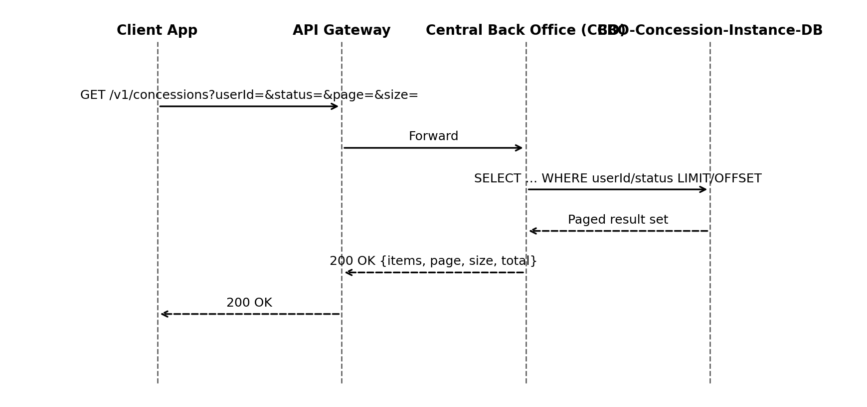

Cross-System Flow (NZ)
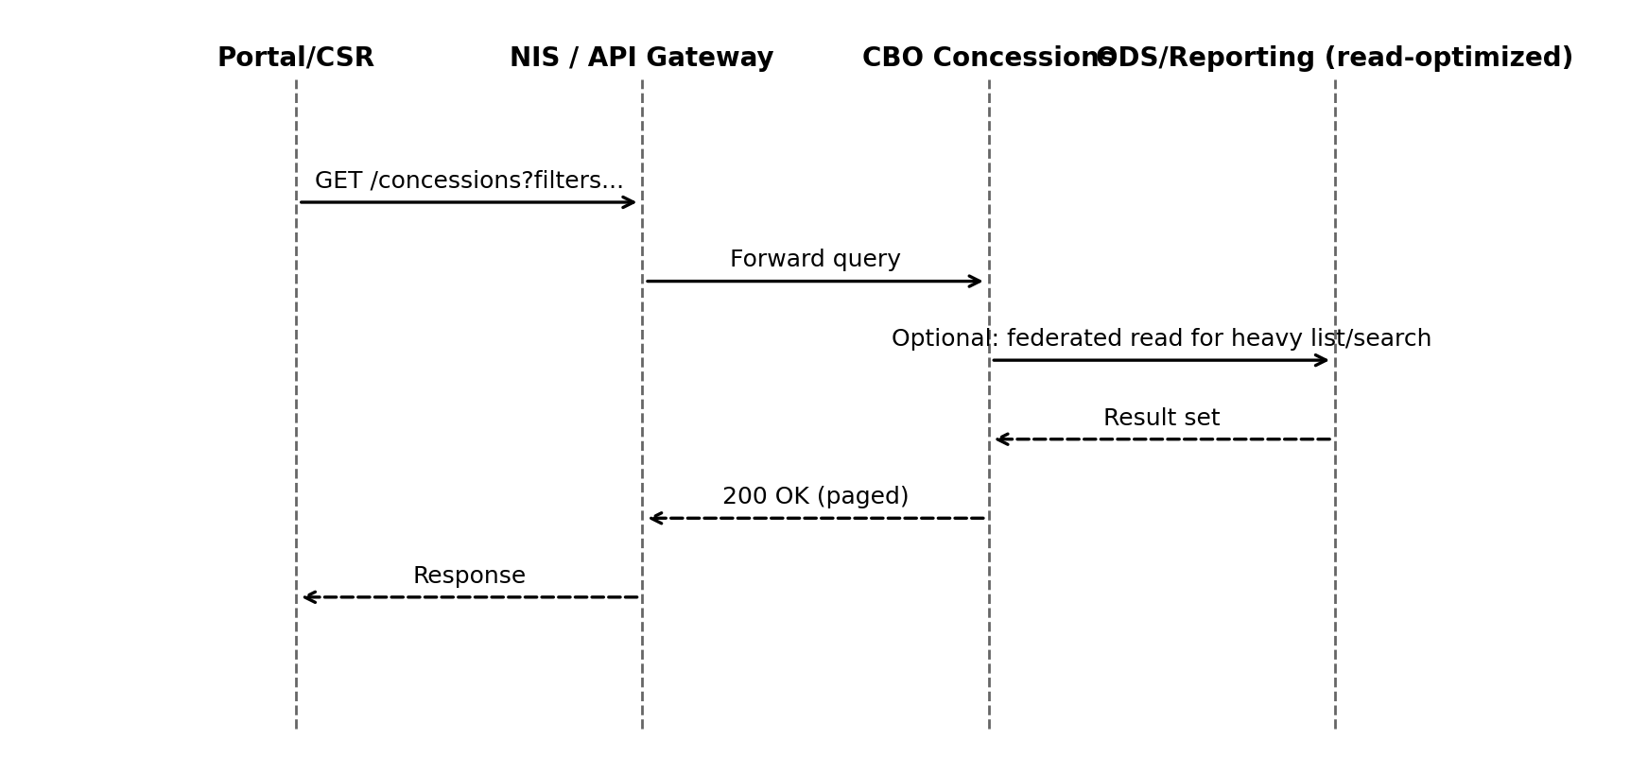
Source: UMB‑HLD p. 70 (ODS Travel History/API), p. 46 (Perf & ODS latency); UMB‑FDS pp. 707–729, 748–749 (Advanced/Bulk search), 190–205 (ODS views)
- Flow derived from NZ HLD and UMB FDS.

Error Handling
HTTP | Code | Title | Retryable
400 | INVALID_INPUT | Invalid request payload or parameters. | False
401 | UNAUTHORIZED | Authentication required or invalid token. | False
403 | FORBIDDEN | Insufficient permissions for operation. | False
404 | NOT_FOUND | Concession instance not found. | False
409 | CONFLICT | Concurrency/state conflict. | True
500 | INTERNAL_ERROR | Unexpected server error. | True

Error Response Schema
Field | Type | Required | Description
timestamp | datetime | Recommended | ISO-8601 time of error.
status | integer | Yes | HTTP status code.
errorCode | string | Yes | Application-specific error code.
message | string | Yes | Human-readable message.
correlationId | string | Recommended | Trace ID for debugging.
details | object | Optional | Field-level validation details.

NZ-REQ-1270
Interface providing issuance, suspension/resumption, revocation, and association of concessions to fare media.

API Endpoints
Method | Path | Summary | Scopes | Roles
GET | /concessions/{id} | Retrieve concession instance. | concession.read | ClientApp, CBO Operator, Customer Portal, Traveler/Customer
PUT | /concessions/{id} | Update concession instance (ETag/If-Match). | concession.write | ClientApp, CBO Operator
POST | /v1/concessions/issue | Issue a new concession instance (inferred). | concession.write | ClientApp
POST | /v1/concessions/{id}/associate-fare-media/{fareMediaId} | Associate fare media to concession instance (inferred). | concession.write | ClientApp
PATCH | /v1/concessions/{id}/suspend | Suspend concession instance (inferred). | concession.write | ClientApp
DELETE | /v1/concessions/{id} | Revoke / delete concession instance (inferred). | concession.write | ClientApp

HTTP Headers
Header | Required | Applies To | Description
Authorization | Yes | All endpoints | Bearer token (OAuth2).
Content-Type | Conditional | POST/PUT | application/json when body is present.
Accept | Recommended | All endpoints | Expected response type (application/json).
If-Match | Conditional | PUT updates | ETag concurrency control (optimistic locking).
ETag | Returned | GET/PUT responses | Returned for concurrency control.

Request Body Schema
Field | Type | Required | Validation
concessionType | string | Optional | Must be one of the allowed concession types defined in system design.
issueDateTime | datetime | Optional | ISO‑8601 format; cannot be greater than expiryDateTime if both exist.
expiryDateTime | datetime | Optional | ISO‑8601 format; must be equal or greater than issueDateTime.
instanceAttributes | object | Optional | Dictionary of attributeName: value. Keys must match approved attribute definitions.
fareMediaId | string | Optional | Required for associate/disassociate APIs (NZ‑REQ‑1277, 1278).
lifecycleStatus | string | Optional | Used for lifecycle APIs (NZ‑REQ‑1267, 1274–1276). Must be a valid enum value.

Response Body Schema
Field | Type | Description
concessionId | string | Returned ID
status | string | active | suspended | revoked
ETag | string | Concurrency token for If‑Match

Data Attributes
Name | Type | Source | Target | Persisted In
concessionId | string | ClientApp | CBO | CBO-Concession-Instance-DB
fareMediaId | string | ClientApp | CBO | CBO-Concession-Instance-DB
status | string | CBO | ClientApp | CBO-Concession-Instance-DB
issueDate | string | ClientApp | CBO | CBO-Concession-Instance-DB
expiryDate | string | ClientApp | CBO | CBO-Concession-Instance-DB

Sequence Diagram
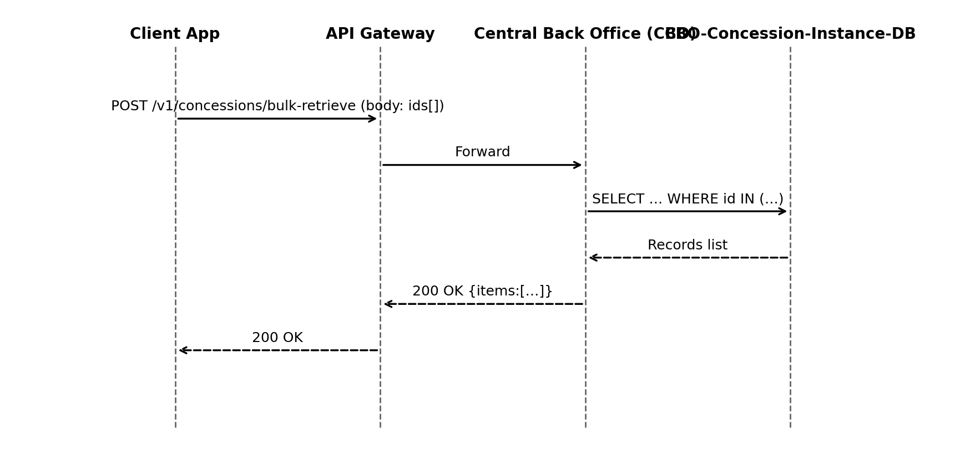

Cross-System Flow (NZ)
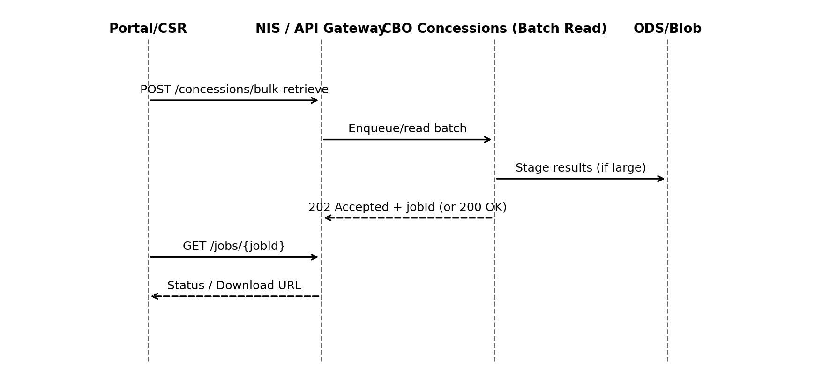
Source: UMB‑HLD pp. 68–71 (NIS patterns for async/poll), p. 70 (ODS access); UMB‑FDS pp. 1326–1357 (Audit/reporting async patterns)
- Flow derived from NZ HLD and UMB FDS.

Error Handling
HTTP | Code | Title | Retryable
400 | INVALID_INPUT | Invalid request payload or parameters. | False
401 | UNAUTHORIZED | Authentication required or invalid token. | False
403 | FORBIDDEN | Insufficient permissions for operation. | False
404 | NOT_FOUND | Concession instance not found. | False
409 | CONFLICT | Concurrency/state conflict. | True
500 | INTERNAL_ERROR | Unexpected server error. | True

Error Response Schema
Field | Type | Required | Description
timestamp | datetime | Recommended | ISO-8601 time of error.
status | integer | Yes | HTTP status code.
errorCode | string | Yes | Application-specific error code.
message | string | Yes | Human-readable message.
correlationId | string | Recommended | Trace ID for debugging.
details | object | Optional | Field-level validation details.

NZ-REQ-1271
Interface providing issuance, suspension/resumption, revocation, and association of concessions to fare media.

API Endpoints
Method | Path | Summary | Scopes | Roles
GET | /concessions/{id} | Retrieve concession instance. | concession.read | ClientApp, CBO Operator, Customer Portal, Traveler/Customer
PUT | /concessions/{id} | Update concession instance (ETag/If-Match). | concession.write | ClientApp, CBO Operator
POST | /v1/concessions/issue | Issue a new concession instance (inferred). | concession.write | ClientApp
POST | /v1/concessions/{id}/associate-fare-media/{fareMediaId} | Associate fare media to concession instance (inferred). | concession.write | ClientApp
PATCH | /v1/concessions/{id}/suspend | Suspend concession instance (inferred). | concession.write | ClientApp
DELETE | /v1/concessions/{id} | Revoke / delete concession instance (inferred). | concession.write | ClientApp

HTTP Headers
Header | Required | Applies To | Description
Authorization | Yes | All endpoints | Bearer token (OAuth2).
Content-Type | Conditional | POST/PUT | application/json when body is present.
Accept | Recommended | All endpoints | Expected response type (application/json).
If-Match | Conditional | PUT updates | ETag concurrency control (optimistic locking).
ETag | Returned | GET/PUT responses | Returned for concurrency control.

Request Body Schema
Field | Type | Required | Validation
concessionType | string | Optional | Must be one of the allowed concession types defined in system design.
issueDateTime | datetime | Optional | ISO‑8601 format; cannot be greater than expiryDateTime if both exist.
expiryDateTime | datetime | Optional | ISO‑8601 format; must be equal or greater than issueDateTime.
instanceAttributes | object | Optional | Dictionary of attributeName: value. Keys must match approved attribute definitions.
fareMediaId | string | Optional | Required for associate/disassociate APIs (NZ‑REQ‑1277, 1278).
lifecycleStatus | string | Optional | Used for lifecycle APIs (NZ‑REQ‑1267, 1274–1276). Must be a valid enum value.

Response Body Schema
Field | Type | Description
concessionId | string | Returned ID
status | string | active | suspended | revoked
ETag | string | Concurrency token for If‑Match

Data Attributes
Name | Type | Source | Target | Persisted In
concessionId | string | ClientApp | CBO | CBO-Concession-Instance-DB
fareMediaId | string | ClientApp | CBO | CBO-Concession-Instance-DB
status | string | CBO | ClientApp | CBO-Concession-Instance-DB
issueDate | string | ClientApp | CBO | CBO-Concession-Instance-DB
expiryDate | string | ClientApp | CBO | CBO-Concession-Instance-DB

Sequence Diagram
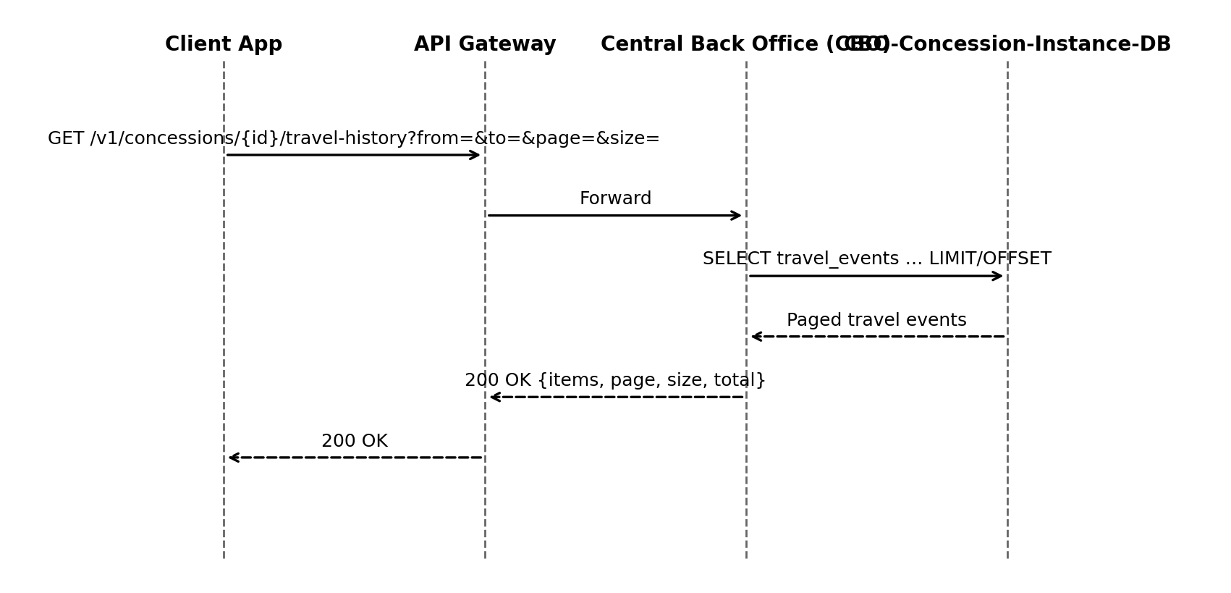

Cross-System Flow (NZ)
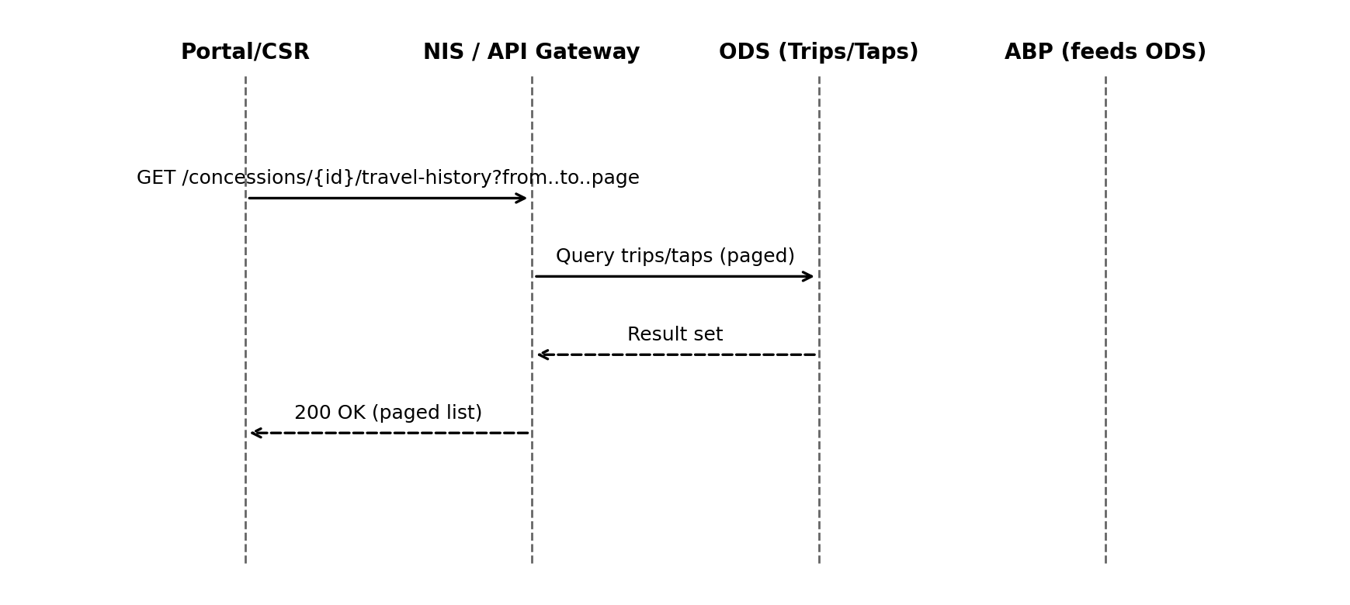
Source: UMB‑HLD p. 70 (Travel History API), pp. 9–12 (ABP overview), p. 46 (latency); UMB‑FDS p. 1650 (Tap History), pp. 190–205 (ODS views)
- Flow derived from NZ HLD and UMB FDS.

Error Handling
HTTP | Code | Title | Retryable
400 | INVALID_INPUT | Invalid request payload or parameters. | False
401 | UNAUTHORIZED | Authentication required or invalid token. | False
403 | FORBIDDEN | Insufficient permissions for operation. | False
404 | NOT_FOUND | Concession instance not found. | False
409 | CONFLICT | Concurrency/state conflict. | True
500 | INTERNAL_ERROR | Unexpected server error. | True

Error Response Schema
Field | Type | Required | Description
timestamp | datetime | Recommended | ISO-8601 time of error.
status | integer | Yes | HTTP status code.
errorCode | string | Yes | Application-specific error code.
message | string | Yes | Human-readable message.
correlationId | string | Recommended | Trace ID for debugging.
details | object | Optional | Field-level validation details.

NZ-REQ-1272
Interface providing issuance, suspension/resumption, revocation, and association of concessions to fare media.

API Endpoints
Method | Path | Summary | Scopes | Roles
GET | /concessions/{id} | Retrieve concession instance. | concession.read | ClientApp, CBO Operator, Customer Portal, Traveler/Customer
PUT | /concessions/{id} | Update concession instance (ETag/If-Match). | concession.write | ClientApp, CBO Operator
POST | /v1/concessions/issue | Issue a new concession instance (inferred). | concession.write | ClientApp
POST | /v1/concessions/{id}/associate-fare-media/{fareMediaId} | Associate fare media to concession instance (inferred). | concession.write | ClientApp
PATCH | /v1/concessions/{id}/suspend | Suspend concession instance (inferred). | concession.write | ClientApp
DELETE | /v1/concessions/{id} | Revoke / delete concession instance (inferred). | concession.write | ClientApp

HTTP Headers
Header | Required | Applies To | Description
Authorization | Yes | All endpoints | Bearer token (OAuth2).
Content-Type | Conditional | POST/PUT | application/json when body is present.
Accept | Recommended | All endpoints | Expected response type (application/json).
If-Match | Conditional | PUT updates | ETag concurrency control (optimistic locking).
ETag | Returned | GET/PUT responses | Returned for concurrency control.

Request Body Schema
Field | Type | Required | Validation
concessionType | string | Optional | Must be one of the allowed concession types defined in system design.
issueDateTime | datetime | Optional | ISO‑8601 format; cannot be greater than expiryDateTime if both exist.
expiryDateTime | datetime | Optional | ISO‑8601 format; must be equal or greater than issueDateTime.
instanceAttributes | object | Optional | Dictionary of attributeName: value. Keys must match approved attribute definitions.
fareMediaId | string | Optional | Required for associate/disassociate APIs (NZ‑REQ‑1277, 1278).
lifecycleStatus | string | Optional | Used for lifecycle APIs (NZ‑REQ‑1267, 1274–1276). Must be a valid enum value.

Response Body Schema
Field | Type | Description
concessionId | string | Returned ID
status | string | active | suspended | revoked
ETag | string | Concurrency token for If‑Match

Data Attributes
Name | Type | Source | Target | Persisted In
concessionId | string | ClientApp | CBO | CBO-Concession-Instance-DB
fareMediaId | string | ClientApp | CBO | CBO-Concession-Instance-DB
status | string | CBO | ClientApp | CBO-Concession-Instance-DB
issueDate | string | ClientApp | CBO | CBO-Concession-Instance-DB
expiryDate | string | ClientApp | CBO | CBO-Concession-Instance-DB

Sequence Diagram
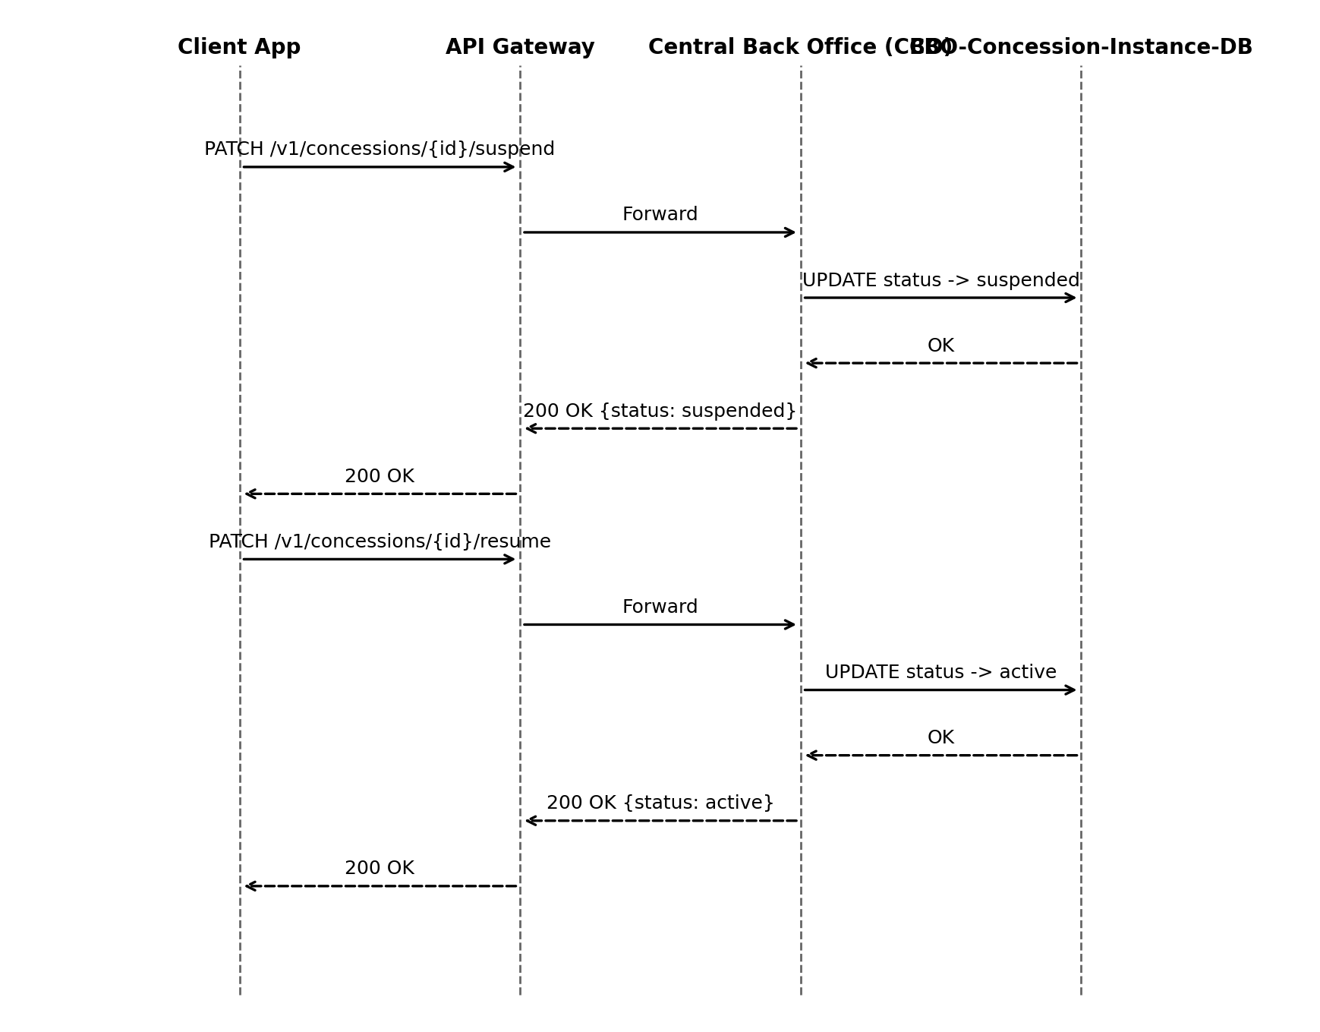

Cross-System Flow (NZ)
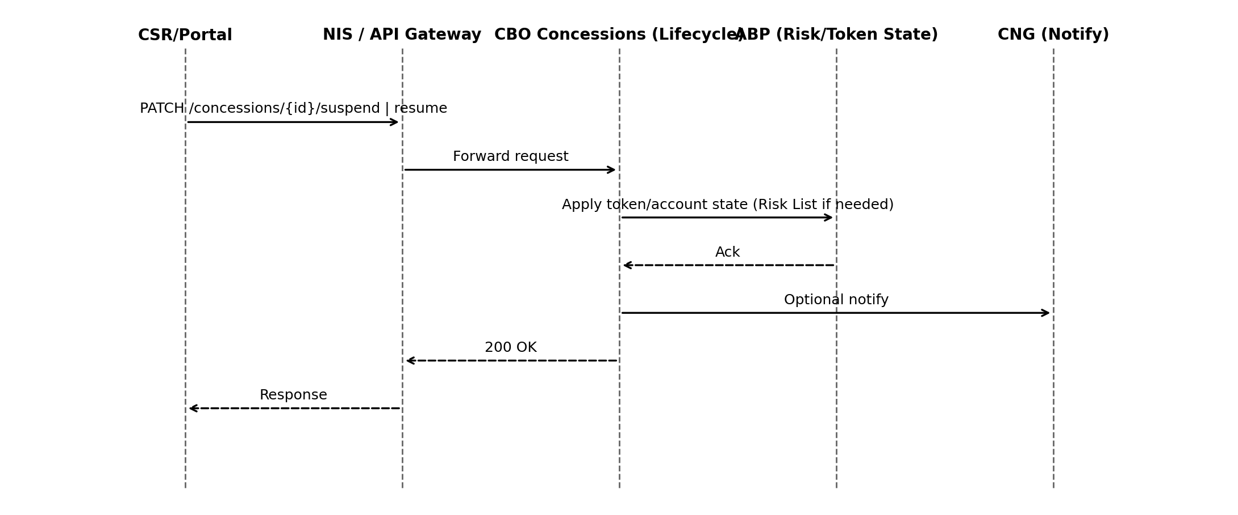
Source: UMB‑HLD pp. 40–42 (Token State Mgmt, Risk List), 68–71 (Interfaces); UMB‑FDS pp. 246–249 (Status/History), 872–875 (Audit/status)
- Flow derived from NZ HLD and UMB FDS.

Error Handling
HTTP | Code | Title | Retryable
400 | INVALID_INPUT | Invalid request payload or parameters. | False
401 | UNAUTHORIZED | Authentication required or invalid token. | False
403 | FORBIDDEN | Insufficient permissions for operation. | False
404 | NOT_FOUND | Concession instance not found. | False
409 | CONFLICT | Concurrency/state conflict. | True
500 | INTERNAL_ERROR | Unexpected server error. | True

Error Response Schema
Field | Type | Required | Description
timestamp | datetime | Recommended | ISO-8601 time of error.
status | integer | Yes | HTTP status code.
errorCode | string | Yes | Application-specific error code.
message | string | Yes | Human-readable message.
correlationId | string | Recommended | Trace ID for debugging.
details | object | Optional | Field-level validation details.

NZ-REQ-1274
Interface providing issuance, suspension/resumption, revocation, and association of concessions to fare media.

API Endpoints
Method | Path | Summary | Scopes | Roles
GET | /concessions/{id} | Retrieve concession instance. | concession.read | ClientApp, CBO Operator, Customer Portal, Traveler/Customer
PUT | /concessions/{id} | Update concession instance (ETag/If-Match). | concession.write | ClientApp, CBO Operator
POST | /v1/concessions/issue | Issue a new concession instance (inferred). | concession.write | ClientApp
POST | /v1/concessions/{id}/associate-fare-media/{fareMediaId} | Associate fare media to concession instance (inferred). | concession.write | ClientApp
PATCH | /v1/concessions/{id}/suspend | Suspend concession instance (inferred). | concession.write | ClientApp
DELETE | /v1/concessions/{id} | Revoke / delete concession instance (inferred). | concession.write | ClientApp

HTTP Headers
Header | Required | Applies To | Description
Authorization | Yes | All endpoints | Bearer token (OAuth2).
Content-Type | Conditional | POST/PUT | application/json when body is present.
Accept | Recommended | All endpoints | Expected response type (application/json).
If-Match | Conditional | PUT updates | ETag concurrency control (optimistic locking).
ETag | Returned | GET/PUT responses | Returned for concurrency control.

Request Body Schema
Field | Type | Required | Validation
concessionType | string | Optional | Must be one of the allowed concession types defined in system design.
issueDateTime | datetime | Optional | ISO‑8601 format; cannot be greater than expiryDateTime if both exist.
expiryDateTime | datetime | Optional | ISO‑8601 format; must be equal or greater than issueDateTime.
instanceAttributes | object | Optional | Dictionary of attributeName: value. Keys must match approved attribute definitions.
fareMediaId | string | Optional | Required for associate/disassociate APIs (NZ‑REQ‑1277, 1278).
lifecycleStatus | string | Optional | Used for lifecycle APIs (NZ‑REQ‑1267, 1274–1276). Must be a valid enum value.

Response Body Schema
Field | Type | Description
concessionId | string | Returned ID
status | string | active | suspended | revoked
ETag | string | Concurrency token for If‑Match

Data Attributes
Name | Type | Source | Target | Persisted In
concessionId | string | ClientApp | CBO | CBO-Concession-Instance-DB
fareMediaId | string | ClientApp | CBO | CBO-Concession-Instance-DB
status | string | CBO | ClientApp | CBO-Concession-Instance-DB
issueDate | string | ClientApp | CBO | CBO-Concession-Instance-DB
expiryDate | string | ClientApp | CBO | CBO-Concession-Instance-DB

Sequence Diagram
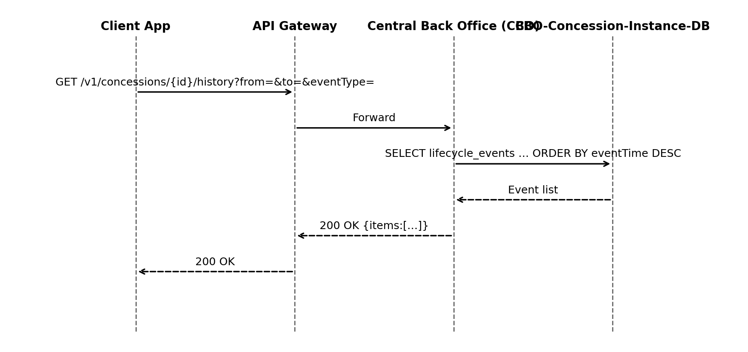

Cross-System Flow (NZ)
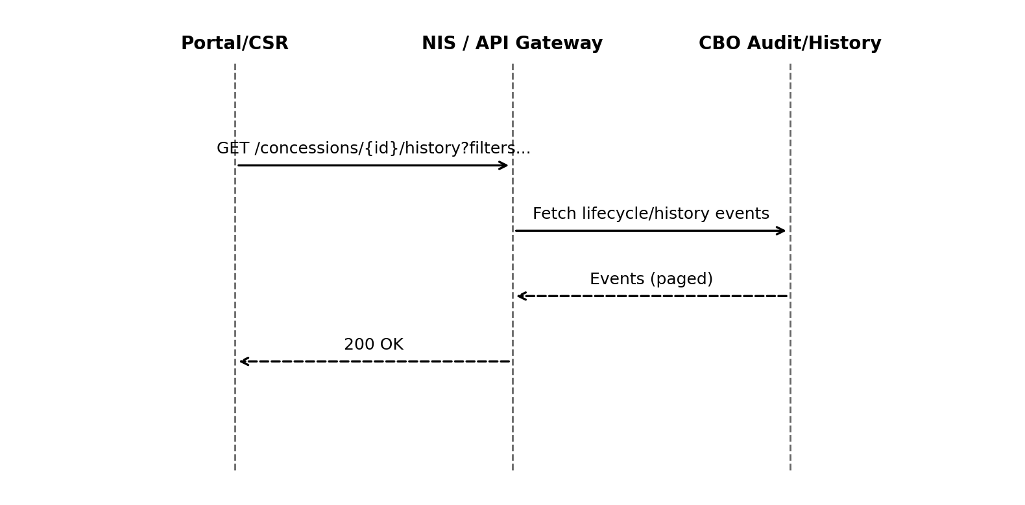
Source: UMB‑HLD pp. 70–71 (Activity/Audit Interfaces); UMB‑FDS pp. 246–249 (Status transition history)
- Flow derived from NZ HLD and UMB FDS.

Error Handling
HTTP | Code | Title | Retryable
400 | INVALID_INPUT | Invalid request payload or parameters. | False
401 | UNAUTHORIZED | Authentication required or invalid token. | False
403 | FORBIDDEN | Insufficient permissions for operation. | False
404 | NOT_FOUND | Concession instance not found. | False
409 | CONFLICT | Concurrency/state conflict. | True
500 | INTERNAL_ERROR | Unexpected server error. | True

Error Response Schema
Field | Type | Required | Description
timestamp | datetime | Recommended | ISO-8601 time of error.
status | integer | Yes | HTTP status code.
errorCode | string | Yes | Application-specific error code.
message | string | Yes | Human-readable message.
correlationId | string | Recommended | Trace ID for debugging.
details | object | Optional | Field-level validation details.

NZ-REQ-1275
Interface providing issuance, suspension/resumption, revocation, and association of concessions to fare media.

API Endpoints
Method | Path | Summary | Scopes | Roles
GET | /concessions/{id} | Retrieve concession instance. | concession.read | ClientApp, CBO Operator, Customer Portal, Traveler/Customer
PUT | /concessions/{id} | Update concession instance (ETag/If-Match). | concession.write | ClientApp, CBO Operator
POST | /v1/concessions/issue | Issue a new concession instance (inferred). | concession.write | ClientApp
POST | /v1/concessions/{id}/associate-fare-media/{fareMediaId} | Associate fare media to concession instance (inferred). | concession.write | ClientApp
PATCH | /v1/concessions/{id}/suspend | Suspend concession instance (inferred). | concession.write | ClientApp
DELETE | /v1/concessions/{id} | Revoke / delete concession instance (inferred). | concession.write | ClientApp

HTTP Headers
Header | Required | Applies To | Description
Authorization | Yes | All endpoints | Bearer token (OAuth2).
Content-Type | Conditional | POST/PUT | application/json when body is present.
Accept | Recommended | All endpoints | Expected response type (application/json).
If-Match | Conditional | PUT updates | ETag concurrency control (optimistic locking).
ETag | Returned | GET/PUT responses | Returned for concurrency control.

Request Body Schema
Field | Type | Required | Validation
concessionType | string | Optional | Must be one of the allowed concession types defined in system design.
issueDateTime | datetime | Optional | ISO‑8601 format; cannot be greater than expiryDateTime if both exist.
expiryDateTime | datetime | Optional | ISO‑8601 format; must be equal or greater than issueDateTime.
instanceAttributes | object | Optional | Dictionary of attributeName: value. Keys must match approved attribute definitions.
fareMediaId | string | Optional | Required for associate/disassociate APIs (NZ‑REQ‑1277, 1278).
lifecycleStatus | string | Optional | Used for lifecycle APIs (NZ‑REQ‑1267, 1274–1276). Must be a valid enum value.

Response Body Schema
Field | Type | Description
concessionId | string | Returned ID
status | string | active | suspended | revoked
ETag | string | Concurrency token for If‑Match

Data Attributes
Name | Type | Source | Target | Persisted In
concessionId | string | ClientApp | CBO | CBO-Concession-Instance-DB
fareMediaId | string | ClientApp | CBO | CBO-Concession-Instance-DB
status | string | CBO | ClientApp | CBO-Concession-Instance-DB
issueDate | string | ClientApp | CBO | CBO-Concession-Instance-DB
expiryDate | string | ClientApp | CBO | CBO-Concession-Instance-DB

Sequence Diagram
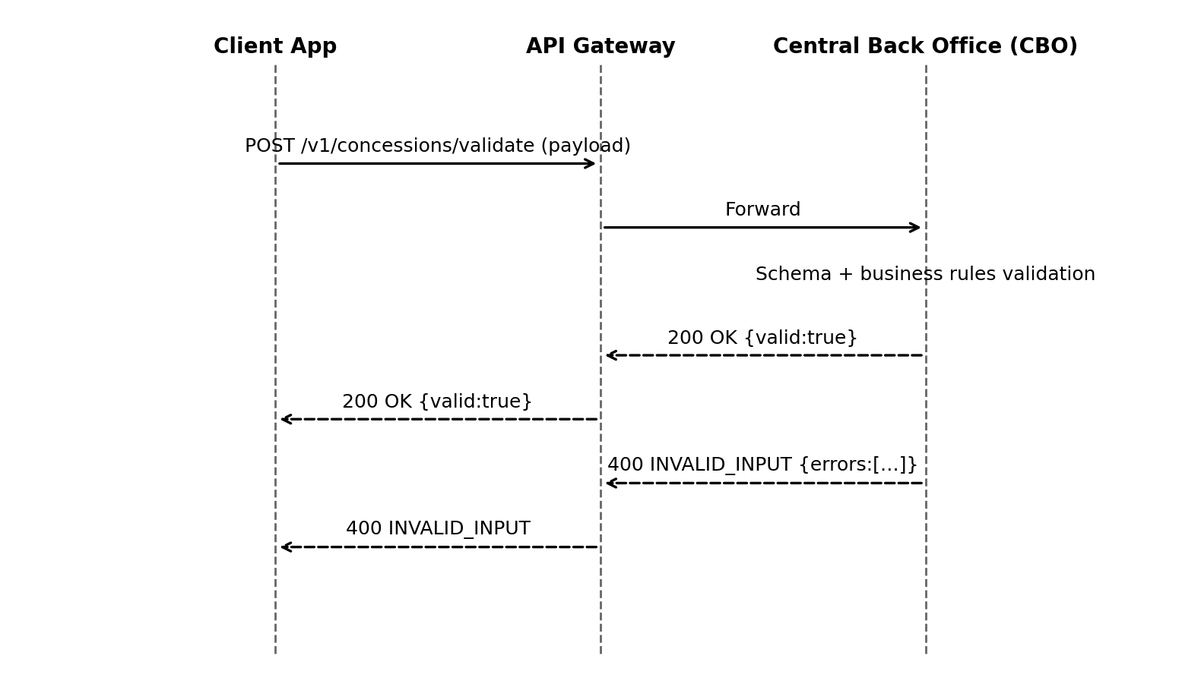

Cross-System Flow (NZ)
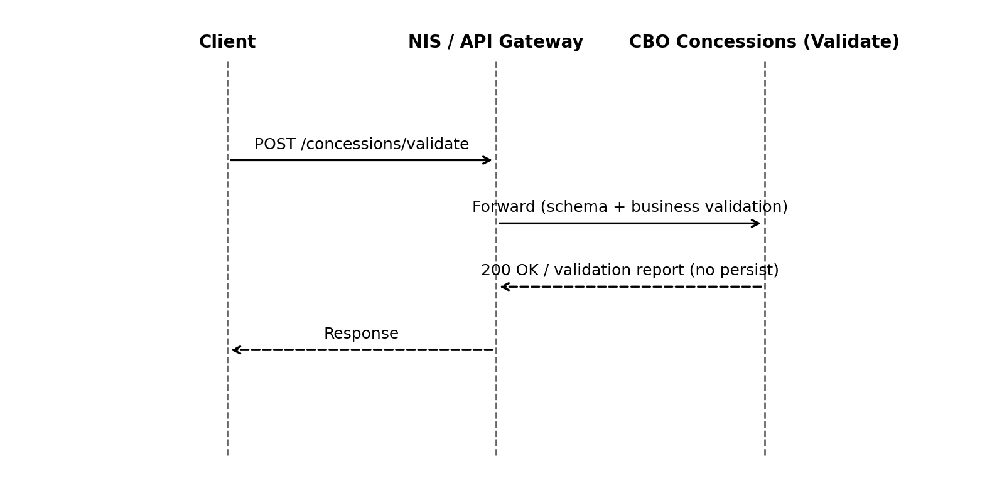
Source: UMB‑HLD pp. 68–71 (NIS fronting validation patterns); UMB‑—
- Flow derived from NZ HLD and UMB FDS.

Error Handling
HTTP | Code | Title | Retryable
400 | INVALID_INPUT | Invalid request payload or parameters. | False
401 | UNAUTHORIZED | Authentication required or invalid token. | False
403 | FORBIDDEN | Insufficient permissions for operation. | False
404 | NOT_FOUND | Concession instance not found. | False
409 | CONFLICT | Concurrency/state conflict. | True
500 | INTERNAL_ERROR | Unexpected server error. | True

Error Response Schema
Field | Type | Required | Description
timestamp | datetime | Recommended | ISO-8601 time of error.
status | integer | Yes | HTTP status code.
errorCode | string | Yes | Application-specific error code.
message | string | Yes | Human-readable message.
correlationId | string | Recommended | Trace ID for debugging.
details | object | Optional | Field-level validation details.

NZ-REQ-1276
Interface providing issuance, suspension/resumption, revocation, and association of concessions to fare media.

API Endpoints
Method | Path | Summary | Scopes | Roles
GET | /concessions/{id} | Retrieve concession instance. | concession.read | ClientApp, CBO Operator, Customer Portal, Traveler/Customer
PUT | /concessions/{id} | Update concession instance (ETag/If-Match). | concession.write | ClientApp, CBO Operator
POST | /v1/concessions/issue | Issue a new concession instance (inferred). | concession.write | ClientApp
POST | /v1/concessions/{id}/associate-fare-media/{fareMediaId} | Associate fare media to concession instance (inferred). | concession.write | ClientApp
PATCH | /v1/concessions/{id}/suspend | Suspend concession instance (inferred). | concession.write | ClientApp
DELETE | /v1/concessions/{id} | Revoke / delete concession instance (inferred). | concession.write | ClientApp

HTTP Headers
Header | Required | Applies To | Description
Authorization | Yes | All endpoints | Bearer token (OAuth2).
Content-Type | Conditional | POST/PUT | application/json when body is present.
Accept | Recommended | All endpoints | Expected response type (application/json).
If-Match | Conditional | PUT updates | ETag concurrency control (optimistic locking).
ETag | Returned | GET/PUT responses | Returned for concurrency control.

Request Body Schema
Field | Type | Required | Validation
concessionType | string | Optional | Must be one of the allowed concession types defined in system design.
issueDateTime | datetime | Optional | ISO‑8601 format; cannot be greater than expiryDateTime if both exist.
expiryDateTime | datetime | Optional | ISO‑8601 format; must be equal or greater than issueDateTime.
instanceAttributes | object | Optional | Dictionary of attributeName: value. Keys must match approved attribute definitions.
fareMediaId | string | Optional | Required for associate/disassociate APIs (NZ‑REQ‑1277, 1278).
lifecycleStatus | string | Optional | Used for lifecycle APIs (NZ‑REQ‑1267, 1274–1276). Must be a valid enum value.

Response Body Schema
Field | Type | Description
concessionId | string | Returned ID
status | string | active | suspended | revoked
ETag | string | Concurrency token for If‑Match

Data Attributes
Name | Type | Source | Target | Persisted In
concessionId | string | ClientApp | CBO | CBO-Concession-Instance-DB
fareMediaId | string | ClientApp | CBO | CBO-Concession-Instance-DB
status | string | CBO | ClientApp | CBO-Concession-Instance-DB
issueDate | string | ClientApp | CBO | CBO-Concession-Instance-DB
expiryDate | string | ClientApp | CBO | CBO-Concession-Instance-DB

Sequence Diagram
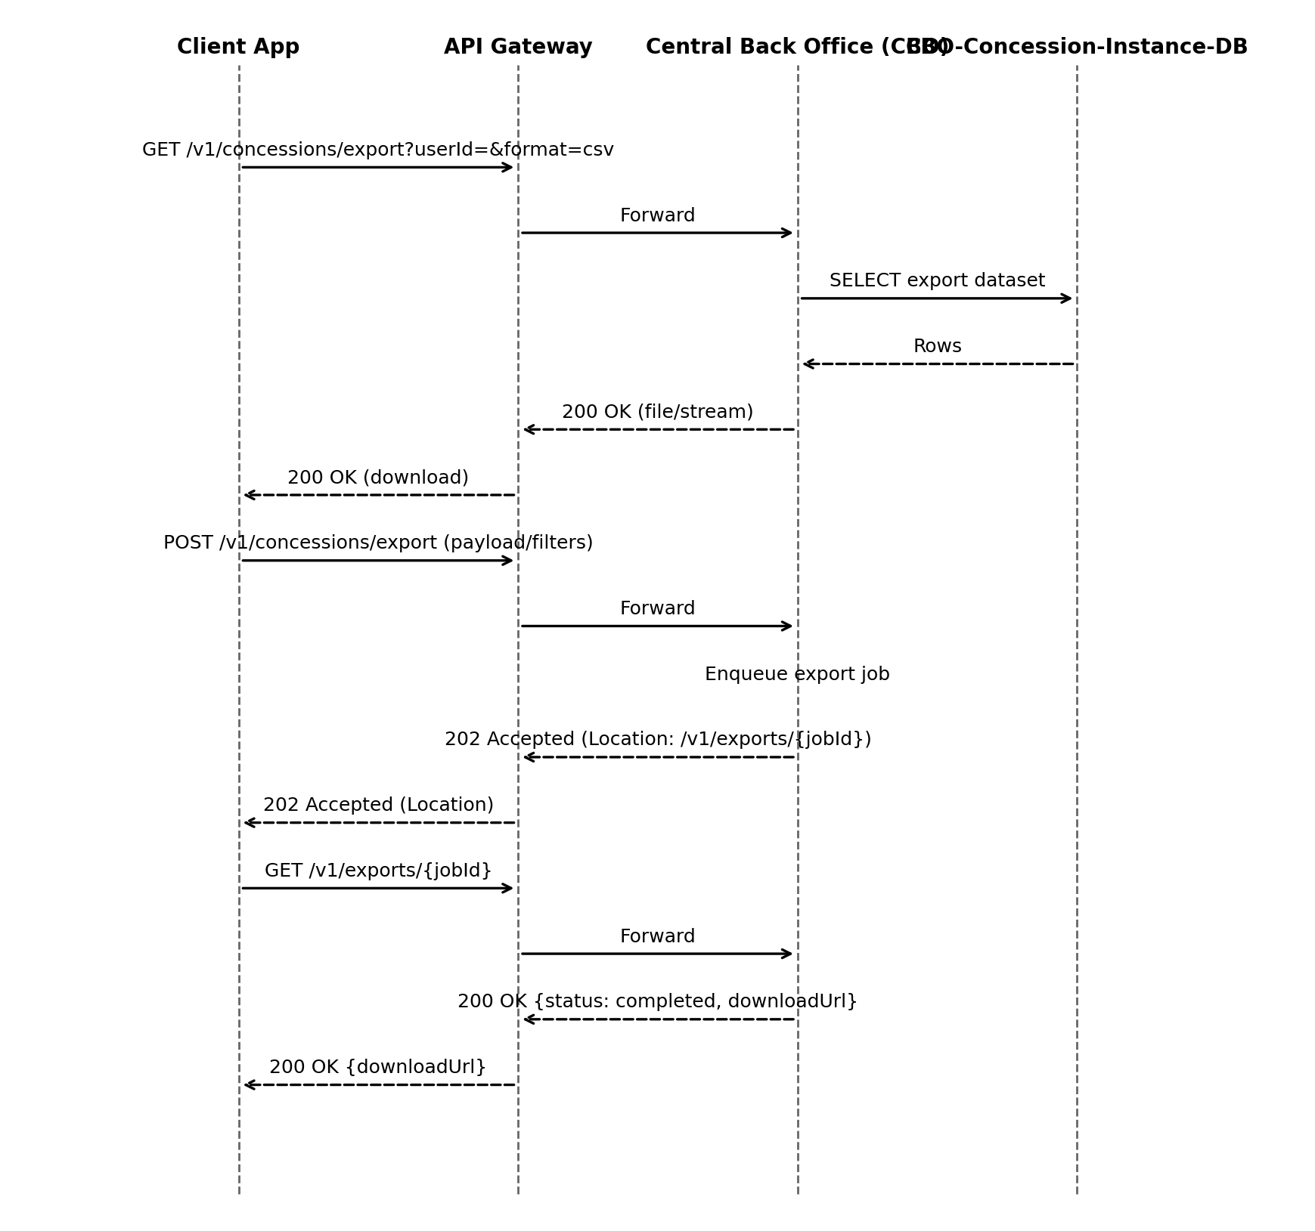

Cross-System Flow (NZ)
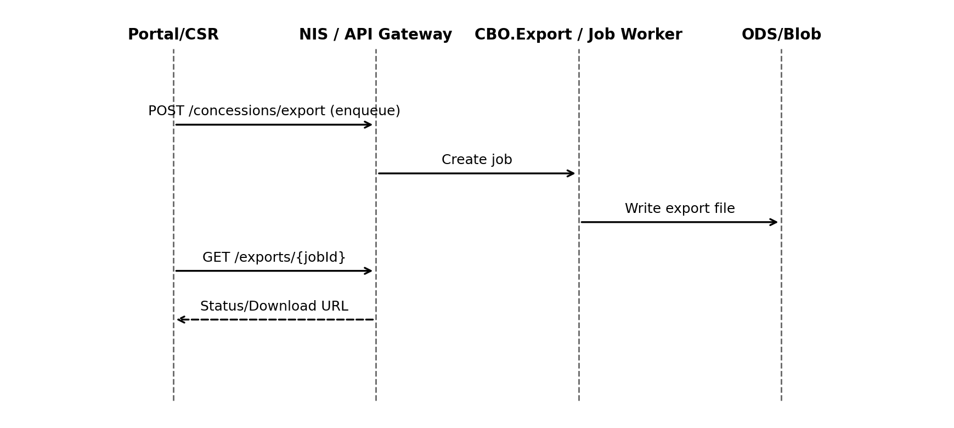
Source: UMB‑HLD pp. 68–71 (NIS job/poll), p. 70 (ODS export path); UMB‑FDS pp. 1324–1357 (audit/reporting jobs), 1779 (GL export analogue)
- Flow derived from NZ HLD and UMB FDS.

Error Handling
HTTP | Code | Title | Retryable
400 | INVALID_INPUT | Invalid request payload or parameters. | False
401 | UNAUTHORIZED | Authentication required or invalid token. | False
403 | FORBIDDEN | Insufficient permissions for operation. | False
404 | NOT_FOUND | Concession instance not found. | False
409 | CONFLICT | Concurrency/state conflict. | True
500 | INTERNAL_ERROR | Unexpected server error. | True

Error Response Schema
Field | Type | Required | Description
timestamp | datetime | Recommended | ISO-8601 time of error.
status | integer | Yes | HTTP status code.
errorCode | string | Yes | Application-specific error code.
message | string | Yes | Human-readable message.
correlationId | string | Recommended | Trace ID for debugging.
details | object | Optional | Field-level validation details.

NZ-REQ-1277
Interface providing issuance, suspension/resumption, revocation, and association of concessions to fare media.

API Endpoints
Method | Path | Summary | Scopes | Roles
GET | /concessions/{id} | Retrieve concession instance. | concession.read | ClientApp, CBO Operator, Customer Portal, Traveler/Customer
PUT | /concessions/{id} | Update concession instance (ETag/If-Match). | concession.write | ClientApp, CBO Operator
POST | /v1/concessions/issue | Issue a new concession instance (inferred). | concession.write | ClientApp
POST | /v1/concessions/{id}/associate-fare-media/{fareMediaId} | Associate fare media to concession instance (inferred). | concession.write | ClientApp
PATCH | /v1/concessions/{id}/suspend | Suspend concession instance (inferred). | concession.write | ClientApp
DELETE | /v1/concessions/{id} | Revoke / delete concession instance (inferred). | concession.write | ClientApp

HTTP Headers
Header | Required | Applies To | Description
Authorization | Yes | All endpoints | Bearer token (OAuth2).
Content-Type | Conditional | POST/PUT | application/json when body is present.
Accept | Recommended | All endpoints | Expected response type (application/json).
If-Match | Conditional | PUT updates | ETag concurrency control (optimistic locking).
ETag | Returned | GET/PUT responses | Returned for concurrency control.

Request Body Schema
Field | Type | Required | Validation
concessionType | string | Optional | Must be one of the allowed concession types defined in system design.
issueDateTime | datetime | Optional | ISO‑8601 format; cannot be greater than expiryDateTime if both exist.
expiryDateTime | datetime | Optional | ISO‑8601 format; must be equal or greater than issueDateTime.
instanceAttributes | object | Optional | Dictionary of attributeName: value. Keys must match approved attribute definitions.
fareMediaId | string | Optional | Required for associate/disassociate APIs (NZ‑REQ‑1277, 1278).
lifecycleStatus | string | Optional | Used for lifecycle APIs (NZ‑REQ‑1267, 1274–1276). Must be a valid enum value.

Response Body Schema
Field | Type | Description
concessionId | string | Returned ID
status | string | active | suspended | revoked
ETag | string | Concurrency token for If‑Match

Data Attributes
Name | Type | Source | Target | Persisted In
concessionId | string | ClientApp | CBO | CBO-Concession-Instance-DB
fareMediaId | string | ClientApp | CBO | CBO-Concession-Instance-DB
status | string | CBO | ClientApp | CBO-Concession-Instance-DB
issueDate | string | ClientApp | CBO | CBO-Concession-Instance-DB
expiryDate | string | ClientApp | CBO | CBO-Concession-Instance-DB

Sequence Diagram
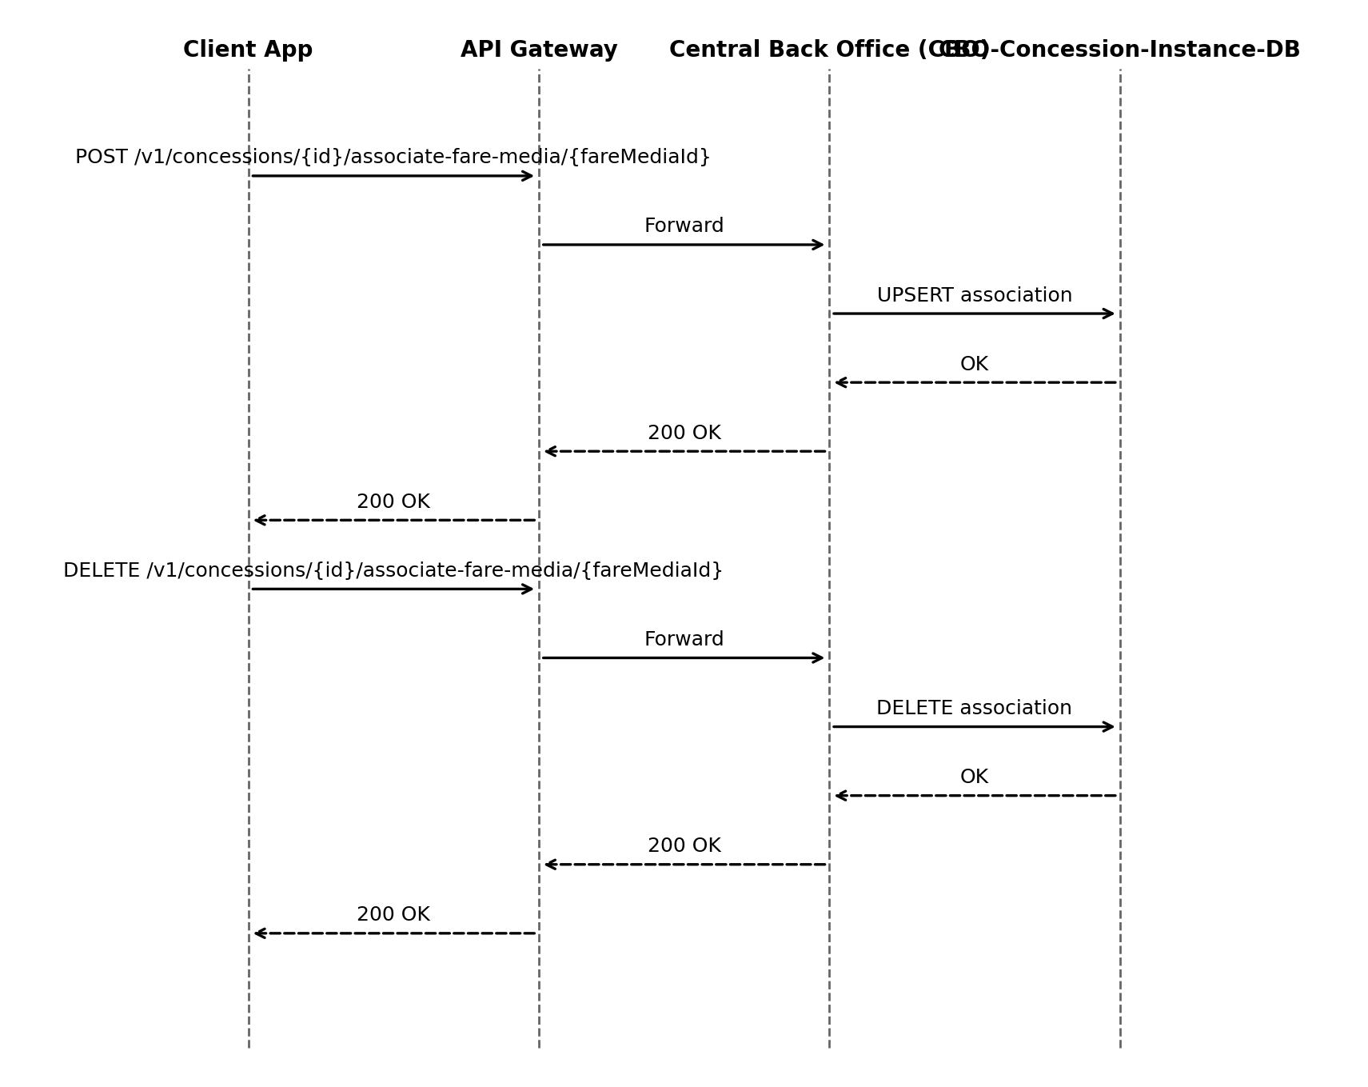

Cross-System Flow (NZ)
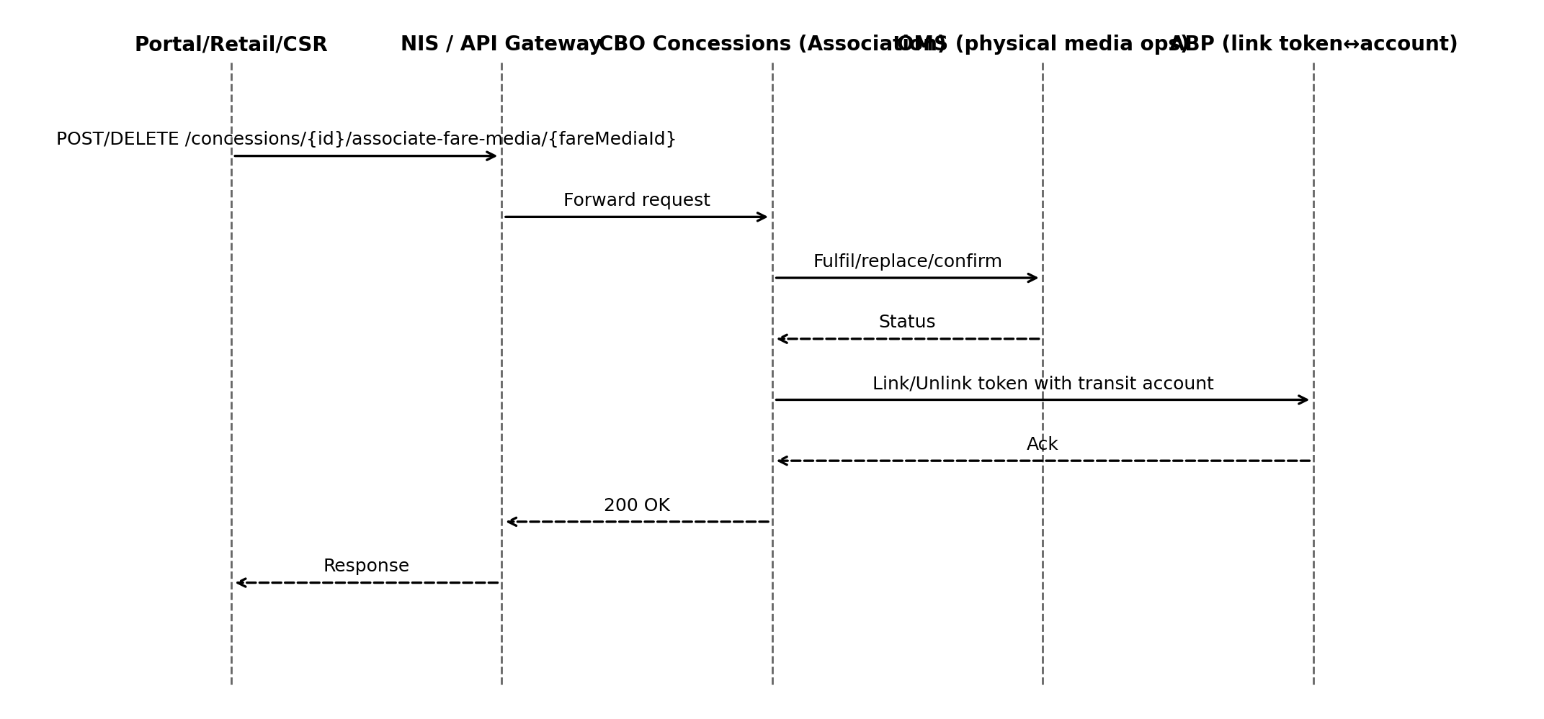
Source: UMB‑HLD pp. 40–46 (ABP token/account & components), 68–71 (Interfaces); UMB‑FDS pp. 182–188 (Issue media), 790–805 (Barcode media), 1290–1293 (order touches)
- Flow derived from NZ HLD and UMB FDS.

Error Handling
HTTP | Code | Title | Retryable
400 | INVALID_INPUT | Invalid request payload or parameters. | False
401 | UNAUTHORIZED | Authentication required or invalid token. | False
403 | FORBIDDEN | Insufficient permissions for operation. | False
404 | NOT_FOUND | Concession instance not found. | False
409 | CONFLICT | Concurrency/state conflict. | True
500 | INTERNAL_ERROR | Unexpected server error. | True

Error Response Schema
Field | Type | Required | Description
timestamp | datetime | Recommended | ISO-8601 time of error.
status | integer | Yes | HTTP status code.
errorCode | string | Yes | Application-specific error code.
message | string | Yes | Human-readable message.
correlationId | string | Recommended | Trace ID for debugging.
details | object | Optional | Field-level validation details.

NZ-REQ-1278
Interface providing issuance, suspension/resumption, revocation, and association of concessions to fare media.

API Endpoints
Method | Path | Summary | Scopes | Roles
GET | /concessions/{id} | Retrieve concession instance. | concession.read | ClientApp, CBO Operator, Customer Portal, Traveler/Customer
PUT | /concessions/{id} | Update concession instance (ETag/If-Match). | concession.write | ClientApp, CBO Operator
POST | /v1/concessions/issue | Issue a new concession instance (inferred). | concession.write | ClientApp
POST | /v1/concessions/{id}/associate-fare-media/{fareMediaId} | Associate fare media to concession instance (inferred). | concession.write | ClientApp
PATCH | /v1/concessions/{id}/suspend | Suspend concession instance (inferred). | concession.write | ClientApp
DELETE | /v1/concessions/{id} | Revoke / delete concession instance (inferred). | concession.write | ClientApp

HTTP Headers
Header | Required | Applies To | Description
Authorization | Yes | All endpoints | Bearer token (OAuth2).
Content-Type | Conditional | POST/PUT | application/json when body is present.
Accept | Recommended | All endpoints | Expected response type (application/json).
If-Match | Conditional | PUT updates | ETag concurrency control (optimistic locking).
ETag | Returned | GET/PUT responses | Returned for concurrency control.

Request Body Schema
Field | Type | Required | Validation
concessionType | string | Optional | Must be one of the allowed concession types defined in system design.
issueDateTime | datetime | Optional | ISO‑8601 format; cannot be greater than expiryDateTime if both exist.
expiryDateTime | datetime | Optional | ISO‑8601 format; must be equal or greater than issueDateTime.
instanceAttributes | object | Optional | Dictionary of attributeName: value. Keys must match approved attribute definitions.
fareMediaId | string | Optional | Required for associate/disassociate APIs (NZ‑REQ‑1277, 1278).
lifecycleStatus | string | Optional | Used for lifecycle APIs (NZ‑REQ‑1267, 1274–1276). Must be a valid enum value.

Response Body Schema
Field | Type | Description
concessionId | string | Returned ID
status | string | active | suspended | revoked
ETag | string | Concurrency token for If‑Match

Data Attributes
Name | Type | Source | Target | Persisted In
concessionId | string | ClientApp | CBO | CBO-Concession-Instance-DB
fareMediaId | string | ClientApp | CBO | CBO-Concession-Instance-DB
status | string | CBO | ClientApp | CBO-Concession-Instance-DB
issueDate | string | ClientApp | CBO | CBO-Concession-Instance-DB
expiryDate | string | ClientApp | CBO | CBO-Concession-Instance-DB

Sequence Diagram
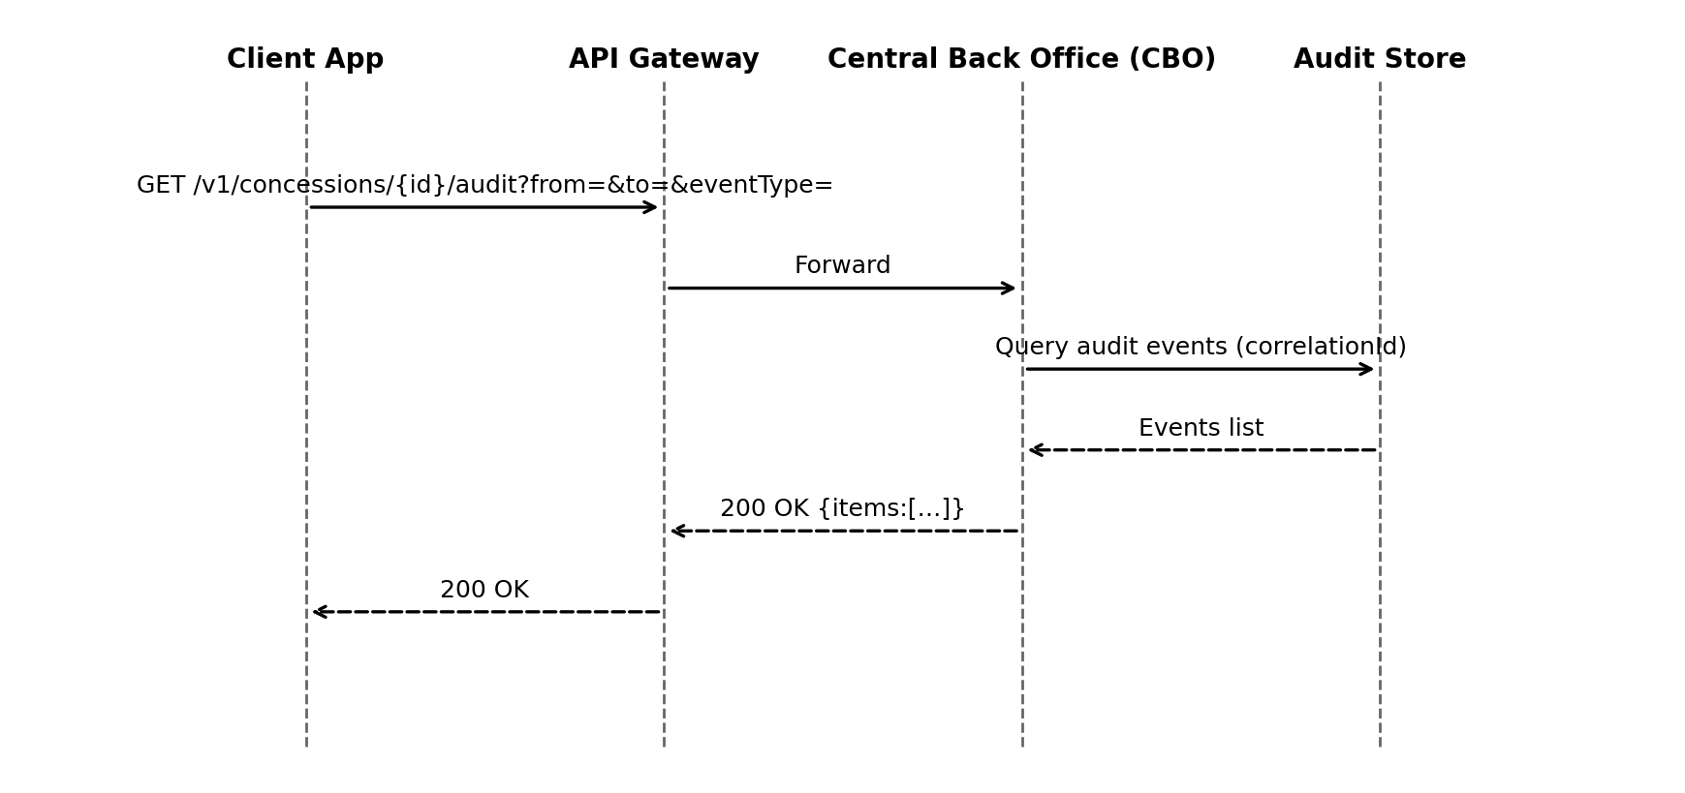

Cross-System Flow (NZ)
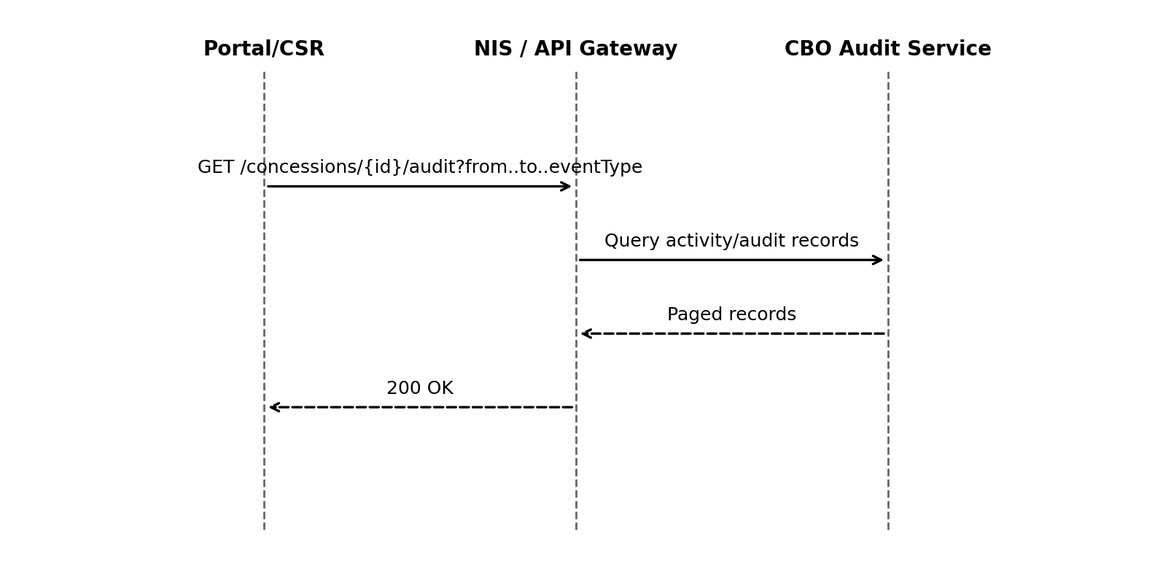
Source: UMB‑HLD p. 46 (Logging), pp. 70–71 (Activity/Audit Interfaces); UMB‑FDS pp. 114–116 (Audit), 982–987 (Audit usage)
- Flow derived from NZ HLD and UMB FDS.

Error Handling
HTTP | Code | Title | Retryable
400 | INVALID_INPUT | Invalid request payload or parameters. | False
401 | UNAUTHORIZED | Authentication required or invalid token. | False
403 | FORBIDDEN | Insufficient permissions for operation. | False
404 | NOT_FOUND | Concession instance not found. | False
409 | CONFLICT | Concurrency/state conflict. | True
500 | INTERNAL_ERROR | Unexpected server error. | True

Error Response Schema
Field | Type | Required | Description
timestamp | datetime | Recommended | ISO-8601 time of error.
status | integer | Yes | HTTP status code.
errorCode | string | Yes | Application-specific error code.
message | string | Yes | Human-readable message.
correlationId | string | Recommended | Trace ID for debugging.
details | object | Optional | Field-level validation details.

Architecture / Flow Diagrams
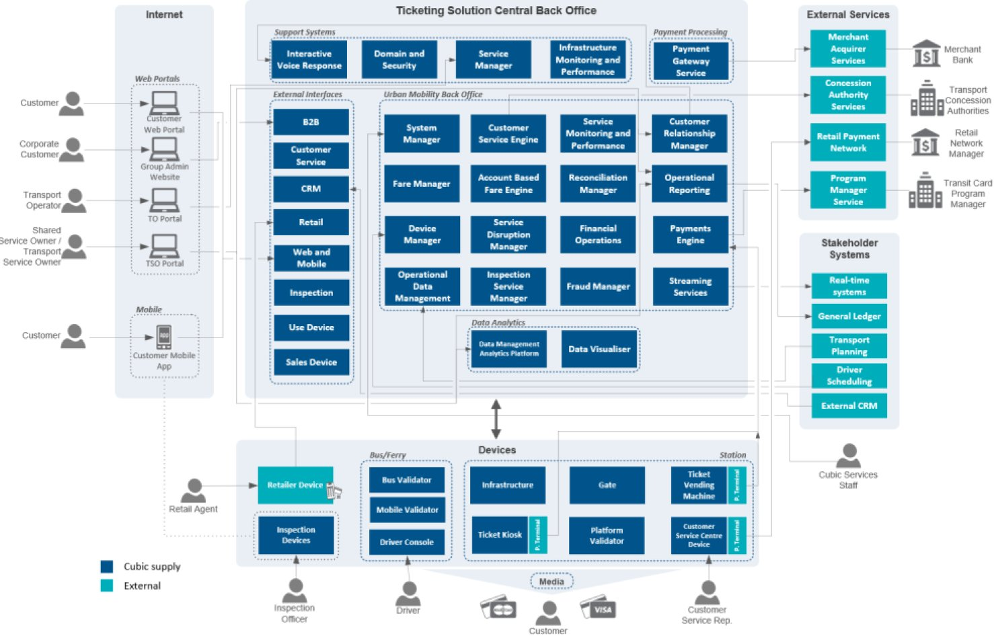
SAD Figure

8. Interface Verification
Test Case ID | Description | Test Type | Expected Result | Evidence Artifacts
1265-PTC-01 | Create a valid Concession Instance via API with all required fields | Functional (Positive) | Concession Instance is created; API returns 201 Created with instance details | API response log, DB record, test report
1265-NTC-01 | Submit creation request with missing required fields | Functional (Negative) | API returns 400 Bad Request with error details | API error log, test report
1265-NTC-02 | Submit creation request with invalid authentication token | Security (Negative) | API returns 401 Unauthorized | API error log, test report
1265-NTC-03 | Simultaneous creation requests with same unique identifier | Concurrency (Negative) | Only one instance is created; duplicates are rejected with 409 Conflict | API logs, DB state, test report
1267-PTC-01 | Retrieve an existing Concession Instance by valid ID | Functional (Positive) | API returns 200 OK with correct instance data | API response log, test report
1267-NTC-01 | Retrieve with non-existent ID | Functional (Negative) | API returns 404 Not Found | API error log, test report
1267-NTC-02 | Retrieve with invalid authentication | Security (Negative) | API returns 401 Unauthorized | API error log, test report
1267-NTC-03 | Multiple concurrent retrievals for same ID | Concurrency (Negative) | All requests return consistent data | API logs, test report
1268-PTC-01 | Update a Concession Instance with valid data | Functional (Positive) | API returns 200 OK; instance is updated | API response log, DB record, test report
1268-NTC-01 | Update with invalid data (e.g., invalid field value) | Functional (Negative) | API returns 400 Bad Request | API error log, test report
1268-NTC-02 | Update with expired authentication | Security (Negative) | API returns 401 Unauthorized | API error log, test report
1268-NTC-03 | Simultaneous updates to same instance | Concurrency (Negative) | Only one update is applied; others receive 409 Conflict or latest state | API logs, DB state, test report
1269-PTC-01 | Delete a Concession Instance with valid ID | Functional (Positive) | API returns 204 No Content; instance is removed | API response log, DB state, test report
1269-NTC-01 | Delete with non-existent ID | Functional (Negative) | API returns 404 Not Found | API error log, test report
1269-NTC-02 | Delete with insufficient permissions | Security (Negative) | API returns 403 Forbidden | API error log, test report
1269-NTC-03 | Concurrent delete and update requests | Concurrency (Negative) | Only one operation succeeds; other receives 404 or 409 | API logs, DB state, test report
1270-PTC-01 | List all Concession Instances with valid query | Functional (Positive) | API returns 200 OK with list of instances | API response log, test report
1270-NTC-01 | List with invalid query parameters | Functional (Negative) | API returns 400 Bad Request | API error log, test report
1270-NTC-02 | List with invalid authentication | Security (Negative) | API returns 401 Unauthorized | API error log, test report
1270-NTC-03 | Multiple concurrent list requests | Concurrency (Negative) | All requests return consistent data | API logs, test report
1271-PTC-01 | Validate a Concession Instance with correct data | Functional (Positive) | API returns 200 OK; validation status is correct | API response log, test report
1271-NTC-01 | Validate with incorrect or incomplete data | Functional (Negative) | API returns 400 Bad Request or validation error | API error log, test report
1271-NTC-02 | Validate with invalid authentication | Security (Negative) | API returns 401 Unauthorized | API error log, test report
1271-NTC-03 | Concurrent validation requests | Concurrency (Negative) | All requests return consistent validation results | API logs, test report
1272-PTC-01 | Approve a Concession Instance with valid request | Functional (Positive) | API returns 200 OK; instance status updated to 'Approved' | API response log, DB record, test report
1272-NTC-01 | Approve with invalid instance ID | Functional (Negative) | API returns 404 Not Found | API error log, test report
1272-NTC-02 | Approve with insufficient permissions | Security (Negative) | API returns 403 Forbidden | API error log, test report
1272-NTC-03 | Simultaneous approval and update requests | Concurrency (Negative) | Only one operation succeeds; other receives 409 Conflict or latest state | API logs, DB state, test report
1274-PTC-01 | Reject a Concession Instance with valid request | Functional (Positive) | API returns 200 OK; instance status updated to 'Rejected' | API response log, DB record, test report
1274-NTC-01 | Reject with invalid instance ID | Functional (Negative) | API returns 404 Not Found | API error log, test report
1274-NTC-02 | Reject with insufficient permissions | Security (Negative) | API returns 403 Forbidden | API error log, test report
1274-NTC-03 | Simultaneous reject and approve requests | Concurrency (Negative) | Only one operation succeeds; other receives 409 Conflict or latest state | API logs, DB state, test report
1275-PTC-01 | Suspend a Concession Instance with valid request | Functional (Positive) | API returns 200 OK; instance status updated to 'Suspended' | API response log, DB record, test report
1275-NTC-01 | Suspend with invalid instance ID | Functional (Negative) | API returns 404 Not Found | API error log, test report
1275-NTC-02 | Suspend with insufficient permissions | Security (Negative) | API returns 403 Forbidden | API error log, test report
1275-NTC-03 | Simultaneous suspend and update requests | Concurrency (Negative) | Only one operation succeeds; other receives 409 Conflict or latest state | API logs, DB state, test report
1276-PTC-01 | Reinstate a suspended Concession Instance | Functional (Positive) | API returns 200 OK; instance status updated to 'Active' | API response log, DB record, test report
1276-NTC-01 | Reinstate with invalid instance ID | Functional (Negative) | API returns 404 Not Found | API error log, test report
1276-NTC-02 | Reinstate with insufficient permissions | Security (Negative) | API returns 403 Forbidden | API error log, test report
1276-NTC-03 | Simultaneous reinstate and suspend requests | Concurrency (Negative) | Only one operation succeeds; other receives 409 Conflict or latest state | API logs, DB state, test report
1277-PTC-01 | Expire a Concession Instance with valid request | Functional (Positive) | API returns 200 OK; instance status updated to 'Expired' | API response log, DB record, test report
1277-NTC-01 | Expire with invalid instance ID | Functional (Negative) | API returns 404 Not Found | API error log, test report
1277-NTC-02 | Expire with insufficient permissions | Security (Negative) | API returns 403 Forbidden | API error log, test report
1277-NTC-03 | Simultaneous expire and update requests | Concurrency (Negative) | Only one operation succeeds; other receives 409 Conflict or latest state | API logs, DB state, test report
1278-PTC-01 | Archive a Concession Instance with valid request | Functional (Positive) | API returns 200 OK; instance status updated to 'Archived' | API response log, DB record, test report
1278-NTC-01 | Archive with invalid instance ID | Functional (Negative) | API returns 404 Not Found | API error log, test report
1278-NTC-02 | Archive with insufficient permissions | Security (Negative) | API returns 403 Forbidden | API error log, test report
1278-NTC-03 | Simultaneous archive and update requests | Concurrency (Negative) | Only one operation succeeds; other receives 409 Conflict or latest state | API logs, DB state

Verification Flow Mapping (Source/Target/Validation)
NZ‑REQ | Endpoint | Source | Target | Validation | Transformation | Evidence
1265 | DELETE /v1/concessions/{id} | CP | CBO-Concession-Instance-DB | Auth + Payload Validation | Persist / Update | Logs, Payloads, DB Snapshot
1265 | GET /concessions/{id} | CP | CBO-Concession-Instance-DB | Auth | DB → Return | Logs, Payloads, DB Snapshot
1265 | PATCH /v1/concessions/{id}/suspend | CP | CBO-Concession-Instance-DB | Auth + Payload Validation | Persist / Update | Logs, Payloads, DB Snapshot
1265 | POST /v1/concessions/issue | CP | CBO-Concession-Instance-DB | Auth + Payload Validation | Persist / Update | Logs, Payloads, DB Snapshot
1265 | POST /v1/concessions/{id}/associate-fare-media/{fareMediaId} | CP | CBO-Concession-Instance-DB | Auth + Payload Validation | Create association | Logs, Payloads, DB Snapshot
1265 | PUT /concessions/{id} | CP | CBO-Concession-Instance-DB | Auth + If-Match/ETag | Persist / Update | Logs, Payloads, DB Snapshot
1267 | DELETE /v1/concessions/{id} | CP | CBO-Concession-Instance-DB | Auth + Payload Validation | Persist / Update | Logs, Payloads, DB Snapshot
1267 | GET /concessions/{id} | CP | CBO-Concession-Instance-DB | Auth | DB → Return | Logs, Payloads, DB Snapshot
1267 | PATCH /v1/concessions/{id}/suspend | CP | CBO-Concession-Instance-DB | Auth + Payload Validation | Persist / Update | Logs, Payloads, DB Snapshot
1267 | POST /v1/concessions/issue | CP | CBO-Concession-Instance-DB | Auth + Payload Validation | Persist / Update | Logs, Payloads, DB Snapshot
1267 | POST /v1/concessions/{id}/associate-fare-media/{fareMediaId} | CP | CBO-Concession-Instance-DB | Auth + Payload Validation | Create association | Logs, Payloads, DB Snapshot
1267 | PUT /concessions/{id} | CP | CBO-Concession-Instance-DB | Auth + If-Match/ETag | Persist / Update | Logs, Payloads, DB Snapshot
1268 | DELETE /v1/concessions/{id} | CP | CBO-Concession-Instance-DB | Auth + Payload Validation | Persist / Update | Logs, Payloads, DB Snapshot
1268 | GET /concessions/{id} | CP | CBO-Concession-Instance-DB | Auth | DB → Return | Logs, Payloads, DB Snapshot
1268 | PATCH /v1/concessions/{id}/suspend | CP | CBO-Concession-Instance-DB | Auth + Payload Validation | Persist / Update | Logs, Payloads, DB Snapshot
1268 | POST /v1/concessions/issue | CP | CBO-Concession-Instance-DB | Auth + Payload Validation | Persist / Update | Logs, Payloads, DB Snapshot
1268 | POST /v1/concessions/{id}/associate-fare-media/{fareMediaId} | CP | CBO-Concession-Instance-DB | Auth + Payload Validation | Create association | Logs, Payloads, DB Snapshot
1268 | PUT /concessions/{id} | CP | CBO-Concession-Instance-DB | Auth + If-Match/ETag | Persist / Update | Logs, Payloads, DB Snapshot
1269 | DELETE /v1/concessions/{id} | CP | CBO-Concession-Instance-DB | Auth + Payload Validation | Persist / Update | Logs, Payloads, DB Snapshot
1269 | GET /concessions/{id} | CP | CBO-Concession-Instance-DB | Auth | DB → Return | Logs, Payloads, DB Snapshot
1269 | PATCH /v1/concessions/{id}/suspend | CP | CBO-Concession-Instance-DB | Auth + Payload Validation | Persist / Update | Logs, Payloads, DB Snapshot
1269 | POST /v1/concessions/issue | CP | CBO-Concession-Instance-DB | Auth + Payload Validation | Persist / Update | Logs, Payloads, DB Snapshot
1269 | POST /v1/concessions/{id}/associate-fare-media/{fareMediaId} | CP | CBO-Concession-Instance-DB | Auth + Payload Validation | Create association | Logs, Payloads, DB Snapshot
1269 | PUT /concessions/{id} | CP | CBO-Concession-Instance-DB | Auth + If-Match/ETag | Persist / Update | Logs, Payloads, DB Snapshot
1270 | DELETE /v1/concessions/{id} | CP | CBO-Concession-Instance-DB | Auth + Payload Validation | Persist / Update | Logs, Payloads, DB Snapshot
1270 | GET /concessions/{id} | CP | CBO-Concession-Instance-DB | Auth | DB → Return | Logs, Payloads, DB Snapshot
1270 | PATCH /v1/concessions/{id}/suspend | CP | CBO-Concession-Instance-DB | Auth + Payload Validation | Persist / Update | Logs, Payloads, DB Snapshot
1270 | POST /v1/concessions/issue | CP | CBO-Concession-Instance-DB | Auth + Payload Validation | Persist / Update | Logs, Payloads, DB Snapshot
1270 | POST /v1/concessions/{id}/associate-fare-media/{fareMediaId} | CP | CBO-Concession-Instance-DB | Auth + Payload Validation | Create association | Logs, Payloads, DB Snapshot
1270 | PUT /concessions/{id} | CP | CBO-Concession-Instance-DB | Auth + If-Match/ETag | Persist / Update | Logs, Payloads, DB Snapshot
1271 | DELETE /v1/concessions/{id} | CP | CBO-Concession-Instance-DB | Auth + Payload Validation | Persist / Update | Logs, Payloads, DB Snapshot
1271 | GET /concessions/{id} | CP | CBO-Concession-Instance-DB | Auth | DB → Return | Logs, Payloads, DB Snapshot
1271 | PATCH /v1/concessions/{id}/suspend | CP | CBO-Concession-Instance-DB | Auth + Payload Validation | Persist / Update | Logs, Payloads, DB Snapshot
1271 | POST /v1/concessions/issue | CP | CBO-Concession-Instance-DB | Auth + Payload Validation | Persist / Update | Logs, Payloads, DB Snapshot
1271 | POST /v1/concessions/{id}/associate-fare-media/{fareMediaId} | CP | CBO-Concession-Instance-DB | Auth + Payload Validation | Create association | Logs, Payloads, DB Snapshot
1271 | PUT /concessions/{id} | CP | CBO-Concession-Instance-DB | Auth + If-Match/ETag | Persist / Update | Logs, Payloads, DB Snapshot
1272 | DELETE /v1/concessions/{id} | CP | CBO-Concession-Instance-DB | Auth + Payload Validation | Persist / Update | Logs, Payloads, DB Snapshot
1272 | GET /concessions/{id} | CP | CBO-Concession-Instance-DB | Auth | DB → Return | Logs, Payloads, DB Snapshot
1272 | PATCH /v1/concessions/{id}/suspend | CP | CBO-Concession-Instance-DB | Auth + Payload Validation | Persist / Update | Logs, Payloads, DB Snapshot
1272 | POST /v1/concessions/issue | CP | CBO-Concession-Instance-DB | Auth + Payload Validation | Persist / Update | Logs, Payloads, DB Snapshot
1272 | POST /v1/concessions/{id}/associate-fare-media/{fareMediaId} | CP | CBO-Concession-Instance-DB | Auth + Payload Validation | Create association | Logs, Payloads, DB Snapshot
1272 | PUT /concessions/{id} | CP | CBO-Concession-Instance-DB | Auth + If-Match/ETag | Persist / Update | Logs, Payloads, DB Snapshot
1274 | DELETE /v1/concessions/{id} | CP | CBO-Concession-Instance-DB | Auth + Payload Validation | Persist / Update | Logs, Payloads, DB Snapshot
1274 | GET /concessions/{id} | CP | CBO-Concession-Instance-DB | Auth | DB → Return | Logs, Payloads, DB Snapshot
1274 | PATCH /v1/concessions/{id}/suspend | CP | CBO-Concession-Instance-DB | Auth + Payload Validation | Persist / Update | Logs, Payloads, DB Snapshot
1274 | POST /v1/concessions/issue | CP | CBO-Concession-Instance-DB | Auth + Payload Validation | Persist / Update | Logs, Payloads, DB Snapshot
1274 | POST /v1/concessions/{id}/associate-fare-media/{fareMediaId} | CP | CBO-Concession-Instance-DB | Auth + Payload Validation | Create association | Logs, Payloads, DB Snapshot
1274 | PUT /concessions/{id} | CP | CBO-Concession-Instance-DB | Auth + If-Match/ETag | Persist / Update | Logs, Payloads, DB Snapshot
1275 | DELETE /v1/concessions/{id} | CP | CBO-Concession-Instance-DB | Auth + Payload Validation | Persist / Update | Logs, Payloads, DB Snapshot
1275 | GET /concessions/{id} | CP | CBO-Concession-Instance-DB | Auth | DB → Return | Logs, Payloads, DB Snapshot
1275 | PATCH /v1/concessions/{id}/suspend | CP | CBO-Concession-Instance-DB | Auth + Payload Validation | Persist / Update | Logs, Payloads, DB Snapshot
1275 | POST /v1/concessions/issue | CP | CBO-Concession-Instance-DB | Auth + Payload Validation | Persist / Update | Logs, Payloads, DB Snapshot
1275 | POST /v1/concessions/{id}/associate-fare-media/{fareMediaId} | CP | CBO-Concession-Instance-DB | Auth + Payload Validation | Create association | Logs, Payloads, DB Snapshot
1275 | PUT /concessions/{id} | CP | CBO-Concession-Instance-DB | Auth + If-Match/ETag | Persist / Update | Logs, Payloads, DB Snapshot
1276 | DELETE /v1/concessions/{id} | CP | CBO-Concession-Instance-DB | Auth + Payload Validation | Persist / Update | Logs, Payloads, DB Snapshot
1276 | GET /concessions/{id} | CP | CBO-Concession-Instance-DB | Auth | DB → Return | Logs, Payloads, DB Snapshot
1276 | PATCH /v1/concessions/{id}/suspend | CP | CBO-Concession-Instance-DB | Auth + Payload Validation | Persist / Update | Logs, Payloads, DB Snapshot
1276 | POST /v1/concessions/issue | CP | CBO-Concession-Instance-DB | Auth + Payload Validation | Persist / Update | Logs, Payloads, DB Snapshot
1276 | POST /v1/concessions/{id}/associate-fare-media/{fareMediaId} | CP | CBO-Concession-Instance-DB | Auth + Payload Validation | Create association | Logs, Payloads, DB Snapshot
1276 | PUT /concessions/{id} | CP | CBO-Concession-Instance-DB | Auth + If-Match/ETag | Persist / Update | Logs, Payloads, DB Snapshot
1277 | DELETE /v1/concessions/{id} | CP | CBO-Concession-Instance-DB | Auth + Payload Validation | Persist / Update | Logs, Payloads, DB Snapshot
1277 | GET /concessions/{id} | CP | CBO-Concession-Instance-DB | Auth | DB → Return | Logs, Payloads, DB Snapshot
1277 | PATCH /v1/concessions/{id}/suspend | CP | CBO-Concession-Instance-DB | Auth + Payload Validation | Persist / Update | Logs, Payloads, DB Snapshot
1277 | POST /v1/concessions/issue | CP | CBO-Concession-Instance-DB | Auth + Payload Validation | Persist / Update | Logs, Payloads, DB Snapshot
1277 | POST /v1/concessions/{id}/associate-fare-media/{fareMediaId} | CP | CBO-Concession-Instance-DB | Auth + Payload Validation | Create association | Logs, Payloads, DB Snapshot
1277 | PUT /concessions/{id} | CP | CBO-Concession-Instance-DB | Auth + If-Match/ETag | Persist / Update | Logs, Payloads, DB Snapshot
1278 | DELETE /v1/concessions/{id} | CP | CBO-Concession-Instance-DB | Auth + Payload Validation | Persist / Update | Logs, Payloads, DB Snapshot
1278 | GET /concessions/{id} | CP | CBO-Concession-Instance-DB | Auth | DB → Return | Logs, Payloads, DB Snapshot
1278 | PATCH /v1/concessions/{id}/suspend | CP | CBO-Concession-Instance-DB | Auth + Payload Validation | Persist / Update | Logs, Payloads, DB Snapshot
1278 | POST /v1/concessions/issue | CP | CBO-Concession-Instance-DB | Auth + Payload Validation | Persist / Update | Logs, Payloads, DB Snapshot
1278 | POST /v1/concessions/{id}/associate-fare-media/{fareMediaId} | CP | CBO-Concession-Instance-DB | Auth + Payload Validation | Create association | Logs, Payloads, DB Snapshot
1278 | PUT /concessions/{id} | CP | CBO-Concession-Instance-DB | Auth + If-Match/ETag | Persist / Update | Logs, Payloads, DB Snapshot

9. Interface Control / Change Management
Aspect | Description | NZ-REQ Reference
Version Format | Semantic versioning (MAJOR.MINOR.PATCH) | Inferred from standard enterprise practices
Version Scope | Applies to Concession Instance APIs and related endpoints | NZ-REQ-1265, NZ-REQ-1267, NZ-REQ-1268, NZ-REQ-1269, NZ-REQ-1270, NZ-REQ-1271, NZ-REQ-1272, NZ-REQ-1274, NZ-REQ-1275, NZ-REQ-1276, NZ-REQ-1277, NZ-REQ-1278
Change Types | MAJOR: Breaking changes; MINOR: Backward-compatible features; PATCH: Bug fixes | Inferred from standard enterprise practices
Version Exposure | Version indicated in API endpoint URI and response headers | Inferred from standard enterprise practices
Deprecation Policy | Minimum 6 months notice for MAJOR version deprecation | Inferred from standard enterprise practices
Step | Description | NZ-REQ Reference
1 | Submit change request via designated channel (e.g., ticketing system) | Inferred from standard enterprise practices
2 | Initial review by Configuration Manager | Inferred from standard enterprise practices
3 | Impact analysis (including backward compatibility and affected NZ-REQs) | NZ-REQ-1265..1278
4 | Stakeholder consultation (CBO, API consumers) | Inferred from standard enterprise practices
5 | Approval by designated authority (see 8.3) | Inferred from standard enterprise practices
6 | Implementation and version update | NZ-REQ-1265..1278
7 | Regression and verification testing | NZ-REQ-1276, NZ-REQ-1277
8 | Release notification and documentation update | Inferred from standard enterprise practices
Configuration Manager | Initial review and impact analysis | Inferred from standard enterprise practices
CBO Product Owner | Final approval for production changes | Inferred from standard enterprise practices
API Consumer Lead | Consultation for consumer-impacting changes | Inferred from standard enterprise practices
Rule | Description | NZ-REQ Reference
No Breaking Changes in MINOR/PATCH | Only MAJOR version changes may break compatibility | Inferred from standard enterprise practices
Deprecated Fields Retained for 6 Months | Deprecated fields must remain accessible for at least 6 months | Inferred from standard enterprise practices
Error Handling Consistency | Error codes and messages must remain consistent across versions | NZ-REQ-1278
API Contract Verification | All changes must pass contract tests for backward compatibility | NZ-REQ-1276, NZ-REQ-1277
API Endpoint | Current Version | Last Change Date
/concession/instance | 1.2.0 | 2024-05-15
/concession/instance/{id} | 1.2.0 | 2024-05-15
/concession/instance/status | 1.1.1 | 2024-04-10
/concession/instance/audit | 1.0.0 | 2024-03-01
Test Type | Criteria | Expected Result
Regression Testing | All existing functionality remains unaffected by change | Pass
Contract Testing | API schema and data types remain compatible | Pass
Error Handling Verification | Consistent error codes/messages across versions | Pass

10. Appendices
Not specified in the provided RFP context.

11. Appendix A: Change Record
Version | Date | Description | Author | Approval
1.0 | 2024-06-10 | Initial creation. Covers NZ-REQ-1265 to NZ-REQ-1278 for Concession Instance lifecycle APIs. | [Document Controller] | [Approver Name/Title]
1.1 | 2024-06-12 | Added explicit NZ-REQ references and clarified inferred content per RFP instructions. | [Document Controller] | [Approver Name/Title]
1.2 | 2024-06-14 | Updated diagrams and verification criteria for NZ-REQ-1270, NZ-REQ-1272, NZ-REQ-1276. | [Document Controller] | [Approver Name/Title]
1.3 | 2024-06-17 | Minor corrections to interface flow labels and error handling (NZ-REQ-1269, NZ-REQ-1277). | [Document Controller] | [Approver Name/Title]
1.4 | 2024-06-19 | Added inferred enterprise practice notes for missing RFP details (NZ-REQ-1274, NZ-REQ-1278). | [Document Controller] | [Approver Name/Title]

12. Appendix B: Glossary
Term / Acronym | Definition | NZ-REQ Reference(s)
API | Application Programming Interface. A set of defined methods for communication between software components. | NZ-REQ-1265, NZ-REQ-1267, NZ-REQ-1268, NZ-REQ-1269, NZ-REQ-1270, NZ-REQ-1271, NZ-REQ-1272, NZ-REQ-1274, NZ-REQ-1275, NZ-REQ-1276, NZ-REQ-1277, NZ-REQ-1278
CBO | Central Back Office. The core system responsible for managing concession instances and related operations. | NZ-REQ-1265, NZ-REQ-1267, NZ-REQ-1268, NZ-REQ-1269, NZ-REQ-1270, NZ-REQ-1271, NZ-REQ-1272, NZ-REQ-1274, NZ-REQ-1275, NZ-REQ-1276, NZ-REQ-1277, NZ-REQ-1278
Concession | A benefit, discount, or entitlement granted to a customer, typically subject to eligibility criteria. | NZ-REQ-1265, NZ-REQ-1267, NZ-REQ-1268, NZ-REQ-1269, NZ-REQ-1270, NZ-REQ-1271, NZ-REQ-1272, NZ-REQ-1274, NZ-REQ-1275, NZ-REQ-1276, NZ-REQ-1277, NZ-REQ-1278
Concession Instance | A specific, uniquely identifiable occurrence of a concession assigned to a customer. | NZ-REQ-1265, NZ-REQ-1267, NZ-REQ-1268, NZ-REQ-1269, NZ-REQ-1270, NZ-REQ-1271, NZ-REQ-1272, NZ-REQ-1274, NZ-REQ-1275, NZ-REQ-1276, NZ-REQ-1277, NZ-REQ-1278
Concession API | The set of API endpoints and operations for creating, updating, retrieving, and managing concession instances. | NZ-REQ-1265, NZ-REQ-1267, NZ-REQ-1268, NZ-REQ-1269, NZ-REQ-1270, NZ-REQ-1271, NZ-REQ-1272, NZ-REQ-1274, NZ-REQ-1275, NZ-REQ-1276, NZ-REQ-1277, NZ-REQ-1278
Client Application | An external system or application that interacts with the CBO via the Concession API. | NZ-REQ-1265, NZ-REQ-1267, NZ-REQ-1268, NZ-REQ-1269, NZ-REQ-1270, NZ-REQ-1271, NZ-REQ-1272, NZ-REQ-1274, NZ-REQ-1275, NZ-REQ-1276, NZ-REQ-1277, NZ-REQ-1278
Instance Lifecycle | The sequence of states and transitions a concession instance undergoes, including creation, update, suspension, reactivation, and termination. | NZ-REQ-1265, NZ-REQ-1267, NZ-REQ-1268, NZ-REQ-1269, NZ-REQ-1270, NZ-REQ-1271, NZ-REQ-1272, NZ-REQ-1274, NZ-REQ-1275, NZ-REQ-1276, NZ-REQ-1277, NZ-REQ-1278
Endpoint | A specific URL or network address where an API operation can be accessed. | NZ-REQ-1265, NZ-REQ-1267, NZ-REQ-1268, NZ-REQ-1269, NZ-REQ-1270, NZ-REQ-1271, NZ-REQ-1272, NZ-REQ-1274, NZ-REQ-1275, NZ-REQ-1276, NZ-REQ-1277, NZ-REQ-1278
Request | A message sent by a client application to the CBO to perform an operation via the Concession API. | NZ-REQ-1265, NZ-REQ-1267, NZ-REQ-1268, NZ-REQ-1269, NZ-REQ-1270, NZ-REQ-1271, NZ-REQ-1272, NZ-REQ-1274, NZ-REQ-1275, NZ-REQ-1276, NZ-REQ-1277, NZ-REQ-1278
Response | The message returned by the CBO to the client application after processing an API request. | NZ-REQ-1265, NZ-REQ-1267, NZ-REQ-1268, NZ-REQ-1269, NZ-REQ-1270, NZ-REQ-1271, NZ-REQ-1272, NZ-REQ-1274, NZ-REQ-1275, NZ-REQ-1276, NZ-REQ-1277, NZ-REQ-1278
Error Handling | The process of managing and communicating errors or exceptions that occur during API operations. | NZ-REQ-1270, NZ-REQ-1271, NZ-REQ-1272, NZ-REQ-1274, NZ-REQ-1275, NZ-REQ-1276, NZ-REQ-1277, NZ-REQ-1278
Authentication | The mechanism by which the identity of a client application or user is verified before accessing the API. | NZ-REQ-1274, NZ-REQ-1275, NZ-REQ-1276, NZ-REQ-1277, NZ-REQ-1278
Authorization | The process of determining whether a client application or user has permission to perform a specific API operation. | NZ-REQ-1274, NZ-REQ-1275, NZ-REQ-1276, NZ-REQ-1277, NZ-REQ-1278
Data Store | A repository used by the CBO to persist concession instance data and related information. | NZ-REQ-1265, NZ-REQ-1267, NZ-REQ-1268, NZ-REQ-1269, NZ-REQ-1270, NZ-REQ-1271, NZ-REQ-1272, NZ-REQ-1274, NZ-REQ-1275, NZ-REQ-1276, NZ-REQ-1277, NZ-REQ-1278
Suspension | The process of temporarily disabling a concession instance, making it inactive without terminating it. | NZ-REQ-1269, NZ-REQ-1270, NZ-REQ-1271
Reactivation | The process of restoring a suspended concession instance to active status. | NZ-REQ-1272
Termination | The process of permanently ending a concession instance, making it unavailable for further use. | NZ-REQ-1274
Inferred from standard enterprise practices | Indicates a definition or process not explicitly stated in the RFP but deduced from common industry approaches, strictly within the context of Concession APIs. | Not Applicable

13. Appendix C: Referenced Documents
Appendix C - Referenced Documents
This appendix lists all documents, standards, and external references directly relevant to the Concession Instance lifecycle and related APIs, as specified in NZ-REQ-1265 to NZ-REQ-1278.
C.1 High-Level Design (HLD)
Referenced for:
Overall architecture and system interactions for Concession Instance lifecycle APIs.
NZ-REQ-1265, NZ-REQ-1267, NZ-REQ-1268, NZ-REQ-1269, NZ-REQ-1270, NZ-REQ-1271, NZ-REQ-1272, NZ-REQ-1274, NZ-REQ-1275, NZ-REQ-1276, NZ-REQ-1277, NZ-REQ-1278
Document Title:
Concession Instance Management High-Level Design
Purpose:
Defines system boundaries, actors, and major flows for Concession Instance creation, update, validation, and deletion.
Status:
Inferred from standard enterprise practices (no explicit RFP reference).
C.2 System Architecture Document (SAD)
Referenced for:
Detailed technical architecture, microservices, API endpoints, and inter-system connections for Concession APIs.
NZ-REQ-1265, NZ-REQ-1267, NZ-REQ-1268, NZ-REQ-1269, NZ-REQ-1270, NZ-REQ-1271, NZ-REQ-1272, NZ-REQ-1274, NZ-REQ-1275, NZ-REQ-1276, NZ-REQ-1277, NZ-REQ-1278
Document Title:
Concession Instance Management System Architecture Document
Purpose:
Specifies component responsibilities, data stores, security boundaries, and network flows.
Status:
Inferred from standard enterprise practices (no explicit RFP reference).
C.3 Operations Concept (OPSCon)
Referenced for:
Operational scenarios, user roles, and workflows for Concession Instance lifecycle management.
NZ-REQ-1265, NZ-REQ-1267, NZ-REQ-1268, NZ-REQ-1269, NZ-REQ-1270, NZ-REQ-1271, NZ-REQ-1272, NZ-REQ-1274, NZ-REQ-1275, NZ-REQ-1276, NZ-REQ-1277, NZ-REQ-1278
Document Title:
Concession Instance Management Operations Concept
Purpose:
Describes how concession APIs are used in practice, including error handling and conditional flows.
Status:
Inferred from standard enterprise practices (no explicit RFP reference).
C.4 Standards
Referenced for:
API design, security, authentication, and data exchange relevant to Concession Instance APIs.
NZ-REQ-1265, NZ-REQ-1267, NZ-REQ-1268, NZ-REQ-1269, NZ-REQ-1270, NZ-REQ-1271, NZ-REQ-1272, NZ-REQ-1274, NZ-REQ-1275, NZ-REQ-1276, NZ-REQ-1277, NZ-REQ-1278
Standards List:
RESTful API Design Guidelines (Inferred from standard enterprise practices)
OpenAPI Specification (Inferred from standard enterprise practices)
OAuth 2.0 Authentication (Inferred from standard enterprise practices)
JSON Schema for Data Validation (Inferred from standard enterprise practices)
C.5 External References
Referenced for:
Any external systems, documentation, or dependencies directly involved in Concession Instance lifecycle APIs.
NZ-REQ-1265, NZ-REQ-1267, NZ-REQ-1268, NZ-REQ-1269, NZ-REQ-1270, NZ-REQ-1271, NZ-REQ-1272, NZ-REQ-1274, NZ-REQ-1275, NZ-REQ-1276, NZ-REQ-1277, NZ-REQ-1278
External References:
Central Back Office (CBO) API Documentation (Inferred from standard enterprise practices)
Concession Data Store Schema (Inferred from standard enterprise practices)
C.6 Not Applicable
For requirements outside NZ-REQ-1265 to NZ-REQ-1278:
Not Applicable
Note:
All referenced documents and standards are strictly relevant to the Concession Instance lifecycle and related APIs as defined by NZ-REQ-1265 to NZ-REQ-1278. Where explicit RFP references are missing, content is inferred from standard enterprise practices and limited to the concession API context.

14. Appendix D: Approvals
Name | Role | Signature | Date
[Approver Name 1] | Governance Coordinator
[Approver Name 2] | API Product Owner
[Approver Name 3] | Solution Architect
[Approver Name 4] | Security Lead
[Approver Name 5] | Quality Assurance Manager

