Assignment 2 final
King Banaian
2025-02-21
##Loading needed libraries

Loading the data
The method I used above includes the forecast library, which allows me to use some slightly different ways of creating the training data and the testind datasets.
# Read and prepare the data
data <- read.csv("USTRADE.csv")
data$observation_date <- as.Date(paste0(data$observation_date, "-01"), format="%m/%d/%Y-%d")
# Convert to time series object
ts_data <- ts(data$USTRADE, frequency=12,
start=c(year(min(data$observation_date)), month(min(data$observation_date))))
summary(ts_data)
## Min. 1st Qu. Median Mean 3rd Qu. Max.
## 3108 5564 10376 10174 14849 15874

Splitting the data
Now we will create the training data through the end of 2021, set up the testing period of 2022-23, and then a last set to hold 2024:
# Split into training (up to Dec 2021) and test (2022-2023)
train_data <- window(ts_data, end=c(2021,12))
test_data <- window(ts_data, start=c(2022,1), end=c(2023,12))

Forecasts for 2022-23
We now generate the forecasts and use the accuracy() function to collect forecast summary statistics.
# Generate forecasts
naive_fc <- naive(train_data, h=24)
snaive_fc <- snaive(train_data, h=24)
drift_fc <- rwf(train_data, h=24, drift=TRUE)
# Calculate accuracy measures
naive_accuracy <- accuracy(naive_fc, test_data)
snaive_accuracy <- accuracy(snaive_fc, test_data)
drift_accuracy <- accuracy(drift_fc, test_data)
##Create a pretty table to compare the forecast error statistics for 2022-2023
I’m going to make a data frame here report out three important error statsitics: the root mean squared error (RMSE), the mean absolute error (MAE) and the mean absolute percent error (MAPE). I wasn’t very fussy in how I graded what you did to make this table. I just wanted to see how you would present the results.
# Calculate accuracy measures
naive_accuracy <- accuracy(naive_fc, test_data)
snaive_accuracy <- accuracy(snaive_fc, test_data)
drift_accuracy <- accuracy(drift_fc, test_data)
# Create comparison table
comparison_table <- data.frame(
Method = c("Naive", "Seasonal Naive", "Drift"),
RMSE = round(c(naive_accuracy[2,"RMSE"],
snaive_accuracy[2,"RMSE"],
drift_accuracy[2,"RMSE"]), 2),
MAE = round(c(naive_accuracy[2,"MAE"],
snaive_accuracy[2,"MAE"],
drift_accuracy[2,"MAE"]), 2),
MAPE = round(c(naive_accuracy[2,"MAPE"],
snaive_accuracy[2,"MAPE"],
drift_accuracy[2,"MAPE"]), 2)
)
# Print table
print("Forecast Accuracy Comparison:")
## [1] "Forecast Accuracy Comparison:"
print(kable(comparison_table))
##
##
## |Method | RMSE| MAE| MAPE|
## |:--------------|------:|------:|----:|
## |Naive | 179.06| 169.35| 1.09|
## |Seasonal Naive | 294.40| 281.91| 1.81|
## |Drift | 56.86| 41.83| 0.27|
As you can see, the drift model is better across all three forecast accuracy summary statistics. We will use this to create our final forecast for 2024.
##Make 2024 forecast
In this section I have added a graph that shows how 2024 actually turned out (since I gave you those data) to your forecast.
## [1] "\n2024 Forecasts (Drift Method):"
## Point Forecast Lo 80 Hi 80 Lo 95 Hi 95
## Jan 2024 15614.96 15510.89 15719.04 15455.79 15774.13
## Feb 2024 15627.22 15479.97 15774.48 15402.01 15852.43
## Mar 2024 15639.49 15459.05 15819.93 15363.53 15915.45
## Apr 2024 15651.75 15443.29 15860.20 15332.94 15970.55
## May 2024 15664.01 15430.83 15897.19 15307.40 16020.62
## Jun 2024 15676.27 15420.72 15931.83 15285.43 16067.11
## Jul 2024 15688.53 15412.37 15964.70 15266.17 16110.89
## Aug 2024 15700.80 15405.42 15996.17 15249.05 16152.54
## Sep 2024 15713.06 15399.61 16026.51 15233.68 16192.44
## Oct 2024 15725.32 15394.75 16055.88 15219.76 16230.87
## Nov 2024 15737.58 15390.71 16084.45 15207.09 16268.07
## Dec 2024 15749.84 15387.38 16112.31 15195.50 16304.19
## Scale for x is already present.
## Adding another scale for x, which will replace the existing scale.
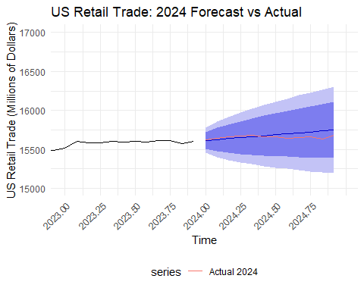
The error bands are quite large, but the forecast tracks pretty well to the actual data, as you can see on the graph I’ve drawn. The way I have done the forecast only uses data through 2023 (updating the drift method’s parameters from 2021).

