

|  |
| --- |
| MACROECONOMIC POLICY COMMUNICATION |
| Blended course: Self-paced content |
| COURSE PLAN—MODULE 1 |

|  |
| --- |
|  |

I

**TABLE OF CONTENTS**

MODULE 1: Policy Communication 2

UNIT 0: Introduction to Module 1 2

SECTION 1: Evolution of Policy Communication 2

UNIT 1.1: Starting at Secrecy and Ambiguity 2

<VIDEO 1.1> "Policy Communication: Secrecy and Ambiguity” [word count: 475] 2

UNIT 1.2: Moving toward Transparency and Clarity 4

<VIDEO 1.2> “Policy Communication: Toward Transparency and Clarity” [word count: 319] 4

UNIT 1.3: Discovering the Benefits of Clear Communication 4

UNIT 1.4: Costs of Unclear Communication 6

SECTION 2: Transparency and Clarity 9

UNIT 2.1: Institutional Communications Framework 9

UNIT 2.2: Role of Transparency and Clarity 10

<VIDEO 2.1> “The Role of Transparency and Clarity” [word count: 346] 10

UNIT 2.3: How to Measure Transparency and Clarity? 11

UNIT 2.4: Communicating with Transparency and Clarity in Mind—Best Practice in Central Banks 14

UNIT 2.5: Selected Recent Communications Challenges 17

UNIT 2.6 Knowledge Check 19

# MODULE 1: Policy Communication

## UNIT 0: Introduction to Module 1

Policy communication is the bedrock of modern macroeconomic policy. In this module, we start by reviewing the evolution of policy communication from the practice of “revealing as little as possible” to being open and transparent. We then identify the main benefits of transparency before finally outlining the essential elements that policymakers should communicate in their respective macroeconomic policy areas.

By the end of this module, you will be able to:

1. Summarize the historical context of institutional policy communication.
2. Identify the main benefits/purposes of transparency.
3. Describe the essential elements that policymakers should communicate in their respective macroeconomic policy areas.
4. Explain that transparency is a necessary but not sufficient condition for effective communication.

# SECTION 1: Evolution of Policy Communication

## UNIT 1.1: Starting at Secrecy and Ambiguity

The history of policy communication is a short one and can be divided into two defining periods. First is the period of secrecy, and later, of transparency. In the following video, let's explore how the secrecy of policy communication first came about.

### <VIDEO 1.1> "Policy Communication: Secrecy and Ambiguity” [word count: 475]

Policy communication, as a discipline, has a short history. Most central banks and ministries of finance started communicating about their policies fairly recently, during the 1990s. Let me walk you down memory lane, to better understand the first period of policy communication, one that valued secrecy. For illustration, we will use examples from advanced countries and central banks. But believe me, the story would be similar with emerging market countries as well.

Janet Yellen, the former Chairwoman of the United States Federal Reserve System, recalled that early in her career central banks as a rule did not discuss monetary policy decisions or their future policy intentions.

During the early days of central banking the view was that monetary policy is a subject too complicated for the public to comprehend and appreciate. Montague Norman, who served as Governor of the Bank of England between 1920 and 1944, famously uttered that central BANKERS should “*Never explain and never excuse*”.

Rumor has it that a 1960s job description for a Bank of England Advisor stipulated the following task: “*Keep the Bank out of the press and the press out of the Bank*”.

Things started to change in the late 1970s as the lawmakers and the public realized that policymakers wield tremendous powers of which little is known and understood. To check such powers, in 1977 the U.S. Congress passed a law that required the Chairman of the U.S. Federal Reserve to testify twice a year before Congress, during the so-called “Humphrey-Hawkins” testimony. How did that go? Did policymakers become immediately great, transparent communicators?

Well, let’s say that the progress was slow. Alan Greenspan, who served as U.S. Fed Chairman from 1987 till 2006, famously recalled having to learn a new INCOHERENT “language”, called Fed-speak.

Why was there a need to develop a new language that used ambiguous and cautious statements to obscure and detract meaning from the statement?

The answer is simple. Incoherent messaging aimed to prevent financial markets from overreacting. Remember that central banks did not communicate much back then. They kept their data, assumptions, macroeconomic projections, and policy deliberations secret. Infrequent statements (say, every six months) could be easily misunderstood by financial markets and by journalists. As a result, these communications tended to move financial markets a lot, sometimes in the wrong direction.

There was another reason for not telling the public the central BANKERS’ intentions. Many notable economists, such as Milton Friedman or Robert Lucas, argued that only unexpected fiscal and monetary policy changes will affect output and employment. Let me share a personal experience about this. In the 1990s, when I was in graduate school, I got the following essay assignment from my professor: “*Only unexpected monetary policy matters. Discuss*.”

Only in the 1990s did economists start believing that expected policy developments have real effects on the economy. That belief changed policy communication forever.

**<END OF VIDEO >**

**What are examples of ambiguous statements?**

Can you make up exactly what Mr. Greenspan was trying to say in these quotes? Don't worry if you can't! Neither can most people. The ambiguity was intentional.

All examples below can be found at <https://web.archive.org/web/20120212132248/http://www.dallasfed.org/news/speeches/greenspeak.html>

<INTERACTIVE COURSE PRESENTATION_START>

**QUOTE 1**. “*The members of the Board of Governors and the Reserve Bank presidents foresee an implicit strengthening of activity after the current rebalancing is over, although the central tendency of their individual forecasts for real GDP still shows a substantial slowdown, on balance, for the year as a whole*.”

— Alan Greenspan, Testimony from the Federal Reserve Board's semiannual monetary policy report to the Congress before the Committee on Banking, Housing, and Urban Affairs, U.S. Senate on February 13, 2001

**QUOTE 2**. “*Risk takers have been encouraged by a perceived increase in economic stability to reach out to more distant time horizons. But long periods of relative stability often engender unrealistic expectations of it[s] permanence and, at times, may lead to financial excess and economic stress.*”

— Alan Greenspan, testimony on his 35th appearance before the Financial Services Committee of the US House of Representatives on July 20, 2005

**QUOTE 3**. “*Clearly, sustained low inflation implies less uncertainty about the future, and lower risk premiums imply higher prices of stocks and other earning assets. We can see that in the inverse relationship exhibited by price/earnings ratios and the rate of inflation in the past. But how do we know when irrational exuberance has unduly escalated asset values, which then become subject to unexpected and prolonged contractions as they have in Japan over the past decade?*”

— Alan Greenspan, "The Challenge of Central Banking in a Democratic Society", December 5, 1996.

**QUOTE 4**. "*So far there is little evidence to undermine the notion that most of the productivity increase of recent years has been structural and that structural productivity may still be accelerating.*"

— Alan Greenspan, Before the U.S. Senate on monetary policy, December 5, 1996

<INTERACTIVE COURSE PRESENTATION_END>

## UNIT 1.2: Moving toward Transparency and Clarity

In the following video, we explore the more recent period of policy communication, a period that shifted toward transparency and clarity.

The experience of the past 30 or so years has shown that effective policy communication requires both transparency and clarity. A transparent institution discloses a lot of information—often prescribed in legislation—in a timely manner through its various reports, minutes of policy meetings, interviews, social media, and other channels. The “quantity of disclosure” is not sufficient, however. Quickly disclosing large volumes of hard-to-interpret information does not really help policy communication. Clarity is another dimension of policy communication that needs to be assessed.

### <VIDEO 1.2> “Policy Communication: Toward Transparency and Clarity” [word count: 319]

Policy communication changed forever with the advent of three developments.

First, continued push for accountability of public officials from lawmakers, the media, and the public. Public accountability rests on the principle that those TRUSTED with public power have an obligation to act in the public interest, justify their conduct to the citizens they serve, and face consequences for improper actions. In addition, during the 1980s and 1990s many central banks gained so-called operational independence, that is, they became free to pursue all necessary policies to achieve the primary objective of price stability.

Alan Greenspan in 2002 wrote that “*Openness is an obligation of a central bank in a free and democratic society*.” Of course, frequent communication by itself does not guarantee that the message is transparent or indeed clear and useful to its recipient. But open communication is a necessary tool to assess whether the policymakers are WORTHY of their roles.

The second development concerns advances in macroeconomics that allowed economists outside of a central bank to “replicate” the policymaking process. An example is the invention of the so-called policy reaction function, popularly known as the “Taylor Rule.” Over time, more data on inflation, national accounts, and the exchange rates were made available to economists outside of central banks. Statistical techniques, such as the Hodrick-Prescott filter, allowed for quick estimates of the slack in countries’ economies. And simple macroeconomic models allowed simulations of the most likely policy responses. The advent of the internet in the second half of the 1990s accelerated these developments and demystified policymaking. Now almost anybody could “play the governor” and come up with a competing policy narrative.

Third, and perhaps the most important development, is that policymakers learned that communication helps them do their job better and more easily. By communicating the anticipated path of future decisions, they will be able to guide public expectations about the key macroeconomic variables that they want to affect.

**<END OF VIDEO >**

## UNIT 1.3: Discovering the Benefits of Clear Communication

Up to roughly the 1990s, legal pressures for transparent communication had limited impact on policymakers, who continued “to mumble with great incoherence” only more frequently. It was “peer pressure” from outside researchers as well as in-house realization of the benefits of guiding public expectations slowly drove policymakers toward more transparent communication.

Additional driver of transparency in communication was the declining cost of information dissemination. The cost of getting out a narrative was impossibly high before the invention of the printing press, when authors would have to copy text by hand. Even after the printing press became widespread in the early 16th century, authors had to pay for printing and distribution of their own pamphlets.[1] Think of Martin Luther nailing his 95 theses to the Wittemberg church door. [Source of the picture: <https://en.m.wikipedia.org/wiki/File:Ferdinand_Pauwels_-_Luther_hammers_his_95_theses_to_the_door.jpg>]

The cost of information dissemination dropped with mass-circulation newspapers in the second half of 1800s, when literacy rates increased dramatically. The cost of new information then declined further with the emergence of radio and television during the 20th century. Finally, it went to essentially zero with the arrival of internet and social media.

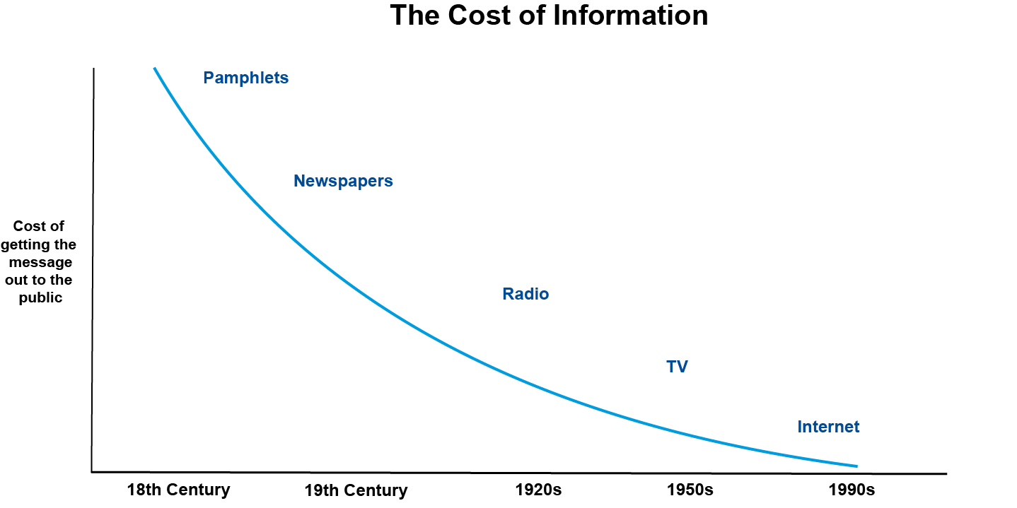

It is said that “*If you don’t own your story, your competitors will, and you won’t like their version*.” If the policymaker says, “no comment” or “I don’t respond to rumors,” the outside world will likely believe that the rumor is true. Analysts from financial institutions speaking on TV channels, bloggers on the internet, and international financial institutions may present alternative policy narratives that could be different, sometimes perhaps strikingly different, from the narrative preferred by the policymaker. Hence, the need to get a credible narrative out to the public was imposed on the central banks and other policymaking institutions whether they liked it or not.

Rapid evolution of macroeconomic analytical and simulation tools accelerated the push toward transparent communication. Policy reaction functions became popular, easy-to-use benchmarks to evaluate (and criticize) central bank activities. <Link to PDF#1> With readily available data on inflation and gross domestic product, anybody with elementary knowledge of statistical techniques and a spreadsheet could comment on the movement of the policy interest rates.

## UNIT 1.4: Costs of Unclear Communication

Policymakers themselves discovered the cost of non-transparent and non-credible communication. Lars Svensson, who served as the Deputy Governor of Swedish Central Bank from 2007 to 2013, noted that the divergence between policymaker’s intentions and public expectations could be “costly”. He showed that in mid-2009 , Swedish financial markets expected that Swedish future policy interest rates—four to six quarters ahead—will be some 100 basis points higher than what the policymakers themselves considered appropriate .

Let’s look carefully at Figure 2. It plots the difference between what financial markets expected the short-term interest rate to be during the next 12 quarters (three years) and where the Riksbank was projecting the policy rate during this time. You will notice that during 2007 (the various black lines) the differences were minimal, widening only during the third year of the forecast. The four 2009 forecasts (April-to-October) stand out: financial markets thought that the central bank will hike the policy rate by 1 percentage point (100 basis points) during the next 4-to-6 quarters. In contrast, the central bank thought that the policy rate would need to stay broadly unchanged to meet Riksbank’s inflation target.

This is a big difference of opinion, and it begs two questions. First, why is there such a drastic difference? Was it a communication mistake? Second, why should this difference be costly for the economy?



<<https://larseosvensson.se/wp-content/uploads/2013/07/Lars-3.jpg> >

Figure 2. Sweden: Differences between Market Expectations and the Policy Rate Path, February 2007 through October 2009

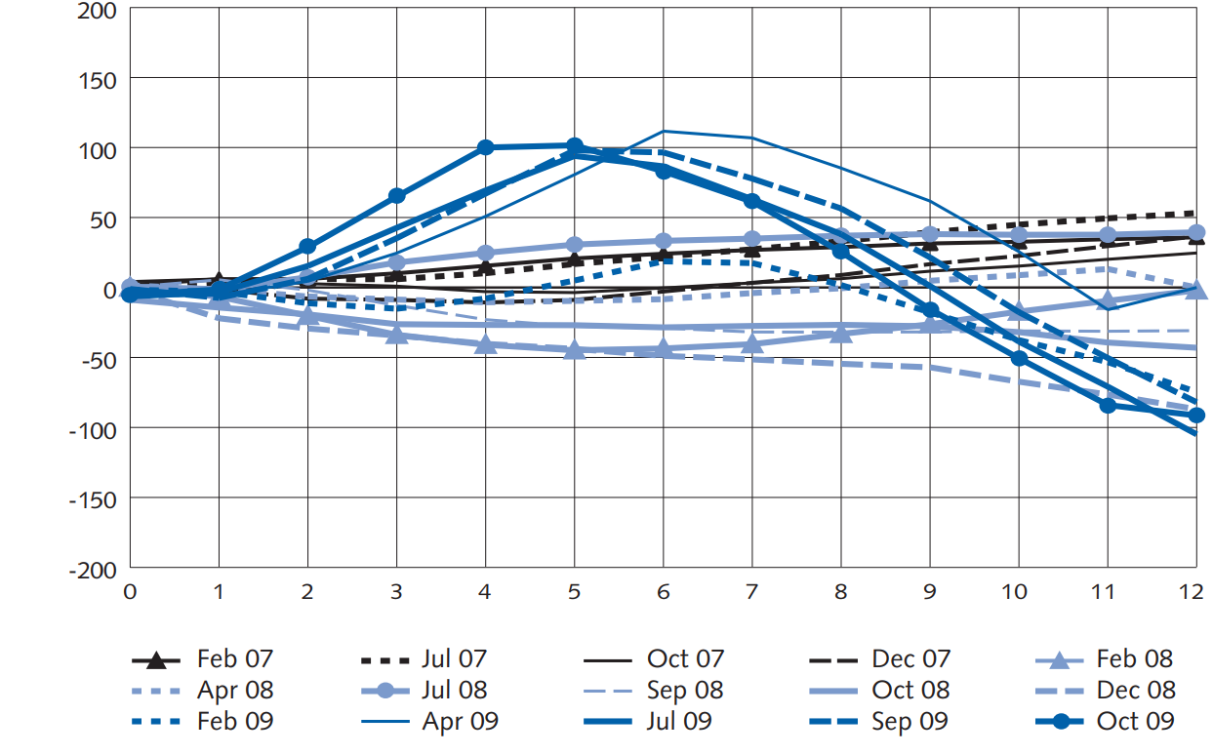

Notes: Vertical axis = the difference between market expectations of the policy rate and the policy rate published by the Riksbank after each quarterly policy decision; Horizontal axis = the number of quarters after the quarter of the policy decision.

Source: L. Svensson. 2010. “Policy Expectations and Policy Evaluations: The Role of Transparency and Communication.” *Sveriges Riksbank Economic Review*. <https://larseosvensson.se/papers/polexpevalabs/>.

The answer to the first question is easy: Lars Svensson argued that *the central bank did not communicate its intentions clearly*. The Riksbank policymakers mentioned “some probability of a further cut in the future”, however, they also emphasized that “the rate is now close to its lower limit” and that “the traditional monetary policy has largely reached its lower limit”. The financial markets read these statements as an indication that the Riksbank would sooner rather than later lift its policy rate from the then-level of 0.25 percent, that is, the effective zero lower bound.

Let’s now answer the second question: Why should such a minute misunderstanding cost the economy dearly? If there is a difference between the policy rate path that the central bank prefers and the path that the market expects, *it is the path expected by the markets that matters*. The path that the markets expect determines what the actual market rates for lenders and depositors will be, thus affecting the economy. All else being equal, a market-expected path that is *higher* than the central bank’s published path means that the actual lending rates will be *higher* than those intended by the policymaker. Hence, Swedish policymakers’ communication, which was misunderstood by the financial markets, ended up being costly for the economy, imposing tighter monetary conditions than what was needed. The ensuing economic slowdown in 2010–2011 was probably deeper than it would have been without such misunderstanding!

A lot of evidence suggests that greater transparency leads to more predictable short-term interest rate movements and increased stability in long-term interest rates and inflation expectations. Drew and Karagedikli (2008) documented this link for New Zealand and Jansen (2011) for the United States.

Thus, it should not come as a surprise what policymakers then began to say during the 2010s about the need to communicate clearly:

<INTERACTIVE COURSE PRESENTATION_START>

“*…a transparent central bank contributes to its own mission, by steering expectations and making its monetary policy more effective*.”

— Mario Draghi, President of the European Central Bank (2011–2029), speaking at a 2014 conference, <https://www.bis.org/review/r140424b.htm>



<<https://en.wikipedia.org/wiki/File:Mario_Draghi_in_2021_crop.jpg> >

“*Monetary policy is 98 percent talk and only 2 percent action. The ability to shape market expectations of future policy through public statements is one of the most powerful tools the Fed has*.”

— Ben S. Bernanke, Chairman of the Federal Reserve System (2006-2014), writing in a 2015 blog, <https://www.brookings.edu/articles/inaugurating-a-new-blog/>

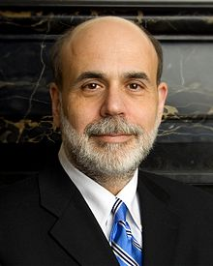

<https://upload.wikimedia.org/wikipedia/commons/thumb/3/3f/Ben_Bernanke_official_portrait.jpg/330px-Ben_Bernanke_official_portrait.jpg >

<INTERACTIVE COURSE PRESENTATION_END>

# SECTION 2: Transparency and Clarity

## UNIT 2.1: Institutional Communications Framework

The general principles for effective communications and the overall communications framework are applicable across a range of institutions and policies. These principles were summarized in IMF (2015) and IMF (2018), which argues the following best international practices:

<HOTSPOT 1.2.1a_START>

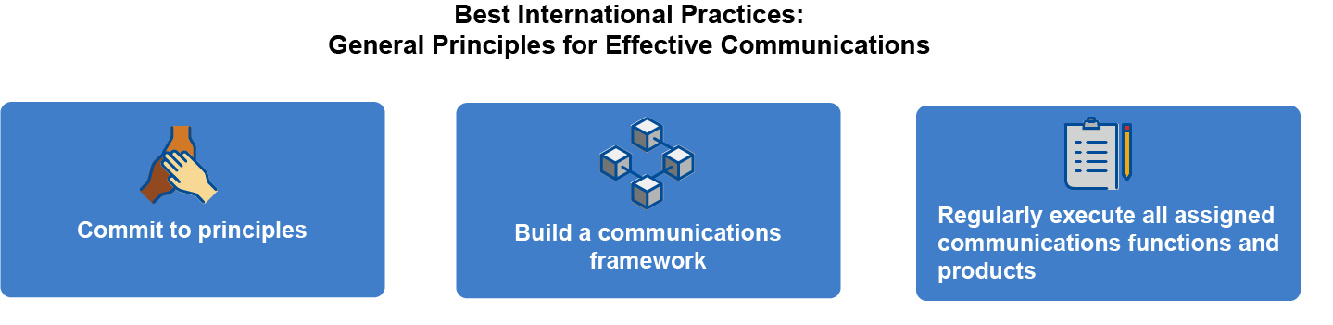

* **Commit to principles** for effective communications, such as *transparency and clarity, timeliness, precision, consistency, predictability, and equal access to information*. We will discuss transparency and clarity next.
* **Build a communications framework** that covers *objectives, principles, communicators, messages, audiences, channels and formats, and impact assessment*. Such a framework provides a basis for developing more effective communication strategies, tactics, and products.
* **Regularly execute all assigned communications functions and products,** including the *organization of the flow of information, procedures, guidelines and processes, and structure and staffing*. The list of communications is long and includes a calendar of policy decisions, press releases, press conferences to further explain the decisions, periodic policy reports, minutes of policy discussions, and speeches and interviews. The principle starts with adhering to a calendar of events agreed well in advance.

<HOTSPOT_END>

**The principles support the delivery of a compelling narrative on how the institution is achieving its policy objectives.** Having these elements in place is beneficial in both normal times and in periods of stress. When addressing these principles, it is important to distinguish strategic communications issues from operational ones.

<HOTSPOT 1.2.1b_START>



(1) *Strategic issues,* such as goals and principles, along with stable institutional-wide procedures, should be approved by the management of the institution and focus on longer-term institutional and interdepartmental matters that are not likely to require changes for some time.

(2) *Operational issues* are managed by departments and divisions on a day-today basis and should be kept out of strategic documents to preserve operational flexibility and adaptability, including by adapting new technologies and techniques.

<HOTSPOT_END>

## UNIT 2.2: Role of Transparency and Clarity

Let us focus on two key elements from the above list. Effective policy communication requires that the communicating institution (1) embraces transparency and (2) acquires necessary communication tools and skills. Having explored the evolution of policy communication and the realized benefits, we now focus on what transparency and clarity mean in practice and how to “measure” them.

### <VIDEO 2.1> “The Role of Transparency and Clarity” [word count: 346]

There is one quote about communication that I like a lot. American author Seth Godin once wrote: “*Maybe, instead of insisting that people listen more closely, you could speak more clearly*.”

Can an institution that’s transparent also communicate poorly or unclearly?

What is clear communication, anyway?

Finally, transparency and clarity: how are these two related?

Being transparent is a choice that governments and other institutions make. Theybelieve that by being transparent and predictable, they will assist households and firms in their decision-making.

Transparency does not mean publishing immediately everything that the institution thought, wrote, or said about its various activities. Public institutions think, write, and say A LOT and not all of it is of interest to the public.

On any given day, a central bank makes dozens of decisions that COULD be published on its web, on social media, in papers or on TV. The monetary operations department purchased so many ounces of gold; the research department published two papers dealing with this and that; the Governor spoke at a lunch with captains of industry; and so on. I hope you see where I’m going with this: large volumes of information are of little use if they have the potential to confuse or bore the intended recipients. Publishing “everything” could just lead to an unhelpful cacophony of voices.

Indeed, a transparent institution can be a poor communicator. Rather than informing the recipients it can overwhelm them. To put it differently, transparency is a necessary first step toward effective policy communication. But it is not sufficient.

Clarity is an equally important dimension of communication. If the message is clear, the markets and public will understand where monetary policy is heading and will adjust their expectations of future policy rates and inflation as the bank intended. If the message lacks clarity, the public’s expectations will diverge from policymakers' intentions.

So, here comes the key lesson. **Decide what you need to be transparent about. Find out what matters to the public and formulate a set of clear and consistent messages.**

**<END OF VIDEO >**

## UNIT 2.3: How to Measure Transparency and Clarity?

There is shared agreement that transparency and clarity improve the effectiveness of public policies and provide the basis for accountability. An institution that is not transparent about what it is doing does not have much to communicate. Increased recognition of these principles has led central banks and other policymaking agencies to devote considerable resources and effort to improving their transparency. Most of the research on measuring transparency was done for central banks, but ministries of finances are getting fair amount of attention as well (Unsal, Papageorgiou, and Garbers (2022) review the literature on central bank transparency; End and Hong (2022) do the same for fiscal transparency).

Clarity of communication can be “measured” as well. Specifically, for the central bank case, one can ask whether the verbal description of inflation factors (the narrative) is aligned with macroeconomic projections and policy rate decisions. One can ask whether the public would be able to “replicate” the policy decision with the information provided in central bank communication (Bulíř, Čihák, and Šmídková 2012). If the public would, then communication has been clear. If they would not, then communication was not clear, and it may have confused the recipients rather than guided them.

To learn more about alternative indexes of policy transparency and measurements of clarity, review <PDF #2 and PDF #4>.

What does an institution need be transparent about? There are clearly many criteria to assess policy communication, but they can be summarized into three broad groups that cover all communication aspects in which the public is interested. The institution needs to be transparent about:

<INTERACTIVE ACCORDION OR HOTSPOT_START>

1. **Objectives**. Policymakers must make clear what they are mostly trying to achieve. The primary role of monetary policy is to provide a nominal anchor for the economy, either through maintaining an exchange rate peg, monetary aggregate target, or fulfilling an inflation target. A primary macroeconomic objective for a ministry of finance ensures that the public debt remains sustainable, while providing the agreed public goods. Well-defined objectives will underpin the expectations of the public about the exchange rate, inflation, the trajectory of debt, and so on.
2. **The analytical and forecasting framework**. This step is more important than it may initially seem. By explaining their analytical and forecasting framework, policymakers will give the public a chance to assess how reasonable their forecasts are. Consider a central bank with an objective of keeping the national currency pegged to the U.S. dollar or the euro. The peg will not be credible unless the central bank talks about its foreign exchange reserves, balance of payments flows, and its intervention policy. This task is even more acute for inflation targeting central banks—they tend to go to great lengths to explain their forecasting and policy analysis systems. See, alphabetically, the Czech central bank [here](https://www.cnb.cz/en/faq/How-is-the-forecast-drawn-up/) and [here](https://www.cnb.cz/en/monetary-policy/monetary-policy-reports/boxes-and-articles/The-updated-g3-core-forecasting-model-and-the-shadow-forecast/), the Bank of Ghana [here](https://www.bog.gov.gh/monetary-policy/our-monetary-policy-framework/), Bangko Sentral ng Pilipinas [here](https://www.bsp.gov.ph/Price%20Stability/targeting.pdf), and the Swedish central bank [here](https://www.riksbank.se/en-gb/monetary-policy/the-path-to-a-monetary-policy-decision/the-riksbank-makes-forecasts/).
3. **Policy process**. Finally, the public must be able understand the decision-making process in the institution. No central bank follows a model or a rule blindly: the decision-making process is typically a mix of “technical” work and expert judgment, spiced with a fair amount of political economy. The release of forecasts for output and inflation are key news items for the business and financial media. Forecasts change over time, because of new information, and of changes in its interpretation of economic developments. In turn, policymakers’ evolving views on the economic outlook are a central element in the analyses and discussions of academics, financial market participants, and commentators in the business media, who are the main conduit of information to the public.

<INTERACTIVE ACCORDION OR HOTSPOT_END>

If this seems like a tall order, it is! The good news is that there is no need to reinvent the wheel—the advanced-country central banks of Sweden, New Zealand, or Czechia or ministries of finance of Canada, Australia, New Zealand, and the United Kingdom offer plenty of examples to follow.

Look at the standard preface of the Czech National Bank’s Monetary Policy Report.

<https://www.cnb.cz/export/sites/cnb/en/monetary-policy/.galleries/monetary_policy_reports/2024/spring_2024/download/mpr_2024_spring.pdf>

Can you identify the objectives? Are they clearly defined? How about the forecasting and policy analysis system? Do you understand how the policy decision is taken? What is the policy instrument?

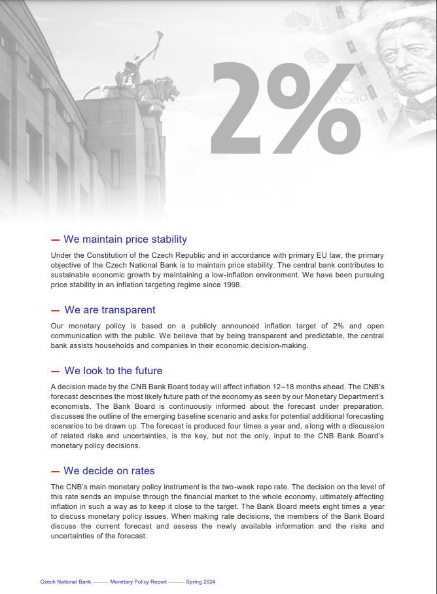

## UNIT 2.4: Communicating with Transparency and Clarity in Mind—Best Practice in Central Banks

Central banks have been at the forefront of policy communication and their experiences carry over to other public institutions. Of course, it is not one-size-fits-all. The best practice depends on the policy framework, the analytical level of the institution, the available channels, and stakeholder level of sophistication. However, there is general agreement on four key building blocks.

<INTERACTIVE ACCORDION OR COURSE PRESENTATION_START>

1. **Objectives of monetary policy**

It’s worth repeating the institutional mandate in every communication. The policymaker ought to frame all his policy decisions as leading toward the primary objective. For example, each Czech National Bank Monetary Policy Report features the same message on its first page:

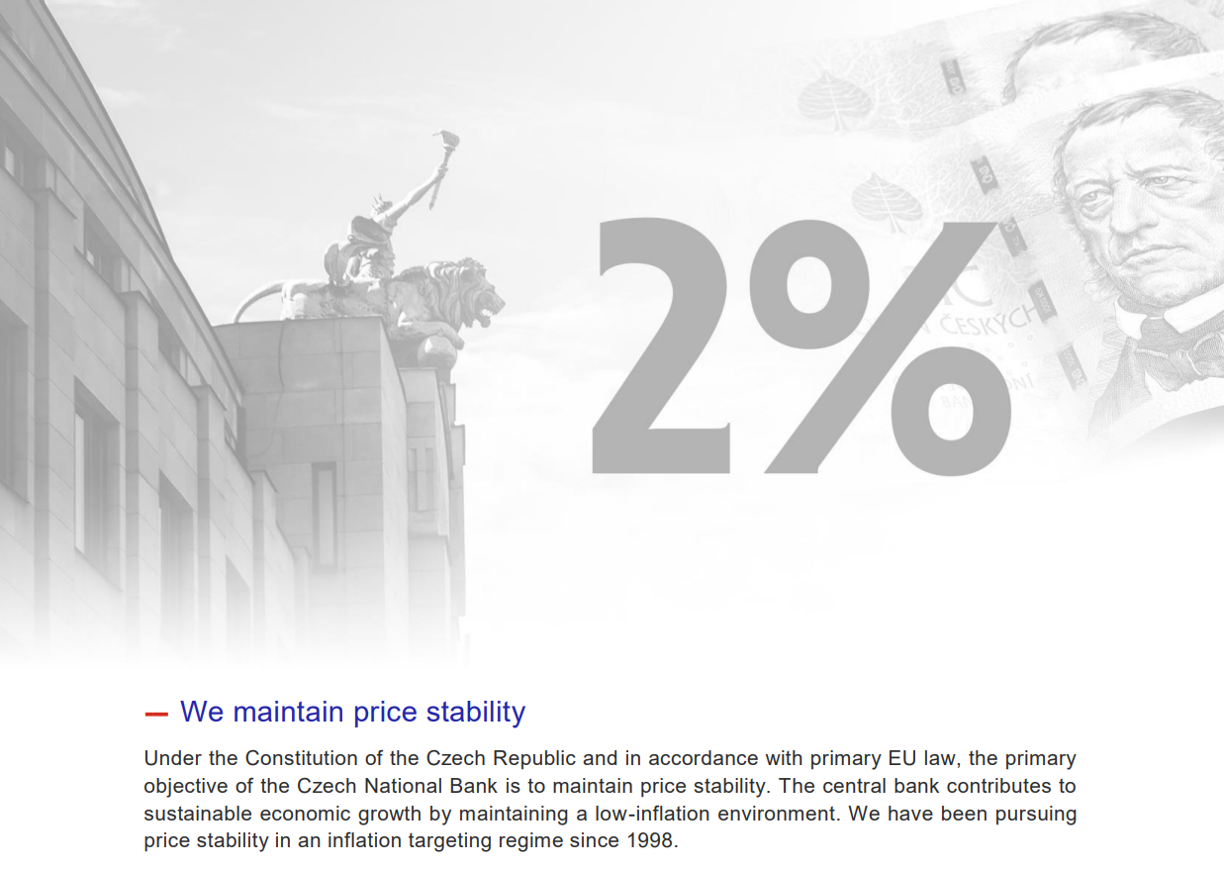

Note that both objective and the explicit numerical targets are given.

Communication of the primary objective is not trivial. For example, most inflation targeting countries have changed their definitions several times during the last 30 years. There are pros and cons to using the alternative definitions <Link to PDF#4>.

1. **Strategy of monetary policy (how to achieve the objectives)**

Monetary policy should be explained in words that both experts and laypersons can understand.

See examples from the Reserve Bank of New Zealand (2024) <https://www.rbnz.govt.nz/-/media/project/sites/rbnz/files/monetary-policy/about-monetary-policy/the-monetary-policy-strategy-2024.pdf> and from the Bank of Ghana <https://www.bog.gov.gh/monetary-policy/our-monetary-policy-framework/>. Both are aimed at educated readers with relatively advanced understanding of key economic concepts and language.

Central banks may also try to make it simpler through a video that explains monetary policy in layperson’s terms. See the Swedish Riksbank take on this task.

<https://www.riksbank.se/en-gb/press-and-published/riksbanken-play/2020/what-is-monetary-policy/>

1. **Economic outlook and risks**

While the first two blocks can be nontechnical, economic outlook and risks require both technical output and its translation into non-technical language. Economic outlook (the central bank’s macroeconomic forecast) gives financial experts a chance to understand the analyses that underpin policymakers’ decisions. The practice of individual central banks differs, depending on the monetary policy framework in place and the economic environment in which they operate. Central banks in low-income, resource-rich countries encounter distinctive challenges in their communication strategies due to economic volatility, heavy reliance on natural resources, and underdeveloped financial systems.

Let’s zoom in on the communication challenges in alternative monetary regimes.

<HOTSPOT START>

* Communicating monetary policy in an *inflation targeting regime* has well-established best practice:
  + Interest rate and inflation are two well-known concepts.
  + The key challenge is to explain the policy tradeoff: to keep inflation low monetary policy has to occasionally slow down the economic growth
  + The interest rate link to the business cycle inflation is understood:
    - Inflation (expected to increase) above target—increase the interest rate
    - Inflation (expected to decrease) below target—lower the interest rate
* Communicating policy in a *money targeting regime* is more challenging.
  + The money target is an indirect target, implying some interest rate which will affect inflation. It is an indirect and complex approach that is not easy to communicate.
  + Reserve money is a difficult concept—the public understands only notes and coins.
  + The target is set as a rate of growth—difficult for public to distinguish when it is meant to stimulate and when not.
* Communicating policy in a *“fixed” exchange rate regime* easily becomes a “sensitive” story.
  + The ER regime itself can be complex, with multiple options: a basket of currencies, a crawling peg, an exchange rate band, a currency board and so on.
  + The link between a “fixed” ER and domestic price stability—“we are importing the price level from abroad”—is complex and difficult to understand for the layperson.
  + Inflation developments are not fully under the central bank’s control—fiscal policy becomes the driver of the business cycle—while price stability remains the responsibility of the central bank.
  + The stability of the “fixed” ER regime depends on the level of foreign exchange reserves. This is often a delicate issue that calls for transparency!

<HOTSPOT_END>

Still, common traits can be found! The most transparent central banks will reveal their projections of the four key variables: inflation, output, the policy interest rate, and the exchange rate. As of 2024, however, the number of central banks publishing all four variables was barely in the double digits.

This is what the Norwegian central bank published in its 2024 Monetary policy report <https://www.norges-bank.no/contentassets/1c8d6c55dbc84a749396db8f82b7be44/mpr_1-24.pdf?v=21032024092308>

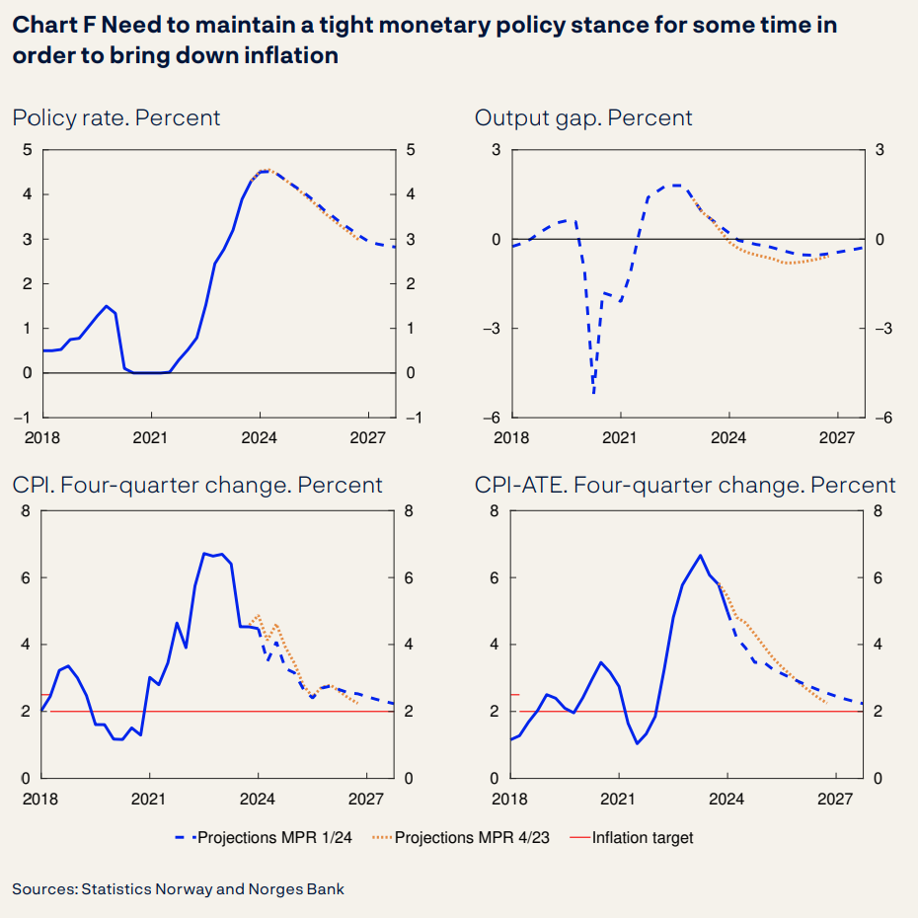

p.9

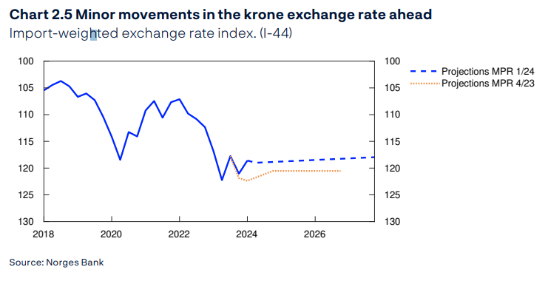

p.20

1. **Policy decisions and forward guidance**

Should the central bank decide to publish its own projection of the policy rate (or the exchange rate), it must make clear to the public that this is a *forecast*, not a *commitment* to a specific value in some distant future. This is how the Norges Bank went about it in its March 2024 Monetary Policy Report <p.8 <https://www.norges-bank.no/contentassets/1c8d6c55dbc84a749396db8f82b7be44/mpr_1-24.pdf?v=21032024092308>> [stress added]

*The forecast in this Report indicates that the policy rate will continue to lie at 4.5 percent in the period to autumn before gradually moving down. […]*

*There is uncertainty about future developments in the Norwegian economy. […] If cost inflation remains elevated or the krone turns out to be weaker than projected, inflation may remain high for longer than currently projected. In that case, the Committee is prepared to raise the policy rate again. If there is a more pronounced slowdown in the Norwegian economy or inflation declines more rapidly, the policy rate may be lowered earlier than currently envisaged.*

Explore alternative approaches to communicating uncertainty of macroeconomic forecasts and their implications for policy decisions and forward guidance in **<PDF #5>**.

<INTERACTIVE ACCORDION OR COURSE PRESENTATION_END>

Now, please reflect on the above Norges Bank policy decision and forward guidance example:

* Do you understand the narrative?
* What is the current decision?
* What is the forward guidance?
* Is it clear that policymakers reserve their right to change the stance of monetary policy as needed?
* What would guide their decisions? How would you explain this to the policymaker in your institution?

## UNIT 2.5: Selected Recent Communications Challenges

Let’s close this module with a reminder of a few recent communication challenges. Please reflect on your institution communications in light of these challenges.

* **The COVID-19 pandemic.** 
  + The pandemic saw monetary policy decisions presented as part of an overall policy package, with little emphasis on central banks’ primary mandates, notably price stability. Did central bank communications in your country adequately defend its mandate during this episode?
  + The ministries of finance were seen as “underwriting” the whole economy with massive fiscal stimuli. The resulting fiscal deficits dramatically increased public debt, pushing many low-income and emerging market countries near a sovereign debt crisis, thus necessitating fiscal consolidation. How is this policy change communicated in your country?
* **Reviews of the policy frameworks.** Major central banks (Fed, ECB, and Bank of Japan) as well as others (Bank of Canada, Bank of England) have reviewed their policy frameworks recently. These institutions exert heavy influence on both global market conditions and central bank practices in other countries, so it is important to view central bank actions in your home country relative to the global environment, both in terms of policy and communications practices.
* **Recent inflation forecast error and related communications challenges.** A major forecast and policy errors occurred, as the COVID-19 pandemic receded. Inflationary pressures from both supply-side pressures as well as oversized fiscal stimuli were viewed as “transitory” and agencies failed to tighten monetary and fiscal policies in a timely manner. The result was several years of inflation exceeding the official inflation objectives. Most central banks and treasuries in their communications sought to minimize their responsibility rather than squarely address the reasons for their misjudgment. Important lessons for communications can be learned from this sequence of events. Was this a major problem in your institution/country?

## UNIT 2.6 Knowledge Check

**1. <Multiple choice>** Consider the following scenario. After peaking in mid-2023, by January 2024 inflation appears to be declining toward the central bank’s target. The central bank provides “forward guidance, communicating a cautiously declining path of its policy rate (red line), implying perhaps two 25-basis-point cuts during the second half of 2024. In contrast, the financial markets are much more optimistic and expect four or even five cuts during 2024, with the first cut as early as in February 2024. We can visualize this situation in the following picture:

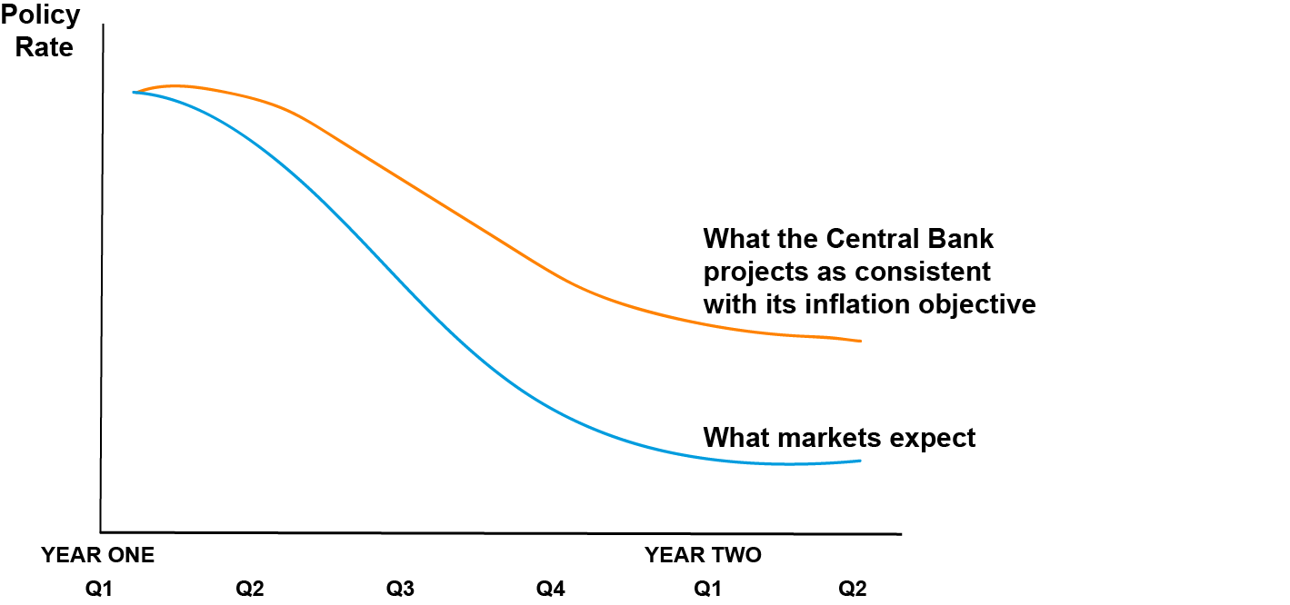

***What does such a difference in these two interest rate paths mean for the monetary and credit conditions in the economy and future inflationary developments?***

1. It has no impact on the economy as the policy interest rate does not affect credit interest rates.

**<Feedback>** This is **incorrect**. Policy interest rate changes pass through into lending rates. Try again.

1. Monetary and credit conditions will be tighter than the central bank intended in its macroeconomic forecast and inflation will likely be lower than projected.

**<Feedback>** This is **incorrect**. Lending rates will follow the market expectations and will therefore be higher than the level envisaged by the central bank in its forecast. Try again.

1. Monetary and credit conditions will be looser than the central bank intended in its macroeconomic forecast, stimulating the economy, and inflation will likely be higher than projected.

**<Feedback>** This is **correct**. Lending rates will follow the market expectations and will therefore go below the level envisaged by the central bank in its forecast. As a result, all interest rates in the economy will be lower than those predicted by the central bank’s macroeconomic forecast. Such lower rates will overstimulate the economy and inflation will likely end up being higher than projected in the central bank forecast.

1. It is impossible to tell as we do not know whether lenders will follow the central bank forecast or market expectations.

**<Feedback>** This is **incorrect**. Financial market expectations are formed and published by banks and other financial institutions rates. It is very unlikely that a financial analyst from a bank would publish an interest rate forecast that is different from this bank’s view. Try again.

2. **<Multiple choice>** Building on the example of two diverging policy rate paths from the <Knowledge Check #1>, what can the central bank do to align the market expectations of interest rates with its own preferred path of the interest rate?

1. The central bank cannot do anything—the central bank cannot force market participants to change their views.

**<Feedback>** This is **incorrect**. Changes in market expectations do not require any arm twisting by the policymaker. Try again.

1. The central bank should adopt the “wait and see” approach. Surely the financial markets will come around.

**<Feedback>** This is **incorrect**. Ignoring the divergence in views will invalidate the central bank’s forecast—actual inflation will be different from the forecast because monetary conditions will be different from those intended by the central bank. Inactivity will damage central bank’s credibility. Try again.

1. The central bank should cut the rate in line with what the financial market experts predict. After all, markets know the best.

**<Feedback>** This is **incorrect**. The central bank’s interest rate forecast is as such to bring inflation back to the target, thus satisfying the primary objective of the central bank. Cutting the rate below its own forecast implies that either the initial central bank forecast was off the mark or that the central bank is giving up on its primary objective. Try again.

1. The central bank must communicate its own forecast more clearly. If needed, it could hike the policy rate.

**<Feedback>** This is **correct**. Providing the policymaker believes that the path of the policy rate will deliver inflation at the target level, it should bring market expectations closer to its own. A hike in the policy rate may be needed to reinforce the policymaker’s view about the appropriate level of interest rate to achieve the central bank primary objective of price stability.

3. **<Multiple choice>** What is a key benefit of transparent communication from organizations and governments during a crisis or pandemic situation?

1. It increases public trust in the organization/government by providing substantive information, accountability, and opportunities for participation.

**<Feedback>** This is **correct**. Transparent communication with substantive information, accountability, and public participation helps build public trust in public institutions. Transparent communication is seen as crucial for fostering long-term relationships with the public.

1. It reduces the need for employees to ask questions or provide feedback since all information is openly shared.

**<Feedback>** This is **incorrect**. Transparency requires the opposite—it expects greater engagement by employees in the dialog with the public.

1. It allows organizations to avoid taking responsibility for mistakes or poor decisions.

**<Feedback>** This is **incorrect**. If anything, the opposite is true—policy mistakes ought to be discussed in order to learn from them.

1. It leads to information overload for the public since too many details are shared.

**<Feedback>** This is **incorrect**. Transparency does not lead to information overload. Bad communication leads to information overload.

**<PDF #1>**

**What Is a Policy Reaction Function?**

|  |  |
| --- | --- |
| In 1992, Professor John Taylor published an article in which he argued that he can replicate the seemingly complex decisions by the central bank by using a simple formula. |  |

The Taylor rule suggests that the central banks were adjusting the policy interest rate in response to deviations of inflation from its target level and deviations of output from its potential level. Specifically, the original Taylor rule formula was:

***i* = *p* + 0.5y + 0.5(p - 2) + 2,**

*where i = the interest rate; p = the rate of inflation, and 2 is the inflation objective of the central bank; y = the output gap (percent deviation of real GDP from potential GDP; and the constant of 2 indicates the neutral real interest rate, a level at which inflation would be neither increasing nor decreasing).*

The rule says that the U.S. Fed would increase the interest rate by 0.5 percentage point for each 1 percentage point that inflation exceeds its 2% target and by 0.5 percentage point for each 1 percentage point that output exceeds its potential level.

The rule aims to stabilize inflation around 2% and output around its potential level. When inflation is at the target level of 2% and output is at potential, the rule prescribes a policy rate of *p* + 2 = 2 + 2 = 4%, which was at that time the historical average of the U.S. policy rate.

Of course, no central bank governor would follow the Taylor Rule blindly. The rule simply provided a benchmark against which to assess monetary policy decisions.

Do you want to know more about the origins of the Taylor Rule? [Read Asso, Kahn, and Leeson. 2007. “The Taylor Rule and the Transformation of Monetary Policy.”](https://www.kansascityfed.org/documents/541/pdf-rwp07-11.pdf) Federal Reserve Bank of Kansas City working paper.

**<END OF PDF>**

<PDF #2>

**Transparency Indexes**

Economic literature offers multiple indexes that measure transparency of an institution. For example, [Dincer and Eichengreen (2014)](https://www.ijcb.org/journal/ijcb14q1a6.pdf) and Dincer, Eichengreen, and Geraats (2022) is one of such indexes for central banks—they calculate and periodically update measures of central bank transparency for more than 120 countries based on five broad criteria: political, economic, procedural, policy, and operational. Two results are quite clear. First, the advanced countries lead the way. Second, pretty much everybody has gotten more transparent over time.

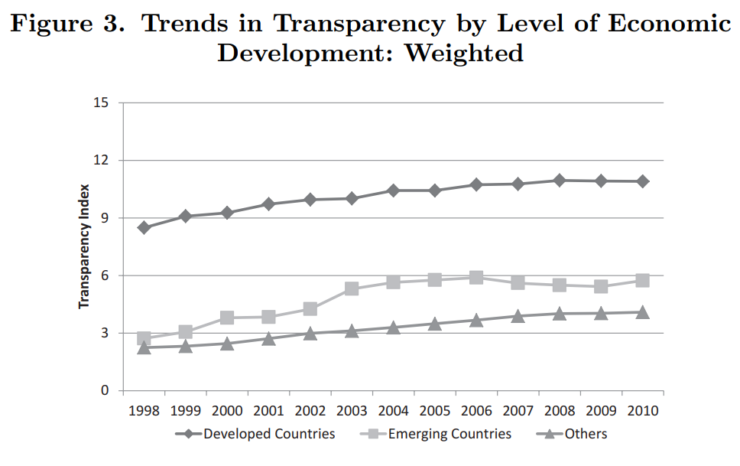

Source: Dincer and Eichengreen (2014).

A more recent IMF index by [Unsal, Papageorgiou, and Garbers (2022)](https://www.imf.org/-/media/Files/Publications/WP/2022/English/wpiea2022022-print-pdf.ashx) provides a more granular approach to measuring central bank transparency.

Ministries of finance have been pressured to be more open about their activities as well. Organizations such as [*Open Government Partnership*](https://www.opengovpartnership.org/open-gov-guide/fiscal-openness-open-budgets/) *(OGP)* or [*International Budget Partnership*](https://internationalbudget.org/open-budget-survey/) have long pushed for fiscal transparency. The goals of Open Budgets are summed up as follows:

*Every year, governments collect and spend billions of taxpayer funds to pay for public services like education and healthcare. The public has a right to know how that money is allocated and how it is spent. Making budgets open to public input and scrutiny can help ensure that government planning and spending align with public priorities. In particular, people should be able to see that money is spent equitably, addressing the needs of women, people with disabilities, youth, and low-income groups, among others. OGP members have made their budgets increasingly transparent, yet more work remains for governments to proactively increase civic participation and oversight.*

**<END OF PDF>**

<PDF #3>

**Readability as One Dimension of Clarity**

Assessing the clarity of policy communication needs to be approached from several angles. But there is a relatively straightforward test to tell whether the text is *readable*.

The Flesch–Kincaid readability tests1 are designed to indicate how difficult a passage is to understand. The *Flesch–Kincaid Grade Level Formula* presents a score as a U.S. grade level, suggesting the number of years of education generally required to understand the text (there are also Flesch–Kincaid tests for other languages). The Flesch–Kincaid calculation is mechanical, weighing word length and sentence length.

Texts that are difficult to read (and understand) have different impact on markets than texts that are easy to read (Jansen, 2011; Bulíř, Čihák, Jansen, 2012). While some central banks have provided easy-to-understand English writings, others have made understanding of its intentions more difficult for the reader. As an example from Bulíř, Čihák, Jansen (2012), while a reader of a Bank of England press statement would need about 12 years of schooling (that is, to finish high school) to comprehend the statement, a reader of Bank of Thailand would need about 16 years (that is, to complete four years of college).

Chart 1. Summary Statistics for Readability of Press Statements (Flesch-Kincaid grade level, 1997–2010).

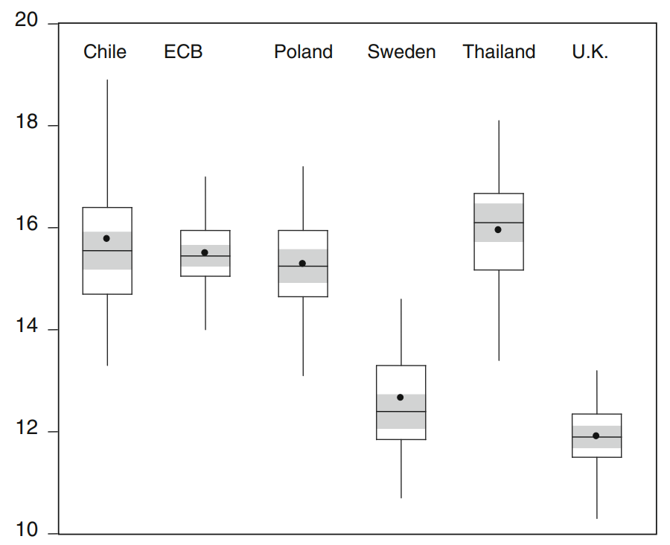

Note: The boxplot denotes the sample mean with a circle; the median and its 95 percent confidence interval with a line and the shaded area, respectively; the left and right sides of the box indicate the lower and upper quartiles; the whiskers are defined as the first quartile *minus* 1.5*interquartile range (IQR) and the third quartile *plus* 1.5*IQR.

Source: [Bulir, Cihak, and Jansen 2012](https://ales-bulir.wbs.cz/bulir__cihak__jansen__what_drives_clarity__oer.pdf).

Of course, the Flesch–Kincaid score does not ensure that the meaning of text is necessarily clearer. It only looks at word length and sentence length.

Let’s look at another example: a sentence from the Swedish central bank Monetary Policy Report (Table 1). It contains a lot of long, foreign words. As a result, it has a very high Flesch–Kincaid grade score—the reader should have finished a master’s degree and started on their PhD!

We then asked an artificial intelligence model to rewrite the sentence in the style of William Shakespeare, which yielded a sonnet! The sentences are short and so are the words, giving us a very low Flesch–Kincaid grade level of 6. To comprehend this rewritten sentence, only six years of schooling should now suffice. Do you think central banks should write in Shakespearean style from now on?

Table 1. Readability Contest: Modern Economist versus William Shakespeare

|  |  |
| --- | --- |
| **Text** | Flesch–Kincaid **Grade Level Score** |
| **The original sentence as in Riksbank’ Monetary Policy Report**  Since September 2017, the Riksbank has used a variation band of 1–3 percent for the outcomes for CPIF 1 inflation, to illustrate that monetary policy cannot micromanage inflation. | 17.6 |
| **The sentence written in the style of William Shakespeare by AI (Perplexity)**  Since autumn's month of nine and ten,  The Riksbank hath a varying band to ken,  From one to three, the range doth lie,  For CPIF's inflated breath to ply.  A lesson plain, that coin and rate's command,  Cannot micromanage th'inflated land.  For monetary policy, howsoever wise,  Hath limits in its sphere where inflation lies. | 5.7 |

1 Consumer price index with a fixed interest rate

What is the lesson from this tongue-in-cheek example? Mechanically assessing readability using the Flesch–Kincaid score is only a small part of assessing the clarity of communication. The original Riksbank sentence is written in economist jargon (“variation band”; “CPIF inflation”; “monetary policy cannot micromanage”), making it a challenging read for a layperson. Shakespeare is not the answer, either. While the words may sound clearer, it is doubtful that anyone—including the experts—would understand Riksbank’s intention.

**<END OF PDF>**

<PDF #4>

**How to Communicate the Primary Objective**

The public needs to be aware of what it is the institution trying to achieve. Let’s look at the seemingly simple task of communicating the inflation objective.

Virtually all central banks list domestic currency stability as their primary objective. Furthermore, this objective is typically clarified as a numerical goal (target), expressed as annual percent change in the consumer price index.

But how exactly should the target be specified? Assume that the policymaker has in mind inflation of about 2 percent per annum, but he is aware that the central bank can achieve precisely 2.0-percent inflation only by sheer luck. There are several communication possibilities seen at various central banks and their associated advantages and challenges.

**Possible Ways of Communicating a 2-Percent Inflation Target**

|  |  |  |
| --- | --- | --- |
| **The central bank will aim…** | **Advantages** | **Disadvantages/Challenges** |
| …at achieving price stability. | None | Does not anchor expectations  Not transparent |
| …at achieving inflation of 2% inflation over the medium term. | Specific number will anchor expectations | The central bank seems concerned only about a longer horizon. Will it care about inflation today? What is the medium term? How to assess the fulfillment of such an objective? |
| …at keeping inflation in a range of 1-3%. | Easier to fulfill | Does not anchor expectations well: markets may doubt that the mid-point of 2% is the true target. |
| …at 2% inflation with a ±1percent tolerance band. | Easier to fulfill | Somewhat misleading message—the policymaker does not “tolerate” inflation. Markets may infer that the policymaker will react to inflation only if more than 1 percentage point from the target. |
| …at 2% inflation. | Anchors expectations | Difficult to fulfill the target. How to communicate the inflation forecast? What if it takes a long time to get back to the target? |

From the menu of five options, let’s look at the last two options, the inflation target with a tolerance band and without one.

**Brazil: Inflation target with a tolerance band**

We will start with Brazil. The following was reported by Reuters on May 15, 2024: *Brazil's central bank chief Roberto Campos Neto said […] that the monetary authority is committed to pursuing its 3% inflation target, and that its policy discussions should "not even mention" the center and band of that goal*.

What was the problem and why did this statement make a headline?

The central bank has had an inflation target of 3 percent with a so-called tolerance interval of ±1.5percentage point. Chart 1 shows inflation performance until April 2024 (IPCA inflation, blue line) and survey of inflation expectations until April 2026 (Focus, red line).

**Chart 1. Brazil: Inflation Expectations Stay Above the Target**

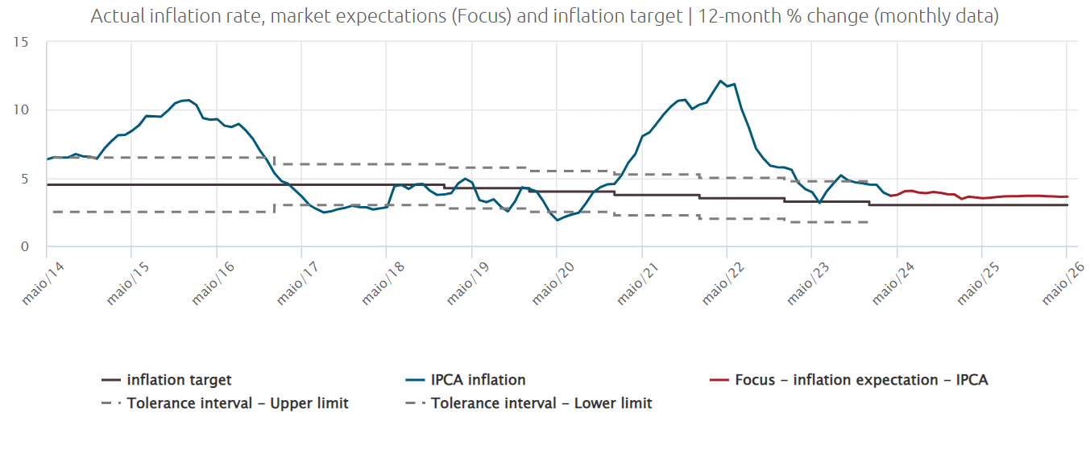

Source: [Banco Central Do Brasil](https://www.bcb.gov.br/estatisticas/detalhamentoGrafico/graphicstatistics/precos), extracted on May 17, 2024.

First, the Governor realized that the expectation of inflation was significantly higher than the 3-percent target during the two-year period from May 2024 to May 2026. In other words, the public does not believe that the central bank will meet its objective. Second, he wanted to assure the markets and the public that the policymakers are indeed targeting 3 percent, “anchoring” expectations at 3 percent. To stress this point, he wants to downplay the importance of the tolerance band, claiming that it is not binding in their deliberations (it “should not be mentioned”).

Do you see Mr. Campos Neto’s predicament? On the one hand, the tolerance band helped to explain that inflation is volatile and that it cannot be “fixed” at 3 percent. On the other hand, it contributed to unmooring of inflation expectations as actual inflation accelerated in late 2020 and did not return quickly to the target by early 2024.

**Sweden: Inflation target as a single number**

What about the last option of setting the target as a single number, without any qualifications? For example, the Swedish central bank uses such a framework: Riksbank’s target is specified as an annual rate of increase of 2 percent for the consumer price index. Of course, this setup has required additional clarification as no central bank can keep inflation at a precise number all the time. The so-called variation band is to signal to the public that ±1percent volatility of inflation around the target is quite normal and is to be expected.

In 2018, the Riksbank used the following clarification on its website:

*“Although the aim is that inflation shall be 2 percent, outcomes will always vary around the target. To illustrate in a simple manner the fact that monetary policy has little ability to steer inflation in detail, the Riksbank uses a variation band in its monetary policy communication with effect from September 2017. A variation band that stretches between 1 and 3 per cent captures approximately three-quarters of outcomes for CPIF inflation since mid-1995. The variation band does not affect the formulation of monetary policy. The Riksbank always aims for 2 per cent inflation, regardless of whether inflation is initially inside or outside the variation band.”*

The formulation gradually evolved and in 2024 it read:

*“Since September 2017, the Riksbank has used a variation band of 1–3 per cent for the outcomes for CPIF inflation, to illustrate that monetary policy cannot micromanage inflation. The variation band is intended to show that inflation varies around the target and will not be exactly 2 per cent every single month. However, the objective of monetary policy is still that inflation shall be 2 per cent, the variation band of 1-3 per cent is not what is known as a target interval.”*

Before going to the next module, reflect on the following above example from Sweden:

* What is the main communication challenge of having a single-number target, say 2 or 3 percent?
* Which of the two Riksbank clarifications above do you find easier to understand?

**<END OF PDF>**

<PDF #5>

**How do you communicate uncertainty surrounding the forecasts of inflation and other macroeconomic variables?**

Central banks produce forecasts knowing well that these projections are unlikely to materialize exactly. For sure, the economy is going to be hit with some unexpected domestic or external shocks. Or the forecasting framework could be imprecise, with some of the coefficients slightly off. How to explain to the public that the projections should be taken seriously but perhaps with a grain of salt?

One should view the macroeconomic projections more like a compass, giving a general direction. They are certainly not precise GPS instructions saying “in 20 meters make a sharp turn on the First Street and continue for 230 meters…”

In addressing the uncertainty challenge central banks have typically adopted one of the three possible communication approaches:

|  |  |
| --- | --- |
| Communication Approach | Example |
| 1. **A fan chart that shows a central line representing the most likely forecast value for future periods**.   Around this central line, there are ranges or "fans" that spread out further into the future, depicting the increasing uncertainty of predictions the farther out they extend. | [Bank of Thailand](https://www.bot.or.th/content/dam/bot/documents/en/our-roles/monetary-policy/mpc-publication/monetary-policy-report/MPR_2024_Q1.pdf) |
| 1. A central or baseline projection, while spelling out in words the underlying uncertainty   In the Norges Bank example: the projections are uncertain. The uncertainty surrounding the inflation projections is especially high now that inflation is high, and inflation expectations lie above the inflation target. The central bank’s forecasts have undergone much revision over the past year. If the economic outlook, the balance of risks or the assessment of the functioning of the economy change, the policy rate may prove to be different from the one projected. | [Norges Bank](https://www.norges-bank.no/contentassets/1c8d6c55dbc84a749396db8f82b7be44/mpr_1-24.pdf?v=24052024143115) |
| 1. A set of alternative scenarios surrounding the baseline scenario . Typically, but not always, the alternative scenarios are symmetric, that is one projects higher inflation while the other projects lower inflation.   The example from the Czech National Bank shows an alternative scenario of elevated inflation expectations, leading to a higher projected inflation (the red line) as compared to the baseline scenario (blue line). The black bars indicated the estimated difference between the alternative and baseline scenarios. | [Czech National Bank](https://www.cnb.cz/export/sites/cnb/en/monetary-policy/.galleries/forecast/analysts_meetings/download/analysts_2024_mpr_winter.pdf) |

Of course, none of these approaches provides a silver bullet, and each brings its own challenges.

* Fan charts are difficult to explain to the layperson and may be seen as overly mechanical.
* Too strongly worded statements about uncertainty may undermine the trust in the forecast. “*So, is the forecast just a bunch of made-up numbers*”?
* Alternative forecasts are time consuming to produce and the (expert) public may ask how likely the alternative scenarios are relative to the baseline. Furthermore, there is a limit to how many alternative scenarios the public can process.

**<END OF PDF>**

1. Historians estimated that a single copy of a pamphlet would cost about the same as a chicken (see *The Economist*. 2011. How Luther Went Viral. December 17. <https://www.economist.com/christmas-specials/2011/12/17/how-luther-went-viral>.