

|  |
| --- |
| EFFECTIVE POLICY COMMUNICATION |
| Blended course: Self-paced content |
| COURSE PLAN—MODULE 2 |

|  |
| --- |
|  |

**TABLE OF CONTENTS**

MODULE 2: Central Bank Communication with the General Public 2

UNIT 0: Introduction to Module 2 3

SECTION 1: How Central Banks Communicate with the Public 3

UNIT 1.1: Communicating with the Public Versus with Financial Experts 3

<VIDEO 1.1> "Talking to the Public Requires a Different Approach” [word count: 218] 3

UNIT 1.2: Examples of Public Outreach 5

<PDF 1> "Data on Central Bank Outreach” 6

UNIT 1.3: Communication or Transparency? 6

SECTION 2: Why Do Central Banks Communicate with the Public? 7

UNIT 2.1: Building Trust by Being Accountable 7

<VIDEO 2.1> "Trust and Accountability” [word count: 250] 7

UNIT 2.2: Managing Inflation Expectations 8

<VIDEO 2.2> "The Importance of Anchored Inflation Expectations” [word count: 474] 9

SECTION 3: Communicating with the Public: Challenges and Strategies 11

UNIT 3.1: Key Challenges 11

<VIDEO 3.1> "Communicating with the Public: Key Challenges” [word count: 411] 11

UNIT 3.2: How to Better Inform the Public? 13

Knowledge Check 15

# MODULE 2: Central Bank Communication with the General Public

## UNIT 0: Introduction to Module 2

Central banks are increasingly engaging with the public to explain their policy actions. In this module, we start by describing how central banks communicate with the general public and in which sense this differs from communicating with experts. Next, we discuss two main objectives for public engagement, namely building trust and managing expectations. Third, we outline three challenges that central banks face in this context, and we discuss potential strategies to overcome these challenges.

By the end of this module, you will be able to:

1. Describe differences between communicating with experts and with the general public
2. Differentiate between central bank transparency and communication.
3. Describe two main objectives of central bank communication with the general public.
4. Identify three challenges of central bank communication with the public and potential strategies to overcome these challenges.

# SECTION 1: How central banks communicate with the public

## UNIT 1.1: Communicating with the public versus with financial experts

Communicating with the public is still new for central bankers. This type of communication differs quite a lot from engaging with the traditional audience of financial experts, market participants, and the media. In the following video, let’s explore these differences.

**<Asset 2.1.1>**

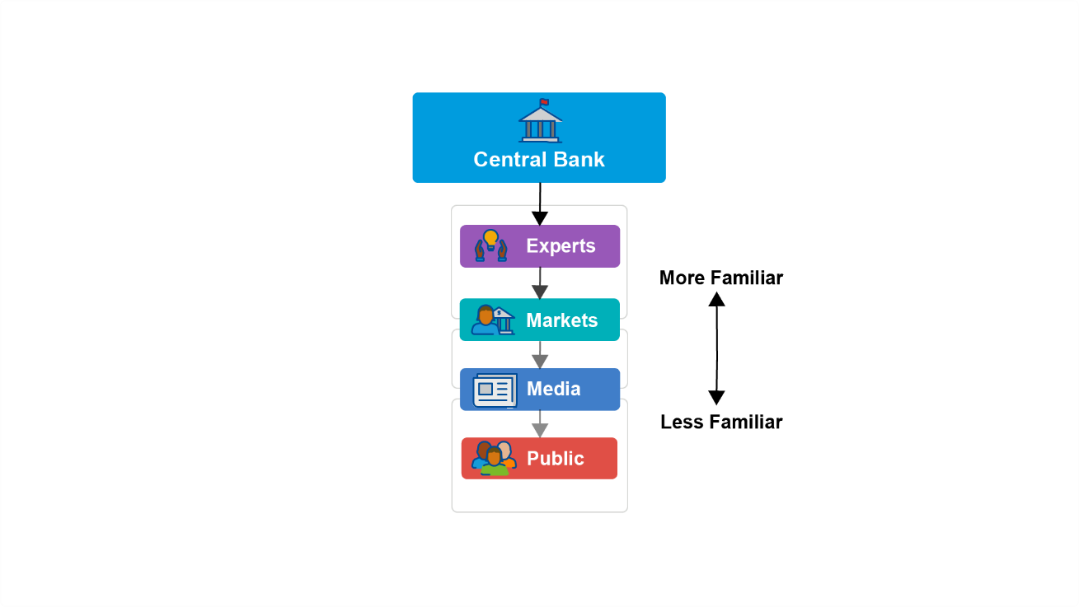

### <VIDEO 1.1> "Talking to the Public Requires a Different Approach” [word count: 218]

Central bankers are quite used to talking to audiences of financial experts. For instance, most central bank governors give frequent press conferences on policy decisions. Financial experts, market participants, and journalists follow such events very closely. Let’s look at one example. Here we see the President of the European Central Bank getting ready to discuss a monetary policy decision in June 2024. As we can see by the crowd of journalists, there is a lot of media attention for this event. What we also see is that the setting is slightly formal. The speakers are standing on a podium behind lecterns. If we were to watch the press conference, it would take us close to one hour, and we would hear lots of technical details.

Talking to the public is much newer for central bankers. And it differs in important ways from communicating with experts. For instance, centrals banks could reach out to the public via less traditional media channels, such as YouTube. The European Central Bank and Bangko Sentral ng Pilipinas are two examples of central banks producing YouTube shorts. In these videos, the setting is informal. Also, there would not be long discussions of technical details. Perhaps you could come up with more differences between these YouTube shorts and the technical press conference?

**<END OF VIDEO >**

So, why are central banks reaching out to the public? And is this new type of communication working? That is what we will explore in the rest of this module.

## UNIT 1.2: Examples of Public Outreach

Central bank outreach to the public has become widespread by now. The graph shows data for 75 central banks and their activity with the public. Websites are important—more than 80% of these central banks do outreach via their corporate websites. Social media also matters—almost all share information via X (formerly known as Twitter), LinkedIn, or YouTube. In some cases, the outreach is via the personal social media account of the central bank governor.

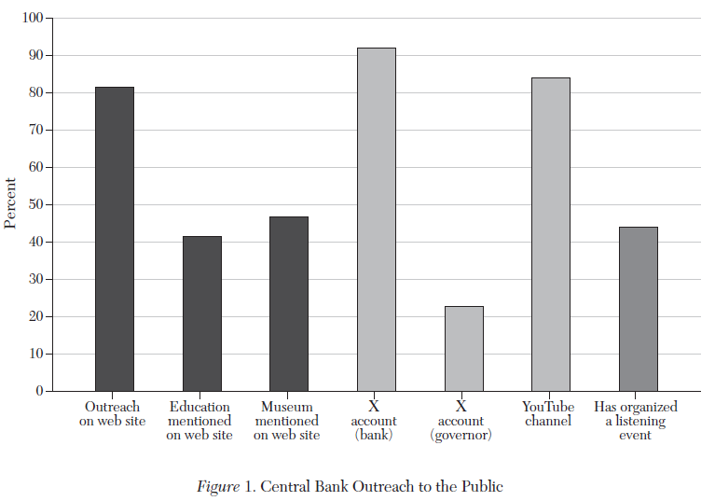

Source: Blinder et al. (2024). Central bank communication with the public: Promise or false hope? Journal of Economic Literature 62(2): 425-457. <https://doi.org/10.1257/jel.20231683>

|  |
| --- |
| Would you like to know all the details about the central bank outreach described in Figure 1? That is possible, as the underlying data for this chart has been made available by the researchers. You can download the data in an Excel sheet via this website: [Data for: Central bank communication with the general public: Promise or false hope? (openicpsr.org)](https://www.openicpsr.org/openicpsr/project/184303/version/V1/view)  The relevant data for Figure 1 is in the tab called ‘Data Figure 1_raw’. You will see here the information about the different central banks. You can use the columns V – AB to filter for central banks from various regions, such as the Americas, Asia, or Europe.  In addition to the data for Figure 1, this Excel sheet has background information for some of the other figures shown in this module. |

Let’s look at some concrete examples of such public outreach by central banks.

<COURSE PRESENTATION_START>

* [SLIDE 1] The **Bank of Jamaica** has a format called *Centrally Speaking.* This program covers all aspects of the central bank in general, but, naturally, it has featured episodes about monetary policy. Recent episodes are available on YouTube: [Bank of Jamaica - YouTube.](https://www.youtube.com/@CentralBankJamaica)
* [SLIDE 2] The **Bank Negara Malaysia** provides snapshots of monetary policy statements. These are short visualizations accompanied by short bullet-points outlining key elements of monetary policy decisions. Here is an example from 2024:

<https://www.bnm.gov.my/documents/20124/14357919/MPS_Snapshot_2024_05_en.pdf>

* [SLIDE 3] As part of its monetary policy review, the **U.S. Federal Reserve** organized a range of *Fed Listens* events. During these events, Fed officials engaged with members of the public on how monetary policy affects their daily lives and livelihoods. [Federal Reserve Board - Fed Listens](https://www.federalreserve.gov/monetarypolicy/review-of-monetary-policy-strategy-tools-and-communications-fed-listens-events.htm)
* [SLIDE 4] To inform the public, the **Bank of Uganda** organizes a range of activities, including town hall meetings, presentations to organizations and clubs, and the creation and dissemination of public awareness material. See also: <https://www.bou.or.ug/mediacenter/publiceducation/>

<COURSE PRESENTATION_END>

## UNIT 1.3: Communication or Transparency?

Central bank transparency and communication are closely related. However, there is a subtle difference, which becomes very relevant when talking to the public.

We can think of transparency as the central bank opening up to the public.

|  |
| --- |
| In economic terms, **transparency** means there is a supply of information by the central bank. |

Over the years, central banks have taken great steps in opening up to the public.

But, when the central bank opens up, is anyone listening? Supplying information is nice, but is there demand for such information? This is where the communication perspective comes in. One traditional way to think of policy communication is to ask:

|  |
| --- |
| *“Who says what to whom in what channel, and with what effect?”*  Lasswell, 1948. |

Traditionally, the “whom” was an audience of experts. Central bankers could be pretty sure that experts were paying attention.

However, when it comes to the public, this is not necessarily true. The public may simply not see value in information that does not affect them directly or immediately, such as a minute reassessment of the inflation forecast, a change in the policy rate, or a hike in the countercyclical capital buffer. In this current age of social media, there is an endless stream of news and content competing for the public's attention.

While the central bank could be very open and transparent, if there is little interest in their information, we should not assume that their communication is effective.

# SECTION 2: Why do central banks communicate with the public?

## UNIT 2.1: Building Trust by Being Accountable

If it is challenging for central bankers to reach the public, why do they make so much effort to do so? One important reason is accountability to build trust. The second is managing the public’s expectations, particularly about the future path of inflation. In the following video, we start by exploring the concepts of trust and accountability.

### <VIDEO 2.1> "Trust and Accountability” [word count: 250]

Communication is key to being accountable and building trust. Accountability matters as central banks have often gained more autonomy over the last few decades. This increased autonomy is illustrated by this graph, which is based on a large dataset collected for many central banks across the globe. Central bank autonomy, on average, has started to increase since the 1990s. This means that many central banks have received increasing autonomy to take monetary policy decisions independently, free of day-to-day political considerations.

But, such increased autonomy comes with a responsibility to be accountable. Monetary policy affects the economy and therefore the lives of ordinary citizens. Accountability requires clear communication. A central bank that remains silent or only talks cryptically about its decisions and actions cannot easily be held accountable. Therefore, the democratic accountability argument is that there’s a need for central banks to communicate with the public.

Being accountable builds trust. If the public trusts the central bank, citizens are confident that the central bank will deliver on its goals. This, in turn, will make it easier for the central bank to manage the economy. On the flip side, a fall in trust can amplify macroeconomic fluctuations and make it harder for the central bank to control inflation. All of this can be summed up by one key quote from European Central Bank President Christine Lagarde addressing the European Parliament in 2019. She said,

 “Central banks have to be understood by the people whom they ultimately serve. This is a key to rebuilding trust.”

**<END OF VIDEO >**

## UNIT 2.2: Managing Inflation Expectations

Can communication with the public also improve the effectiveness of monetary policy? Here we look at a key channel, namely that of inflation expectations.

### <VIDEO 2.2> "The Importance of Anchored Inflation Expectations” [word count: 474]

Expectations are very important for how the macroeconomy works. Suppose customers expect high inflation next year. To make sure that they don’t have to pay higher prices next year, they may already start buying durable products today. Those purchases will stimulate demand and overall growth but will also push up prices. And those higher prices will mean higher inflation, already now!

To make sure that such expectations do not create upward pressures on prices in the economy, central banks are very careful to make sure that long-term inflation expectations are well anchored. For instance, Jerome Powell, the chair of the United States Federal Reserve said during the 2018 Jackson Hole meeting that “Anchored expectations give a central bank greater flexibility to stabilize both unemployment and inflation.”

What do such long-term expectations look like? Let’s look at an example, where expectations were inferred from prices in U.S. financial markets. The graph shows how in the 1980s, market participants expected long-term inflation in the U.S. to be 4% or more. In the 1990s, expectations for long-term inflation started to decline. Over the last ten years, financial experts have been expecting long-term inflation to be mostly in a range between 1.5% and 2.5%. Even with annual inflation averaging over 5% in 2022 and 2023, 10-year ahead inflation expectations have remained close to that range.

This type of stability is what economists have in mind when they say that expectations remain well-anchored. First, it means that inflation expectations are in line with the inflation objective of the central bank. Suppose that a central bank wants to keep inflation close to 2%. Then, ideally, the public would also expect long-run inflation to be close to that 2%. Second, well-anchored means that such expectations do not respond much to macroeconomic surprises or short-term developments. In other words, even when demand or supply shocks occur, the expectations would remain close to the objective.

Here is another example of anchored inflation expectations, this time from households in New Zealand. The chart shows expected inflation over three horizons: expected inflation in 1 year, 2 years, and 5 years. This data was collected through surveys of households, asking them to indicate expected levels of inflation over different time horizons. We can see an interesting difference in the dynamics of these three series around the time of post-covid inflation shocks in 2021 and 2022. Around the time of these post-covid inflation shocks, households in New Zealand were expecting much higher inflation in a year’s time, going all the way up to 7 percent. In contrast, expectations for medium and long-term inflation, which are most relevant for monetary policy, were much less volatile. Households never expected inflation in 2 years’ time to go above 5 percent. Moreover, expected inflation in 5 years’ time always remained close to the 2 percent target for the Reserve Bank of New Zealand.

**<END OF VIDEO >**

# SECTION 3: Communicating with the Public: Challenges and Strategies

## UNIT 3.1: Key Challenges

If central banks are communicating to the public, are they automatically building trust? How can they successfully manage the public’s inflation expectations? As one can imagine, there are still major challenges when it comes to communicating and public trust-building. Let’s explore these challenges in the following video.

### <VIDEO 3.1> "Communicating with the Public: Key Challenges” [word count: 411]

Reaching out to the public is important for central banks. But, there may be a number of challenges in practice. Let’s discuss three such challenges.

First, households and firms usually have a low desire to be informed about monetary policy and can be relatively inattentive to news about it. A study of the general public in the Netherlands showed that about one-quarter of the public is not interested in monetary policy. And, less than 20% do find it very important to be informed about monetary policy. Shocking, right?

Well, perhaps not. Ironically, successful monetary policy itself breeds inattention. When inflation has been low and stable for some time, people feel little incentive to track inflation and monetary policy closely. As Mervyn King, the former Governor of the Bank of England, said, ‘... a successful central bank should be boring - rather like a referee whose success is judged by how little his or her decisions intrude into the game itself’.

However, the reverse is also true. At times when inflation does increase rapidly, the interest in the topic immediately increases. One example is the global surge in inflation that took off after COVID. This chart shows Google searches on the term ‘inflation’. We can see the number of searches strongly increased from 2021 onwards.

Now, let’s consider a second challenge. Reaching the public directly is not always straightforward. In principle, using their own website or social media outlets gives central banks a direct handle on what information reaches the public. However, most of the central bank outreach still seems to reach the public via traditional media channels. For example, television and the printed press are, by far, the most important information sources for the public to learn about the policies of the European Central Bank. In practice, therefore, a central bank may not always have full control over what information reaches the public and in what format. Ask yourself: has your neighbor, partner or parent ever visited your country’s central bank website or Facebook page?

A third factor that complicates communicating with the public is the tendency of central banks to use complex and technical language. To be transparent, central banks often rely on releasing documents containing a lot of technical information. Or, they may be used to giving speeches containing many complicated words and sentences. But, for most members of the public it is very difficult to digest such levels of complexity and detail. Crucial information may get drowned in noise.

**<END OF VIDEO >**

## UNIT 3.2: How to better inform the public?

What strategies can central banks take to better inform the public? Let’s look at three of them.

**<Asset 2.3.2_HOTSPOT_START>**



**Simplify language** | Central banks need to simplify their language. As an example, in recent years, monetary policy statements by the European Central Bank have become shorter with simpler language. The chart below illustrates this. It shows that from 2021 on the policy statements have a lower Flesch-Kincaid grade level. A lower grade level indicates one needs less years of education to understand the policy statements adequately. To understand the more complex statements in 2005 one would need a university degree, as compared to high-school diploma during 2021–2022. A simpler draft of the policy statements makes it easier for the public to comprehend the information provided by the central bank.

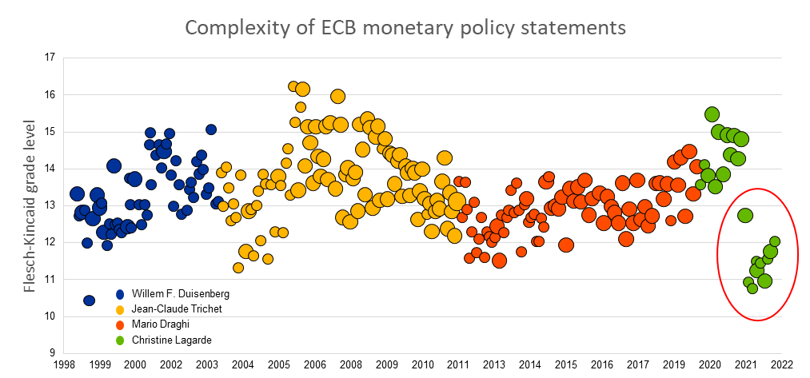

Source: Blinder et al. (2024). Central Bank Communication with the Public: Promise or False Hope? *Journal of Economic Literature* 62 (2): 425–457. <https://doi.org/10.1257/jel.20231683>

**Social media engagement** | To better inform the public, another option is direct engagement via social media. We have already seen some great examples of how central banks are present on platforms such as YouTube or LinkedIn. This presence on social media can help build a relation and trust with the public, all the while informing the public of central bank decisions.

**Layered communication** | Another strategy is layered communication. This means that the same message is presented at different levels of complexity. For experts, a rich set of information would be available in press conferences and technical papers. For interested members of the public, a short non-technical document or video would be made available that presents the main points in an accessible manner. A third layer of communication could be an intuitive visualization that captures the main message, such as the one-page [Snapshots](https://www.bnm.gov.my/monetary-stability#smps) produced by Malaysia’s Bank Negara. If done right, such a visualization would much more likely capture the public’s attention than a long technical document.

**< HOTSPOT_END>**

## Knowledge Check

1. **<Multiple choice>** Which of the following is a key difference between communication with financial experts and the general public?

1. The general public is more attentive to the communication of the central bank than financial experts.

**<Feedback>** This is **incorrect**. Audiences of experts, such as financial market participants, are more likely to be attentive to the words of the central banks

1. Financial experts are more likely to interpret central bank communication correctly, as the central bank intended.

**<Feedback>** This is **correct**. Financial experts will have higher levels of financial literacy, making it more likely they will have a correct understanding of the central bank’s messages.

1. Compared to the public, financial experts are more likely to rely on social media.

**<Feedback>** This is **incorrect**. Social media, such as YouTube or X, are more important in informing the general public.

1. There is a higher demand for central bank information from the public than from financial experts.

**<Feedback>** This is **incorrect**. The public will more often be less attentive to communication by the central bank.

2. **<Multiple choice>** Which of the following is true about the objectives of central bank communication with the general public?

1. Communication with the general public must be detailed in order to be effective.

**<Feedback>** This is **incorrect**. The amount of technical detail is not an objective in and of itself. Moreover, communication with the public is often much less detailed than communication with financial experts.

1. Communication with the general public is solely meant to steer interest rate expectations.

**<Feedback>** This is **incorrect**. This type of communication has two equally important objectives, one of which is anchoring inflation expectations (rather than interest rate expectations), and the other one is building trust.

1. Communication with the public builds trust.

**<Feedback>** This is **correct**. Communication is key to being accountable and building trust. Accountability matters as central banks have gained more autonomy over the last few decades.

1. Communication with the public is meant to lower inflation expectations.

**<Feedback>** This is **incorrect**. It all depends on the current level of inflation versus the inflation target. If the economy is in a deflationary environment, communication may need to elevate inflation expectations. In practice, anchoring inflation expectations at around the inflation objective is what the central bank wants to achieve.

3. **<Multiple choice>** Which of the following is true about *layered* central bank communication?

1. Each layer should have an equal level of technical complexity.

**<Feedback>** This is **incorrect**. It is important instead to have, for each layer, a level of technical complexity that suits the specific audience.

1. Layered communication is never targeted at financial experts.

**<Feedback>** This is **incorrect**. When designing layered communication, one of the layers can be designed specifically for financial experts.

1. Layered communication has been discussed theoretically but has not yet been implemented within the central bank community.

**<Feedback>** This is **incorrect**. Several central banks are already using layering in their external communications.

1. One of the layers could be an intuitive visualization that captures the main message.

**<Feedback>** This is **correct**. One concrete example is the one-page [Snapshots](https://www.bnm.gov.my/monetary-stability#smps) produced by Malaysia’s Bank Negara.