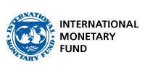

|  |
| --- |
| EFFECTIVE POLICY COMMUNICATION |
| Blended course: Self-paced content |
| COURSE PLAN—MODULE 3 |

|  |
| --- |
|  |

I

**TABLE OF CONTENTS**

MODULE 3: Transmission of Macroeconomic Policies 2

UNIT 0.1: Introduction to Module 3 3

SECTION 1: What a Communicator Must Know 3

UNIT 1.1: The Modern Language of Policy Communication 3

<VIDEO 1.1> ”Finding a Common Language” [word count: 501] 3

UNIT 1.2: The Policy Tradeoff 4

<VIDEO 1.2> Understanding the Policy Tradeoff [word count: 550] 5

SECTION 2: Know your Transmission! 6

UNIT 2.1: The Monetary Transmission Mechanism 6

UNIT 2.2: Applying the Transmission Mechanism 7

<VIDEO 2.2> Demand Shock [word count: 563] 7

UNIT 2.3: The Demand Shock Scenario 8

UNIT 2.4: “Translating Transmission” 15

UNIT 2.5: Module 3 Takeaways 18

Knowledge Check 20

# MODULE 3: Transmission of Macroeconomic Policies

### UNIT 0.1: Introduction to Module 3

Effective policy communication has two essential elements. First, a well-thought-out set of policies that will allow the institution to fulfill its mandate. Most of the underlying analytics behind the policy inputs is written in highly technical language, full of economic jargon, and are generally unintelligible to the public. Yet behind the technical analysis and jargon is a well-known transmission mechanism, which starts from policy actions and ends with economic outcomes. Familiarity with the monetary policy transmission mechanism is a must for every person communicating on behalf of the central bank.

This is where the second element comes in: “translation” of the technical jargon used inside the institution into language that would be understood by the outsiders. Who exactly are these outsiders? On the one hand, it could be other specialists, such as financial market analysts and economists in think tanks and academia, who appreciate the same kind of technical jargon. On the other hand, you have the general public, who are neither familiar nor interested in the jargon.

In this module, we will focus on the first element of policy communication, namely on the monetary transmission mechanism. For example, how does an increase in the interest rate lead to a lower rate of inflation? While the answer is obvious to a macroeconomist, such a question will confound most non-economists. Hence, it is not surprising that central banks make a lot of effort to explain the transmission mechanism to justify their actions. We will then give you several examples of how various central banks attempted to create visuals, videos, and texts to re-frame the technical topics into formats that would appeal to the public.

By the end of this module, you will be able to:

1. Identify the “common language” of macroeconomic policy.
2. Communicate the key policy tradeoff faced by the central bank.
3. Use the transmission mechanism to explain policy actions.

## SECTION 1: What a Communicator Must Know

### UNIT 1.1: The Modern Language of Policy Communication

Since the late 1980s, central banks all over the world have adopted similar macroeconomic frameworks, grounded in the New Keynesian macroeconomic theory. Let’s explore the main assumptions of this framework.

### <VIDEO 1.1> ”Finding a Common Language” [word count: 501]

There is a remarkable convergence in the way central banks think about monetary policy. Virtually all adopted the so-called New Keynesian macroeconomic framework that builds on the principles of Keynesian economics by incorporating microeconomic foundations and rational expectations.

The reason for the adoption of the New Keynesian framework is twofold. First, it combines the tools of dynamic stochastic general equilibrium models with Keynesian concepts like sticky prices and wages. Second, data for most countries and most monetary and exchange rate regimes fit nicely into the framework. Therefore, the framework allows quantitative analysis of policy actions and evaluation of alternative policy scenarios.

There are five key aspects of the New Keynesian framework.

First, a central assumption is that **prices and wages are "sticky"** and do not adjust immediately to changes in economic conditions. This stickiness arises due to factors like the costs of changing price tags. No retailer wants to do it every day! It also reflects the fact that wages are set for several quarters or years ahead. Sticky prices and wages, called nominal rigidities, can lead to periods of involuntary unemployment.

Second, **imperfect**, or monopolistic **competition**, allows firms to be price-setters. Under such conditions, profit-maximizing firms set prices as a *markup* over marginal cost, with the size of the markup depending on the degree of competition and the price elasticity of demand faced by firms. And monopolistic competition also means that firms can choose not just prices of their products, but also the quantities they supply.

Third, new Keynesian models incorporate the assumption of **rational expectations**, where economic agents make forecasts based on all available information. The key implication is that rational expectations prevent policymakers from systematically fooling the households and firms, through so-called time inconsistency.

Suppose that a politician promises to cut personal income tax. This prompts workers to work longer hours, hoping to bring home higher salaries. The economy will boom. However, the time-inconsistent politician increases the tax rate instead, wiping out any household income gains. You can imagine that the next time these workers hear a promise of lower taxes, they will think twice before increasing their supply of labor. Can you think of a similar example with a broken promise of tight monetary policy and lower inflation?

Fourth, sticky prices and monopolistic competition create space for government **stabilization policies**. Indeed, fiscal policy and monetary policy are needed to help the economy return to full employment.

Finally, the New Keynesian framework can be summarized for small open economies in a **model**, which combines just **four behavioral** equations:

First, the Phillips curve (relating today’s inflation to output and expected future inflation),

Second, the investment–saving curve (linking aggregate demand to the policy instruments),

Third, the Uncovered Interest Rate Parity (linking the dynamics of the exchange rate to the interest rate differential vis-à-vis the rest of the world), and

Fourth, a monetary policy reaction function that mimics policymaker’s decisions.

The four-equation framework has been widely used to analyze most real-life developments and shocks and to propose appropriate policy responses.

**<END OF VIDEO >**

### UNIT 1.2: The Policy Tradeoff

Policymaking is about making unpopular choices. Fiscal policymakers must periodically decide between higher taxes or fewer public goods to keep public debt from increasing too much. Monetary policymakers know that lower inflation typically comes at the expense of throttling the rate of growth of the domestic economy and increasing the rate of unemployment.

Let’s talk about the policy tradeoff.

### <VIDEO 1.2> Understanding the Policy Tradeoff [word count: 550]

You’ve heard the expression: “*there’s no free lunch.*” To get something, one must give up something else. To achieve their macroeconomic policy objectives, central banks or treasuries must make unpopular choices. For example, monetary tightening needed to bring down inflation is likely to cause pain to some households. Economists call such an unpopular choice the output-inflation tradeoff.

We will explain this tradeoff using one of the equations in the New Keynesian framework, the Phillips curve. Economists explain the growth in the price level, that is inflation, as depending on public’s expectations of future inflation, the slack in the economy, and price shocks.

So, the Phillips curve has some components that the central bank cannot directly control and others that it can control only indirectly. How does it work?

First, what’s beyond the central banks’ control? For starters, households and firms form their OWN expectations of future inflation based on what they have experienced in the past as well as their OWN PREDICTIONS of the future. Second, price shocks are by definition surprises, such as wars or weather-related shocks.

However, central banks control the slack in the economy and ultimately prices, through its policy tools, such as the interest rate and exchange rate. Think of these as levers for offsetting the pressure from inflation expectations or inflation shocks.

There are timing problems with this control. Any policy change—say a hike in the interest rate—will take time to affect the unemployment rate or the output gap. It may take a year or two to feel the full impact. In other words, the transmission mechanism of monetary policy is slow. Furthermore, the strength of the impact is uncertain and is likely to change over time.

The key point is that economic players understand that monetary tightening today will affect prices tomorrow. Therefore, it is in their interest to adjust their expectations and actions accordingly. Today’s policy actions will thus affect everyone’s behavior for months to come.

Let’s ponder the unpleasant choices policymakers had in 2022, right after the COVID pandemic and at the start of the war in Ukraine. Both events led to major inflationary shocks, such as, global supply chain disruptions, and jumps in energy and food prices. In all countries, consumer prices grew at a faster rate than central banks promised. What were their options?

First, they had to carefully weigh the objectives of stabilizing inflation versus stabilizing output. The policy tradeoff is that tighter monetary policy through higher interest rates would help reduce inflation. This reduction came at the cost of lower output and higher unemployment. Hence, the central banks had to decide how much economic slack to engineer. Tighten too little and inflation stays too high. Tighten too much and the economy slips into a recession and many people lose their jobs. The answer depended on how much weight the policymaker placed on inflation stability versus output stability.

Second, central banks had to account for the risk of expectations drifting upward, away from the inflation target. It is easy to imagine how households and firms would have reacted to central banks staying put and not addressing inflationary developments. Their expectations of inflation would ratchet up. Hence, most central banks aggressively tightened monetary policy, even if that meant risking higher unemployment and lower growth in the short run.

**<END OF VIDEO >**

## SECTION 2: Know your Transmission!

### UNIT 2.1: The Monetary Transmission Mechanism

Let’s recall the primary objective of the central bank, the institution typically entrusted with the execution of monetary policy. In most countries, the primary objective is to keep the value of domestic currency stable, typically specified in terms of low consumer price inflation. In addition, the central bank is also responsible for supporting economic growth and financial stability.

The monetary transmission mechanism refers to the process by which changes in the macroeconomic tools controlled by the central bank, such as the policy rate, exchange rate, or any other economy-wide tools, affect the overall economy and inflation.

The transmission mechanism works through several channels. Click on each icon to learn more.

**<Asset 3.2.1HOTSPOT_START>**

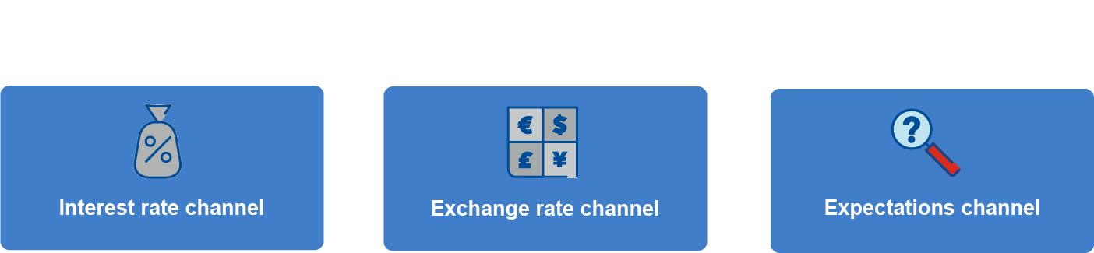

**Interest Rate Channel**

When the central bank raises interest rates, it becomes more expensive for households and businesses to borrow money. This discourages spending on big-ticket items like homes, cars, and business investments. Lower demand slows down economic growth and puts downward pressure on inflation.

Changes in interest rates—all else being equal—also change decisions about spending “today” versus “tomorrow”. With a higher interest rate, one dollar tomorrow has higher purchasing power than before the hike. Households may decide to postpone their purchases and save instead. Economists called this effect intertemporal substitution, and it can have a powerful effect on demand.

**Exchange Rate Channel**

Higher interest rates make domestic assets more attractive to foreign investors, increasing demand for the domestic currency and appreciating the exchange rate. A central bank with large foreign currency reserves can appreciate the value of its domestic currency by selling dollars or euros and buying domestic currency, that is, through foreign exchange interventions. Either way, a stronger, more appreciated currency makes exports more expensive and imports cheaper, reducing overall demand for goods and services produced in the domestic economy. Stronger domestic currency thus lowers demand and domestic inflationary pressures.

Providing that households value imported goods as much as domestically produced goods, stronger domestic currency should lower domestic prices directly. Competition will ensure that the lower price of imported goods in domestic currency—owing to the appreciated exchange rate—will be passed on to the consumers.

**Expectations Channel**

Central bank communication about future policy can shape public expectations of future inflation and economic conditions. If the public expects tighter monetary policy to control inflation, it can moderate wage and price-setting behavior. This channel requires that communication about future policy developments is credible, meaning that households and firms have trust in central bank growth and inflation forecasts.

<HOTSPOT_END>

These three channels are the workhorses of policy communication in any central bank. One can use these channels to explain most of all possible developments. However, there are other channels discussed in the literature. For example, economists sometimes talk about the asset price channel, the credit channel, the risk-taking channel, or even some more exotic transmissions such as the equity financing channel or the “zombie-firm” channel.

In summary, by raising interest rates or appreciating the exchange rate, central banks can cool down an overheating economy and bring inflation back towards its target level through various transmission channels, impacting spending, investment, trade flows, and inflation expectations.

### UNIT 2.2: Applying the Transmission Mechanism

Now we will practice applying the transmission mechanism using the simple New Keynesian model described earlier. We will focus on a common example: the demand shock and the response of the policymaker to bring inflation to a desired level.

### <VIDEO 2.2> Demand Shock [word count: 563]

The demand shock is the most intuitive example of monetary transmission. But what exactly is a demand shock?

An aggregate demand shock is a sudden, temporary increase or decrease in the demand for a bundle of goods and services. It is an unexpected event that shifts the entire demand curve, labeled as CAPITAL D, to the right (a positive demand shock) or to the left (a negative demand shock).

Demand shocks can result from many real-life developments. The surge in demand for electric vehicles, driven by changing consumer preferences, is an example of a positive demand shock for a specific good. Government stimulus checks during the COVID-19 pandemic created a positive aggregate demand shock as household had more money to spend.

A positive demand shock, such as fiscal stimulus, will push the economy—measured by gross domestic product—above its normal or potential level. Economists say that the demand shock opened a positive output gap. A journalist may say that the economy is “running hot.” With low unemployment, workers will be emboldened to ask for higher wages, in the process pushing up the cost of production of goods and services. The supply of goods and services cannot change overnight, so this additional demand faces unchanged supply in the short term. In the diagram we drew the supply curve as mostly vertical. What does that mean for prices?

Well, prices of all goods and services will go up to meet higher demand. If supply fails to increase, the price increase may become long-lasting, becoming inflation. The primary objective of central banks is to prevent exactly this scenario, in which a demand “pulls“ all prices up. How can inflation be prevented?

The central bank will use the tools at its disposal to cool off the economy, typically by increasing the short-term interest rates, an instrument that it controls. Rising interest rates will make the cost of borrowing go up, motivating households and firms to postpone their spending plans. Less spending means businesses will be less keen to raise prices.

But the link from the interest rate to output to prices is not the whole story. The economy is open, meaning that foreigners, so-called nonresidents, can buy and sell domestic financial assets. Higher interest rates make domestic assets more attractive relative to foreign assets and nonresidents will bring their currencies and exchange them for the domestic currency. More foreign exchange flowing to the country will appreciate the domestic currency—meaning that one unit of domestic currency will now buy more dollars.

Exchange rate appreciation will affect the economy. First, more appreciated currency makes the imported goods cheaper, bringing down inflation. For example, instead of an expensive domestic yogurt, the customer may buy a cheaper, imported one. Second, appreciated currency makes domestic production less competitive vis-à-vis its foreign production. Demand for labor to produce goods and services domestically will decline together with demand for country’s exports, closing the output gap and bringing demand in line with supply.

The task here is to understand how far to go in order to offset the inflationary demand shock. If the central bank tightens too much, it can harm the economy with a major recession. Tighten too little and the economy will slip into a spiral of higher inflation leading to higher wages leading to higher production costs and higher inflation. Allow a too large appreciation of the currency and it may irreparably damage the export sector.

**<END OF VIDEO >**

### UNIT 2.3: The Demand Shock Scenario

Let’s explore the demand shock scenario in a quantitative model.

Models are used to simulate the transmission mechanism. The so-called impulse response functions demonstrate how the economy responds to a one-period shock to one of the variables. In the example below it is important to keep in mind that the demand shock lifts the aggregate demand on impact. The shock disappears in the next period—it is a one-period shock. The variables (output, inflation, the exchange rate, and so on) may or may not exhibit persistence. For example, output tends to be persistent, and it may stay elevated for several quarters, even after the response of the policymaker. In contrast, the exchange rate under a floating regime may not be persistent and the exchange rate would return to its pre-shock level quickly.

Let’s work out the effect of the demand shock, with an endogenous response by a hypothetical central bank. Keep in mind that the framework describes an economy with a floating exchange rate and open capital account. The central bank has the primary objective of stabilizing inflation.

**[THIS WILL BE INTERACTIVE SECTION. AFTER EACH SECTION THE SAME 6-CHART PICTURE WILL APPEAR WITH THE RELEVANT PART HIGHLIGHTED]**

<INTERACTIVE COURSE PRESENTATION_START>

1. **Unexpected demand shock** | The economy is hit with an unexpected, temporary positive demand shock, such as a large government stimulus. We see that the output gap is now estimated at 1%, that is, the demand exceeds the potential output (supply) by 1%.

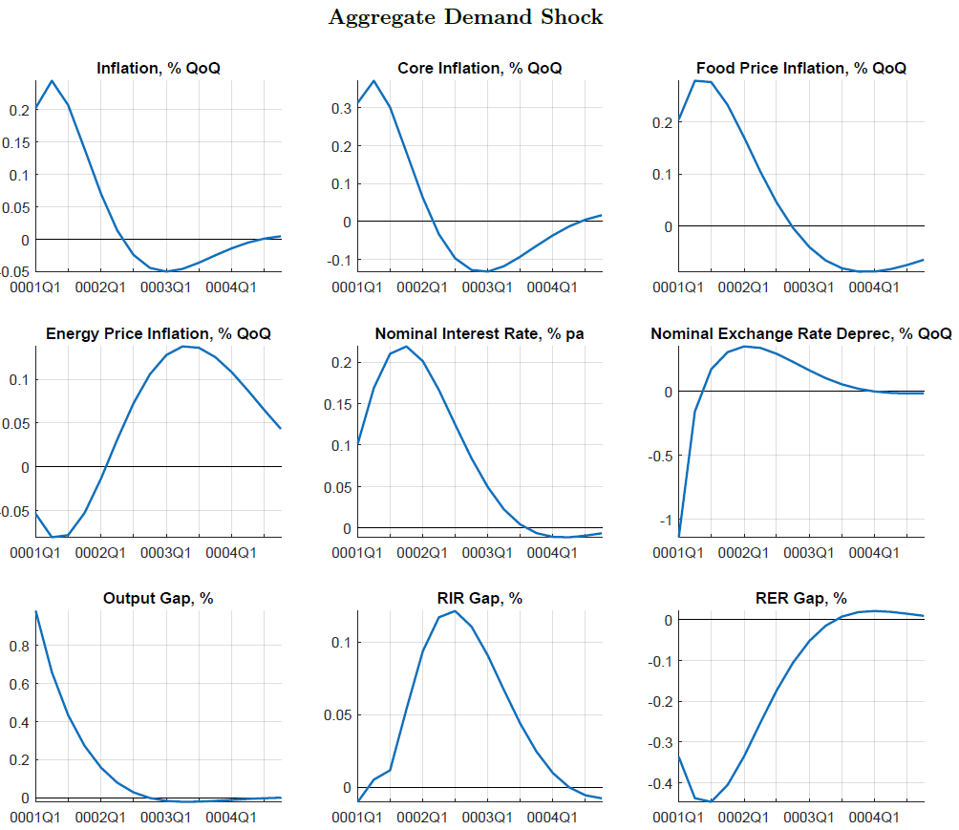

1. **The impact on prices** | Excess demand will create an upward pressure on prices. The central bank anticipates that annualized quarter-on-quarter inflation will accelerate very quickly, by up to additional 0.3 or 0.4 % during the next two quarters. This will push inflation above the central bank target! Inflation—if unchecked—would make the monetary conditions looser than the central bank would like to see as inflation will lower the real interest rate. (Let’s ignore food and energy price inflations—these are driven by mostly by exchange rate developments.)



3. **Policy response** | An increase in the interest rate is therefore consistent with central bank’s primary objective. Our model embeds a policy reaction function that mimics past central bank hikes and cuts in the policy interest rate in response to inflation developments. The interest rate increase of about 25 basis point (one-quarter of one percent) during the next 2–3 quarters will be needed to cool off the economy and keep inflation expectations in check.



1. **Monetary conditions—the real interest rate** | We know that future monetary conditions will tighten from an indicator measuring the difference between the market real interest rate and “neutral” real rate (the rate that would neither cool off nor heat up the economy. Economists call this indicator the real interest rate gap (RIR Gap). The impulse response suggests that monetary conditions will gradually tighten, peaking some 5-6 quarters after the initial demand shock. This delay is one important feature of the transmission mechanism: monetary policy works with a lag. In summary, the *real* monetary conditions tighten because (1) the central bank hiked the nominal interest rate; and (2) inflation started declining fast in the fourth and subsequent quarters. This indicator demonstrates the operation of the interest rate channel: tighter real interest rate conditions cool off the economy and create a downward pressure on inflation.



1. **Exchange rate movement** | Higher interest rates make domestic financial assets, such as bonds, more attractive relative to similar foreign financial assets. Other things being equal, we should see an inflow of dollars, euros, or yen that will be exchanged for the domestic currency and then invested in the domestic financial assets. These foreign exchange flows will appreciate the domestic currency.

(Note that the exchange rate is expressed in units of domestic currency for one unit of foreign currency, so that a negative value implies appreciation. For example, the domestic currency may appreciate from 100 units per one dollar to 99 units per one dollar, which is –1 % movement [(99-100)/100] or appreciation of 1%.)



1. **Monetary conditions—the real exchange rate** | As with the interest rate, we must account for inflation. Hence, we calculate the *real* exchange rate appreciation (or depreciation) of the domestic currency and compare it with the *trend* real exchange rate movement. This indicator is called the real exchange rate gap (RER Gap) and it shows us the operation of the exchange rate channel. We see that the monetary conditions from the exchange rate side tightened quite a bit and even faster than the monetary conditions from the interest rate side. What drives real appreciation in this indicator? It’s a combination of the initial nominal appreciation and higher domestic prices as compared to the rest of the world. Tighter real exchange rate conditions cool off the economy and creates a downward pressure on inflation.



1. **The expectations channel** | What about expectations of inflation? We don’t have a direct indicator of the expectations channel, but we see that in our simulation inflation starts declining during the third quarter while the output gap is still positive. This is an indication that economic agents anticipate tight monetary conditions and moderate their inflation expectations. We can observe the expectations channel as well.



<INTERACTIVE COURSE PRESENTATION_END>

**Summary** | The simulation and the impulse response functions guide our interpretation of the transmission mechanism. We clearly see (1) the propagation of the demand shock; (2) the endogenous response of the policymaker—the interest rate hike; and (3) the operation of the three transmission channels: the interest rate and exchange rate channels, and the expectations channel.

### UNIT 2.4: “Translating Transmission”

So far, we have used a macroeconomic model to explain a policy response to an economic development. But does it mean that the central banks must communicate everything and with everybody in models, supply-demand diagrams, and impulse-response functions? Of course not! The communication departments need to deliver the messages in a media that is familiar to the target audience. Let’s look at some communication examples of monetary transmission from across the world.

<INTERACTIVE COURSE PRESENTATION_START>

1. **Bank of Uganda Comics Series**. The East-African country’s central bank has printed a whole series targeting children. The central bank superhero called Mani explains in plain words, and using real-life examples, the role of the central bank, the cost of inflation, supply and demand shocks, and the policy response of the central bank. For example, the [third book explains the supply shock using the example of a pen that the children need to buy](https://www.bou.or.ug/bouwebsite/bouwebsitecontent/PublicEducation/Comic-Books/Value-of-Your-Money-Comic-Book-Final-Aug-2-18.pdf).

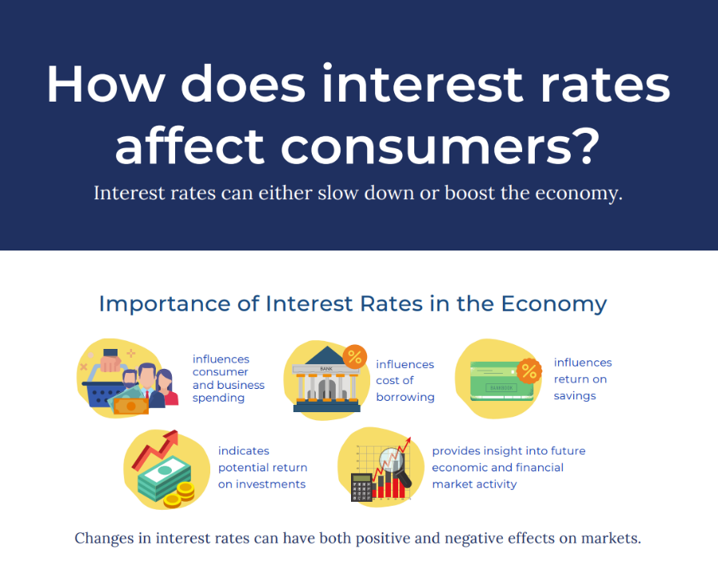**2.A Bangko Sentral ng Pilipinas (BSP) Infographics**. The central bank of the Philippines published multiple infographics in its multimedia outreach that tackle a long range of issues from price stability, BSP’s exchange rate policy, to fairly technical topics of consumer price index rebasing. The presentation on [Why should interest interest you?](https://www.bsp.gov.ph/Media_And_Research/Multimedia/Infographics/Infographics_3_Interest_Rate.pdf) relies mostly on pictograms to explain the monetary policy transmission mechanism and the role of BSP in deciding the policy interest rate.

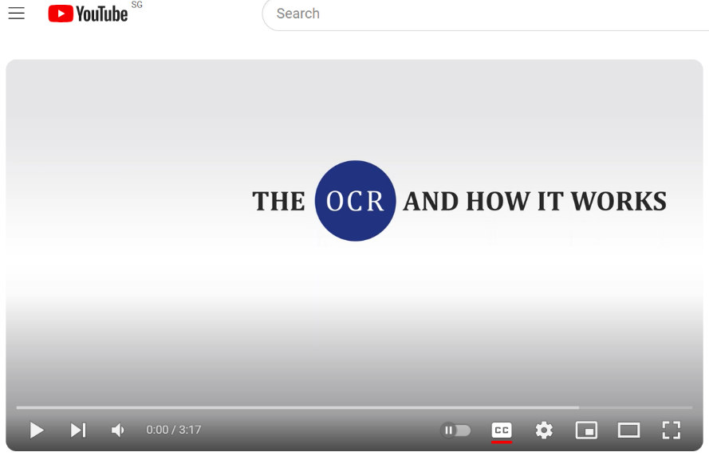**2.B Reserve Bank of New Zealand (RBNZ) YouTube Channel**. The central bank posted videos on YouTube on topics, ranging from shorts explaining the basic concepts (e.g., what is the [role of the policy rate](https://www.youtube.com/watch?v=Elqmiah_uxc) in the monetary transmission mechanism) to reporting on monetary policy meeting and conferences.

Let’s pause here and watch the short RBNZ video and compare it to the BSP infographics. Which approach—the BSP infographics or the RBNZ video—did you find easier to follow? Did you find any major differences between the two central banks in how they explain the transmission mechanism?

<https://www.youtube.com/watch?v=Elqmiah_uxc>

1. 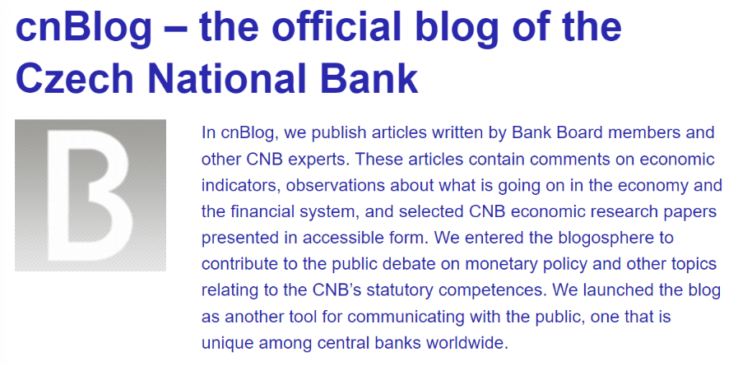**Czech National Bank (CNB) Blog**. Czechia’s central bank launched a regular blog (cnBlog) that publishes articles written by CNB policymakers, senior managers, and selected CNB economic research papers presented in accessible form. In [this blog](https://www.cnb.cz/en/about_cnb/cnblog/Inflation-will-stay-close-to-the-CNBs-2-target-over-the-entire-forecast-horizon/) the Head of the Monetary Policy Department explains the Spring 2024 policy decision and how domestic and external developments affected the cut in the policy rate. Does the blog provide an easy-to-understand description of the transmission mechanism?
2. 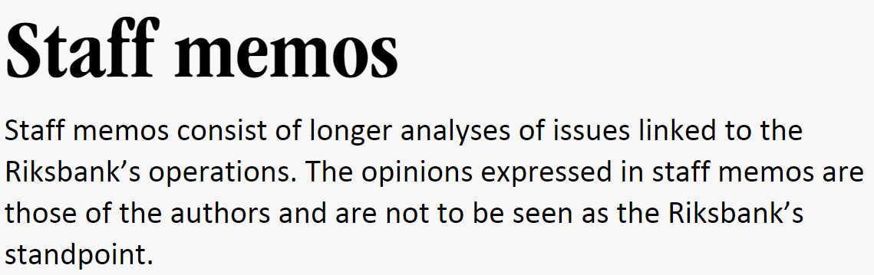**Riksbank’s Staff Memos**. The Swedish central bank has been publishing longer analyses of issues linked to the Riksbank’s operations. The opinions expressed are those of Riksbank’s experts and are not to be seen as policymaker’s standpoint. These memos occupy a space between a blog and a research paper. [This memo](https://intlmonetaryfund.sharepoint.com/teams/CourseSTIEPC-ICDIP/Shared%20Documents/General/Module%203%20(AB)/5.%09https:/www.riksbank.se/globalassets/media/rapporter/staff-memo/engelska/2024/what-drove-the-surge-in-inflation.pdf) attempts to explain Swedish inflation in 2022-23, arguing that demand has contributed to slightly higher prices, but that it has played a relatively limited role compared to other more cost-related factors. Who in your view would benefit from this type of communication?

<INTERACTIVE COURSE PRESENTATION_ENDT>

Let us summarize the lessons from the above examples.

First, a solid understanding of the monetary policy transmission mechanism has been behind each of these communication products, from comic books, infographics, and videos, to a blog and memo. The authors managed to “translate” the monetary model technical language into more accessible formats.

Second, central banks experiment with various formats, depending on the target audience. A Bank of Uganda comic book will not work well for a financial market analyst, and likewise Riksbank’s memo will not work well for a sixth-grader.

### UNIT 2.5: Module 3 Takeaways

Anybody communicating on behalf of a central bank, or any other institution involved in setting macroeconomic conditions need to understand (1) on what basis policy decisions are being made; and (2) how these policy decisions can influence the economy. In other words, the communicator must understand the transmission mechanism.

Before going to the next module, we suggest that you try to replicate on your own the description of the transmission channels for two additional macroeconomic shocks: (1) core inflation unexpectedly increasing by 1% (quarter-on-quarter, annualized) and (2) the exchange rate depreciating by 1% quarter-on-quarter (when annualized, this becomes 4%). The core inflation shock is simulated in <PDF #1> and the exchange rate shock in simulated in <PDF #2>.

* Can you provide the “technical” narrative going through the impulse response functions?
* Can you retell the narrative without the help of the impulse response functions?
* Is it clear what and why the policymaker would move the policy instrument?

**<PDF #1>**

**The Core Inflation Shock**

Replicate on your own the narrative of the transmission mechanism, this time with the shock emanating in core inflation. Several factors could cause such a shock. The post-pandemic surge in core inflation was largely driven by global supply chain disruptions and bottlenecks and energy price shocks. Core inflation can also suddenly increase owing to increased consumer confidence and higher demand facing unchanged supply.

Can you explain why we expect core inflation to increase by more than 1%, even if the initial shock was exactly 1%?

*Hint: (1) Examine the drivers of inflation in the Phillips curve and (2) think about the inflation expectations.*

*Notes: % QoQ denotes quarter-on-quarter change in percent; % pa denotes annualized interest rate in percent; 0001Q1 denotes the simulation value for the first quarter of the first year.*

Shape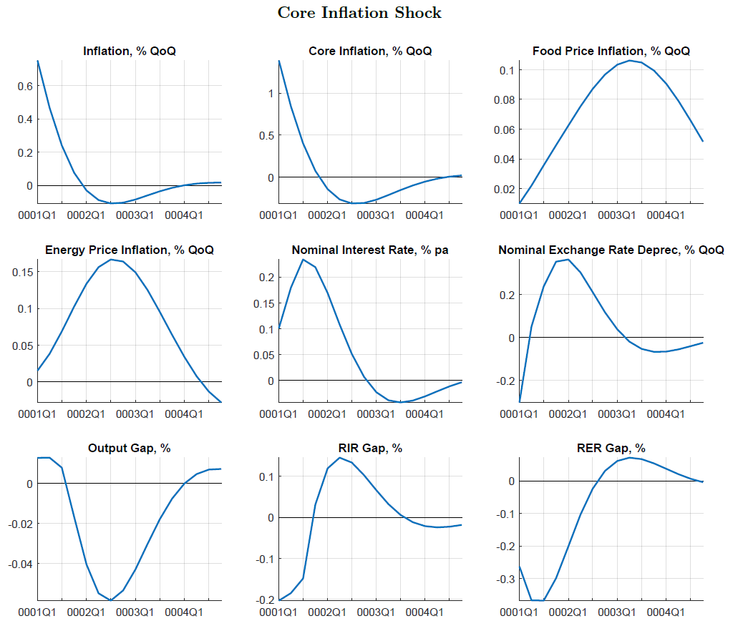

**<END OF PDF>**

<PDF #2>

**The Exchange Rate Shock**

ShapeReplicate on your own the transmission mechanism, this time with the shock emanating in the exchange rate. The Asian financial crisis of the late 1990s is a good example of such a shock: the devaluation of the Thai baht in 1997 triggered a currency contagion that affected neighboring countries, leading to depreciation pressures on their currencies. Doubts that the affected countries had sufficient international reserves was another factor causing the exchange rate shock.

Why is the initial exchange rate depreciation quickly reversed?

*Hint: Recall that the shock is for one period only and that the exchange rate mechanism shows little persistence.*

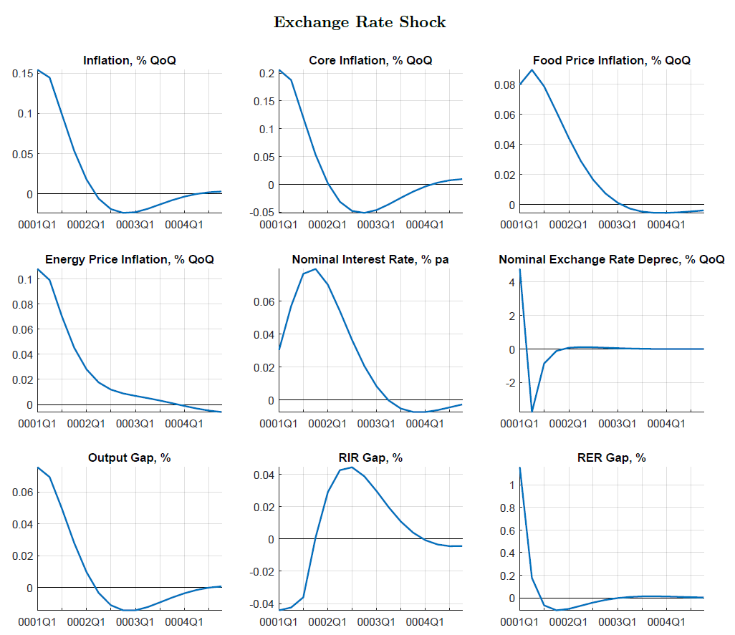

**<END OF PDF>**

## Knowledge Check

1. **<Multiple choice>** The spokesperson should cite as much as possible alternative economic theories and analytical frameworks. She/he does not need to be an expert on the transmission mechanism.

1. Policy institutions, such as central bank or treasuries, value diversity of views, coming from all branches of economic theory.

**<Feedback>** This is **incorrect**. To deliver a consistent policy message, the public institutions need to establish a “common language”. Needless to say, financial analysts, journalists, and the public may not all be interested in the latest theoretical exploits.

1. Every economic event is unique, and the policy institution cannot write a “playbook” that would cover each development.

**<Feedback>** This is **incorrect**. Policy institutions have spent considerable resources to develop tools (“models”) to capture and describe the majority of real-life economic developments.

1. The research department is responsible for explaining the complicated policy responses—the communication department is a just a facilitator.

**<Feedback>** This is **incorrect**. Delaying answers to complex questions until after a response from the research department would render the communication department ineffective.

1. The communication department staff need to have a working knowledge of the transmission mechanism.

**<Feedback>** This is **correct**. To be able to explain policy decisions to the public, the communication department staff need to understand the economic reasoning—the transmission mechanism—behind the policy decisions.

**2. <Multiple choice>** The Research Department in your central bank yesterday issued a new paper that discusses the so-called “zombie-firm channel of monetary policy.” Today you are presenting to market analysts the new macroeconomic forecast. Should you mention the “zombie-firm channel of monetary policy” in your presentation?

1. Definitely. It was just published by a top researcher in your central bank.

**<Feedback>** This is **incorrect**. (1) This channel is not a part of main forecasting model your institution used. (2) You will be distracting your audience away from the key messages. (3) It is highly unlikely that your audience will be aware of the paper.

1. Only if asked by the audience. I will then invite the author to say a few words.

**<Feedback>** This is **incorrect**. You are presenting a macroeconomic forecast and not advertising research papers.

1. If asked, I will note that this is new research that might be used in the future simulations, if found useful.

**<Feedback>** This is **correct**. The key point is to “stay on the message.” The message is the new forecast!

1. Journalists would never ask such a question—I don’t need to prepare.

**<Feedback>** This is **incorrect**. The person communicating on behalf of a public institution should be prepared.

3. **<Multiple choice>** The policymaker went on public TV and said that his government will bring inflation down without tightening of monetary policy, without budgetary spending cuts or higher taxes. Furthermore, there will be no negative impact on employment. Is this a believable statement?

1. The goal of a policymaker is to make everybody happy. He/she can promise at will and does not need to deliver.

**<Feedback>** This is **incorrect**. Such a behavior—making promises and reneging on them—is called time inconsistency and leads to a loss of policymakers’ credibility.

1. The policymaker must carefully explain the policy tradeoff.

**<Feedback>** This is **correct**. Policymaking is typically about making unpopular choices. It means that often to get something, say lower inflation, one must give up something else, say a fiscal stimulus. The key is explaining the tradeoff—if explained well, the public may be able to understand and accept the temporary sacrifice.

1. The policymaker should not explain anything, especially not the policy tradeoff. Explanation will only make him look weak.

**<Feedback>** This is **incorrect**. First, policymakers must be held accountable for their actions. Communicating their objectives and policy tradeoffs is necessary for understanding their actions. Second, if the public does not understand the tradeoff between lower inflation and temporarily higher unemployment, it will not understand the policymakers’ actions and will not adjust their expectations.

1. Communicating the policy tradeoff is good only for transparency.

**<Feedback>** This is **incorrect**. Communicating policymaker’s objectives and policy tradeoffs helps to make policies more effective. If the public understands the tradeoff between lower inflation and temporarily higher unemployment, it will understand the policymakers’ actions and will adjust their expectations accordingly.

**4. <Multiple choice>** The following impulse responses show a *simulation of policy shock* (as before, it depicts a central bank with an inflation objective and floating exchange rate). The policymaker tightened unexpectedly monetary policy by 100 basis point (1 percentage point). Which of the explanations below best corresponds to the standard transmission mechanism?

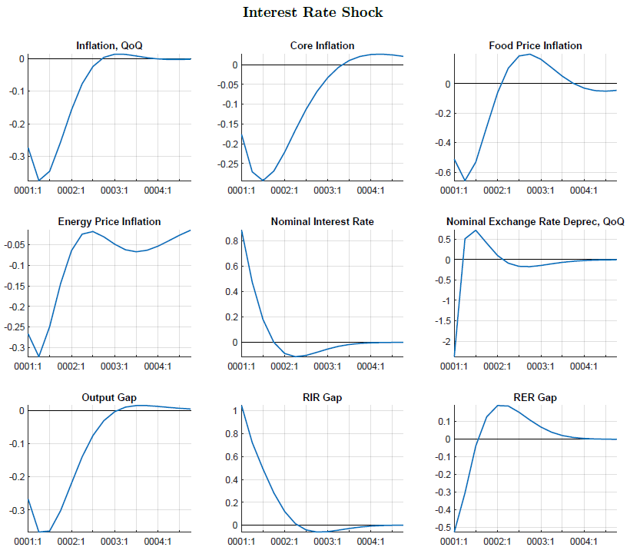

1. Although the policymaker realizes his mistake, given the usual smoothing of the interest rate movements, it takes three quarters for the interest rate to return to close to the initial level. Monetary policy is tight both from the interest rate and exchange rate angles, depressing economic activity. As a result, inflation declines below to target.

**<Feedback>** This is **correct**. Both channels are described correctly.

1. The policymaker starts cutting the rate very quickly. As a result, output booms and the rate of inflation increases.

**<Feedback>** This is **incorrect**. Go back to the impulse responses and observe behavior of output and inflation.

1. The policymaker never realizes his mistake and the interest rate stays permanently high. Inflation expectations will adjust, and inflation will return to the target quickly. Output will temporarily decline owing to nominal depreciation of the exchange rate.

**<Feedback>** This is **incorrect**. Recall that the policymaker does observe the behavior of the economy. Also, the description of the key channels is completely wrong. Go back to the impulse responses and observe behavior of output and inflation.

1. Although the forward-looking policymaker realizes his mistake, he keeps the interest rate high to support the domestic currency. Monetary policy is tight from the interest rate side, but loose from the exchange rate side, so the overall impact on economic activity is neutral.

**<Feedback>** This is **incorrect**. Recall that this is a floating exchange rate regime, and the policymaker does not have an explicit exchange rate objective. Go back to the impulse responses and observe behavior of output and inflation.