

Immunity Debugger
V1.0

Summary

Immunity Debugger is a powerful new way to write exploits, analyze malware, and reverse engineer Win32 binaries. It builds on a solid user interface with function graphing, the industry's first heap analysis tool built specific for heap exploit creation, a large and well supported Python API for easy extensibility.

Python Scripting

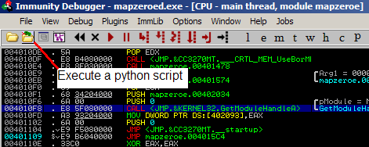

Python scripts can be loaded and modified during runtime. The included Python interpreter will load any changes to your custom scripts on the fly. Sample scripts are included, as is full documentation on how to create your own.

Immunity Debugger plugins are as follows:

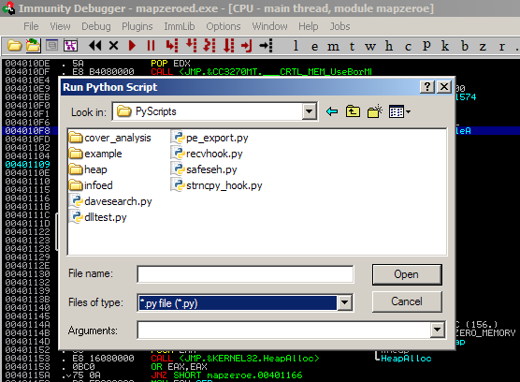

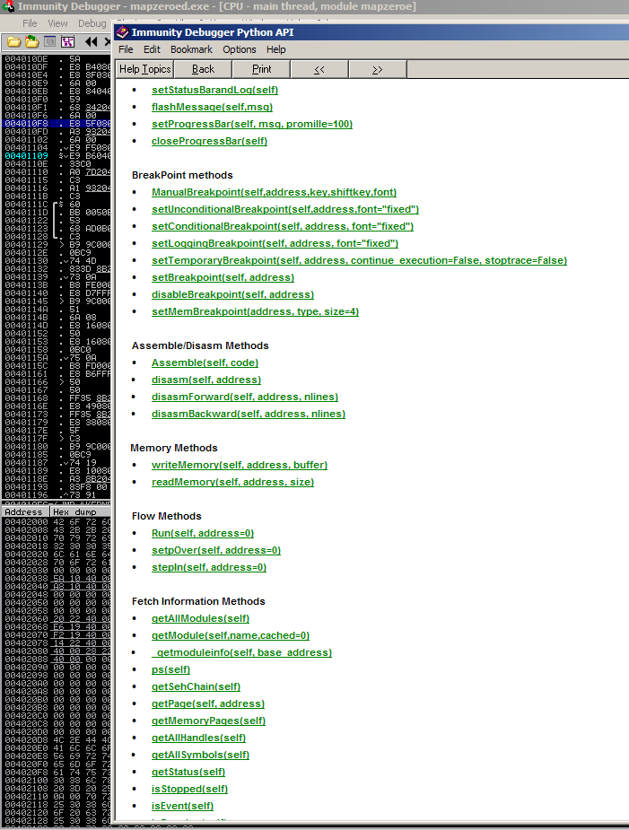

Immunity Debugger's Python API includes many useful utilities and functions. Your scripts can be as integrated into the debugger as any native code. This means your code can create custom tables, graphs, and interfaces of all sorts that remain within the Immunity Debugger user experience. For example, when the Immunity SafeSEH script runs, it outputs the results into a table within the Immunity Debugger window.

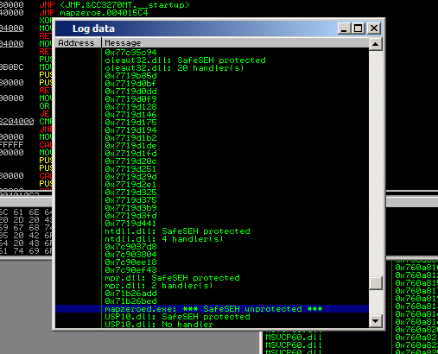

Other scripts can ask for user input with dialogs and combo boxes:
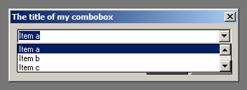
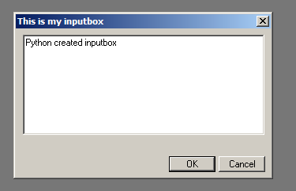

The Best of Both Worlds

Immunity Debugger's interface also includes a command bar. This section at the bottom of Immunity Debuggers, and always available, allows the user to type shortcuts as if they were in a typical text-based debugger, such as WinDBG or GDB. Immunity has implemented aliases to ensure that your WinDBG users do not have to be retrained, and will get the full productivity boost that comes from the best debugger interface on the market.

Commands can be extended in Python as well, or run from the menu-bar.

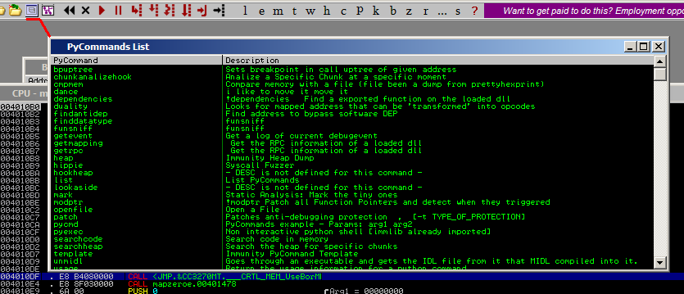

Python commands can also be run directly from our Command Bar. Users can go back to previous entered commands, or just click in the dropdown menu and see all the recently used commands.
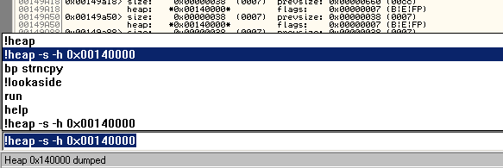

Remote command bar
From the command line menu, you can choose to start a threaded command line server,

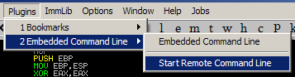
so you can debug remotely from other computer:

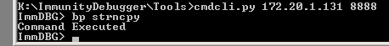

Python Hooks

Often you will want to run a Python script on certain program events, for example, when a breakpoint is hit or an exception is caused. Immunity Debugger hook support includes many debugger events, and more are added with every release.

Built In Graphing

Another Immunity Debugger feature is the capability of creating function graphs. Our Python VCG library will create a window inside Immunity Debugger at the click of a button to graph your selected function. No third party software is required.

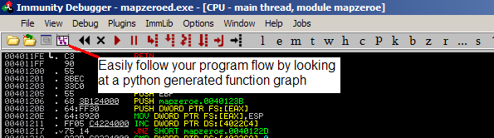
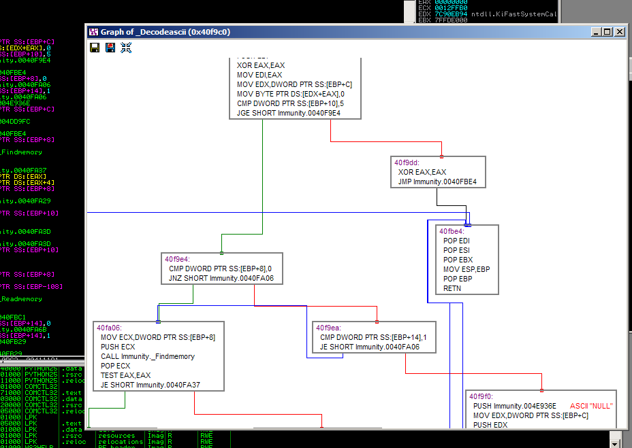

Immunity Debugger is light

Immunity Debugger strives to absorb as few resources on the system as possible. Being too CPU-heavy will cause heap overflows and other complex vulnerabilities to behave differently than they would under normal load. Likewise, fuzzing and other vulnerability analysis is only possible when the debugger is not causing undue system strain.

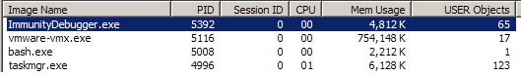

Immunity Debugger shows the info you need
Most debuggers offer only one method to allow you to attach to a process of interest – the pid and the process name. Immunity Debugger offers the pid, process name, services within that process, TPC/UDP ports listened to by that process, complete binary name, and window name. This allows quick and easy access to the exact process you wish to analyze.

