Kevin Bangen

11/17/2020

Foundations of Programming: Python

Assignment 05

Read, process, and write data to a .txt file

# Introduction

This paper will discuss the steps taken in completing Assignment 05. A series of “for” and “while” loops were used to read data from .txt file, process (modify) that data, and write the data to a .txt file. The data, when being modified in python, was stored as a “dictionary”.

# Read .txt file

The script starts with a “for” loop that opens a text file and saves the data to a “dictionary”. The dictionary data is organized by keys for “Task” and “Priority”. That script is shown here:

objFile = open(strFile, "r")

for row in objFile:

strData = row.split(",")

dicRow = {"Task":strData[0], "Priority":strData[1].strip()}

lstTable.append(dicRow)

objFile.close()

print(lstTable)

# Menu

The first text that the user sees when running the script is a “Menu of Options”. This text is created using the print function. The different options in this menu (when acted upon) take you through different elements of a “while” loop.

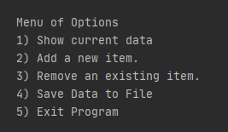

Figure 1: Menu of options shown to the user.

# Option 1

If the user enters “1” the while loop is True for Option 1. This option prints the current data. This is done using inputs that are written to the dictionary in combination with the print function. That script is shown here:

# if (strChoice.strip() == '1'):

# for row in lstTable:

# print(row["Task"] + ", " + row["Priority"])

# continue

# Option 2

If the user enters “2” the while loop is True for Option 2. This options uses the input function in combination with .append() to write the new data to the dictionary. That script is show here:

elif (strChoice.strip() == '2'):

strTask = input("Please provide a task:")

strPrior = input("Please provide a priority:")

dicRow = {"Task": strTask, "Priority": strPrior.strip()}

lstTable.append(dicRow)

continue

# Option 3

If the user enters “3” the while loop is True for Option 3. This option uses a for loop in combination with a .remove() to pull a row from the dictionary. That script is shown here:

elif (strChoice.strip() == '3'):

strDelete=input("Please provide task to delete:")

for row in lstTable:

if (row["Task"] == strDelete):

lstTable.remove(row)

print("Item deleted from list/Table!")

continue

# Option 4

This option saves the collected data to the .txt file. This script is very similar to the script that read the data from the file. The .txt file is opened, the data is written in a particular format using a for loop, and the .txt file is closed. The script is shown here:

elif (strChoice.strip() == '4'):

objFile = open(strFile,"w")

for row in lstTable:

objFile.write(row["Task"] + ", " + row["Priority"]+ '\n')

objFile.close()

print("Data saved to file!")

continue

# Option 5

This option simply closes the file using a break.

# Difficulties + Completed Tests

The primary challenges faced were getting familiar with dictionaries, removing data, and running the script in the command prompt.

Dictionaries are more complex/involved than some of the other data formats and that resulted in a slightly steeper learning curve at multiple points.

Removing data from the file was difficult in that the specific file being removed needed to be identified. I ultimately figured it out, but a feature that I hoped to add, but didn’t, was text that notified the user when it could not find an entry.

Lastly, I had lots of issues running the file in the command prompt. I was ultimately able to have success after re-naming some files/folders and including the entire file path for the .txt file.

Successful tests in PyCharm and the Command Prompt are shown here:

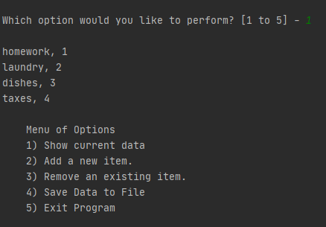

Figure 2: Successful test run in PyCharm.

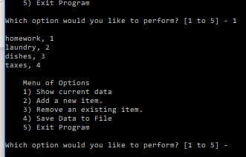

Figure 3: Successful test run in Command Prompt.

# Conclusion

In summary, this paper discussed the steps taken in completing Assignment 05. A series of “for” and “while” loops were used to read data from .txt file, process (modify) that data, and write the data to a .txt file. The data, when being modified in python, was stored as a “dictionary”.