Introduction
At the heart of the paper’s quantification, the estimated efficiency gaps enter directly as a wedge on public spending: an efficiency gap of, say, 0.35 implies that 35 percent of each unit spent does not reach the productive public capital stock—lost to over-invoicing, poor project selection, weak implementation, or inadequate maintenance. The appeal of this formulation is that it separates the level of spending from its productivity—a country spending as much as its peers but with a larger gap wastes a higher share—so that closing the gap raises output without additional budget resources.

Measuring Spending Efficiency: Methodology and SACU Results
This section explains the stochastic-frontier methodology used in the Fiscal Monitor (IMF 2025b) and reports the SACU-specific efficiency-gap estimates that enter the paper’s simulations. Because these gaps conflate several underlying factors—including institutional capacity, governance quality, and country-specific shocks—they do not, on their own, identify the mechanisms by which resources are lost. To address this, Section 4 links the measured gaps to institutional evidence from the Public Investment Management Assessments.

Methodology
This paper relies on the spending-efficiency measures established in Bańkowski, Cho, and Sher (2026), which underpin the October 2025 Fiscal Monitor (IMF 2025b). Their approach compares public spending (the input) with the socioeconomic outcomes it is meant to deliver (the output) in each of the four spending sectors covered by the framework—public investment, education, health, and research and development. Stochastic frontier analysis (SFA) estimates a best-practice production function from a cross-country panel and measures each country’s efficiency as its distance below that frontier. Unlike non-parametric frontiers such as data envelopment analysis, SFA separates genuine inefficiency from statistical noise. It also handles persistent structural differences between countries—such as being landlocked or having a large private health sector. These are absorbed separately, through the four-component (“true random effects”) estimator of Filippini and Greene (2016). The estimator distinguishes time-invariant structural heterogeneity from persistent inefficiency, so the former is not mislabelled as the latter.
Inputs are measured as a five-year moving average of real public spending per capita in purchasing-power-parity terms; outputs combine multiple quantity and quality indicators for each sector (for public investment, for example, road and electricity access alongside infrastructure-quality ratings; for education, enrolment, completion, and learning measures; for health, life expectancy, immunization, and health-system capacity). To avoid sensitivity to any single indicator, scores are averaged across all combinations of the available indicators. Because the estimator is time-varying, it delivers a separate score for each individual country in each individual year, rather than a single cross-sectional snapshot. Each score lies between 0 and 1, with 1 denoting a country on the frontier. Throughout this paper we work with the complementary efficiency gap—one minus the score—so that 0 denotes full efficiency and higher values denote larger shortfalls. Full methodological detail is given in Bańkowski, Cho, and Sher (2026) and the Fiscal Monitor Online Annex (IMF 2025a).

SACU Results
Efficiency gaps persist across sectors in SACU. Figure 1 reports the Fiscal Monitor efficiency gaps for the five SACU countries in three sectors—infrastructure, health, and education—at two points in time (2000 and 2023), alongside the unweighted averages for advanced economies, emerging markets, and sub-Saharan Africa. Three patterns stand out. In every sector, SACU gaps sit above the advanced-economy average and close to the emerging-market level. Infrastructure has improved the most since 2000. Health gaps remain the largest and most persistent, while education has stayed broadly flat even when it deteriorated across advanced economies and emerging markets.
Infrastructure gaps have narrowed but remain wider than peers. The left panel of Figure 1 shows that all five SACU countries closed their infrastructure efficiency gaps substantially between 2000 and 2023. Even so, the SACU average (0.39 in 2023) remains above the advanced-economy average (0.36) and close to the emerging-market level (0.37). The progress reflects both rising spending and strengthened investment-management frameworks, but the remaining gap points to scope for further gains.
Health gaps are persistent and larger than peers. The middle panel shows health efficiency gaps of 0.36 to 0.49 for SACU countries, little changed since 2000 (when the average gap was 0.42 compared to 0.41 in 2023), and above the peer-group averages. Health outcomes in SACU continue to reflect the lingering effects of the HIV/AIDS epidemic, but also structural features of the health systems—urban-rural coverage gaps, workforce pressures, and supply-chain weaknesses—that limit how efficiently spending translates into outcomes.
Education gaps have been broadly stable. The right panel shows education efficiency gaps of 0.31 to 0.44 across SACU. Consequently, the SACU average gap (0.35 in 2023) is in line with the emerging-market average (0.35) and below the sub-Saharan Africa average (0.37). Most countries experienced limited change in efficiency between 2000 and 2023. Lesotho stands out as the exception, with its gap narrowing notably from 0.44 to 0.33. The gaps in South Africa and Namibia ended modestly above their 2000 levels, reaching 0.41 and 0.37 respectively.
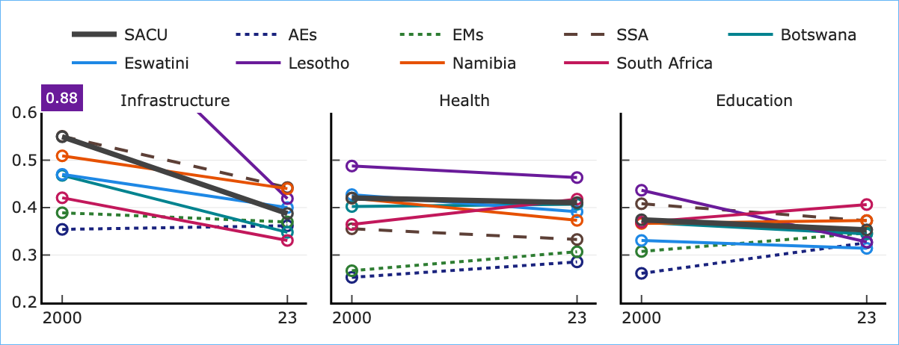 | Note: The chart compares 2000 and 2023 values across three sectors. The thick dark-grey line is the SACU aggregate; thin solid lines show individual countries; dashed/dotted lines show reference averages. The y-axis range is 0.2–0.6; Lesotho’s off-chart 2000 value (0.88) is annotated.
Efficiency Gaps in Health, Education, and Infrastructure Spending
Spending-efficiency comparisons reveal notable differences in where SACU countries stand internationally. Figure 2 sets these gaps in global context, plotting the 2023 efficiency gaps for every country in the database across the three sectors, ordered from highest to lowest gap. In infrastructure (top panel), Namibia, Lesotho, and Eswatini sit close to the median of the global distribution, while Botswana and South Africa are below the median. In contrast, health efficiency gaps in SACU are among the widest in the world (middle panel); all five countries sit in the extreme left tail of the global distribution, with Lesotho (2nd largest gap globally), South Africa (5th), Botswana (6th), Eswatini (9th), and Namibia (14th) highlighting severe inefficiencies. In education (bottom panel), the dispersion is similar to infrastructure: South Africa and Namibia sit in the upper part of the global gap distribution, while Botswana, Lesotho, and Eswatini are closer to the global median.
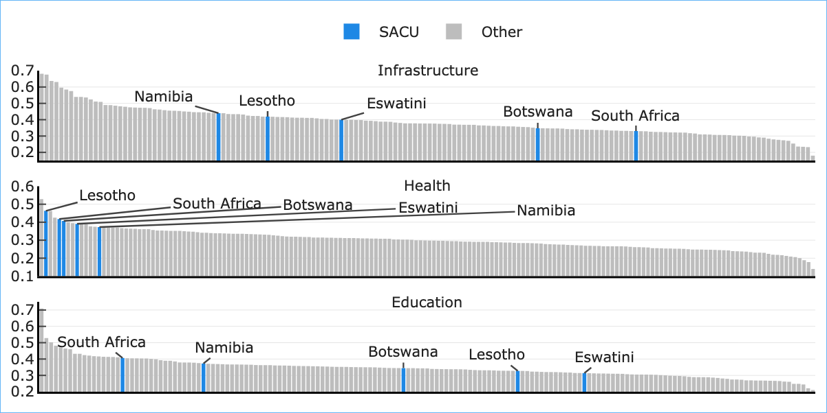 | Note: Each bar is one country; SACU members highlighted in blue.
Spending-Efficiency Gaps Across Countries, 2023
Table 1 summarizes the country-specific efficiency gaps that feed the simulation exercise in Sections 5 and 6. These represent the latest available estimates from the database. For human capital, we report both the education-specific and the health-specific gaps, as well as a blended gap defined as the simple average of the two. The blended gap is used in the model because the Fiscal Monitor DSGE framework treats education and health as a single public human-capital stock (schools and hospitals).
SACU Efficiency Gaps, Latest Available Year
Country | Infrastructure | Education | Health | Blended HC
 | ($e_{GI}$, 2023) | ($e_{GH}^{ edu}$, 2024) | ($e_{GH}^{ hlt}$, 2023) | ($e_{GH}^{ blend}$)
Botswana | 0.35 | 0.36 | 0.41 | 0.38
Eswatini | 0.40 | 0.32 | 0.39 | 0.36
Lesotho | 0.42 | 0.34 | 0.46 | 0.40
Namibia | 0.44 | 0.39 | 0.37 | 0.38
South Africa | 0.33 | 0.42 | 0.42 | 0.42
Note: Blended human-capital gap is the simple average of the education and health gaps.

Appendix: Spending-Efficiency Gaps over Time
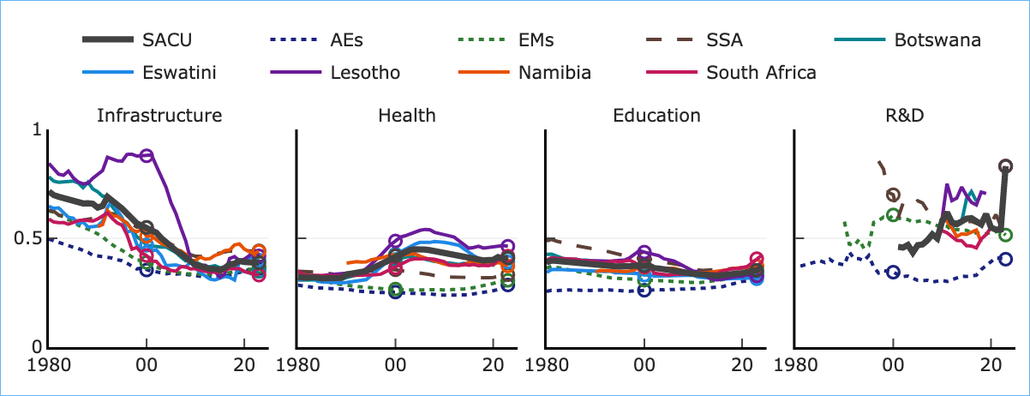 | Note: The thick dark-grey line is the SACU aggregate (unweighted mean of the five members); thin solid lines show the individual countries; dotted lines show reference averages—advanced economies (AEs), emerging markets (EMs), and sub-Saharan Africa (SSA). Hollow circles mark 2000 and 2023.
SACU Spending-Efficiency Gaps over Time
Bańkowski, Krzysztof, Chloe Hyungsun Cho, and Galen Sher. 2026. “Public Spending Efficiency.”
Filippini, Massimo, and William Greene. 2016. “Persistent and Transient Productive Inefficiency: A Maximum Simulated Likelihood Approach.” Journal of Productivity Analysis 45 (2): 187–96.
IMF. 2025a. Fiscal Monitor Online Annex: Methodological Sections. Washington, DC: International Monetary Fund.
———. 2025b. Fiscal Monitor: Spending Smarter—How Efficient and Well-Allocated Public Spending Can Boost Economic Growth. Washington, DC: International Monetary Fund.
———. 2026. “Spending Smarter in SACU: Diagnosis, Modelling, and Policy Implications.”

R&D lies outside the scope of this paper and is not considered further; the analysis focuses on public investment, education, and health.

