DATA CHANGE CONTROL STRATEGY
A champion-led operating model for data platform change governance
Prepared for Change Manager and Change Management review | Draft | July 24, 2026
This document is organized around the five questions raised for this review, in the order they were asked. Each question is its own heading below, with everything relevant to it grouped underneath, so nothing has to be tracked down elsewhere in the document. It's built entirely from the current Change Management Process for Data.

Scope & Assumptions
Item | Basis
Source | One document, the current Change Management Process for Data, including the CR-required tables, tier definitions, Q&A log, and pain points.
Change Manager role | Held by Aimee today, but referred to as a role throughout since incumbents change.
Tier model | Five tiers confirmed: Standard, Minor, Significant, Major, Emergency (see the tier table under Question 2).
Teams in scope | Data Engineering, Database Administration, Platforms, App Dev & Integrations, BI & Reporting, Core Systems, IT Service Management, with InfoSec advisory.

1. Make any recommendations to document (approvers: Aimee & Change Management)
The current process document already surfaces six gaps through its own pain points and Q&A log. These anchor every recommendation below.

Documented Gaps
Gap | Current State | Consequence
Approver counts unclear | Submission requirements and approver counts per category aren't clearly documented. | Requesters guess, causing rework or under-approved changes.
Power BI Service ambiguity | Deploying to Power BI Service has required a CR, yet “publishing new reports” is listed as not requiring one. | Teams can't predict if a CR is needed.
Change window inflexibility | A missed window can't be rescheduled after the fact, so it forces a new change end to end. | Approval cycles wasted on routine timing slips.
Mid-change remediation | Standard recovery steps require opening a separate change to finish the original one. | Routine recovery delayed by an unrelated approval cycle.
CR ownership split undocumented | DT raises the ISM ticket, and Platforms creates the CR for infra work. It's answered in Q&A but not written into procedure. | New hires don't know who owns what.
Tiers lack data examples | The process names five tiers but wants more definition with data-specific examples. | Teams guess independently how a change maps to a tier.

Recommendations
- Rule on whether Power BI Service deployments fall under the “publishing new reports” not-required row or need their own classification (Appendix E). This is the most concrete conflict in the current CR-required table.
- Adopt the tier and approver reference under Question 2 as the single authoritative source for approver counts and submission requirements.
- Approve a short pre-authorized list of common mid-change recovery steps, such as a restart or job re-run, so completing one doesn't require opening a brand-new change (see the procedures under Question 2).
- Consider a short grace period, such as the same business day, so a still-pending change can move to a new window without a full resubmission when it's missed.
- Configure a documented delegate for the Change Manager role so a Minor change never stalls because one person is unavailable.
- Write the DT-raises-ticket, Platforms-creates-CR split into both teams' documented procedures (see Question 2), since it's currently confirmed only in Q&A notes.
- Add the data-specific tier examples under Question 2 to the official process document, closing the gap the process itself flags.
These seven items are the concrete requests for the Change Manager and Change Management to rule on. Questions 2 through 5 below show how each would operate once approved.

2. Ensure procedures are set up to support the team for change control

Collaboration Model
Each team nominates one senior champion to sit on a new Data Change Forum, a commitment of roughly two to four hours a week. The Forum reviews and recommends, and it does not approve. Minor stays with the Change Manager, Significant and Major stay with CAB and ISLT, exactly as today, just with a pre-vetted dependency picture attached.
Team | Champion Focus | ISM Tags Owned
Data Engineering | ETL/ELT, Databricks, deidentification | ETL, Databricks
Database Administration | SQL Server, warehouse, MDM | SQL Server, MDM
Platforms | Servers, network, TIBCO, and CR creation for DT-raised infra work | Server, Network, TIBCO
App Dev & Integrations | PowerApps, APIs | PowerApps, API
BI & Reporting | Power BI Service, Report Server, Gateway | Power BI
Core Systems | Core banking data extracts | Core Banking
IT Service Management | ISM platform, workflow automation | ISM Platform

Approval Chain and Tiers
The approval chain is unchanged. Standard is pre-approved and logged only. Minor is approved by the Change Manager plus additional approvers as needed. Significant goes to CAB. Major goes to CAB and ISLT. Emergency is entered in ISM before work begins and approved by ECAB within two hours, with the Duty Manager able to approve.
Tier | Data Platform Examples | Approval
Standard | Stored ETL procedures, restarting stuck jobs, schema/table adjustments (CR-not-required today) | Log only
Minor | Non-breaking index change, negligible-impact ETL transformation, report publish within existing tech | Change Manager + additional approvers
Significant | Member-visible schema change, Power BI Gateway/Report Server upgrade | CAB
Major | Core platform release, broad-impact technology upgrade | CAB + ISLT
Emergency | MDM restart during an incident, emergency security patch | ECAB within 2 hrs

RACI Matrix
Continued from Question 2, shown in landscape orientation so every column fits.
R = Responsible, A = Accountable, C = Consulted, I = Informed, - = not typically involved.
Producing Team | Champion | Data Gov. | InfoSec | Change Mgr | CAB | ISLT | ECAB/Duty Mgr | Forum
Raise ISM ticket / submit change | R | C | - | - | I | - | - | - | -
Create formal CR (Platforms, infra work) | C | C | - | - | I | - | - | - | -
Classify tier | R | C | C | C | I | - | - | - | A
Identify downstream dependencies | C | R | C | I | - | - | - | - | A
Approve a Minor change | I | C | I | I | A | - | - | - | I
Approve a Significant change | I | I | I | C | C | A | - | - | C
Approve a Major change | I | I | I | C | C | A | A | - | C
Approve an Emergency change (2 hrs) | I | I | - | C | I | - | - | A | I
Implement and validate | R | A | C | - | I | - | - | - | -
Execute rollback or remediation | R | A | - | C | I | - | - | I | -
Update change-control documentation | C | C | A | C | A | I | I | - | C

Standard Operating Procedures
- Classify against the Data Change Request Decision Matrix (Appendix E) before doing anything else.
- Raise the ISM ticket. For infrastructure work owned by Platforms, DT raises the ticket and Platforms creates the CR and assigns it within their own team (Recommendation 6).
- Identify downstream dependencies for Minor, Significant, or Major changes, confirmed with the relevant Forum champion.
- Execute strictly per the documented plan, log actions in real time, and complete a Post-Implementation Review within 5 business days for Minor, Significant, or Major changes.
- Rollback triggers are defined in the change plan up front. The named rollback owner can invoke it without a further approval cycle once a documented trigger is met. Once Recommendation 3 is adopted, a pre-authorized recovery step counts as completing the original change, not a new one.
- No notice is required for Standard. Minor needs 3 business days, Significant needs 5, Major needs 10, and Emergency needs as soon as practical. A missed window can move under Recommendation 4, once approved.
- A record can't close without tier classification, approvals on record, test evidence, a rollback plan, and a completed PIR where required.

Team-Specific Variance
Team | Distinct Before-Change Step | Distinct Validation Step
Data Engineering | Confirm the job is version-controlled before deployment | Row-count and control-total reconciliation
Database Administration | Check capacity and locking impact on the target instance | Query plan and index performance check
Platforms | Confirm the ISM ticket is in hand before creating the CR | Resource and service health check
App Dev & Integrations | Confirm whether the change targets dev or production | Contract and regression test suite
BI & Reporting | Confirm whether it's a report enhancement or a Gateway/Report Server upgrade | Visual render and key-figure spot-check
Core Systems | Confirm the change against vendor-supported options | End-to-end transaction test in non-production
IT Service Management | Confirm the change doesn't break existing routing rules | Full-lifecycle test ticket in non-production

3. Training for each team, specific to their changes and toolset
Every team needs the same foundation, made up of the tier model and the CR-required table, plus depth on their own toolset.
Team | Toolset Focus | Common Mistake → Best Practice
Data Engineering | Git/CI-CD, Databricks jobs | Editing notebooks directly in production → Deploy via CI/CD from a reviewed branch
Database Administration | SQL Server scripting, execution plans | Running DDL live during business hours → Use approved windows with a rehearsed rollback
Platforms | CR creation, server/network/TIBCO | Starting infra work before the ticket exists → Confirm the ticket, then create the CR
App Dev & Integrations | API versioning, contract testing | Shipping a breaking change unannounced → Version the endpoint and test known consumers first
BI & Reporting | Power BI pipelines, semantic models | Editing a shared dataset blind → Check the dependent-reports list first
Core Systems | Vendor change procedures | Patching straight to production → Stage and run a full transaction cycle first
IT Service Management | ISM admin, CMDB maintenance | Letting the dependency map go stale → Run a quarterly accuracy audit
- New hires get a half-day fundamentals module in week one, before their first change. Champions deliver toolset-specific onboarding within the first month. All staff get a 30-minute annual refresher.

4. Explore how we might be able to create workflows in ISM to inform us of upstream system changes
Nothing in ISM today tells a team when an upstream change might affect their pipelines, reports, or applications, so teams find out when something breaks. The fix is a CMDB-style dependency table linking source tables and jobs to downstream datasets, reports, and applications, checked automatically the moment a change is entered.
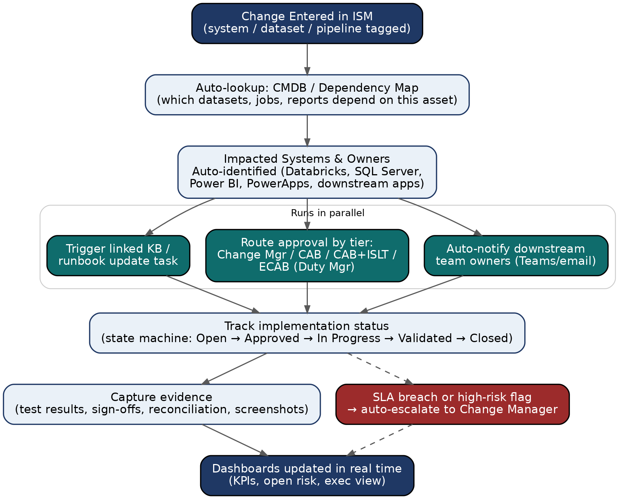
Automated dependency lookup and downstream notification, triggered at ticket creation.
Capability | How It Works | Owner
Notify downstream teams | On ticket creation, ISM queries the dependency table and auto-adds affected champions as watchers. | ISM + champions
Route approvals | The tier field drives routing. Minor goes to the Change Manager, Significant to CAB, Major to CAB+ISLT, and Emergency to ECAB. | IT Service Management
Track status | State machine from Open through Approved, In Progress, Validated, Closed. | IT Service Management
Escalate risk | SLA timers auto-escalate an unapproved Minor change or a nearing Emergency deadline. | IT Service Management
The suggested build order is evidence-capture fields first, then tier-based routing, then dependency mapping starting with the highest-traffic pipelines, then automated notification once coverage is meaningful.

5. Evaluate the kind of changes being shared at Change Management sessions

a. What needs to come back to our teams
- Infrastructure changes from Platforms affecting data platform availability.
- Database platform patching and maintenance windows.
- PowerApps and application releases feeding the data platform.
- Vendor or cloud technology updates affecting data integrations.

b. What we need to share from our teams
- Data pipeline changes and their downstream report impact.
- Schema changes and their regulatory reporting impact.
- New datasets being onboarded.
- Power BI changes with material business-user impact.

c. What we need to stand up separate specific for data (with other teams or for other teams)
A general Change Management meeting can't go deep on data-platform dependency chains without losing every other attendee. We'd recommend a weekly 30-minute Data Change Forum with each team champion, chaired by Data Governance, limited to Minor, Significant, and Major changes touching the data platform. It's advisory only. Significant and Major changes still go to CAB and CAB plus ISLT exactly as today, just with a completed dependency picture attached.

Next Steps
- Circulate this document, including the recommendations under Question 1, to the Change Manager and Change Management for a ruling.
- Nominate a champion per team and hold the Data Change Forum kickoff.
- Fold the RACI matrix, SOPs, and decision matrix into onboarding.

Appendix E. Decision Matrix, Flagged Items
The full Change Request Decision Matrix already exists in the current process document. These are the specific rows in tension with practice, reproduced here because they're the basis for Recommendation 1.
Domain | Change / Activity | CR Required?
Reporting | Publishing new reports within existing technology | No*
System Configuration | Power BI Gateway / Report Server upgrades | Yes
Data | Adjustments to data schemas, tables, or stored procedures | No
Data | Data migrations or archiving activities | Yes
* Power BI Service deployments, such as Member 360, have required a CR despite this row. We recommend that Change Management confirm whether that's intended, or whether the row needs a Yes or conditional variant of its own.

Appendix F. Institutional Knowledge Log
Topic | Current Answer | Status
Who creates the CR for infra work? | DT raises the ticket, Platforms creates the CR. | Decided. Needs to be written into SOPs (Recommendation 6).
Can a missed window be moved? | Only before the window closes, not after. | Decided, flagged as a pain point. Grace period recommended (Recommendation 4).
Approver counts per category | Not clearly documented. | Resolved by this document (Recommendation 2).
Power BI Service deployment | Required a CR despite the not-required row. | Open, escalated as Recommendation 1.
Mid-change remediation | Requires opening a new change. | Open, recommendation drafted (Recommendation 3).

