DATA CHANGE CONTROL STRATEGY
A champion-led operating model for data platform change governance
Prepared for Change Manager and Change Management review | Draft | July 24, 2026
This strategy answers the five outcomes raised for this review, using the current Change Management Process for Data as its only source. It works through the pain points and open questions already recorded in that document rather than proposing a new process.

Scope & Assumptions
Item | Basis
Source | One document, the current Change Management Process for Data, includes the CR-required tables, tier definitions, Q&A log, and pain points.
Change Manager role | Held by Aimee today but referred to as a role throughout since incumbents change.
Tier model | Five tiers confirmed: Standard, Minor, Significant, Major, Emergency (Section 4.1).
Teams in scope | Data Engineering, Database Administration, Platforms, App Dev & Integrations, BI & Reporting, Core Systems, IT Service Management, with InfoSec advisory.

1. Executive Summary
Data moves through more hands than any other asset here. A schema change made confidently by Data Engineering can silently break a Power BI report downstream, and today nothing tells either team about the other before it happens. This strategy proposes a champion from each technical team, shared procedures, toolset-specific training, and ISM workflows that surface dependency automatically, without changing the existing approval chain.
Six gaps already documented in the current process anchor everything below. They are unclear approver counts, the Power BI Service classification conflict, change window inflexibility, mid-change remediation requiring a new CR, an undocumented CR ownership split, and tier definitions without data examples.

2. Current Challenges
All six rows are documented pain points or Q&A items from the current process, not hypothetical gaps.
Gap | Current State | Consequence
Approver counts unclear | Submission requirements and approvers counts per category aren't clearly documented. | Requesters guess, causing rework or under-approved changes.
Power BI Service ambiguity | Deploying to Power BI Service has required a CR, yet “publishing new reports” is listed as not requiring one. | Teams can't predict if a CR is needed.
Change window inflexibility | A missed window can't be rescheduled after the fact, so it forces a new change end to end. | Approval cycles wasted on routine timing slips.
Mid-change remediation | Standard recovery steps require opening a separate change to finish the original one. | Routine recovery delayed by an unrelated approval cycle.
CR ownership split undocumented | DT raises the ISM ticket, and Platforms creates the CR for infra work. Answered in Q&A, not written into procedure. | New hires don't know who owns what.
Tiers lack data examples | The process names five tiers but wants more definition with data-specific examples. | Teams guess independently how a change maps to a tier.

3. Collaboration Model
Each team nominates one senior champion, roughly two to four hours a week, to sit on a new Data Change Forum. The Forum reviews and recommends, and it does not approve. Minor stays with the Change Manager, Significant and Major stay with CAB and ISLT, exactly as today, just with a pre-vetted dependency picture attached.
Team | Champion Focus | ISM Tags Owned
Data Engineering | ETL/ELT, Databricks, deidentification | ETL, Databricks
Database Administration/ Analyst | SQL Server, warehouse, MDM | SQL Server, MDM
Platforms | Servers, network, TIBCO, and CR creation for DT-raised infra work | Server, Network, TIBCO
App Dev & Integrations | PowerApps, APIs | PowerApps, API
BI & Reporting | Power BI Service, Report Server, Gateway | Power BI
Core Systems | Core banking data extracts | Core Banking
IT Service Management | ISM platform, workflow automation | ISM Platform

4. Governance Framework
The approval chain is unchanged: Standard is pre-approved and logged only. Minor is approved by the Change Manager plus additional approvers as needed. Significant goes to CAB. Major goes to CAB and ISLT. Emergency is entered into ISM before work begins and approved by ECAB within two hours, with the Duty Manager able to approve.
- Recommended addition. The Change Manager and Duty Manager are named individual approval points with no documented backup today. A documented delegate for the Change Manager role would stop a Minor change from stalling just because one person is unavailable.

4.1 Tiers with Data Platform Examples
Tier | Data Platform Examples | Approval
Standard | Stored ETL procedures, restarting stuck jobs, schema/table adjustments (CR-not-required today) | Log only
Minor | Non-breaking index change, negligible-impact ETL transformation, report publish within existing tech | Change Manager + additional approvers
Significant | Member-visible schema change, Power BI Gateway/Report Server upgrade | CAB
Major | Core platform release, broad-impact technology upgrade | CAB + ISLT
Emergency | MDM restarted during an incident, emergency security patch | ECAB within 2 hrs.
Every record also captures business, technical, and data impact, retains approvals and evidence per the records-retention standard, and gets reviewed annually or when the underlying process changes. Final sign-off on documentation updates rests with Data Governance and Change Management.

5. RACI Matrix
R = Responsible, A = Accountable, C = Consulted, I = Informed, - = not typically involved.
Producing Team | Champion | Data Gov. | InfoSec | Change Mgr. | CAB | ISLT | ECAB/Duty Mgr. | Forum
Raise ISM ticket / submit change | R | C | - | - | I | - | - | - | -
Create formal CR (Platforms, infra work) | C | C | - | - | I | - | - | - | -
Classify tier | R | C | C | C | I | - | - | - | A
Identify downstream dependencies | C | R | C | I | - | - | - | - | A
Approving a Minor change | I | C | I | I | A | - | - | - | I
Approving a Significant change | I | I | I | C | C | A | - | - | C
Approving a Major change | I | I | I | C | C | A | A | - | C
Approve an Emergency change (2 hrs.) | I | I | - | C | I | - | - | A | I
Implement and validate | R | A | C | - | I | - | - | - | -
Execute rollback or remediation | R | A | - | C | I | - | - | I | -
Update change-control documentation | C | C | A | C | A | I | I | - | C

6. What Belongs in Change Management Sessions

6.1 Information Flow(Feel free to add more)
Should Come Back to Our Teams | Should Come From Our Teams
Infrastructure changes from Platforms affecting data platform availability | Data pipeline changes and their downstream report impact
Database platform patching and maintenance windows | Schema changes and their regulatory reporting impact
PowerApps and application releases feeding the data platform | New datasets being onboarded
Vendor or cloud technology updates affecting data integrations | Power BI changes with material business-user impact

6.2 A Dedicated Data Change Forum
A general Change Management meeting can't go deep on data-platform dependency chains without losing every other attendee. We'd recommend a weekly 30-minute session with each team champion, chaired by Data Governance, limited to Minor, Significant, and Major changes touching the data platform. It's advisory only. Significant and Major changes still go to CAB and CAB plus ISLT exactly as today, just with a completed dependency picture attached.

7. Standard Operating Procedures

7.1 Before, During, and After a Change
- Classify against the Data Change Request Decision Matrix (Appendix E) before doing anything else.
- Raise the ISM ticket. For infrastructure work owned by Platforms, DT raises the ticket and Platforms creates the CR and assigns it within their own team.
- Identify downstream dependencies for Minor, Significant, or Major changes, confirmed with the relevant forum champion.
- Execute strictly per the documented plan, log actions in real time, and complete a Post-Implementation review within 5 business days for Minor, Significant, or Major changes.

7.2 Rollback and Mid-Change Remediation
- Rollback triggers are defined in the change plan up front. The named rollback owner can invoke it without a further approval cycle once a documented trigger is met.
- We'd recommend adding a short pre-authorized field to the change plan template for common recovery steps, such as a restart or job re-run, to fix the documented mid-change remediation pain point. Executing one of those counts as completing the original change, not a new one. This needs Change Management sign-off.

7.3 Notice and Documentation
- Notice required is none for Standard, 3 business days for Minor, 5 for Significant, 10 for Major, and as soon as practical for Emergency.
- We'd recommend a short grace period, such as the same business day, moving a still-pending change to a new window without full resubmission, if the risk profile hasn't changed to fix the missed-window pain point.
- A record can't close without tier classification, approvals on record, test evidence, a rollback plan, and a completed PIR where required.

7.4 Team-Specific Variance
Team | Distinct Before-Change Step | Distinct Validation Step
Data Engineering | Confirm the job is version-controlled before deployment | Row-count and control-total reconciliation
Database Administration | Check capacity and locking impact on the target instance | Query plan and index performance check
Platforms | Confirm the ISM ticket is in hand before creating the CR | Resource and service health check
App Dev & Integrations | Confirm whether the change targets dev or production | Contract and regression test suite
BI & Reporting | Confirm whether it's a report enhancement or a Gateway/Report Server upgrade | Visual render and key-figure spot-check
Core Systems | Confirm the change against vendor-supported options | End-to-end transaction test in non-production
IT Service Management | Confirm the change doesn't break existing routing rules | Full-lifecycle test ticket in non-production

8. Training for Each Team
Every team needs the same foundation, the tier model and the CR-required table, plus depth on their own toolset.
Team | Toolset Focus | Common Mistake → Best Practice
Data Engineering | Git/CI-CD, Databricks jobs | Editing notebooks directly in production → Deploy via CI/CD from a reviewed branch
Database Administration | SQL Server scripting, execution plans | Running DDL live during business hours → Use approved windows with a rehearsed rollback
Platforms | CR creation, server/network/TIBCO | Starting infra work before the ticket exists → Confirm the ticket, then create the CR
App Dev & Integrations | API versioning, contract testing | Shipping a breaking change unannounced → Version the endpoint and test known consumers first
BI & Reporting | Power BI pipelines, semantic models | Editing a shared dataset blind → Check the dependent-reports list first
Core Systems | Vendors change procedures | Patching straight to production → Stage and run a full transaction cycle first
IT Service Management | ISM admin, CMDB maintenance | Letting the dependency map go stale → Run a quarterly accuracy audit
- New hires get a half-day fundamentals module in week one, before their first change. Champions deliver toolset-specific onboarding within the first month. All staff get a 30-minute refresher annually.

9. ISM Workflows for Upstream Change Visibility
Nothing in ISM today tells a team when an upstream change might affect their pipelines, reports, or applications, so teams find out when something breaks. The fix is a CMDB-style dependency table linking source tables and jobs to downstream datasets, reports, and applications, checked automatically the moment a change is entered.
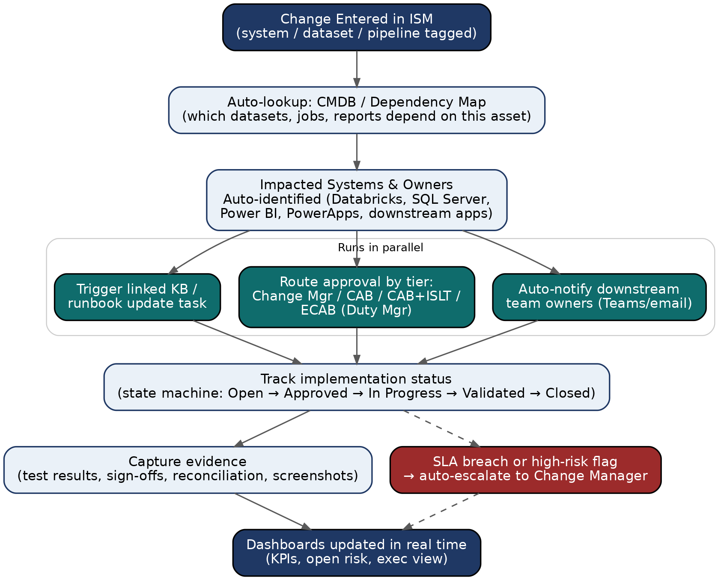
Automated dependency lookup and downstream notification, triggered at ticket creation.
Capability | How It Works | Owner
Notify downstream teams | On ticket creation, ISM queries the dependency table and auto-adds affected champions as watchers. | ISM + champions
Route approvals | Tier field drives routing: Minor to Change Manager, Significant to CAB, Major to CAB+ISLT, Emergency to ECAB. | IT Service Management
Track status | State machine from Open through Approved, In Progress, Validated, Closed. | IT Service Management
Escalate risk | SLA timers auto-escalate an unapproved Minor change or a nearing Emergency deadline. | IT Service Management
The suggested build order is evidence-capture fields first, then tier-based routing, then dependency mapping starting with the highest-traffic pipelines, then automated notification once coverage is meaningful.

10. Recommendations & Next Steps
- Get a documented ruling from Change Management on the Power BI Service classification and the pre-authorized mid-change remediation steps (Section 2 and 7.2). Both are quick wins resolving pain points already raised.
- Publish Appendix E as the single authoritative decision matrix, closing the approver-count gap.
- Close the single-point-of-failure gap by configuring a documented delegate for the Change Manager role (Section 4).
- Start ISM automation with evidence capture and tier-based routing before attempting downstream auto-notification (Section 9).
- Ratify the Data Change Forum as an advisory body, fold the RACI matrix and SOPs into onboarding, and circulate this strategy to Change Management and team leads for comment.

Appendix E. Decision Matrix, Flagged Items
The full Change Request Decision Matrix already exists in the current process document. These are the specific rows in tension with practice, reproduced here because they're the basis for Recommendation 1.
Domain | Change / Activity | CR Required?
Reporting | Publishing new reports within existing technology | No*
System Configuration | Power BI Gateway / Report Server upgrades | Yes
Data | Adjustments to data schemas, tables, or stored procedures | No
Data | Data migrations or archiving activities | Yes
* Power BI Service deployments, such as Member 360, have required a CR despite this row. We recommend Change Management confirm whether that's intended, or whether the row needs a Yes or conditional variant of its own.

Appendix F. Institutional Knowledge Log
Topic | Current Answer | Status
Who creates the CR for infra work? | DT raises the ticket, Platforms creates the CR. | Decided. Needs to be written into SOPs (7.4).
Can a missed window be moved? | Only before the window closes, not after. | Decided, flagged as a pain point. Grace period recommended (7.3).
Approver counts per category | Not clearly documented. | Resolved by this document (Appendix E).
Power BI Service deployment | Required a CR despite the not-required row. | Open, escalated as Recommendation 1.
Mid-change remediation | Requires opening a new change. | Open recommendation drafted (7.2).

