CHANGE CONTROL STRATEGY TEMPLATE
A reusable template for extending the champion-led change control model to any team
Template | Based on the Data Team's Change Control Strategy | July 24, 2026
This is a fill-in-the-blank version of the strategy already completed for the data platform teams. It's organized around the same five questions, in the same order, so any team can produce a matching document without starting from scratch. Sections marked REUSE AS-IS are the organization's existing change process and don't need editing. Sections marked CUSTOMIZE FOR YOUR TEAM have bracketed placeholders to replace with your own content. The completed Data Team version is available separately as a worked example.

Document Control
Field | Value
Document Owner | [Name / role responsible for keeping this current]
Team | [Your team name]
Version | 1.0
Last Reviewed | [Date]
Status | [Draft / Approved]

Scope & Assumptions
Item | Basis
Source | [Name your team's own current process document, if one exists. If none exists, note that this strategy establishes the first documented version.]
Change Manager role | Confirm who holds the Change Manager role today, and note that it's referred to as a role throughout since incumbents change.
Tier model | Five tiers, Standard, Minor, Significant, Major, Emergency, already apply company-wide. No changes needed here.
Teams in scope | [List the specific sub-teams or functions within your group that will each nominate a champion.]

Glossary
REUSE AS-IS. This part is the org's existing process and doesn't change per team.
Term | Definition
CR | Change Request, the formal record created for changes that need governance review.
ISM | IT Service Management, the ticketing platform used to log and route changes.
CAB | Change Advisory Board, the group that reviews and approves Significant-tier changes.
ISLT | The senior leadership group that co-approves Major-tier changes alongside CAB.
ECAB | Emergency Change Advisory Board, the abbreviated approval path for Emergency-tier changes.
CMDB | Configuration Management Database, the system of record for assets and their dependencies.
PIR | Post-Implementation Review, the after-action check completed once a change goes live.
RACI | Responsible, Accountable, Consulted, Informed, the model used to assign roles on each activity.
SLA | Service Level Agreement, the target time within which an action, such as an approval, should happen.
Tier | The classification, Standard, Minor, Significant, Major, or Emergency, that determines how much governance a change needs.

1. Make any recommendations to document (approvers: [Team Approver] & Change Management)
CUSTOMIZE FOR YOUR TEAM. Replace the bracketed text below.
Start by pulling together whatever pain points and open questions your team already has, whether that's a Q&A log, a Slack thread, or just tribal knowledge. Those gaps are what anchor your recommendations.

Documented Gaps
Example row from the Data Team, shown for format only. Replace with your own team's gaps below.
Gap | Current State | Consequence
EXAMPLE: Power BI Service ambiguity | Deploying to Power BI Service has required a CR, yet “publishing new reports” is listed as not requiring one. | Teams can't predict if a CR is needed.
[Your gap 1] | [What the current state is today] | [What it costs the team]
[Your gap 2] | [What the current state is today] | [What it costs the team]
[Your gap 3] | [What the current state is today] | [What it costs the team]

Recommendations
- [Recommendation addressing your first gap. Say what should change and who needs to rule on it.]
- [Recommendation addressing your second gap.]
- [Recommendation addressing your third gap.]
Keep this list to concrete, specific asks. Each one should be something the Change Manager and Change Management can approve or reject on its own, not a general aspiration.

2. Ensure procedures are set up to support the team for change control

Collaboration Model
CUSTOMIZE FOR YOUR TEAM. Replace the bracketed text below.
Each team nominates one senior champion to sit on a coordination forum for your domain, a commitment of roughly two to four hours a week. The forum reviews and recommends, and it does not approve. Minor stays with the Change Manager, Significant and Major stay with CAB and ISLT, exactly as today, just with a pre-vetted dependency picture attached. This part of the model is reusable, only the team list below needs filling in.
Team | Champion Focus | System / Ticket Tags Owned
[Sub-team 1] | [What this team is responsible for] | [Tags]
[Sub-team 2] | [What this team is responsible for] | [Tags]
[Sub-team 3] | [What this team is responsible for] | [Tags]

Approval Chain and Tiers
REUSE AS-IS. This part is the org's existing process and doesn't change per team.
The approval chain is unchanged. Standard is pre-approved and logged only. Minor is approved by the Change Manager plus additional approvers as needed. Significant goes to CAB. Major goes to CAB and ISLT. Emergency is entered in ISM before work begins and approved by ECAB within two hours, with the Duty Manager able to approve.
Only the middle column below is team-specific. Replace the bracketed examples with what each tier actually looks like in your domain.
Tier | [Your Domain] Examples | Approval
Standard | [Pre-approved, no-interruption work specific to your team] | Log only
Minor | [Negligible-impact change specific to your team] | Change Manager + additional approvers
Significant | [Member- or staff-visible change specific to your team] | CAB
Major | [Substantial-impact change specific to your team] | CAB + ISLT
Emergency | [Urgent repair work specific to your team] | ECAB within 2 hrs

RACI Matrix
REUSE AS-IS. This part is the org's existing process and doesn't change per team. Add a row only if your team has a similar ticket/CR ownership split to document.
Continued from Question 2, shown in landscape orientation so every column fits. Replace “[Governance Lead]” with whichever function chairs your forum, such as a Data Governance or Product Governance equivalent.
R = Responsible, A = Accountable, C = Consulted, I = Informed, - = not typically involved.
Producing Team | Champion | [Governance Lead] | InfoSec | Change Mgr | CAB | ISLT | ECAB/Duty Mgr | Forum
Raise ISM ticket / submit change | R | C | - | - | I | - | - | - | -
Classify tier | R | C | C | C | I | - | - | - | A
Identify downstream dependencies | C | R | C | I | - | - | - | - | A
Approve a Minor change | I | C | I | I | A | - | - | - | I
Approve a Significant change | I | I | I | C | C | A | - | - | C
Approve a Major change | I | I | I | C | C | A | A | - | C
Approve an Emergency change (2 hrs) | I | I | - | C | I | - | - | A | I
Implement and validate | R | A | C | - | I | - | - | - | -
Execute rollback or remediation | R | A | - | C | I | - | - | I | -
Update change-control documentation | C | C | A | C | A | I | I | - | C

Standard Operating Procedures
REUSE AS-IS. This part is the org's existing process and doesn't change per team. Keep this shape and only swap in team-specific detail where noted.
- Classify the change against your team's decision matrix before doing anything else. [Reference or build on the starter matrix in Appendix A.]
- Raise the ISM ticket. [If your team has a similar split where one group raises the ticket and another creates the formal CR, document it here, referencing your own Recommendation.]
- Identify downstream dependencies for Minor, Significant, or Major changes, confirmed with the relevant forum champion.
- Execute strictly per the documented plan, log actions in real time, and complete a Post-Implementation Review within 5 business days for Minor, Significant, or Major changes.
- Rollback triggers are defined in the change plan up front. The named rollback owner can invoke it without a further approval cycle once a documented trigger is met. [If your team has a mid-change remediation pain point, describe your own recommended fix here.]
- No notice is required for Standard. Minor needs 3 business days, Significant needs 5, Major needs 10, and Emergency needs as soon as practical. [Note any change-window flexibility your team is recommending.]
- A record can't close without tier classification, approvals on record, test evidence, a rollback plan, and a completed PIR where required.

Team-Specific Variance
CUSTOMIZE FOR YOUR TEAM. Replace the bracketed text below.
Team | Distinct Before-Change Step | Distinct Validation Step
[Sub-team 1] | [What's different before a change] | [What's different for validation]
[Sub-team 2] | [What's different before a change] | [What's different for validation]
[Sub-team 3] | [What's different before a change] | [What's different for validation]

3. Training for each team, specific to their changes and toolset
CUSTOMIZE FOR YOUR TEAM. Replace the bracketed text below.
Every team needs the same foundation, made up of the tier model and your team's decision matrix, plus depth on their own toolset.
Team | Toolset Focus | Common Mistake → Best Practice
[Sub-team 1] | [Tools they work in] | [Common mistake] → [Best practice]
[Sub-team 2] | [Tools they work in] | [Common mistake] → [Best practice]
[Sub-team 3] | [Tools they work in] | [Common mistake] → [Best practice]
- New hires get a half-day fundamentals module in week one, before their first change. Champions deliver toolset-specific onboarding within the first month. All staff get a 30-minute annual refresher. [This cadence is reusable as-is.]

4. Explore how we might be able to create workflows in ISM to inform us of upstream system changes
REUSE AS-IS. This part is the org's existing process and doesn't change per team. Swap “your team's systems” for the actual names once you fill in the diagram and table below.
Nothing in ISM today tells a team when an upstream change might affect their systems, so teams find out when something breaks. The fix is a CMDB-style dependency table linking your systems to whatever consumes them, checked automatically the moment a change is entered.
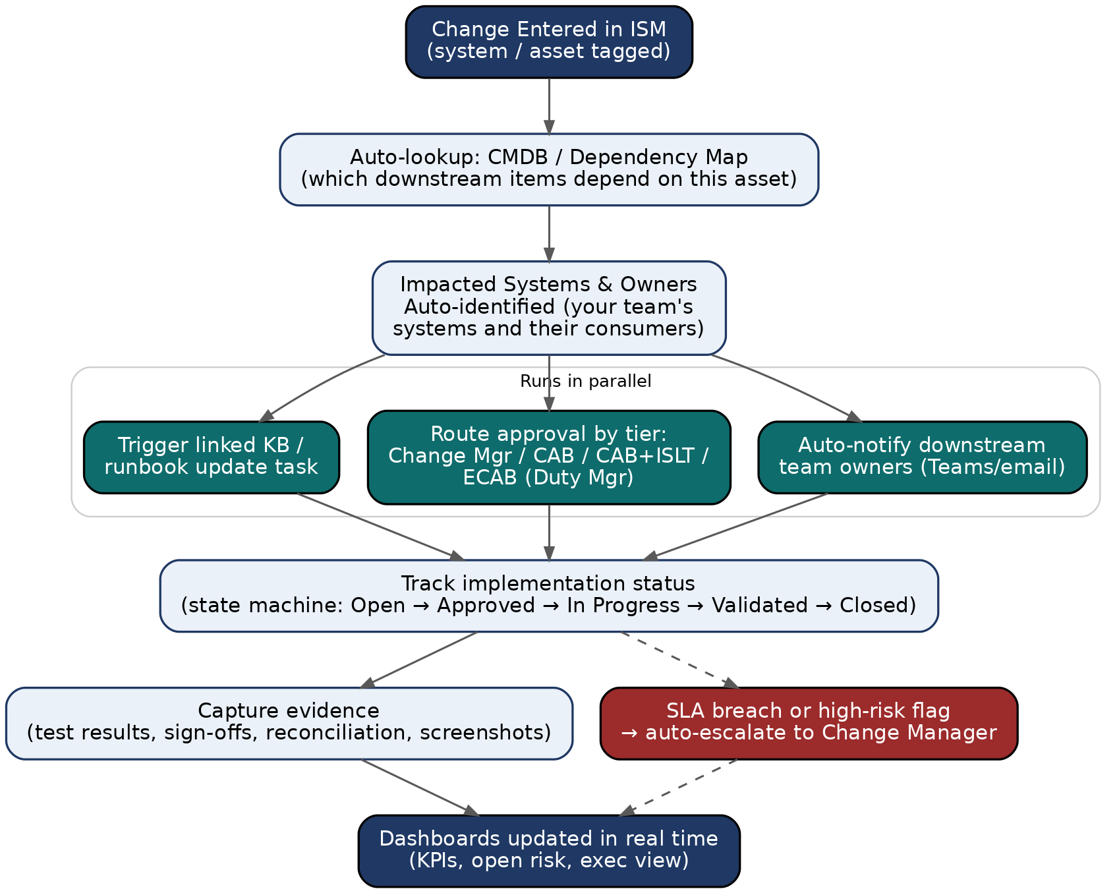
Automated dependency lookup and downstream notification, triggered at ticket creation. Same pattern as the Data Team's version, generalized.
Capability | How It Works | Owner
Notify downstream teams | On ticket creation, ISM queries the dependency table and auto-adds affected champions as watchers. | ISM + champions
Route approvals | The tier field drives routing. Minor goes to the Change Manager, Significant to CAB, Major to CAB+ISLT, and Emergency to ECAB. | IT Service Management
Track status | State machine from Open through Approved, In Progress, Validated, Closed. | IT Service Management
Escalate risk | SLA timers auto-escalate an unapproved Minor change or a nearing Emergency deadline. | IT Service Management
The suggested build order is evidence-capture fields first, then tier-based routing, then dependency mapping starting with your highest-traffic systems, then automated notification once coverage is meaningful. This order is reusable regardless of domain.

5. Evaluate the kind of changes being shared at Change Management sessions

a. What needs to come back to our teams
CUSTOMIZE FOR YOUR TEAM. Replace the bracketed text below.
- [Change category from another team that could affect your systems or availability]
- [Change category that could affect your team's schedules or maintenance windows]
- [Vendor or platform updates affecting your integrations]

b. What we need to share from our teams
CUSTOMIZE FOR YOUR TEAM. Replace the bracketed text below.
- [Change category from your team that could affect other teams downstream]
- [New systems, datasets, or services being onboarded]
- [Changes with material impact to business users]

c. What we need to stand up separate specific for [your domain] (with other teams or for other teams)
REUSE AS-IS. This part is the org's existing process and doesn't change per team. Adjust the specifics, the case for a dedicated forum is the same regardless of domain.
A general Change Management meeting can't go deep on domain-specific dependency chains without losing every other attendee. We'd recommend a weekly 30-minute forum with each team champion, chaired by [your governance function], limited to Minor, Significant, and Major changes touching your domain. It's advisory only. Significant and Major changes still go to CAB and CAB plus ISLT exactly as today, just with a completed dependency picture attached.

How to Use This Template
- Copy this document and replace every bracketed placeholder with your own team's content. Delete the REUSE AS-IS and CUSTOMIZE labels once you're done, they're guidance, not part of the final document.
- Pull your team's real pain points into the Documented Gaps table first. Everything else follows from there.
- Keep the approval chain, tier model, and RACI structure identical to the Data Team's version. Consistency across teams is the point of doing this as a template rather than each team inventing its own format.
- Circulate the finished version to your team's approvers and Change Management for the same kind of ruling the Data Team requested.

Appendix A. Decision Matrix
REUSE AS-IS. This part is the org's existing process and doesn't change per team. Add your own team-specific triggers in the last two rows.
Work down the list. The first question that applies sets the minimum tier. Use it alongside the tier table under Question 2, not instead of it.
Question | Minimum Tier
Is this needed immediately to stop active harm, an outage, or a security exposure? | Emergency
Will members, customers, or staff outside your team notice or be affected? | Significant
Does it touch a system or process owned by another team without prior coordination? | Significant
Does it touch [your team's highest-risk systems]? | Major
Can it be fully undone with no visible impact if something goes wrong? | Minor
Is it pre-approved, routine, and already covered by an existing runbook? | Standard
[Your team-specific trigger] | [Tier]
[Your team-specific trigger] | [Tier]

Appendix B. Institutional Knowledge Log
REUSE AS-IS. This part is the org's existing process and doesn't change per team.
Log any practice your team discovers that isn't written down anywhere, then fold it into the relevant section above so it doesn't get rediscovered the hard way next time.
Date | Logged By | Undocumented Practice Discovered | Now Captured In
EXAMPLE | EXAMPLE | Deploying to Power BI Service required a CR despite not being listed as needing one. | Documented Gaps, Question 1
[Date] | [Name] | [What was discovered] | [Section/table it's now in]
[Date] | [Name] | [What was discovered] | [Section/table it's now in]

Sign-Off
Role | Name | Signature | Date
[Your Team Approver]
Change Management

