**Clustering Analysis**

**Hierarchical:**

Performed hierarchical cluster analysis on the InnovPDA data (use PDA_1.csv).

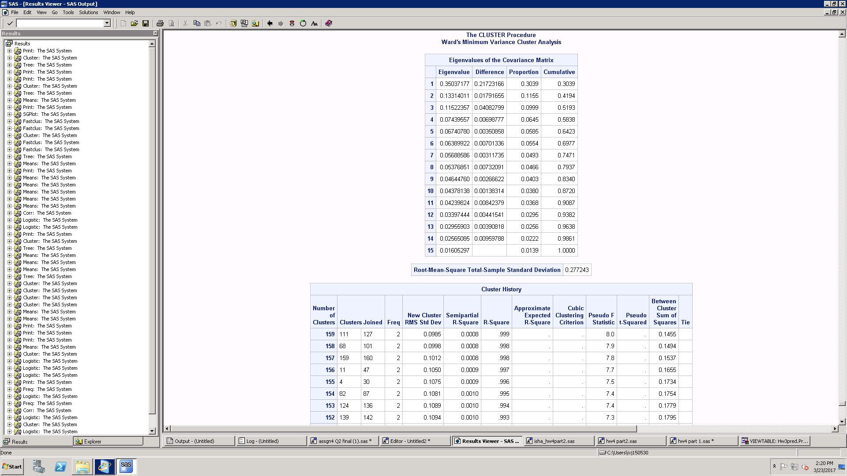

How many segments to be kept? How to decide that?

Ans: We will keep 4 clusters.

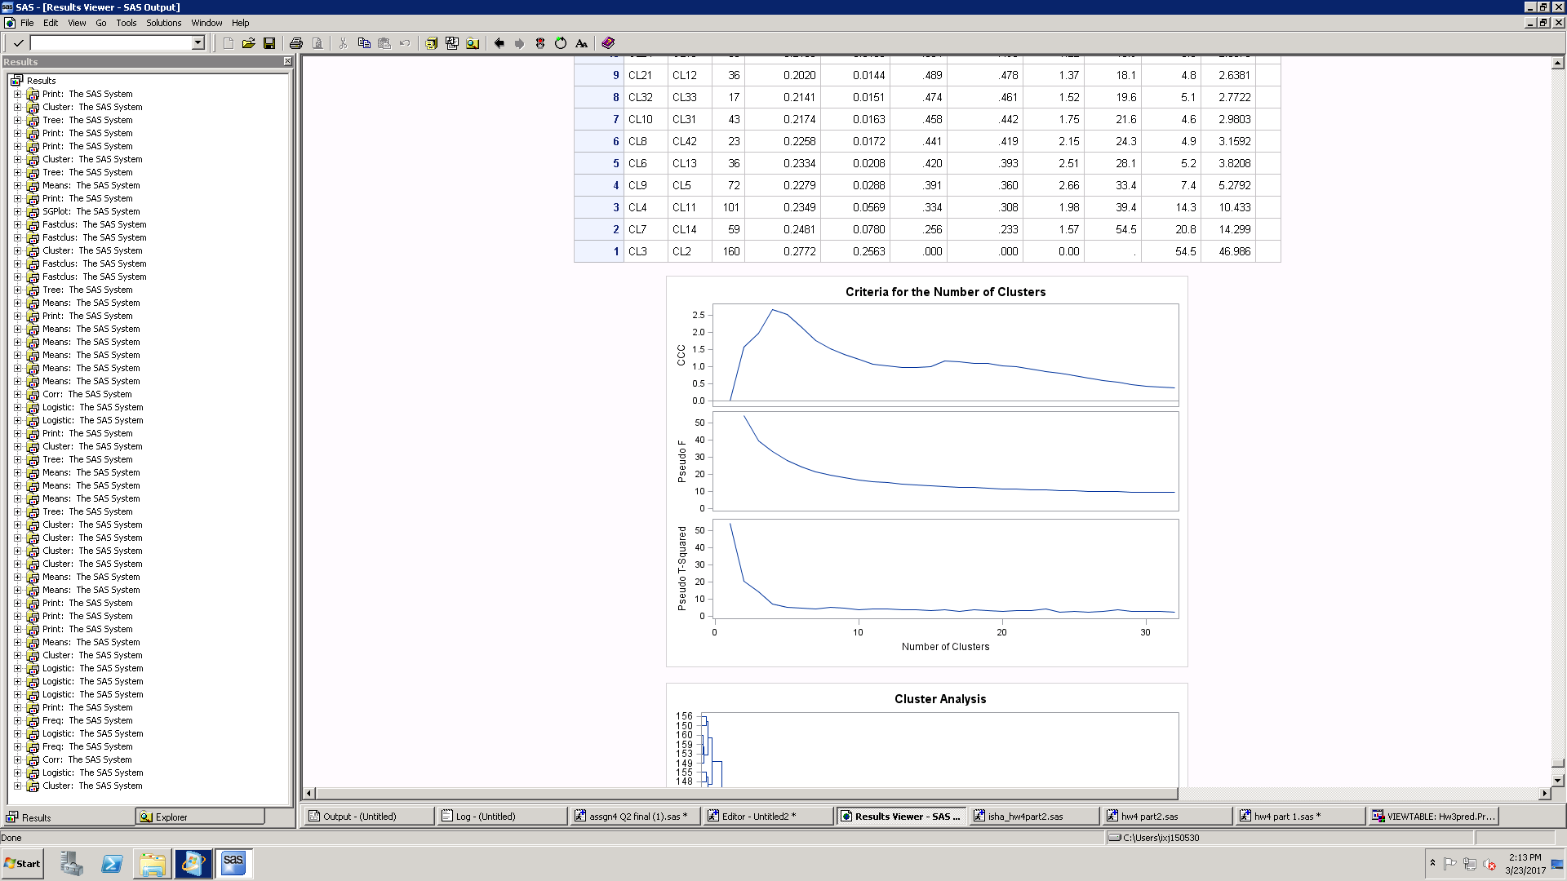

Looking at the above graph, to decide important clusters if I see the ccc values which should be highest is coming to be 4.

The if I see the pseudo value it should be the lowest which in this case is again 4. So, I can say that I will keep 4 segments which will explain the maximum

Also, if I look at the dendrogram the information is least loss when I cut it at the 4-line intersection. Also, I can see that to maximize intercluster variance and minimize intracluster variance I should keep 4 clusters. The distance between the 4 lines is more and the values are closer when within the clusters.

Description of different clusters based on their mean values of responses to X1-X15 and Y1-Y17.

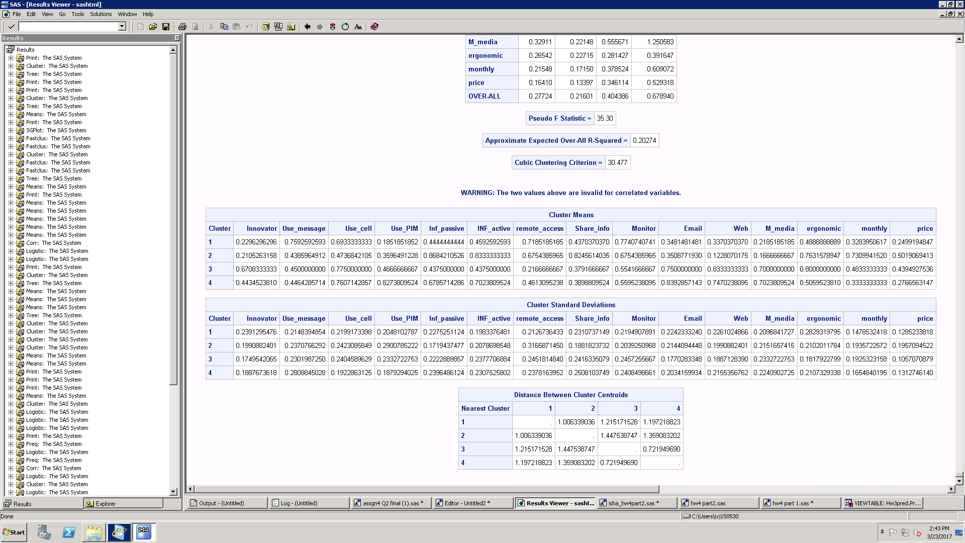

If I look at the means of the 4 clusters.

Cluster 1

In cluster one people are first to adopt the new technology averagely.

People have more income on an average as compared to people in other clusters.

People own pda more than other clusters averagely.

They use cell more often

For them email access is more important as compared to other groups.

They are updated with web, media.

Cluster 2

People use pager or instant messaging more.

They work more from remote location.

Cluster 3

They use a lot of contact management tools as compared to others they receive a lot of information from their colleagues.

Cluster 4

Work from remote location.

Use a lot of contact management tools.

Based on the above analysis, names of each cluster

Cluster 1-Tech savy

Cluster 2- Remote working people

Cluster 3- Socially Active

Cluster 4- Demanding

Which cluster would I target first and which would I target next? Why?

If we want to target price, then cluster 3 is preferred whereas if we want more and more people to adapt the new technology then we will prefer cluster one.

K- Means:

Description of different clusters based on their mean values of responses to X1-X15 and Y1-Y17.

Ans:

Cluster 1

cluster 1 people require remote informational access

Cluster 2

cluster 2 people's colleagues oftenly send them time sensitive information when they are away from office

cluster 2 people oftenly send time sensitive information when away from office

second cluster people are willing to pay 42.89 $ on an average to get features like instant communication, cellular phone etc. in a PDA whereas other people who belong to other clusters are not willing to pay that high amount

for second cluster people are willing to pay more price on an average

cluster 2 people's colleagues oftenly send them time sensitive information when they are away from office

cluster 2 people oftenly send time sensitive information when away from office

Cluster 3

cluster 3 people are early adapters

for cluster 3 people it is important to have permanent web access

college graduates are more interested in the product

on an average third cluster people has more income

cluster 3 people are early adapters

Cluster 4

for cluster 4 people it is important to have continuous email access

Based on the above analysis, labels of each cluster

Cluster 1-late adapters

Cluster 2- premium customer

Cluster 3- early adapters

Cluster 4- demanding

Which cluster would I target first and which would I target next? Why?

According to the interpretation above second cluster will be beneficial to target as they are more willing to pay with the important features desired. After that third cluster will be more beneficial to target.