**A Synopsis Report On**

**Gaze**

**Submitted for the partial fulfilment of the requirement for the**

**award of the**

**Degree of B. Tech**

**(Information Technology)**

**By:**

**Aksa Zehra 1406813012**

**Marvi Khan 1406813040**

**Manan Gupta 1406813037**

**Under the guidance of**

**Mr. Sumit Singh Siddhu**

**(Assistant professor, IT)**



**Department of Information Technology**

**MEERUT INSTITUTE OF ENGINEERING & TECHNOLOGY**

**Approved by A.I.C.T.E.**

**Affiliated to Gautam Buddh Technical University, Lucknow**

**Meerut – 250005**

**(Batch: 2014 – 2018)**

**1. Introduction to the topic**

Gaze is an augmented reality exploration app intended for Android Operating System. Its sole purpose is to explore the world digitally. Gaze is a location-based augmented reality app that brings Google Maps to life, so all you need to do is hold up your phone and the streets in front of you will be transformed with information about nearby facilities.

This application is a unique way to find useful places around you - such as restaurants, ATMs, shops, bus/metro stations and more. Gaze uses your phone’s camera to give you a completely new way of exploring a place, anywhere in the world. To use the app you simply select one of the pre-defined categories, hold up your smartphone and watch as the world around you populates with digitally generated signposts. If you want more information, you simply click on the signpost to get full contact details, user reviews and directions.

When you point the phone's camera in any direction, then you will see overlays of virtual signboards onto the camera view in that direction. Augmented Reality is thus used to enhance the view of your surroundings. This helps you navigate intuitively to places of your interest, using your phone’s camera.

The application sources its information from Google Places so you can be guaranteed that the app is comprehensive and that there’s a decent pool of user reviews, no matter where you are in the world. It lets you check out user reviews, directions, phone numbers, opening hours, price tier, photos and more just from the virtual signboards. You can also choose between camera, list and map views to navigate. You can get the real-time distance to a point of interest and find out how near you are to a place even as you make your way towards it.

**2. Relative work done**

Applications like Zomato and Google Places let you find nearby places, browse through restaurant menus, photos, user reviews and ratings to decide where you want to eat, and use the map feature to guide you there. But Gaze lets you see the world digitally and explore it using the augmented reality feature which makes it easy to learn about the nearby restaurants just by clicking on the digital signboards rather than searching for every single place.

**3. Brief description of the project**

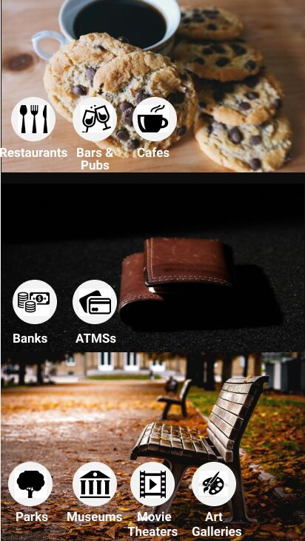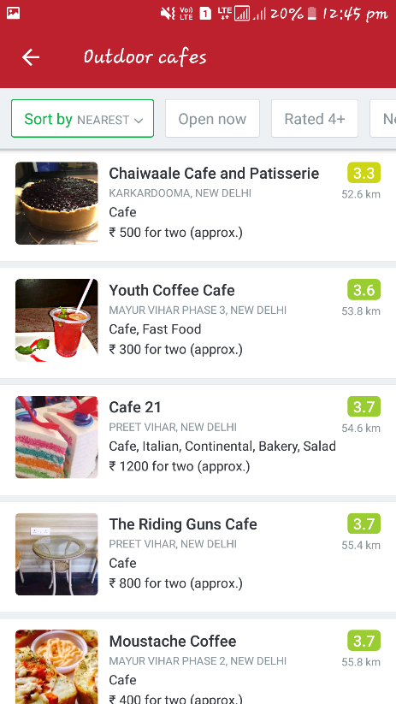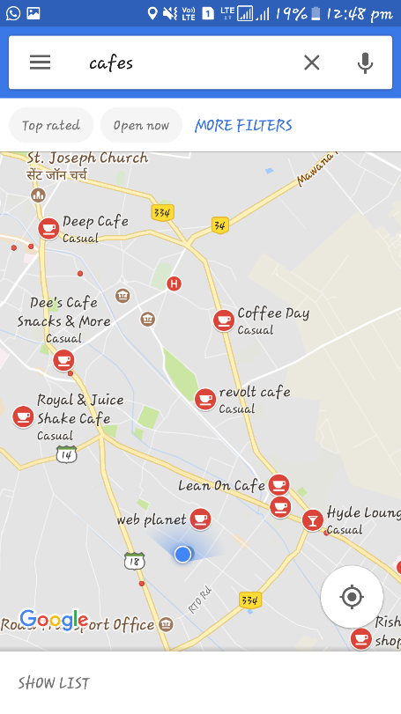 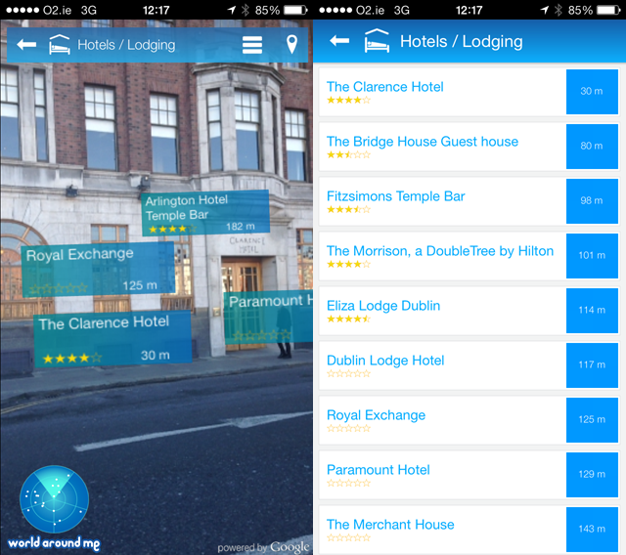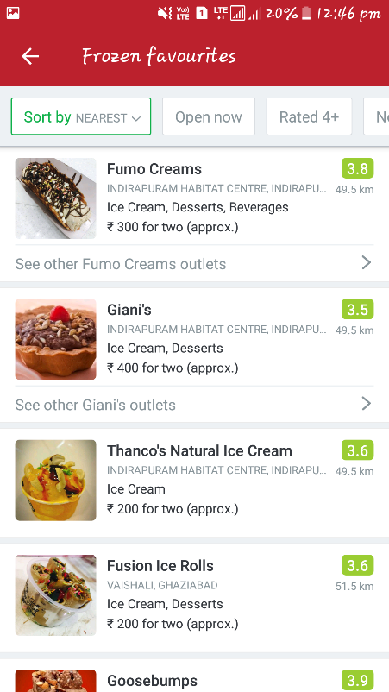 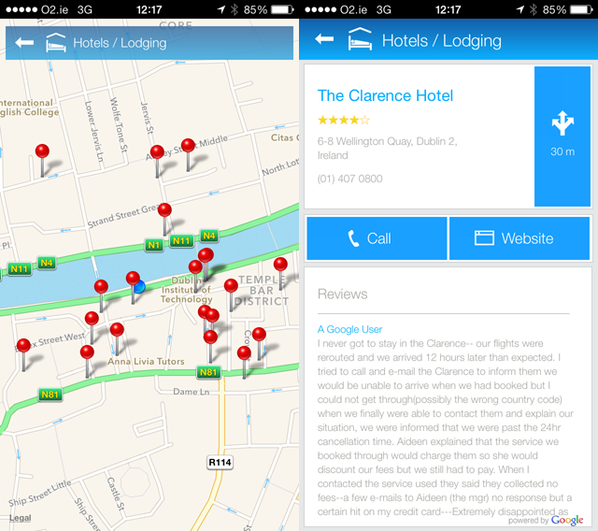

**4. Objectives**

When visiting a place, nearby locations can be found but it can be difficult to match the maps with what we see. Gaze lets you find places in the way most suitable to you. It can be in the form of lists, maps or augmented reality. The augmented reality feature combined with geo-tagging makes it easy to know which direction you should be going and the app makes it easy to quickly access information about the facilities around you.

**Find places like**

* Restaurants | Bars | Cafes
* Banks | ATMs
* Movie Theaters
* Museums | Art Galleries
* Parks
* Gas Stations
* Metro Stations | Train Stations | Bus Stops | Taxi Stands | Airports
* Hospitals | Doctors | Dental Clinics | Pharmacies
* Gyms | Spas
* Hotels
* Shopping Malls | Grocers | Clothing Stores | Book Stores | Shoe Stores

**5. DFD**

List

Eat

Banks

Map

Money

Atms

Camera

Enjoy

**6. Future Scope**

Gaze can be used by hotels and guesthouses to ease the stay of customers. When guest is close to location, a notification with directions on map, options to see arrival, parking, self-check-in info could be sent. If guest has no internet a SMS could help also. If guest doesn’t give GPS permission it could be sent close to check-in time.

Rather than just places, objects can be pinned to the AR map. Guests can find the objects in the rooms when needed just by using the AR feature of Gaze. We can also attach videos/images in augmented reality, instead of writing letters on paper to explain where to find/how to use things.

**7. Laboratory Requirements**

A Personal Computer and an android phone to test.

**FOR DEVELOPMENT**

OS: Windows 8.1 or advance

Android: Android SDK and Java Development Kit (JDK).

Android Studio IDE for development

Adobe Photoshop and Adobe After Effects for graphic design

Google Maps API

Google Places API

Android AR-Core

**7. Work to be carried out in the next semester**

Implementation of AR core and the augmented reality aspect of the project will be done in the next semester. Any additional features that would seem necessary would also be added in the next semester.

**8. References**

developers.google.com/ar/

[developer.android.com/learn](http://www.unity3d.com/learn)

[www.stackoverflow.com](http://www.stackoverflow.com)

[www.youtube.com](http://www.youtube.com)

https://play.google.com/store/apps/details?id=com.application.zomato&hl=en