**Frontend Development with React.js**

**Project Documentation format**

1. **Introduction**
   * **Project Title**: [cookbook]
   * **Team Members**:
   * BARATHRAJ.K(LEADER)
   * BALU.J
   * AGNISHWARAN.M
   * DEVA.M
2. **Project Overview**
   * **Purpose**: Collect and organize recipes in one place
   * **Features**: provide easy instruction for cooking
3. **Running the Application**
   * Provide commands to start the frontend server locally.
     + **Frontend**: npm start in the client directory.
     + **Visual studio**
4. **Component Documentation**
   * **Key Components**: Document major components, their purpose, and any props they receive.
   * **Reusable Components**: Detail any reusable components and their configurations.
   * **Drivelink**:
5. **State Management**
   * **Global State**: Describe global state management and how state flows across the application.
   * **Local State**: Explain the handling of local states within components.
6. **User Interface**
   * Provide screenshots or GIFs showcasing different UI features, such as pages, forms, or interactions.
7. **Styling**

* **CSS Frameworks/Libraries**: Describe any CSS frameworks, libraries, or pre-processors (e.g., Sass, Styled-Components) used.
* **Theming**: Explain if theming or custom design systems are implemented.

1. **Testing**

* **Testing Strategy**: Describe the testing approach for components, including unit, integration, and end-to-end testing (e.g., using Jest, React Testing Library).
* **Code Coverage**: Explain any tools or techniques used for ensuring adequate test coverage.

**9. Screenshots or Demo**

* Provide screenshots or a link to a demo showcasing the application’s features and design.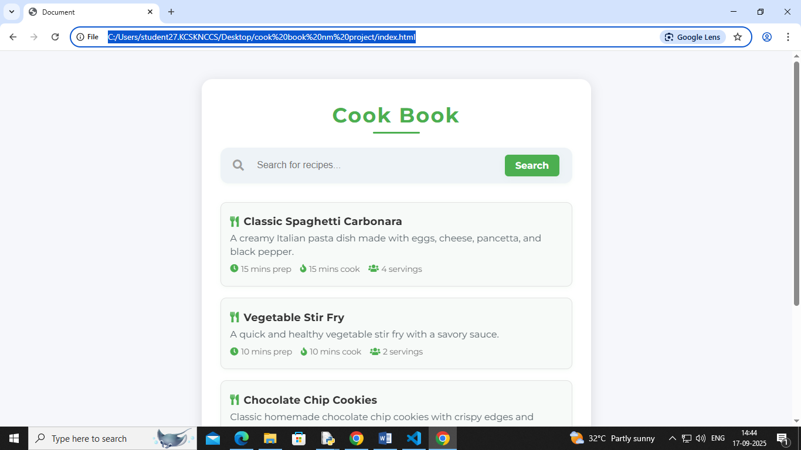

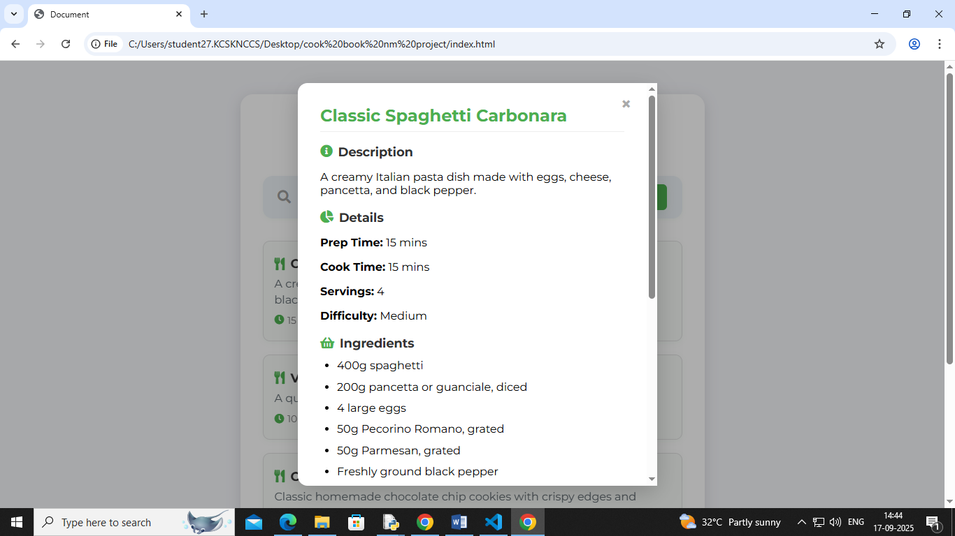

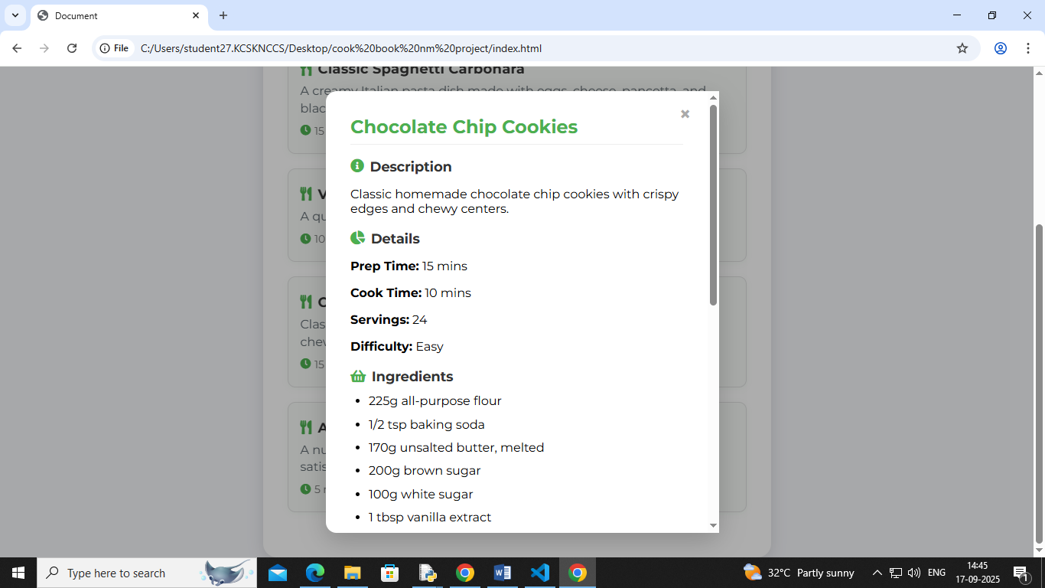

**10. Known Issues**

* Document any known bugs or issues that users or developers should be aware of.

**11. Future Enhancements**

* Outline potential future features or improvements, such as new components, animations, or enhanced styling.

Documentation link :

<https://drive.google.com/file/d/1SFwYv7Mqd4-ZBClpTVPq6PN2v9RAf6gJ/view?usp=drivesdk>