The following are computations related to the behavior of the flowering difference equation.

In my mathematical analysis, I suggested that there ought to be chaotic-seeming behavior for *k*>1. As none of the limit cycles seem stable. This is true on a local level, but that does not mean that they do not arise. In particular, the following Figure 1 (a summary of a deeper numerical analysis) demonstrates that the equation tends to reach odd-length cycles for even integer values of *k*.

Figure 1. Cycle analysis. 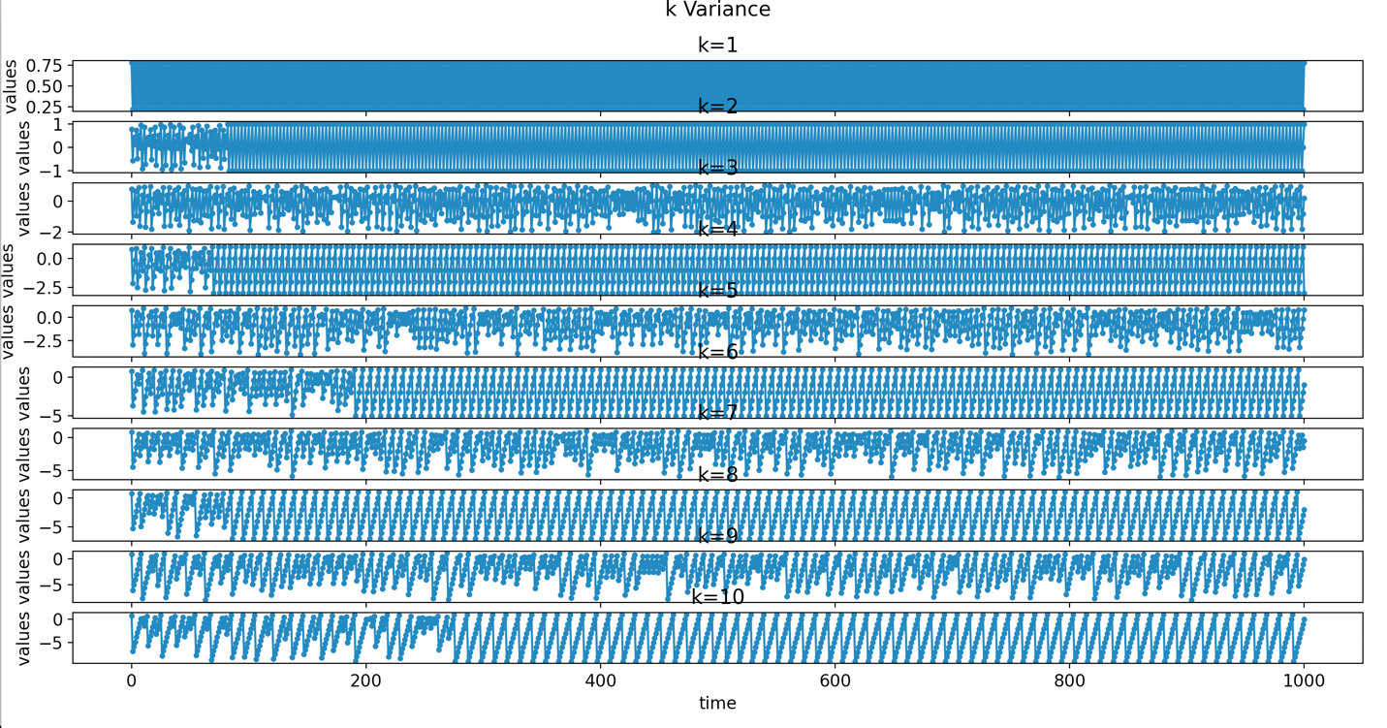

Close examination is not necessary, but it is clear from this chart that even integer values of k produce some regularity. However, this regularity arises out of chaos, not any sort of obvious local stability. Figure 2 shows how this does not seem to occur for any obvious decimal values of *k* (this is not a fine-grained analysis). A blue and white graph

Close value analysis points to this being a rounding issue on the part of the computer. These cycles are reached by Y_t reaching 1 eventually. I believe the cause of this is that integer even multiplication eventually “multiplies” the floating point integer into an integer.

Ignoring these values, for example testing a series of odd *k* values, we see the following results in Output 1.

Table 1. Raw

k Mast Year proportion

[ 3. 0.37762238]

[ 5. 0.26373626]

[ 7. 0.21378621]

[ 9. 0.18381618]

[11. 0.15384615]

[13. 0.13486513]

Thus, it is clear that as k increases, the number of mast years decreases.

Challenge 2:

Figure 3 below is a chart of period lengths between mast years. The regression line has slope 0.4866 and intercept 0.2471, giving it the form 0.4866k+0. 2471. This is not quite the expected result, but very close in order of magnitude and it does appear to have linear growth.

