TEST: Service host interface down

Interface down for 60 seconds on UJS host

UJS service up

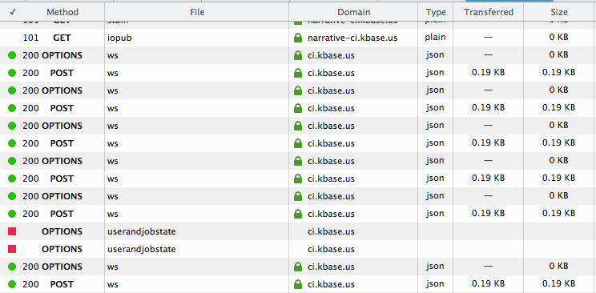

Interface comes back up, execution continues

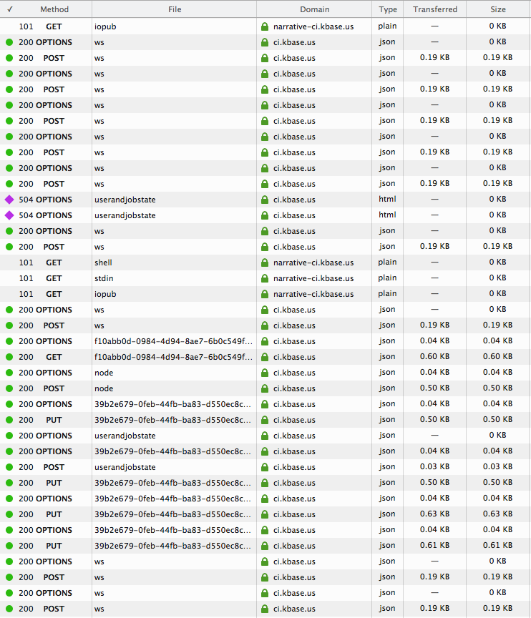

Import appears to work thereafter.

