# Phase 2: Org Setup

In this phase, I set up user profiles and role hierarchy for the Banking Loan Application project. This helps in controlling access and responsibilities of Loan Officers, Underwriters, and Branch Managers.

## Profiles

- Went to Setup → Profiles  
- Cloned the Standard User profile to create new profiles  
- Created the following profiles:  
 * Loan Officer  
 * Underwriter  
 * Branch Manager  
 * Customer Service Officer  
- Permissions will be set later once custom objects are ready.

### Screenshot of Profiles List

-Branch Manager

- Loan Officer

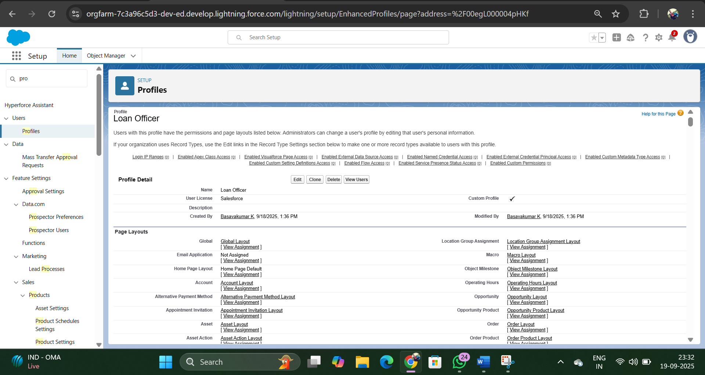

- Customer Service Officer

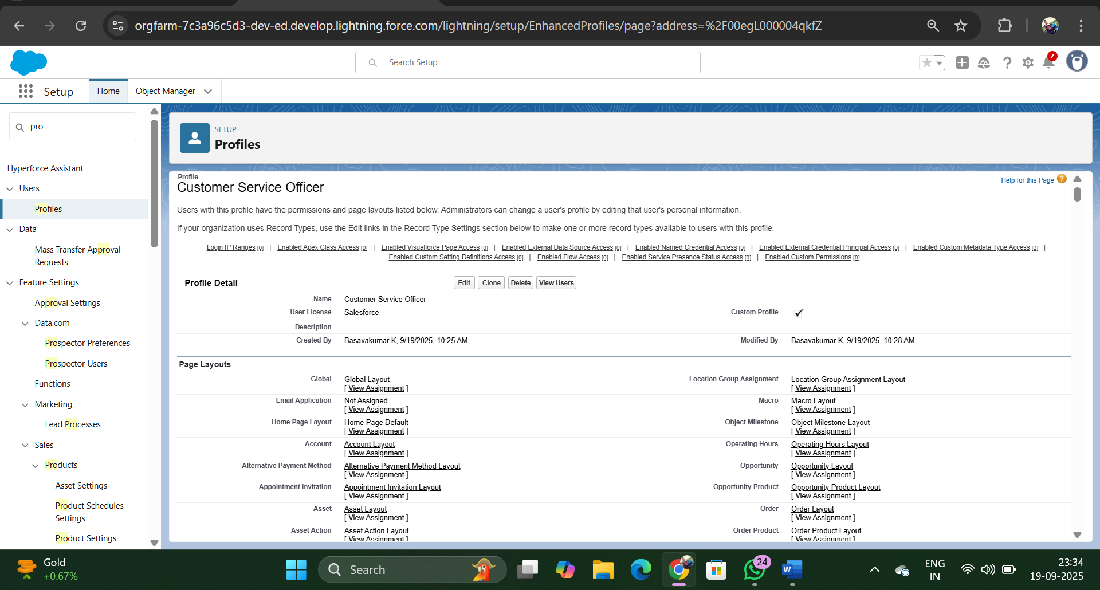

## Create Role Hierarchy

- Went to Setup → Roles → Set Up Roles  
- Added the following hierarchy:  
 * Branch Manager (reports to CEO)  
 * Underwriter (under Branch Manager)  
 * Loan Officer (under Underwriter)  
 * Customer Service Officer (under Loan Officer)  
- Kept myself as System Administrator for full access.

### Screenshot of Role Hierarchy:

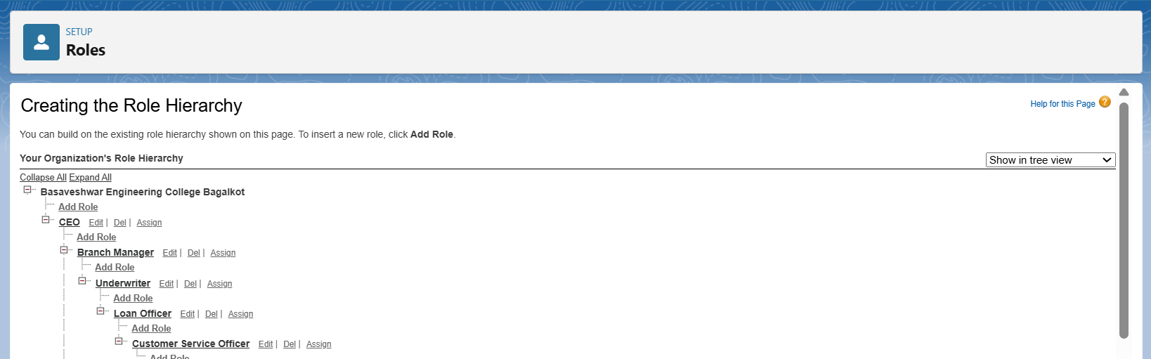

Trailhead Playground allows only 1 active user. Therefore, assigning additional demo users (Loan Officer, Underwriter, etc.) was not implemented in this phase. The concept has been documented for reference.

Profiles and Role Hierarchy were successfully created. This ensures that different users in the Banking Loan Application system have clear access levels.