PSM Ltd. PRESENTS

PETROL STATION MANAGEMENT: DEMO

# SYNOPSIS

*Petrol Station Management: Demo is a new Windows application from the PSM team which allows your company to simulate its day-today business in order to ensure stations are maximising their profits and operating as efficiently as possible.*

*PSM uses data you provide to personalise your management experience and provide you with a more realistic, valuable tool to aid your company in the management of its stations worldwide.*

* *Simple user interface*
* *Console based*
* *Succinct*
* *Provides an accurate simulation of reality*

# PSM: PRO

*PSM: Pro Additional Features:*

* *Windows forms based*
* *Separate employer and employee views*
* *Scenario generator*
  + *What could you be earning?*
* *Change hourly rate of attendant, hours worked and percentage of commission earnt*
* *Change fuel prices and litres of fuel dispensed by a pump per second*
* *Timestamped transactions in Transaction Log*
* *View whole transaction log in program as well as in separate file*
* *Offers option to download transaction log in different formats e.g. docx, csv, pdf*

*Upgrade to PSM: Pro today to unlock more features and functionality– visit our website for more information.*

Table of Contents

SYNOPSIS 1

PSM: PRO 1

HOW IT WORKS 3

STARTUP PAGE 3

BEHIND THE SCENES 3

CREATING A NEW VEHICLE 3

ONCE THE PROGRAM HAS INITIALISED 3

FORECOURT 4

REMOVING A VEHICLE IF IT ISN’T SERVICED QUICK ENOUGH 4

ASSIGNING A VEHICLE TO A PUMP 4

ONCE A VEHICLE HAS REFUELLED 4

DEMO VIEW 5

HOW TO USE PSM: DEMO 6

# HOW IT WORKS

## STARTUP PAGE

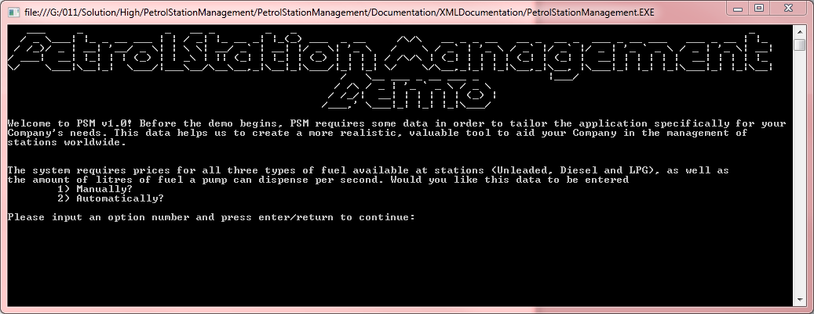

Upon application start-up, the user is presented with a home screen which clearly displays the application title and a message informing the user that that input data is required to provide a more valuable experience.

In order to allow the user to customise their application experience, the user has the option to either manually enter the current prices for Unleaded, Diesel and LPG fuel and determine the rate at which fuel is dispensed by each pump in the petrol station (in litres per second), or have the application automatically select these values.

Unfortunately, the manual entry of these values amongst others (including but not limited to hourly rate of a fuel attendant, hours worked per shift and percentage of commission attendant is eligible for) is a feature of PSM: Pro. Users wishing to explore this option should visit our website for further information on upgrading their package.

Once the user has selected the automatic input of required user data by selecting option number two, the user is prompted to press any single key to continue to PSM: Demo. Once the application has initialised, the demo will begin.

## BEHIND THE SCENES

### CREATING A NEW VEHICLE

When the application initialises, it establishes a timer which will create a new vehicle every X seconds (where X is random and between 1.5 and 2 seconds). This timer will continue to create a new vehicle every X seconds for the duration of the application’s life. When creating a new vehicle, the program randomly selects a vehicle type from a list and assigns it to the vehicle. Based upon that type of vehicle, the program then assigns the current vehicle a current tank capacity, maximum tank capacity, refuel time and fuel type. As newly created vehicles are created with a random amount of fuel already in its tank, the refuel time of a vehicle is based upon the time needed to fully fill the tank given the amount it already contains.

## FORECOURT

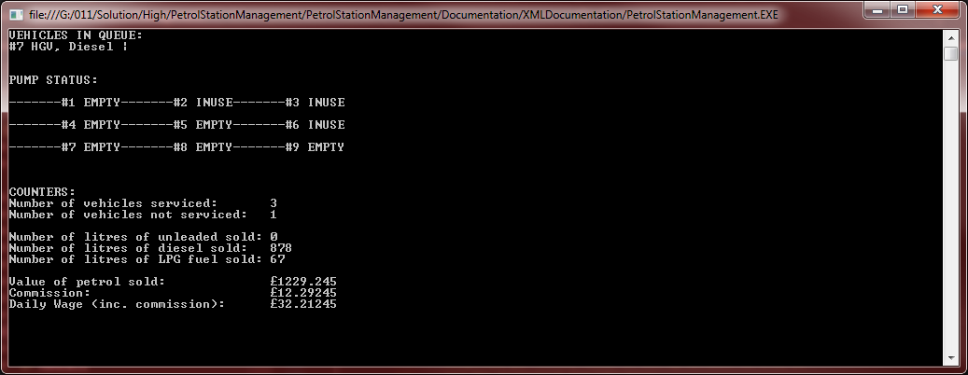

Lane #

Furthest

Middle

Closest

1

2

3

Once the program has initialised, a new timer is established to clear and redraw the console and assign a newly created vehicle to a pump every 1.5 seconds. This timer will continue to perform these functions for the entire duration of the application’s life.

### REMOVING A VEHICLE IF IT ISN’T SERVICED QUICK ENOUGH

If a newly created vehicle is not serviced in X seconds (where X is random and between 1 and 2 seconds), then the vehicle is removed from the forecourt without being serviced, and the number of vehicles that left the forecourt without being serviced is incremented.

### ASSIGNING A VEHICLE TO A PUMP

When assigning a vehicle to an available pump, the program aims to assign to pumps in the furthest column of each lane first before the middle or closest columns, starting with the first lane. This is because any customer using pump #1 would block the way for other vehicles to get to pumps #2 or #3 (the same situation applies for the remaining two lanes). When the pump in the furthest column is no longer available, the pump in the middle is filled next, followed by the pump in the column closest to the entrance. Once a vehicle has been assigned to a pump, its status changes from “EMPTY” to “INUSE” in order to allow the user to quickly identify available pumps across the station.

### ONCE A VEHICLE HAS REFUELLED



Once a vehicle’s refuel time has elapsed, the vehicle is removed from the petrol station forecourt immediately and the vehicle’s transaction details are recorded in the Transaction Log .txt file. The number of vehicles serviced in the program’s lifetime is incremented and the litres of fuel sold/value of fuel sold and Attendant wage figures are updated accordingly.

❶ Vehicle Queue

This is where vehicles are sent upon creation. The vehicle queue contains important information relating to the vehicle, including the vehicle’s ID, the vehicle type and which fuel it runs on. There can be up to five vehicles in the queue at any one time.

# DEMO VIEW

❷ Petrol Station Forecourt

Once a vehicle has been assigned to an available pump, the forecourt graphics are updated to give a more dynamic and realistic user experience. Pumps which are available for use are shown as being “Empty”, whereas engaged pumps are denoted as being “In Use in order to allow the user to easily identify a pump’s status. Users should note that the petrol station forecourt operates a queuing system. This means that any customer using pumps #1 blocks the way for new vehicles to get to pumps #2 or #3 (the same situation applies for the remaining two lanes). Vehicles are removed from the forecourt once they have been refuelled.



❼ Value of petrol sold during the application’s lifetime

Once a vehicle has been serviced and the running total of fuel dispensed updated, the application then re-calculates the value of fuel sold in the application’s lifetime. To do this, the number of litres of each type of fuel dispensed is multiplied by the price per litre of that type of fuel, and added to this total value.

For example, if 1000 litres of Unleaded fuel had been dispensed in the application’s lifetime, the value of fuel sold would be 1000 * £1.249 = £1249.00.

❻ Total number of litres of fuel dispensed in the application’s lifetime

These counter values are updated every time a vehicle with the respective fuel type is serviced to display a running total of the number of litres of each type of fuel dispensed in the application’s lifetime (to satisfy counter #1).

❺ Total number of vehicles which left without being serviced in the application’s lifetime

If a newly created vehicle is not assigned to a pump in X seconds (where X is random and between 1 and 2 seconds), then the vehicle will be removed from the forecourt without being serviced – resulting in a loss of profit. This value is updated every time a vehicle leaves the forecourt without being serviced and aims to satisfy counter #5.

❹ Total number of vehicles serviced in the application’s lifetime

Once a vehicle has been serviced and leaves the petrol station forecourt, this counter value is updated in order to reflect the total number of vehicles that have been serviced in the application’s lifetime. It aims to satisfy counter #4.

❽ Fuel Attendant Wage

The daily wage of a fuel attendant is calculated by multiplying the number of hours in the shift worked by their daily wage e.g. £2.49 * 8 = £19.92. In order to incentivise the role of a fuel attendant, a 1% commission is added to the daily wage of a fuel attendant – resulting in a potentially enormous bonus if the station has been successful during that shift.

❸ Vehicle

Each vehicle contains data about its properties: vehicle type, fuel type, car ID, maximum capacity of its fuel tank, current capacity of its fuel type and the time the vehicle will take to refuel to maximum capacity.

# HOW TO USE PSM: DEMO

* Open the executable file from the “PetrolStationManagement\PetrolStationManagement\bin\Debug\” folder

## Upon application start-up:

* Enter the number ‘2’ followed by the enter/return key to choose to use the program’s default values for fuel prices, fuel attendant wage information and litres of fuel dispensed per second by a pump
  + If you input ‘1’ (the option to manually input the data values), a message box will appear on the screen informing you that you are trying to access a PSM: Pro feature. If you would like access to this feature and many others, please visit our website to for more details on upgrading your package
  + If you input anything other than the numbers 1 or 2, an error message will be displayed on the screen prompting you to try again
* Press any key to initialise the application, and wait for the Petrol Station screen to appear

## Upon appearance of forecourt:

* Sit back and watch reality being simulated right before your very eyes!
* Once you’ve finished with the application
  + Navigate to “PetrolStationManagement\PetrolStationManagement\bin\Debug\TransactionLog.txt” in the source folder and double click to view a log of all successful transactions made in the program’s lifetime
* Use the red cross in the top right hand corner of the window to close the application