**Chapter 1 - ORGANIZATION ANALYSIS**

* **Company Background**
  + History

The Cyber Restoration: Eat and Play was established in the year 2008. The owners of this restaurant are Mr. Apollo Rodriguez and his wife Miranda along with their four friends. Mr. and Mrs. Rodriguez were an IT graduate. They decided to take another path and build their own business when they had a get together with their friends Janine Morales, Martin Morales, Sonia Salvador and Peter Salvador. Janine and Sonia were culinary graduates while Martin and Peter took a business-related course. All of them are married couples. They all like playing board games, it is their bonding time. It gives them the idea to build a business that they will surely enjoy to manage and build. A place where you can play and relax while eating.

* + Vision

Our vision for Cyber Restoration: Eat and Play is to create a welcoming and safe environment for people from all walks of life to discover and play variety of card and board games with their friends and family. A place where people can go to forget the outside world and go restore their life and rejuvenate the feelings they have.

* + Mission and Strategic plan (Goal)

• Provide good and quality food for the customers

• Give a welcoming and comfortable feel for the place

• Get latest games and means of entertainment for the guests

• Provide chill and mind relaxing music

• Show assurance and friendliness for the guests

• Provide good and fun work space

* + Organizational Units and its functions

Owner

Manager

Staff

Assistant Manager

Sous Chef

Executive Chef

Waiter/Waitress

­

* **Present ICT Situation**
  + Information Systems
    - What is the main functions of the IS?

The main function of the Information System is to monitor the company’s Point of Sale (POS), employees’ attendance, product ordering and the payroll.

* + - Who are the users?

Employees of the restaurant are the users of the system.

* + - How IS interacts its subsystems and/or other IS?

The Information System, its’ subsystems and other Information Systems are connected in a Local Area Network.

* + Hardware Inventory
    - Includes Hardware Specifications (…)
  + Software inventory

|  |  |  |  |  |  |  |  |  |
| --- | --- | --- | --- | --- | --- | --- | --- | --- |
| **Organizational Units** | **Information Systems** | **Subsystems** | **Functions** | **User/s** | **Link System/**  **Subsystem** | **Workstations**  **Specification** | **Software** | **Networked**  **(Yes/No)** |
| HR | HRIS | Attendance Recording and Monitoring | Records attendance | Employee | Payroll | WS 1 – Intel Core i5, 4G Ram, 1TB storage | Win10  MS office |  |
|  |  | Merit/Promotion System |  | Staff |  |  |  |  |
| Accounting | Accounting System | Payroll | Records company’s budget. | Staff | Attendance | WS 2 – Intel Core i5, 4G Ram, 1TB storage | Win10  MS office |  |
| Kitchen |  |  | Ordering,  Cooking |  |  |  |  |  |
| Security |  |  | CCTV Monitoring |  |  | WS 2 – Intel Core i5, 4G Ram, 1TB storage | Win10  MS office |  |
| Maintenance |  |  | Fixes defected materials | Staff |  |  |  |  |
| Managerial |  |  | Monitors the flow of the company |  |  | WS 2 – Intel Core i5, 4G Ram, 1TB storage | Win10  MS office |  |
| IT |  |  | Establishes network connection | Staff |  | WS 2 – Intel Core i5, 4G Ram, 1TB storage | Win10  MS office |  |

**Chapter 2 - INFORMATION SYSTEMS STRATEGY**

**STRATEGIC CONCERNS FOR ICT USE**

* + - * **Description Of Computer Networks**
* Attendance Recording and Monitoring System
  + Use to monitor the attendance and movement of employees within their working hours.
* Merit/Promotion System
  + To ensure fair and open promotion and merits for the employees.
* Payroll System
  + Used to organize all the tasks of employee payment and filing of employee taxes.

Advantages

* File Sharing
  + You can easily share data between different users, or access it remotely if you can keep it on other connected devices.
* Resource sharing
  + Using network-connected peripheral devices like printers, scanners and copiers, or sharing software between multiple users, saves money.
* Sharing a single internet connection
  + It is cost-efficient and can help protect your systems if you properly secure the network.
* Increasing storage capacity
  + You can access files and multimedia, such as images and music, which you store remotely on to other machines or network-attached storage devices.
* Scalability
  + Ability of a computing process to be used or produced in a range of capabilities.
* The systems would communicate and work with each other through each task that is given within the network

* **Network Design And Architecture** 
  + **Network Topology**

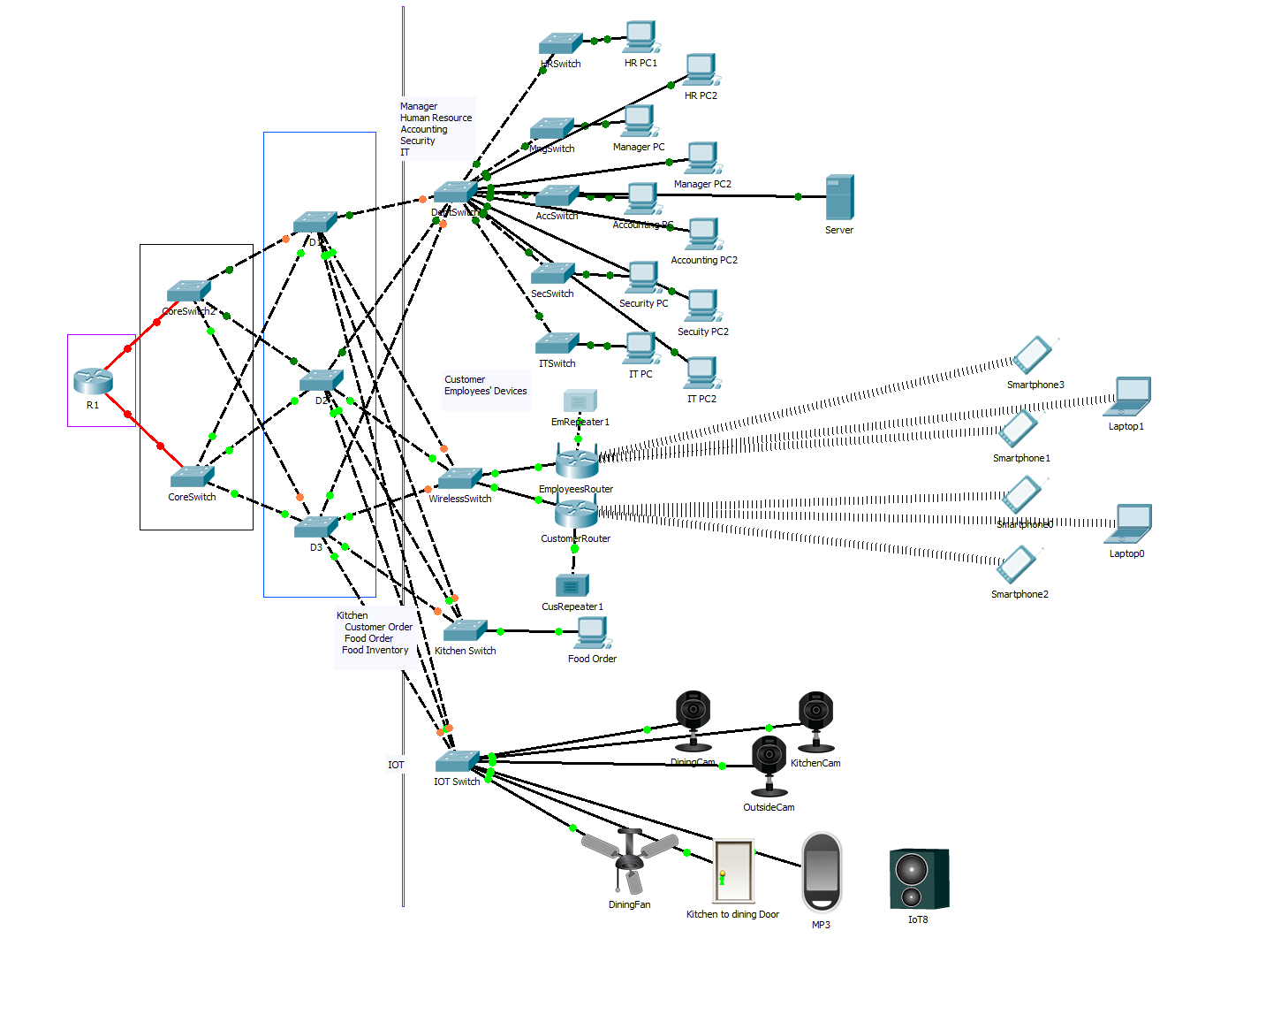This infrastructure has two floors. Our proposal network which is mesh consists of four access switches, two switches on both floor, connected to three distribution switches and each access switches are connected to two core switches then each core switches are connected to a router and the router is connected to the internet. This network will make use of 192.168.5.0/24 as its IP address.

* + **Network Architecture**
    - For this proposal, wireless connection is used for the customer connection to the network. Wired and fiber optic cable are used to access the core switches to ensure a fast and reliable connection to the whole network.
    - Spanning Tree Protocol for redundancy design of the network, VLAN Trunking Protocol is used too so that making on the network is easily done by the network manager. Virtual LAN is used so that logically networked devices act as if they are on their own independent network, Wireless LAN for the enjoyment of the customer eating and playing on the restaurant and Inter-VLAN to forward network traffic from one VLAN to another VLAN using a router.
  + **VLAN Design**
    - For the VLAN Design, nine VLANs are used to cater all the facilities and also customer of the establishment. Two VLAN Servers and three VLAN Clients are used so that in case of one server failure, there is still one that is up.
  + **Security**
    - We put passwords on every switch and encrypt it so that it is not on a plain text. The internet connection has firewall, enabled to decline all unauthorized connection. Every port connected to switch is mac-address filtered and shutdown it when another unauthorized device is connected. Every port that are not used is disabled to prohibit use. And lastly, SSH is used for remote configuration of the network intermediate devices.

**Chapter 3 - INFORMATION AND COMMUNICATIONS TECHNOLOGY (ICT) SOLUTIONS**

* **ICT Resource Requirements**

1. **Servers**

* *Food Order Server*
  1. *Order from Supplier*
  2. *Order from Customer*

1. **Hardware Specification**

* Server
  + Intel Core i5 4gb RAM
* Workstations
  + Intel Core i5 4GB RAM
* Printer
  + HP Printer Deskjet

1. **Software**

* *MS Office*
* *Google Chrome*
* *Mozilla Firefox*

1. **Network Media and Equipment**

* *Cat5 UTP Cable*
* *Cat5 Lan Cable*
* *Cat5 Crossover Cable*

1. **Users**
   * Restaurant Owner
   * Manager
   * Chef
   * Network Manager
   * Restaurant Employees

**Chapter IV – IMPLEMENTATION STRATEGY**

* **PACKET TRACER DESIGN AND SIMULATION**
* **Configuration of its workstation and Equipment**
* **(Pls see sample PKA Exercises)**
* **Economic Feasibility**
* **Schedule Feasibility**