Kevin Banglagan

BSIT-MI181

Code

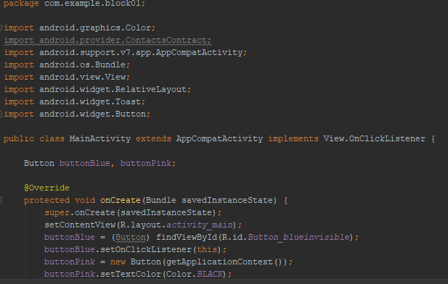

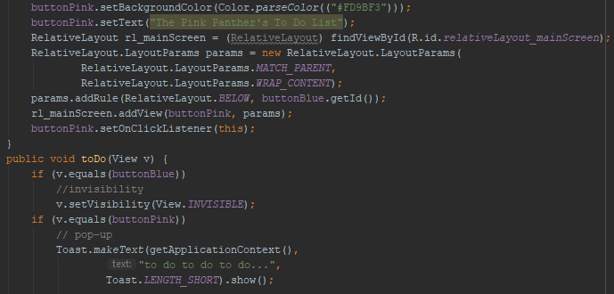

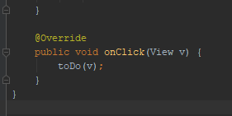

DESIGN

