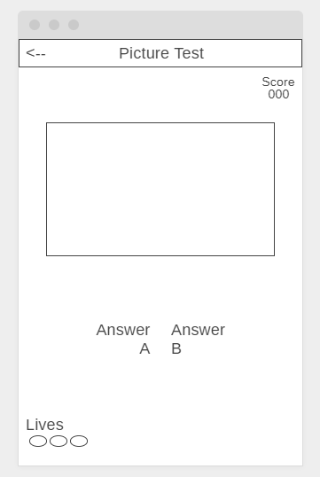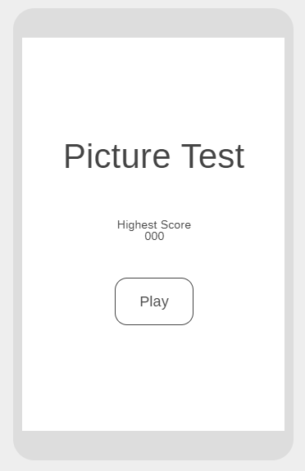

Guess this object



**Picture Test**

Highest Score

000

PLAY

Picture Test

Score

000

Answer

A

Answer

B

Lives

Guess this object

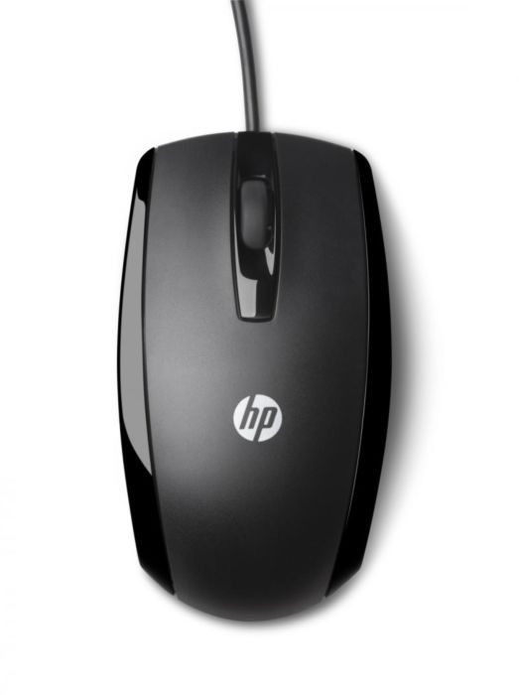

**Picture Test**

Highest Score

000

PLAY

Picture Test

Score

010

Mouse

Car

Lives

Guess this object