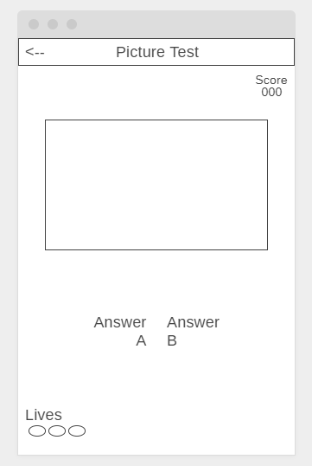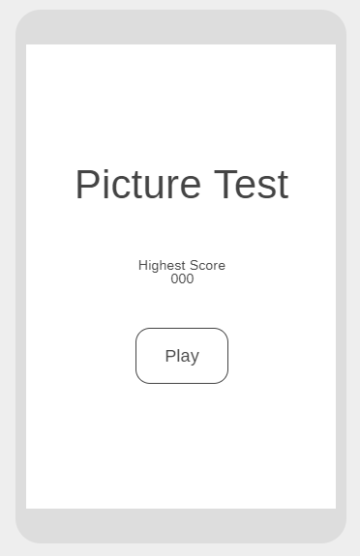

This is the help button

Press this button to go back to the home screen

Guess this object

Choice A

Choice B

Pictures of different items will appear here

Press this button to start the game

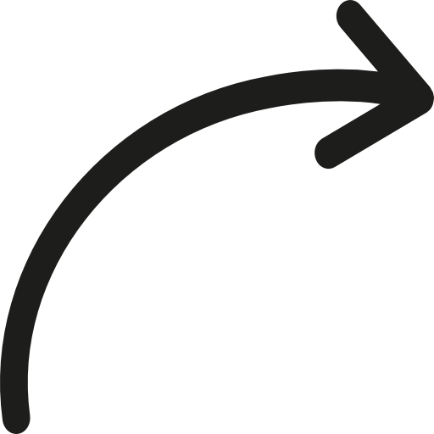

**Picture Test**

Highest Score

000

PLAY

Picture Test

Score

000

Answer

A

Answer

B

Lives

Guess this object

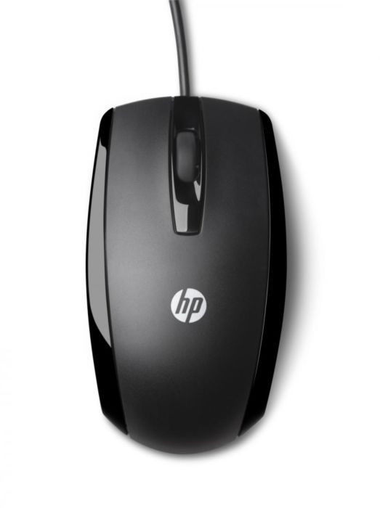

**Picture Test**

Highest Score

000

PLAY

Picture Test

Score

010

Mouse

Car

Lives

Guess this object