|  |  |  |  |
| --- | --- | --- | --- |
| Student Information | | | |
| **Student ID:** | 100592979 | **Student name:** | Tianwei Zhang |
| **Unit code** | ICTPRG601  ICTPRG532 | **Unit title** | Apply advanced object-oriented language skills  Develop advanced mobile multi-touch applications |

**Part 1. Task Instructions**

In this task, you will be presented with a graphic design of an Android mobile app, and detailed software design specification document (Part 2 in this document). Your job is to develop the Android mobile app that meet all the design requirements.

For final submission, you are required to submit the following:

|  |  |
| --- | --- |
| 1. A signed assessment document |  |
| 1. This instruction document with all questions answered and signed off by assessor for each phase. |  |
| 1. Android app project (source code) |  |
| 1. Server-side project (if any) |  |
| 1. Client-side database snapshots |  |
| 1. Server-side database snapshots (if any) |  |
| 1. Web API design document (if any) |  |
| 1. All test plan documents |  |
| 1. All test report documents |  |
| 1. Application files for deployment (e.g. Android APK) |  |

**Part 2. Software Design Specification**

You are required to design & create a game called “Three in a Row” for Android mobile that meet the requirements given by wireframe and this specification. Wireframe design resources are provided separately; requirements from the software perspective are explained in this document. Consult the client for further clarification as required.

1. **Overview of the software**

With this application, user can play a game call “Three in a Row”. The rules of this game are explained in below sections. In the user can configure the game parameters before start. Also, the application can store historical high scores for the user.

Network connection is not required for this application to run. However, one of the optional add-on features requires network connection.

1. **Three in a row game rules**

The size of the grid is changeable, but the following rules are the same for any grid size. 4x4 grid is used as an example to explain the rules below.

The game starts with a 4x4 grid as shown below. Most of the cells in the grid are greyed, with four cells set randomly to 2 red and 2 white.

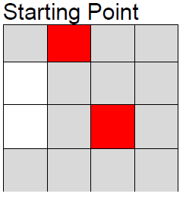

The aim is to remove the grey squares and replace them with either red or white ones – each time a user taps on a grey cell it will change to red or white and then automatically set to the next color for the next tap. To win the game you have to make sure there are NO more than 2 squares of the same color next to each other, either horizontally or vertically, as shown below.

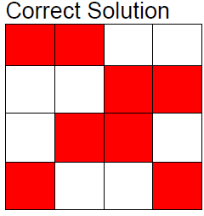

There are no 3 grid cells (squares) in a row with the same color. Hence, the name of this game is called “Three in a row”. The aim of this game is to **avoid** 3 in a row of a particular color – either horizontally or vertically.

Any time 3-in-a-row appears, the game ends and you lose.

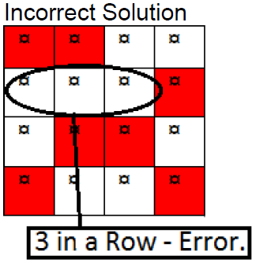

1. **UI Design**

This application consists of 4 pages (A wireframe design is attached separately). Here is the description of all pages

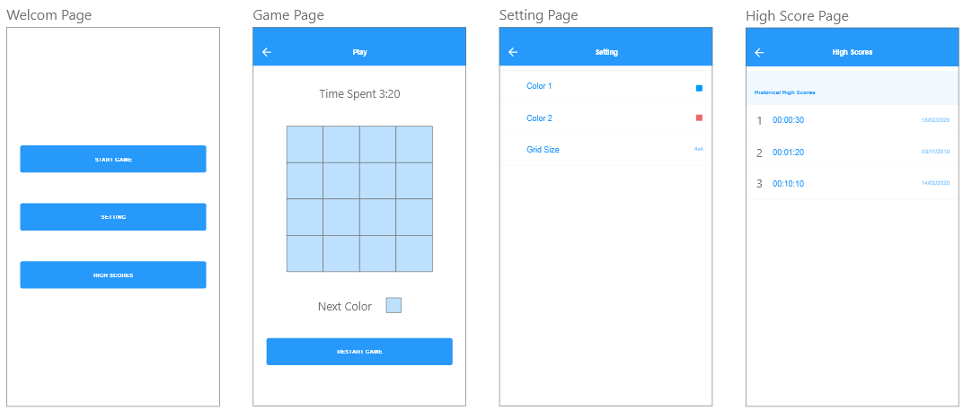

1. Welcome Page

There are three buttons in “Welcome Page”. Click on each button will open each individual functional page. The three buttons are:

* Start Game
* Settings
* High Score

1. Game Page

This is where user play the game. As long as the game starts or restarts, time spent on playing will be recorded. User play the game by clicking the grids. Next color is also show below the grids. Restart game button enable user to start a new game any time.

1. Settings page

Users can set the colors and grids in this page. The setting shall be store in file systems. The application will apply the settings when start up or start new game.

1. High Score page

Top ten scores shall be stored in SQLite database. All these scores shall be listed in this page.

1. **Add-on features**

Add-on features shall be implemented on top of basic functions described in previous sections. Make sure basic functions of the program have been fully implemented and verified before considering add-on features below.

1. Support different screen size

If application is run on a larger screen size, for example pad landscape view, high score information need to be displayed in Game Page as well, as below:

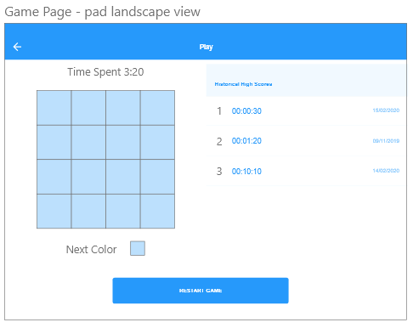

1. Share result to social media

Add buttons for each score in high score page, enable user to share the score information to at least one social media.

1. Support multi-user

Add sign up / sign in function, for different users to login. User information are stored in SQLite

1. Data backup to server

Implement server-side system for user to backup settings and high scores to server.

1. **Documentation requirements**
2. Code following recommended code conversions.
   * Java: <https://google.github.io/styleguide/javaguide.html>
   * Kotlin: <https://kotlinlang.org/docs/reference/coding-conventions.html>
3. Use source code version control system to manage project. You are free to choose any one of the online system like [Github](https://github.com/), [Bitbucket](https://bitbucket.org/), or [Gitlab](https://gitlab.com/)
4. Source code must be fully documented, according to code conversion guides provided in “A” above.

**Part 3. Questions**

|  |  |  |  |  |  |
| --- | --- | --- | --- | --- | --- |
| You are required to finish all the questions in this part for final submission | | | | | |
| **Q1.1** Screenshot layout design for all pages from Android Studio. | | | | | |
| **Answer:** | | | | | |
| **Q1.2** Screenshot all runtime pages from emulator or device. | | | | | |
| **Answer:** | | | | | |
| **Q1.3** Test plan file name | | | | | |
| **Answer:** | | | | | |
| **Q1.4** Test report file name | | | | | |
| **Answer:** | | | | | |
| **Q1.5** Provide URL to version control system repository, and provide a screenshot. | | | | | |
| **Answer:** | | | | | |
| **Q1.6** Present the application to client and get approval. | | | | | |
| Client signature: ________________ Date: __________________ | | | | | |
| **Assessor Name** |  | **Assessor Signature** |  | **Date** |  |

*End of document*