**CSE514, Fall 2022, HW 3 Name: Byeongchan Gwak Student ID:501026**

I chose OptCoNet: an optimized convolutional neural network for an automatic diagnosis of COVID-19

**Q1**

The goal of this network is to classify COVID-19 patients, normal patients, and pneumonia patients on chest X-ray images.

Recently, Convolutional Neural Networks (CNNs) have yielded the most promising results for classifying radiographic images.

So, the authors wanted to use the ability of image classification of CNN networks.

**Q2**

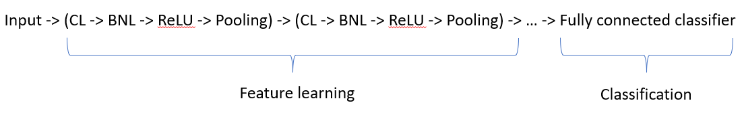

1. Feature learning Phase

1-1. CL layer: Responsible for extracting features from the input images using several convolutional filters. These convolutional filters perform the convolutional operation at every offset of the input image

1-2. BNL layer: A batch normalization layer (BNL) is used between the CL and ReLU to normalize the gradients and activations through the network

1-3. ReLU layer:The features extracted from the CL are mapped into feature space using a nonlinear rectified linear unit (ReLU) activation function

1-4. Pooling layer: The PL is used to reduce the dimensions of the feature maps obtained from the CL

2. Classification Phase

The last layer of ‘Feature leaning Phase’ is a fully connected classifier layer that classifies the extracted features from the CL and MPL into a particular class.

**Q3**

The thesis used performance metrics of accuracy, sensitivity, specificity, precision, and F1-score, and receiver operating characteristic (ROC).

Accuracy : $\frac{TP+TN}{TP+FP+FN+TN}$

Sensitivity : TP / (TP + FN)

Specificity : TN / (TN + FP)

Precision: TP / (TP + FP)

F1-score: harmonic mean of precision and recall

How to calculate?

Draw confusion matrix like below and plug in the value above equation.

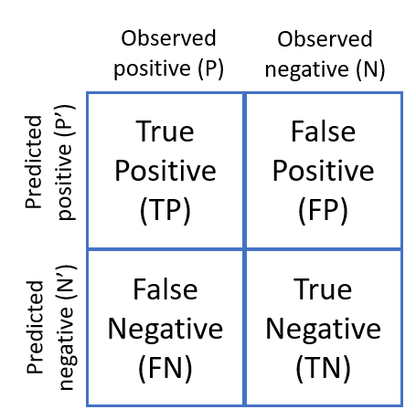

Extra.

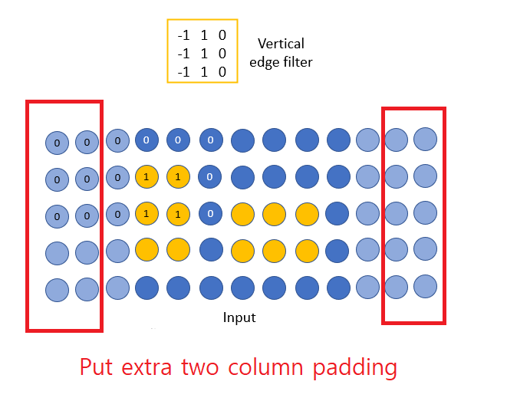

Feature map:

