Kristoffer Corbett

Increment 5

Table of Contents

1. Introduction and requirements pg.2
2. Revisions pg.2
3. Running the software pg.3
4. Viewing stored models pg.4
5. Add/Update/Delete abilities pg.6
6. Add/Update/Delete stats pg.8
7. Add/Update/Delete weapons pg.10
8. Add/Update/Delete units pg.12
9. Common Problems pg.14
10. Data backup pg.20
11. Introduction

Welcome to the Warhammer 40k army tracker software. This is PC software designed for use with windows 10. In order to utilize the software you will need to also install JRE version 8 or higher. You can input different weapons, abilities, stats, and link them to various models. The goal of this first version of the software is to track and maintain models from the Adeptus Custodes army. The weapons, abilities, and stats of 10 commonly used models are included in the product. Future armies will be added in later updates but are beyond the scope of this initial project.

1. Revisions

This most recent version of the software includes several major and minor revisions:

* Images have been updated throughout to most recent software version
* Modified add/update for all tabs to provide user feedback on success
* Added functionality for units tab, including view/add/update/delete
* Output window for all view has had 2 new columns added, Stats Name and caster. Caster was unintentionally omitted from previous versions.

Section IV. Updated images for model viewer

Section V. Updated images for abilities

Section VI. Updated images for stats

Section VII. Updated images for weapons

Section VIII. Added unit tab instructions

Section IX. Added unit tab error feedback

1. Running the software

Please ensure you have the database up and running before launching the program. Database setup is covered in the installation instructions. You may start the database by launching the XAMPP Control Panel. If you installed to the recommended directory this can be found at c:\xampp\xampp-control.exe

Once the control panel is open click on the start button for the Apache server, followed by the MySQL start button, as shown below:

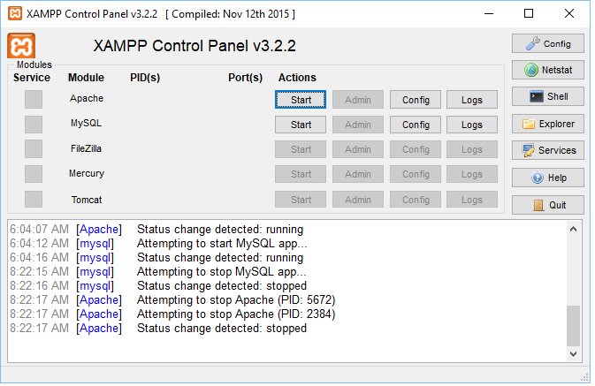

Now that the database is running launch the interface program. You may launch the program by navigating to the directory you downloaded WarhammerCRUD.jar to and double clicking on the file.

1. Viewing stored models

When you launch the program, you will see the screen shown below. You may return to this screen at any time by selecting the “View models” tab at the top of the window. From here you may view all models stored in the database or select individual models. After selecting which model to display click the “Display Model(s)” button to show the model(s) in the lower window.

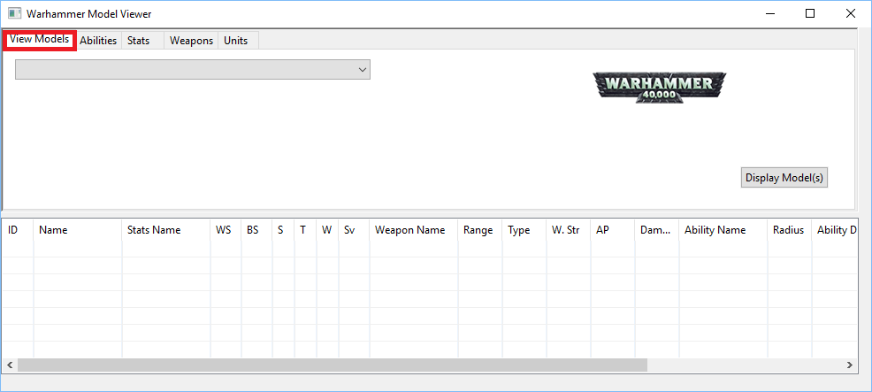

You may use the drop-down menu to select which models to view. Selecting “view all models” will list all models currently stored in the database.

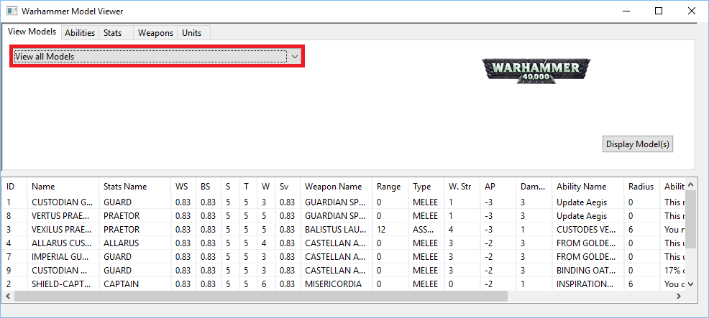

Selecting a model by name will allow you to display models individually. You may use the scroll bar at the bottom to view the stats in full.

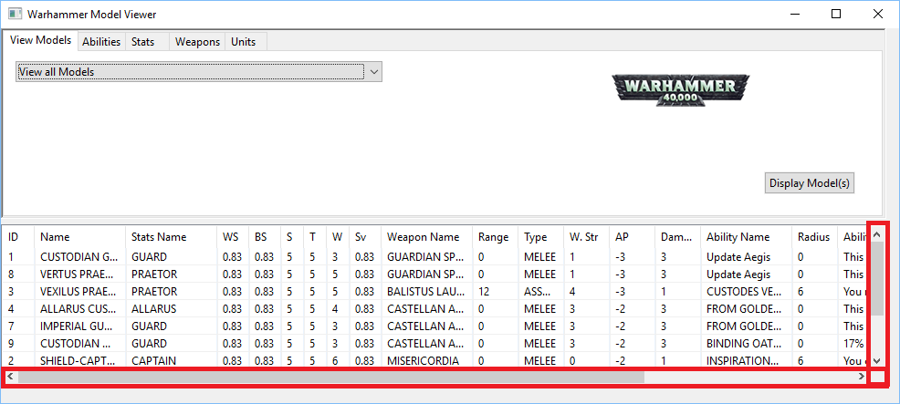

1. Add/Update/Delete abilities

To manage unit abilities, begin by selecting the “Abilities” tab at the top of the window. You will be presented with the screen shown below.

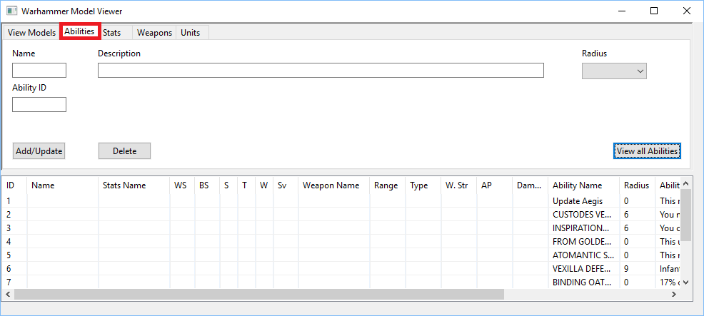

Begin by clicking the view all abilities button. This will display a list of all abilities currently stored in the database including ID #’s, name, radius, and a description.

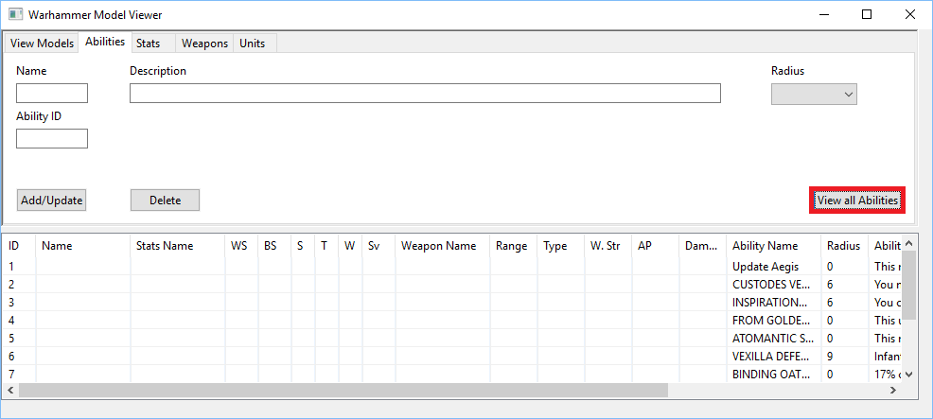

To add or update an ability fill out the provided fields and select the radius from the drop-down menu. Name and description will appear in the new/modified ability exactly as you type them. The ability id must be a positive integer.

Please note that inputting an existing ID will update the specified record instead of adding a new one. This will keep all current values in the database except those you chose to populate by inputting new values. After you are satisfied with the field data click the “add/update” button to finalize the record.

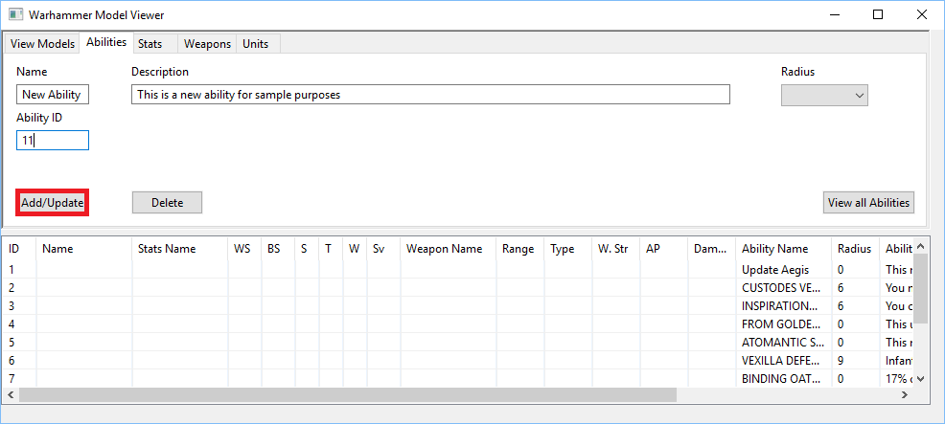

You will need to click view all abilities before changes will be visible.

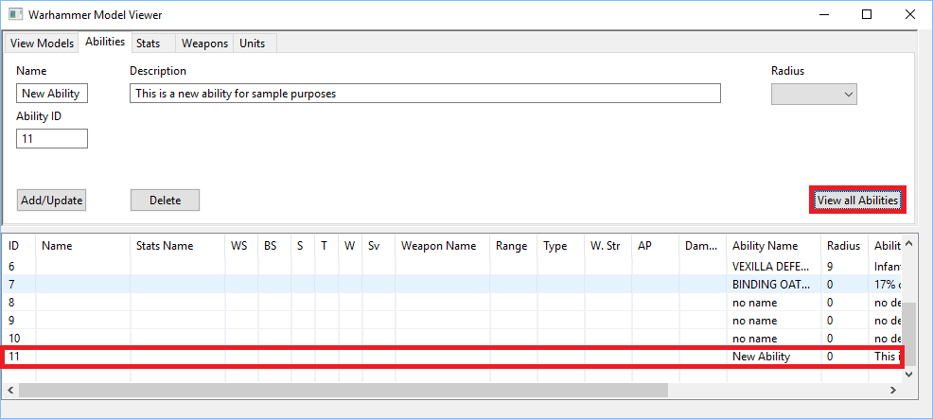

From this screen you may also delete existing abilities. When deleting abilities all fields are ignored except ability id. Input the id of the record you would like to delete and click the delete button to remove it. You will need to again click view all abilities before changes are visible. Please note you cannot delete abilities that are currently in use by 1 or more units.

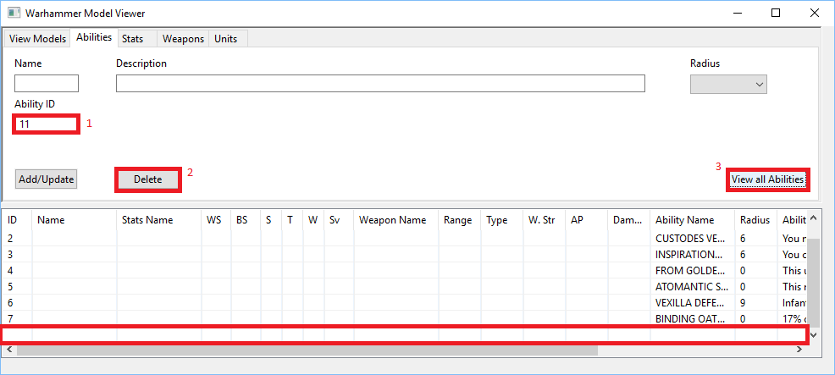

1. Add/Update/delete stats

To manage unit stats, begin by selecting the “Stats” tab at the top of the window. You will be presented with the screen shown below.

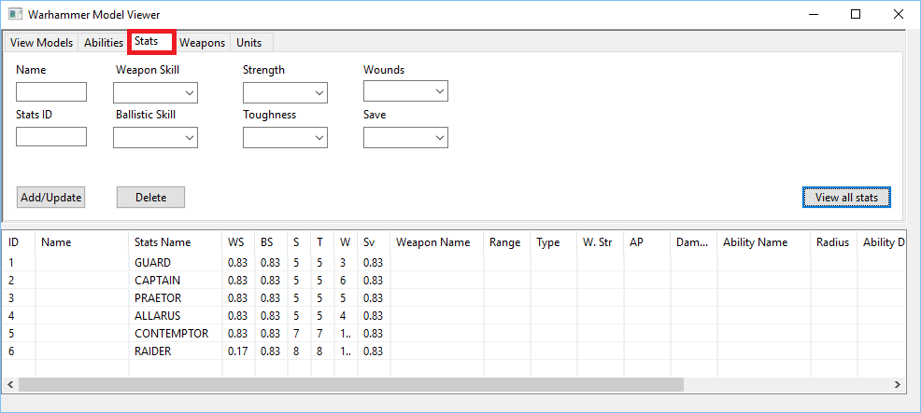

Begin by clicking the view all stats button. This will display a list of all stats currently stored in the database including ID #’s, name, weapon skill, ballistic skill, strength, toughness, wounds, and save.

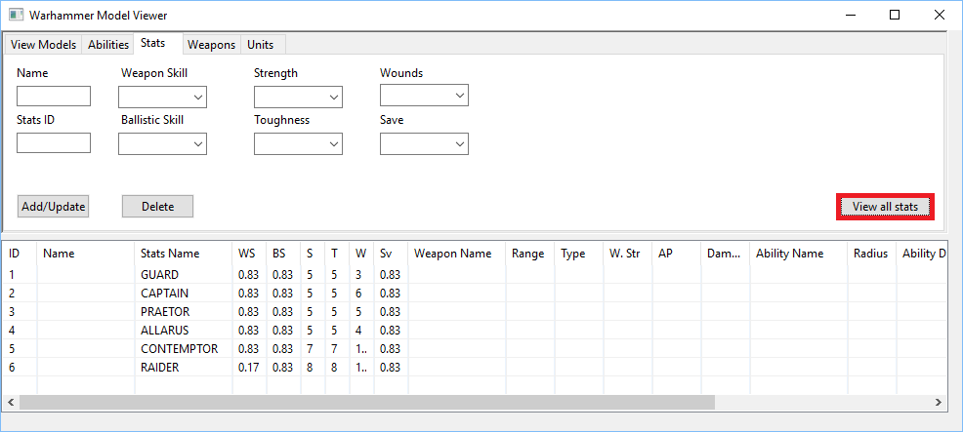

To add or update a stats record type in a new or existing ID. When adding a record you may leave the drop downs and name field empty to use default values or specify all information. Name will appear in the new/modified ability exactly as you type it. The ability id must be a positive integer.

Please note that inputting an existing ID will update the specified record instead of adding a new one. This will keep all current values in the database except those you chose to populate by inputting new values. After you are satisfied with the field data click the “add/update” button to finalize the record.

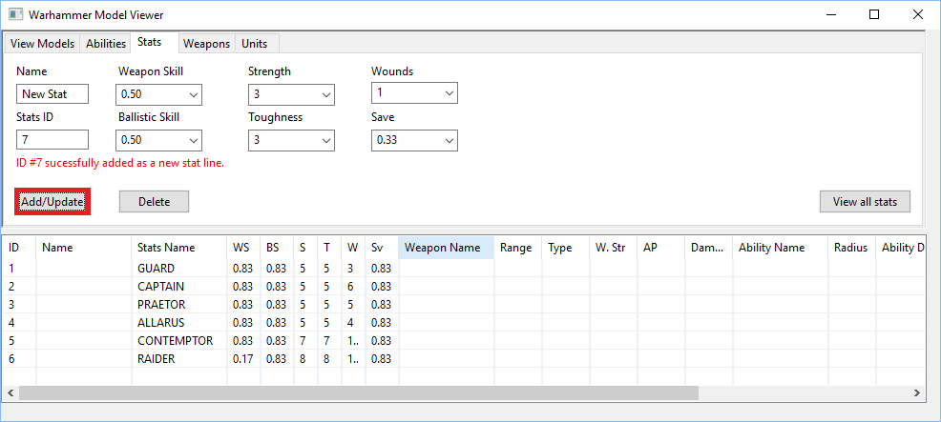

You will need to click view all stats before changes will be visible.

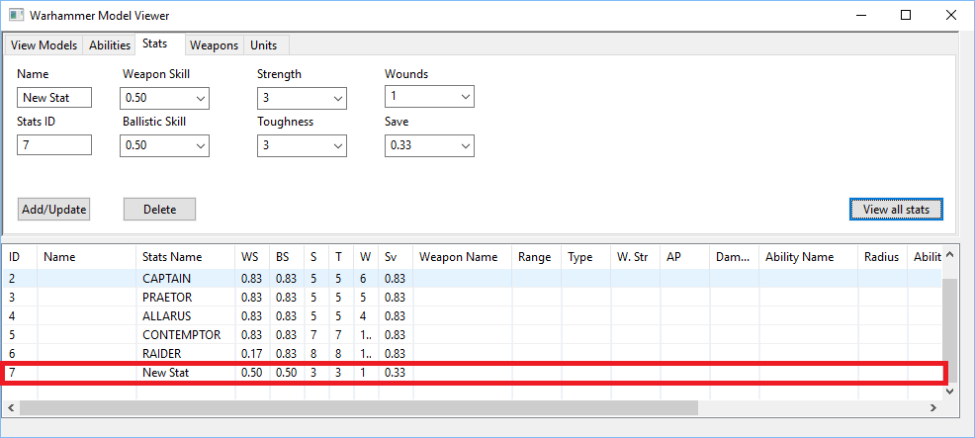

From this screen you may also delete existing stat records. When deleting stats all fields are ignored except stats id. Input the id of the record you would like to delete and click the delete button to remove it. You will need to again click view all stats before changes are visible. Please note you cannot delete stats that are currently in use by 1 or more units.

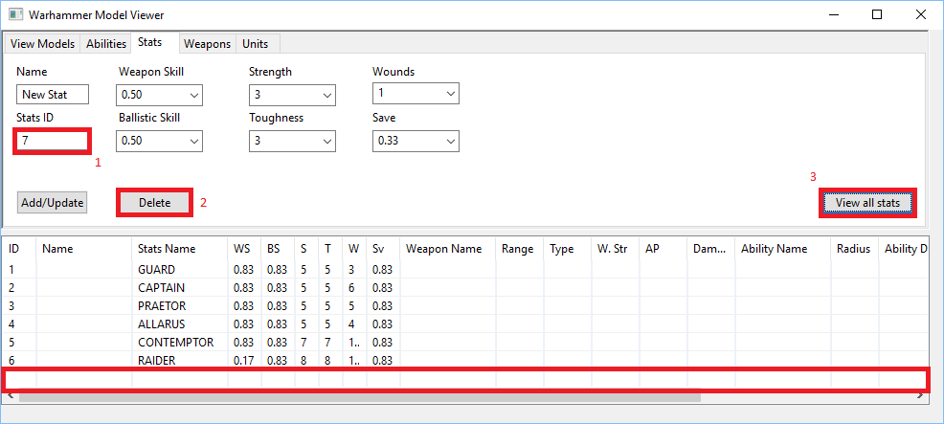

1. Add/Update/Delete Weapons

To manage weapons, begin by selecting the “Weapons” tab at the top of the window. You will be presented with the screen shown below.

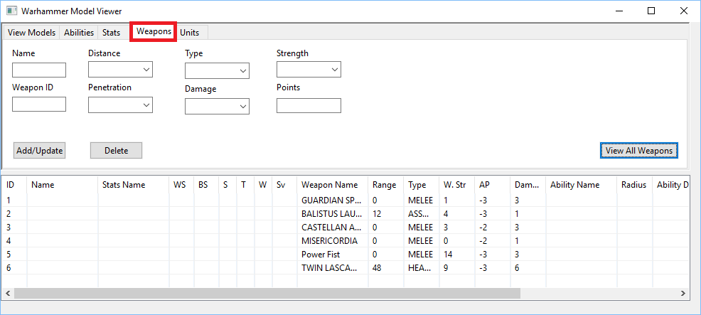

Begin by clicking the view all weapons button. This will display a list of all stats currently stored in the database including ID #’s, name, distance, penetration, type, damage, strength, and points.

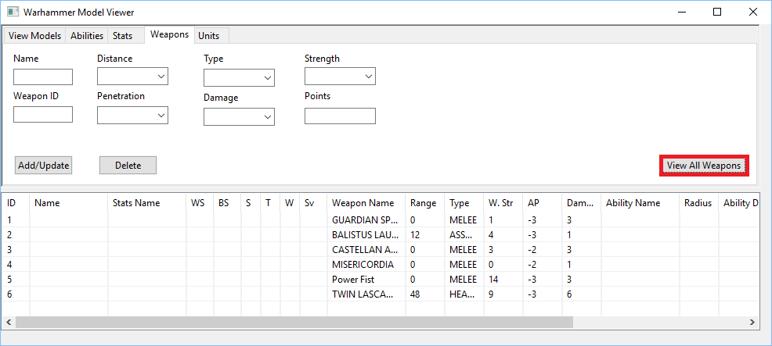

To add or update a weapon type in a new or existing ID. When adding a record you may leave the drop downs, name, and points fields empty to use default values or specify all information. Name will appear in the new/modified ability exactly as you type it. The ability id and points must both be positive integers.

Please note that inputting an existing ID will update the specified record instead of adding a new one. This will keep all current values in the database except those you chose to populate by inputting new values. After you are satisfied with the field data click the “add/update” button to finalize the record.

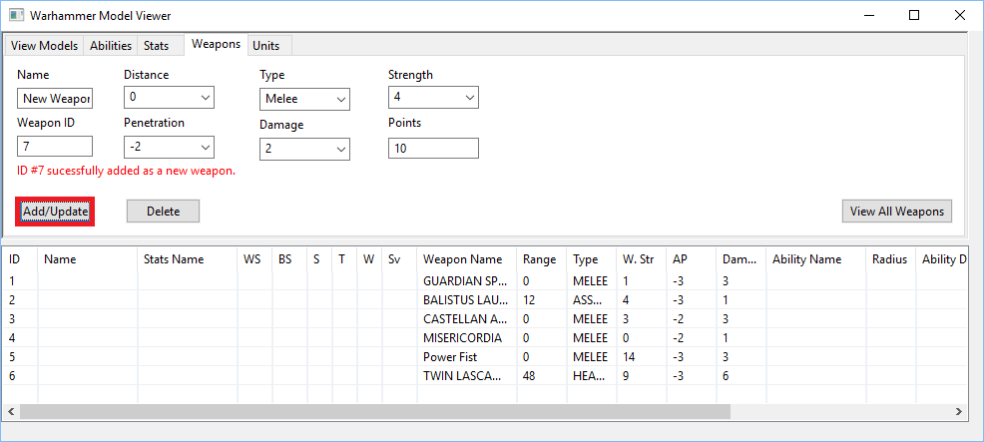

You will need to click view all weapons before changes will be visible.

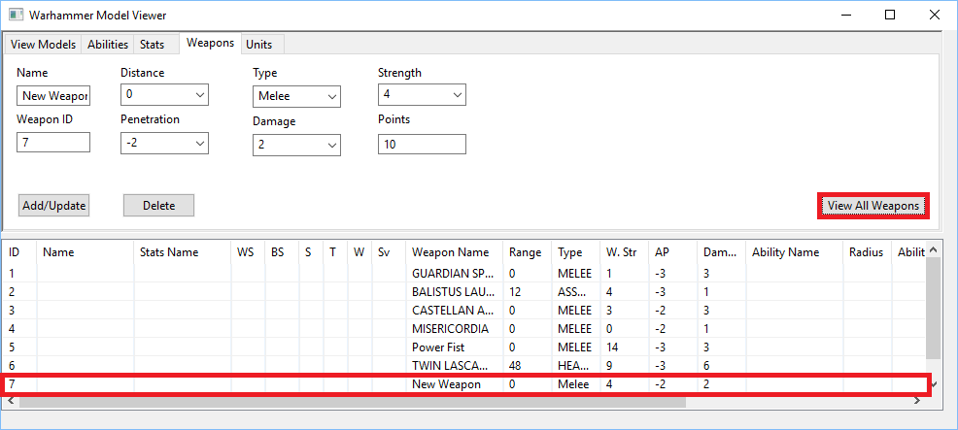

From this screen you may also delete existing weapons. When deleting weapons all fields are ignored except weapon id. Input the id of the record you would like to delete and click the delete button to remove it. You will need to again click view all weapons before changes are visible. Please note you cannot delete weapons that are currently in use by 1 or more units.

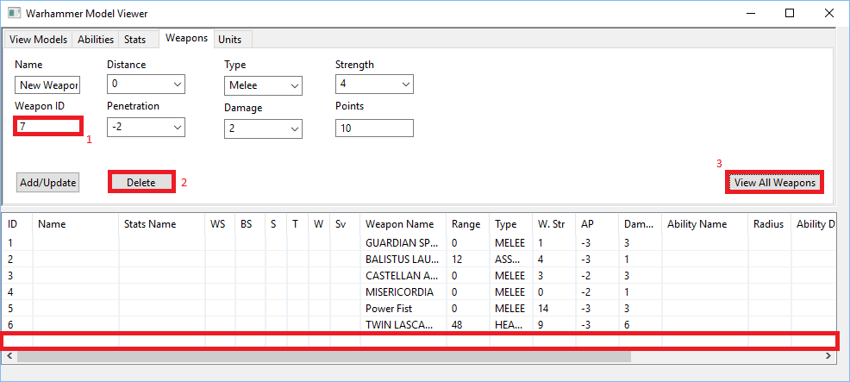

1. Add/Update/Delete Units

To manage units, begin by selecting the “Units” tab at the top of the window. You will be presented with the screen shown below.

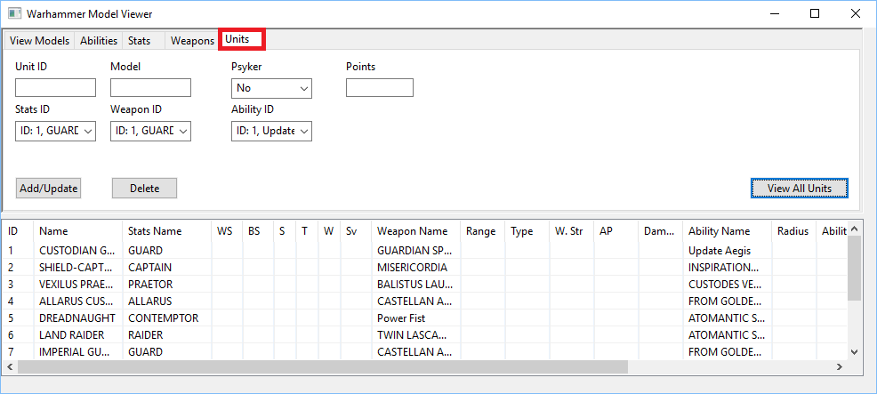

Begin by clicking the view all units button. This will display a list of all stats currently stored in the database including ID #’s, point costs, date the model was added/updated, if it is a spellcaster, as well as the name of the model and which stats/ability/weapon it is using.

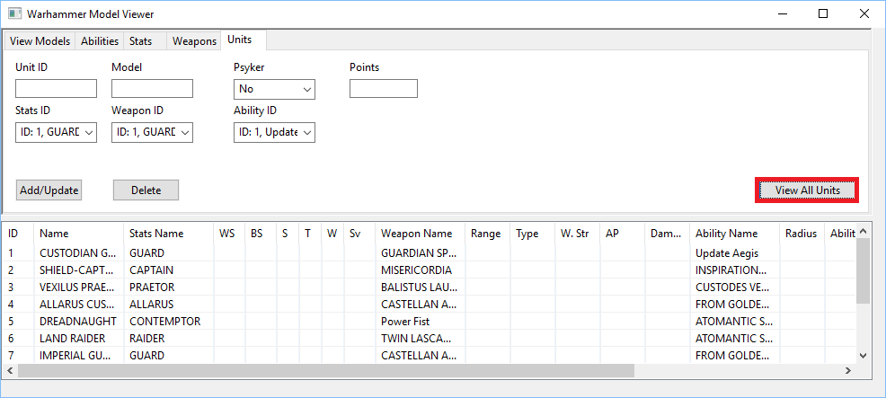

To add or update a unit type in a new or existing ID. When adding a record you may leave the drop downs, name, and points fields empty with the exception of stats/weapon/ability ID, to use default values or specify all information. Units must always include a stat/weapon/ability on creation though these can be freely changed through updates. Name will appear in the new/modified unit exactly as you type it. The unit id and points must both be positive integers.

Please note that inputting an existing ID will update the specified record instead of adding a new one. This will keep all current values in the database except those you chose to populate by inputting new values. As the stat/weapon/ability fields are required please ensure you have the correct ones selected before performing an update. After you are satisfied with the field data click the “add/update” button to finalize the record.

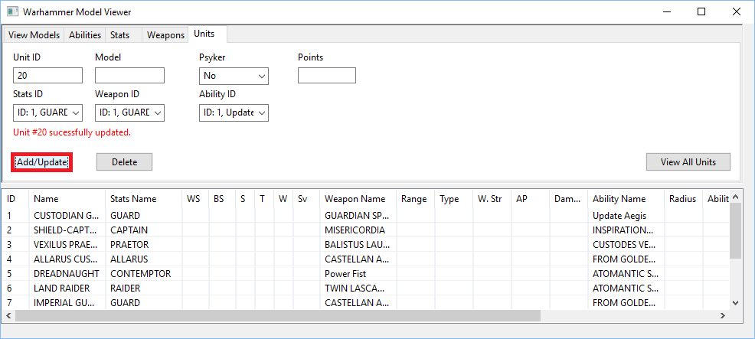

You will need to click view all units before changes will be visible.

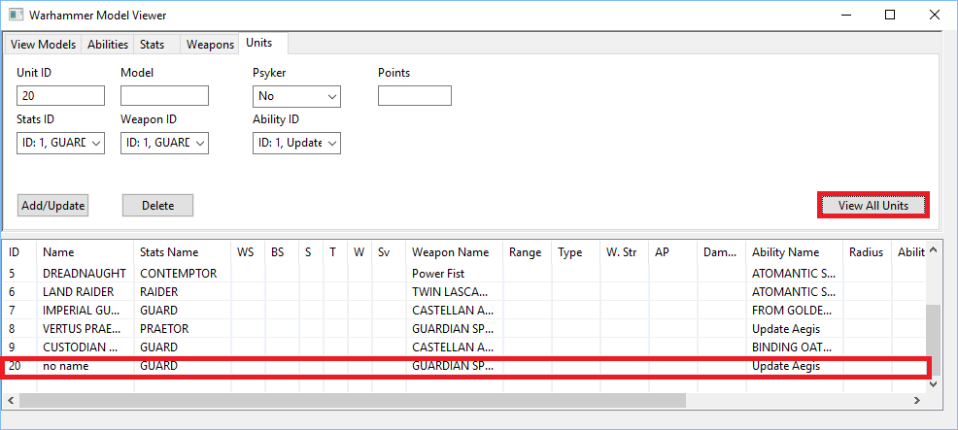

From this screen you may also delete existing units. When deleting units all fields are ignored except unit id. Input the id of the record you would like to delete and click the delete button to remove it. You will need to again click view all units before changes are visible.

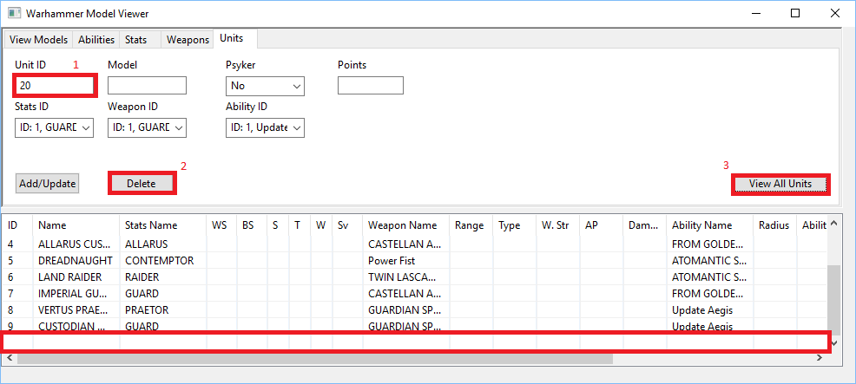

1. Common Problems
   1. Launching the program without the database running will display the following error. Please exit the program and ensure the database is running then re-launch.

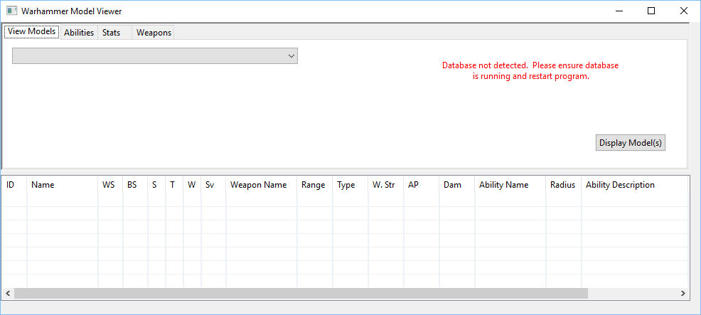

* 1. The ability id must always be entered in integer format. If you attempt to use text or enter a negative integer you will receive one of the following errors.

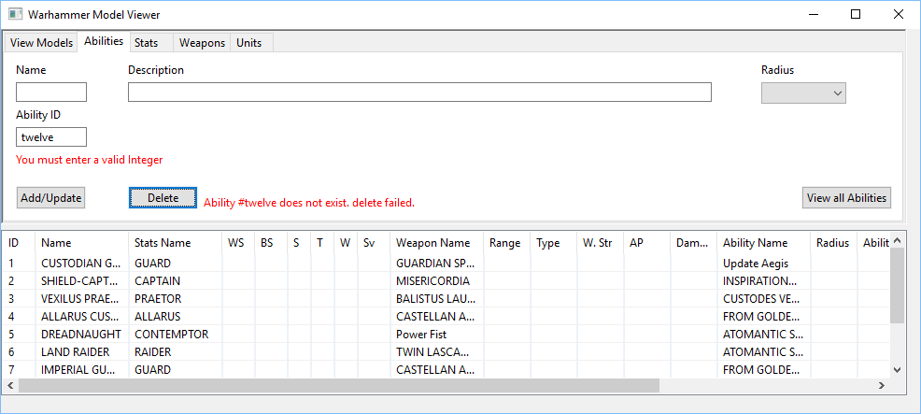

* 1. If you attempt to delete an ability currently in use by 1 or more models the following error message will notify you the operation cannot be completed.

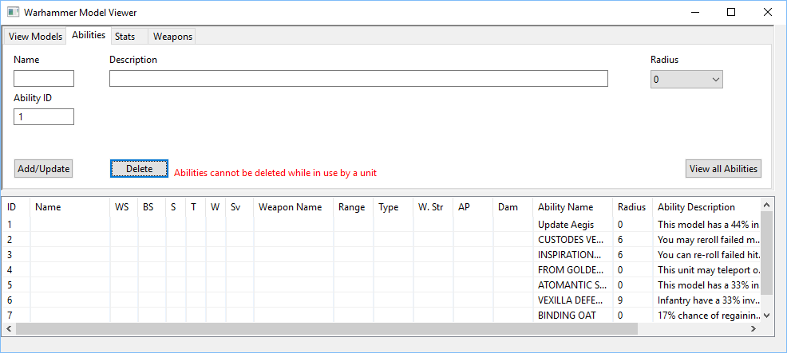

* 1. The stats id must always be entered in integer format. If you attempt to use text or enter a negative integer you will receive one of the following errors.

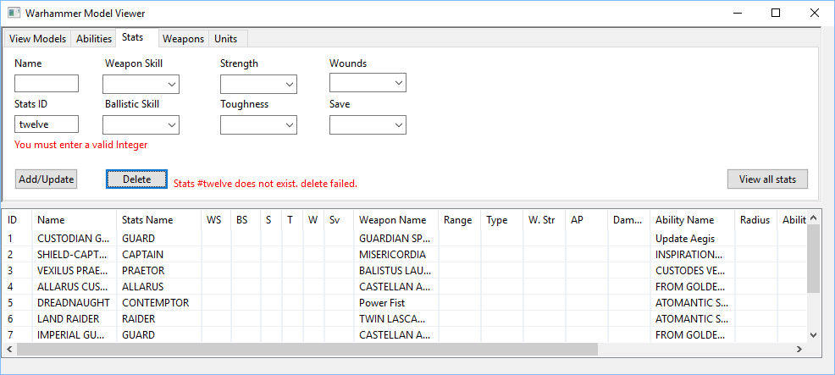

* 1. If you attempt to delete a stats record currently in use by 1 or more models the following error message will notify you the operation cannot be completed.

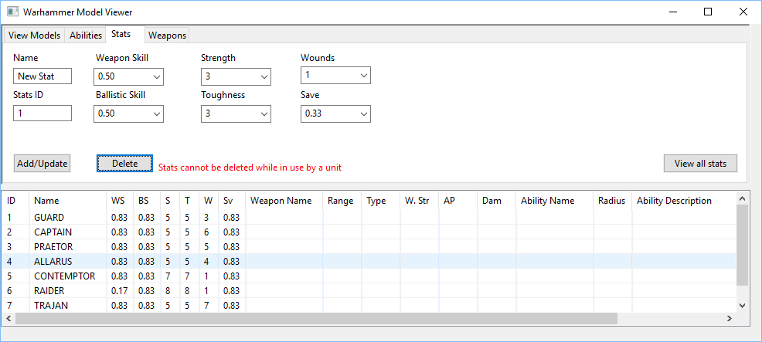

* 1. The weapon id must always be entered in integer format. If you attempt to use text or enter a negative integer you will receive one of the following errors.

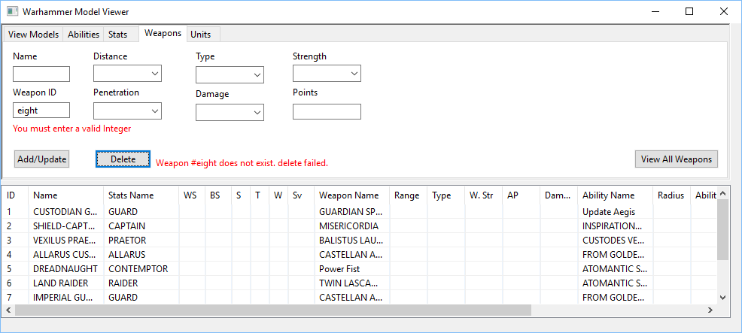

* 1. If you attempt to delete a weapon currently in use by 1 or more models the following error message will notify you the operation cannot be completed.

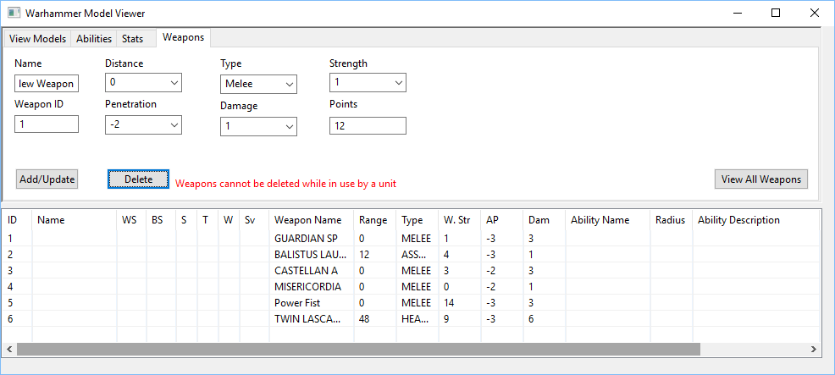

* 1. The weapon points value must always be entered in integer format. If you attempt to use text or enter a negative integer you will receive one of the following errors.

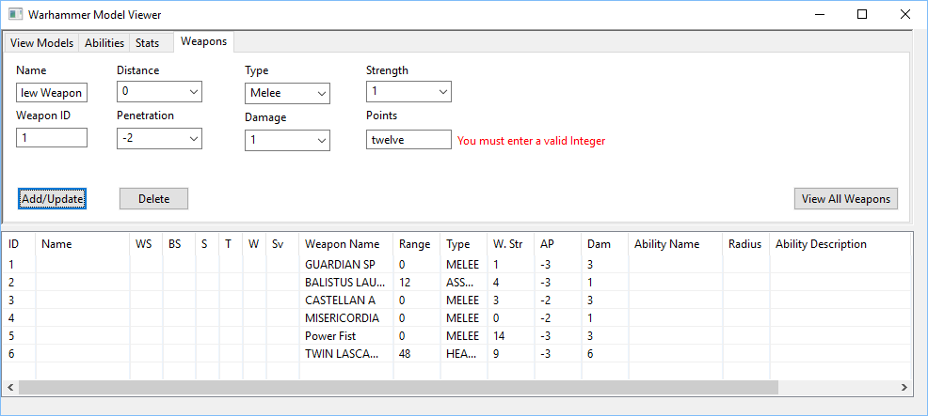

* 1. The unit id must always be entered in integer format. If you attempt to use text or enter a negative integer you will receive one of the following errors.

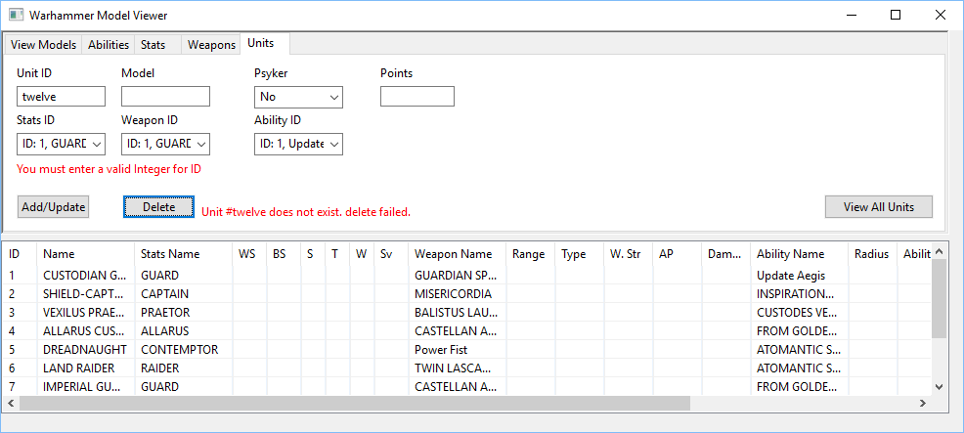

* 1. The unit points value must always be entered in integer format. If you attempt to use text or enter a negative integer you will receive one of the following errors.

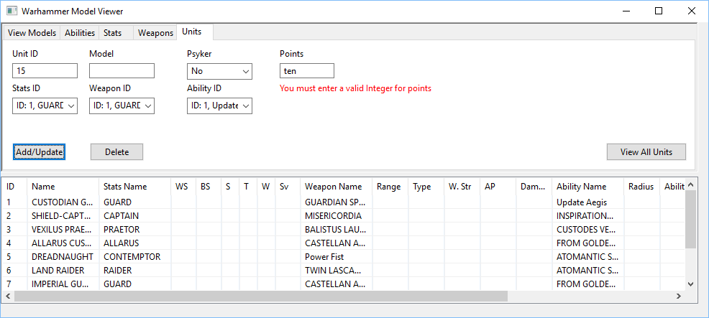

* 1. Stats/Weapon/Ability ID cannot be blank. For the most up to date stats/weapons/abilities always click the View All Units before attempting any unit operations or the following error may occur.

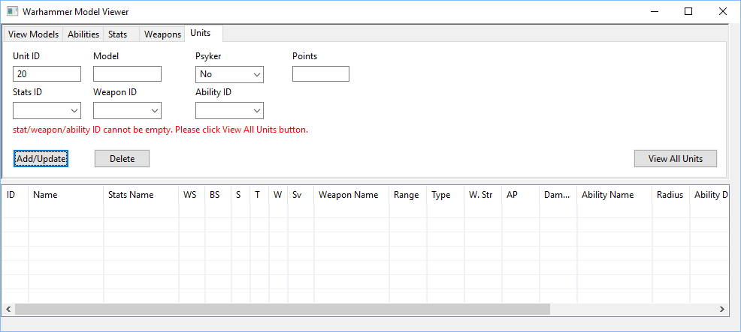

1. Data Backup

There is no automated data backup included with this software. The actual software does not change at all during use and can be re-downloaded if you lose the file.

It is recommended that you perform a monthly manual backup of the database. Manual backups are performed from phpMyAdmin(please see installation instructions page 2 if u are unsure how to launch phpMyAdmin). Once phpMyAdmin is open select the Warhammer database, the export tab, and then click go. This will download a file titled warhammer.sql which can be used to restore the database in the event of a loss of data.

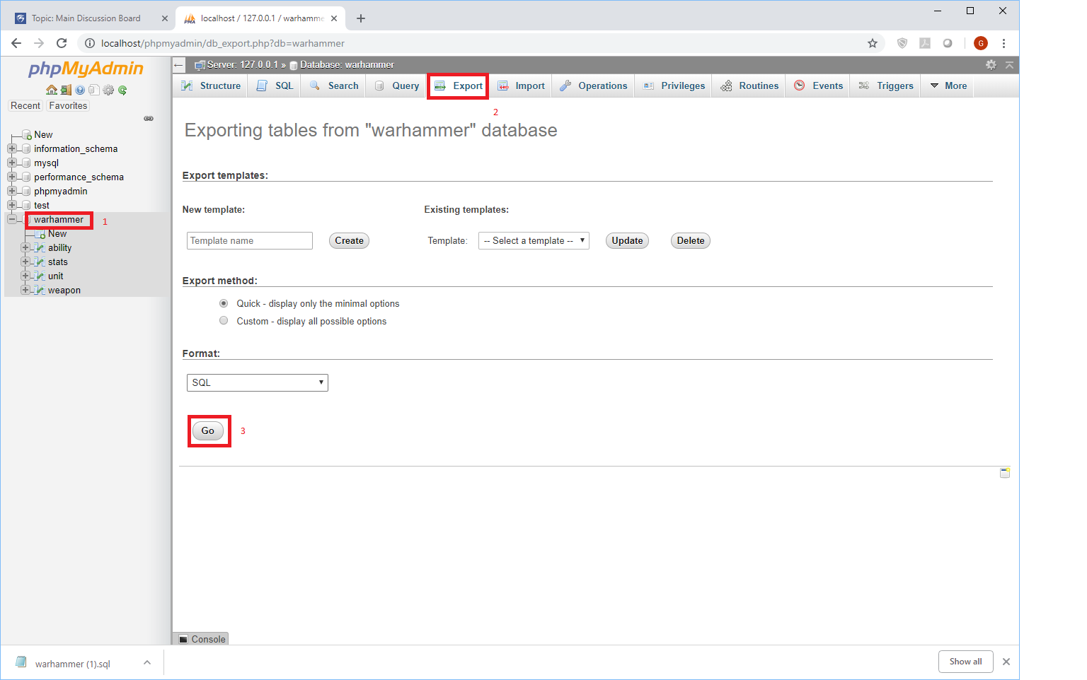

To restore data in the event of a failure you may utilize your backup .sql file with the following steps:

Step 1. Remove the corrupted database. Select new from the phpMyAdmin tree. If you do not see “warhammer” listed move on to step 2. Select the check box next to “Warhammer” then click the drop button. If a popup asks you to confirm, click “ok”.

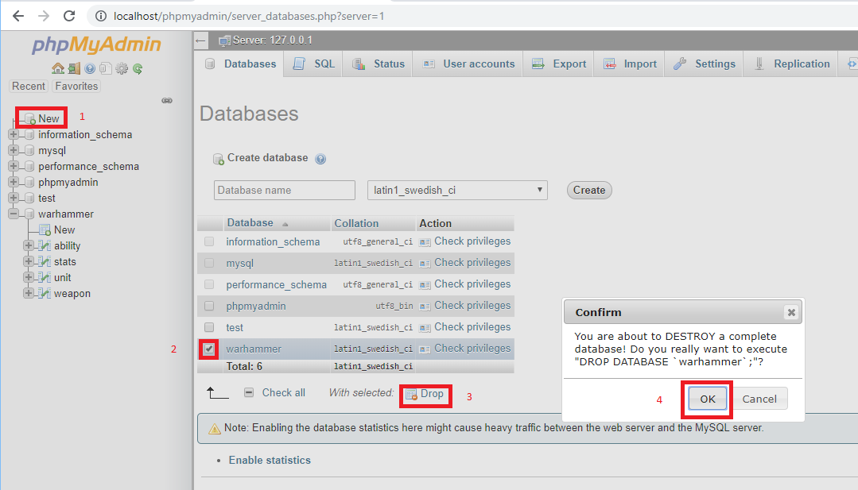

Step 2. Create a fresh database. Type “warhammer”(all lowercase) into the database name box, then click create.

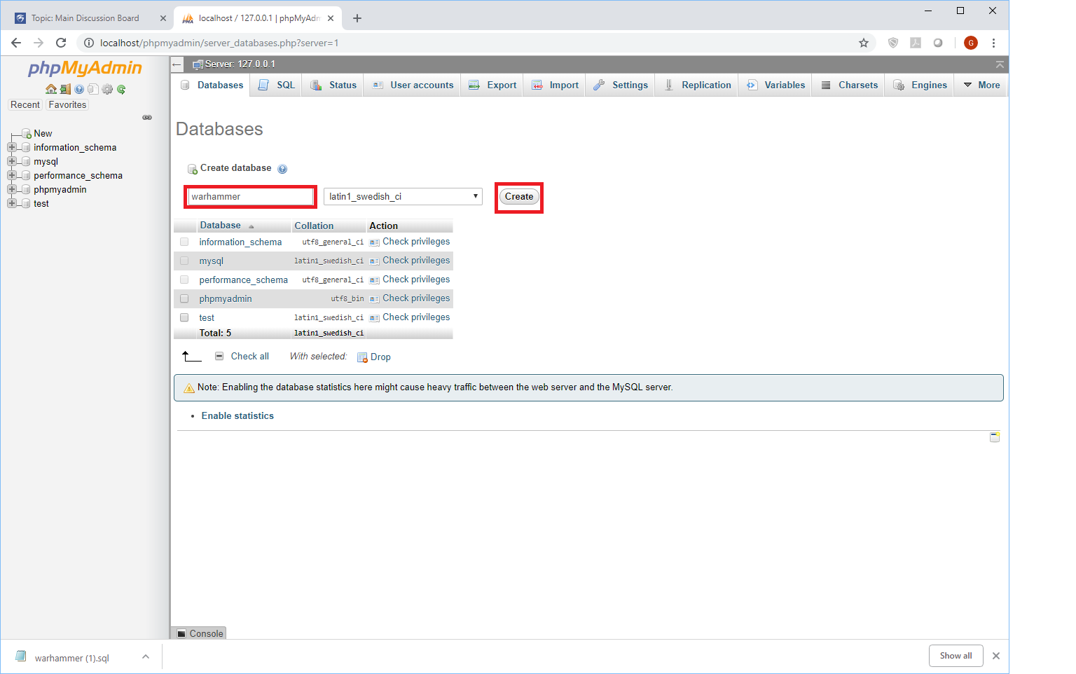

Step 3. Import data backup. Select the import tab at the top. Click choose file and navigate to the “Warhammer.sql” file you created during your most recent backup. Finally click go at the bottom of the window.

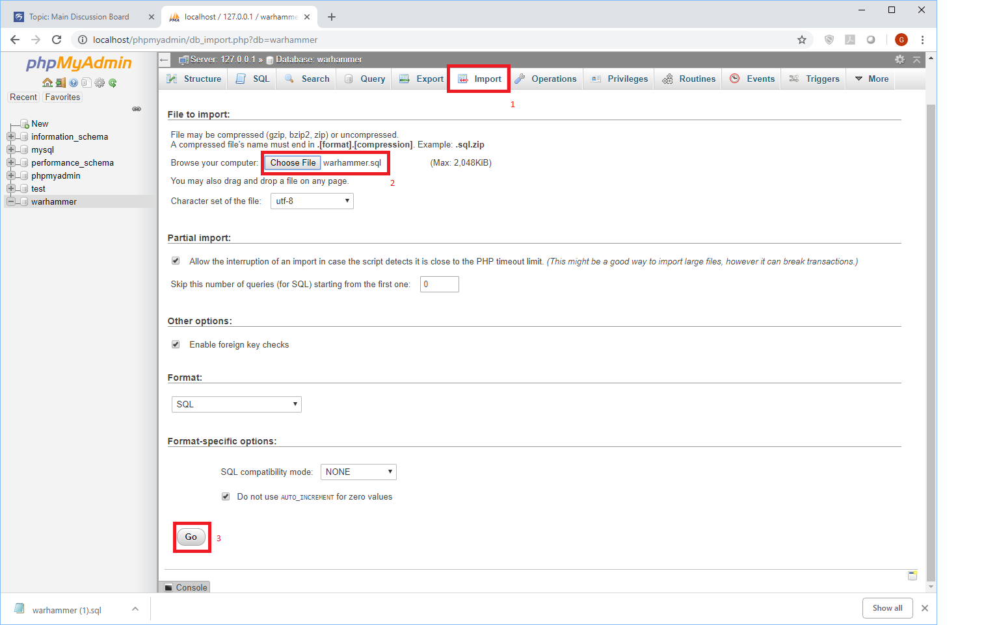

Congratulations you have successfully restored your database!