Brian K. Davis

How to have a More Secure Key Management System

October 6, 2014

American Sentinel University

Professor James Thomas Prunier

Abstract

Cryptographic systems of today has good options for encryption algorithms (AES,DES,Rijndael,Blowfish, and others) and as “algorithms” they are very good at securing data, but the part that makes them very useful and also at the same time the weak link in the cryptographic system is the “Key/Password/Pass Phrase” that each of these algorithms require to do the encryption and decryption operations. The weakness comes from the many different areas of “Key Management” which involves the creation,distribution, and storage of the keys. If encryption algorithms some how can work without a (Key or Password) cryptographic systems of today would be very secure. Since currently the cryptographic systems of today requires some form of a “Key” to operate we have to deal with the issue and it risks, to create and some how keep the “Key” secured from unauthorized access and usage. This paper will focus how to keep the “Key” secured and will review and learn from how current systems of today secure the “Key” to look for ways to have better secure solutions for key management that can be both secure and possible for systems of today without causing too much negative side effects on the system.

Table of Contents

I. Current Key Management Practices

1. Key, Vector, and Pass Phrase Generation

A. Human
B. System

2. Key Storage

A. Store the Key within or near the Ciphertext Physical Location

1. SmartCard (When Ciphertext and Key is stored at same location)
2. Software Application
3. Hardware device

B. Store the Key at a Separate Physical location of the Ciphertext

1. Network Online Storage (Database,file,images,audio,video)
2. Physical Offline Storage (File Cabinet,Paper,Safe)
3. Hardware Device (USB,SmartCard,HardDrive,RFID)
4. BioMetrics (Fingerprint, Eye, Audio, Facial)
5. Memorization of the Key (Password, Pass Phrase)

C. Temporary keys

1. Session Keys
2. Use once and delete the key after use (If ciphertext is still needed regenerate new key)

3. Key Distribution / Sharing

A. Physical

B. Online

1. SSL delivery of Symmetric key (From point A to B)
2. Public Key (RSA) used to securely pass Symmetric key (From point A to B)
3. 3rd Party Server Host

4. Key Usage For (Encrypt/Decrypt) Operations

A. Human Input Key

1.Manually Type [User Knows]
2.Insert A Device that has Key [User Has] (SmartCard,USB,and Etc)
3.BioMetrics [User Has] (Fingerprint,Facial,Audio)

B. System Input Key

1.System retrieves Key from some source (Local or Remote)

II. Ways to Improve Current Key Management Practices

1. System Only Controlled Key Management

A. Generation
B. Storage
C. Distribution / Sharing
D. Usage

III. Conclusion

IV. References

1. Key, Vector, and Pass Phrase Generation

Current cryptographic algorithms requires at least the use of some form of a key, and some have options to use an initialization vector (IV) and/or a pass phrase in addition to a key. There are three options in generating these and they are human, system, or a hybrid approach of both.

The key, initialization vector (IV), and pass phrase can all be generated and supplied to the encryption algorithm by a human user. This has some positive and negative effects, if the data being encrypted requires the user to manually enter in the key in order to decrypt it then it would be best if the user generated the key so that it could be something that they can easily remember. This also leads to an negative effect in that often users would pick a key that is too easy and that anybody can end up guessing after a few tries. This ends up creating an insecure key because it can be easily guessed by an attacker and the data that was encrypted with that insecure key would no longer be secured.

Another option is to have all of the options generated by the system where the encryption algorithm is in use. This option will require the system to either output the key so that the user know what it is to use later on to decrypt the data or the system has to save it in some fashion to pull up at a later time for decryption. Having the system generate the key and other options can ensure that they are “secure” by having them a certain length and have a high level of randomness in them that it would be very hard for an attacker to guess what they are. If the system outputs the key and the user has to save it themselves in order to use it later on could lead to a potential security issue if that key was misplaced or an attacker some how got a hold of it.

A hybrid approach where the system generates some of the options (Key,IV) and the user generates the other half (Pass Phrase) can also be used and it also shares some of the same positive and negative effects that were mention for the other generation methods. The hybrid approach can be done in many different ways.

One method would to have the user generate a “Pass Phrase” and/or “Password” and using those to help generate the Key and initialization vector in some fashion. A very common method is to use the user generated “Password” and then “Salt” it to become the key. Adding “Salt” to the password is just adding some thing extra to the Password to make the key stronger and harder to guess by the attacker. If the system uses a Salt that does not contain any Personal Identifying Information (PII) that belongs to the user like First and/or Last names, email, or Social Security Number it can make the combination of Password + Salt very secure and hard to guess. But, if the Salt contains any Personal Identifying Information (PII) the attacker can just run a dictionary type of attack against the Password and Salt using publicly known information about the user and with some social engineering could lead to the attacker eventually finding out the user's key, similar to what happen with the latest iCloud hack that hackers used to guess the passwords of celebrities. (Smith, 2014)

2. Key Storage

DirecTV
DVD DRM

A. Store the Key within or near the Ciphertext Physical Location

The storing of the key is very important, there are generally three different methods of storage, storing the key with the ciphertext, storing it at a separate physical location, only storing it temporary, or a hybrid of any of the mention methods.

Storing the key within or near the ciphertext physical location can be in two different forms in the software or some type of a hardware device. With software it can be hard-coded into the application code, stored in some form of a document (database,text file,image,video). Hardware can be stored on a RAM, or ROM chip loaded from a source like a hard drive or inputted data. Removable media and devices can also be used to physically store the key with the ciphertext (encrypted data). Examples of this could be a smartcard that includes encrypted data (ciphertext) that also includes the decryption key within the smartcard. It could also be “nearby” the Ciphertext in that the encrypted data is located in the physical device where the smartcard is inserted into providing the keys needed to “unlock” decrypt the encrypted data within the physical device.

Another example of storing the key along with the ciphertext on the same device is cell phone encryption where the user uses their cell phone to encrypt their data on their phone like pictures and etc and then also store the keys to that encryption within the phone itself, instead of storing it at an remote or 3rd party location, like the iPhone storing the encryption and decryption keys on the iPhone instead of on the iCloud servers. (Kirk, 2014)

B. Store the Key at a Separate Physical location of the Ciphertext

From a security point of view storing the key and ciphertext in two separate (Physical or Logical) locations provides much more protection than storing both together or nearby each other. If an attacker gets physical access to the device or software that has the key and encrypted data stored at the same location or near each other all an attacker has to do is figure out how and where it is stored and from there has access to the key and then can decrypt the ciphertext.

Example of this is with satellite PayTV services like DirecTV, where both the encrypted (TV channels) and the keys needed to decrypt (view) them are sent together with the satellite “Signal” feed that goes directly to the receiver. There is a smartcard that goes inside of the receiver that contains the subscriber information and also the decryption algorithm needed to decrypt the channels so that they can be viewed. The smartcard also saves the currently used decryption key that is needed to decrypt the channels, periodically DirecTV will update the decryption key that is stored on the smartcard again through the satellite signal. (Hamlyn-Harris, 2012)

There is a major issue with the satellite PayTV approach with storing the decryption key inside of the smartcard and receiving it together with the encrypted channels to the same near by physical devices, the receiver and smartcard.

This approach allows an “attacker” (Person who wants to have free TV) to have both pieces of the puzzle all in one package. The satellite companies just depends on the “secrecy” of the methods that they use to keep the right channels decrypted while keeping the others encrypted if the user is not signed up for those packages. All the attacker has to do is just figure out the “secret” and can get the key. (Hamlyn-Harris, 2012)

This can be done by directly hacking the smart card, there are many different ways to do this and one that hacker Chris Tarnovsky used is a physical process that directly taps into the smartcard and reads the electrical signals it produces to get the binary bits (1 and 0) that is being generated or received on the smartcard. Then using some software to decode that can get the source code and encryption keys being used by the smartcard. (Hamlyn-Harris, 2012) (Wired Magazine, 2008) (Tarnovsky, 2008)

Once the smartcard is “hacked” this information can be shared with others and by knowing the internal code being used can hack the other cards much easier. This getting the keys being used for decryption is very easy till the satellite PayTV changes the coding of the card remotely or issuing new ones to other subscribers. But, again this process can be repeated by hackers and the PayTV companies would have to again reissue new smartcard or internal code for them. With remote coding hackers can monitor the updates to the smart card from the satellite signal and also figure out what they are doing and can do some actions to prevent them from not allowing them to get the keys and keep them from continuing to keep their free TV. (Hamlyn-Harris, 2012)

This clearly shows the importance of when possible of keeping the key and ciphertext physically separated from each other and not bundled up into the same package.

There are many different ways to store the ciphertext and the key that belongs to it separate from each other. The most common method is for the user or owner of the encrypted data to actually memorize the Key “Password” in their head and use it when it is required to decrypt the ciphertext when needed. This method has a clear separation from the ciphertext, but also forces the user to memorize it and there is a possibility that the user can forget it, which the user would then be force to only create a password that can be memorized easily or to store it some where.

Other storage possibilities could be “Physical” or “Software” which were mention earlier and can be in the following forms, Online or Offline Databases or documents, physical storage in a safe, USB, BioMetrics like Fingerprint or facial recognition, and etc.

While keeping the key and ciphertext “physically” or “logically” (stored in different folders and locations within a hard drive or other hardware device but still “physically” on one device) stored separately from each other generally provides a more secure method in storage it also presents a challenge in key management when it comes to the use of the keys for encryption or decryption, some how the software or user has to locate the key first before it can be used. The locating of the key depending on how often it is needed can slow down the process of encryption or decryption operations. For uses that have 1,000's of users that need to have access to keys every 5 or 10 mins this method might not be the best method for storage.

C. Temporary Storage for Keys

At times an Information System (A collection of computer systems and devices) might only need to store a key temporary and then delete the key after a short period of time. Commonly this is used for Session Keys when transmitting encrypted data on a network from a sender to a receiver. After the communication linked is closed the session key is deleted. This key can be stored in-memory on the server RAM or in a database or some other medium.

3. Key Distribution / Sharing

Exchanging or Distributing the keys needed for encryption and decryption operations from point A to B can be done basically in two different forms in person physically or through some online network.

A. Physical

Key distribution done in person is the most restrictive method to use since it physically requires some person to go from point A to point B to deliver the key in some form. It can be mailed, done through a secure carrier, faxed, told over the phone, and etc. A person to person exchange through is the most secure and less likely to be intercepted by a 3rd party. But, there are still physical security reasons still involved, a 3rd party “adversary” might be following Person B that has the new key, they notice that they put it inside of their briefcase, adversary knows that the key is inside of the briefcase so they can follow Person B, till they get an opportunity to steal or copy the key that is inside of the briefcase or even replace it with another key. So even with a person to person exchange of key physical security must also be considered for the key exchange meeting.

B. Online

Online or Network key distribution while not as secure as a physical key exchange offers a much less physical restrictive method to use for the key exchange. There are many different methods that can be used for an network based key distribution.

Some are the following below:

1. TLS/SSL delivery of Symmetric key (From point A to B)
2. Public Key (RSA) used to securely pass Symmetric key (From point A to B)
3. 3rd Party Server Host

With option #1, a “Private” Symmetric key (1 key does Encryption and Decryption key) can be exchanged from Point A to Point B using a Transport Layer Security (TLS) or Secure Socket Layer (SSL) connection to have an encrypted secured communication channel to exchange the key on, with little risk of a 3rd party intercepting the communication.

Option #2 uses a “Public” Asymmetric key (Public key encrypt, Private key decrypt) to pass an encrypted private symmetric key from point A to point B. This is done by the sender Point A uses Point B public key to encrypt the symmetric key and then sends it to Point B which has the private key to decrypt the key.

Option #3 uses some type of a 3rd Party server to act as a medium for the exchange of keys between two points using either options #1 or #2. Instead of a direct exchange between A and B, the exchange goes from
Point A → Server → Point B

Point B → Server → Point A

Option #3 makes it possible to exchange keys with many different points and the Point don't have to worry about any details on the exchange since it is handled by the 3rd party server. All Points do is make a request to the server and the server handles the details of the key exchange.

4. Key Usage For (Encrypt/Decrypt) Operations

Key usage for an Information System comes in two basic forms and it is human and system.

A. Human Input Key

For an Information System that requires a human (user) to input a key for (encryption or decryption operations) can be done in three different ways.

1. The Human User can manually type in the key using something that they “know” or had memorized. Most commonly through Information Systems ties in the access control system with encryption and decryption keys that belongs or have rights to the keys. When a user logs into the Information System, based on user rights the system grants permission to the user for certain keys in the system. In that situation Human users don't have to actually enter in the actual encryption or decryption key, they just need to have access rights to the Information System.

2. Instead of manually entering in a key or password the user can provide some thing that the user has like a SmartCard,USB,MicroFlash card, and etc.

3. Another option is to use what the Human user is, by using some type of BioMetrics like a fingerprint,Facial or voice recognition, and etc.

For added security an information system can require more than one type of “Human” input. Like a manual password entry with facial recognition.

B. System Input Key

In terms of “Key” security the Information System can programmatically retrieve the keys needed to be used in some fashion for the user. This can be done in many different ways. The system can retrieve the keys from a local or remote database somewhere, which is the most common method,or it can retrieve it from sort of an document or file within the local or a remote system.

Both methods of key input has their positive and negative effects, having the human enter in the key manually poses some security risks, but if the Information System uses common encryption methods then the key used can be used with any another system that uses the same encryption algorithm to decrypt the ciphertext encrypted by the original Information System.

On the other hand if the “Key” is inputted or retrieved by the Information System the system has to have some sort of an output function or capability to work with other systems in order to have data encrypted on one system and decrypted on another without both ends having the same software.

II. Ways to Improve Current Key Management Practices

Current key management practices of today in Information Systems have some room for improvement that can help make the management of the cryptographic keys more secured than what is currently being used by most systems of today.

1. System Only Controlled Key Management

A. Generation

Some Information systems generate keys for use ahead of time and store them in a database for future use. While this can help free up the system resources during daily operations and have stricter controls over their specific use this presents some serious security issues because if the database gets hacked, or if some how these keys were made available to unauthorized personnel and if they made copies of the keys before they were actually used the keys that were copied could be used to decrypt any data that were encrypted with those pre-made keys. This also presents another issue in that it would be very hard to tell if the keys were copied before their actual use, so detection this security issue would be very hard unless they left evidence of a break into the system.

For best security it would be best to only generate keys right before their actual use. Once a key is generated it meta data should also be generated for the key which can include information about what the key is for, who or what roles have permissions to use the key, and at least set and record the cryptoperiod for the key that sets its expiration date.
(Barker, Smid, Branstad, & Chokhani, 2013, p.60)

B. Storage

Private keys must always be stored on an information system encrypted and never in plaintext. The meta data related to the key, that contains sensitive information about the key and it's uses should also be encrypted. (Barker, Smid, Branstad, & Chokhani, 2013, p. 51)

Before a key goes into storage it need to be check to make sure it is not corrupt and that the meta data related to the key is also correct before storing it. One way to do this is with a digital signature of the key and meta data. When a key is created a hash of the key should also be made and stored as the digital signature of the key. Any time that the key needs to be checked for any errors the hash code of the original key can be compared with the current key if they match then the key is valid. If meta data is embedded with the key the hash code can also include the meta data. (Barker, Smid, Branstad, & Chokhani, 2013, p. 51)

When the key is in storage when possible the keys need to be separate from the encrypted data that the keys belong to. Meta data and any other information that can be used to figure out what a key does and who it belongs to should also be keep separate from the key, keeping it compartmented so that if some how an attacker is able to get access to the database the attacker won't have access to everything they need in order to use the keys. If the database is designed correctly by having the keys encrypted and has obfuscated database tables the attacker hopefully won't know what or where the keys are in the database. But, a poorly design database with table names EncryptionKey, DecryptionKey, MetaData, would be asking for some serious security issues.

Periodically the Information System needs to check the cryptoperiod of the keys being stored and if they had expired they need to be deleted, and if the encrypted data that the old keys encrypted is still needed then the old key needs to decrypt the data and then generate a new key for the data and store the new key. After checking that the key generation was successful then the system deletes the old key from the system and make the proper notifications if needed about the update. (Barker, Smid, Branstad, & Chokhani, 2013, p.60)

Most Information Systems of today mainly just use a database system to store the keys and their meta data. To have stronger security it would be best to also use other storage systems for the keys like, files, images, audio, and etc using Steganography (hiding things secretly inside an object) and other methods.

One way to use this type of system would be to generate a key and its hash code, then get the hash code of the original data before encrypting it. Take the key and encrypt the data and it outputs an ciphertext, delete the original data. Take the key and encrypt it with another key, the resulting ciphertext split it into parts.

Take the parts and store them inside different files on the system or on a remote server somewhere. Before storing the parts of the ciphertext in the file add a file name and byte location of the key within the file of where the other parts are stored after the original part is added into a file.
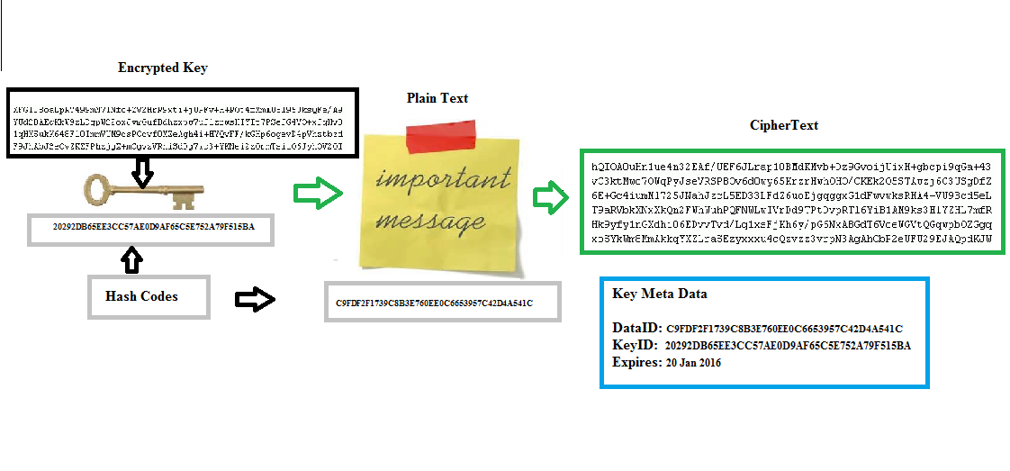
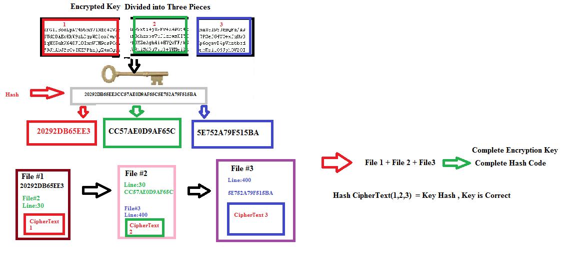

Having a key storage system like this would provide a very high level of security. It might come at a cost in system performance through because the system has to look for three different pieces stored at three different places instead of everything being with in the same database. This performance issue might make this system impossible five or so years ago but currently information systems network speeds and performance had improved greatly and might not suffer from such a performance issue today.

III. Conclusion

To have a Secure Key Management System today there are a lot of methods and things that has to be done and for each specific Information System the security requirements will vary from one system to another. The most important element in the encryption and decryption operations of an Information System is the Key Management System, without it or a poorly designed one would result in a very unsecured system because it will put the keys that does the encryption and decryption at risk of being discovered by unauthorized users.

References

Hamlyn-Harris, J. H. (2012, March 29). Pay-TV Smartcard Hacking – How Easy Is It? Retrieved from
http://goo.gl/StTjfW

Wired Magazine. (2008, June 2). How to Reverse-Engineer a Satellite TV Smart Card
[Video file]. Retrieved from
http://goo.gl/i5rtnA

Tarnovsky, C. (2008, August 8). Inducing Momentary Faults Within Secure Smartcards / Microcontrollers.
Retrieved from
http://goo.gl/PdhdEA

Kirk, J. (2014, September 19). Google to turn on encryption by default in next Android version.
Retrieved from
http://goo.gl/xobipT

Barker, E., Smid, M., Branstad, D., & Chokhani, S. (2013).
A Framework for Designing Cryptographic Key Management Systems (800-130).
Retrieved from
http://goo.gl/85csPk

