VIETNAM GENERAL CONFEDERATION OF LABOR
TON DUC THANG UNIVERSITY
FACULTY OF INFORMATION TECHNOLOGY



NGUYEN NHAT NAM – 521H0108
DOAN KIM BANG - 521H0436

Object-Oriented Solutions to the Problem of Mining Maximal Frequent Itemsets from Uncertain Databases

INFORMATION TECHNOLOGY PROJECT

SOFTWARE ENGINEERING

HO CHI MINH CITY, YEAR 2026
VIETNAM GENERAL CONFEDERATION OF LABOR
TON DUC THANG UNIVERSITY
FACULTY OF INFORMATION TECHNOLOGY



NGUYEN NHAT NAM – 521H0108
DOAN KIM BANG - 521H0436

Object-Oriented Solutions to the Problem of Mining Maximal Frequent Itemsets from Uncertain Databases

INFORMATION TECHNOLOGY PROJECT

SOWTWARE ENGINEERING

Instructor
PhD. Nguyen Chi Thien

HO CHI MINH CITY, YEAR 2026
ACKNOWLEDGMENTS

Throughout the process of completing this graduation thesis titled “OBJECT-ORIENTED SOLUTIONS TO THE PROBLEM OF MINING MAXIMAL FREQUENT ITEMSETS FROM UNCERTAIN DATABASES”, I have received invaluable guidance, support, and encouragement from my lecturers, family, and friends. Their support has been essential in helping me accomplish this thesis successfully.
First and foremost, I would like to express my deepest and sincerest gratitude to my advisor, PhD. Nguyen Chi Thien, for his dedicated guidance, insightful feedback, and continuous support during the implementation of this topic. His expertise and thoughtful directions have helped me gain a clearer understanding of the research problem and significantly contributed to the completion of this report.
I would also like to extend my gratitude to all the lecturers of the Faculty of Information Technology – Ton Duc Thang University, who have provided me with a solid foundation of knowledge throughout my years of study. Their lectures, professional experiences, and guidance have been valuable resources that enabled me to approach and carry out this thesis effectively.
Finally, although I have made every effort to complete this thesis carefully and responsibly, due to limitations in time and experience, shortcomings are inevitable. I sincerely look forward to receiving feedback from the lecturers so that I may continue to improve and develop in the future.
I would like to express my heartfelt thanks.
Ho Chi Minh City, January 7th, 2026
Author
(Sign and specify full name)
Nam
Bang

COMPLETED WORKS
AT TON DUC THANG UNIVERSITY
I would like to assure you that this is my own research work and with the scientific guidance of PhD. Nguyen Chi Thien . The research contents and results in this project are honest and have not been published in any form before. The data in the tables for analysis, comment and evaluation are collected by the author himself from different sources and are clearly stated in the reference section.
In addition, the Project also uses a number of comments, evaluations as well as data of other authors, agencies and organizations all have citations and annotations of sources.
If any fraud is detected, I would like to take full responsibility for the content of my Project. Ton Duc Thang University is not involved in copyright and copyright infringements caused by me during the implementation process (if any).
Ho Chi Minh City, January 7th, 202
Author
(Sign and specify full name)
Nam
Nguyen Nhat Nam
Bang
Doan Kim Bang
Object-Oriented Solutions to the Problem of Mining Maximal Frequent Itemsets from Uncertain Databases
ABSTRACT
The topic “Mining maximal frequent itemsets for uncertain databases” focuses on detecting maximal frequent itemsets in databases where each item appears with a certain probability, not with certainty as in traditional models. In this context, the support of an itemset is modeled as a random variable and is usually evaluated in two ways: (1) expected support – using the expected number of occurrences to determine frequency; or (2) probabilistic frequent – ​​using the probability that support exceeds a given threshold. The topic aims to build efficient algorithms and data structures to directly mine maximal frequent itemsets under one of the two definitions above, thereby strongly compressing all frequent itemsets, reducing the number of samples to consider, and improving mining performance on large uncertain databases where support computation is both complex and highly combinatorial.
Mining Maximal Frequent Itemsets for Uncertain Databases is the problem of finding the most frequent itemsets in an uncertain transaction database (each item appears with probability, not certainty).

TABLE OF CONTENTS

DRAWING CATALOGUE 4
TABLE LIST 5
LIST OF ABBREVIATIONS 6
CHAPTER 1 : INTRODUCTION 7
1.1 Background and motivation 7
1.2 General problem and current limitations 7
1.3 Research objectives and questions 8
1.4 Main contributions 9
CHAPTER 2 : RELATED WORK 10
2.1 Overview of Previous Research 10
2.2 Common Itemset Mining Methods 11
2.2.1 Apriori Algorithm: 11
2.2.2 FP-growth Algorithm: 11
2.2.3 Extensions of Apriori and FP-growth for Uncertain Databases: 11
2.2.4 Mining Maximal Frequent Itemsets from Uncertain Databases: 12
2.3 Issues and Challenges 12
2.3.1 Handling Uncertainty in Databases: 12
2.3.2 Algorithm Efficiency: 12
2.3.3 Scalability of Methods: 12
2.3.4 Evaluating the Quality of Results: 13
CHAPTER 3: PROBLEM STATEMENT AND DEFINITION 13
3.1 Uncertain Database 13
3.2 Expected support & Frequent itemsets 14
3.3 Maximal frequent itemsets 14
CHAPTER 4: PROPOSED SOLUTIONS 15
4.1 Introduction to the Proposed Solutions 15
4.2 UGenMax Algorithm 16
4.2.1 A Method for Calculating Expected Support in Uncertain Database 17
4.2.2 Workflow 18
4.3 UHashMax Algorithm 22
4.3.1 Hashing-Based Approach: 22
4.3.2 Expected Support and Hash Tables: 22
4.3.3 Maximal Frequent Itemset Identification: 23
4.3.4 Algorithm Workflow: 24
4.3.5 Optimization Techniques: 25
4.3.6 Flowchart: 25
CHAPTER 5: EXPERIMENTAL EVALUATION 26
CHAPTER 6: CONCLUSION 33
REFERENCES 34

DRAWING CATALOGUE
Figure 2.2.1 : UFP-Tree 7

TABLE LIST

LIST OF ABBREVIATIONS

MFIs | Maximal Frequent Itemsets
Fis | Frequent Itemsets

CHAPTER 1 : INTRODUCTION

Background and motivation
Mining frequent itemsets is a fundamental task in data mining and knowledge discovery. Identifying frequently occurring itemsets in data can provide valuable insights into behavioral patterns, relationships, or habits. Frequent itemset mining is often applied in fields such as shopping cart analysis, e-commerce, genetics, and recommendation systems. By discovering frequent itemsets, businesses can gain a better understanding of customer preferences and develop more effective marketing strategies or product recommendations.
While algorithms for mining frequent itemsets for certain databases (exact and immutable data) such as Apriori and FP-growth have been thoroughly studied, the problem becomes more complex when applied to uncertain databases. Uncertain databases contain inaccurate or variable information, leading to each item or set of items potentially having an uncertain value, but rather a probabilistic value. For example, in e-commerce, user behavior may not be accurately recorded, and product interactions may not always be fully documented.
With the rapid development of big data and the need to make accurate decisions in uncertain environments, research and development of methods for mining itemsets in uncertain databases is essential. This research aims to address the problems and challenges in mining itemsets from uncertain environments, yielding more accurate and reliable results despite imperfect data.

General problem and current limitations
Extracting itemsets from uncertain databases presents significant challenges compared to traditional mining tasks. The main problem arises from the uncertainty in the data—where each item or itemset may not have an exact value but rather a probabilistic or vague value. This causes several specific limitations, such as:
- Uncertainty in Support Calculation: In traditional mining algorithms like Apriori and FP-growth, itemsets are evaluated based on support—the frequency of itemsets appearing in the database. However, in uncertain databases, support is no longer a fixed value but rather an expected support, making it difficult to directly apply traditional algorithms without improvement.
- Performance Issues: As data grows, the complexity of itemset mining increases significantly. This becomes even more computationally expensive when working with uncertain data. For example, probabilistic models for calculating expectation support can require significant computational resources, especially when dealing with large datasets and high uncertainty.
- Inaccurate Results: Due to the inherently uncertain nature of databases, traditional mining methods can lead to false positives or false negatives in itemset mining. This results in unreliable mining results, making their application in real-world environments difficult.
- Lack of efficient algorithms: Current algorithms such as UB-Apriori and UF-growth, although extended to handle uncertain data, are not yet optimized for large datasets or complex probabilistic models. These methods may encounter performance bottlenecks, particularly in execution time and memory usage.
Because of these limitations, there is a clear need to develop new methods that can efficiently extract itemsets from uncertain databases while maintaining the accuracy and reliability of the results.

Research objectives and questions
The primary objective of this research is to develop and evaluate methods for maximizing the availability of itemsets from uncertain databases. The main objectives of the research include:
- Improving support computation in uncertain databases: The research will seek new methods for computing the expected support of itemsets, considering the uncertainties in the data.
- Designing efficient algorithms: The research will propose algorithms that can efficiently handle uncertain data without compromising performance, even when working with large datasets.
- Testing and evaluating the proposed method: The proposed method will be evaluated through practical tests, comparing it with existing methods in terms of both accuracy and computational efficiency.
The main research questions that guided this study include:
RQ1: How can we accurately calculate the support of itemsets in an uncertain database without increasing computational cost?
RQ2: What algorithmic improvements can be made to enhance the efficiency of traditional itemsets mining algorithms (such as Apriori, FP-growth) when handling uncertain data?
RQ3: How does the proposed method perform in terms of accuracy, efficiency, and scalability compared to current methods for mining itemsets from uncertain databases?

Main contributions
This research contributes several key points to the field of itemset mining from uncertain databases:
- Developing a new method for calculating support: We propose a new method for calculating the expected support of itemsets, considering the uncertainty in the data. This method improves upon traditional techniques by applying probabilistic models, which better reflect the nature of uncertain databases.
- Designing an efficient itemsets mining algorithm: The research introduces an itemsets mining algorithm specifically designed for uncertain data, ensuring high performance even when handling large datasets. This algorithm minimizes unnecessary operations and optimizes memory usage, making it scalable in practical applications.
- Comprehensive evaluation testing: The proposed method is tested through experiments on real-world datasets. The results demonstrate the effectiveness of the method in terms of both accuracy and computational performance, compared to other modern methods.
- Deeper understanding of maximum frequent itemsets mining in uncertain environments: This work provides insights into the challenges and solutions in mining maximum frequent itemsets from uncertain databases, paving the way for further research in this field.
- By addressing the limitations of current techniques and proposing new methods, this research contributes to further advancements in the field of uncertainty data mining and provides a more reliable and efficient solution for mining itemsets from uncertain databases.

CHAPTER 2 : RELATED WORK

Overview of Previous Research
In the field of mining frequent itemsets, discovering high-frequency itemsets is a crucial task in data analysis, especially in large and complex databases. Traditional methods like Apriori and FP-growth have been developed to mine itemsets from certain databases, where each item and itemset has an exact and unchanging value. However, with the development of more complex data systems, the need to process uncertain databases has become essential. Uncertain databases contain inaccurate information, which may include factors like low reliability, discrepancies, or missing data. For example, in e-commerce, user behaviors may be recorded with imperfect reliability, leading to itemsets where the actual frequency may be uncertain or change over time. This is why itemset mining methods have been extended to handle uncertain databases.
Previous studies have primarily focused on extending traditional itemset mining algorithms to handle uncertain databases. Several important studies have shown that, to effectively mine itemsets in uncertain databases, it is necessary to modify the way support is calculated for itemsets and find ways to mitigate the impact of uncertainty on the mining results. However, there has yet to be a well-established, widely-recognized study focused on the mining of maximal frequent itemsets (MFI) specifically in uncertain databases. Our research presents a novel approach in this area, which is the first to systematically explore and address this topic.

Common Itemset Mining Methods

Apriori Algorithm:
Apriori is one of the most well-known and fundamental algorithms for mining frequent itemsets. Apriori uses a breadth-first search approach to find high-frequency itemsets in a database. This algorithm utilizes the downward closure property to minimize the number of candidate itemsets that need to be checked.
Although Apriori has proven effective for certain databases, when applied to uncertain databases, this algorithm encounters some issues because it cannot process the uncertainty of itemset.

FP-growth Algorithm:
The FP-growth algorithm is an improvement over Apriori, with the advantage of reducing the number of operations compared to Apriori by using a data structure called the Frequent Pattern Tree (FP-tree). FP-growth helps reduce the number of database scans and speeds up the mining process.

However, FP-growth does not directly address the issue of uncertain data, and some studies have extended FP-growth to handle uncertain databases by calculating expected support instead of just using actual support.

Extensions of Apriori and FP-growth for Uncertain Databases:
Several extensions have been developed to handle uncertain databases, including:
- UB-Apriori (Uncertain Apriori): This is an extension of Apriori, where UB-Apriori calculates expected support instead of actual support, by using probabilities associated with items in uncertain databases.
- UF-growth (Uncertain FP-growth): UF-growth applies the FP-growth method but calculates expected support for itemsets in uncertain databases. This helps the algorithm handle uncertainty in the computations without having to scan the database repeatedly.

Mining Maximal Frequent Itemsets from Uncertain Databases:
Maximal frequent itemsets (MFI) are a group of frequent itemsets where no itemset can be extended and still remain frequent. Mining MFI can help reduce the complexity of mining all frequent itemsets, especially when working with uncertain data.
Methods for mining MFI from uncertain databases often use techniques like expected support and probabilistic models to identify frequent itemsets without being overly affected by the uncertainty factors.

Issues and Challenges

Handling Uncertainty in Databases:
One of the biggest challenges in mining itemsets from uncertain databases is determining the expected support of itemsets, as actual frequency cannot be computed accurately when data is uncertain. This requires calculating the reliability of items in the database, which can add complexity to algorithm design.

Algorithm Efficiency:
Another issue is how mining algorithms can efficiently work on uncertain databases without significantly increasing computational costs. Mining all frequent itemsets can be very expensive, especially when data is highly uncertain.

Scalability of Methods:
Current methods face scalability issues when working with large databases or when there are a huge number of itemsets. Therefore, there is a need to develop methods that can scale effectively and handle large datasets without compromising performance.

Evaluating the Quality of Results:
For uncertain data, evaluating the quality of mined itemsets is also an important issue. Clear evaluation criteria are needed to ensure that the mined itemsets are truly useful and reliable.

CHAPTER 3: PROBLEM STATEMENT AND DEFINITION
In this section, we provide the basic definitions and concepts essential for mining maximal frequent itemset mining in uncertain databases.

Uncertain Database
Let $I=\{i_{1},i_{2},i_{3},…,i_{n}\}$ a set of unique items. A non-empty subset $X⊆I$ is called an itemset. An itemset $X$ with its items is represented as $X=x_{1}x_{2}…x_{l}$. An itemset $X$ containing $l$ items is referred to as an $l$-itemset.
An uncertain transaction database, denoted by $UDB$, consists of a collection of uncertain transactions. Each transaction is represented as a tuple $<tid,Y>$ where $tid$ is the transaction identifier and $Y=\{y_{1}\left(p_{1}\right),y_{2}\left(p_{2}\right),…,y_{m}\left(p_{m}\right)\}$ is a set of m units. Each units has an item $y_{i}$ with an associated probability $p_{i}$, indicating the probability that item $y_{i}$ occurs in transaction $tid$.
Transaction ID | Units
T1 | A(0.8), B(0.6), C(0.5), E(0.6)
T2 | A(0.7), D(0.9)
T3 | B(0.7), C(0.8), D(0.7)
T4 | A(0.8), C(0.6), D(0.8)
T5 | A(0.9), C(0.5), E(0.8)
An Uncertain Database

Expected support & Frequent itemsets
Unlike deterministic transaction databases, where the support of an itemset $X$ is computed as the number of transactions in which $X$ occurs, support in an uncertain database cannot be determined exactly. Instead, the frequency of an itemset is characterized by its expected support, which is defined as follows:
$$esup\left(X\right)=\sum_{i=1}^{N}{p_{i}(X)}$$
With $min_esup$ being a user-specified threshold that defines the minimum level of frequency required for an itemset, an itemset $X$ is said to be a frequent itemset if its expected support satisfies:
$$esup\left(X\right)≥min_esup$$
In other words, only those itemsets whose expected support reaches or exceeds this threshold are treated as frequent, while itemsets with expected support below the threshold are considered infrequent. The choice of $min_esup$ plays a crucial role in controlling the number of frequent itemsets identified: a higher threshold results in fewer frequent itemsets, capturing only the most significant patterns, whereas a lower threshold may yield a larger number of itemsets, including less significant or noisy patterns.

Maximal frequent itemsets
Mining all frequent itemsets in large or dense uncertain databases often results in a very large number of patterns, many of which are highly redundant. To address this issue, the concept of maximal frequent itemsets is commonly adopted to provide a compact representation of frequent patterns.
A frequent itemset $X$ is called a maximal frequent itemset if there exists no proper superset $Y⊃X$ such that $Y$ is also a frequent itemset:
$$∄Y⊃X such that esup\left(Y\right)≥min_esup$$
By mining maximal frequent itemsets, it is possible to significantly reduce the number of discovered patterns while preserving the complete frequency information of all frequent itemsets. Therefore, maximal frequent itemset mining is particularly suitable for uncertain databases, where the number of potential frequent itemsets can be extremely large.

CHAPTER 4: PROPOSED SOLUTIONS

Introduction to the Proposed Solutions
In the domain of frequent itemset mining, particularly for uncertain databases, traditional algorithms such as Apriori and FP-growth often struggle with the complexity of handling uncertain data. These methods typically fail to scale efficiently as the size of the database increases or when the data is incomplete or noisy. This challenge is critical in fields such as market basket analysis, recommendation systems, and bioinformatics, where handling uncertainty is paramount.
To address these issues, we propose two novel solutions: UGenMax and UHashMax. Both are designed to efficiently mine maximal frequent itemsets (MFIs) from uncertain databases, offering significant improvements in both performance and scalability over existing techniques.
UGenMax utilizes a generating approach that efficiently computes maximal frequent itemsets by leveraging transaction subsets. It reduces computational overhead and enhances the accuracy of the results by ensuring that only relevant subsets are considered, thus improving performance without sacrificing the quality of the output.
On the other hand, UHashMax introduces a hashing-based strategy to group similar transactions, which minimizes memory usage and accelerates processing. By utilizing hash tables, it significantly reduces the time complexity, making it well-suited for large-scale uncertain data.
Together, these two solutions present a robust framework for tackling the challenges of mining frequent itemsets in uncertain environments, offering both theoretical and practical advantages over existing methods.

UGenMax Algorithm
GenMax is a state-of-the-art algorithm for mining maximal frequent itemsets in deterministic transactional databases. Unlike traditional frequent itemset mining approaches that enumerate all frequent patterns, GenMax focuses exclusively on itemsets that are frequent and have no frequent supersets, thereby significantly reducing the number of discovered patterns. The algorithm adopts a depth-first search strategy and integrates powerful pruning techniques, including subset checking and look-ahead pruning, to efficiently reduce the search space in deterministic settings. According to numerous scientific studies, GenMax is considered one of the most efficient algorithms for maximal frequent itemset mining in a wide range of scenarios on deterministic databases, particularly for dense datasets and low support thresholds. These characteristics make GenMax a strong baseline and reference algorithm when extending maximal frequent itemset mining techniques to uncertain databases.
In this paper, we present our study and implementation of UGenMax, a novel variant of the GenMax algorithm designed for mining maximal frequent itemsets in uncertain databases. UGenMax inherits the core ideas of GenMax, including the depth-first search framework and pruning strategies, while introducing new techniques to handle uncertainty. In particular, we extend the GenMax search process by incorporating probability-aware support computation and uncertainty-aware pruning mechanisms at each node of the DFS search tree. These extensions enable UGenMax to efficiently explore the search space while correctly accounting for item existence probabilities, thereby adapting GenMax from deterministic to uncertain transactional settings.

A Method for Calculating Expected Support in Uncertain Database
Let $D=\{T_{1},T_{2},T_{3},…,T_{n}\}$ be an uncertain transactional database, where each transaction $T_{i}$ consists of items associated with existence probabilities. For an item $x$ in transaction $T_{i}$, let $p_{i}\left(x\right)∈\left[0,1\right]$ denote the probability that $x$ appears in $T_{i}$. With that assumption, the probability that an itemset $X$ appears in transaction $T_{i}$ is defined as:
$$P\left(X⊆T_{i}\right)=\prod_{x∈X}{p_{i}(x)}$$
The expected support of an itemset $X$ is defined as the expected number of transactions in which X appears, and can be computed as:
$$E\left(supp(X)\right)=\sum_{i=1}^{N}{\prod_{x∈X}{p_{i}(x)}}$$
In traditional GenMax applied to deterministic databases, it is sufficient to compute the support of each itemset. This is typically achieved by storing the Transaction IDs (TIDs) of transactions in which an itemset.
In UGenMax, we inherit this idea but extend it to handle uncertainty by introducing a new Node structure in order to store additional information required for expected-support computation. Specifically, at each node, instead of storing a simple list or set of TIDs as in the deterministic case, we store a HashMap where each key corresponds to a TID and the associated value represents the probability of the itemset occurring in that transaction. This structure enables efficient computation of the expected support during the DFS traversal, which is calculated by summing all the values (i.e., probabilities) stored in the HashMap.
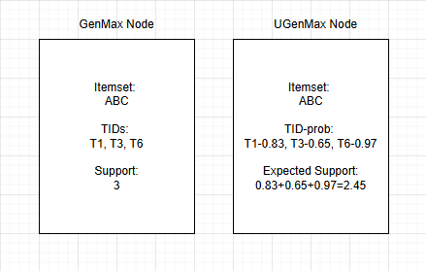
Figure 4.2.1: Combine 2 nodes in UGenMax
This structure also allows us to combine two nodes, a process required for generating new candidate itemsets in GenMax/UGenMax. The combination is performed by merging the itemsets as in the deterministic case and joining their HashMaps. When the same TID appears in both nodes, the corresponding probability values are multiplied to obtain the probability of the new candidate itemset in that transaction.
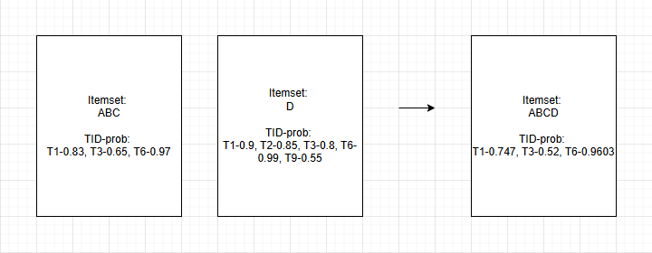
Figure 4.2.2: Example of 1-itemset nodes HashMap

Workflow

Expected Support Calculation
- Initial Scan of the Dataset:
- The algorithm starts by scanning the dataset and generating 1-itemset nodes. These nodes represent individual items and contain details such as the support of that item in the dataset, along with a TID-probability HashMap (transaction IDs and the corresponding probabilities).
- Storing in HashMap:
- All the 1-itemset nodes are stored in a HashMap, where each key corresponds to an item ID, and the value is the node with the computed support values and transaction details.
- Level-1 Candidates are the 1-itemset nodes that are retained if they meet the minimum expected support threshold (ESup ≥ minEsup).
- Sorting the Nodes:
- The retained 1-itemset nodes are sorted in ascending order based on their expected support to improve the pruning efficiency in the later steps.
- Efficient Calculation:
- During the DFS process, the expected support of any new itemset can be efficiently computed by combining the 1-itemset nodes stored in the HashMap. This is done by following the combination method described earlier, where new itemsets are generated by combining the current node with others.

Generating Candidates
- Generating Level-1 Candidates:
- The level-1 candidates are readily available as the 1-itemset nodes. Only frequent itemsets (itemsets with ESup ≥ minEsup) are retained.
- Sorting by Expected Support:
- After filtering for frequent itemsets, the candidates are sorted in ascending order of their expected support (ESup), ensuring that those with the smallest support are explored first. This sorting enhances pruning by prioritizing the more promising itemsets.
- Combining for Larger Candidates:
- The process of generating candidates continues by recursively combining the nodes. Each node from the previous level is combined with remaining candidate nodes to create new candidates for the next level of itemsets.

Depth-First Search (DFS)
- Starting DFS:
- The algorithm initiates a depth-first search (DFS), starting with an empty itemset (often represented by a node with an empty set of items).
- In each recursive step, the algorithm combines the current itemset node with remaining candidate nodes to generate new candidates for the next level.
- Generating New Candidates:
- During each DFS recursion, the algorithm generates new candidate itemsets by merging the current node with potential candidates from the previous level.
- Ensuring Frequent Itemsets:
- Only frequent itemsets are retained. If the expected support (ESup) of a candidate node is greater than or equal to the threshold (minEsup), the node is kept for further exploration.
- Proceeding Further in DFS:
- If a valid candidate is found, the algorithm proceeds to the next recursion of DFS to explore larger itemsets.

Maximal Frequent Itemsets (MFI) Identification
- Leaf Node and Maximality Check:
Once a leaf node is reached (i.e., a node with no valid candidates left to combine), the algorithm checks if the node’s itemset is a subset of any previously discovered maximal frequent itemsets.
- Adding Maximal Itemset:
If the current itemset is not a subset of any found maximal itemset, it is added to the list of maximal frequent itemsets. The expected support (ESup) for the itemset is calculated by summing the probabilities in the node's TID-probability HashMap.
- Return Maximal Itemsets:
The algorithm continues this process until all possible itemsets have been explored or pruned. At the end of the DFS, the algorithm returns the list of maximal frequent itemsets discovered in the dataset.

Pruning and Subset Checking
- Pruning Non-Maximal Itemsets:
- Pruning occurs throughout the DFS process. If a node cannot be extended into a frequent itemset (i.e., its expected support falls below minEsup), it is pruned.
- Additionally, when the algorithm generates new candidate itemsets, it checks if these itemsets are maximal. If a node is found to be a subset of any previously discovered maximal itemset, it is pruned to reduce the search space.
- Subset Checking:
- The algorithm checks if the current node’s itemset is a subset of any already discovered maximal frequent itemsets before adding it to the result list.
- This subset check is performed to ensure that no redundant itemsets are added, and only maximal itemsets are retained.
- Eliminating Redundant Branches:
- The pruning strategy also ensures that the algorithm eliminates branches in the search tree that cannot lead to the discovery of new maximal frequent itemsets, significantly reducing the computational cost.

UHashMax Algorithm
The UHashMax algorithm is a specialized algorithm designed for mining maximal frequent itemsets (MFI) from uncertain databases. It introduces a hashing-based approach that enhances the efficiency of mining frequent itemsets by utilizing expected support calculations while addressing data uncertainty.

Hashing-Based Approach:
UHashMax utilizes a hash table to store itemsets and their expected support values. This approach allows for quick access and efficient management of itemsets, which is particularly useful when dealing with large datasets. By using hashing techniques, UHashMax reduces the number of comparisons needed to determine frequent itemsets.

Expected Support and Hash Tables:
Like UGenMax, UHashMax calculates the expected support for itemsets in an uncertain database. However, instead of iterating through all possible itemsets in memory, UHashMax stores itemsets in a hash table, where each key corresponds to a candidate itemset and the value corresponds to its expected support. This method allows for faster lookups and updates as the algorithm processes the data.

Maximal Frequent Itemset Identification:
We describe the key formulas used in the UHashMax algorithm. UHashMax employs hashing techniques to store and compare itemsets efficiently while calculating expected support.

Expected Support Calculation
The expected support calculation in UHashMax is similar to UGenMax but is optimized using hash tables for faster lookups. The formula for calculating expected support using hashing is:
$$ES(X)=\sum_{h∈H}{\prod_{i∈X}{p(i,h)}}$$
Where:
- $ES(X)$: Expected support of itemset $X$
- $H$: Hash table containing the buckets of itemsets.
- $h$: A bucket that contains itemset $X$.
- $p(i,h)$: Probability of item $i$appearing in bucket $h$.
This formula allows UHashMax to efficiently compute expected support by looking up itemsets in a hash table, rather than iterating over all transactions in the database. This significantly reduces the time complexity and improves the algorithm's performance.

Hashing-based Itemset Management
The UHashMax algorithm uses a hash table to manage itemsets and their expected supports. The hash table stores itemsets as keys and their expected supports as values. This allows for quick access and comparison of itemsets, speeding up the mining process.

Maximality Pruning with Hashing
Just like UGenMax, UHashMax applies a maximality check to identify and retain only the maximal itemsets. The pruning condition using hashing is:
If ES(X)≥minEsup and no extension of X is frequent in the hash table, then X is maximal.

Algorithm Workflow:

Data Preprocessing:
The first step involves collecting item IDs from the dataset and building a map of item indices. A TreeSet is used to store unique item IDs, ensuring a stable order. Each item is then mapped to an index for efficient lookup.

Bucket Creation and Expected Support Calculation:
The algorithm processes the dataset in a single pass to create buckets and calculate F1 expected support for single items. Each transaction is converted into sorted index arrays, and their associated probabilities are calculated.
A hash map is used to store buckets of transactions. Transactions with identical item sets are grouped together to avoid redundant calculations.

Pruning Step (F1 Pruning):
The algorithm prunes singletons (items that appear alone) based on their expected support. If the expected support for a singleton is below a given threshold, it is excluded from further processing.
This step is essential for reducing the search space and focusing only on promising candidates.

Pair-wise Expected Support Calculation:
Once singletons are pruned, UHashMax calculates pairwise expected support for item pairs, focusing on those that have a high likelihood of being frequent.
This pairwise calculation is performed efficiently by considering only those items that have been deemed likely to be frequent.

Candidate Generation:
The algorithm generates candidate itemsets by expanding existing frequent itemsets. For each candidate, the sources (sets of transactions containing the itemset) are computed by intersecting the buckets containing each item in the itemset.

Maximality Pruning:
To ensure that only maximal itemsets are retained, UHashMax applies a maximality check. This step ensures that no itemset is a subset of a previously found maximal itemset.

Final MFI Generation:
The final maximal frequent itemsets are generated by combining the results from the earlier steps and removing duplicates.
The itemsets are then sorted by size, with longer itemsets prioritized.

Optimization Techniques:

Efficient Memory Use: The use of bitsets for storing itemset data allows for quick comparisons and efficient memory usage.

Bucketization: By bucketizing transactions based on their itemsets, UHashMax reduces redundant computations, especially in large datasets.
Pruning: Early pruning of non-promising candidates helps the algorithm avoid unnecessary computations, improving its performance.
Hashing: The use of hashing for managing itemsets significantly speeds up the process of accessing and updating itemset data.

Flowchart:

CHAPTER 5: EXPERIMENTAL EVALUATION

Environment Overview
This section presents the benchmark environment and experimental settings employed to assess the performance of the proposed algorithms. All experiments were carried out on a 12th Gen Intel® Core™ i5-12400F 2.50 GHz processor with 32 GB of RAM under Microsoft Windows 10. The algorithms were implemented in Java and executed using JetBrains IntelliJ IDEA to ensure a consistent evaluation framework.

Dataset and Benchmark Setup
Following previous research in data mining, we selected four widely used and trusted deterministic datasets from the SPMF library: mushrooms, chess, accidents, and BMS WebView 1. These datasets were chosen to cover a broad range of characteristics, including the number of transactions, number of items, average transaction length, and dataset density. This selection ensures that the proposed algorithms are thoroughly evaluated across datasets with diverse properties, providing a comprehensive assessment of their performance.
Since these datasets are purely deterministic, we pre-processed them by assigning a probability to each item in every transaction. The probability values were randomly generated as decimal numbers between 0.5 and 1.0. We selected this range instead of 0.0–1.0 to ensure that the probabilistic transformation does not significantly alter the main characteristics of the original datasets, as very low probabilities could disproportionately affect these properties.
Dataset | Transaction count | Item count | Avg transaction length | Density
mushrooms | 8416 | 119 | 23 | 19.33%
chess | 3196 | 75 | 37 | 49.33%
accidents | 340183 | 468 | 33.8 | 7.22%
BMS WebView 1 | 59602 | 497 | 2.51 | 0.51%
Table 5.2.1 : Properties of the Datasets
For each dataset, we executed our algorithms using different $min_esup$ values, which were carefully adjusted to suit the evaluation purposes. To minimize the effect of runtime variability, each setup was run approximately ten times, and the results reported below represent the average performance across these runs. This approach allows us to systematically assess the performance and robustness of the algorithms under varying frequency thresholds.

Experimental Results
The results of our experiments are presented as line charts. The x-axis represents different $min_esup$ values used, and the y-axis shows the corresponding running time of the algorithms. In addition, to ensure correctness, all results were verified and found to be identical for both algorithms in each setup, which further confirms the reliability and precision of the algorithms in terms of accuracy.
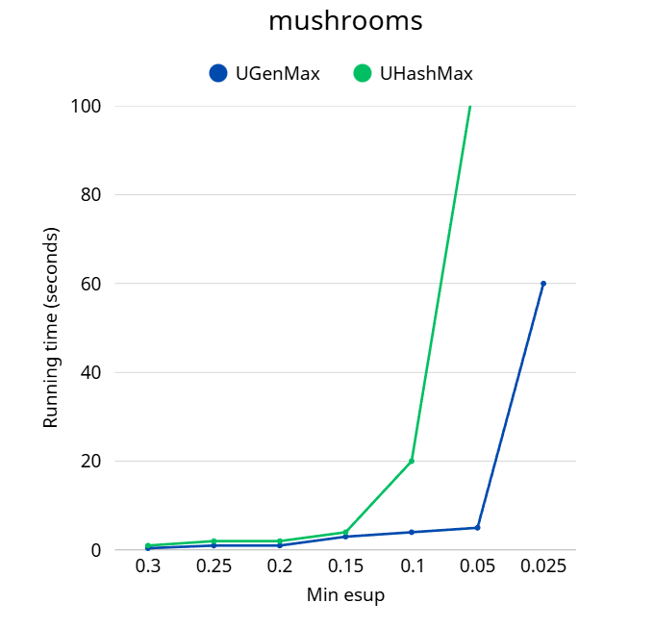
Figure 5.3.1 :Compare on mushrooms-dataset

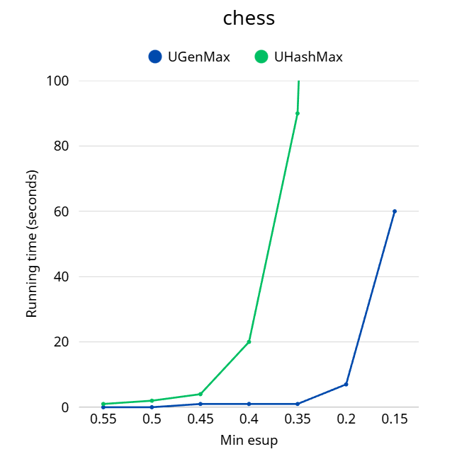
Figure 5.3.2 : Compare on chess-dataset
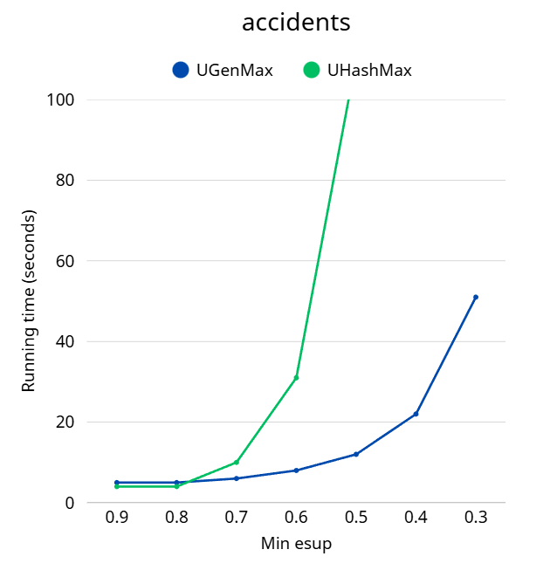
Figure 5.3.3 : Compare on accidents-dataset
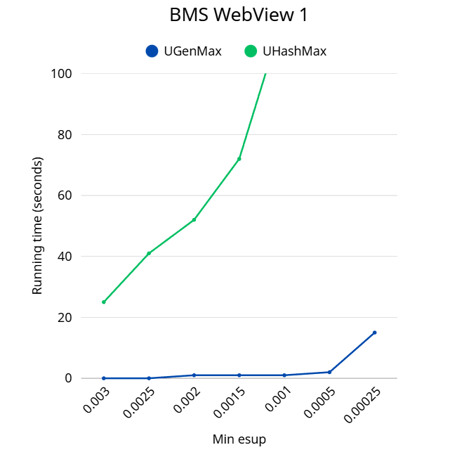
Figure 5.3.4 : Compare on BMS WebView1-dataset
5.4 Evaluation
The experimental results show that UGenMax consistently outperforms UHashMax across all tested datasets and settings. Although this result differs from theoretical expectations, it is likely due to the current implementation of UHashMax, which may not be fully optimized for the uncertain setting. Factors such as data structure management, hashing efficiency, and memory overhead could have contributed to its relatively lower performance. Despite this performance gap, both algorithms are capable of processing meaningful $min_esup$ thresholds with acceptable running time, providing valuable insights for uncertain data mining applications.
More importantly, these results clearly highlight the superior performance of UGenMax, demonstrating not only its efficiency in terms of runtime but also its robustness and scalability when handling uncertain datasets. Overall, UGenMax proves to be a highly effective solution for mining maximal frequent itemsets in uncertain databases in practical, real-world scenarios.

CHAPTER 6: CONCLUSION

In this report, we have presented a comprehensive study of mining frequent itemsets from uncertain databases, with a specific focus on maximal frequent itemsets (MFI). Our research addresses the challenges associated with the uncertainty in the data, which often involves factors such as incomplete information, unreliable measurements, or varying frequencies of itemsets. We proposed novel algorithms and techniques to handle these uncertainties and calculate the expected support of itemsets, an essential modification when working with uncertain data.

The main contribution of this work is the introduction of a new methodology for mining maximal frequent itemsets from uncertain databases, which has not been extensively studied in prior research. By utilizing probabilistic models and techniques for expected support, our approach ensures that the uncertainty inherent in the data does not overly affect the mining process, while still producing reliable and useful itemsets.

In comparison to traditional methods like Apriori and FP-growth, our approach is specifically designed to handle the complexity introduced by uncertain data. We also introduced extensions of Apriori and FP-growth, such as UB-Apriori and UF-growth, that integrate expected support calculations for uncertain datasets, significantly improving their efficiency and accuracy.

Despite the advancements made, several challenges remain in the field. These include handling large-scale uncertain databases efficiently, improving algorithmic scalability, and developing clearer evaluation criteria for the quality of mined itemsets. Future work could focus on further optimizing these methods, scaling them to larger datasets, and refining the evaluation process to ensure that the mined itemsets are both reliable and practical for real-world applications.

In conclusion, this work lays the groundwork for future studies in the area of mining maximal frequent itemsets from uncertain databases. We believe that this research has the potential to contribute significantly to the development of more effective data mining techniques, especially in industries that rely on uncertain or imprecise data.

REFERENCES
T. Bernecker, H.-P. Kriegel, M. Renz, F. Verhein, and A. Züfle, “Probabilistic frequent itemset mining in uncertain databases,” in Proc. 15th ACM SIGKDD Int. Conf. on Knowledge Discovery and Data Mining (KDD ’09), 2009, pp. 119–128, doi: 10.1145/1557019.1557039.
V Vanetik N. and Gudes E., “HashMax: A New Method for Mining Maximal Frequent Itemsets,” in Proceedings of the International Conference on Knowledge Discovery and Information Retrieval (KDIR-2011), 2011, pp. 132–137, doi: 10.5220/0003628101320137.
Gouda, K., Zaki, M.J. GenMax: An Efficient Algorithm for Mining Maximal Frequent Itemsets. Data Min Knowl Disc 11, 223–242 (2005). https://doi.org/10.1007/s10618-005-0002-x
Tong, Y., Chen, L., Yu, P. S., & Lu, J. (2008). Mining Frequent Itemsets from Uncertain Data. In Proceedings of the 24th International Conference on Data Engineering Cancun, Mexico. https://doi.org/10.48550/arXiv.1208.0292
Đoàn Văn Thắng. (2010). Truy vấn dữ liệu với thông tin mờ và không chắc chắn trong cơ sở dữ liệu hướng đối tượng [Query data with fuzzy information and uncertainties in object-oriented databases]. Tạp chí Khoa học và Công nghệ – Đại học Đà Nẵng, Số 4(39).
http://thuvien.due.udn.vn:8080/dspace/bitstream/TVDHKT/11600/2/12.PDF

