SPARQL QUERIES in STARDOG 5.2.1

1. List the tobacco users who are CC patients.

select ?cc_diag ?patient ?tu_role

where

{{?cc_diag a icd9cm:MM_CLASS_7355.}union{?cc_diag a icd9cm:MM_CLASS_6577.}union{?cc_diag a icd9cm:MM_CLASS_6581.}union{?cc_diag a icd9cm:MM_CLASS_6578.}union{?cc_diag a icd9cm:MM_CLASS_6579.}union{?cc_diag a icd9cm:MM_CLASS_6580.}

{?tu_role a ocr:OCRSEV_00000545.

?tu_role obo:RO_0000052 ?patient.

?cc_diag obo:IAO_0000136 ?patient.

?patient a obo:NCBITaxon_9606.}}

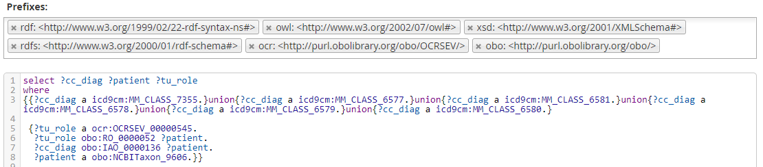

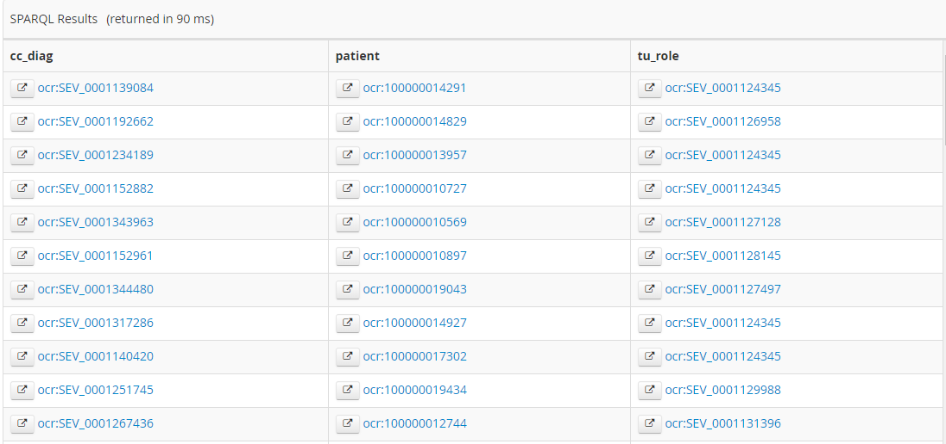

SQL validation:

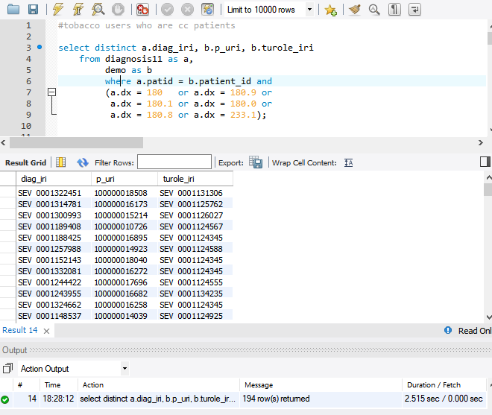

2. List the CC patients who have HIV:

select ?cc_diag ?patient ?hiv_diag

where

{{{?cc_diag a icd9cm:MM_CLASS_7355.}union{?cc_diag a icd9cm:MM_CLASS_6577.}union{?cc_diag a icd9cm:MM_CLASS_6581.}union{?cc_diag a icd9cm:MM_CLASS_6578.}union{?cc_diag a icd9cm:MM_CLASS_6579.}union{?cc_diag a icd9cm:MM_CLASS_6580.}}

{?hiv_diag a icd9cm:MM_CLASS_5563.

?hiv_diag obo:IAO_0000136 ?patient.

?cc_diag obo:IAO_0000136 ?patient.

?patient a obo:NCBITaxon_9606.}}

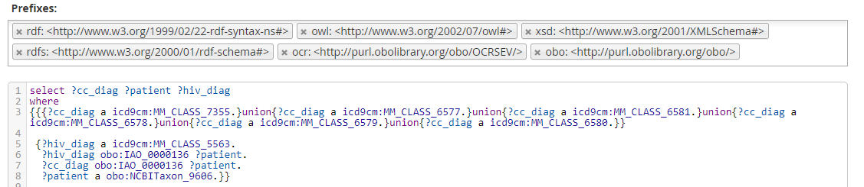

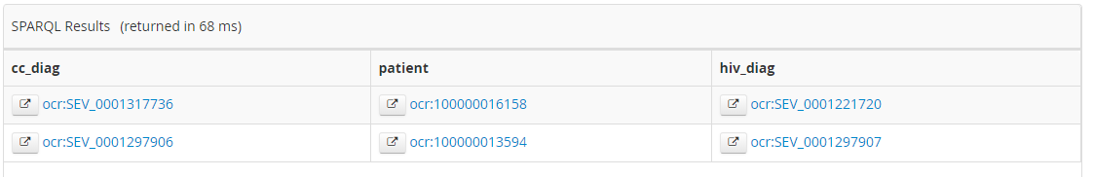

SQL Validation

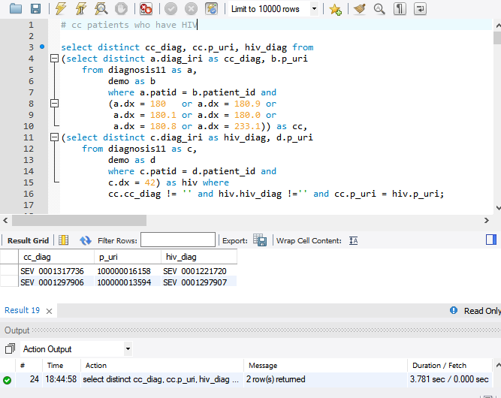

3. Calculate the age of all CC patients.

select (?pat as ?patient)

((xsd:integer(strafter(strafter(?diag_date, '/'), '/')))-(xsd:integer(strafter(strafter(?pat_date, '/'), '/'))) as ?age)

where

{

{{?cc_diag a icd9cm:MM_CLASS_7355.}union{?cc_diag a icd9cm:MM_CLASS_6577.}union{?cc_diag a icd9cm:MM_CLASS_6581.}union{?cc_diag a icd9cm:MM_CLASS_6578.}union{?cc_diag a icd9cm:MM_CLASS_6579.}union{?cc_diag a icd9cm:MM_CLASS_6580.}}

{?cc_diag obo:OBI_0000312 ?process.

?process obo:BFO_0000155 ?interval.

?interval obo:RO_0002091 ?date_iri.

?date_iri rdfs:label ?diag_date.}

{?pat a obo:NCBITaxon_9606.

?cc_diag obo:IAO_0000136 ?pat.

?pat obo:RO_0000056 ?neo.

?neo obo:BFO_0000155 ?tr2.}

optional{?birth a obo:UBERON_0035946.

?birth obo:BFO_0000139 ?neo.

?birth obo:BFO_0000155 ?tr1.

{?tr1 obo:BFO_0000139 ?tr2.

?tr1 obo:BFO_0000139 ?tr3.

?tr3 rdfs:label ?pat_date.}

}

}

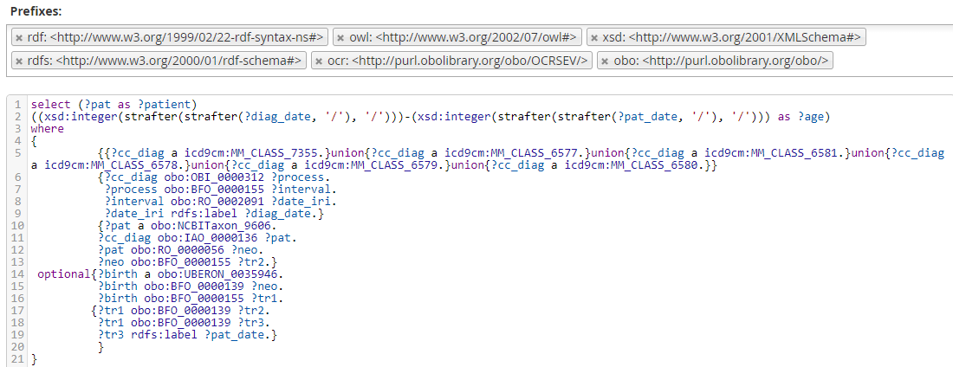

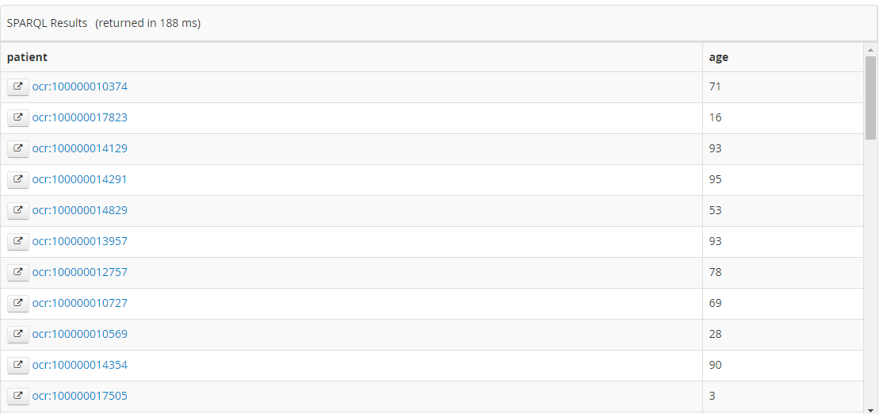

SQL Validation:

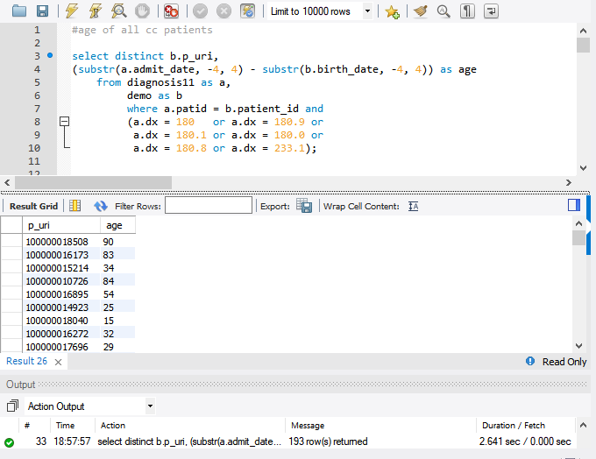

4. List the smoking prevalence within MMSAs along with the number of CC patients within each MMSA.

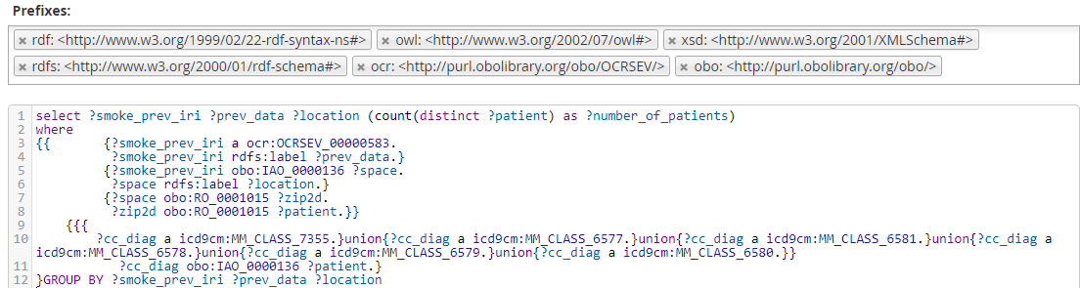

select ?smoke_prev_iri ?prev_data ?location (count(distinct ?patient) as ?number_of_patients)

where

{{ {?smoke_prev_iri a ocr:OCRSEV_00000583.

?smoke_prev_iri rdfs:label ?prev_data.}

{?smoke_prev_iri obo:IAO_0000136 ?space.

?space rdfs:label ?location.}

{?space obo:RO_0001015 ?zip2d.

?zip2d obo:RO_0001015 ?patient.}}

{{{

?cc_diag a icd9cm:MM_CLASS_7355.}union{?cc_diag a icd9cm:MM_CLASS_6577.}union{?cc_diag a icd9cm:MM_CLASS_6581.}union{?cc_diag a icd9cm:MM_CLASS_6578.}union{?cc_diag a icd9cm:MM_CLASS_6579.}union{?cc_diag a icd9cm:MM_CLASS_6580.}}

?cc_diag obo:IAO_0000136 ?patient.}

}GROUP BY ?smoke_prev_iri ?prev_data ?location

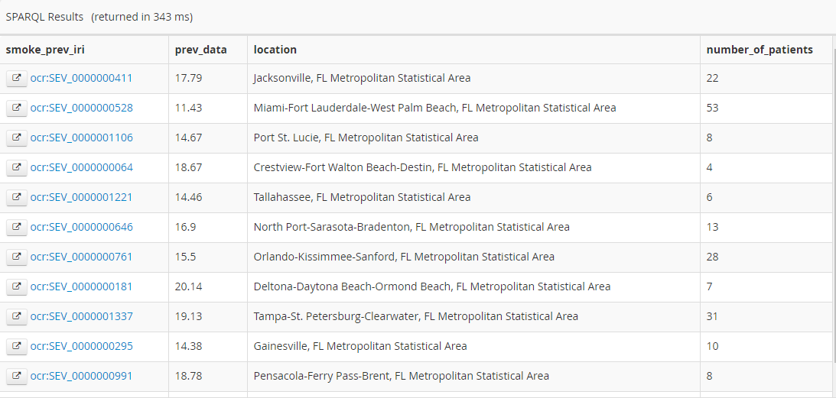

5. List the drinking prevalence within MMSAs and the number of CC patients in each MMSA.

select ?drink_prev_iri ?prev_data ?location (count(distinct ?patient) as ?number_of_patients)

where

{

{{?drink_prev_iri a ocr:OCRSEV_00000601.

?drink_prev_iri rdfs:label ?prev_data.}

{?drink_prev_iri obo:IAO_0000136 ?space.

?space rdfs:label ?location.}

{?space obo:RO_0001015 ?zip2d.

?zip2d obo:RO_0001015 ?patient.}}

{{{

?cc_diag a icd9cm:MM_CLASS_7355.}union{?cc_diag a icd9cm:MM_CLASS_6577.}union{?cc_diag a icd9cm:MM_CLASS_6581.}union{?cc_diag a icd9cm:MM_CLASS_6578.}union{?cc_diag a icd9cm:MM_CLASS_6579.}union{?cc_diag a icd9cm:MM_CLASS_6580.}}

?cc_diag obo:IAO_0000136 ?patient.}

}GROUP BY ?drink_prev_iri ?prev_data ?location

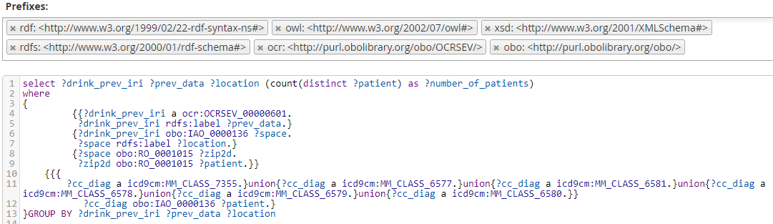

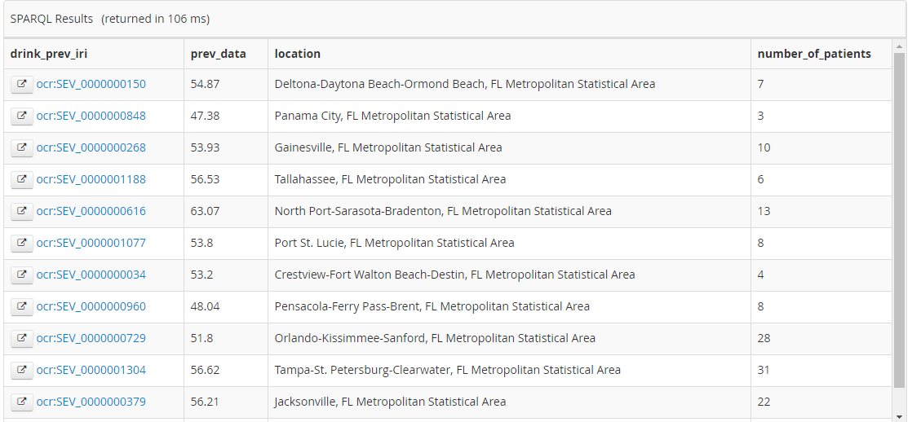

6. List the number of CC patients and the number of hospitals within a 3-digit zip.

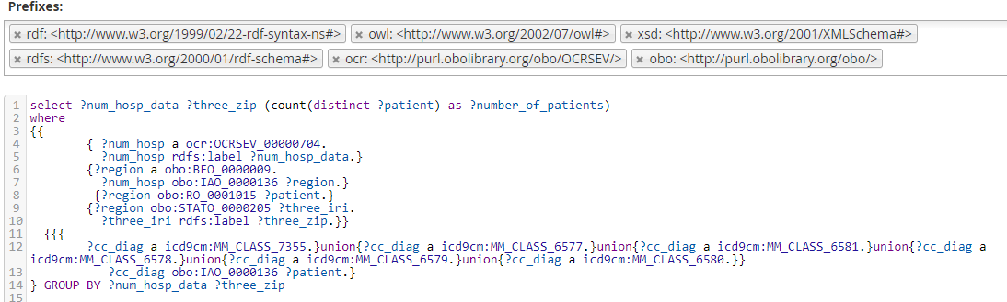

select ?num_hosp_data ?three_zip (count(distinct ?patient) as ?number_of_patients)

where

{{

{ ?num_hosp a ocr:OCRSEV_00000704.

?num_hosp rdfs:label ?num_hosp_data.}

{?region a obo:BFO_0000009.

?num_hosp obo:IAO_0000136 ?region.}

{?region obo:RO_0001015 ?patient.}

{?region obo:STATO_0000205 ?three_iri.

?three_iri rdfs:label ?three_zip.}}

{{{

?cc_diag a icd9cm:MM_CLASS_7355.}union{?cc_diag a icd9cm:MM_CLASS_6577.}union{?cc_diag a icd9cm:MM_CLASS_6581.}union{?cc_diag a icd9cm:MM_CLASS_6578.}union{?cc_diag a icd9cm:MM_CLASS_6579.}union{?cc_diag a icd9cm:MM_CLASS_6580.}}

?cc_diag obo:IAO_0000136 ?patient.}

} GROUP BY ?num_hosp_data ?three_zip

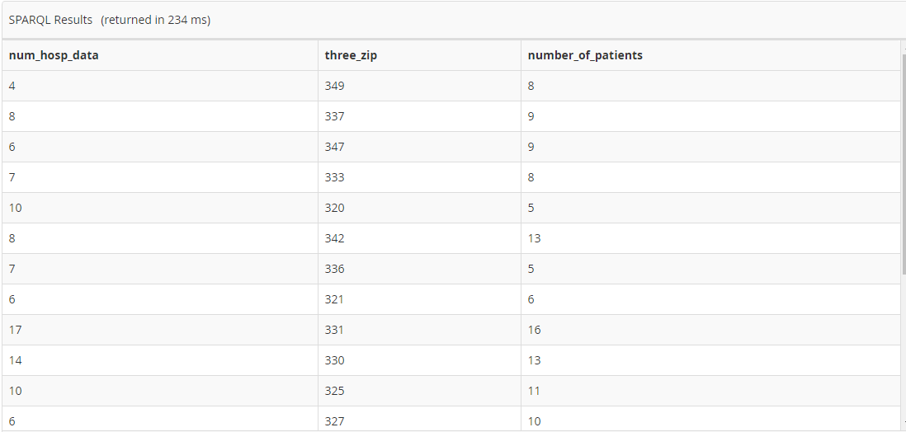

SQL Validation:

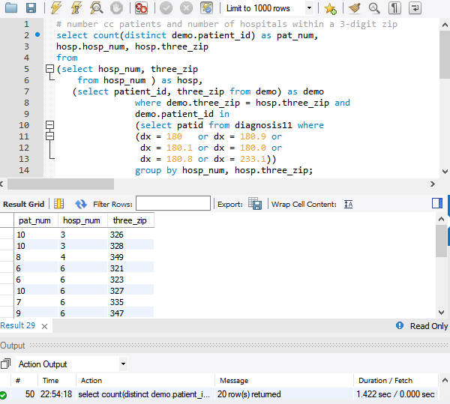

7. List the number of CC patients and number of physicians within a 3-digit zip.

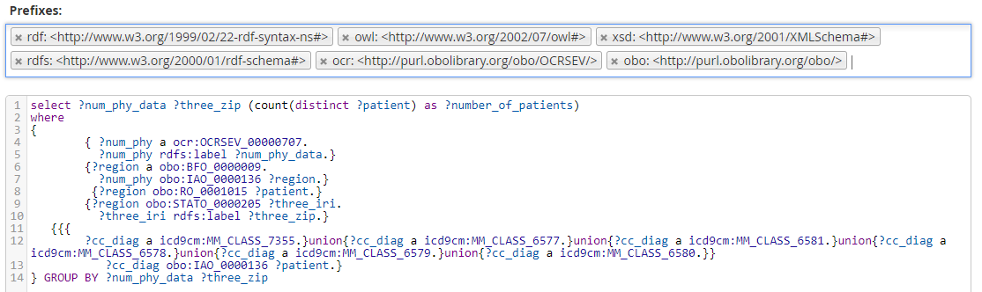

select ?num_phy_data ?three_zip (count(distinct ?patient) as ?number_of_patients)

where

{

{ ?num_phy a ocr:OCRSEV_00000707.

?num_phy rdfs:label ?num_phy_data.}

{?region a obo:BFO_0000009.

?num_phy obo:IAO_0000136 ?region.}

{?region obo:RO_0001015 ?patient.}

{?region obo:STATO_0000205 ?three_iri.

?three_iri rdfs:label ?three_zip.}

{{{

?cc_diag a icd9cm:MM_CLASS_7355.}union{?cc_diag a icd9cm:MM_CLASS_6577.}union{?cc_diag a icd9cm:MM_CLASS_6581.}union{?cc_diag a icd9cm:MM_CLASS_6578.}union{?cc_diag a icd9cm:MM_CLASS_6579.}union{?cc_diag a icd9cm:MM_CLASS_6580.}}

?cc_diag obo:IAO_0000136 ?patient.}

} GROUP BY ?num_phy_data ?three_zip

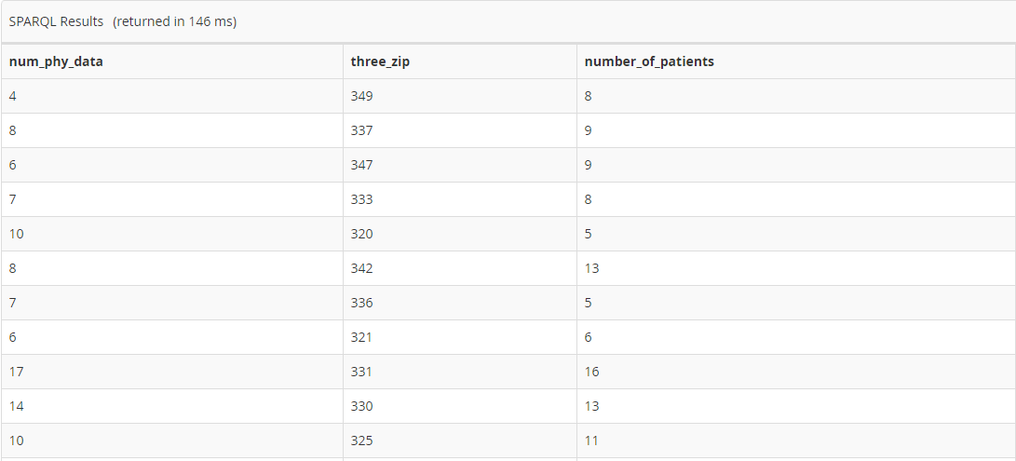

8. List the number of cc patients per hospital along with hospital’s MSPB score which is < 1 (national median)

select distinct ?ccn ?mspb_score (count(distinct ?patient) as ?pat_num)

where

{{{?hosp a obo:OMRSE_00000102.

?hosp obo:STATO_0000205 ?ccn_iri.

?hosp obo:OMRSE_00000068 ?orgn_iri.

?ccn_iri rdfs:label ?ccn.

?mspb a ocr:OCRSEV_00000740.

?mspb obo:IAO_0000136 ?orgn_iri.

?mspb rdfs:label ?mspb_score.

{?gyn_iri a obo:NCBITaxon_9606.

?orgn_iri obo:RO_0002351 ?gyn_iri.}

{?hce_iri a obo:OGMS_0000097.}

{?gyn_iri obo:BFO_0000056 ?hce_iri.}

{?orgn_iri obo:BFO_0000056 ?hce_iri.}

{?hce_iri obo:BFO_0000057 ?patient.}}

FILTER EXISTS{{{

?cc_diag a icd9cm:MM_CLASS_7355.}union{?cc_diag a icd9cm:MM_CLASS_6577.}union{?cc_diag a icd9cm:MM_CLASS_6581.}union{?cc_diag a icd9cm:MM_CLASS_6578.}union{?cc_diag a icd9cm:MM_CLASS_6579.}union{?cc_diag a icd9cm:MM_CLASS_6580.}}

?cc_diag obo:IAO_0000136 ?patient.}}

FILTER((xsd:float(?mspb_score)) < 1)

}GROUP BY ?ccn ?mspb_score

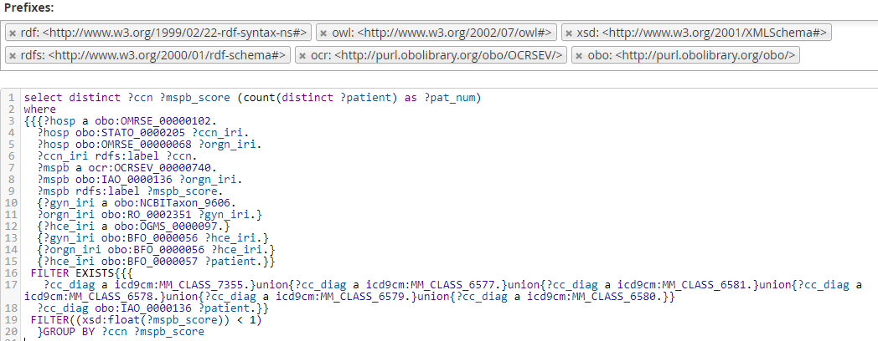

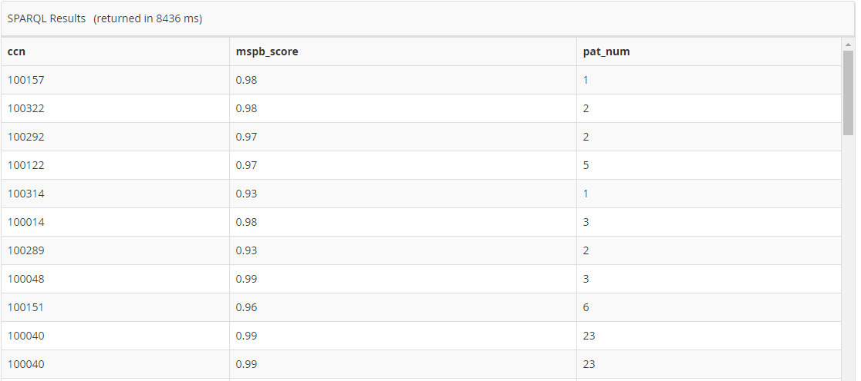

9. What is the experience of every physician in years and how many CC patients has each physician encountered?

select ?npi ?grad_year ((2016-(xsd:integer(?grad_year))) as ?exp_years) (count(distinct ?patient) as ?pat_num)

where{

{{?hosp a obo:OMRSE_00000102.

?hosp obo:OMRSE_00000068 ?orgn_iri.

?orgn_iri obo:RO_0002351 ?gyn_iri.}

{?gyn_iri a obo:NCBITaxon_9606.}

{?gyn_iri obo:BFO_0000056 ?resi_iri.}

{?gyn_iri obo:STATO_0000205 ?npi_iri.}

{?npi_iri rdfs:label ?npi.}

{?resi_iri obo:RO_0002093 ?year_iri.

?year_iri rdfs:label ?grad_year. }

{?orgn_iri obo:RO_0002351 ?gyn_iri.}

{?hce_iri a obo:OGMS_0000097.}

{?gyn_iri obo:BFO_0000056 ?hce_iri.}

{?orgn_iri obo:BFO_0000056 ?hce_iri.}

{?hce_iri obo:BFO_0000057 ?patient.}}

FILTER EXISTS{{{

?cc_diag a icd9cm:MM_CLASS_7355.}union{?cc_diag a icd9cm:MM_CLASS_6577.}union{?cc_diag a icd9cm:MM_CLASS_6581.}union{?cc_diag a icd9cm:MM_CLASS_6578.}union{?cc_diag a icd9cm:MM_CLASS_6579.}union{?cc_diag a icd9cm:MM_CLASS_6580.}}

?cc_diag obo:IAO_0000136 ?patient.}

} GROUP BY ?npi ?grad_year

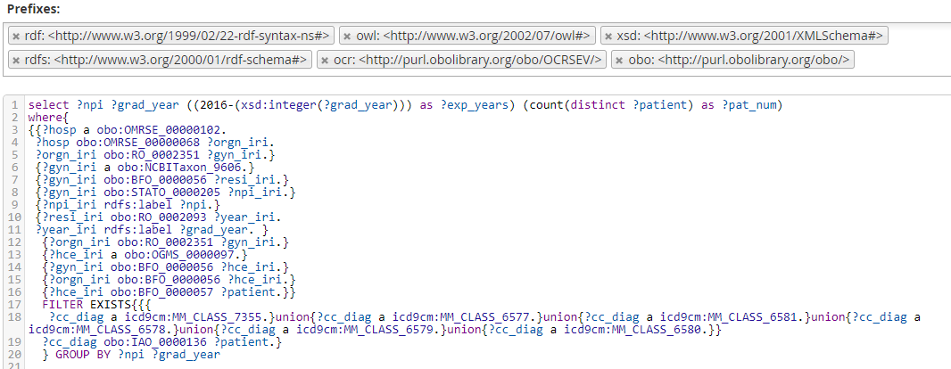

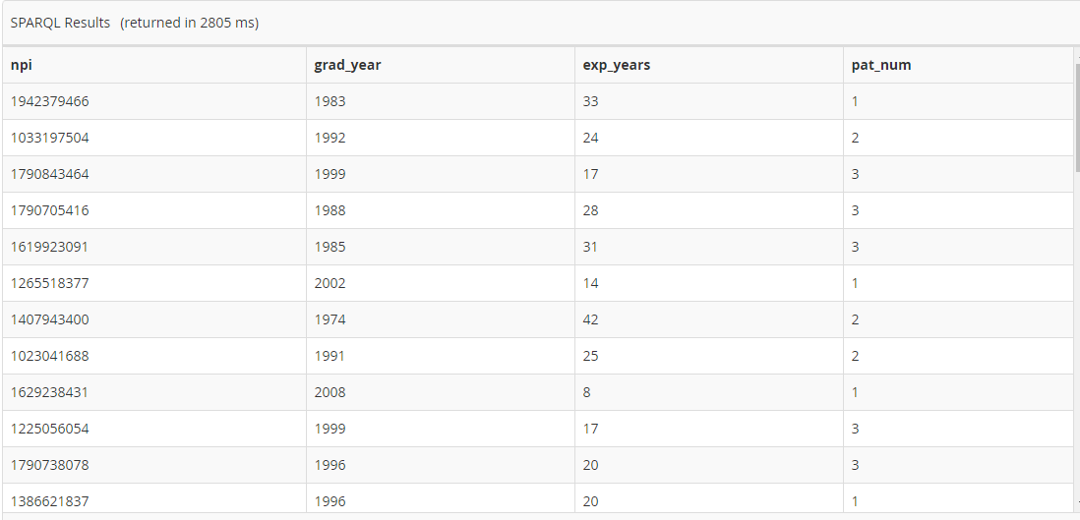

10. List the number of CC physicians per CC patient.

select distinct ?patient (count(distinct ?gyn_iri) as ?gyn_num)

where

{

{{?hosp a obo:OMRSE_00000102.

?hosp obo:OMRSE_00000068 ?orgn_iri.

?orgn_iri obo:RO_0002351 ?gyn_iri.}

{?gyn_iri a obo:NCBITaxon_9606.}

{?gyn_iri obo:BFO_0000056 ?resi_iri.}

{?gyn_iri obo:STATO_0000205 ?npi_iri.}

{?npi_iri rdfs:label ?npi.}

{?resi_iri obo:RO_0002093 ?year_iri.

?year_iri rdfs:label ?grad_year. }

{?orgn_iri obo:RO_0002351 ?gyn_iri.}

{?hce_iri a obo:OGMS_0000097.}

{?gyn_iri obo:BFO_0000056 ?hce_iri.}

{?orgn_iri obo:BFO_0000056 ?hce_iri.}

{?hce_iri obo:BFO_0000057 ?patient.}}

FILTER EXISTS{{{

?cc_diag a icd9cm:MM_CLASS_7355.}union{?cc_diag a icd9cm:MM_CLASS_6577.}union{?cc_diag a icd9cm:MM_CLASS_6581.}union{?cc_diag a icd9cm:MM_CLASS_6578.}union{?cc_diag a icd9cm:MM_CLASS_6579.}union{?cc_diag a icd9cm:MM_CLASS_6580.}}

?cc_diag obo:IAO_0000136 ?patient.}

} GROUP BY ?patient

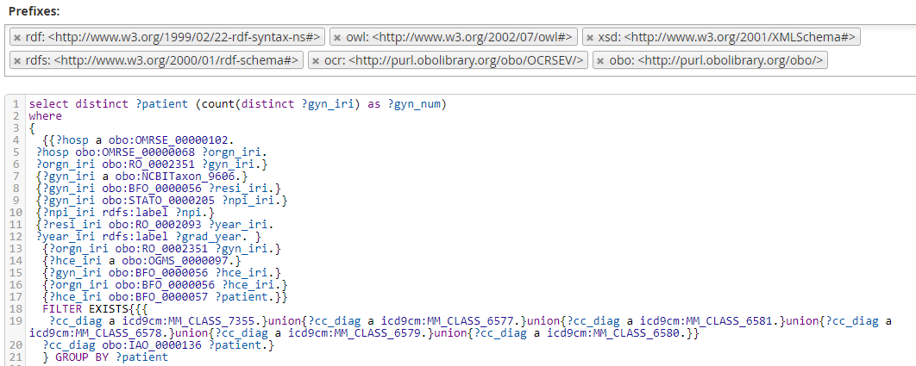

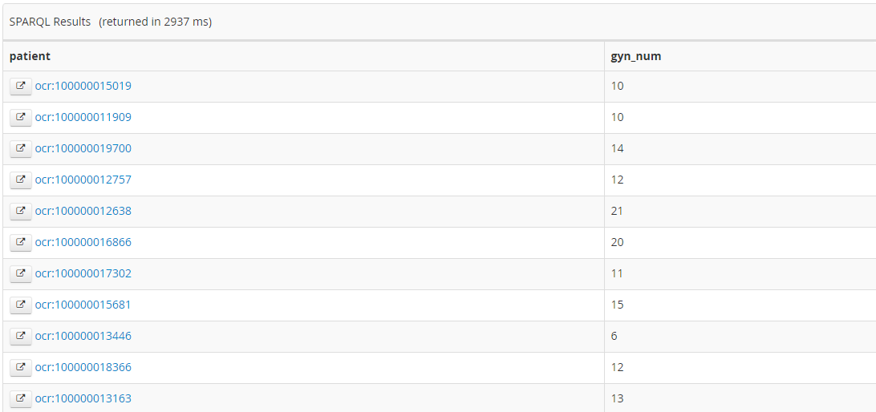

11. List the number of CC patients and average experience of physician per hospital.

select distinct ?ccn (FLOOR(AVG(2016-(xsd:integer(?grad_year)))) as ?avg_exp_years) (count(distinct ?patient) as ?pat_num)

where

{

{{?hosp a obo:OMRSE_00000102.

?hosp obo:STATO_0000205 ?ccn_iri.

?hosp obo:OMRSE_00000068 ?orgn_iri.

?ccn_iri rdfs:label ?ccn.

?orgn_iri obo:RO_0002351 ?gyn_iri.}

{select distinct ?gyn_iri ?npi ?grad_year ?patient where{

{?gyn_iri a obo:NCBITaxon_9606.}

{?gyn_iri obo:BFO_0000056 ?resi_iri.}

{?gyn_iri obo:STATO_0000205 ?npi_iri.}

{?npi_iri rdfs:label ?npi.}

{?resi_iri obo:RO_0002093 ?year_iri.

?year_iri rdfs:label ?grad_year. }

{?orgn_iri obo:RO_0002351 ?gyn_iri.}

{?hce_iri a obo:OGMS_0000097.}

{?gyn_iri obo:BFO_0000056 ?hce_iri.}

{?orgn_iri obo:BFO_0000056 ?hce_iri.}

{?hce_iri obo:BFO_0000057 ?patient.}}}}

{FILTER EXISTS{{{

?cc_diag a icd9cm:MM_CLASS_7355.}union{?cc_diag a icd9cm:MM_CLASS_6577.}union{?cc_diag a icd9cm:MM_CLASS_6581.}union{?cc_diag a icd9cm:MM_CLASS_6578.}union{?cc_diag a icd9cm:MM_CLASS_6579.}union{?cc_diag a icd9cm:MM_CLASS_6580.}}

?cc_diag obo:IAO_0000136 ?patient.}}

} GROUP BY ?ccn

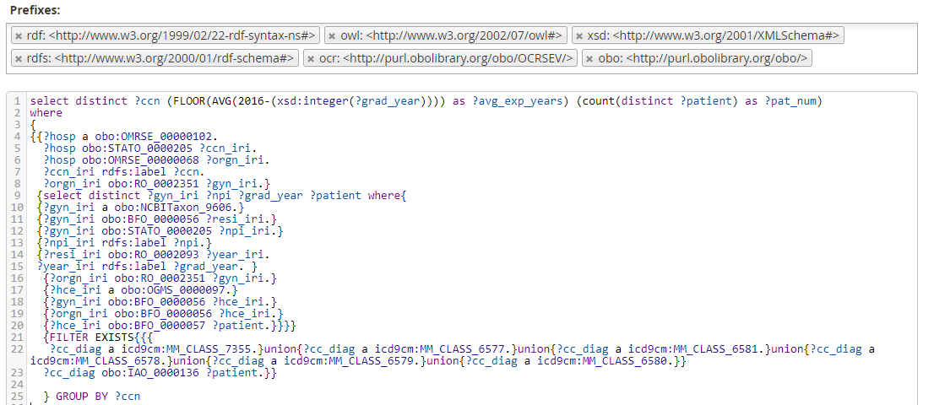

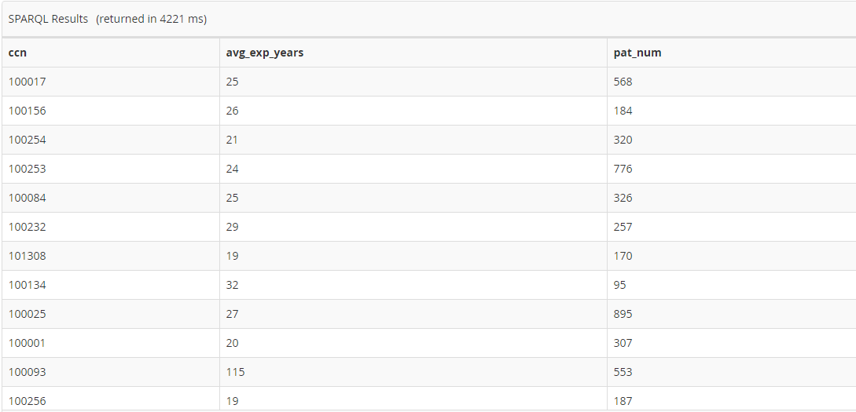

12. List the maximum recorded systolic and diastolic per CC patient.

select distinct ?patient (max(xsd:integer(strbefore(?bp, '/'))) as ?max_systolic)

(max(xsd:integer(strafter(?bp, '/'))) as ?max_diastolic)

where

{

{?bpmd a obo:VSO_0000005.

?bpmd rdfs:label ?bp.

?bpmd obo:IAO_0000136 ?bp_iri.

?bp_iri obo:RO_0000052 ?patient.

}

{{{

?cc_diag a icd9cm:MM_CLASS_7355.}union{?cc_diag a icd9cm:MM_CLASS_6577.}union{?cc_diag a icd9cm:MM_CLASS_6581.}union{?cc_diag a icd9cm:MM_CLASS_6578.}union{?cc_diag a icd9cm:MM_CLASS_6579.}union{?cc_diag a icd9cm:MM_CLASS_6580.}}

?cc_diag obo:IAO_0000136 ?patient.}

FILTER(((xsd:integer(strbefore(?bp, '/'))) > 120)||((xsd:integer(strafter(?bp, '/'))) > 80))

} GROUP BY ?patient

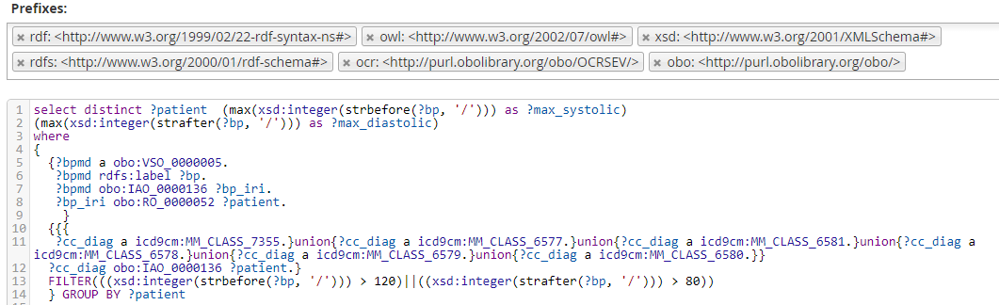

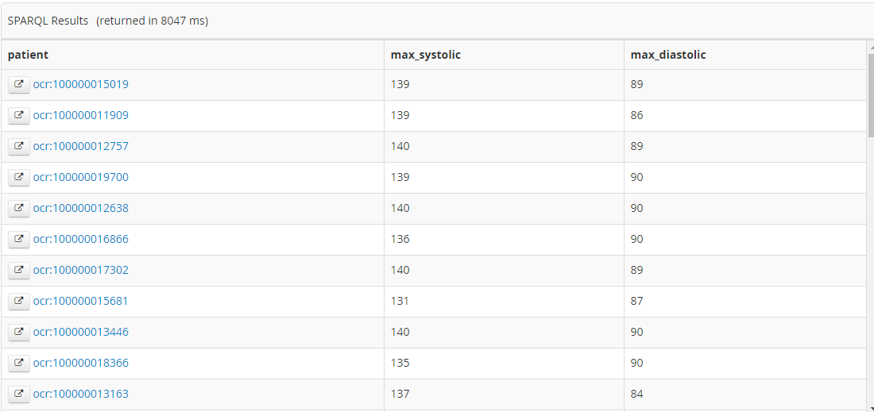

13. List the CC patient who have elevated blood pressure (between 120/80 and 130/80).

select distinct ?patient ?bp

where

{

{?bpmd a obo:VSO_0000005.

?bpmd rdfs:label ?bp.

?bpmd obo:IAO_0000136 ?bp_iri.

?bp_iri obo:RO_0000052 ?patient.

}

{{{

?cc_diag a icd9cm:MM_CLASS_5861.}union{?cc_diag a icd9cm:MM_CLASS_5563.}union{?cc_diag a icd9cm:MM_CLASS_7355.}union{?cc_diag a icd9cm:MM_CLASS_6577.}union{?cc_diag a icd9cm:MM_CLASS_6581.}union{?cc_diag a icd9cm:MM_CLASS_6578.}union{?cc_diag a icd9cm:MM_CLASS_6579.}union{?cc_diag a icd9cm:MM_CLASS_6580.}}

?cc_diag obo:IAO_0000136 ?patient.}

FILTER(((xsd:integer(strbefore(?bp, '/'))) > 120)&&((xsd:integer(strbefore(?bp, '/'))) < 130)&&((xsd:integer(strafter(?bp, '/'))) < 80))

}

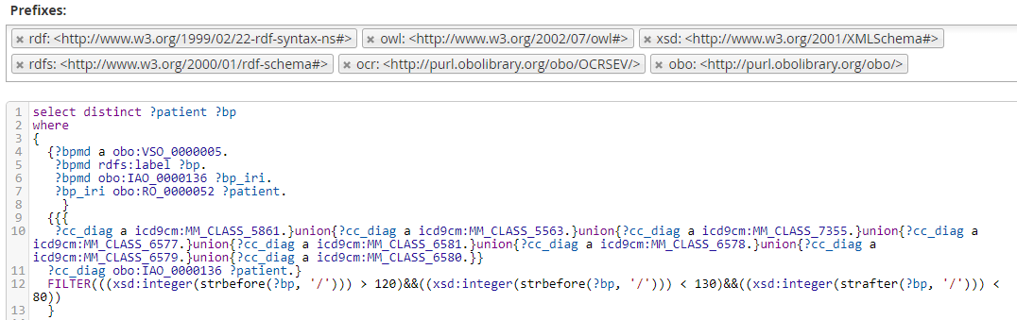

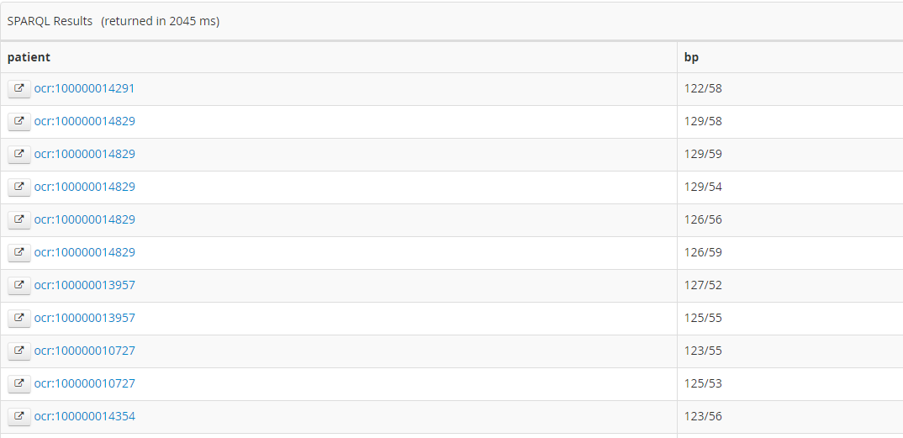

14. Count the number of CC patients who have high blood pressure (> 130/80).

select (count(distinct ?patient) as ?pat_num)

where

{

{?bpmd a obo:VSO_0000005.

?bpmd rdfs:label ?bp.

?bpmd obo:IAO_0000136 ?bp_iri.

?bp_iri obo:RO_0000052 ?patient.

}

{{{ ?cc_diag a icd9cm:MM_CLASS_7355.}union{?cc_diag a icd9cm:MM_CLASS_6577.}union{?cc_diag a icd9cm:MM_CLASS_6581.}union{?cc_diag a icd9cm:MM_CLASS_6578.}union{?cc_diag a icd9cm:MM_CLASS_6579.}union{?cc_diag a icd9cm:MM_CLASS_6580.}}

?cc_diag obo:IAO_0000136 ?patient.}

FILTER(((xsd:integer(strbefore(?bp, '/'))) > 129)||((xsd:integer(strafter(?bp, '/'))) > 79))

}

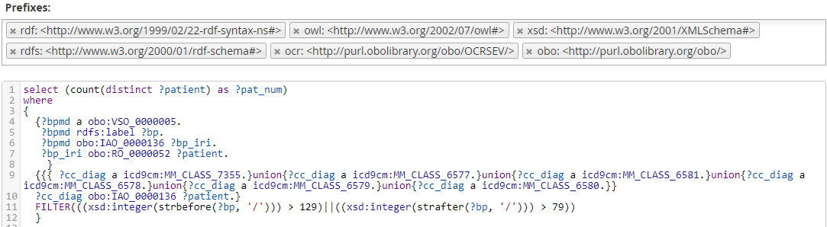

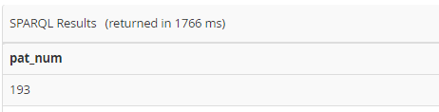

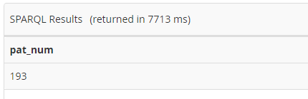

SQL Validation

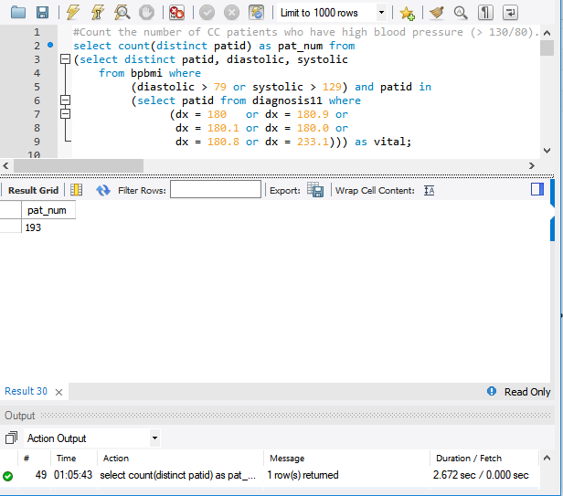

15. Count the number of CC patients who are underweight.

select (count(distinct ?patient) as ?pat_num)

where

{

{?bmi_iri a obo:CMO_0000105.

?bmi_iri rdfs:label ?bmi.

?bmi_iri obo:IAO_0000136 ?bm_iri.

?bm_iri obo:RO_0000052 ?patient.

}

{{{

?cc_diag a icd9cm:MM_CLASS_7355.}union{?cc_diag a icd9cm:MM_CLASS_6577.}union{?cc_diag a icd9cm:MM_CLASS_6581.}union{?cc_diag a icd9cm:MM_CLASS_6578.}union{?cc_diag a icd9cm:MM_CLASS_6579.}union{?cc_diag a icd9cm:MM_CLASS_6580.}}

?cc_diag obo:IAO_0000136 ?patient.}

FILTER((xsd:float(?bmi)) < 18.5)

}

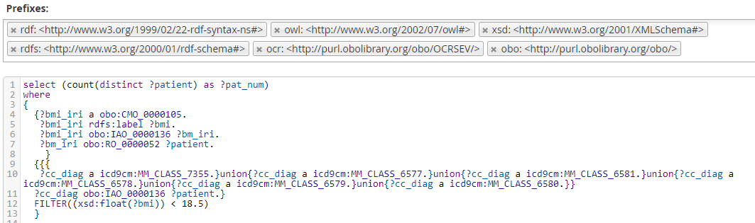

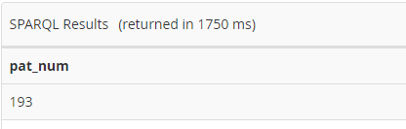

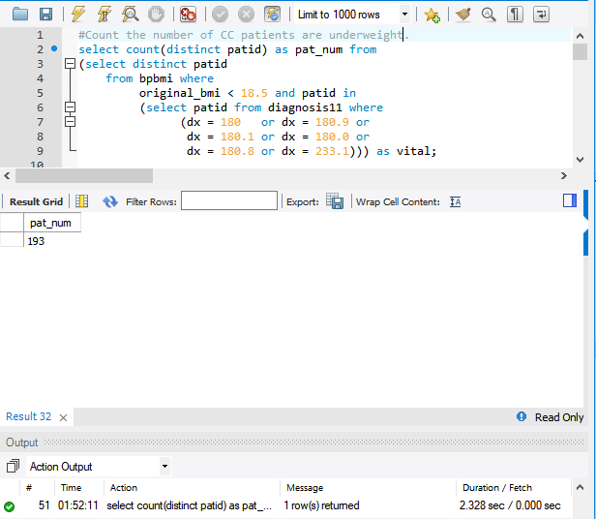

16. List the CC patients with their minimum and maximum recorded BMI.

select ?patient (max(xsd:float(?bmi)) as ?max_bmi) (min(xsd:float(?bmi)) as ?min_bmi)

where

{

{?bmi_iri a obo:CMO_0000105.

?bmi_iri rdfs:label ?bmi.

?bmi_iri obo:IAO_0000136 ?bm_iri.

?bm_iri obo:RO_0000052 ?patient.

}

{{{

?cc_diag a icd9cm:MM_CLASS_7355.}union{?cc_diag a icd9cm:MM_CLASS_6577.}union{?cc_diag a icd9cm:MM_CLASS_6581.}union{?cc_diag a icd9cm:MM_CLASS_6578.}union{?cc_diag a icd9cm:MM_CLASS_6579.}union{?cc_diag a icd9cm:MM_CLASS_6580.}}

?cc_diag obo:IAO_0000136 ?patient.}

} GROUP BY ?patient

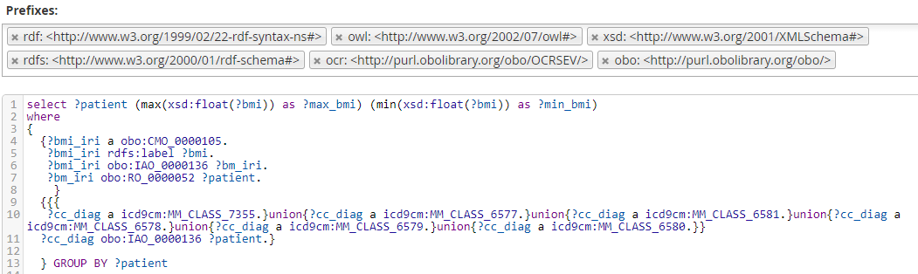

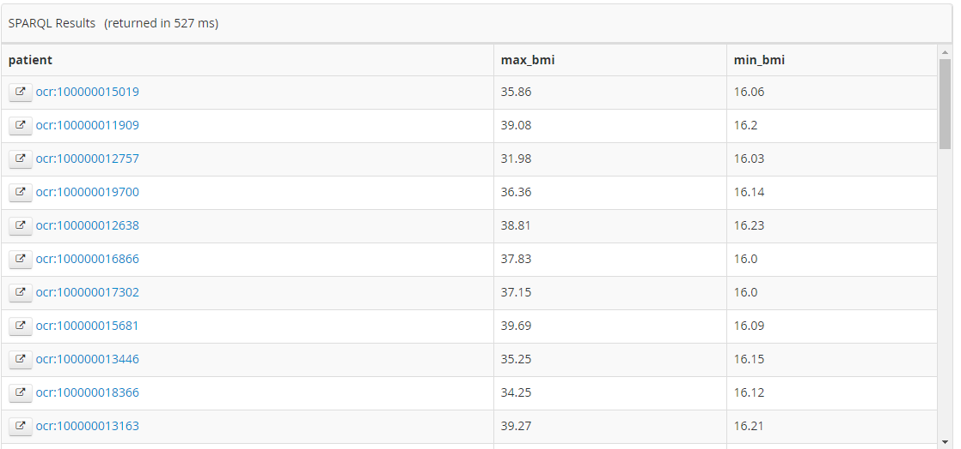

17. List the CC patients with abnormal BMI and high blood pressure along with BMI and BP taken during different encounters.

select distinct ?patient ?bmi ?bp

where

{

{?bmi_iri a obo:CMO_0000105.

?bmi_iri rdfs:label ?bmi.

?bmi_iri obo:IAO_0000136 ?bm_iri.

?bm_iri obo:RO_0000052 ?patient.

}

{?bpmd a obo:VSO_0000005.

?bpmd rdfs:label ?bp.

?bpmd obo:IAO_0000136 ?bp_iri.

?bp_iri obo:RO_0000052 ?patient.

}

{{{

?cc_diag a icd9cm:MM_CLASS_5861.}union{?cc_diag a icd9cm:MM_CLASS_5563.}union{?cc_diag a icd9cm:MM_CLASS_7355.}union{?cc_diag a icd9cm:MM_CLASS_6577.}union{?cc_diag a icd9cm:MM_CLASS_6581.}union{?cc_diag a icd9cm:MM_CLASS_6578.}union{?cc_diag a icd9cm:MM_CLASS_6579.}union{?cc_diag a icd9cm:MM_CLASS_6580.}}

?cc_diag obo:IAO_0000136 ?patient.}

FILTER(((xsd:float(?bmi)) > 24.9) || ((xsd:float(?bmi)) < 18.5))

FILTER(((xsd:integer(strbefore(?bp, '/'))) > 129)||((xsd:integer(strafter(?bp, '/'))) > 79))

}

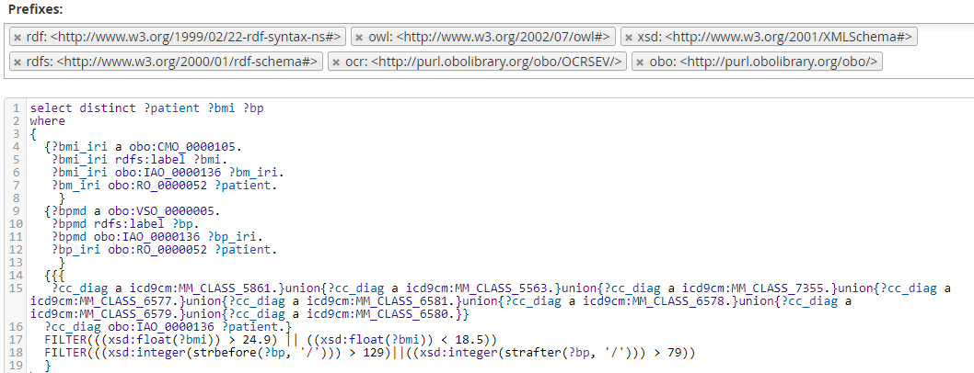

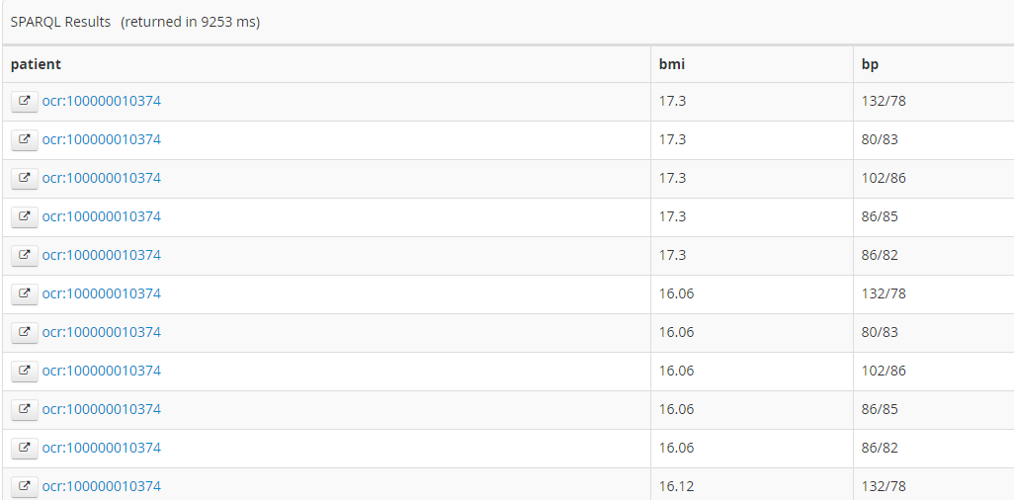

18. How many people got diagnosed with CC after the effective date of BCCPTA? List both the policies with their effective dates and the number of people who got diagnosed with CC after the effective dates.

select ?act ?policy_date (count(distinct ?patient) as ?num_pat)

where{

{

{

{ ?date_iri a obo:IAO_0000314.

?date_iri obo:BFO_0000050 ?doc_iri.

?date_iri obo:IAO_0000136 ?temp_iri.}

{?doc_iri obo:OBI_0000295 ?act_iri.

?act_iri rdfs:label ?act.}

{?temp_iri rdfs:label ?policy_date.}}

{{{ ?cc_diag a icd9cm:MM_CLASS_7355.}union{?cc_diag a icd9cm:MM_CLASS_6577.}union{?cc_diag a icd9cm:MM_CLASS_6581.}union{?cc_diag a icd9cm:MM_CLASS_6578.}union{?cc_diag a icd9cm:MM_CLASS_6579.}union{?cc_diag a icd9cm:MM_CLASS_6580.}}

{?cc_diag obo:IAO_0000136 ?patient.}

{?patient a obo:NCBITaxon_9606.}

{?cc_diag obo:OBI_0000312 ?process_iri.}

{?process_iri obo:BFO_0000155 ?intervl_iri.}

{?intervl_iri obo:RO_0002091 ?dat_iri.}

{?dat_iri rdfs:label ?admit_date.}}

}

FILTER(

(xsd:float(concat((strafter(strafter(?policy_date, '/'), '/')),'.',(strbefore(?policy_date, '/'))))) <

(xsd:float(concat((strafter(strafter(?admit_date, '/'), '/')),'.',(strbefore(?admit_date, '/'))))))

} GROUP BY ?act ?policy_date

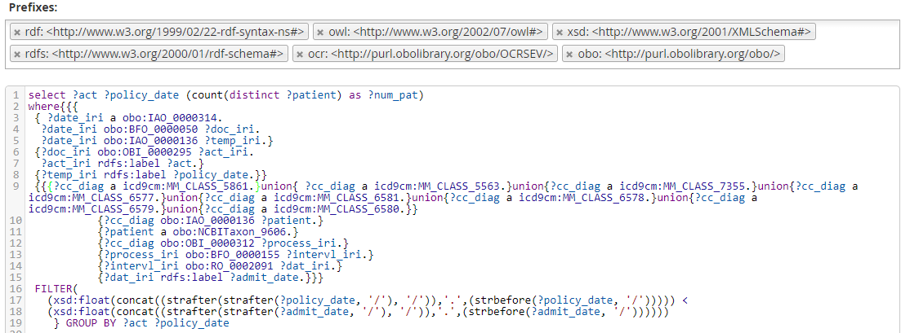

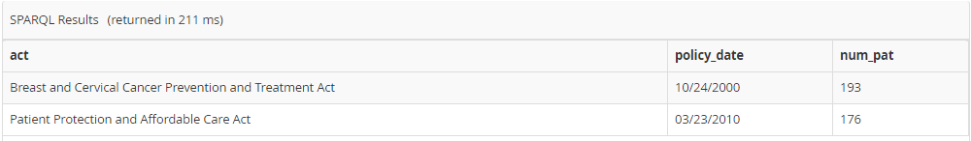

SQL Validation:

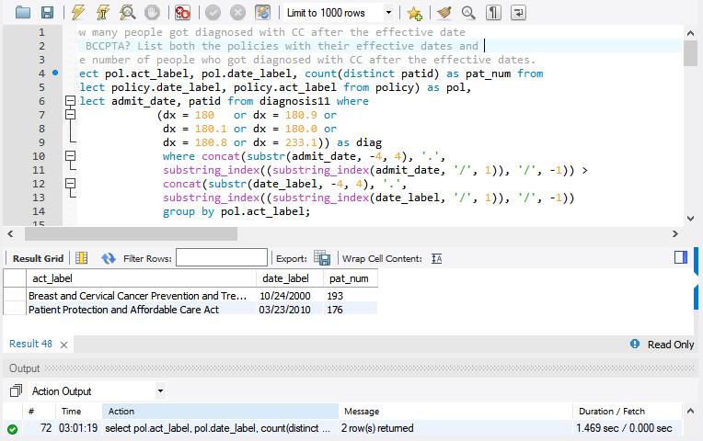

19. List all CC patients who also have a diagnosis of HIV having female biological sex and those who use tobacco along with their race, ethnicity, gender, sexual orientation, smoking prevalence in their MMSA region and the number of physicians they have had an encounter with.

select distinct ?patient ?race ?ethnicity ?gender_value ?sexual_ori_value ?prev_data (count(distinct ?gyn_iri) as ?gyn_num) where

{ {?race_id a obo:OMRSE_00000099.}{?race_iri obo:OBI_0000312 ?race_id.}{?race_iri a ?race.}{?race_iri obo:IAO_0000136 ?patient.}

{?eth_id a obo:OMRSE_00000101.}{?eth_iri obo:OBI_0000312 ?eth_id.}{?eth_iri a ?ethnicity.}{?eth_iri obo:IAO_0000136 ?patient.}

{?gen_id a obo:OMRSE_00000135.}{?gen_iri obo:OBI_0000312 ?gen_id.}{?gen_iri rdfs:label ?gender_value.}{?gen_iri obo:IAO_0000136 ?patient.}

{?so_id a obo:OMRSE_00000142.}{?so_iri obo:OBI_0000312 ?so_id.}{?so_iri rdfs:label ?sexual_ori_value.}{?so_iri obo:IAO_0000136 ?patient.}

{?tu_role a ocr:OCRSEV_00000545.?tu_role obo:RO_0000052 ?patient.}

{?hiv_diag a icd9cm:MM_CLASS_5563.?hiv_diag obo:IAO_0000136 ?patient.}

{{?smoke_prev_iri a ocr:OCRSEV_00000583.?smoke_prev_iri rdfs:label ?prev_data.}

{?smoke_prev_iri obo:IAO_0000136 ?space.?space rdfs:label ?location.}

{?space obo:RO_0001015 ?zip2d.?zip2d obo:RO_0001015 ?patient.}}

{{?orgn_iri obo:RO_0002351 ?gyn_iri.}{?gyn_iri a obo:NCBITaxon_9606.}{?gyn_iri obo:BFO_0000056 ?resi_iri.}{?gyn_iri obo:STATO_0000205 ?npi_iri.}

{?npi_iri rdfs:label ?npi.}

{?resi_iri obo:RO_0002093 ?year_iri.?year_iri rdfs:label ?grad_year. }

{?orgn_iri obo:RO_0002351 ?gyn_iri.}

{?hce_iri a obo:OGMS_0000097.}{?gyn_iri obo:BFO_0000056 ?hce_iri.}{?orgn_iri obo:BFO_0000056 ?hce_iri.}{?hce_iri obo:BFO_0000057 ?patient.}}

{{{?cc_diag a icd9cm:MM_CLASS_7355.}union{?cc_diag a icd9cm:MM_CLASS_6577.}union{?cc_diag a icd9cm:MM_CLASS_6581.}union{?cc_diag a icd9cm:MM_CLASS_6578.}union{?cc_diag a icd9cm:MM_CLASS_6579.}union{?cc_diag a icd9cm:MM_CLASS_6580.}} ?cc_diag obo:IAO_0000136 ?patient.}

FILTER EXISTS { ?sex a obo:PATO_0000383. ?sex obo:RO_0000052 ?patient.}} GROUP BY ?patient ?race ?ethnicity ?gender_value ?sexual_ori_value ?prev_data

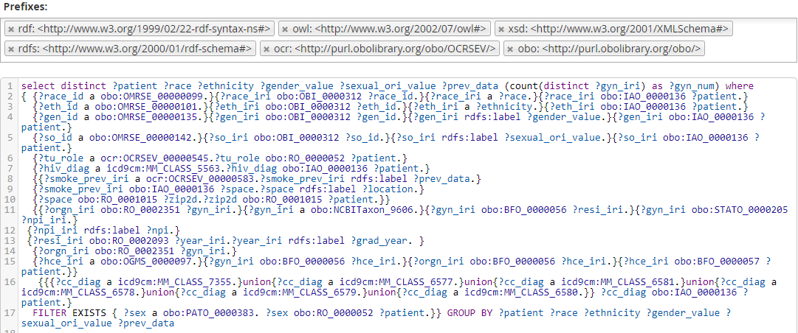

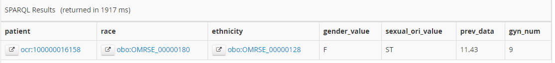

20. List all people who have HIV and who got diagnosed with CC after the effective date of BCCPTA along with their race, gender, sexual orientation, smoking prevalence in their MMSA region, the ccn of the hospitals they have had an encounter at, the MSPB score of those hospitals and the number of physicians per hospital they have had an encounter with.

This is the most complex query covering all five levels of SEM and it takes 6 minutes to finish.

select distinct ?ccn ?mspb_score ?patient ?race ?gender_value ?sexual_ori_value ?prev_data (count(distinct ?gyn_iri) as ?gyn_num) where{{{?race_id a obo:OMRSE_00000099.}{?race_iri obo:OBI_0000312 ?race_id.}{?race_iri a ?race.}{?race_iri obo:IAO_0000136 ?patient.}{?gen_id a obo:OMRSE_00000135.}{?gen_iri obo:OBI_0000312 ?gen_id.}{?gen_iri rdfs:label ?gender_value.}{?gen_iri obo:IAO_0000136 ?patient.}{?so_id a obo:OMRSE_00000142.}{?so_iri obo:OBI_0000312 ?so_id.}{?so_iri rdfs:label ?sexual_ori_value.}{?so_iri obo:IAO_0000136 ?patient.}

{?hiv_diag a icd9cm:MM_CLASS_5563.?hiv_diag obo:IAO_0000136 ?patient.}

{{?smoke_prev_iri a ocr:OCRSEV_00000583.?smoke_prev_iri rdfs:label ?prev_data.}{?smoke_prev_iri obo:IAO_0000136 ?space.?space rdfs:label ?location.}{?space obo:RO_0001015 ?zip2d.?zip2d obo:RO_0001015 ?patient.}}

{{?orgn_iri obo:RO_0002351 ?gyn_iri.}{?gyn_iri a obo:NCBITaxon_9606.}{?gyn_iri obo:BFO_0000056 ?resi_iri.}{?gyn_iri obo:STATO_0000205 ?npi_iri.}{?npi_iri rdfs:label ?npi.}{?resi_iri obo:RO_0002093 ?year_iri.?year_iri rdfs:label ?grad_year. }{?orgn_iri obo:RO_0002351 ?gyn_iri.}{?hce_iri a obo:OGMS_0000097.}{?gyn_iri obo:BFO_0000056 ?hce_iri.}{?orgn_iri obo:BFO_0000056 ?hce_iri.}{?hce_iri obo:BFO_0000057 ?patient.}}

{?hosp a obo:OMRSE_00000102.?hosp obo:STATO_0000205 ?ccn_iri.?hosp obo:OMRSE_00000068 ?orgn_iri.?ccn_iri rdfs:label ?ccn.?mspb a ocr:OCRSEV_00000740.?mspb obo:IAO_0000136 ?orgn_iri.?mspb rdfs:label ?mspb_score.{?gyn_iri a obo:NCBITaxon_9606.?orgn_iri obo:RO_0002351 ?gyn_iri.}{?hce_iri a obo:OGMS_0000097.}{?gyn_iri obo:BFO_0000056 ?hce_iri.}{?orgn_iri obo:BFO_0000056 ?hce_iri.}{?hce_iri obo:BFO_0000057 ?patient.}}

{{{?cc_diag a icd9cm:MM_CLASS_7355.}union{?cc_diag a icd9cm:MM_CLASS_6577.}union{?cc_diag a icd9cm:MM_CLASS_6581.}union{?cc_diag a icd9cm:MM_CLASS_6578.}union{?cc_diag a icd9cm:MM_CLASS_6579.}union{?cc_diag a icd9cm:MM_CLASS_6580.}} ?cc_diag obo:IAO_0000136 ?patient.}{{?cc_diag obo:IAO_0000136 ?patient.}{?patient a obo:NCBITaxon_9606.}{?cc_diag obo:OBI_0000312 ?process_iri.}{?process_iri obo:BFO_0000155 ?intervl_iri.}{?intervl_iri obo:RO_0002091 ?dat_iri.}{?dat_iri rdfs:label ?admit_date.}}

{{ ?date_iri a obo:IAO_0000314. ?date_iri obo:BFO_0000050 ?doc_iri. ?date_iri obo:IAO_0000136 ?temp_iri.}{?doc_iri obo:OBI_0000295 ?act_iri. ?act_iri rdfs:label 'Breast and Cervical Cancer Prevention and Treatment Act'.}{?temp_iri rdfs:label ?policy_date.}}

}FILTER((xsd:float(concat((strafter(strafter(?policy_date, '/'), '/')),'.',(strbefore(?policy_date, '/'))))) <

(xsd:float(concat((strafter(strafter(?admit_date, '/'), '/')),'.',(strbefore(?admit_date, '/'))))))

} GROUP BY ?ccn ?mspb_score ?patient ?race ?gender_value ?sexual_ori_value ?prev_data

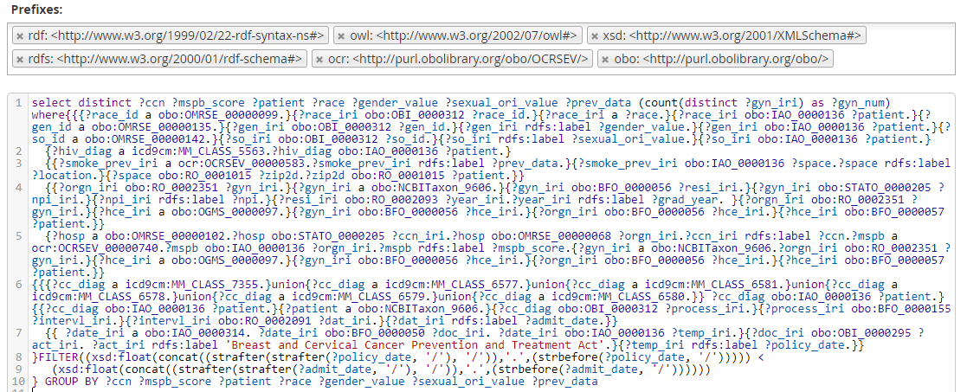

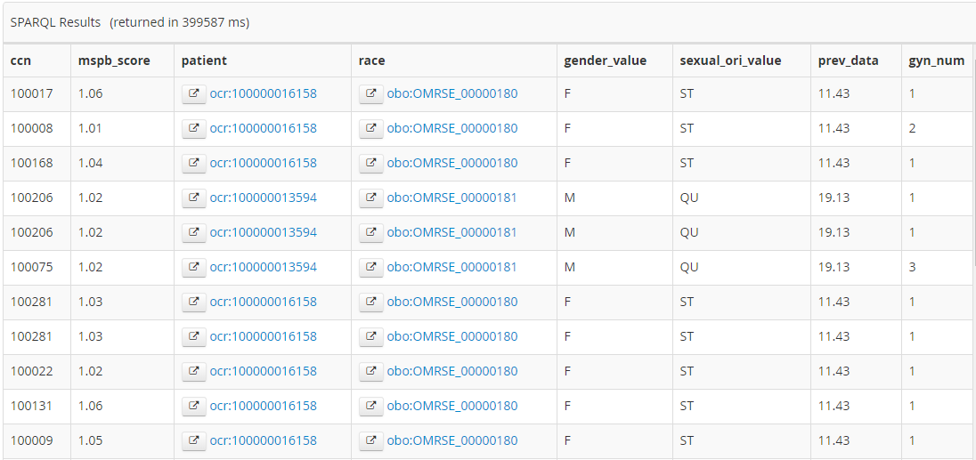

ONTOP SPARQL:

List all patients who are tobacco users:

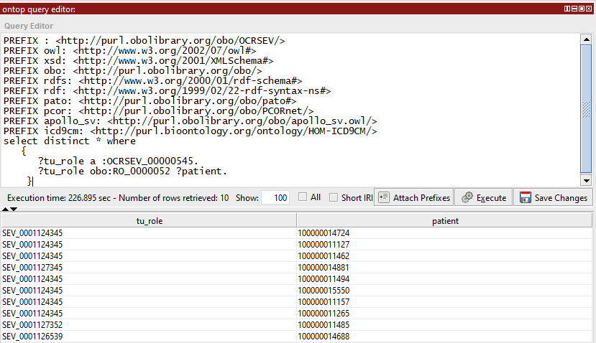

List all CC patients who are tobacco users: (11 minutes) – the same query runs only for 90 milli seconds in stardog.

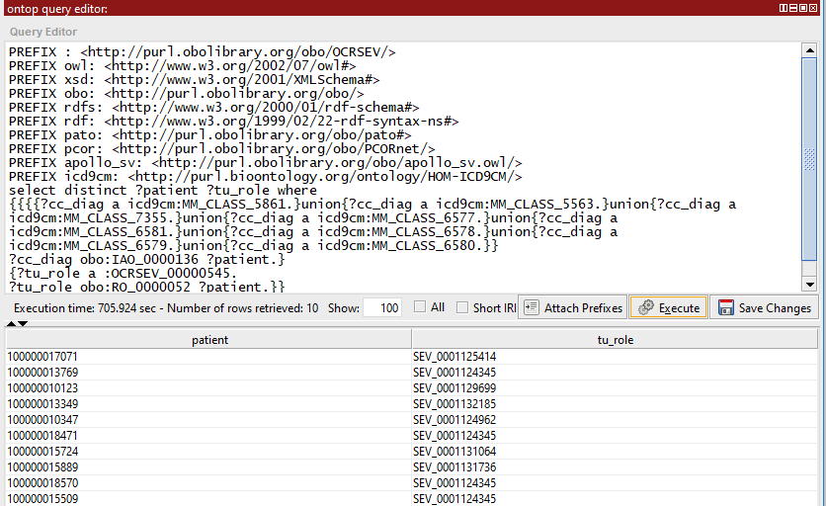

3. Basic query constructed based one mapping: List all instances of PCORnet Hispanic identity datum along with the level of CRCCP SEM, its corresponding ETL instances and the patients associated with these instances.

This query took 29 minutes before RDB optimization. Now, it takes 5 seconds or less.

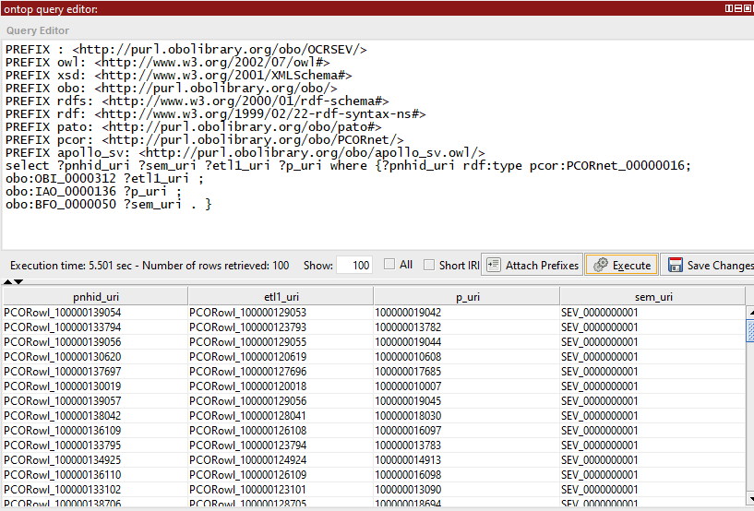

Queries to prove the effect of OCRSEV in semantic data integration:

1. Query to show inheritance

Which instances are instances of subclasses of ‘clinical measurement’?

* The results should include all instances of BMI, diagnosis and its subclasses

|  |
| --- |
| select distinct ?type ?label ?ind |
|  | where { |
|  | ?ind a ?type . |
|  | ?type rdfs:subClassOf ?supertype . |
|  | ?supertype rdfs:label 'clinical measurement'. |
|  | ?type rdfs:label ?label. |
|  |  |
|  | } ORDER BY ?type |

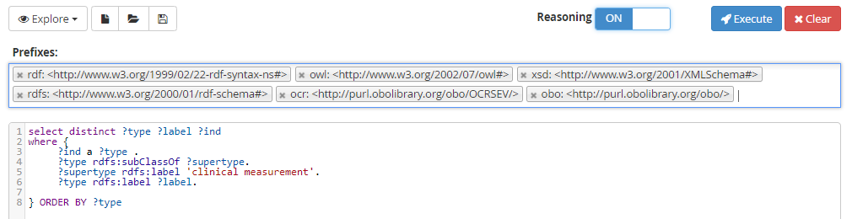

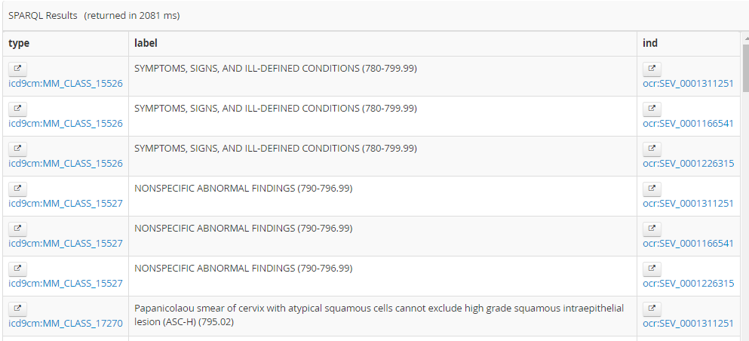

2. Query to show DL expressivity in OCRSEV

Which class is defined by the “ ‘has participant’ some ‘Homo sapiens’ “ axiom and what are its instances?

According to the ontology models, “screening for malignant neoplasm of cervix” satisfies the condition mentioned in the query.

select ?type ?label ?ind

where {

?ind a ?type.

?type rdfs:subClassOf ?supertype.

?supertype a owl:Restriction ;

owl:onProperty obo:BFO_0000057 ;

owl:someValuesFrom obo:NCBITaxon_9606

.

?type rdfs:label ?label.

}

