ASL Online

Kareem K. Beazer

January 10, 2014

MerchZone

MerchZone is a web application designed for various artists and groups within the local music and entertainment industry. This application will allow users to upload all of their merchandise to one central location. The data will then be displayed in a structured manner to targeted audiences within the local industry.

*“I found myself surrounded by numerous entrepreneurs and vendors, all trying to sell me their products. When I asked them if they had their products online, many of them told me they couldn’t afford it. It was then that I came up with the MerchZone concept. A way to grant exposure to those that may be suffering from a low budget income, but are gifted with a high value talent.”*

Progress Schedule

The project will be broken up into 2 phases this month.

**Phase 1:**

**Week 1**

* + Start researching and gathering project information

**-** Design scheme and logo concepts will be created

**Week 2**

* + Development of the application starts

- User flowchart and wire diagrams will be implemented

**Phase 2:**

**Week 3**

* + Complete sign up, login, and welcome pages for application
  + Include all required data for application functionality

- GUI will be created

- CRUD functionality will be implemented

**Week 4**

* Test application to ensure proper functionality
* Polish application to give it a professional look and feel

- Error testing and debugging will be performed

- Optimize application for final presentation

Design Template

**Logo**



**Brand and Application colors**

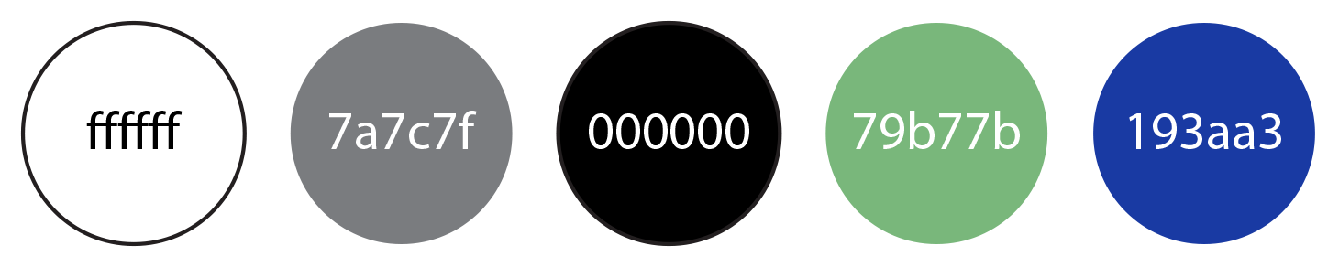

**Font Type**

Arial, sans-serif

Database Structure

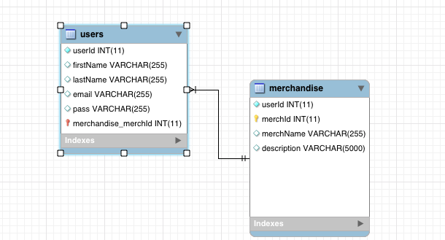

MerchZone Wireframes

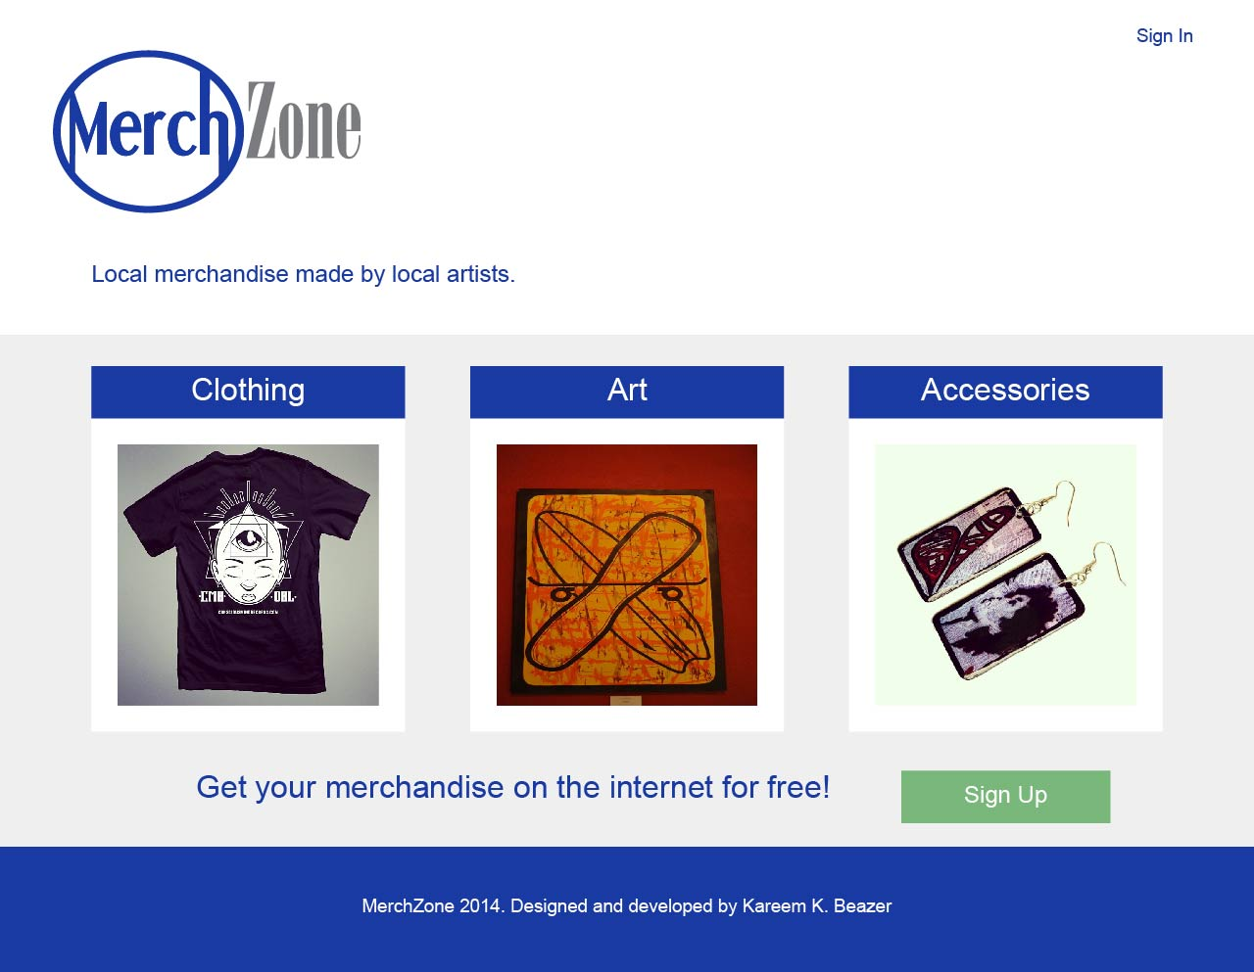

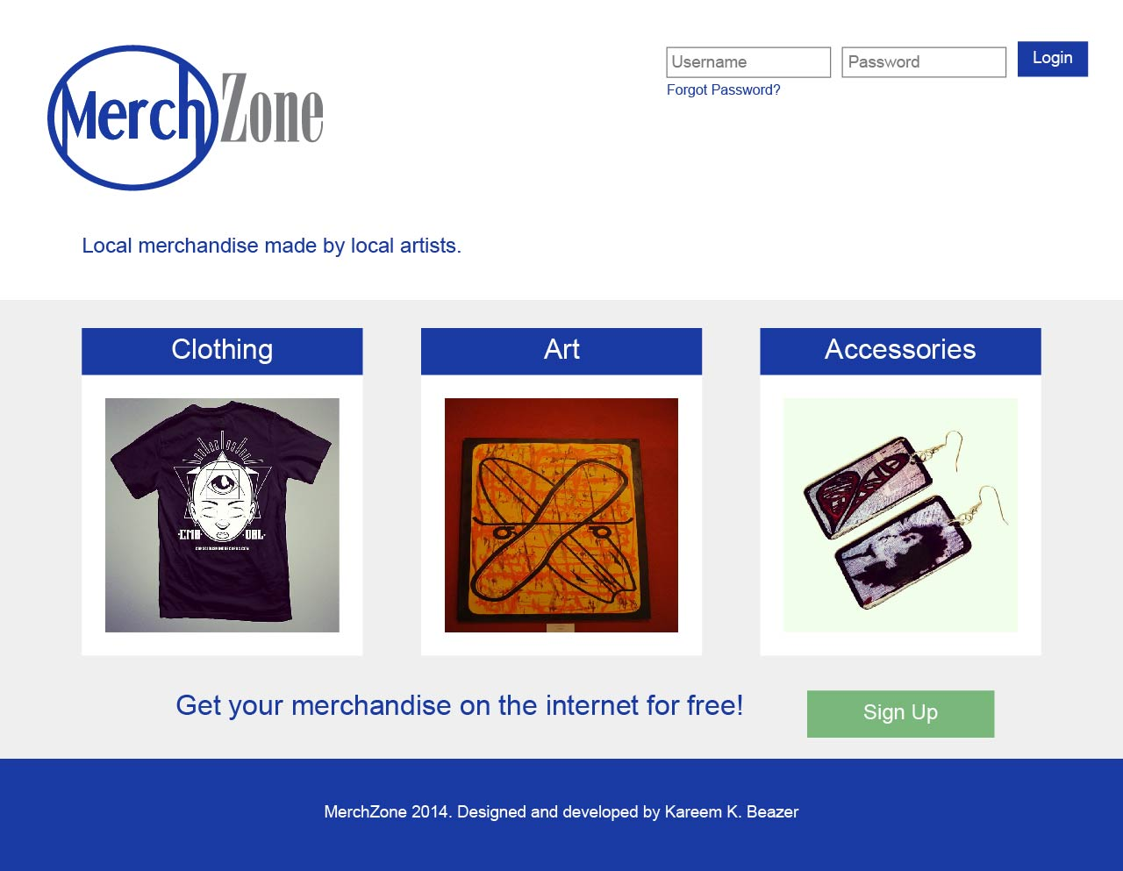

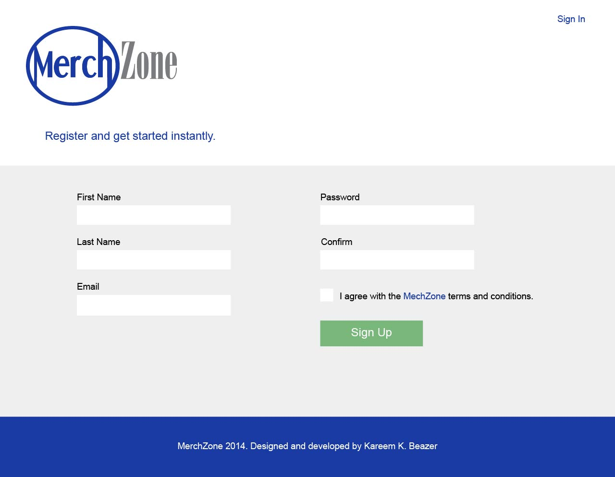

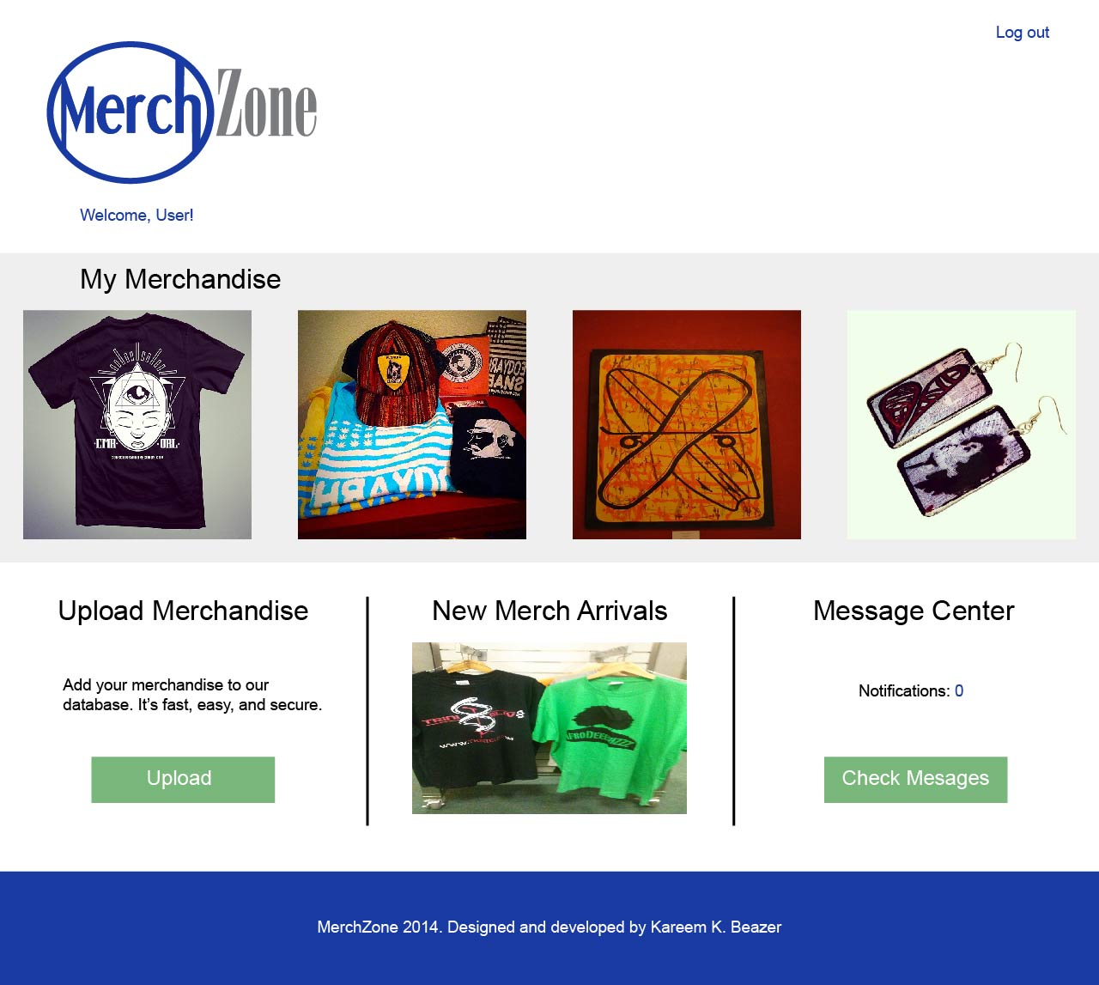

Language and Framework

The chosen language is going to be PHP. It will allow the application to be dynamically updated whenever users interact with the database.

I decided to go with the CodeIgnitor framework for this project. Although this will be my first attempt at using this framework, CodeIgnitor is fully documented and has numerous tutorial videos that I can use to my advantage.