

**KBEngine**

**WebConsole Guide**

Table of contents

Environment Configuration 3

1. Requirements 3

2. Setup 3

Operation Steps 3

1. Start the server 3

2. Login system 4

Server Management Functions 5

1. User Management 5

2. Cluster Management 7

3. Performance Analysis 9

4. Log View 12

5. State Diagram 13

6. Python Console 14

7. Watcher 15

8. SpaceViewer 16[16](#_Toc469995951)

## Environment Configuration

### Requirements

Python Version: Python3.X (recommended 3.3 or above)

Django Version: 1.8.9

### Setup

* + 1. First, install the matching Django module for Python. If you do not want to install Django, there are two options:
* If you are using python2.6.6, enter into the “kbe/tools/server/django_packages" directory and extract the Django-1.6.11.tar.gz file (unzip to the current directory);
* If you are using python2.7 or above, go to the “kbe/tools/server/django_packages” directory and extract the Django-1.8.9.tar.gz file (unzip to the current directory).
  + 1. Modify sync_db.bat, sync_db.sh and run_server.bat, run_server.sh to match the path to the python you are using. On first run you need to initialize the data:
* python3.3 + django 1.8.9 under windows, run “sync_db.bat”
* python3.3 + django 1.8.9 under linux, run “sync_db.sh”;
* python2.6 + django 1.6.11 under linux, run “sync_db_dj-1.6.sh”;
* python2.6 + django 1.6.1 under windows, please refer to “sync_db_dj-1.6.sh” and build a .bat file.

## Operation Steps

### Start the server

* Linux: Run the run_server.sh script, or deploy to nginx. In a browser, open “<http://xxx.xxx.xxx.xxx:8000/wc/>” for access where “xxx.xxx.xxx.xxx” is the Linux machine’s IP address;
* Windows: Run run_server.bat (make sure to change python folder in run_server.bat to your own python folder) and open “<http://xxx.xxx.xxx.xxx:8000/wc/>” in a web browser, where ”xxx.xxx.xxx.xxx” is the machine’s IP address.

### Login System

The initial login requires a default username and password to login to the user management interface and create a new administrative user:

* When using the Web Console for the first time, the default login account is “Admin” and the default password is “123456”, this account is also the only background administrative account. Please promptly change your password after login.
* The first time you use the Admin account to enter the background, you need to create a server management account using your user account name and UID. After creating a new user account, log out of Admin and log into the new user.
* The background environment is python3.3 + django 1.8.9, and python2.6.6 + django-1.6.11 under linux. Tests passed.
* All functions of the Web Console are derived from the KBEngine server. Therefore, to use the functions of the console, it must be ensured that the server process runs correctly.
* If you have any questions, please ask them on the KBEngine official forum.

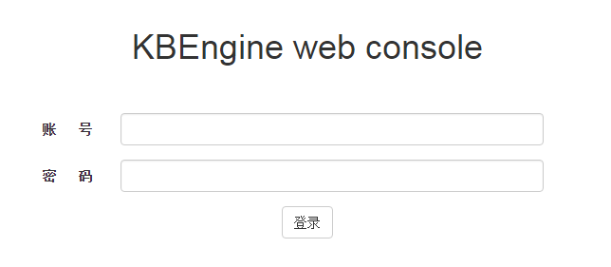

2-1-1登录界面

## Server Management Functions

### User Management

#### Account Management

On this page, you can manage users who use the Web Console, or manage Administrator accounts.

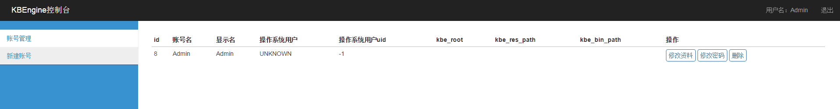

3-1-1-1 Account Management Interface

#### Management user creation

* Account name: Login account;
* Nickname: Displayed after login;
* Login password: Any combination of alphanumeric characters;
* Confirm password: Enter the password again;
* Operating System user: Linux system user name who is running KBE server. Please ignore under Windows.
* Operating System uid: Linux system user uid. Make sure to enter the uid of the user running KBE server, otherwise it cannot be managed. Please ignore under Windows.
* KBE_ROOT: The KBE_ROOT directory. Defaults to the root of the current Web Console. (can be empty)
* KBE_RES_PATH: The KBE_RES_PATH directory. Defaults to the root of the current Web Console. (can be empty)
* KBE_BIN_PATH: The KBE_BIN_PATH directory. Defaults to the root of the current Web Console. (can be empty)

Note: Because there can be multiple KBEs on a single server, each managed system uses User, UID, KBE_ROOT, KBE_RES_PATH, KBE_BIN_PATH and cannot be referenced by other users.

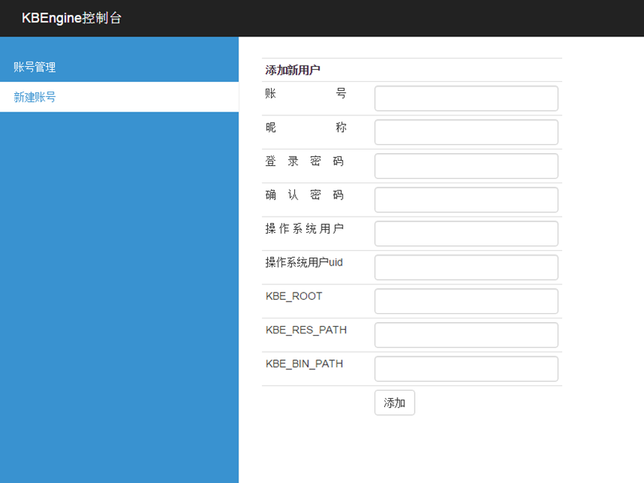

3-1-2-1 New account

#### Modify user

Enter the new user properties and click OK to modify.

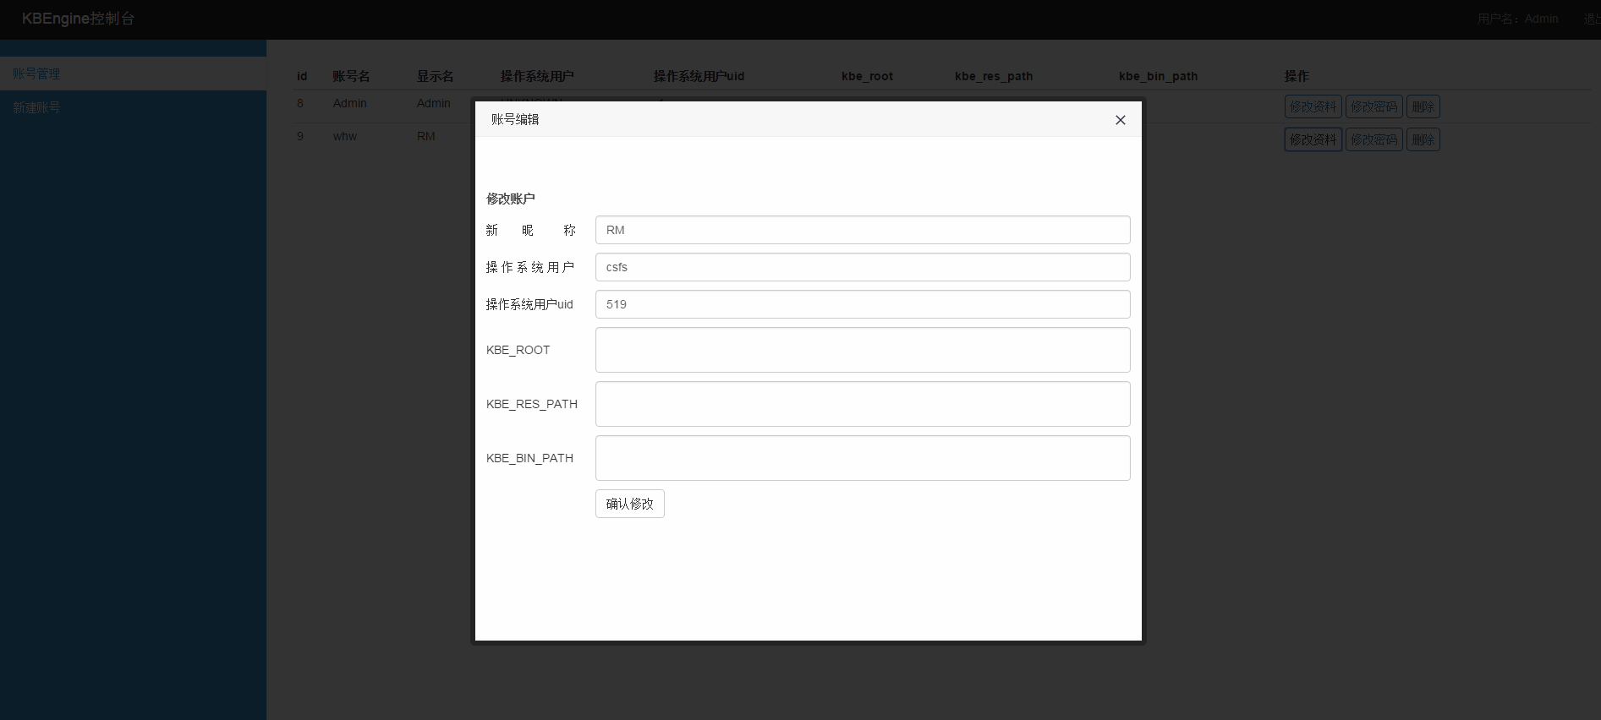

3-1-3-1 Account editing

#### Change password

Enter the new password twice and click Modify.

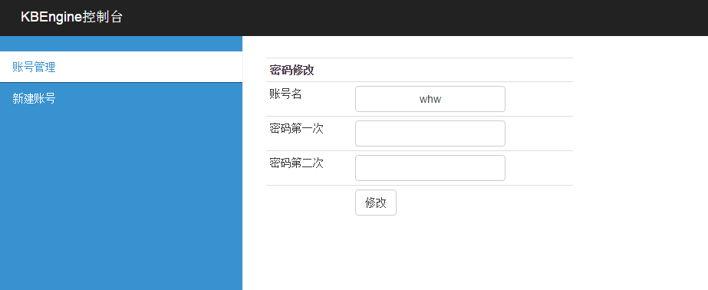

3-1-4-1 Password Modification

### Cluster Management

#### Server Management

In the “Server Management” page, you can manage and view resource consumption of started KBE processes.

* STOP operation: Stop current process.
* KILL operation: Kill current process.
* Start new component: Start new KBE service or component.
* Stop the server: Stop the current KBE server and all processes.
* Save current server configuration: Save the current KBE server process configuration.

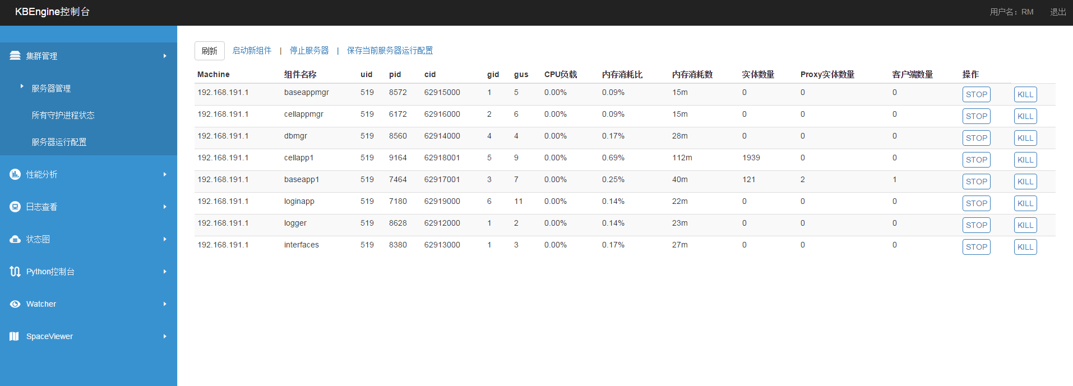

3-2-1-1 Server Management Interface

#### Start new component

On this page you can create any number of component processes within the server cluster.

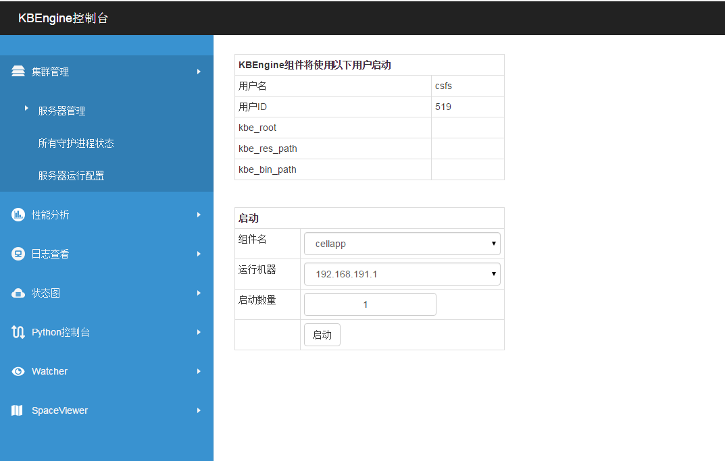

3-2-2-1 Start new component interface

#### All daemon status

Here you can view machine information and resources for all KBE processes in the server cluster.

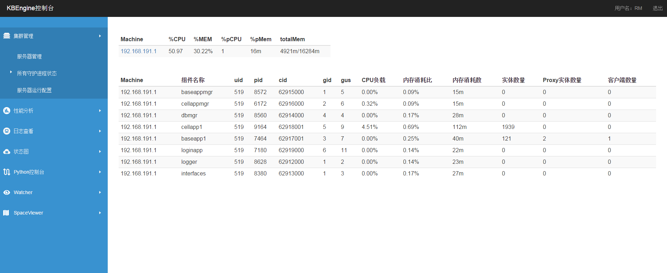

3-2-3-1 All daemon status

#### Server configurations

On this page you can load and delete previously saved server configurations.

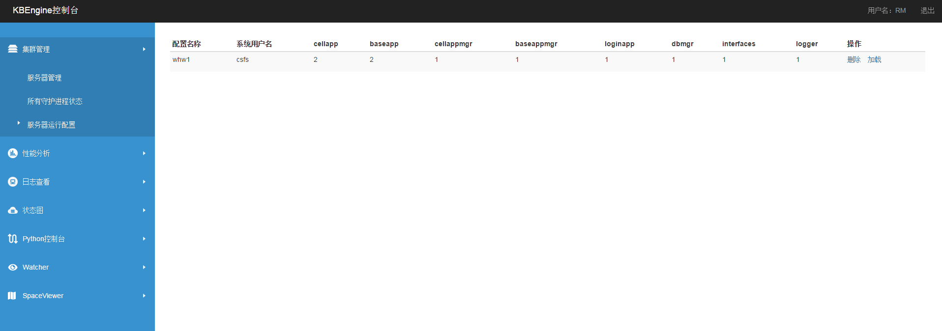

3-2-4-1 Server configurations

### Performance Analysis

Here you can select the component process you want to analyze.

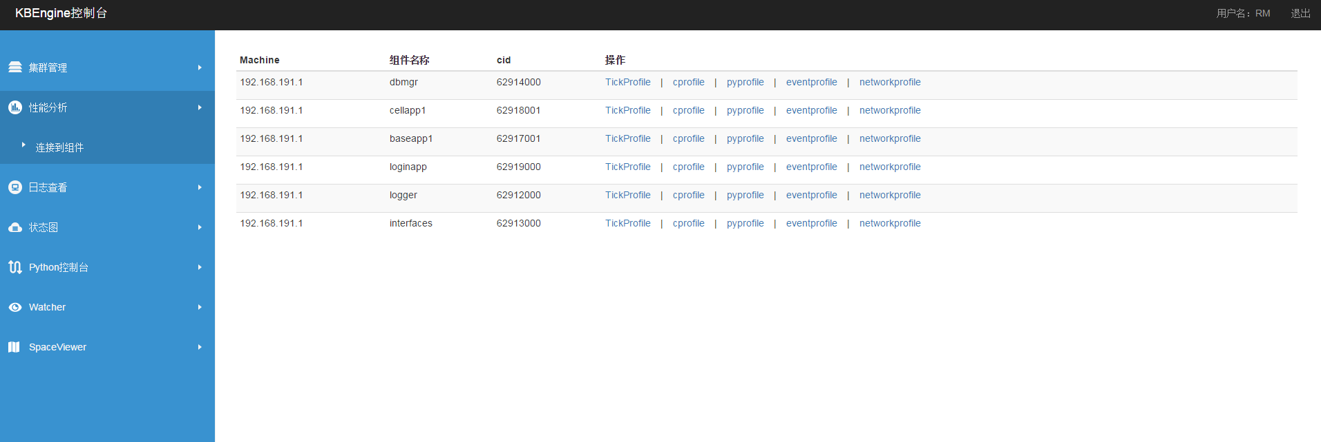

3-3-0-1 Component process selection screen

#### TickProfile

On this page you can query the tick profile. The query duration is empty, with a default length of 10 seconds. Click the bars on the graph to see details.

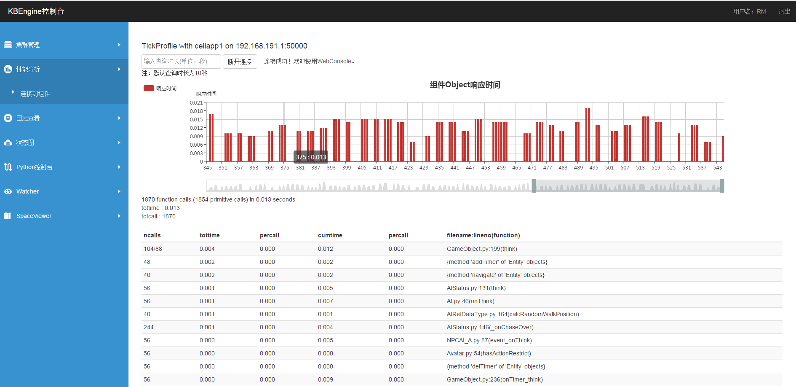

3-3-1-1 TickProfile screen

#### Cprofile

Here you can perform cprofile analysis queries. The query duration is empty with a default length of 10 seconds.

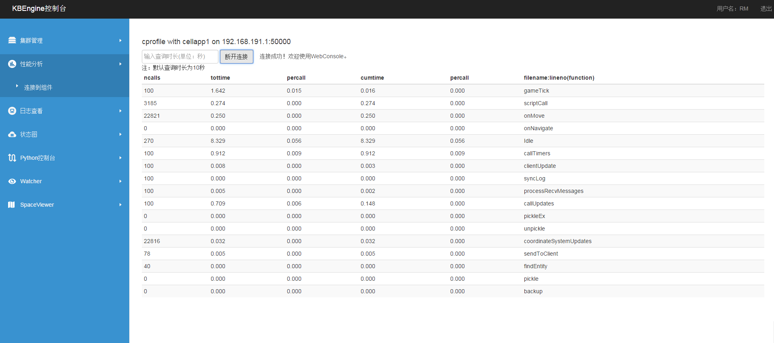

3-3-2-1 Cprofile screen

#### Pyprofile

Here you can perform pyprofile analysis queries. The query duration is empty with a default length of 10 seconds.

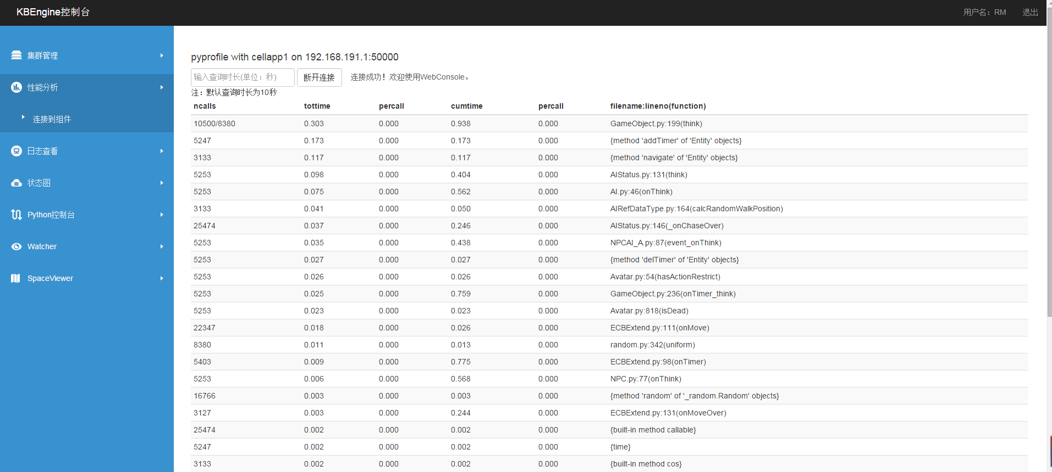

3-3-3-1 PyProfile screen

#### Eventprofile

Here you can analyze event profile information. The query duration is empty with a default length of 10 seconds.

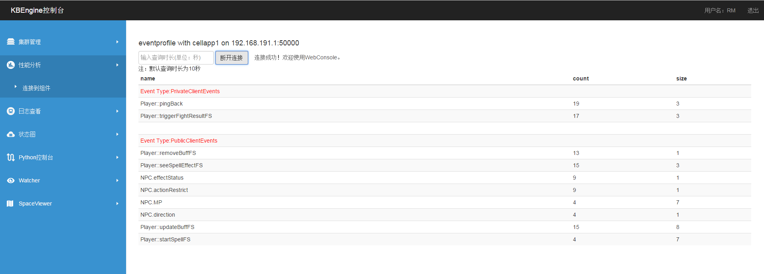

3-3-4-1 EventProfile screen

#### Networkprofile

Here you can analyze network performance information. The query duration is empty with a default length of 10 seconds.

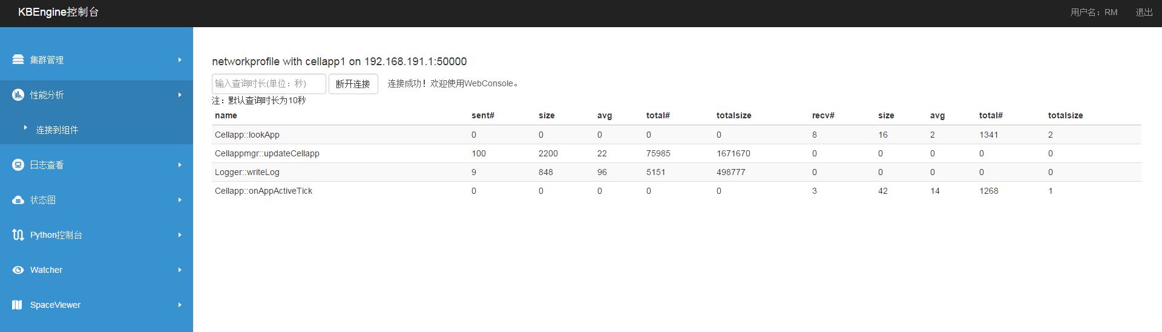

3-3-4-1 NetWorkProfile screen

### Log View

#### Real-time log

This page provides real-time log viewing and filtering. Click on the arrow for a drop down filtering menu. Use this page to view log data from all KBEngine processes.

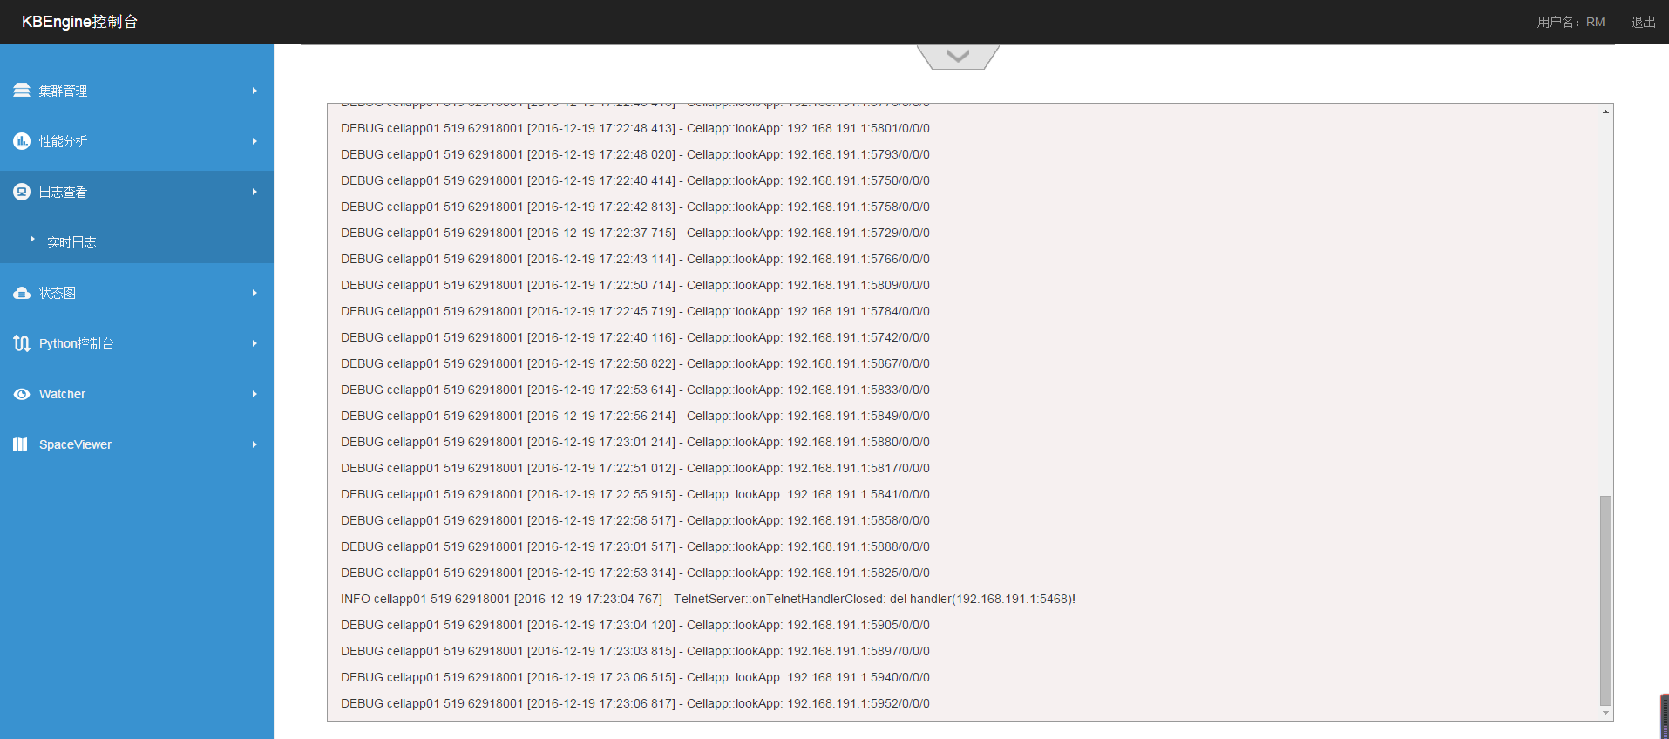

3-4-1-1 Real-time log interface

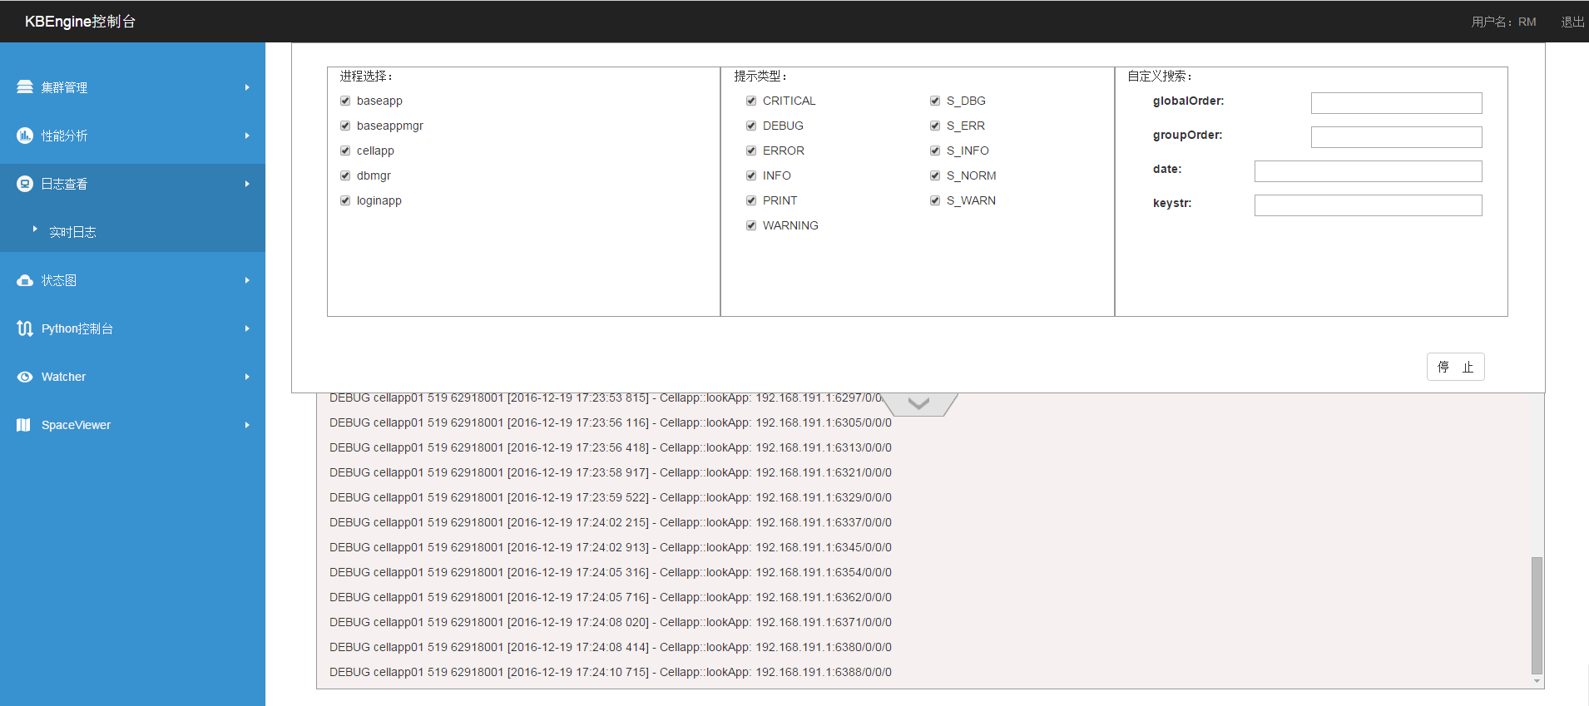

3-4-1-2 Real-time log filtering

### State Diagram

The State Diagram page provides a linear chart of the current state of cellapp and baseapp. Click the name to see line graphs for each components individual processes.

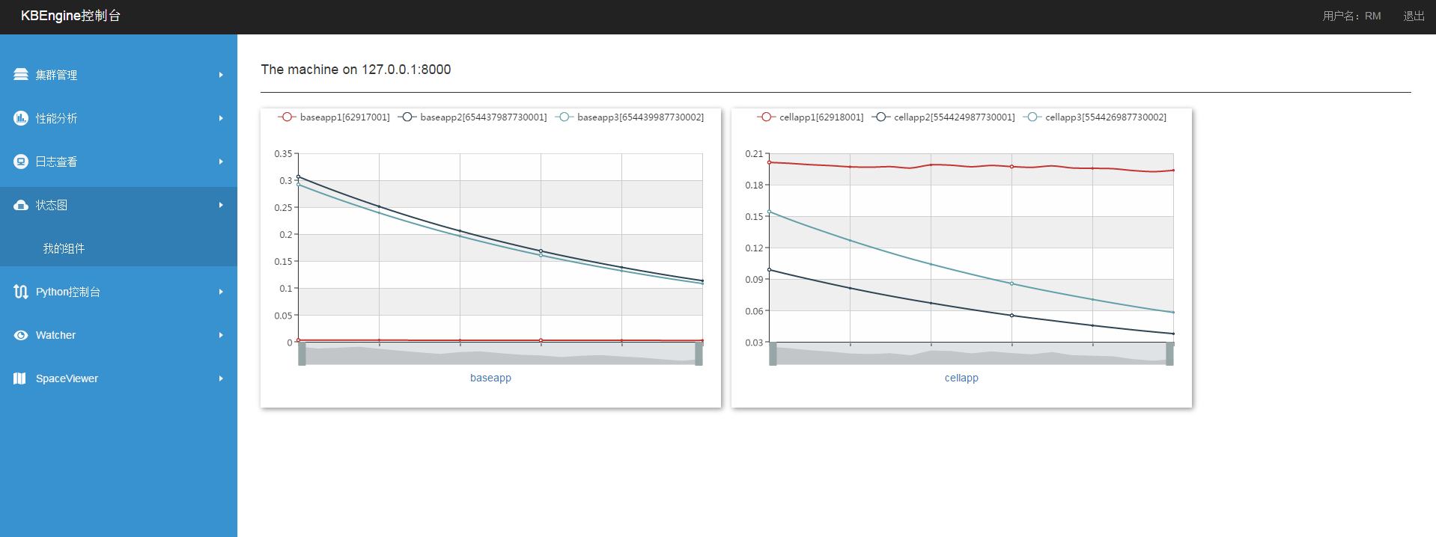

3-5-1-1 Component overview page

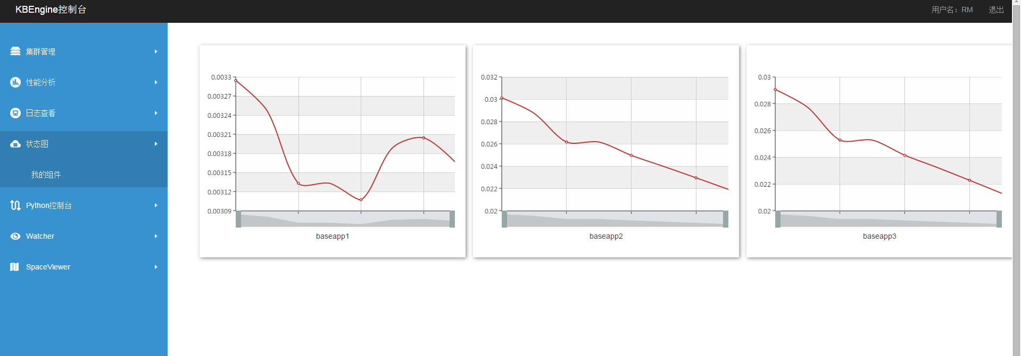

3-5-1-2 Component processes page

### Python Console

On this page you can connect a python console (through telnet) to a single process and enter commands to be executed by clicking the send button on the console page.

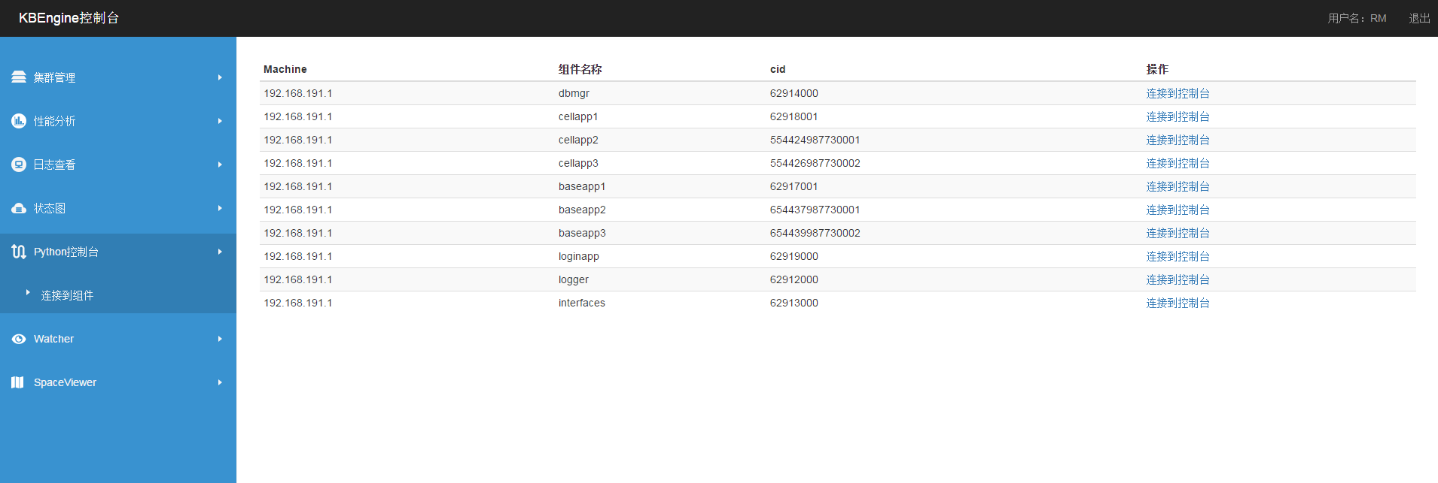

3-6-1-1 Python Console Process Selection Page

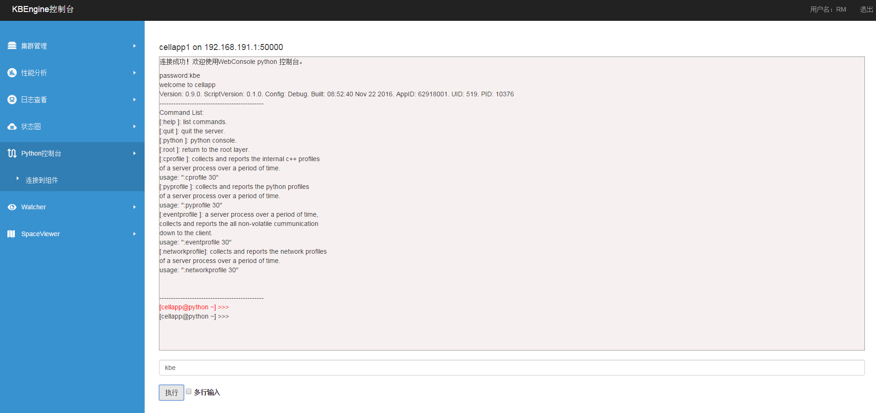

3-6-1-2 Python Console Page

### Watcher

The watcher provides developers with a single view of all the status information for a single component process (attributes, response speed, etc.) and updates the data to the process watcher page in real time.

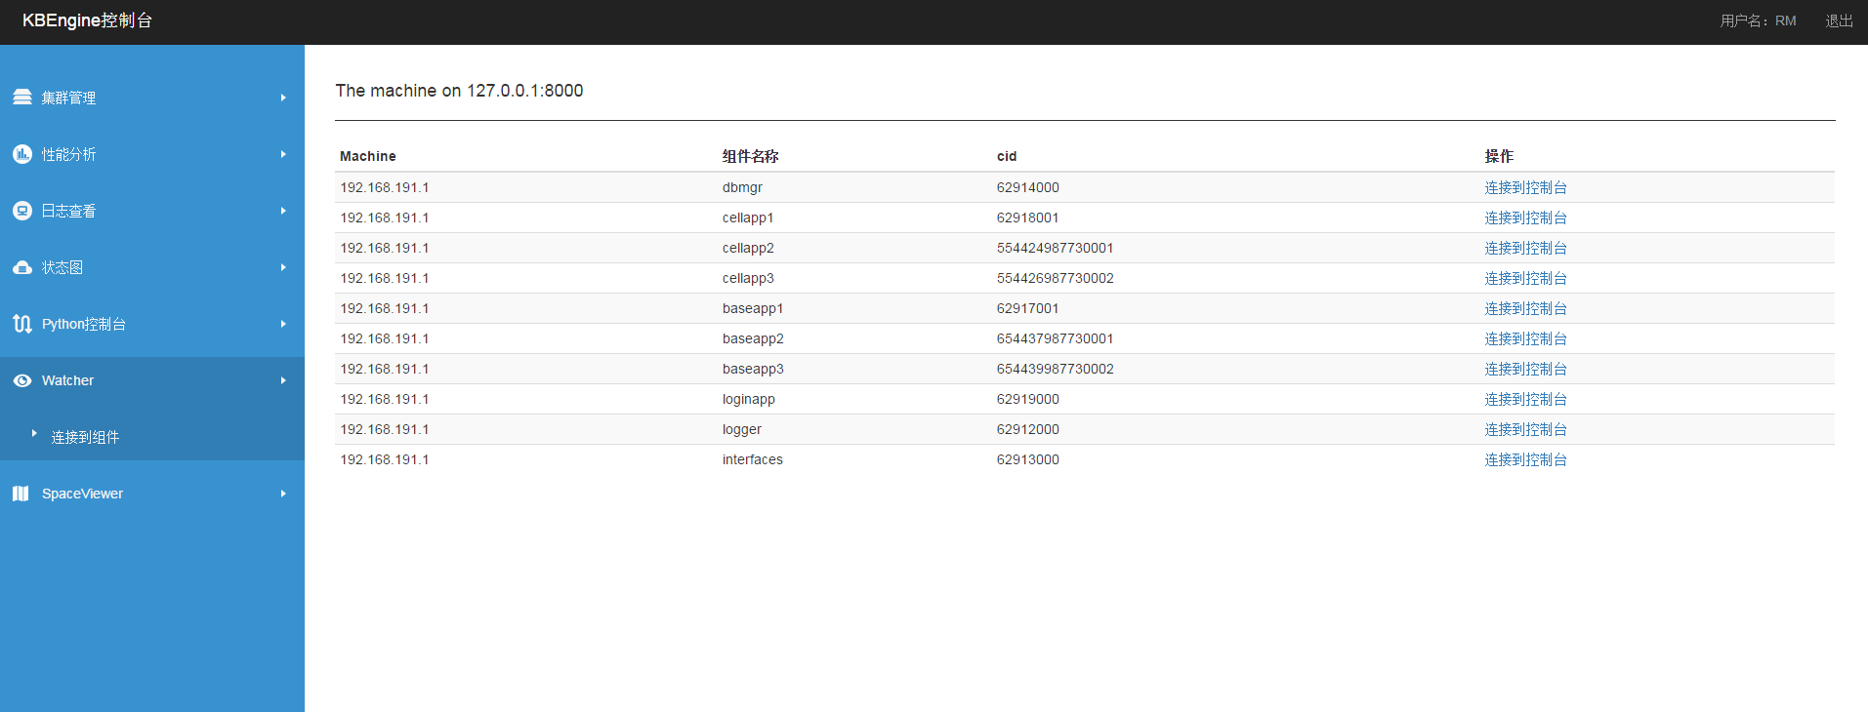

3-7-1-1 Watcher Process Selection Page

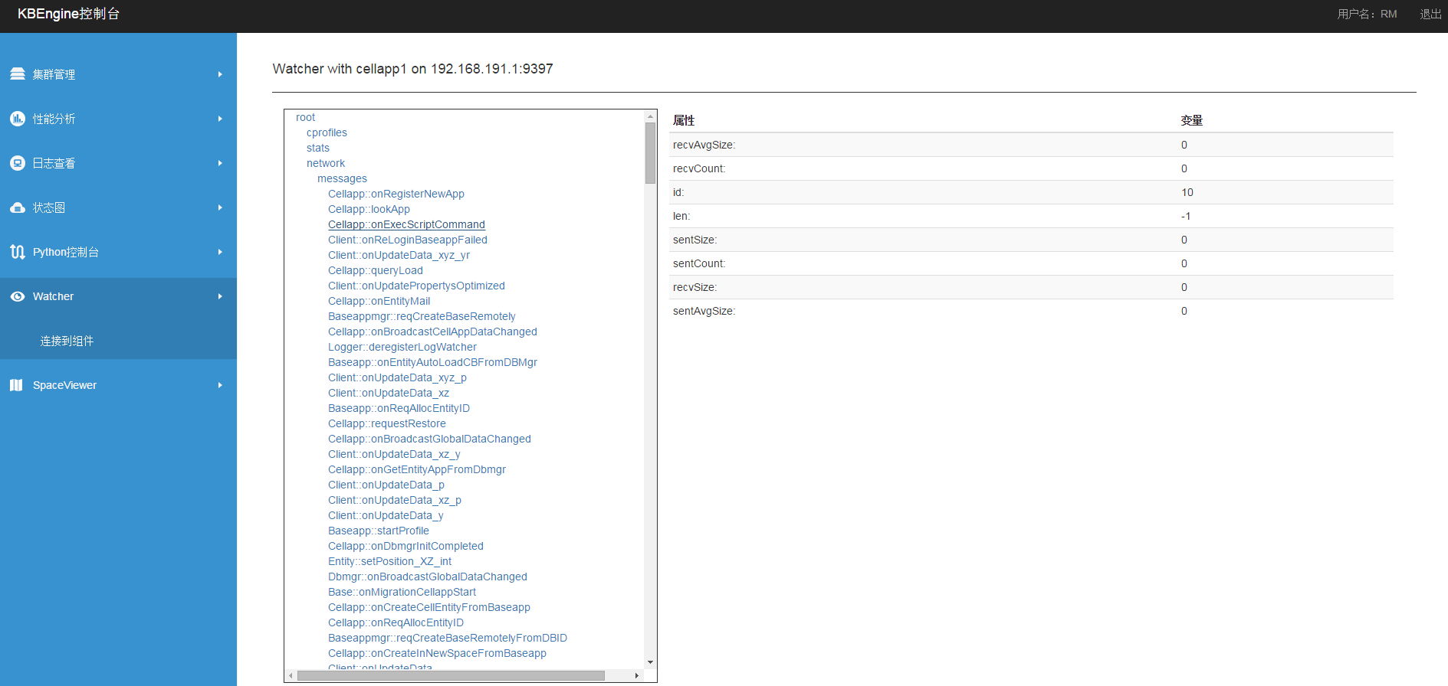

3-7-1-2 Watcher Operation Page

### SpaceViewer

In SpaceViewer, you can see the distribution of entities in all Spaces in the game. The space list on the left is updated as new spaces are created. The selected Space is displayed in real time on the right, showing its state and distribution.

Note: Since the size of the space map cannot be obtained independently, the value of the XY axis of the SpaceViewer is determined by the maximum X and Y values of all entities.

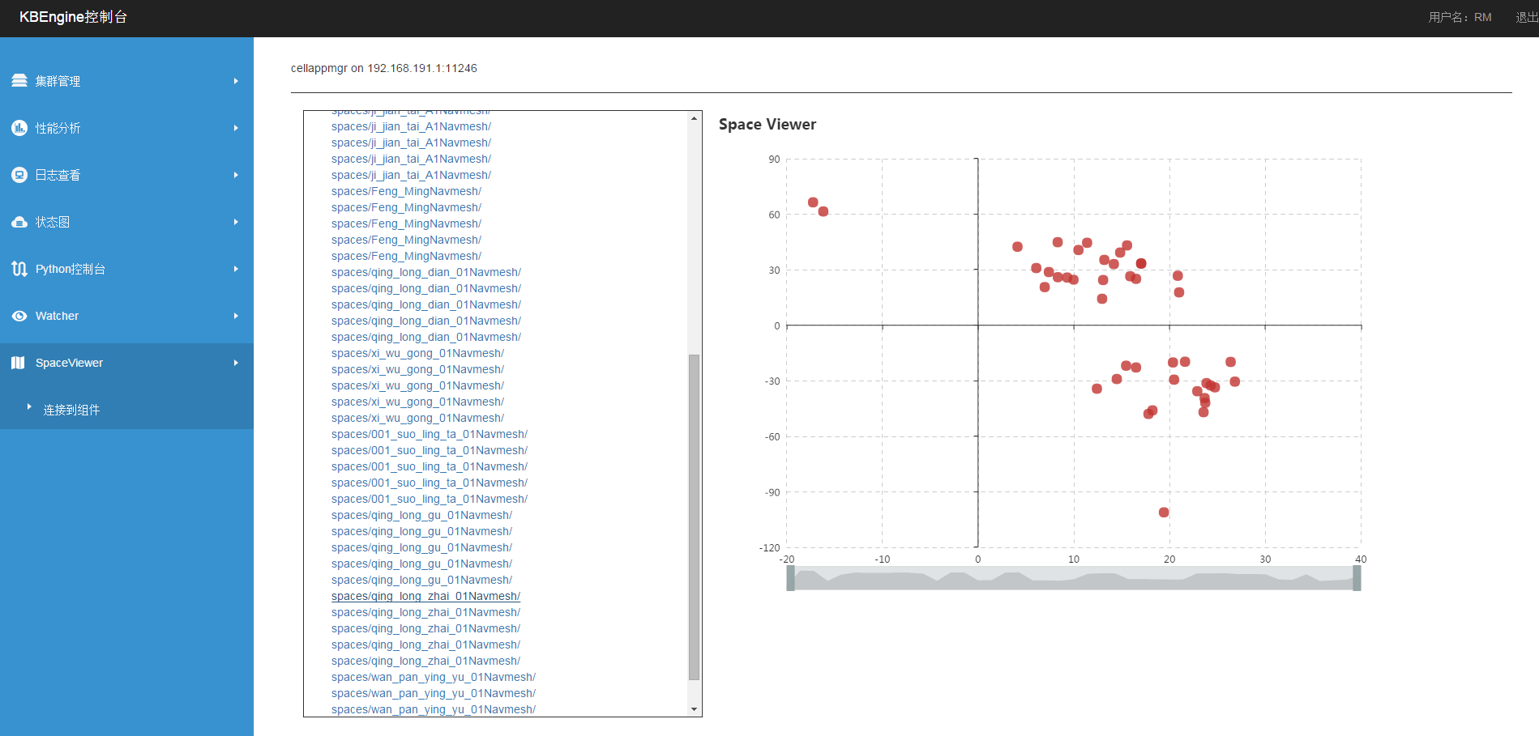

3-8-1-1 SpaceView Page