Objects

Relational model

Business process

Interface. Table pages, rows in a list.

Object fields list

# Objects

System contains following objects:

* Cities
* Malls
* Premises
* Users
* Roles
* Website parameters

Objects Relational Model

City

Premise

Mall

USER

PHOTO

PHOTO

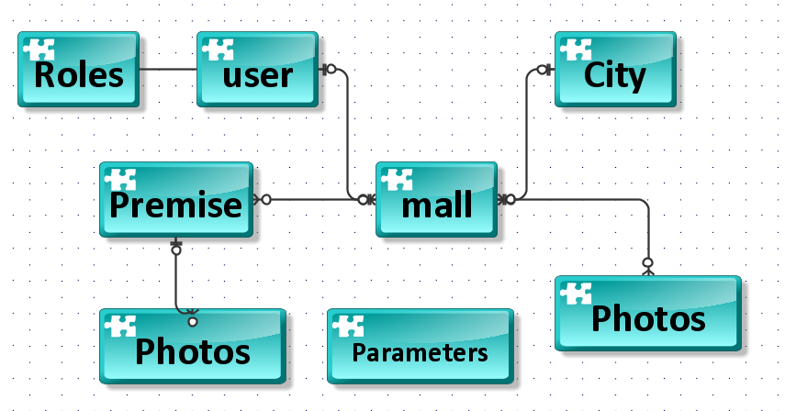

## Users

Users accounts are added to the website when

1. User register their accounts,
2. Administrator registers user accounts

User account has following fields

Username optional

Email which is unique for user account

User account can be assigned to several roles at the same time.

Crud operation for user accounts is available only for administrator

## Role

There must be role list available only for administrator.

Crud operation for role records is available only for administrator

Role list looks like following

1. Administrator
2. Landlord
3. Tenant

System treat tenant role as the same as unauthenticated and unauthorized user.

There is no registration user with Tenant role. System register system only with landlord role.

## Cities

Cities should have simple crud operation, available to administrator only.

## Malls

Malls are registered by user with role landlord, administrator.

Mall can have photos.

Each mall may have only certain number of photos. Number of photos is identified in parameters section.

Photos are saved in file system, not in database. The name of photo must have unique identifier of mall record, bottom dash and order number of photo.

For example,

for first photo 2aaaaaaa-bbbb-cccc-dddd-1eeeeeeeeeee_1 and

for second photo 2aaaaaaa-bbbb-cccc-dddd-1eeeeeeeeeee_2.

Mall have several premises

Mall is assigned to one city.

Mall has approval statuses, which have following values:

1. ForApproval
2. Rejected
3. Approved

System has default value for mall approval status. This parameter is stored in website parameters.

Mall has visibility statuses, which are:

1. Hidden
2. Visible

## Premises

Premises are registered by user with landlord role

Premise can have photos.

Each premise may have only certain number of photos. Number of photos is identified in parameters section.

Photos are saved in file system, not in database. The name of photo must have unique identifier of mall record, bottom dash and order number of photo. Example is given in Mall section

Premise is assigned to only one mall.

Premise has approval statuses, which have following values:

1. ForApproval
2. Rejected
3. Approved

System has default value for premise approval status. This parameter is stored in website parameters.

Premise

Premise has visibility statuses, which are:

1. Hidden
2. According to calendar
3. Visible

Hidden means that, premises are invisible, in premise’s list for unauthenticated users or tenants.

According to calendar.

Premise can have one or more occupation time periods, which have start date and end date. Time period may look like following

(Open period) 25.11.2019 – null. Where null value can be understood as future, with no end date. It means that premise is occupied and it is not known when it becomes free.

(Closed period) 25.10.2019 – 25.11.2019. It means that premise is occupied only in indicated period, and premise will be free arter 25.11.2019.

Premise time periods are not allowed to intersect.

Visible means that, premises are visible, in premise’s list for unauthenticated users or tenants.

Price Rates (hereinafter rates).

Mall can have rates, which indicate price for square meter. Rates are entered by landlord and administrator. Rates predefine premise’s price.

Premise’s price = area * rate.

When landlord enters new premise, landlord is able to choose the price rate, and system automatically multiplies price rate to premise area, giving overall premise price. But overall premise price can be edited by landlord any time.

Crud operations are used for price rates.

## Website parameters.

Website parameters (hereinafter parameters) are held in database table. Also parameters are held in web-config file.

System considers parameters in web-config as default values, when database table is empty on not filled yet. If parameters exist in database table then systems uses parameters in database table.

System has following parameters:

* Number of rows displayed in a list view.
* Confirmation Email text.
* Maximum Number of photos assigned to mall
* Maximum Number of photos assigned to premise
* Maximum size for photo uploaded.

# Registration

Registration.

Registration is straightforward, done by email. Registration requires email confirmation.

Registration form requires following fields:

1. User email
2. User name
3. Password
4. Password confirmation

Registration goes as followings:

1

User enters

Email,

Username

Password

Password confirmation

Click send button

2

System will send confirmation letter to the user.

The text of confirmation letter can be changed from parameters page.

3

If user didn’t confirm his account, he is not allowed to login to the website. Every time when user tries to login with NOT confirmed account, system sends him a confirmation email.

# Business process.

Business process is shown in picture below.

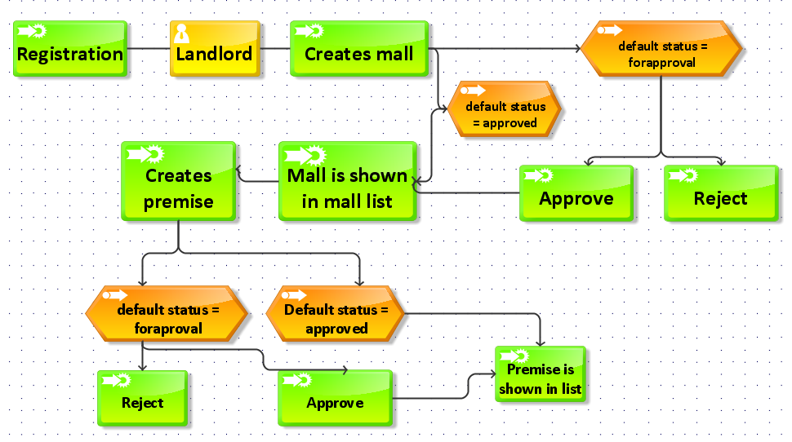

# Interface

Menu for administrator

Malls list

Premises list

Users list

Menu for landlord

All mall list

Own mall list

All premises list

Own premises list

Tenant

All premises list

All mall list

|  |  |  |  |  |  |  |  |
| --- | --- | --- | --- | --- | --- | --- | --- |
|  | Create | Read own record | Read all records  (in a list and single record views) | Read & edit all records  (Reading in a list and single record views)  Editing in a single record view | Read and Edit own records  (Reading in a list and single record views)  Editing in a single record view | Delete all records  Delete in a single record view | Delete own records  Delete in a single record view |
| User | ALT | ALT | A | A | AL |  |  |
| Roles | A | A | A | A | A |  |  |
| Malls | AL | ALT | ALT | A | AL (malls assigned to user) | A | AL(malls assigned to user) |
| Premises | AL | ALT | ALT | A | AL (premises belonged to landlord via malls) | A | AL |
| Rates | AL | AL | A | A | AL | A | AL |

Where

A – Administrator

L – Landlord

T - Tenant

|  |  |  |  |  |  |  |  |
| --- | --- | --- | --- | --- | --- | --- | --- |
|  | Create | Read own record | Read all records  (in a list and single record views) | Read & edit all records  Reading and editing in a list view) | Read and Edit own records  Reading and editing in a list view | Delete all records  Delete in a list view | Delete own records  Delete in a list view |
| Calendar  (inside premise form) | AL  (inside premise form) | AL |  | A (inside premise form) | AL (inside premise form) | A (inside premise form) | AL (inside premise form) |

Edit operation is done in its own form.

Delete operation is done is its own form.

Calendar’s crud operations are realized in premise’s edit form.

# Object Fields

Mall

|  |  |  |  |
| --- | --- | --- | --- |
| Name | String |  |  |
| Address | String |  |  |
| NumberOfFloors | Int |  |  |
| PhoneNumber | String |  |  |
| City | City |  |  |
| ApprovalStatus | Enum |  |  |
| Visibility | Enum |  |  |

Mall Photo

|  |  |  |  |
| --- | --- | --- | --- |
| Path | String |  |  |

Premise

|  |  |  |  |
| --- | --- | --- | --- |
| Number | String | Premise number |  |
| Floor | String | Premise floor  it’s value can’t be bigger than overall number of floors in mall |  |
| Mall | Mall | Reference to the mall |  |
| Area | Double |  |  |
| Price | Double |  |  |
| ApprovalStatus | Enum |  |  |
| Visibility | Enum |  |  |
| Photos | PremisePhoto |  |  |

Premise Photo

|  |  |  |  |
| --- | --- | --- | --- |
| Path | String |  |  |

User

|  |  |  |  |
| --- | --- | --- | --- |
| FirstName | String |  |  |
| SurName | String |  |  |
| Phone | String |  |  |
| Malls | Collection Mall | Reference to malls |  |

City

|  |  |  |  |
| --- | --- | --- | --- |
| CityName | String |  |  |
| Malls | Collection Mall | Reference to malls |  |