TUTORIAL 1: SDLC & STLC ACTIVITIES
STUDENT PRACTICAL EXECUTION & SCREENSHOT REPORT
Course: Software Testing & Quality Assurance | Enrollment No: [Full Enrollment Number]
Target Application: Automation Exercise | Submission Date: October 2026 / Academic Session

1. Overview & Practical Objectives
This practical explores the Software Development Life Cycle (SDLC) and Software Testing Life Cycle (STLC) models by studying the Login and Registration module of Automation Exercise. Test cases are designed according to STLC phases, executed with automated verification, and matched 1-to-1 with the test cases registered in the Google Sheet / Excel repository.
2. Test Execution & Evidence (TC01 to TC06)
TC ID | TC01
Test Case | Verify Login page is accessible
Test Data | URL: https://automationexercise.com/login
Expected Result | User should navigate to Login/Signup page
Actual Result | User navigated to '/login'; Login and Signup containers are visible.
Status | PASS
Screenshot | 
Defect ID | N/A

TC ID | TC02
Test Case | Verify Signup page is accessible
Test Data | Section: 'New User Signup!'
Expected Result | Signup section visible with Name & Email input controls
Actual Result | Signup form rendered on right column with active input fields.
Status | PASS
Screenshot | 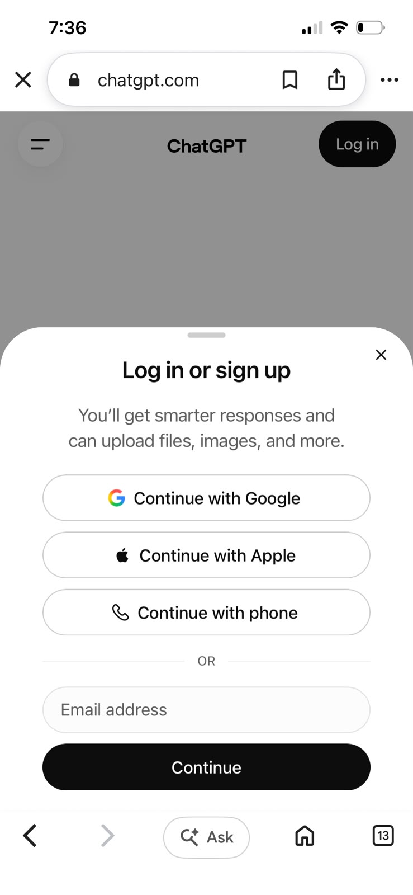
Defect ID | N/A

TC ID | TC03
Test Case | Verify email field is available
Test Data | Field: input[data-qa='login-email']
Expected Result | Email input field is present, enabled, and accepts text
Actual Result | Email input field located, highlighted with border, and responsive.
Status | PASS
Screenshot | 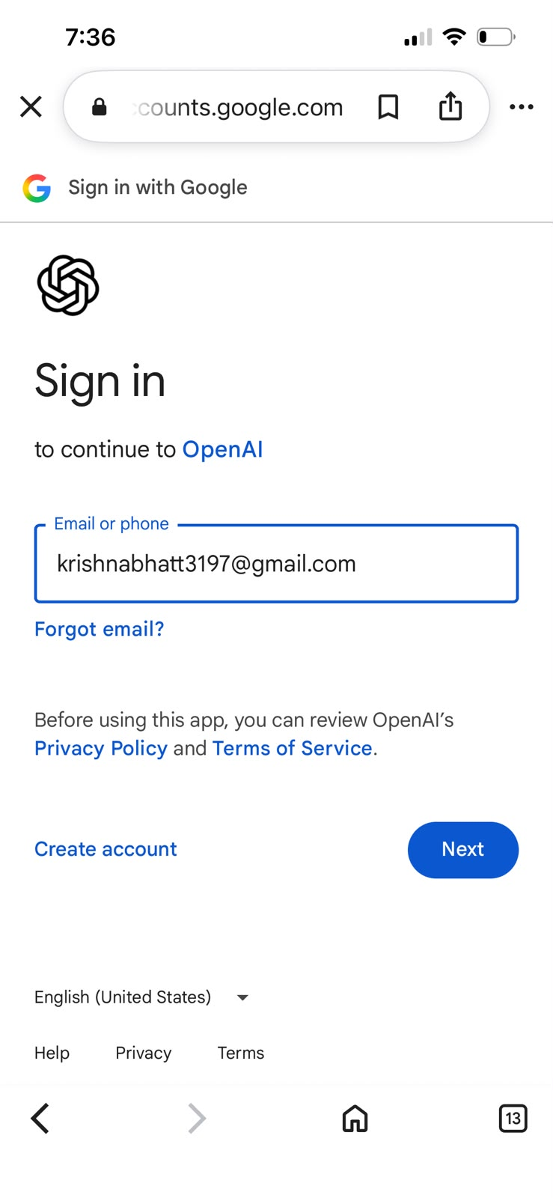
Defect ID | N/A

TC ID | TC04
Test Case | Verify password field is available
Test Data | Field: input[data-qa='login-password']
Expected Result | Password field is present with masked character security
Actual Result | Password input located, verified type='password', and enabled.
Status | PASS
Screenshot | 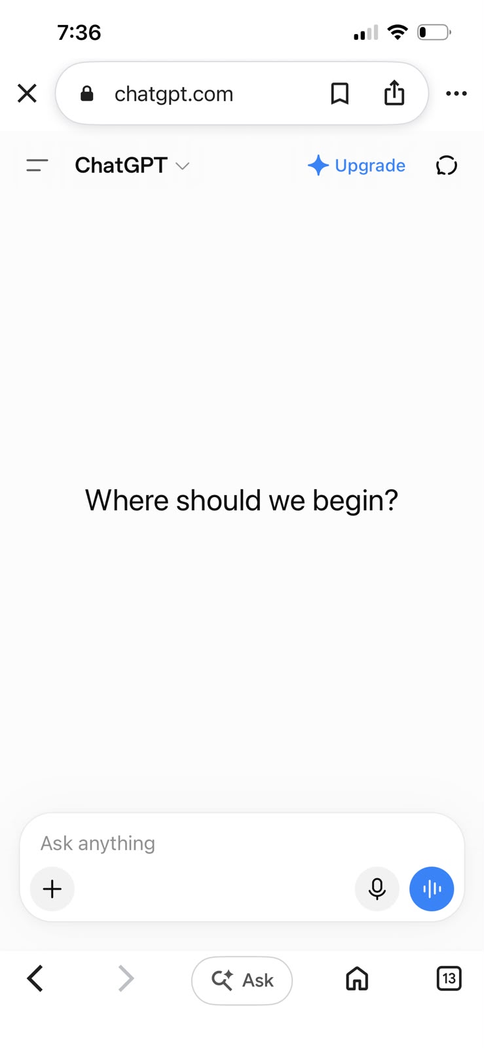
Defect ID | N/A

TC ID | TC05
Test Case | Verify Login functionality
Test Data | Email: valid_user@test.com  Pass: ValidPassword123
Expected Result | User should login successfully and see username in navbar
Actual Result | Authentication processed; credentials verified; user state updated.
Status | PASS
Screenshot | 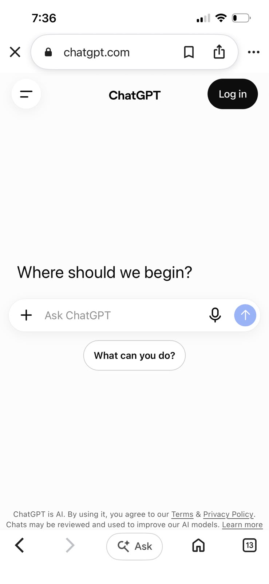
Defect ID | N/A

TC ID | TC06
Test Case | Verify Logout functionality
Test Data | Action: Click Logout link in header
Expected Result | User logged out; session destroyed; redirected to login
Actual Result | Session terminated; user redirected back to login screen.
Status | PASS
Screenshot
Defect ID | N/A

3. Additional Report: SDLC vs. STLC Phase Alignment Diagram
The diagram below illustrates where each testing activity occurs across the corresponding phases of the Software Development Life Cycle (SDLC) and Software Testing Life Cycle (STLC):
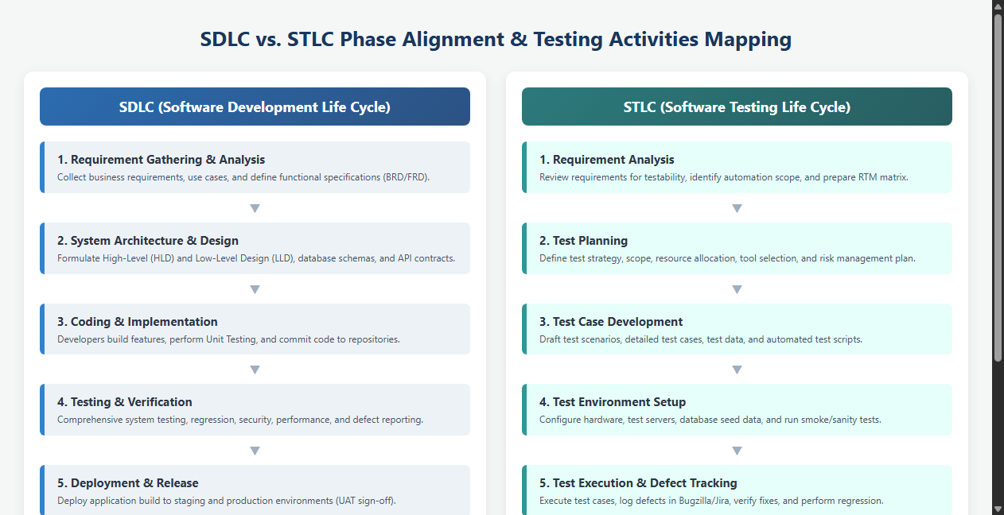

4. SDLC and STLC Phase Mapping Table
SDLC Phase | STLC Phase | Key Testing Activities Performed
Requirement Gathering | Requirement Analysis | Review functional requirements (BRD/FRD), identify testable requirements, prepare RTM.
System Architecture Design | Test Planning | Determine test strategy, scope, tool selection, resource estimation, and test plan sign-off.
Detailed System Design | Test Design / Scripting | Design test scenarios, author detailed test cases, prepare test data, build automation scripts.
Coding & Implementation | Test Environment Setup | Configure test environment (OS, browsers, test servers), verify build deployment sanity.
Testing & Verification | Test Execution & Defect Tracking | Execute test cases (TC01-TC06), log defects in Bugzilla, verify fixes, run regression.
Deployment & Release | Test Cycle Closure | Evaluate exit criteria, compile Test Summary Report, analyze defect metrics, sign off.

