TUTORIAL 9: TESTING METHODOLOGIES & COVERAGE
BLACK BOX, WHITE BOX, INTEGRATION & SYSTEM TESTING
Course: Software Testing & Quality Assurance | Enrollment No: 2604040330001
Target Application: OrangeHRM Demo (https://opensource-demo.orangehrmlive.com) | Submission Date: October 2026

1. Practical Purpose & Methodological Framework
This tutorial covers the primary testing paradigms in software engineering: Black Box Testing (spec-based testing without internal code knowledge), Integration Testing (interface data exchange between modules), System Testing (end-to-end lifecycle verification), and White Box Testing (structural code coverage, Control Flow Graph analysis, and statement/branch/path coverage).
2. Black Box, Integration & System Test Execution
TC ID | BB01
Test Case | Black Box - Valid login
Test Data | User: Admin  Pass: admin123
Expected Result | User authenticated; Dashboard loaded
Actual Result | Authenticated successfully; Dashboard widgets render.
Status | PASS
Screenshot | 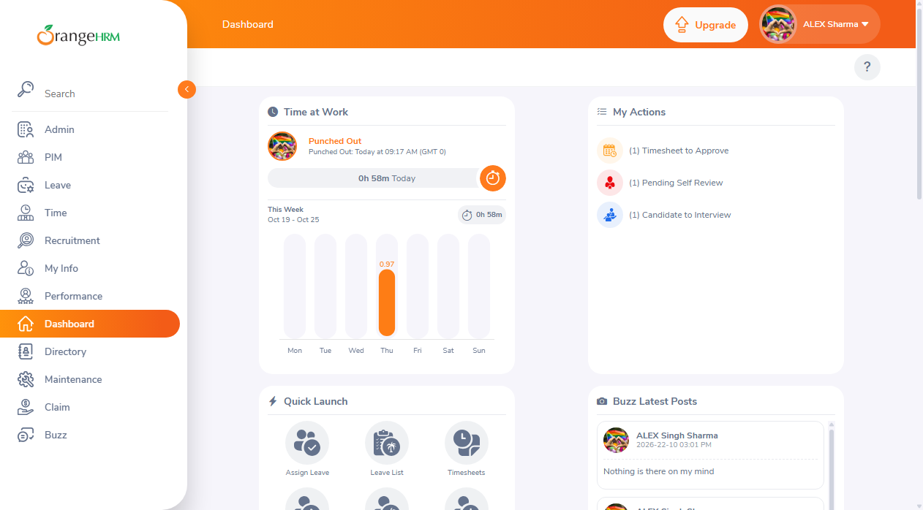
Defect ID | N/A

TC ID | BB02
Test Case | Black Box - Invalid login
Test Data | User: Admin  Pass: wrongpass123
Expected Result | Alert banner displayed: 'Invalid credentials'
Actual Result | Alert banner 'Invalid credentials' rendered correctly.
Status | PASS
Screenshot | 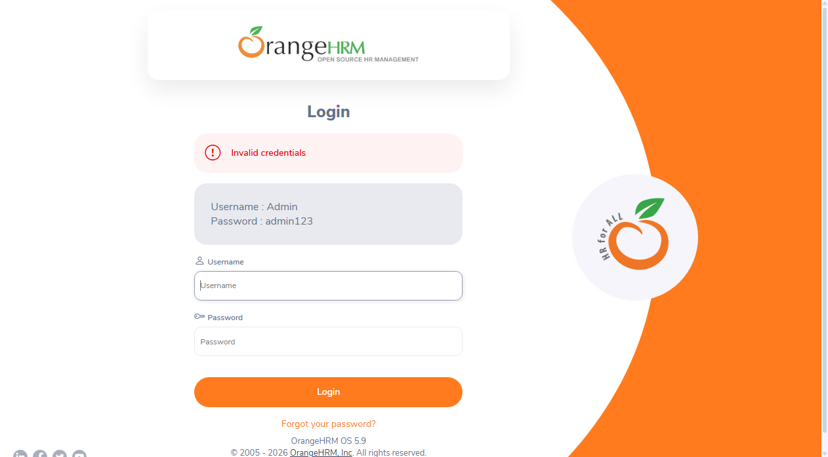
Defect ID | N/A

TC ID | BB03
Test Case | Black Box - Blank login
Test Data | User: [Empty]  Pass: [Empty]
Expected Result | Required validation message under inputs
Actual Result | Form highlights required fields without submission.
Status | PASS
Screenshot | 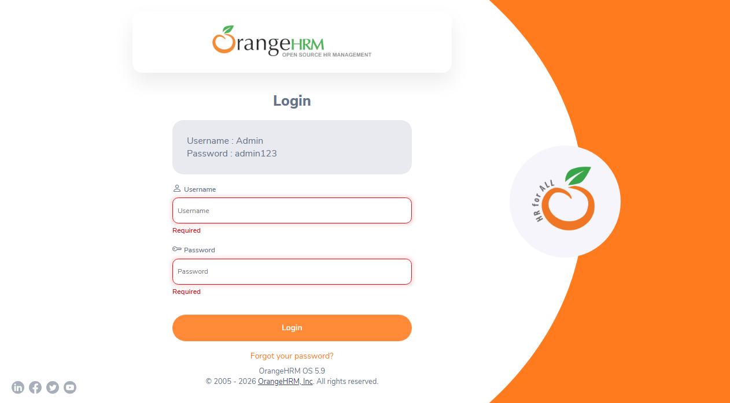
Defect ID | N/A

TC ID | INT01
Test Case | Integration - Login to Dashboard
Test Data | User: Admin  Pass: admin123
Expected Result | Auth session seamlessly handed over to Dashboard API
Actual Result | Auth token established; Dashboard metrics populated.
Status | PASS
Screenshot
Defect ID | N/A

TC ID | INT02
Test Case | Integration - Dashboard to PIM
Test Data | Module: PIM
Expected Result | Data bus connects Dashboard to Employee Management
Actual Result | PIM employee list view loaded with records table.
Status | PASS
Screenshot | 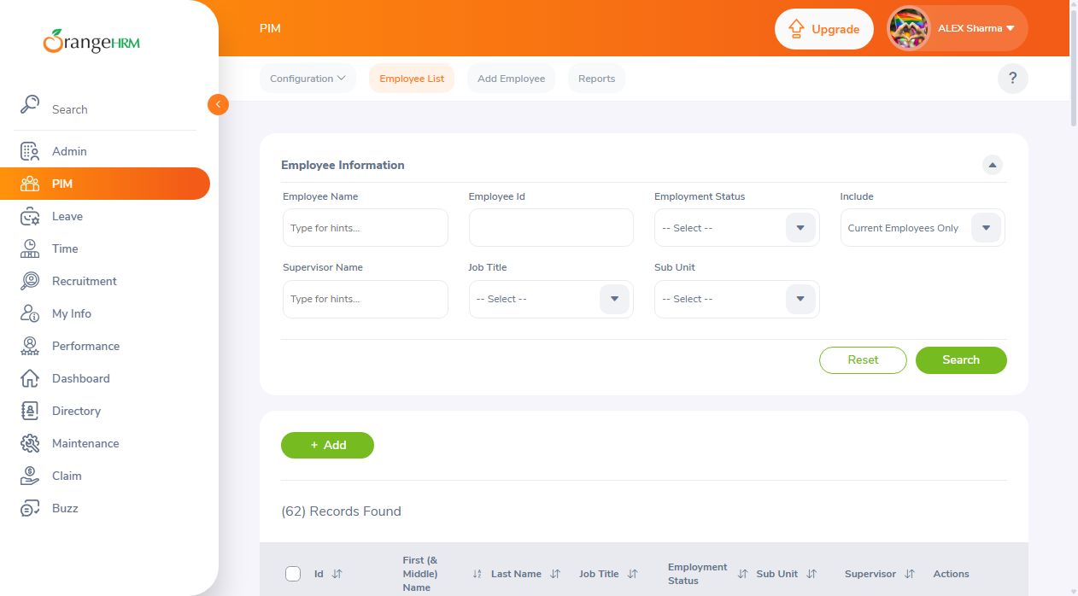
Defect ID | N/A

TC ID | SYS01
Test Case | System - Complete Workflow
Test Data | End-to-End User Journey
Expected Result | Login -> PIM -> Search Employee -> Profile -> Logout
Actual Result | Complete persona lifecycle executes without errors.
Status | PASS
Screenshot
Defect ID | N/A

3. White Box Testing: Logic, Control Flow Graph & Coverage Analysis
A Python business-logic program ('calculate_bonus.py') was analyzed to demonstrate Statement, Branch, and Path coverage using Control Flow Graph (CFG) modeling:
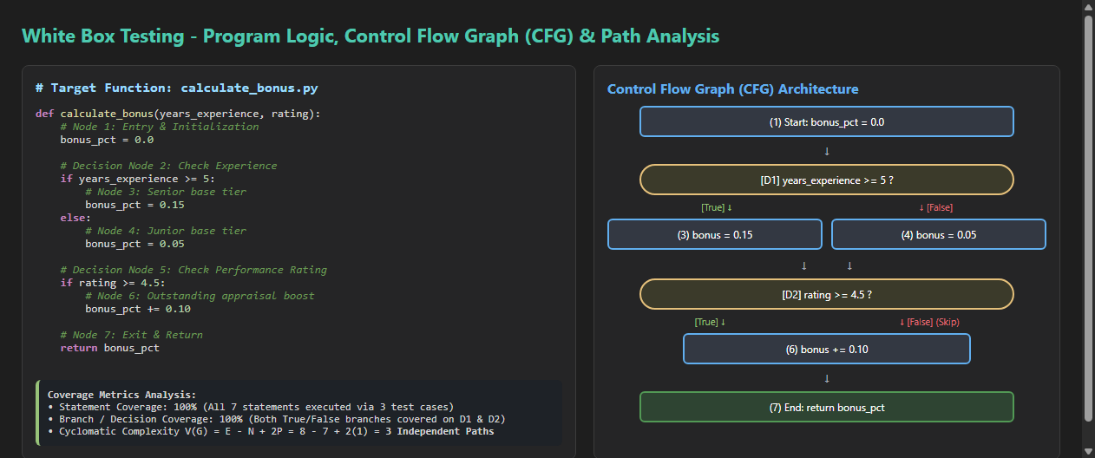
Test Case | Input (Years, Rating) | Executed Path | Target Coverage | Result
WB_TC01 | years=6, rating=4.8 | 1 -> 2 -> 3 -> 5 -> 6 -> 7 | Statement + Branch (True, True) | Bonus: 0.25 (PASS)
WB_TC02 | years=2, rating=3.5 | 1 -> 2 -> 4 -> 5 -> 7 | Statement + Branch (False, False) | Bonus: 0.05 (PASS)
WB_TC03 | years=7, rating=4.0 | 1 -> 2 -> 3 -> 5 -> 7 | Branch Coverage (True, False) | Bonus: 0.15 (PASS)
• Cyclomatic Complexity V(G) = Edges (8) - Nodes (7) + 2P (2) = 3 Independent Basis Paths.
• Statement Coverage: 100% (All 7 statements executed).
• Branch Coverage: 100% (All True/False outcomes traversed).
• Path Coverage: 100% (All 3 independent execution paths verified).

