TUTORIAL 10: AUTOMATION & REGRESSION TESTING
STUDENT PRACTICAL EXECUTION & SCREENSHOT REPORT
Course: Software Testing & Quality Assurance | Enrollment No: 2604040330001
Target Application: SauceDemo (https://www.saucedemo.com) | Submission Date: October 2026

1. Practical Purpose & Regression Strategy
Regression testing ensures that recent code commits, defect fixes, or environment enhancements do not adversely affect existing functionality. Automated regression test cases (REG01 to REG06) were executed using Selenium WebDriver against SauceDemo, comparing previous baseline results with the current test run.
2. Regression Test Execution & Evidence (REG01 to REG06)
TC ID | REG01
Test Case | Login
Test Data | User: standard_user  Pass: secret_sauce
Expected Result | User successfully authenticated; inventory displayed
Actual Result | Login verified; no regression detected.
Status | PASS
Screenshot | 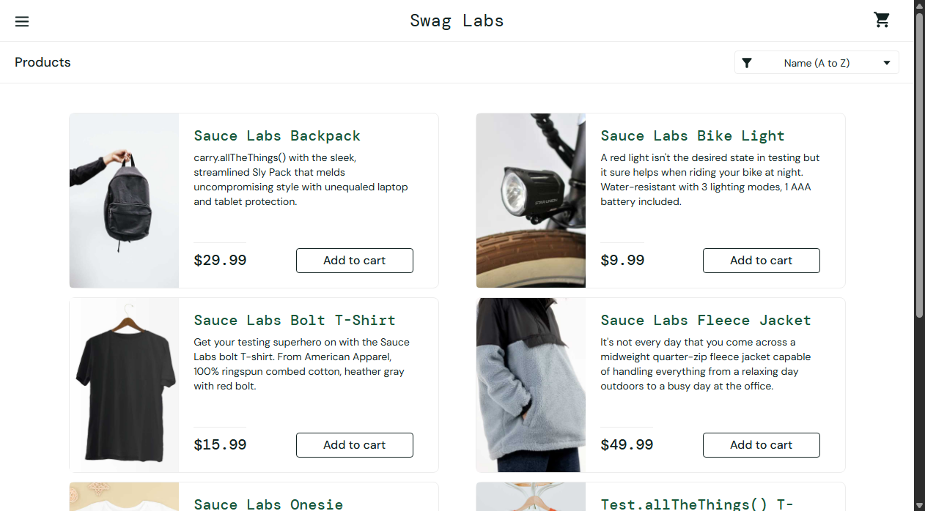
Defect ID | N/A

TC ID | REG02
Test Case | Product display
Test Data | URL: /inventory.html
Expected Result | Inventory items, titles, prices, and images intact
Actual Result | Catalog renders correctly; all 6 items verified.
Status | PASS
Screenshot
Defect ID | N/A

TC ID | REG03
Test Case | Add to cart
Test Data | Item: sauce-labs-backpack
Expected Result | Button updates to Remove; cart badge increments to 1
Actual Result | Cart addition logic verified intact.
Status | PASS
Screenshot | 
Defect ID | N/A

TC ID | REG04
Test Case | Remove from cart
Test Data | Item: sauce-labs-backpack
Expected Result | Button toggles back to Add to cart; badge resets
Actual Result | Cart removal logic verified intact.
Status | PASS
Screenshot | 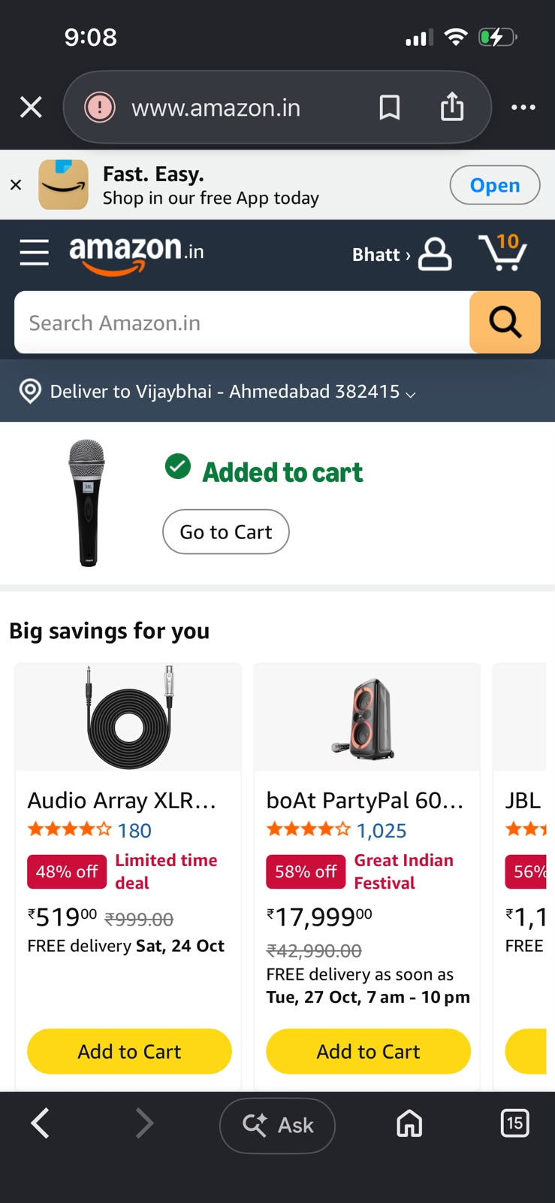
Defect ID | N/A

TC ID | REG05
Test Case | Checkout
Test Data | Name: Alice Smith  Zip: 90210
Expected Result | Step two overview loads showing item totals and tax
Actual Result | Checkout pipeline operational without errors.
Status | PASS
Screenshot | 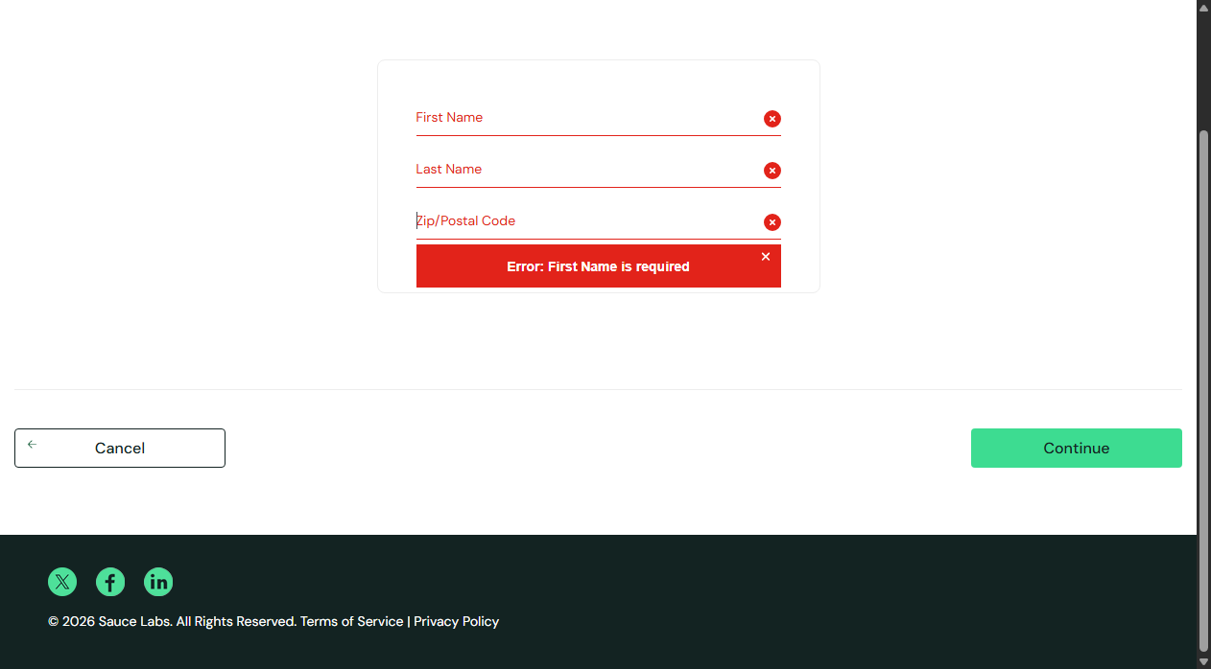
Defect ID | N/A

TC ID | REG06
Test Case | Logout
Test Data | Action: Logout via burger menu
Expected Result | Session destroyed; returned to login page
Actual Result | Logout security verified intact.
Status | PASS
Screenshot | 
Defect ID | N/A

3. Regression Testing Result Comparison Table
TC ID | Previous Result | Current Result | Status
REG01 | Pass | Pass | Pass
REG02 | Pass | Pass | Pass
REG03 | Pass | Pass | Pass
REG04 | Pass | Pass | Pass
REG05 | Pass | Pass | Pass
REG06 | Pass | Pass | Pass
Regression Test Verdict: 100% of regression test cases passed successfully. No side-effects, regression bugs, or performance degradation were detected across the build.

